Name: | Class:

Complete the sentences. Score / 5

on the floor in the country after meals
near a busy road before meals the habitat where you live

You shouldn’t throw trash on the floor .
You should brush your teeth ______________.
You shouldn’t play soccer ______________.
You should help protect ________________.
You should wash your hands _____________.
You should clean up after a picnic ____________.
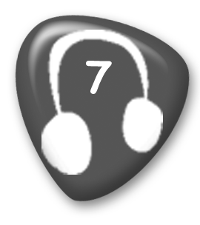
Listen and check () or put an X in the box. Score / 10

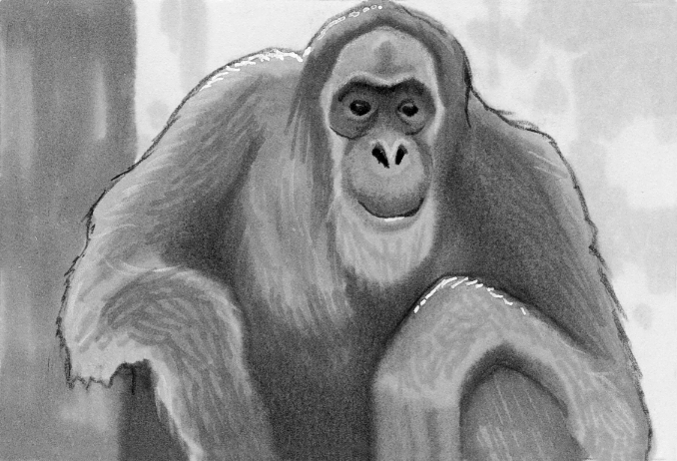
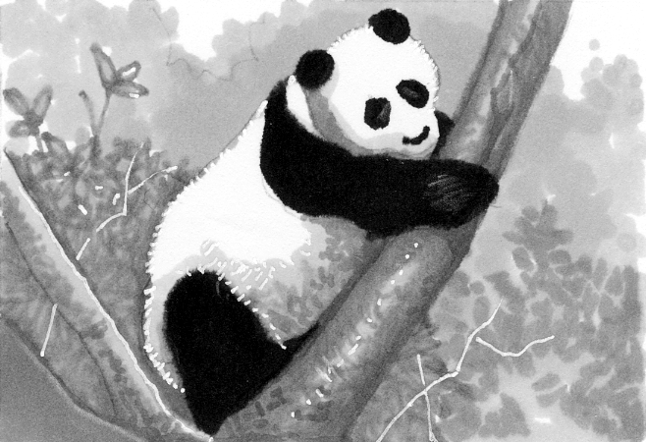
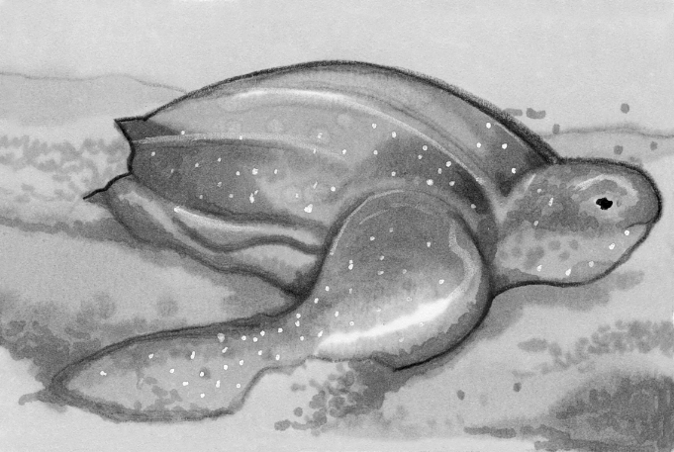



1 2 3 4 5 6

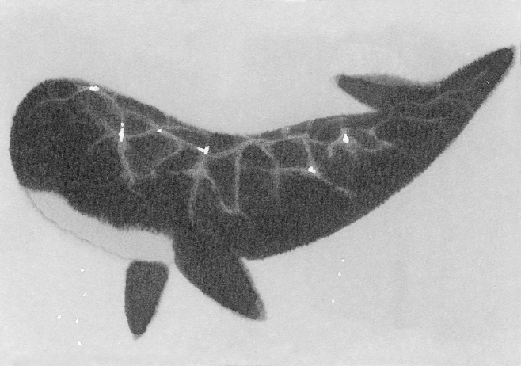
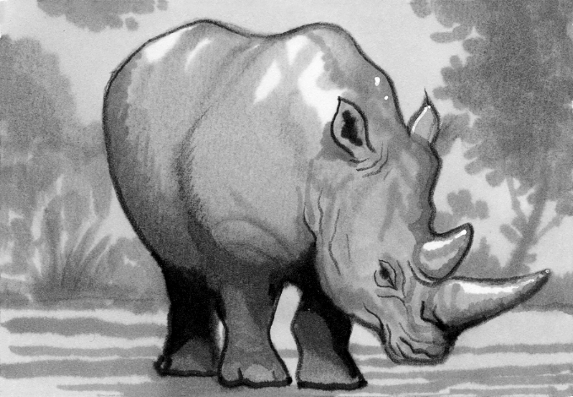
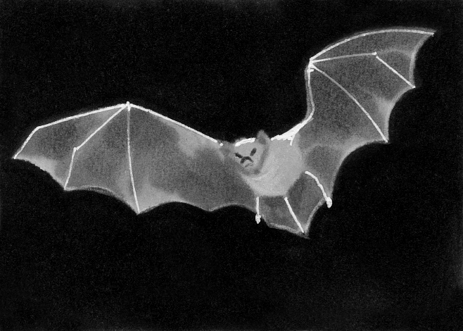

7 8 9 10 11

Total unit score / 15

