Name: | Class:

Circle the word that doesn't belong. Score / 5
 | cartoon | documentary | news | funny | quiz
 | exciting | boring | amazing | job | interesting
 | teeth | hairbrush | molar | chew | gum
 | thirty | a quarter to | o’clock | a quarter after | clock
 | thief | commentator | writer | driver | actor
 | show | movie theater | turn on | watch | channel

Look at the pictures. Then read and write. Score / 10

have lunch skate buy a computer
brush her teeth play soccer sleep
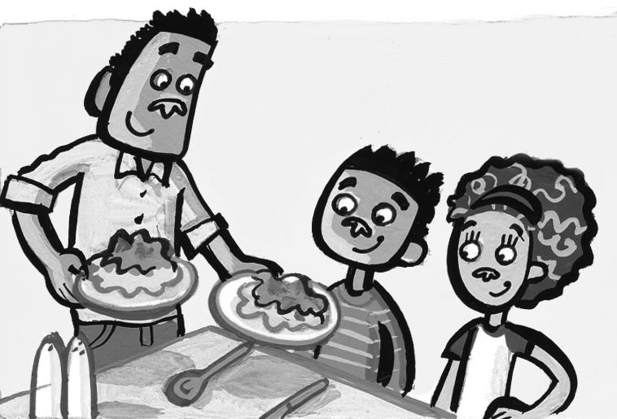
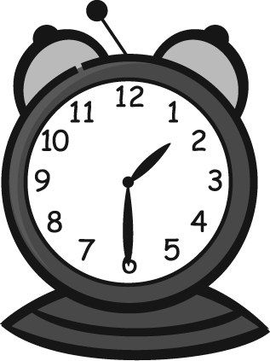
They’re going to have lunch at one thirty.

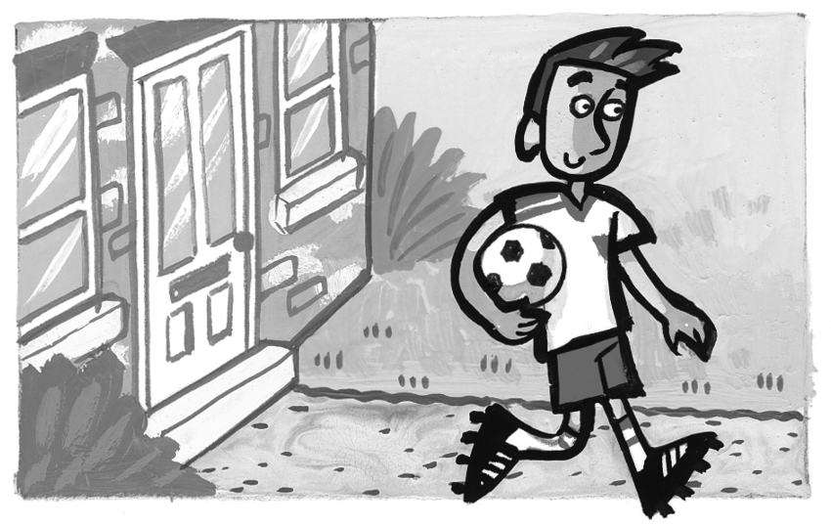
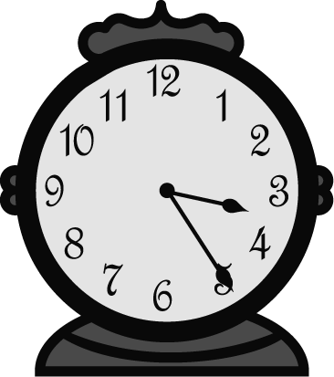
______________________

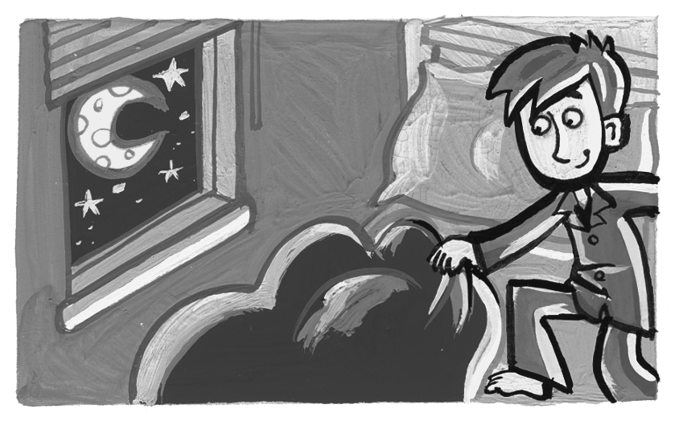
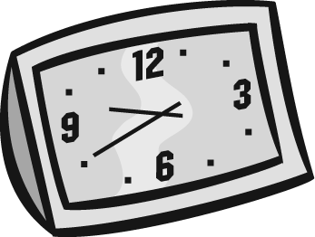
______________________

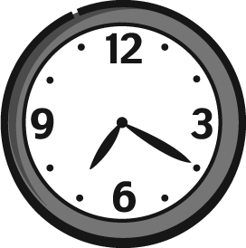
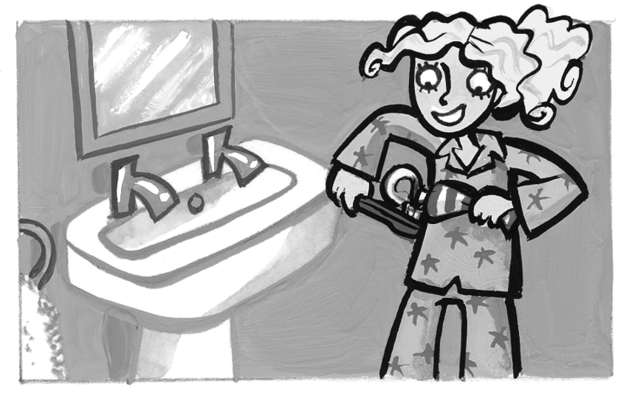
______________________

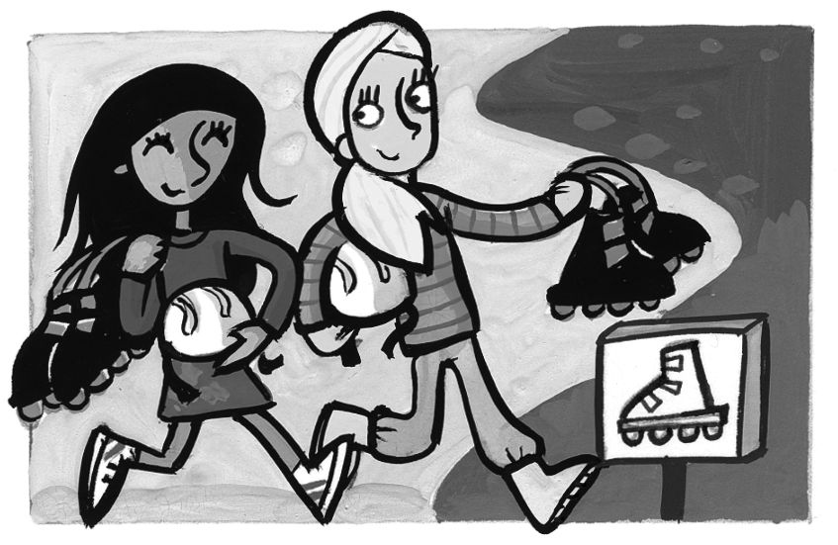
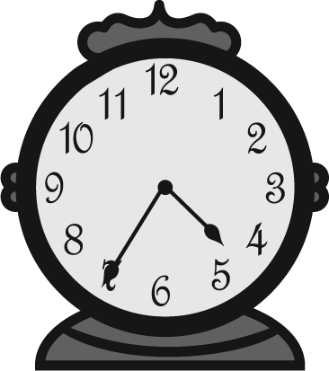
______________________

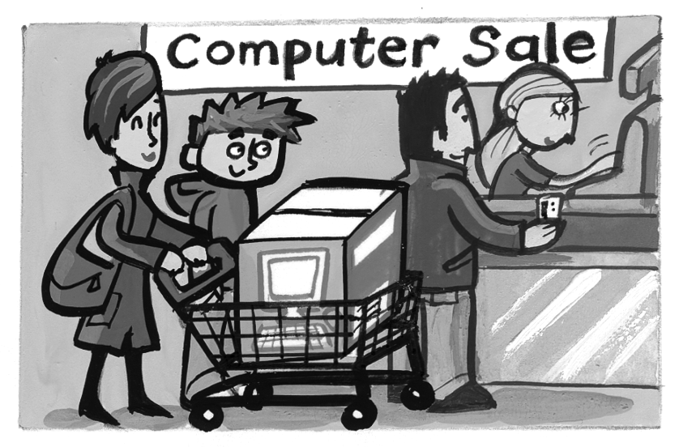
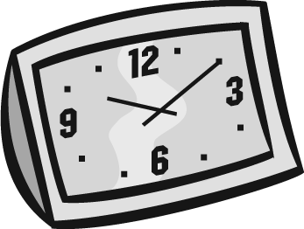
______________________

Total review score / 15

