Name: | Class:

Read and match. Score / 5

Was he playing in the classroom when her mom arrived home.
When we were sailing to the island, when I cut my foot.
I was swimming in the ocean when he broke the chair?
When you were traveling in Italy, our boat hit an iceberg.
She wasn’t doing her homework did you visit Rome?
Did it start to rain when they were having a picnic?

Read and write the words. Score / 10

A dangerous thing that
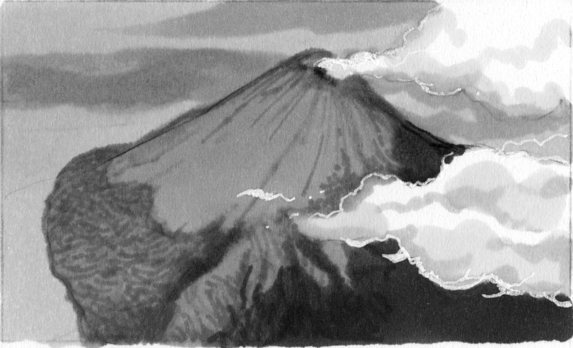
volcanoes do. erupt___

A person who stops a fire. ______

The month between January
and March. ______

A disaster after there is an
earthquake underwater. ______

A direction you can go if you don’t turn left or right. ______

A place where you can borrow books. ______

A place in the city where you can go for help. ______

A place that has water around it. ______

A cloud that is near the ground and stops you from seeing well. ______

A place where you can catch a bus. ______


A place where you can go for dinner. ______

Total review score / 15

