Name: | Class:

Listen and write the number. Score / 5


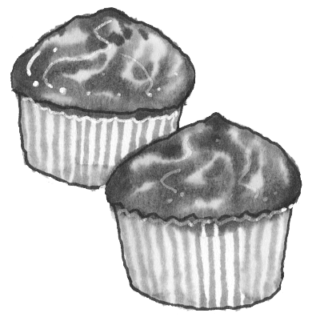


_ _ _ _ _ _
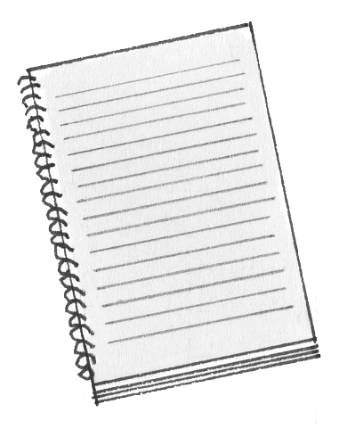



_ _ _ _ _1_

Circle the correct answer. Score / 10

A lion sound / sounds like a tiger.
You use a fork / knife to cut your food.
Lemonade looks / tastes like water.
Our house is / are made of stone.
We have four / five senses.
My ice cream tastes / taste like strawberries.
He knows / nose the answer.
Their / There sweaters are made of wool.
Metal / Glass can break easily.
Candy is made with salt / sugar.


Pizza is a famous Italian / English food.

Total review score / 15

