
Name: | Class:

Read and match. Score / 5

You shouldn’t go into a field she’s won the competition.

She’s so happy because been ice-skating?

When the sun is strong, that has a bull in it.

The teacher’s angry you should wear a hat.

Have you ever cleaned the bathroom this week.

They haven’t because her students haven't
done their homework.

Listen and check (). Score / 10

 |  | 
He’s climbed the mountain. |  | 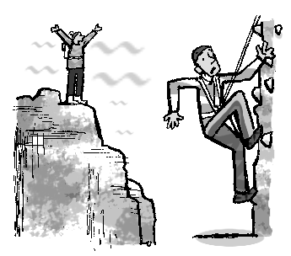  
We wanted to eat salad.
She used a computer.
Some frogs are spotted.
He started his homework.
Pandas are endangered.
Have they cleaned the car?

Total review score / 15

