Name: | Class:

Complete the story. Score / 10

going yet was Nothing anything everywhere already
might because bought will enough

Next Saturday is Tom’s birthday and he is (1) __going__ to have a big party.
He has (2) ________ invited everyone. Yesterday, his friend Sam went shopping because he wanted to find the perfect present for Tom.

In the morning, Sam looked (3) ________ but he couldn’t find anything.
At four o’clock in the afternoon, Sam (4) ________ looking in the sports store when he found something perfect for Tom: a skateboard. "Tom is going to love this!" Sam thought.

When Sam was leaving the store he saw Tom, who was very excited.
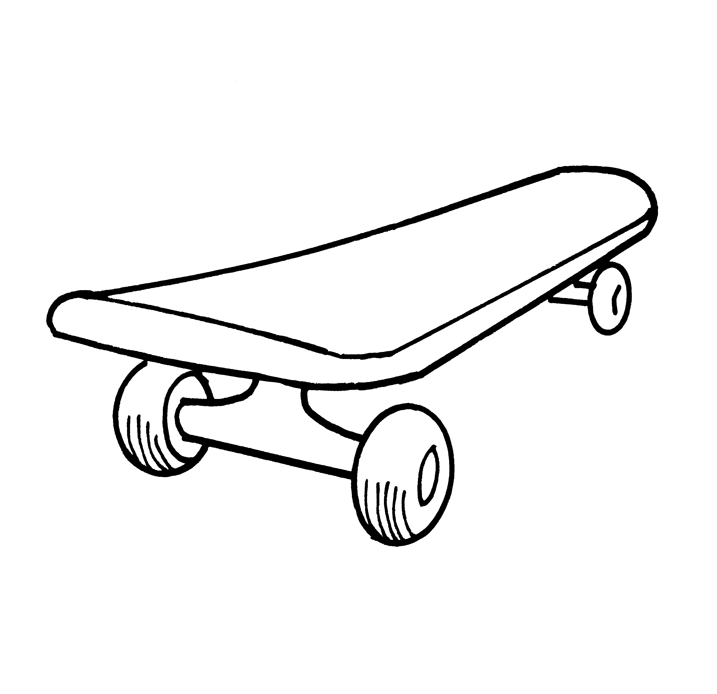
"Look!" Tom said, "I (5) ________ a new skateboard – I love it!" Tom saw Sam’s shopping bag. "What did you buy?" he asked.
"(6) ________," said Sam, and put the bag behind his back.

Complete the charts. Score / 10

unicorn rocket jellyfish griffin coral chopsticks centaur
plankton peanut butter recipe engineer satellite

under the ocean

____________

____________

____________

beasts

unicorn

____________

____________

space

rocket

____________

____________

food

____________

____________

____________

Read and match. Score / 10

A: No, I’m not. I wanted to do something more interesting.

B: No, I think I will be an art teacher.

C: Something light. Not wool. I might use cotton.

D: Yes. I’ve just started designing clothes.

E: Yes, I do. I’m going to start making it tomorrow.

F: No, but I’m going to make a skirt for the school dance. I’ve just finished the design. Look!
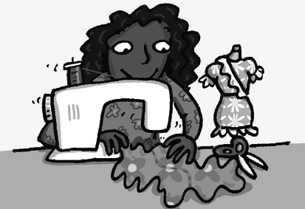
Teacher: Hi, Debbie. Are you still going
to chess club?
Debbie: (1) A

Teacher: Oh. Do you have a new hobby?
Debbie: (2) __

Teacher: Great. Have you used your
designs to make any clothes yet?
Debbie: (3) __

Teacher: That’s fantastic! I really like
the pockets. What’s it going to be made of?
Debbie: (4) __

Teacher: Do you have enough time?
Debbie: (5) __

Teacher: Do you want to be a fashion
designer in the future?
Debbie: (6) __


Listen and circle. Score / 5

The boy is going to make spaghetti with squid and crab / octopus.
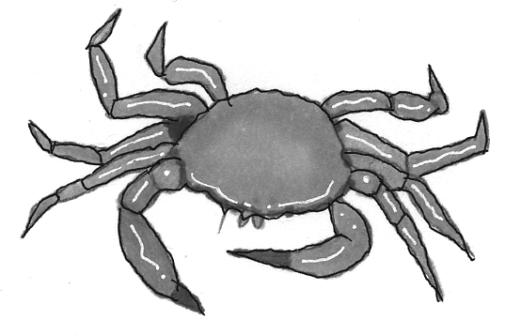
The spaghetti / sauce is too hot.
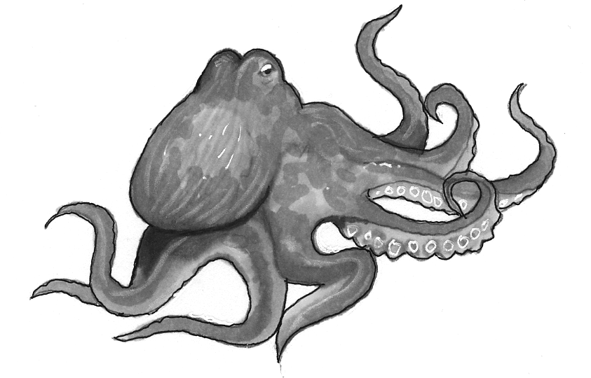
They decide to invite someone / everyone for dinner.
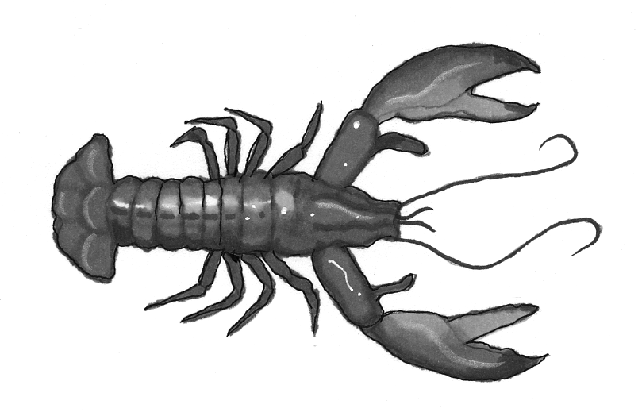
Their friend Daisy will / won’t be busy.
Tony might not / will like the food.
Mary is / isn’t still in India.

Total end of level score / 35

