

1 Cross out the incorrect words. (10 points)
2 sing, breathe fire, fur, scales, 3 ugly, lion’s tail, horn, feathers, 4 tail, half man, wings, half eagle,
5 sing, breathe fire, ugly, live close to water, 6 fur, half bird, scales, half fish

2 Look at Dan’s schedule. Complete the questions. (5 points)
2 Who is he going to see, 3 When is he going to call, 4 Where is he going to go, 5 Who is he going to watch, 6 When is he going to make



1 Listen and circle. (10 points)
2 space, 3 five, 4 vegetables, 5 read or take pictures, 6 won’t

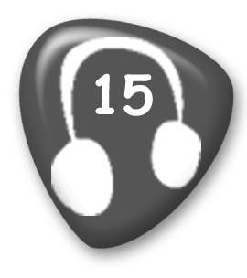
Assistant: Good morning. Can I help you?
Woman: Yes, I’d like some information about your space trips.
Assistant: Of course.
Woman: What planets will we be able to see?
Assistant: The first planet you will see is Earth. It will look amazing! After that, we’ll see Venus.
Woman: And Mars?
Assistant: No, we won’t be able to see Mars.
Woman: Will I be comfortable on the trip?
Assistant: Yes, our rockets have a lot of space!
Woman: Good. How long will the flight be?
Assistant: Just five hours. We will arrive before we have dinner.
Woman: What will we eat?
Assistant: We have delicious space meals made of vegetables.
Woman: What will we do in the evening?
Assistant: There aren’t a lot of things to do. You should bring a book. You can take pictures, too.
Woman: OK. And how much will the trip cost?
Assistant: It’s one million dollars.
Woman: One million dollars! Oh, no! I think I’ll have to find a different trip here on Earth.

2 Read and match. (5 points)
2 d, 3 a, 4 c, 5 b, 6 a

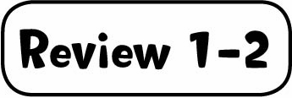

1 Listen and complete. (10 points)
2 (big) wings, 3 a cave, 4 people, 5 12, 6 A

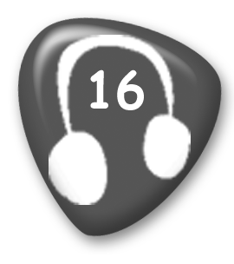
Boy: I read a good story last night.
Woman: Can you tell me about it?
Boy: Yes. The name of the story was The Helper.
Woman: How do you spell "helper"?
Boy: H-E-L-P-E-R.
Woman: Oh, helper. And was the story about a person who helped people?
Boy: No, not a person. It was a creature with big wings.
Woman: Oh. That’s interesting. Did it live near the ocean?
Boy: No, it lived in a cave.
Woman: Was it a dragon?
Boy: No, it wasn’t. But it could fly. It helped people. It flew around to tell them when there was danger.
Woman: Did it help a lot of people?
Boy: Yes, it did.
Woman: Was it a long story?
Boy: No. It was only 12 pages. I read it all last night.

2 Read and match. (5 points)
2 a, 3 e, 4 f, 5 b, 6 d



1 Read and check () the correct sentences. (5 points)
2 a, 3 b, 4 b, 5 b, 6 a

2 Read and complete. (10 points)
2 flashlight, 3 backpack, 4 sleep, 5 behind, 6 country



1 Read and write yes or no. (10 points)
2 yes, 3 no, 4 no, 5 yes, 6 yes, 7 no, 8 no, 9 no, 10 no, 11 yes

2 Listen and number. (5 points)
vegetables − 5, cookies − 6, cheese − 4, popcorn − 3, soup − 2

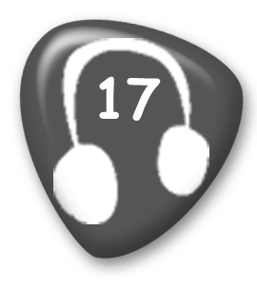
1 My favorite snack is very healthy. There are lots of different things you can choose to eat. Some are long and yellow, and some are round and orange, green, or red. They taste very different, too. But they are all sweet. I always eat some after lunch.
2 My favorite food is hot. It can be made of tomatoes, potatoes, or other vegetables. Sometimes it has meat in it, too. I eat this food in the fall and winter. You can’t eat this food for breakfast. It’s a food for lunch or dinner. You always eat it with a spoon.
3 I don’t eat my favorite snack at home, but when I go to the movies I eat a lot! It’s small, but you can buy a big bag. It’s not very healthy, but I love it!
4 I put my favorite food in sandwiches. It’s yellow and sometimes it smells strong. It’s the most important topping on a pizza.
5 You should eat my favorite food every day. I do. It can be green, red, purple, or orange. You can use my favorite food to make salad or soup. People put this food on pizzas, too.
6 My favorite snack is sweet. I eat them in the afternoon with a cup of coffee. You can have them in the morning with a glass of milk, too. You shouldn't eat a lot of my favorite snacks because they have a lot of sugar in them.

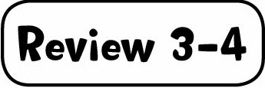

1 Complete the table. (10 points)
Snacks: cookies, popcorn
Things we cook with: oven, pan
Things we eat with: chopsticks, knife, fork
Cooking instructions: mix, heat, cut

2 Listen and write the number. (5 points)
2 spaghetti and tomato sauce, 3 fruit, 4 popcorn, 5 bread and jam, 6 cookies

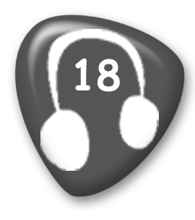
1 Girl: Did you enjoy lunch today?
Boy: Yes. I had a cheese sandwich.
Girl: Boring!
Boy: Not for me. I love cheese!
2 Boy: Were you hungry when you were playing volleyball?
Girl: No. I had a big plate of spaghetti and tomato sauce last night.
3 Girl: How long were you playing the guitar this afternoon?
Boy: Hmm … about two hours.
Girl: Wow!

Boy: I stopped to have a banana and an apple after an hour. But I was playing all afternoon.
4 Boy: Why were you brushing your teeth for ten minutes this morning?
Girl: I was eating popcorn before breakfast, so I needed to brush my teeth well.
Boy: Why were you eating popcorn in the morning?
Girl: It’s my favorite snack. Don’t tell Mom, OK?
5 Girl: I was so tired when we were doing our homework last night.
Boy: Me, too. It was a good idea to have some bread and jam when we were working.
6 Boy: That movie we were watching last night wasn’t very good.
Girl: I wasn’t watching carefully.
Boy: No. You were busy eating all the cookies!
Girl: No, I wasn’t!
Boy: Yes, you were!



1 Complete the table. (10 points)
for: three hours, six years, four months, two weeks, years
since: April 21, 2011, Tuesday, this morning, Sunday

2 Read and check () or put an X in the box. (5 points)
2 , 3 , 4 , 5 , 6



1 Listen and number. (5 points)
free running − 2, board games − 6, fashion design − 5, skateboarding − 3, chess − 4

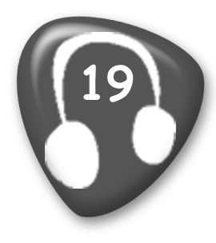
1 It’s something you do in the mountains or hills. You need to have strong legs. You should wear a helmet.
2 This hobby has been popular since the 1990s. People who do this are in very good shape. You have to run a lot, jump, and climb walls. You can do it anywhere in the city, but you should be careful, because it’s dangerous.
3 This hobby started in the 1970s. It is still very popular with young people. They learn tricks and go to special parks to practice. You shouldn’t do this hobby near the road. And you should wear a helmet and knee pads.
4 This game has been popular for hundreds of years. It is difficult. You have to think carefully before you move. The board has black and white squares. Sometimes schools have a club for this hobby where students practice for competitions.
5 People who do this hobby draw new clothes. Sometimes they paint and sew T-shirts, too. If you like clothes and making things, this is a good hobby for you.

6 This can be fun for all the family on rainy days and on vacations. There are lots of different games to play.

2 Circle the music words. (10 points)
Students should circle: tempo, melody, opera, tune, rhythm, bass guitar, improvisation, notes, harmony, rhyme

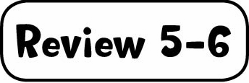

1 Read and check () or put an X in the box. (5 points)
2 , 3 , 4 , 5 , 6

2 Read and match. (10 points)
2 Crabs have lived for millions of years. 3 They don't have anything to do. 4 She doesn't have anyone to play soccer with. 5 No one has gone fishing with him. 6 He’s done free running since he was 13.

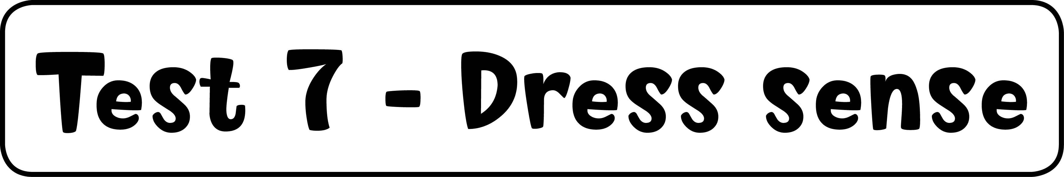

1 Read and match. (5 points)
2 c, 3 d, 4 b, 5 f, 6 e

2 Listen and check () or put an X in the box. (10 points)
2 , 3 , 4 , 5 , 6


1 Hello? Who’s there? Mom!
2 Brr! My hands are so cold.
3 Wow, thanks, Dad! I love my new bike. This is the best present I’ve ever had.
4 Hello, my name’s Daniel. What’s yours?
5 Oh! It’s so hot today. Did you put some water in the backpack?
6 Sorry, what did you say?



1 Listen and check () the things Jenny has already done. (5 points)
2 (not checked), 3 , 4 , 5 (not checked), 6 (not checked)

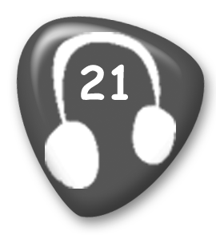
Girl: Hello?
Boy: Hi, Jenny. Are you having a good vacation?
Girl: Yes, thanks, Tim. We’ve already done a lot of things. This morning we went to the
History Museum.
Boy: Is the museum next to the river?
Girl: No, it’s up the big hill in the center of the city. I haven’t been to the river yet.
Tomorrow, we’re going to take a boat along the river and take pictures of the city.
Boy: Great! I’m sure you’ve already been to the college.
Girl: Yes, we went there yesterday. I think I’ll study there in the future.
Boy: So, what are you doing now?
Girl: Well, I’ve just been to the castle. I think we’re going to have something to eat now.
Boy: It’s a very busy vacation, Jenny. Are you feeling tired?
Girl: No! After lunch we’re going to walk on the Roman walls and then go shopping.
Boy: So you haven’t been shopping yet?
Girl: No, not yet. But I might buy you a little present this afternoon.
Boy: Great! Have a good day!

2 Read and complete. (10 points)
2 took, 3 put, 4 bought, 5 lost, 6 shouted, 7 looked, 8 found, 9 heard, 10 felt, 11 cleaned

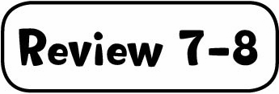

1 Read and check () or put an X in the box. (10 points)
3 , 4 , 5 , 6 , 7 , 8 , 9 , 10 , 11 , 12

2 Match the letters to make words. (5 points)
cities: Sydney, countries: India, Germany, nationalities: French, Portuguese

