Name: | Class:

Cross out the incorrect words. Score / 10
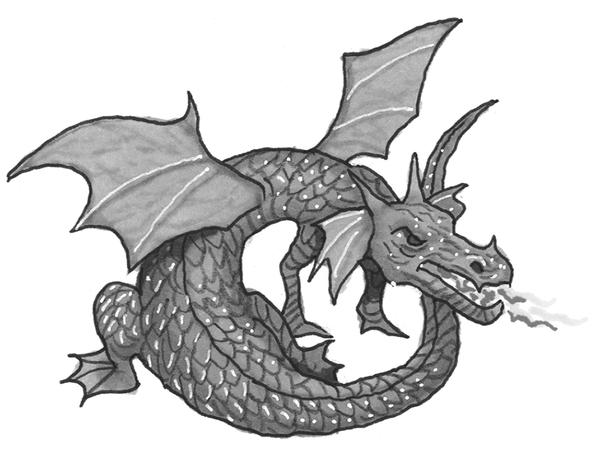
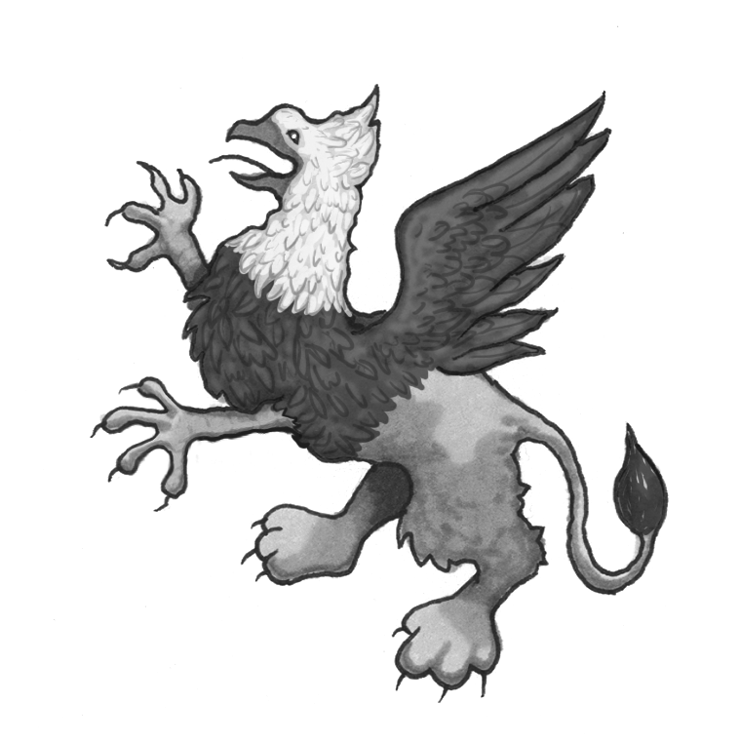
 |  | claws | horn |  |  |  | sing | breathe fire
 |  | sing | make nests |  |  |  | fur | scales

 | 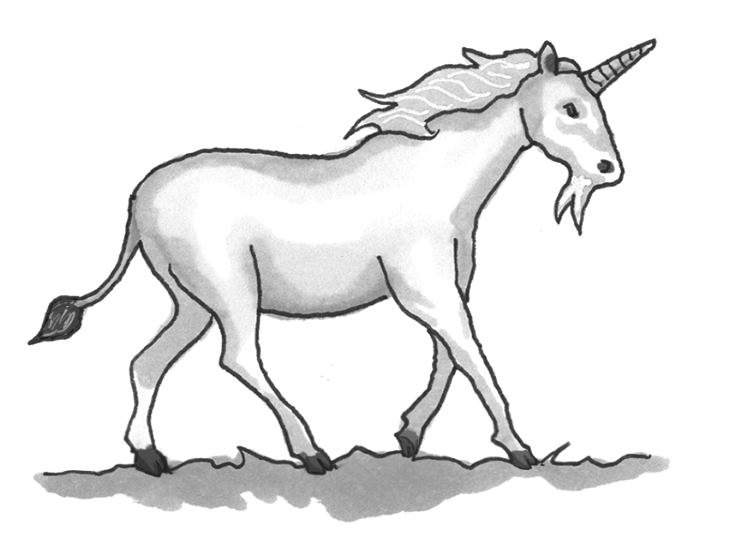 | ugly | lion’s tail |  | 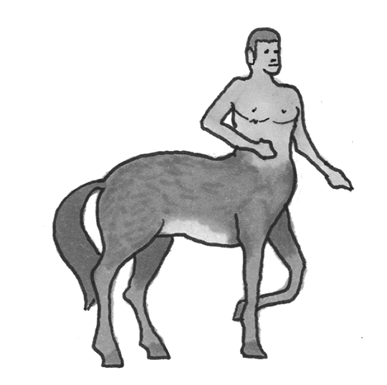 |  | tail | half man
 |  | horn | feathers |  |  |  | wings | half eagle

 | 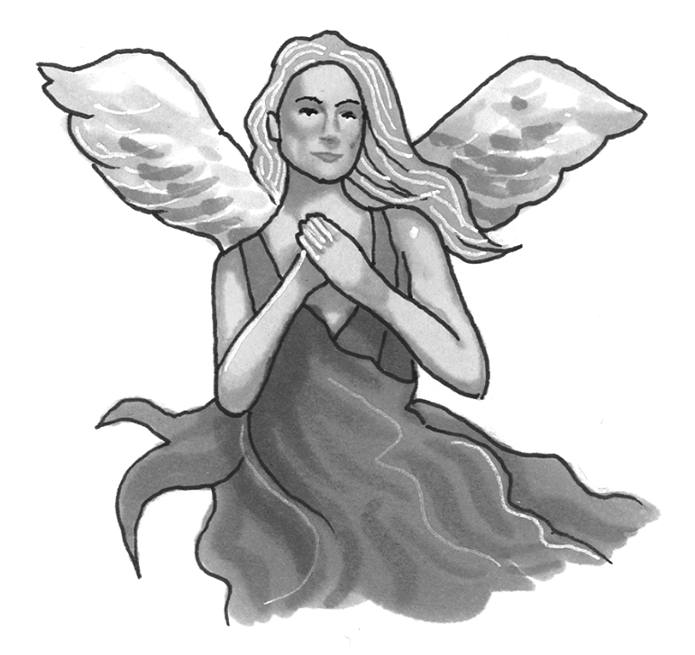 | sing | breathe fire |  |  | 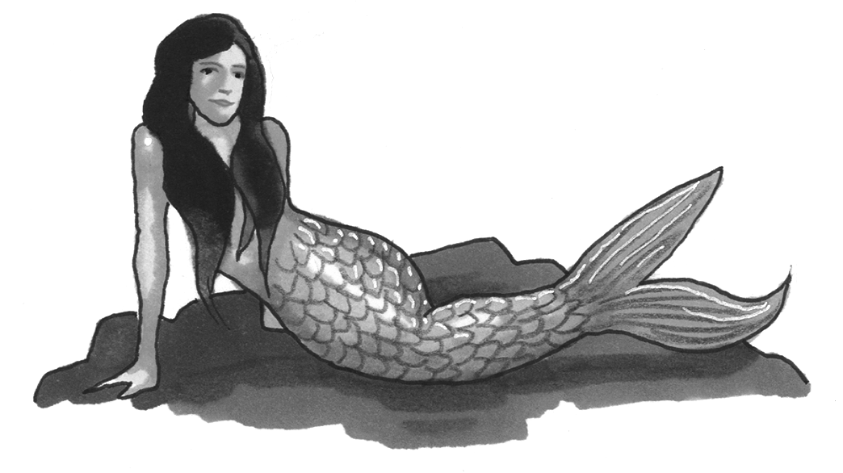 | fur | half bird
 |  | ugly | live close to water |  |  |  | scales | half fish

Look at Dan’s schedule. Complete the questions. Score / 5

Saturday | Sunday
9 a.m. – buy fish | 11 a.m. – go to the gym
10 a.m. – see doctor | 3 p.m. – watch soccer with Maria
1 p.m. – call Alex | 8 p.m. – make pizza

When What Who Where When Who

What is he going to buy at 9 o’clock on Saturday morning? Fish.
_____________ at 10 o’clock on Saturday morning? The doctor.
_____________ Alex? At 1 o’clock on Saturday afternoon.
_____________ at 11 o’clock on Sunday morning? To the gym.
_____________ soccer with at 3 o’clock on Sunday? Maria.
_____________ pizza? At 8 o’clock on Sunday evening.

Total unit score / 15

