Name: | Class:

Read and check () the correct sentence in each pair. Score / 5
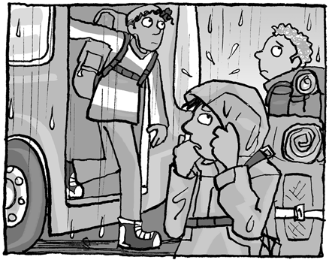
a When they arrived, it rained.
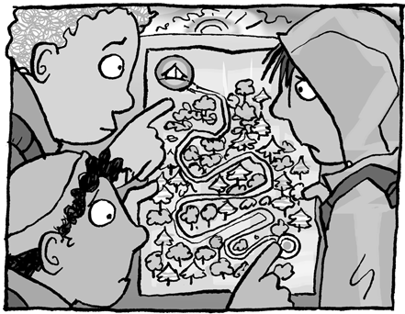

b When they arrived, it was raining.

a They were looking for a campsite on the map.
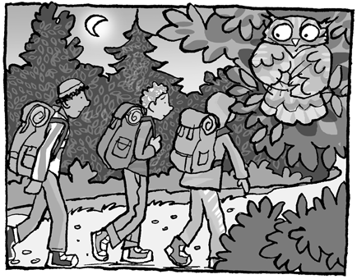
b They was looking for a campsite on the map.

a It was got late when they were walking.
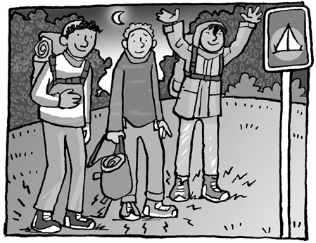
b It was getting late when they were walking.

a Their feet was hurting after the long walk.
b Their feet were hurting after the long walk.
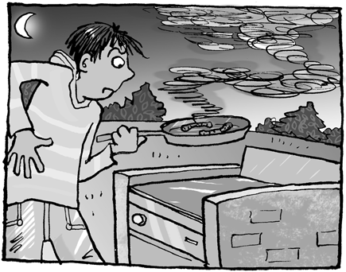
a He was cooking the sausages good.
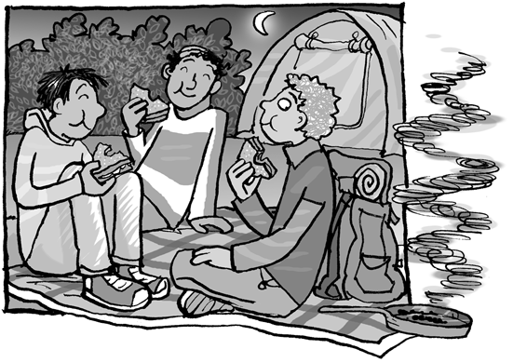
b He was cooking the sausages badly.

a They were talking and eating sandwiches.
b They were talked and ate sandwiches.

Read and complete. Score / 10
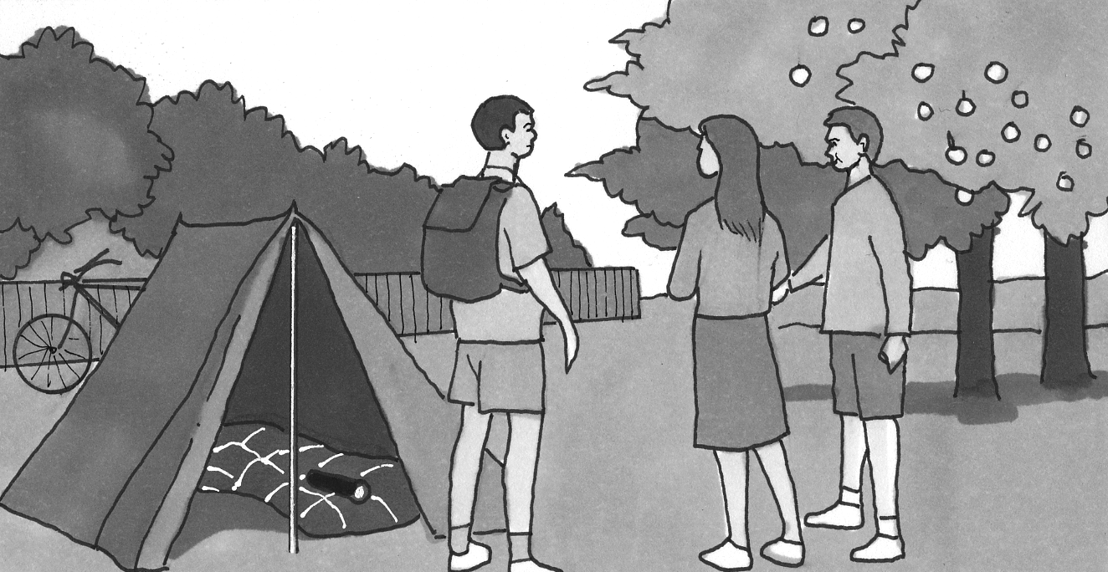
The boy wearing a T-shirt is
going to camp.
T-shirt sweater skirt
There is a _______ on the sleeping bag.
umbrella sign flashlight
The boy on the left has a __________.
suitcase backpack purse
One boy is going to __________ in the tent.
study sleep run
There is a bike __________ the tent.
next to between behind
The tent is in the __________.
city country town

Total unit score / 15

