Name: | Class:

Read and write yes or no. Score / 10

They are going to have breakfast. no_
There aren’t enough cupcakes. __
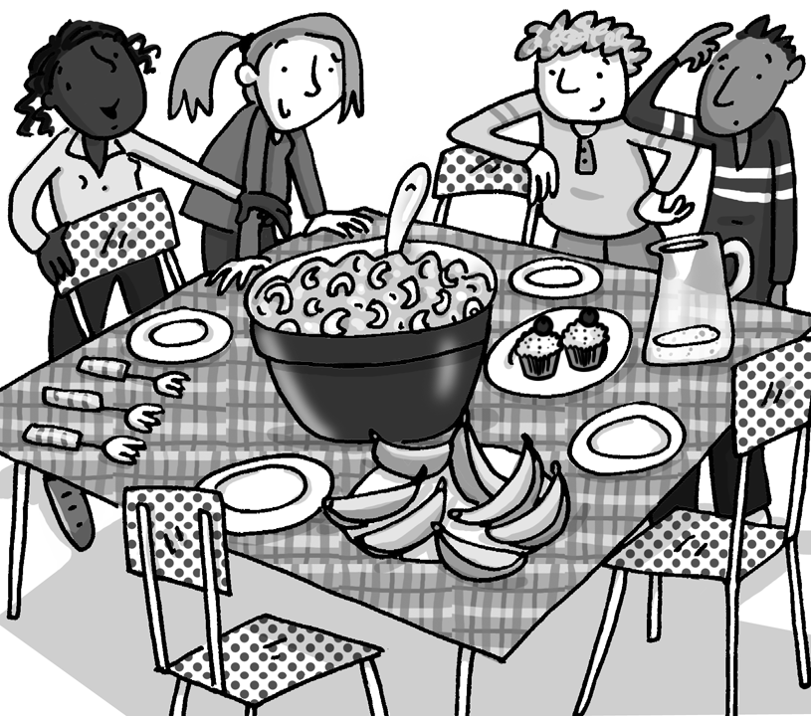
They are going to eat with chopsticks. __
There is too much sushi in the big bowl. __
There isn’t enough water. __
There are too many bananas. __
There is too much jam. __
They don't have any plates. __
All the things on the table are snacks. __
There are enough cups for the water. __

They aren’t sitting down. __
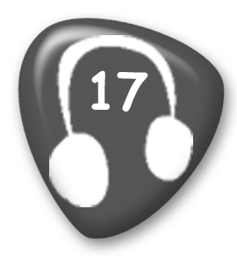
Listen and number. Score / 5

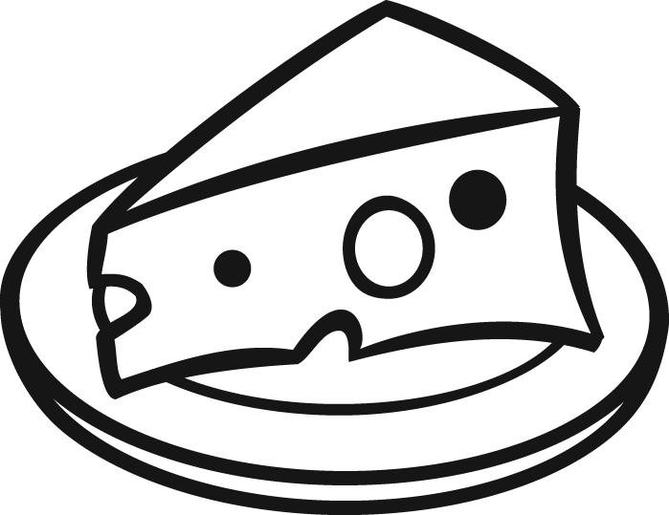
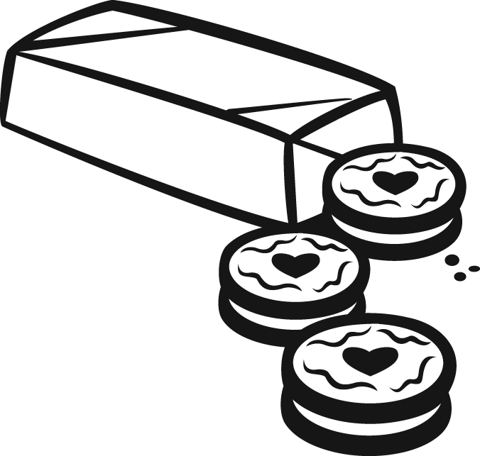
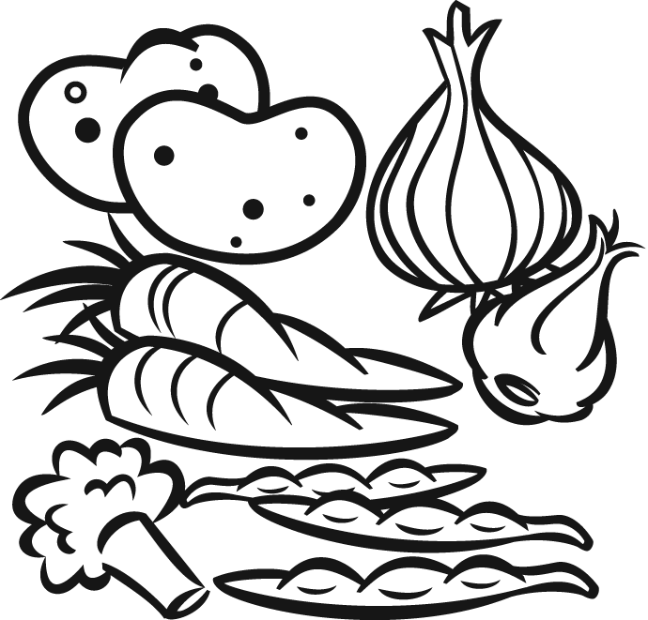

__ __ __
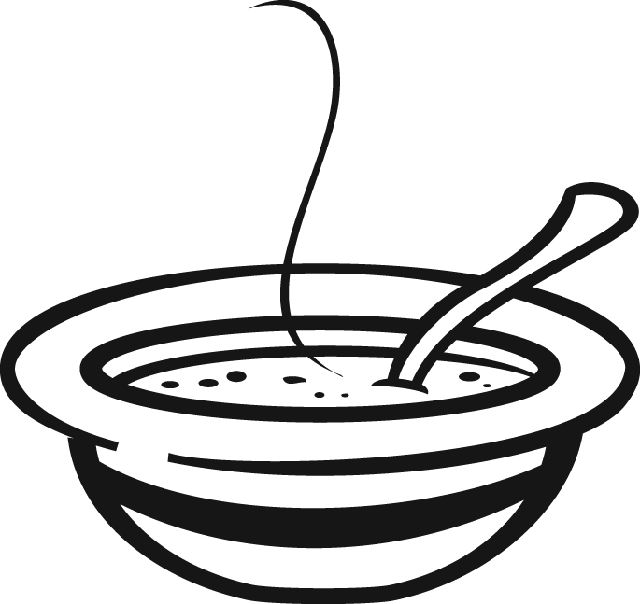
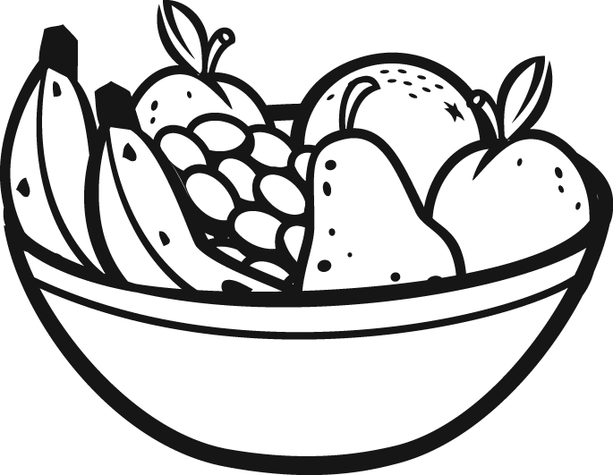
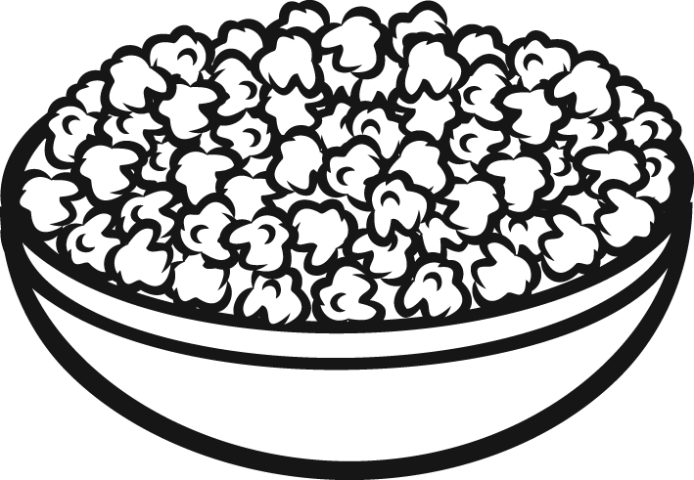

__ __ 1

Total unit score / 15

