Name: | Class:

Complete the chart. Score / 10

ten o’clock three hours six years April 21 2011
Tuesday four months this morning years Sunday two weeks

for | since
______________________  ______________________  ______________________  ______________________  ______________________  ______________________ | _______ten o’clock_______  ______________________  ______________________  ______________________  ______________________  ______________________

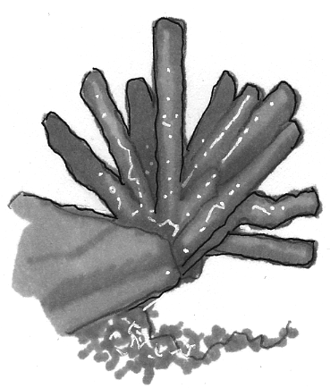
Read and check () or put an X in the box. Score / 5

Coral reefs look like forests.
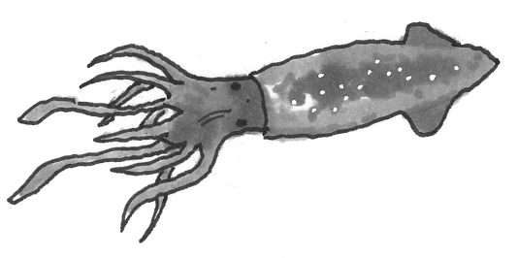

A squid has seven legs.
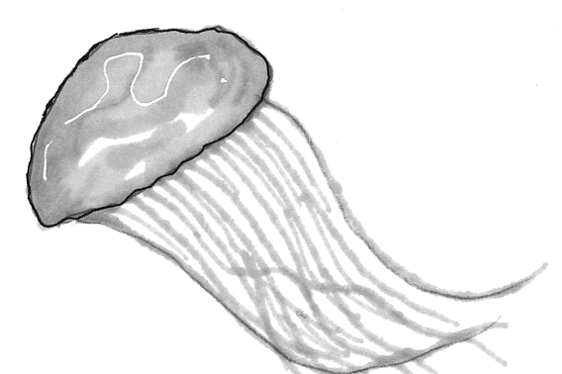
Jellyfish don't have brains or bones.
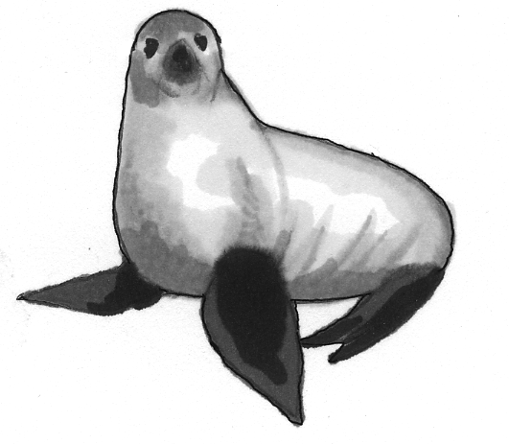
Seals lay eggs.
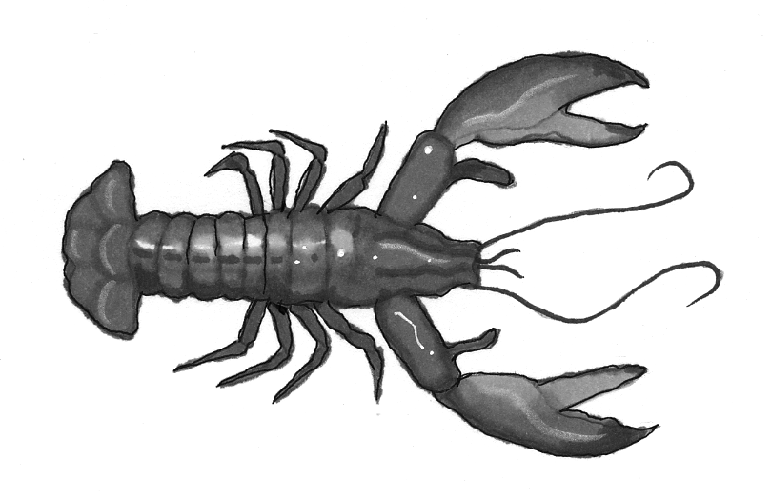
Lobsters have a hard shell.
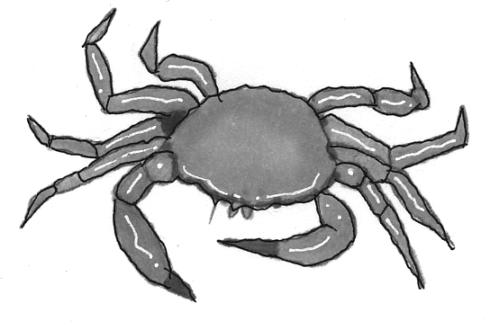
Crabs don't have claws.

Total unit score / 15

