Name: | Class:

Listen and check () the things Jenny has
already done. Score / 5


The History Museum. The river.
The college. The castle.
The Roman walls. The stores.

Read and complete. Score / 10

cleaned bought lost heard took opened put
shouted looked found felt

On Monday morning, Danny couldn’t find his new cell phone.
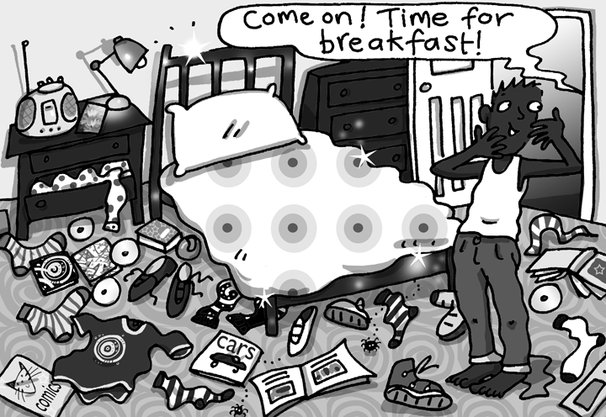
He (1) opened all the cupboards, (2) _____ everything
out and (3) ________ it on his bedroom floor. "I’ve just
(4) ________ my phone," Danny thought, "and I’ve
already (5) ________ it!"
"Come on! Time for breakfast!" his mom (6) ________ up the stairs.
"I’ve (7) ________ everywhere and I still haven’t (8) ________ it!"

Danny thought.
Then he (9) ________ his phone ringing. He (10) ________ something

moving in his pocket. "My phone!" he thought.

"Hello?" Danny said.

"Hello, Danny. Can you come downstairs for breakfast now, please?"

"OK, Mom."
After breakfast, Danny (11) ________ his room for four hours!

Total unit score / 15

