Name: | Class:

Listen and complete. Score / 10

The story was called The Helper .

The creature had .

It lived in .

It helped a lot of .

The story was pages.

A B C
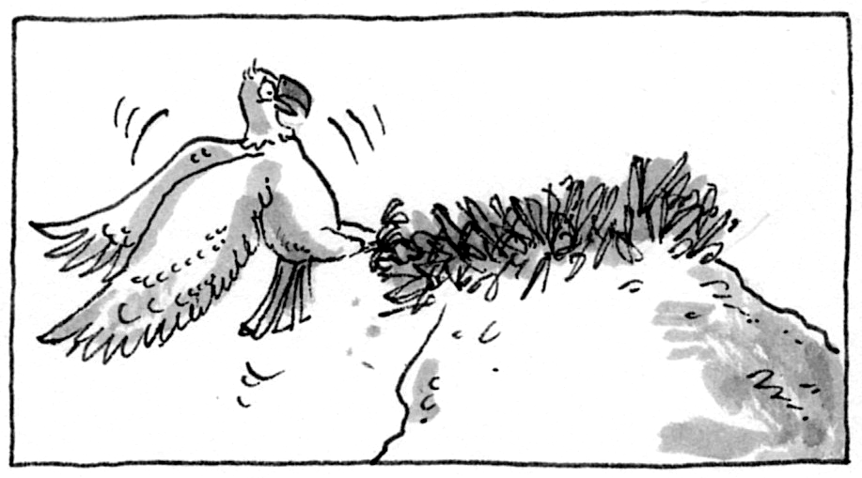
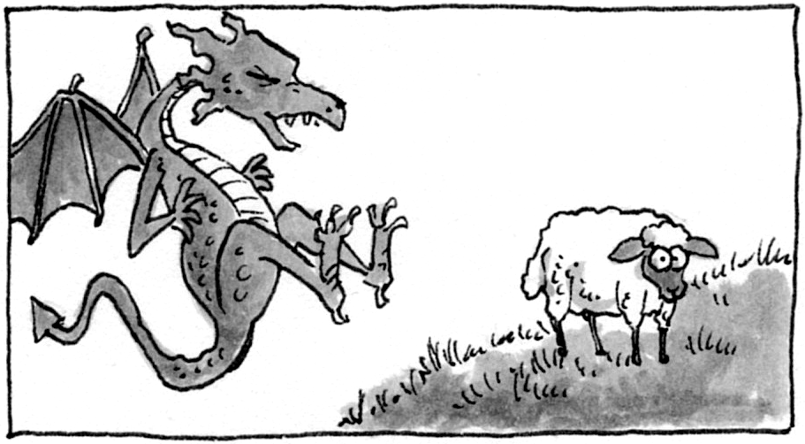
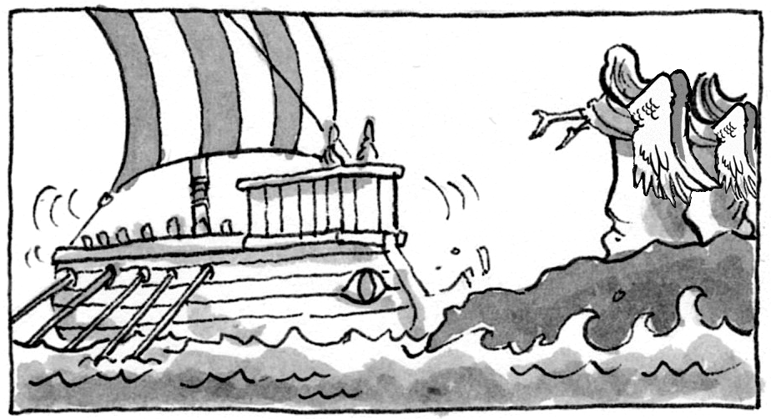

What’s the best picture for the story? _________________

Read and match. Score / 5

The astronaut will fly c a) him homework today.
His teacher is not going to give _ b) to school tomorrow.
She is going to visit _ c) to the Moon next month.
One day she will study _ d) on Mars in the future.
They won’t come _ e) Paris in the spring.
People won’t live _ f) English in college.

Total review score / 15

