Name: | Class:

Read and check () or put an X in the box. Score / 5

Everyone is doing something different.

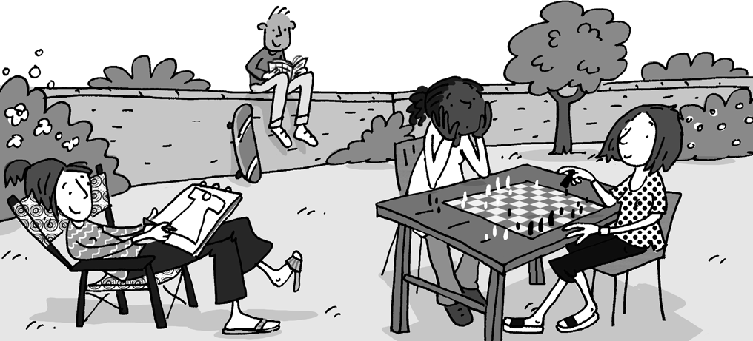
The boy isn’t doing anything.
They are somewhere quiet.
There isn’t anyone sitting on the wall.
No one is playing tennis.
Everyone is sitting down.

Read and match. Score / 10

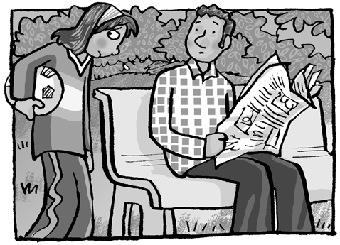
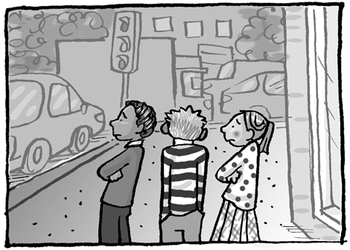
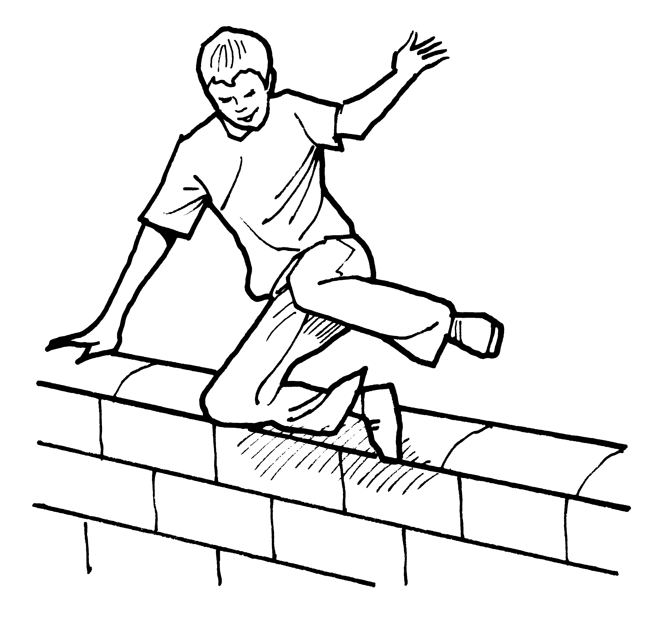
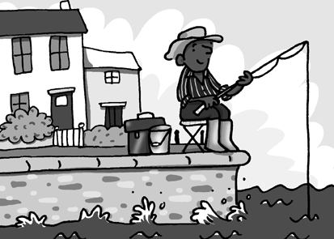
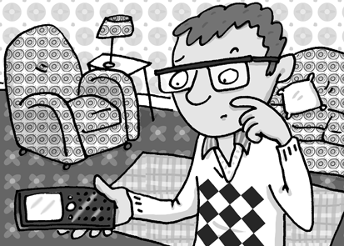
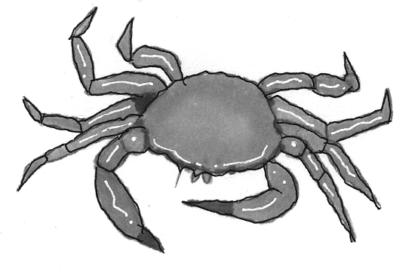

His friend | anything | to play soccer with.
Crabs have | free running | fishing with him.
They don't have | still hasn’t | called him.
She doesn't have | has gone | for millions of years.
No one | lived | since he was thirteen.
He’s done | anyone | to do.

Total review score / 15

