Name: | Class:

Read and check () or put an X in the box. Score / 10

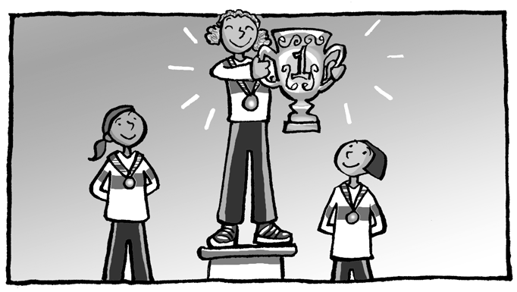
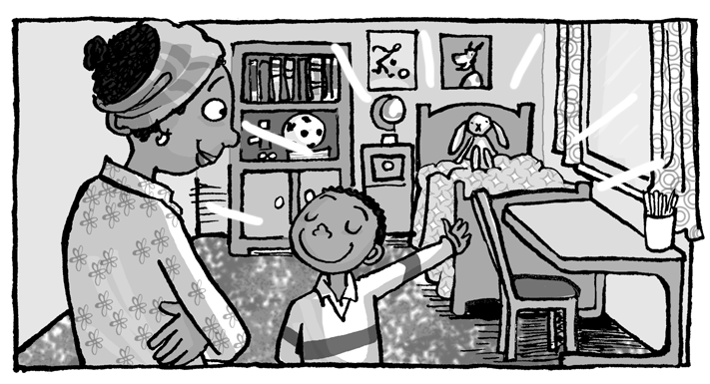
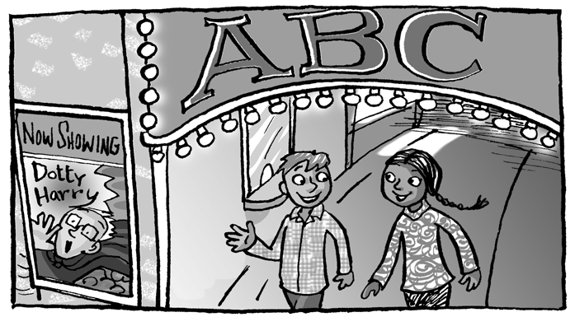
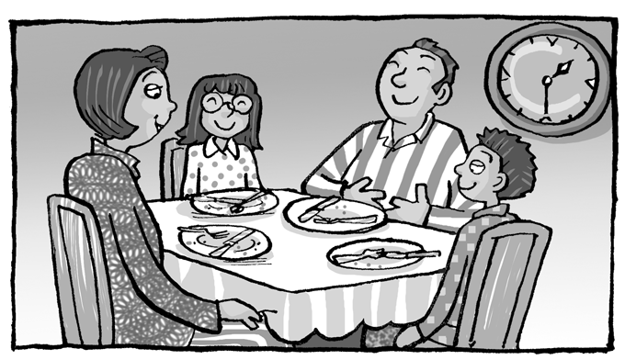


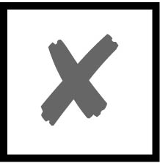
They’re wearing scarves and gloves. They might be hungry.

They’ve just seen a movie. They’ve just finished
dinner.
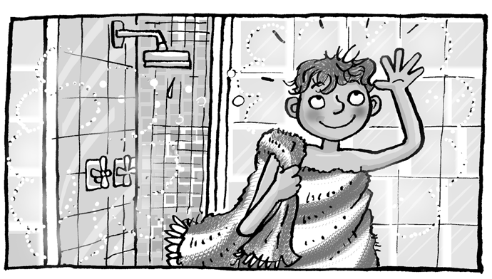

He has already cleaned his room. He’s wearing a helmet.
His mom may be angry. He’s just washed his hair.
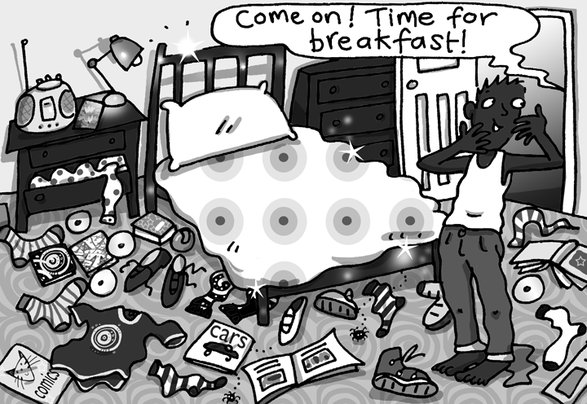

She might be bored.  He might not be happy.
She’s feeling excited.  There are umbrellas everywhere.

Match the letters to make words. Score / 5

Liver-
In-
Fr-
Portu-
Syd-
Ger-
-many
-pool
-guese
-ney
-ench
-dia

cities
Liverpool
________________

countries
________________
________________

nationalities
________________
________________

Total review score / 15

