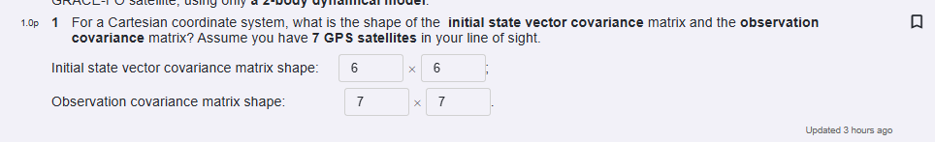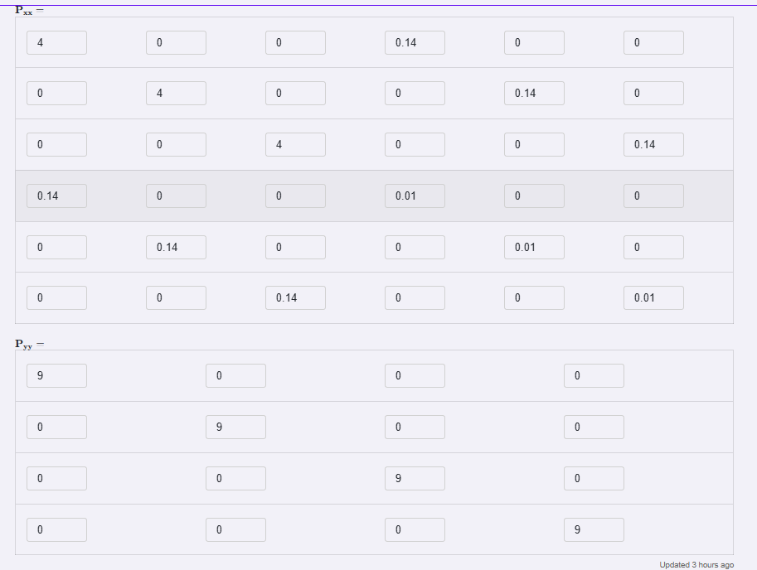

Symbols:
- ﻿﻿f: ﻿dynamical model of the system [va​], such that dtdx​=f(t,x,p)﻿
- x: state vector, made up of the position and the velocity of the satellite in the ECR frame. [rv​]﻿
- ﻿r: position vector (in ECR)
- ﻿v: velocity vector (in ECR)
- a: acceleration vector (in ECR)
- 03⋅3​: 3x3 zero matrix
- I3⋅3​: 3x3 identity matrix
- μ: Earth's gravitational constant﻿(=GM)
- Ω﻿: Earth's roation matrix
﻿
- ωE​﻿: ﻿Earth's rotation rate

