INSTITUTO SUPERIOR TECNOLÓGICO TECSUP



DEPARTAMENTO DE TECNOLOGÍA DIGITAL.
Diseño y desarrollo de software.

Aplicaciones Móviles Multiplataforma

SEMANA 07 - Laboratorio

NOMBRE DE ESTUDIANTES
Quispe Arias, Ismael

Lima - Perú
Abril 2024

Link Github: https://github.com/ismaeltec123/lab7_multiplataforma.git

Funciones nuevas utilizadas en este laboratorio:

1. showDialog y AlertDialog
Uso: Mostrar ventanas modales para errores o confirmaciones.

Ejemplo:
showDialog(
context: context,
builder: (context) => AlertDialog(
title: Text('Cerrar sesión'),
...
),
);

2. Navigator.pushNamedAndRemoveUntil
Uso: Navegación y limpieza total del historial de pantallas.

Ejemplo:

Navigator.pushNamedAndRemoveUntil(
context,
MyApp.routeLogin,
(route) => false,
);

3. SwitchListTile
Uso: Tile con interruptor incorporado.

Ejemplo:

SwitchListTile(
value: true,
onChanged: (value) {
...
},
title: Text("Notificaciones"),
);

4. ThemeMode.system, darkTheme y ColorScheme.fromSeed
Uso: Tema oscuro, claro y esquema de color derivado de un color semilla.

Ejemplo:

themeMode: ThemeMode.system,
darkTheme: ThemeData(...),

5. SingleChildScrollView para el login y configuración
Uso: Permite hacer scroll en pantallas pequeñas.

6. TextField con obscureText, suffixIcon, y textInputAction
Uso: Mejora de experiencia del usuario al escribir contraseñas.

Ejemplo:
obscureText: !_isPasswordVisible,
textInputAction: TextInputAction.next,
suffixIcon: IconButton(...),

Capturas:
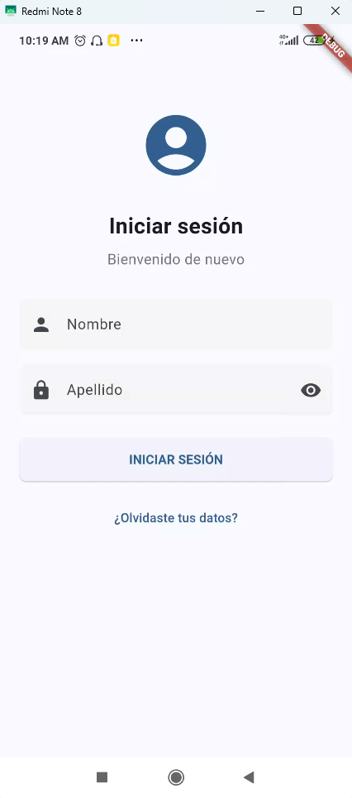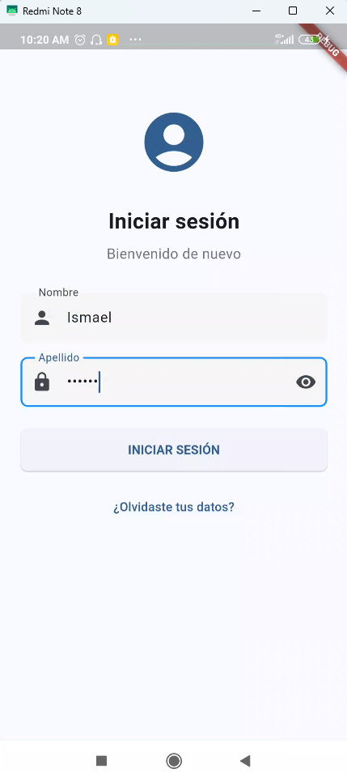

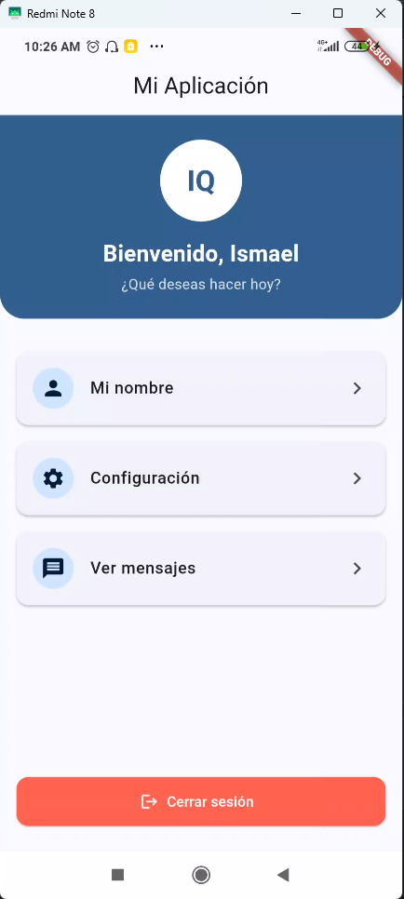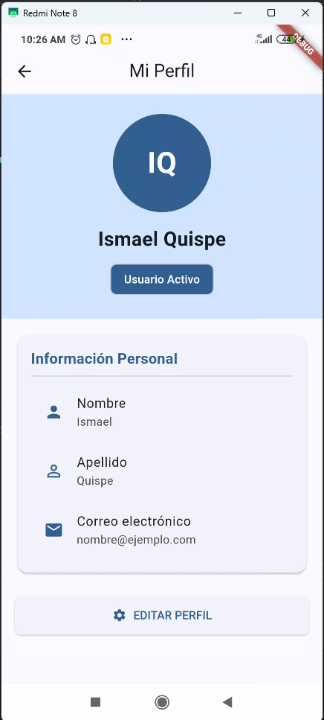

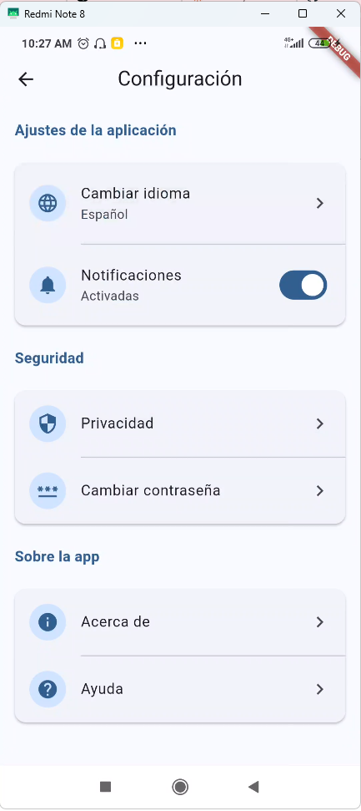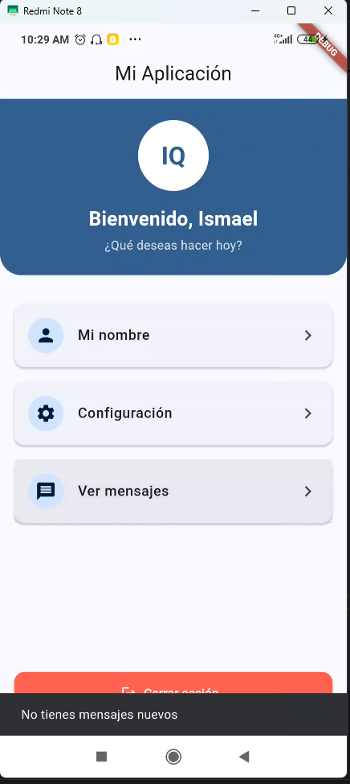

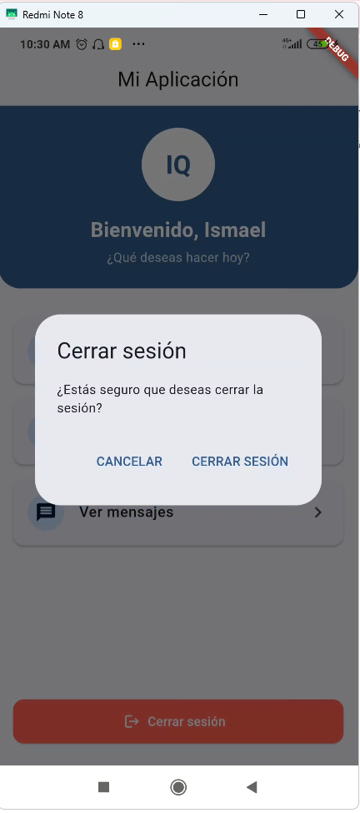

Codigo:import 'package:flutter/material.dart';

void main() {
runApp(MyApp());
}

class MyApp extends StatelessWidget {
static const String routeLogin = "/";
static const String routeHome = "/home";
static const String routeDetalle = "/detalle";
static const String routeConfiguracion = "/configuracion";

@override
Widget build(BuildContext context) {
return MaterialApp(
title: 'Mi Aplicación',
theme: ThemeData(
colorScheme: ColorScheme.fromSeed(
seedColor: Colors.blue,
brightness: Brightness.light,
),
useMaterial3: true,
fontFamily: 'Roboto',
elevatedButtonTheme: ElevatedButtonThemeData(
style: ElevatedButton.styleFrom(
minimumSize: Size(double.infinity, 48),
shape: RoundedRectangleBorder(
borderRadius: BorderRadius.circular(8),
),
),
),
inputDecorationTheme: InputDecorationTheme(
filled: true,
fillColor: Colors.grey.shade100,
border: OutlineInputBorder(
borderRadius: BorderRadius.circular(8),
borderSide: BorderSide.none,
),
focusedBorder: OutlineInputBorder(
borderRadius: BorderRadius.circular(8),
borderSide: BorderSide(color: Colors.blue, width: 2),
),
contentPadding: EdgeInsets.symmetric(horizontal: 16, vertical: 16),
),
),
darkTheme: ThemeData(
colorScheme: ColorScheme.fromSeed(
seedColor: Colors.blue,
brightness: Brightness.dark,
),
useMaterial3: true,
fontFamily: 'Roboto',
elevatedButtonTheme: ElevatedButtonThemeData(
style: ElevatedButton.styleFrom(
minimumSize: Size(double.infinity, 48),
shape: RoundedRectangleBorder(
borderRadius: BorderRadius.circular(8),
),
),
),
inputDecorationTheme: InputDecorationTheme(
filled: true,
fillColor: Colors.grey.shade800,
border: OutlineInputBorder(
borderRadius: BorderRadius.circular(8),
borderSide: BorderSide.none,
),
focusedBorder: OutlineInputBorder(
borderRadius: BorderRadius.circular(8),
borderSide: BorderSide(color: Colors.blue, width: 2),
),
contentPadding: EdgeInsets.symmetric(horizontal: 16, vertical: 16),
),
),
themeMode: ThemeMode.system,
initialRoute: routeLogin,
routes: {
routeLogin: (context) => LoginPage(),
routeHome: (context) => HomePage(),
routeDetalle: (context) => DetallePage(),
routeConfiguracion: (context) => ConfiguracionPage(),
},
);
}
}

// ---------------------------------
// LOGIN CON VALIDACIÓN - REDISEÑADO
// ---------------------------------
class LoginPage extends StatefulWidget {
@override
_LoginPageState createState() => _LoginPageState();
}

class _LoginPageState extends State<LoginPage> {
final _userController = TextEditingController();
final _passController = TextEditingController();
bool _isPasswordVisible = false;

String correctUser = "Ismael";
String correctPass = "Quispe";

void _login() {
if (_userController.text == correctUser &&
_passController.text == correctPass) {
Navigator.pushNamedAndRemoveUntil(
context,
MyApp.routeHome,
(route) => false,
);
} else {
showDialog(
context: context,
builder: (context) => AlertDialog(
title: Text('Error de inicio de sesión'),
content: Text('Usuario o contraseña incorrectos. Por favor, inténtalo de nuevo.'),
actions: [
TextButton(
onPressed: () => Navigator.pop(context),
child: Text('ACEPTAR'),
),
],
),
);
}
}

@override
Widget build(BuildContext context) {
final colorScheme = Theme.of(context).colorScheme;

return Scaffold(
body: SafeArea(
child: SingleChildScrollView(
child: Padding(
padding: EdgeInsets.all(24),
child: Column(
crossAxisAlignment: CrossAxisAlignment.start,
children: [
SizedBox(height: 40),
Center(
child: Icon(
Icons.account_circle,
size: 80,
color: colorScheme.primary,
),
),
SizedBox(height: 32),
Center(
child: Text(
'Iniciar sesión',
style: TextStyle(
fontSize: 24,
fontWeight: FontWeight.bold,
),
),
),
SizedBox(height: 8),
Center(
child: Text(
'Bienvenido de nuevo',
style: TextStyle(
fontSize: 16,
color: Colors.grey.shade600,
),
),
),
SizedBox(height: 32),
TextField(
controller: _userController,
decoration: InputDecoration(
labelText: "Nombre",
prefixIcon: Icon(Icons.person),
),
textInputAction: TextInputAction.next,
),
SizedBox(height: 16),
TextField(
controller: _passController,
decoration: InputDecoration(
labelText: "Apellido",
prefixIcon: Icon(Icons.lock),
suffixIcon: IconButton(
icon: Icon(
_isPasswordVisible ? Icons.visibility_off : Icons.visibility,
),
onPressed: () {
setState(() {
_isPasswordVisible = !_isPasswordVisible;
});
},
),
),
obscureText: !_isPasswordVisible,
onSubmitted: (_) => _login(),
),
SizedBox(height: 24),
ElevatedButton(
onPressed: _login,
child: Text(
"INICIAR SESIÓN",
style: TextStyle(fontWeight: FontWeight.bold),
),
),
SizedBox(height: 16),
Center(
child: TextButton(
onPressed: () {
ScaffoldMessenger.of(context).showSnackBar(
SnackBar(content: Text("Función no implementada")),
);
},
child: Text("¿Olvidaste tus datos?"),
),
),
],
),
),
),
),
);
}
}

// ---------------------------------
// HOME PAGE CON MENÚ - REDISEÑADO
// ---------------------------------
class MenuItem {
final String title;
final IconData icon;
final VoidCallback onTap;

MenuItem({required this.title, required this.icon, required this.onTap});
}

class HomePage extends StatelessWidget {
@override
Widget build(BuildContext context) {
final colorScheme = Theme.of(context).colorScheme;

final List<MenuItem> menuItems = [
MenuItem(
title: "Mi nombre",
icon: Icons.person,
onTap: () {
Navigator.pushNamed(context, MyApp.routeDetalle);
},
),
MenuItem(
title: "Configuración",
icon: Icons.settings,
onTap: () {
Navigator.pushNamed(context, MyApp.routeConfiguracion);
},
),
MenuItem(
title: "Ver mensajes",
icon: Icons.message,
onTap: () {
ScaffoldMessenger.of(context).showSnackBar(
SnackBar(content: Text("No tienes mensajes nuevos")),
);
},
),
];

return Scaffold(
appBar: AppBar(
title: Text("Mi Aplicación"),
centerTitle: true,
elevation: 0,
),
body: Column(
children: [
Container(
padding: EdgeInsets.all(24),
width: double.infinity,
decoration: BoxDecoration(
color: colorScheme.primary,
borderRadius: BorderRadius.only(
bottomLeft: Radius.circular(24),
bottomRight: Radius.circular(24),
),
),
child: Column(
crossAxisAlignment: CrossAxisAlignment.center,
children: [
CircleAvatar(
radius: 40,
backgroundColor: colorScheme.onPrimary,
child: Text(
"IQ",
style: TextStyle(
fontSize: 28,
fontWeight: FontWeight.bold,
color: colorScheme.primary,
),
),
),
SizedBox(height: 16),
Text(
"Bienvenido, Ismael",
style: TextStyle(
fontSize: 22,
fontWeight: FontWeight.bold,
color: colorScheme.onPrimary,
),
),
SizedBox(height: 4),
Text(
"¿Qué deseas hacer hoy?",
style: TextStyle(
fontSize: 14,
color: colorScheme.onPrimary.withOpacity(0.8),
),
),
],
),
),
SizedBox(height: 16),
Expanded(
child: ListView.builder(
padding: EdgeInsets.symmetric(horizontal: 16, vertical: 8),
itemCount: menuItems.length,
itemBuilder: (context, index) {
return Card(
margin: EdgeInsets.symmetric(vertical: 8),
elevation: 2,
shape: RoundedRectangleBorder(
borderRadius: BorderRadius.circular(12),
),
child: ListTile(
contentPadding: EdgeInsets.symmetric(horizontal: 16, vertical: 8),
leading: CircleAvatar(
backgroundColor: colorScheme.primaryContainer,
child: Icon(
menuItems[index].icon,
color: colorScheme.onPrimaryContainer,
),
),
title: Text(
menuItems[index].title,
style: TextStyle(
fontWeight: FontWeight.w500,
fontSize: 16,
),
),
trailing: Icon(Icons.chevron_right),
onTap: menuItems[index].onTap,
),
);
},
),
),
Padding(
padding: const EdgeInsets.fromLTRB(16, 0, 16, 24),
child: ElevatedButton.icon(
onPressed: () {
showDialog(
context: context,
builder: (context) => AlertDialog(
title: Text('Cerrar sesión'),
content: Text('¿Estás seguro que deseas cerrar la sesión?'),
actions: [
TextButton(
onPressed: () => Navigator.pop(context),
child: Text('CANCELAR'),
),
TextButton(
onPressed: () {
Navigator.pop(context);
Navigator.pushNamedAndRemoveUntil(
context,
MyApp.routeLogin,
(route) => false,
);
},
child: Text('CERRAR SESIÓN'),
),
],
),
);
},
icon: Icon(Icons.logout),
label: Text("Cerrar sesión"),
style: ElevatedButton.styleFrom(
backgroundColor: Colors.redAccent,
foregroundColor: Colors.white,
minimumSize: Size(double.infinity, 48),
shape: RoundedRectangleBorder(
borderRadius: BorderRadius.circular(12),
),
),
),
),
],
),
);
}
}

class DetallePage extends StatelessWidget {
@override
Widget build(BuildContext context) {
final colorScheme = Theme.of(context).colorScheme;

return Scaffold(
appBar: AppBar(
title: Text("Mi Perfil"),
centerTitle: true,
),
body: SingleChildScrollView(
child: Column(
children: [
Container(
padding: EdgeInsets.all(24),
width: double.infinity,
color: colorScheme.primaryContainer,
child: Column(
children: [
CircleAvatar(
radius: 60,
backgroundColor: colorScheme.primary,
child: Text(
"IQ",
style: TextStyle(
fontSize: 36,
fontWeight: FontWeight.bold,
color: colorScheme.onPrimary,
),
),
),
SizedBox(height: 16),
Text(
"Ismael Quispe",
style: TextStyle(
fontSize: 24,
fontWeight: FontWeight.bold,
),
),
SizedBox(height: 8),
Chip(
backgroundColor: colorScheme.primary,
label: Text(
"Usuario Activo",
style: TextStyle(
color: colorScheme.onPrimary,
fontWeight: FontWeight.w500,
),
),
),
],
),
),
Padding(
padding: EdgeInsets.all(16),
child: Card(
elevation: 2,
shape: RoundedRectangleBorder(
borderRadius: BorderRadius.circular(12),
),
child: Padding(
padding: EdgeInsets.all(16),
child: Column(
crossAxisAlignment: CrossAxisAlignment.start,
children: [
Text(
"Información Personal",
style: TextStyle(
fontSize: 18,
fontWeight: FontWeight.bold,
color: colorScheme.primary,
),
),
Divider(),
ListTile(
leading: Icon(Icons.person, color: colorScheme.primary),
title: Text("Nombre"),
subtitle: Text("Ismael"),
),
ListTile(
leading: Icon(Icons.person_outline, color: colorScheme.primary),
title: Text("Apellido"),
subtitle: Text("Quispe"),
),
ListTile(
leading: Icon(Icons.email, color: colorScheme.primary),
title: Text("Correo electrónico"),
subtitle: Text("nombre@ejemplo.com"),
),
],
),
),
),
),
Padding(
padding: EdgeInsets.symmetric(horizontal: 16, vertical: 8),
child: ElevatedButton.icon(
onPressed: () {
Navigator.pushNamed(context, MyApp.routeConfiguracion);
},
icon: Icon(Icons.settings),
label: Text("EDITAR PERFIL"),
style: ElevatedButton.styleFrom(
padding: EdgeInsets.symmetric(vertical: 12),
),
),
),
],
),
),
);
}
}

class ConfiguracionPage extends StatelessWidget {
@override
Widget build(BuildContext context) {
final colorScheme = Theme.of(context).colorScheme;

return Scaffold(
appBar: AppBar(
title: Text("Configuración"),
centerTitle: true,
),
body: SingleChildScrollView(
child: Column(
crossAxisAlignment: CrossAxisAlignment.start,
children: [
Padding(
padding: EdgeInsets.all(16),
child: Text(
"Ajustes de la aplicación",
style: TextStyle(
fontSize: 16,
fontWeight: FontWeight.bold,
color: colorScheme.primary,
),
),
),
Card(
margin: EdgeInsets.symmetric(horizontal: 16, vertical: 8),
elevation: 2,
shape: RoundedRectangleBorder(
borderRadius: BorderRadius.circular(12),
),
child: Column(
children: [
ListTile(
leading: CircleAvatar(
backgroundColor: colorScheme.primaryContainer,
child: Icon(
Icons.language,
color: colorScheme.primary,
),
),
title: Text("Cambiar idioma"),
subtitle: Text("Español"),
trailing: Icon(Icons.chevron_right),
contentPadding: EdgeInsets.symmetric(horizontal: 16, vertical: 8),
onTap: () {
ScaffoldMessenger.of(context).showSnackBar(
SnackBar(
content: Text("Función no implementada"),
behavior: SnackBarBehavior.floating,
shape: RoundedRectangleBorder(
borderRadius: BorderRadius.circular(8),
),
),
);
},
),
Divider(height: 1, indent: 72),
SwitchListTile(
value: true,
onChanged: (value) {
ScaffoldMessenger.of(context).showSnackBar(
SnackBar(
content: Text("Función no implementada"),
behavior: SnackBarBehavior.floating,
shape: RoundedRectangleBorder(
borderRadius: BorderRadius.circular(8),
),
),
);
},
secondary: CircleAvatar(
backgroundColor: colorScheme.primaryContainer,
child: Icon(
Icons.notifications,
color: colorScheme.primary,
),
),
contentPadding: EdgeInsets.symmetric(horizontal: 16, vertical: 8),
title: Text("Notificaciones"),
subtitle: Text("Activadas"),
),
],
),
),
Padding(
padding: EdgeInsets.all(16),
child: Text(
"Seguridad",
style: TextStyle(
fontSize: 16,
fontWeight: FontWeight.bold,
color: colorScheme.primary,
),
),
),
Card(
margin: EdgeInsets.symmetric(horizontal: 16, vertical: 8),
elevation: 2,
shape: RoundedRectangleBorder(
borderRadius: BorderRadius.circular(12),
),
child: Column(
children: [
ListTile(
leading: CircleAvatar(
backgroundColor: colorScheme.primaryContainer,
child: Icon(
Icons.security,
color: colorScheme.primary,
),
),
title: Text("Privacidad"),
trailing: Icon(Icons.chevron_right),
contentPadding: EdgeInsets.symmetric(horizontal: 16, vertical: 8),
onTap: () {
ScaffoldMessenger.of(context).showSnackBar(
SnackBar(
content: Text("Función no implementada"),
behavior: SnackBarBehavior.floating,
shape: RoundedRectangleBorder(
borderRadius: BorderRadius.circular(8),
),
),
);
},
),
Divider(height: 1, indent: 72),
ListTile(
leading: CircleAvatar(
backgroundColor: colorScheme.primaryContainer,
child: Icon(
Icons.password,
color: colorScheme.primary,
),
),
title: Text("Cambiar contraseña"),
trailing: Icon(Icons.chevron_right),
contentPadding: EdgeInsets.symmetric(horizontal: 16, vertical: 8),
onTap: () {
ScaffoldMessenger.of(context).showSnackBar(
SnackBar(
content: Text("Función no implementada"),
behavior: SnackBarBehavior.floating,
shape: RoundedRectangleBorder(
borderRadius: BorderRadius.circular(8),
),
),
);
},
),
],
),
),
Padding(
padding: EdgeInsets.all(16),
child: Text(
"Sobre la app",
style: TextStyle(
fontSize: 16,
fontWeight: FontWeight.bold,
color: colorScheme.primary,
),
),
),
Card(
margin: EdgeInsets.symmetric(horizontal: 16, vertical: 8),
elevation: 2,
shape: RoundedRectangleBorder(
borderRadius: BorderRadius.circular(12),
),
child: Column(
children: [
ListTile(
leading: CircleAvatar(
backgroundColor: colorScheme.primaryContainer,
child: Icon(
Icons.info,
color: colorScheme.primary,
),
),
title: Text("Acerca de"),
trailing: Icon(Icons.chevron_right),
contentPadding: EdgeInsets.symmetric(horizontal: 16, vertical: 8),
onTap: () {
ScaffoldMessenger.of(context).showSnackBar(
SnackBar(
content: Text("Función no implementada"),
behavior: SnackBarBehavior.floating,
shape: RoundedRectangleBorder(
borderRadius: BorderRadius.circular(8),
),
),
);
},
),
Divider(height: 1, indent: 72),
ListTile(
leading: CircleAvatar(
backgroundColor: colorScheme.primaryContainer,
child: Icon(
Icons.help,
color: colorScheme.primary,
),
),
title: Text("Ayuda"),
trailing: Icon(Icons.chevron_right),
contentPadding: EdgeInsets.symmetric(horizontal: 16, vertical: 8),
onTap: () {
ScaffoldMessenger.of(context).showSnackBar(
SnackBar(
content: Text("Función no implementada"),
behavior: SnackBarBehavior.floating,
shape: RoundedRectangleBorder(
borderRadius: BorderRadius.circular(8),
),
),
);
},
),
],
),
),
SizedBox(height: 24),
],
),
),
);
}
}

