

Faculty of Engineering and Built Environment
School of
Electrical and Electronic Engineering

LIGHTNING AND SURGE PROTECTION OF PHOTOVOLTAIC INSTALLATION
Coordinated SPD, Supercapacitor Buffering, and Time-Dependent Isolation in MATLAB/Simulink

By
Ihtisham Fazil
Student Number: A00049392

This Report is submitted in partial fulfilment of the requirements of the Master of Engineering Degree in Sustainable Electrical Energy Systems (TU207/TU217)

August 2026
Supervisor: [Supervisor Name]

Declaration
I hereby certify that this material, which I now submit for assessment on the programme of study leading to the award of ME in Sustainable Electrical Energy Systems, is entirely my own work and has not been submitted for assessment for any academic purpose other than in partial fulfilment for that stated above.

Signed: ________________________________ Date: __________________

Acknowledgements
I would like to express my sincere gratitude to my supervisor for the guidance, constructive criticism, and encouragement provided throughout this research. The advice received during the formulation of the protection concept and the refinement of the simulation methodology was invaluable in transforming the original proposal into a reproducible engineering study.
I also acknowledge the academic staff of the School of Electrical and Electronic Engineering, Technological University Dublin, for the knowledge and technical perspective developed through the Master of Engineering programme in Sustainable Electrical Energy Systems. Their emphasis on rigorous modelling, safety, critical evaluation, and professional engineering practice shaped the approach adopted in this thesis.
Finally, I am grateful to my family and friends for their patience and support during the completion of the project. This work required repeated model development, verification, and documentation cycles, and their encouragement was greatly appreciated.

Abstract
Photovoltaic installations are exposed to lightning-induced and switching-related overvoltages because their arrays, DC cabling, power-electronic converters, and control equipment are commonly installed over extended outdoor areas. Conventional protection relies principally on grounding, surge protective devices (SPDs), and disconnection; however, a fixed threshold alone does not distinguish a harmless short-duration disturbance from a sustained abnormal condition. This thesis develops and verifies a coordinated protection concept in which a nonlinear metal-oxide varistor (MOV) based SPD provides the primary fast clamping function, a controlled supercapacitor interface buffers limited residual DC-bus energy, and a magnitude-and-duration supervisory controller commands relay isolation only when the disturbance is sufficiently severe or persistent.
The system was implemented as a modular MATLAB/Simulink project. Because Simscape and Simscape Electrical were not available in the execution environment, physically derived discrete equations were implemented in functional Level-2 MATLAB S-functions for the photovoltaic source, perturb-and-observe maximum power point tracking (MPPT), averaged boost converter, source/cable impedance, DC-bus dynamics, nonlinear finite-capability MOV, dynamic supercapacitor interface, relay/contactor, and averaged microinverter load. A separate switching H-bridge inverter demonstration was also implemented. Sixteen final scenarios evaluated normal operation, irradiance variation, short ripple, moderate and severe design transients, repeated surges, sustained overvoltage, emergency isolation, automatic and manual recovery, supercapacitor current limiting, sensor noise, inverter integration, solver convergence, and intentional SPD overstress. Paired protection comparisons used identical input profiles and initial conditions for unprotected, SPD-only, conventional relay, and integrated modes.
The unified single-diode PV model reproduced the configured module points with errors below 1.62%, while steady-state MPPT efficiency reached 99.98%. Under the severe design transient, the unprotected DC-bus peak of 338.30 V was reduced to 69.83 V by the integrated system, corresponding to a 79.36% reduction. The final engineering-assumption SPD remained within its 1000 A and 2000 J ratings in all design scenarios, with 34.49% peak-current utilisation and 25.71% energy utilisation in the severe case. The sustained-overvoltage test produced a 44.75 ms persistence interval before the trip command, consistent with the configured 45 ms criterion, and automatic reconnection occurred after an uninterrupted 350 ms safe-voltage dwell. The switching inverter delivered 23.89 V RMS at 50.00 Hz with a 1.66% power-balance error. Solver convergence showed a maximum critical-metric difference of 0.429%, and repeated runs were deterministic. All 16 scenarios and 351 traceable assertions passed; one intentionally out-of-envelope test correctly produced an SPD overstress state.
The results show that the SPD remains the dominant element for instantaneous surge limitation, while the supercapacitor and time-dependent controller provide complementary energy buffering, selective continuity, controlled isolation, and recovery. The work is a laboratory-scale averaged simulation study and does not constitute direct-lightning, certified insulation-coordination, grid-compliance, or hardware qualification testing.
Keywords: photovoltaic protection; lightning-induced overvoltage; surge protective device; metal-oxide varistor; supercapacitor; MPPT; adaptive protection; relay coordination; MATLAB/Simulink.

Table of Contents
CHAPTER 1: INTRODUCTION XX
1.1 Background and motivation XX
1.2 Vulnerability of photovoltaic installations XX
1.3 Problem statement XX
1.4 Research gap XX
1.5 Research question, aim and objectives XX
1.6 Novelty and contributions XX
1.7 Scope and limitations XX
1.8 Thesis organisation XX
CHAPTER 2: LITERATURE REVIEW XX
2.1 Lightning and surge exposure of PV systems XX
2.2 Transient coupling and modelling XX
2.3 External lightning protection and grounding XX
2.4 Surge protective devices and MOV behaviour XX
2.5 SPD coordination, placement and protection distance XX
2.6 PV modelling and MPPT XX
2.7 Supercapacitor buffering in renewable systems XX
2.8 Intelligent isolation and microinverter protection XX
2.9 Synthesis of the literature and research gap XX
CHAPTER 3: METHODOLOGY XX
3.1 Research design and implementation environment XX
3.2 End-to-end workflow and model architecture XX
3.3 PV source and MPPT model XX
3.4 Averaged boost converter and DC bus XX
3.5 Surge generator, cable and grounding impedance XX
3.6 SPD/MOV model and rating procedure XX
3.7 Supercapacitor interface XX
3.8 Protection controller and relay/contactor XX
3.9 Averaged and switching inverter models XX
3.10 Simulation scenarios and fair comparisons XX
3.11 Evaluation metrics and validation XX
3.12 Numerical verification, safety and ethics XX
CHAPTER 4: RESULTS XX
4.1 End-to-end verification status XX
4.2 PV-model and MPPT results XX
4.3 Normal operation and short disturbances XX
4.4 Paired protection-mode comparisons XX
4.5 SPD capability and design margins XX
4.6 Supercapacitor response XX
4.7 Timed isolation and recovery XX
4.8 Microinverter results XX
4.9 Fast SPD component tests XX
4.10 Solver convergence and repeatability XX
CHAPTER 5: DISCUSSION XX
5.1 Summary and interpretation of findings XX
5.2 Relationship to previous research XX
5.3 Novelty and engineering implications XX
5.4 Protection trade-offs XX
5.5 Limitations XX
5.6 Future research XX
CHAPTER 6: CONCLUSIONS AND RECOMMENDATIONS XX
6.1 Conclusions XX
6.2 Recommendations XX
REFERENCES XX
APPENDIX A: FINAL SYSTEM PARAMETERS XX
APPENDIX B: FINAL SIMULATION SCENARIOS XX

List of Figures
Figure 1. End-to-end research workflow from proposal requirements through physical modelling, scenario execution, evaluation, numerical verification and reporting. XX
Figure 2. Functional architecture of the final PV lightning and surge protection model. XX
Figure 3. Representative laboratory-scale surge waveform used for the full-system transient studies. XX
Figure 4. Magnitude-and-duration protection-state logic used by the integrated controller. XX
Figure 5. Modelled PV I-V curves at the evaluated irradiance and temperature conditions. XX
Figure 6. Modelled PV P-V curves using the same single-diode equation as the simulated plant. XX
Figure 7. PV power and available MPP during the irradiance-step validation scenario. XX
Figure 8. Fair paired comparison of DC-bus peak voltage for the moderate design transient. XX
Figure 9. Fair paired comparison of DC-bus peak voltage for the severe design transient. XX
Figure 10. Fair paired comparison of DC-bus peak voltage for the repeated-surge scenario. XX
Figure 11. Fair paired comparison of DC-bus peak voltage for the sustained-overvoltage scenario. XX
Figure 12. Demanded and actual MOV current in representative design and capability scenarios. XX
Figure 13. T16 intentional out-of-envelope SPD capability test. XX
Figure 14. Supercapacitor current request, limited command and actual dynamic current. XX
Figure 15. Supercapacitor ESR power and cumulative dissipated energy. XX
Figure 16. Separation of fault detection, controller command and physical relay state. XX
Figure 17. Automatic recovery timing showing the continuous safe-voltage dwell before reconnection. XX
Figure 18. Manual-reset scenario showing retained isolation until reset is asserted. XX
Figure 19. Low-voltage H-bridge inverter output voltage and current. XX
Figure 20. Switching-inverter shutdown response following the protection command. XX
Figure 21. Standards-inspired 1.2/50 µs MOV voltage-impulse numerical test. XX
Figure 22. Standards-inspired 8/20 µs MOV current-impulse numerical test. XX
Figure 23. Relative solver-convergence differences for the principal electrical and timing metrics. XX

List of Tables
Table 1. Representative literature and the coordination gap addressed in this thesis XX
Table 2. Selected final model parameters XX
Table 3. Final simulation scenario matrix XX
Table 4. Validation of the unified single-diode PV model XX
Table 5. MPPT validation results XX
Table 6. Paired moderate and severe design-transient comparison XX
Table 7. Paired repeated-surge and sustained-overvoltage comparison XX
Table 8. SPD capability results for design and intentional-overstress cases XX
Table 9. Supercapacitor dynamic response and current limiting XX
Table 10. Switching microinverter demonstration results XX
Table 11. Standards-inspired fast SPD numerical component tests XX
Table 12. Solver-convergence results for the severe design transient XX
Table 13. Final key simulation parameters XX
Table 14. Final scenario definitions XX

List of Abbreviations
Abbreviation | Definition
AC | Alternating current
DC | Direct current
EMI | Electromagnetic interference
ESR | Equivalent series resistance
IEC | International Electrotechnical Commission
LPS | Lightning protection system
MCOV | Maximum continuous operating voltage
MOV | Metal-oxide varistor
MPP | Maximum power point
MPPT | Maximum power point tracking
P&O | Perturb and observe
PV | Photovoltaic
PWM | Pulse-width modulation
RMS | Root mean square
SC | Supercapacitor
SPD | Surge protective device
THD | Total harmonic distortion
TVS | Transient voltage suppressor
UVLO | Undervoltage lockout

CHAPTER 1

INTRODUCTION

1.1 Background and motivation
Solar photovoltaic generation has become a central technology in the transition toward low-carbon electricity because it can be deployed from small building-integrated systems to utility-scale plants. The electrical value of a PV installation, however, depends not only on energy conversion efficiency but also on the ability of the installation to remain safe and available under abnormal environmental and electrical conditions. Lightning and surge exposure is especially important because PV modules, string conductors, junction boxes, DC converters and inverters are distributed over large outdoor areas and therefore present multiple paths through which transient overvoltages can reach sensitive electronic equipment. Hernández et al. established that PV installations require protection measures tailored to their particular electrical and geometric characteristics rather than direct adoption of conventional low-voltage assumptions [1]. Subsequent work has reinforced the importance of external lightning protection, earthing and coordinated surge protection for both small and large PV plants [2], [5], [6].
Lightning-related disturbances arise through several mechanisms. A direct strike can inject extremely high current into a structure or an external lightning protection system, whereas a nearby strike can induce common-mode and differential-mode voltages through electromagnetic coupling. Switching operations and fault clearing can also create shorter energy transients that are much smaller than a direct lightning discharge but still harmful to semiconductors and control electronics. Pons and Tommasini showed that risk assessment and appropriate SPD placement are fundamental to PV protection [3], while the case histories reported by Martzloff illustrate how field damage may result from complex combinations of induced overvoltage, insulation breakdown and subsequent DC fault current [4]. More recent numerical work has shown that PV-module geometry, grounding and converter connection strongly affect the resulting transient stresses [7], [8].
Conventional PV protection practice therefore combines external lightning protection, equipotential bonding, grounding, SPDs and isolation devices. Each element addresses a different part of the risk. The SPD provides the very fast nonlinear diversion or clamping response required during a steep voltage rise; the grounding and cable network determines the actual residual voltage that appears at protected equipment; and an isolating device can disconnect a circuit when an abnormal condition persists. These functions are complementary rather than interchangeable. In particular, a mechanical relay is too slow to clamp a fast surge front and should not be modelled as the primary lightning protective element. This engineering distinction is central to the protection architecture developed in this thesis.
The research is motivated by a practical coordination problem. A fixed voltage threshold can be effective for identifying a severe abnormal state, but it cannot by itself distinguish a harmless short-duration ripple from a disturbance that lasts long enough to create thermal or dielectric stress. Immediate disconnection improves safety but may unnecessarily reduce energy availability when the transient could have been absorbed or clamped without interrupting service. Conversely, attempting to preserve continuity at all costs may leave the converter and downstream electronics exposed during a sustained fault. The problem is therefore not simply to lower the highest voltage; it is to coordinate fast passive clamping, limited energy buffering, and selective time-dependent isolation.

1.2 Vulnerability of photovoltaic installations
The vulnerability of a PV installation is shaped by its outdoor exposure, conductor length, converter topology and grounding arrangement. Charalambous et al. showed that the geometry and earthing of large PV applications influence the appropriate external lightning protection design [2]. Formisano et al. demonstrated that nearby strikes can induce both common-mode and differential-mode voltages in a PV module, with the resulting stress depending on capacitive and inductive coupling [7]. The same research group later incorporated a DC/DC converter into the transient model and showed that the electrical operating condition of the module can influence the stresses reaching the power-conditioning stage [8]. These findings are important because a PV protection study that treats the source, cable and converter as ideal disconnected blocks may underestimate interaction during a transient.
Sensitive PV components are not limited to the module itself. Maximum-power-point trackers, gate drivers, microcontrollers, communication units, semiconductor switches and inverter DC-link components typically have lower impulse withstand capability than exposed structural elements. Damage may therefore occur even when the PV module remains physically intact. Damianaki et al. highlighted the developed potentials that can occur in a grid-connected PV park under lightning conditions [9], while Wang et al. showed that the effective protection distance of an SPD depends on cable parameters, equipment impulse withstand and SPD voltage-current characteristics [10]. Thus, the voltage measured at an SPD terminal is not necessarily identical to the voltage experienced by a remote converter.
The DC nature of a PV array introduces a further complication. Once an insulation path is established, the PV source can continue supplying current after the initial transient has decayed. This is one reason why transient protection and controlled isolation should be treated as coordinated layers rather than as substitutes. Di Napoli et al. showed the value of active panel-level disconnection for safe access and fault management in PV plants [31]. Although that work addressed a different operational objective, it supports the broader principle that the condition after a transient matters as much as the transient peak itself.

1.3 Problem statement
The problem addressed in this thesis is the lack of coordinated response between fast surge suppression, short-duration energy buffering and time-aware isolation in a small-scale PV protection model. A conventional SPD is intentionally fast and nonlinear, but it does not determine whether the underlying system condition has recovered. A conventional relay can isolate a sustained abnormal condition, but if it is applied as an immediate fixed-threshold device it can trip during startup or benign transients. A supercapacitor can absorb or release energy rapidly, but it must be interfaced through a current-limited converter and cannot be assumed to absorb the energy of a direct lightning strike. The design challenge is to integrate these functions without assigning an unrealistic role to any single component.
The original project proposal identified four practical shortcomings: unnecessary disconnection during harmless short-duration voltage disturbances, limited capability to buffer a transient before isolation, minimal real-time feedback in conventional protection logic, and reduced reliability caused by repeated stress. These points are addressed here by a layered architecture. The MOV-based SPD remains the primary fast protective branch; the supercapacitor is assigned only the bounded residual-energy and DC-bus buffering role; and the supervisory controller evaluates both the magnitude and persistence of the measured bus voltage before commanding a physical relay.
A second problem is methodological. Protection claims can be misleading if different protection modes are tested with different surge waveforms, initial states or pre-event operating conditions. For example, a conventional relay that has already opened during startup cannot be fairly compared with an integrated controller that is still supplying the load when the surge arrives. The final simulation framework therefore qualifies protection arming after startup and performs explicit pre-event checks so that all paired configurations are healthy and energised before the common disturbance is applied.

1.4 Research gap
The literature contains mature work on PV lightning risk, external LPS and grounding [1]-[6], induced transient modelling [7]-[9], and SPD coordination [10]-[13]. It also contains extensive research on PV source modelling and MPPT [17]-[21], supercapacitor energy storage and power smoothing [22]-[24], MOV behaviour [25]-[27], and microinverter topologies [28]-[30]. Recent work has additionally considered intelligent overvoltage and surge protection for solar inverters [15] and adaptive overvoltage protection in PV-rich systems [16]. These bodies of work establish the individual technical foundations required for the present project.
Taken together, however, the reviewed literature leaves a narrower coordination question insufficiently explored: how can a low-voltage PV system combine a finite nonlinear SPD, a current-limited supercapacitor buffer, and a controller that explicitly distinguishes surge magnitude from surge duration, while retaining fair comparison against conventional protection modes? Existing studies commonly concentrate on one of these layers. SPD-oriented research emphasises residual voltage, energy, placement and protection distance; supercapacitor research focuses primarily on power smoothing and state balancing; and relay research focuses on fault detection and coordination. The integrated interaction among these three time scales is therefore the specific gap addressed in this thesis.
The novelty is consequently not claimed as the invention of the SPD, supercapacitor, MPPT or relay individually. Rather, within the scope of literature reviewed, the contribution lies in their coordinated integration and reproducible verification in a single modular MATLAB/Simulink study, with explicit component capability limits, event-window energy accounting, startup-qualified protection, safe-dwell recovery, fair four-mode comparisons, numerical convergence checks and traceable assertions. This narrower and defensible novelty statement is used throughout the thesis.

1.5 Research question, aim and objectives
The research question of the present thesis is: Can a coordinated protection architecture that combines MOV-based surge clamping, controlled supercapacitor buffering, and magnitude-and-duration-based relay isolation improve the transient resilience of a small-scale PV installation while avoiding unnecessary disconnection during short disturbances?
The aim is to develop, simulate and verify an end-to-end laboratory-scale PV protection model that distinguishes short transient events from sustained overvoltage and quantifies the electrical and operational trade-offs among alternative protection configurations.
1. Develop a unified PV source and MPPT model suitable for transient studies and validate its I-V, P-V and MPP behaviour.
2. Model the DC source, boost converter, cable impedance, DC bus and downstream inverter/load as a coupled dynamic system.
3. Implement a finite nonlinear MOV/SPD model that distinguishes demanded current, actual current, saturation and energy capability.
4. Implement a supercapacitor interface with ESR, converter inductance, dynamic current control and current limiting.
5. Develop a supervisory controller that uses voltage magnitude and disturbance duration, including startup qualification, isolation, recovery delay, automatic reset and manual reset.
6. Compare unprotected, SPD-only, SPD plus conventional relay, and integrated protection under identical events.
7. Verify component limits, solver convergence, repeatability and traceable scenario assertions.

1.6 Novelty and contributions
The main contributions of the thesis are summarised below. They are deliberately stated at the level supported by the implemented simulation and the reviewed literature.
• A modular low-voltage MATLAB/Simulink architecture that integrates the PV source, P&O MPPT, averaged boost converter, cable/source impedance, DC-bus dynamics, finite MOV, dynamic supercapacitor interface, protection controller, relay/contactor and averaged inverter load.
• A protection strategy in which the SPD performs primary fast clamping, the supercapacitor handles bounded residual energy and bus regulation, and the relay is commanded by magnitude-and-duration logic rather than by an undifferentiated instantaneous threshold.
• A capability-aware SPD evaluation that separates demanded current from actual finite current and uses explicit current and energy design margins. An intentional out-of-envelope case verifies that overstress is detected rather than hidden by numerical clipping.
• Fair paired protection comparisons that programmatically verify identical disturbances and pre-event operating conditions before voltage-reduction and event-energy metrics are calculated.
• An end-to-end verification framework containing 16 final scenarios, 351 assertions, solver-convergence analysis and deterministic repeatability checks.

1.7 Scope and limitations
The study is intentionally bounded. It represents a laboratory-scale 48 V DC-bus PV system and uses averaged transient disturbances for the complete system simulation. It does not reproduce the full electromagnetic and thermal energy of a direct lightning strike. Separate 1.2/50 microsecond voltage and 8/20 microsecond current component tests are included to evaluate the shared MOV equations at fast time scales; these are standards-inspired numerical tests rather than certified compliance tests.
Simscape and Simscape Electrical were not installed in the execution environment. Consequently, the final model uses physically derived discrete equations inside modular Level-2 MATLAB S-functions. This approach permits reproducible coupled dynamics and clear signal logging, but it is not a substitute for a validated electromagnetic transient package, manufacturer-certified component model or hardware impulse test. Similarly, the 1000 A and 2000 J SPD ratings are engineering datasheet-style assumptions selected from the calculated design envelope; they are not a claim about a specific certified commercial product.
The detailed switching inverter is a separate 24 V RMS, 50 Hz low-voltage demonstration used to verify PWM, filtering, power balance and protection shutdown. The main multi-scenario sweep uses an averaged microinverter input model for computational efficiency. Grid synchronisation, anti-islanding certification, electromagnetic compatibility, insulation coordination, direct-lightning attachment physics and Arduino hardware deployment are outside the scope of this thesis.

1.8 Thesis organisation
The remainder of this thesis is organised as follows. Chapter 2 reviews PV lightning exposure, induced transient modelling, grounding, SPD coordination, MOV characteristics, PV/MPPT models, supercapacitor buffering, intelligent protection and microinverter research, and then identifies the specific coordination gap. Chapter 3 presents the complete modelling and validation methodology. Chapter 4 reports the results without extended interpretation, following the supplied results-writing guidance. Chapter 5 interprets the findings, relates them to previous research, discusses the novelty, engineering implications and limitations, and identifies future work. Chapter 6 summarises the conclusions and recommendations. The appendices provide the final key parameters and scenario matrix used by the canonical model.

CHAPTER 2

LITERATURE REVIEW

2.1 Lightning and surge exposure of photovoltaic systems
There has been long-standing interest in lightning protection of photovoltaic installations because their exposed geometry and distributed conductors differ from the compact arrangement of many conventional loads. Hernández et al. provided an early systematic treatment of the protective measures and standardisation considerations specific to PV installations [1]. Pons and Tommasini similarly emphasised risk assessment and the need for SPDs on both DC and AC sides where appropriate [3]. Christodoulou et al. subsequently summarised practical lightning protection techniques, including risk evaluation, external and internal protection, equipment withstand and grounding [5]. These studies establish a consensus that PV lightning protection cannot be reduced to one component; it is a system-level coordination problem.
Field evidence also demonstrates the complexity of attributing PV damage to a single mechanism. Martzloff examined two PV installations damaged during thunderstorms and noted that available evidence was not sufficient to attribute all damage directly to a lightning flash [4]. An induced overvoltage may initiate insulation breakdown, after which the normal PV DC source can sustain damaging current. This observation remains relevant to contemporary PV systems because it separates the short transient that initiates an event from the longer electrical condition that determines its final consequence.
Large-scale installations introduce additional concerns associated with conductor length, support structures and earthing. Charalambous et al. developed methods for assessing external lightning protection and grounding options for large PV plants [2]. Damianaki et al. calculated developed potentials in a grid-connected PV park and showed the importance of LPS design for protecting equipment and personnel [9]. Although the present thesis addresses a small laboratory-scale system, these larger-system studies provide the physical justification for retaining nonzero source, cable and grounding impedance in the simulation rather than using an ideal zero-impedance reference.

2.2 Transient coupling and modelling
Accurate transient modelling is critical because the voltage appearing at the converter depends on the electromagnetic path between the lightning event and the protected equipment. Formisano et al. developed a three-dimensional semi-analytical method for induced voltages in PV modules under nearby strikes and demonstrated that both common-mode and differential-mode stresses depend on geometrical and coupling parameters [7]. Their later work connected the PV module model to a DC/DC converter, thereby showing that converter operating conditions and high-frequency module characteristics influence the final stress [8].
Hetita et al. reviewed PV-system modelling during lightning strikes and compared simulation approaches, protection methods and lightning-protection-system design considerations [6]. Their synthesis highlights two methodological lessons relevant to this thesis. First, modelling fidelity must be matched to the research question: a geometry-resolved electromagnetic model is necessary for attachment and field-coupling questions, whereas a lumped circuit can be appropriate for coordination studies after an induced source waveform has been defined. Second, the protection system should be evaluated as part of the electrical network because grounding, cable inductance and converter impedance can change the residual voltage.
The present work therefore does not claim to model lightning-channel physics. Instead, the complete PV system receives a parameterised laboratory-scale double-exponential disturbance through finite source resistance and inductance. This modelling choice isolates the research question of coordination among SPD, supercapacitor and relay. To ensure that the MOV equations are also exercised at conventional impulse time scales, the same MOV model is used in separate 1.2/50 microsecond voltage and 8/20 microsecond current component-level tests.

2.3 External lightning protection and grounding
External lightning protection is concerned with intercepting a strike, conducting current to earth, controlling potential rise and reducing dangerous side flashing. Charalambous et al. compared isolated and non-isolated external protection options for large-scale PV applications and emphasised the role of appropriate earthing design [2]. Christodoulou et al. similarly treated grounding as a core element of PV lightning protection [5]. These studies indicate that an SPD cannot be evaluated independently of the path through which its current returns to ground.
In a lumped transient model, the same principle appears through lead inductance and grounding resistance. A steep current through even a few microhenries can produce substantial inductive voltage. Therefore, the final model includes SPD lead inductance, grounding inductance and grounding resistance in addition to the nonlinear MOV characteristic. The objective is not to reconstruct a site-specific earth grid but to avoid the unrealistic conclusion that a protection branch connected to an ideal ground clamps all equipment to exactly its nominal knee voltage.
Abda et al. studied lightning-induced transients in a hybrid PV-wind system and showed that protection performance depends on coordinated placement and standard-informed design [13]. Their findings are consistent with the broader literature: protection quality is determined not simply by whether an SPD is present, but by how its energy capability, residual voltage, conductor path and the protected equipment interact.

2.4 Surge protective devices and MOV behaviour
Metal-oxide varistors are widely used in surge protective devices because their current-voltage characteristic is strongly nonlinear. Below the conduction region the device carries very small leakage current, whereas above the knee voltage its effective resistance falls rapidly and a large transient current can be diverted. He provides a comprehensive account of ZnO-varistor microstructure, conduction mechanisms, ageing and macro-characteristics [25]. This nonlinear behaviour explains why a realistic SPD model must distinguish ordinary leakage, the transition region and high-current conduction.
Brito et al. proposed a wide-range model for metal-oxide surge arresters and validated it against laboratory measurements over multiple current waveforms and operating regions [26]. Their work demonstrates that a single ideal clamp voltage is insufficient when peak current, waveform shape and absorbed energy are important. Van Niekerk and Bokoro further showed that repeated DC surge exposure contributes to MOV degradation [27], reinforcing the need to calculate energy rather than only instantaneous voltage.
In this thesis, the MOV is represented by a configurable nonlinear power-law characteristic with separate demanded and actual current. The distinction is essential. If a numerical model simply sets the current equal to the lower of demanded current and rating, then checks that the resulting current is below the same rating, the safety test is circular. The final implementation instead retains the demanded current, saturation duration and cumulative energy status so that out-of-envelope operation can be explicitly detected.

2.5 SPD coordination, placement and protection distance
The performance of an SPD system depends on coordination among devices and the equipment to be protected. Lo Piparo et al. evaluated the probability of apparatus damage when a coordinated SPD system is installed and demonstrated that selection and coordination affect the residual risk [11]. Their later work proposed an engineering approach and tool for SPD selection under lightning overvoltages [12]. These studies support a capability-based design perspective rather than a binary present/absent interpretation of surge protection.
Placement is equally important. Wang et al. analysed the effective protection distance of an SPD in a PV system and showed that cable length, load impulse withstand and SPD voltage-current characteristics influence whether one SPD can protect remote equipment [10]. In the 2024 study, oscillation and surge propagation along the connection between combiner and inverter were shown to affect the residual overvoltage. This finding motivates the explicit cable resistance and inductance included in the present model, even though the laboratory-scale system is much shorter than a utility PV field.
The reviewed SPD literature also clarifies the intended contribution of the supercapacitor. The supercapacitor does not replace the SPD during the steepest high-current event. The SPD remains the rapid nonlinear branch. The storage element is introduced downstream as a controlled buffer for limited residual energy and short bus disturbances, thereby potentially reducing the energy that the SPD and downstream load must accommodate during events that lie within the converter capability.

2.6 PV modelling and MPPT
A protection model is meaningful only if the underlying PV source and converter behave plausibly before the fault. Villalva et al. developed a widely cited single-diode modelling approach in which the nonlinear I-V equation is adjusted to match open-circuit, short-circuit and maximum-power data [20]. Batzelis reviewed single-diode parameter-extraction methods and showed the importance of accuracy, robustness and physically meaningful parameters [21]. The present model therefore uses one implicit single-diode equation for the plant, I-V/P-V figures and MPP reference instead of using unrelated equations for simulation and plotting.
MPPT is required because the operating point of a PV source shifts with irradiance, temperature and electrical loading. Esram and Chapman compared numerous MPPT methods and established the broad trade-offs among implementation complexity, sensors, convergence and tracking performance [17]. El-Khozondar et al. later reviewed a larger set of algorithms and similarly emphasised algorithm selection based on efficiency and practical implementation [18]. Perturb and observe remains attractive for a laboratory-scale study because it is transparent, widely understood and computationally modest.
Bhukya and Kota showed that dynamic weather and partial shading can challenge conventional P&O tracking and proposed a faster alternative [19]. The present thesis does not attempt to improve MPPT theory. Instead, P&O is used as a controlled baseline, and its performance is explicitly measured so that an apparent protection improvement cannot be attributed to a malfunctioning PV operating point. Steady-state and post-irradiance-step efficiencies are therefore included in the validation suite.

2.7 Supercapacitor buffering in renewable systems
Supercapacitors are well suited to rapid charge-discharge applications because they offer high power density and very large cycle life compared with electrochemical batteries. Mbendane et al. reviewed the role of supercapacitors in renewable systems for managing short-term power fluctuations and voltage stability [22]. Uno and Toyota demonstrated a supercapacitor energy-storage arrangement with voltage equalisation and selective taps [23], while Li et al. developed a high-efficiency equalisation scheme for renewable-generation applications [24]. Together these studies establish the suitability of supercapacitors for fast power buffering, but they also show that practical systems require voltage management and controlled interfacing.
For surge-related use, two limitations are especially important. First, a supercapacitor stores finite energy according to its capacitance and operating-voltage window. Second, directly connecting a large capacitance across a DC bus can produce uncontrolled inrush and excessive current. The present model therefore uses a 15 F equivalent bank behind an averaged bidirectional interface with 1.5 mH path inductance, 55 mΩ ESR, an 18 A current limit, a dynamic current controller and explicit charge/discharge efficiency. This preserves the rapid-buffering concept while preventing the storage element from becoming an ideal unlimited sink.
The distinction between total simulation energy and event-window energy is also drawn from good energy-storage practice. Startup regulation can cause charge transfer even when no surge occurs. Therefore, the evaluation calculates total absorbed energy, released energy, ESR loss and incremental event energy relative to the corresponding pre-event behaviour. This prevents ordinary DC-bus regulation from being incorrectly reported as lightning energy absorption.

2.8 Intelligent isolation and microinverter protection
Protection coordination increasingly incorporates digital sensing and state-aware logic. Edosa et al. implemented a microcontroller-based overvoltage and surge protection system for solar inverters using voltage sensing, varistors, protective relays and other protection devices [15]. At distribution-system scale, Emon demonstrated that adaptive overcurrent and overvoltage relay coordination can address nuisance tripping and coordination problems associated with high PV penetration [16]. Although these works address different voltage levels and architectures, they support the principle that protection decisions can be improved when state and timing information are considered rather than relying only on a static threshold.
Inverter behaviour is also relevant because the protected load is not a passive resistor in a practical PV system. Hasan et al. reviewed isolated grid-connected PV microinverters and discussed efficiency, safety and topology trade-offs [28]. Premkumar et al. reviewed grid-connected microinverter control schemes and topologies [29], while Yuan et al. examined topology, efficiency and reliability trends in commercially relevant microinverters [30]. These studies justify representing the downstream equipment as a regulated power-electronic load rather than only a fixed resistance.
The main scenario sweep in this thesis therefore uses an averaged microinverter input model with efficiency, UVLO, overvoltage shutdown, current limiting and soft start. A separate low-voltage H-bridge switching demonstration verifies that the protection command can shut down a PWM inverter and that the model can reproduce an approximately 24 V RMS, 50 Hz output. The separate demonstration is deliberately not presented as a grid-compliant microinverter.

2.9 Synthesis of the literature and research gap
Table 1. Representative literature and the coordination gap addressed in this thesis
Study | Primary focus | Relevant contribution | Gap relative to this thesis
Hernández et al. [1] | PV lightning/surge protection | Systematic adaptation of protection principles to PV installations | No SC-buffer/time-aware coordination
Charalambous et al. [2] | External LPS and grounding | Assessment framework for large PV plants | Focuses on external protection/earthing
Hetita et al. [6] | Lightning modelling review | Synthesises PV transient models and LPS approaches | Does not implement proposed multi-layer controller
Formisano et al. [7], [8] | Induced overvoltage modelling | Common/differential mode and converter interaction | High-fidelity coupling, not energy-buffer/isolation study
Lo Piparo et al. [11], [12] | SPD coordination | Probability-based selection and coordinated protection | No controlled SC branch
Wang et al. [10] | SPD protection distance | Links cable parameters, SPD V-I and residual voltage | No duration-aware relay logic
Mbendane et al. [22] | Supercapacitor smoothing | Shows fast storage value in renewable systems | Not a lightning/SPD coordination framework
Edosa et al. [15] | Intelligent inverter protection | Microcontroller sensing and relay-based protection | Does not evaluate SC energy buffering with fair four-mode comparisons
Present thesis | Integrated coordination | SPD + dynamic SC + magnitude-duration relay + verified paired tests | Laboratory-scale simulation; hardware remains future work

Table 1 shows that the novelty emerges from integration rather than from any single device. The reviewed literature supplies strong foundations for each subsystem, but the combination of finite SPD capability, controlled storage, duration-based isolation, startup qualification, safe-dwell recovery and fair protection-mode comparison is not the principal focus of those studies. The methodology in Chapter 3 was designed specifically to test that combination while preserving the established physical roles of the individual protective elements.

CHAPTER 3

METHODOLOGY

3.1 Research design and implementation environment
The study used a deterministic simulation-and-verification design. The independent engineering factor was the protection configuration and, within each scenario, the disturbance type, magnitude and duration. Primary dependent variables included peak DC-bus voltage, voltage reduction relative to a paired unprotected case, SPD demanded and actual current, SPD event energy, supercapacitor event energy and ESR loss, relay detection and physical switching times, event-window load energy, MPPT efficiency and component-limit status. The design therefore combines transient waveform analysis with explicit pass/fail assertions.
MATLAB and Simulink were used as the implementation environment. Simscape and Simscape Electrical were not installed. In order to retain physically coupled behaviour without substituting decorative blocks, each electrical subsystem was implemented with discrete differential or algebraic equations inside a dedicated Level-2 MATLAB S-function. The canonical model contains functional subsystems for Scenario Inputs, PV Source, MPPT Controller, Averaged Boost Converter, Cable and Source Impedance, Surge Generator, DC Bus Dynamics, SPD MOV, Supercapacitor Interface, Protection Controller, Relay Contactor, Averaged Microinverter Protected Load, and Measurements and Logging. This modularity allows each physical role to be inspected and tested separately.
The complete project is controlled by a single main.m entry point. Running this file validates the environment and parameters, builds the canonical Simulink model when required, performs preflight checks, runs unit tests and all scenarios, calculates event-based metrics, generates figures and tables, performs solver-convergence and repeatability checks, produces the report, and verifies the required deliverables. This orchestration reduces the risk that a thesis table originates from a different parameter set than the model used for the figures.

3.2 End-to-end workflow and model architecture
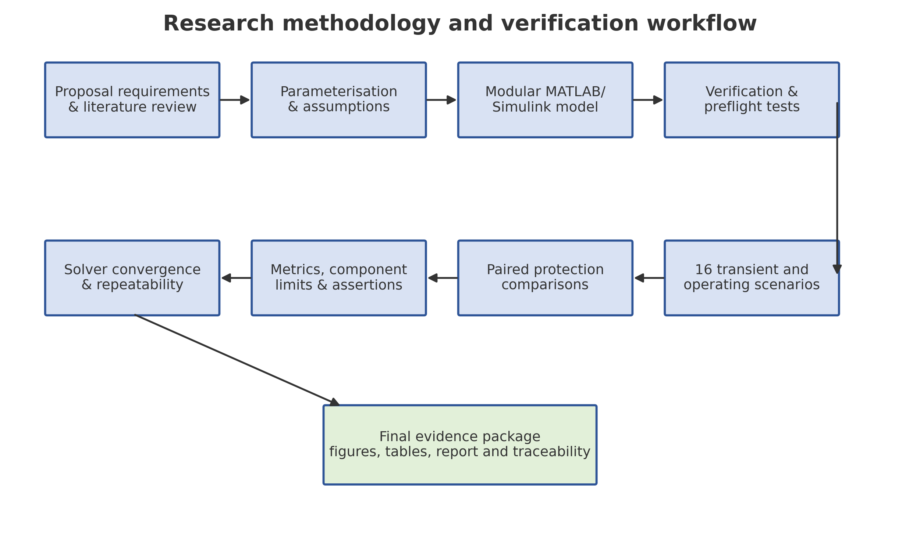
Figure 1. End-to-end research workflow from proposal requirements through physical modelling, scenario execution, evaluation, numerical verification and reporting.
Figure 1 summarises the workflow. Requirements from the project proposal were first converted into traceable implementation and validation requirements. Component equations and engineering assumptions were then centralised in configuration files. After model generation and preflight checks, the final scenario suite was executed. Evaluation was performed on named logged signals, after which numerical convergence, repeatability, component-capability checks and assertion-level traceability were generated automatically.
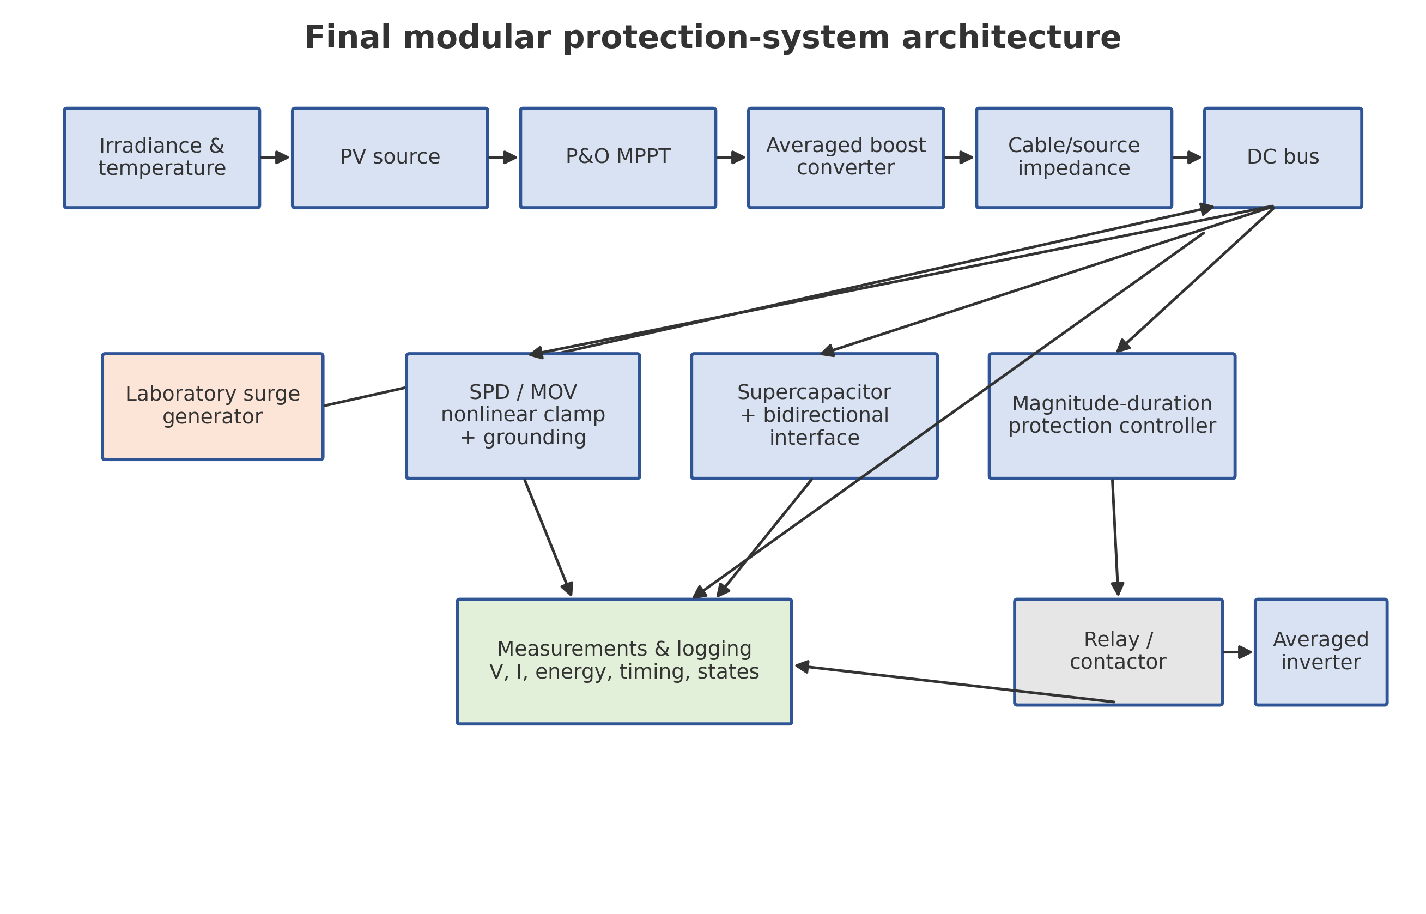
Figure 2. Functional architecture of the final PV lightning and surge protection model.
As shown in Figure 2, the protection architecture is layered. The PV source feeds an averaged boost converter controlled by P&O MPPT. The source and cable impedance connect the converter to a nominal 48 V DC bus. The surge generator perturbs this electrical network through finite source impedance. The MOV/SPD branch provides the fast nonlinear protective path. A controlled supercapacitor branch exchanges bounded current with the DC bus. The protection controller observes the bus voltage and controls the relay/contactor feeding the averaged microinverter load. Measurements from all major branches are logged for post-processing.
Table 2. Selected final model parameters
Subsystem | Parameter | Final value
PV module | Rated power / Voc / Isc | 200 W / 43.2 V / 6.15 A
PV module | Vmp / Imp | 36.0 V / 5.56 A
PV single diode | Rs / Rsh / ideality | 0.12 Ω / 300 Ω / 1.30
MPPT | Sample time / duty step | 2 ms / 0.0005
Boost converter | L / RL / switching frequency | 2.5 mH / 0.08 Ω / 20 kHz
DC bus | Nominal voltage / capacitance | 48 V / 20 mF
Cable | R / L | 0.18 Ω / 45 µH
SPD/MOV | MCOV / knee | 58 V / 62 V
SPD/MOV | Selected current / energy rating | 1000 A / 2000 J
Supercapacitor | C / ESR / initial voltage | 15 F / 55 mΩ / 30 V
SC converter | Current limit / path L | 18 A / 1.5 mH
Controller | Warning / emergency | 1.10 pu / 1.45 pu
Controller | Allowed duration / safe dwell | 45 ms / 350 ms
Relay | Open / close delay | 8 ms / 12 ms
Solver | Production step / convergence step | 0.25 ms / 0.125 ms

Table 2 lists the principal final parameters. These values are engineering assumptions selected for a laboratory-scale study because the proposal did not specify commercial component part numbers. The parameter provenance is stated explicitly in the project documentation. In particular, the SPD values represent a final design envelope, not certification of a specific market device.

3.3 PV source and MPPT model
The PV subsystem uses the implicit single-diode equation, with the same implementation reused for the plant, I-V curves, P-V curves and numerical MPP reference. This avoids the inconsistency that can arise when a simplified plotting equation is used to validate a different plant equation. The current I is obtained from
I = I_ph - I_0 [ exp((V + I R_s)/(n N_s V_t)) - 1 ] - (V + I R_s)/R_sh (1)
where Iph is the irradiance-dependent photocurrent, I0 is the diode saturation current, Rs and Rsh are the series and shunt resistances, n is the diode ideality factor, Ns is the number of series cells and Vt is the thermal voltage. The configured module contains 72 cells, Rs = 0.12 Ω, Rsh = 300 Ω and n = 1.30. Temperature and irradiance influence the source through the configured current and voltage coefficients. A numerical iteration is used to solve the implicit current relation.
The P&O controller measures actual PV voltage and current, calculates instantaneous PV power and changes the duty cycle by a small perturbation according to the sign of the preceding power change. The controller sample time is 2 ms and the duty step is 0.0005, with bounds of 0.08 and 0.65. The controller therefore operates much more slowly than the internal averaged boost-converter state update, which is intentional for a digital MPPT implementation.
MPPT efficiency was not calculated against a fixed 207 W number during irradiance transients. Instead, the available MPP is recomputed with the same single-diode model over the corresponding evaluation window. The integral efficiency is
η_MPPT = [ ∫ P_PV(t) dt / ∫ P_MPP,available(t) dt ] × 100% (2)
Startup and steady-state efficiencies are reported separately. For the irradiance-step scenario, the analysis additionally checks that the irradiance step occurred, the available MPP changed, the tracked power followed the new value and no protection trip was generated by ordinary environmental dynamics.

3.4 Averaged boost converter and DC bus
The main scenario sweep uses an averaged boost-converter model to avoid a switching time step that would make the complete sixteen-scenario verification unnecessarily expensive. The inductor state follows
L_b di_L/dt = V_PV - (1-D)V_bus - R_L i_L (3)
where Lb = 2.5 mH, D is the MPPT duty ratio and RL = 0.08 Ω. A nominal converter efficiency of 0.94 is included in the energy transfer. The 48 V bus contains 20 mF of capacitance and is precharged to 48 V so that transient tests begin from a controlled operating condition rather than from an unrealistic zero-voltage startup.
The DC-bus equation is an explicit current balance. Positive supercapacitor current is defined as charging from the bus into the supercapacitor, and positive SPD current flows from the bus into the protective branch. With this convention,
C_bus dV_bus/dt = I_boost + I_surge - I_SPD - I_SC,bus - I_load (4)
This equation is important for interpreting the results. A decrease in peak bus voltage can result from SPD current, supercapacitor charging current, or both. The logged branch currents make it possible to identify which mechanism dominated a particular event instead of inferring the mechanism only from the voltage trace.

3.5 Surge generator, cable and grounding impedance
The complete-system surge generator uses a parameterised double-exponential transient for short impulse scenarios. A normalised waveform of the form
s(t) = K [ exp(-αt) - exp(-βt) ] (5)
is scaled so that the actual injected source reaches the configured peak. The final design scenarios use laboratory-scale millisecond rise and decay constants rather than attempting to reproduce the electromagnetic time scale of a direct lightning channel. The source path contains 3 Ω resistance and 120 µH inductance. The PV cable contributes 0.18 Ω and 45 µH. These nonzero impedances ensure that current, voltage and residual energy are coupled realistically at the research scale.
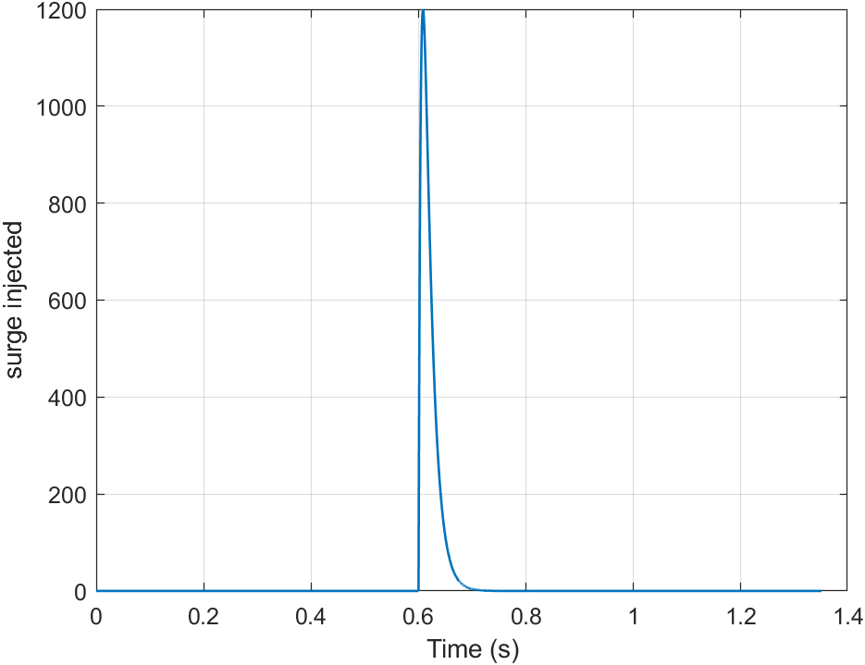
Figure 3. Representative laboratory-scale surge waveform used for the full-system transient studies.
Figure 3 shows the laboratory-scale surge waveform. Short-impulse scenarios use this family of waveforms, repeated-surge scenarios apply multiple pulses with controlled spacing, and sustained-overvoltage scenarios use a bounded longer-duration disturbance to exercise the magnitude-duration controller. The fast SPD component tests described later are separate and use microsecond-scale waveforms.

3.6 SPD/MOV model and rating procedure
The SPD branch is based on a nonlinear MOV model. Below the configured MCOV the MOV carries a leakage current of 20 µA. Above the 62 V knee, demanded current rises according to a power-law characteristic controlled by the nonlinear exponent and dynamic-resistance parameters. Lead resistance, lead inductance, ground resistance and ground inductance are included. The implementation uses shared functions for demanded current, actual current, capability state and energy update so that the complete-system model and fast component tests use the same MOV characteristic.
Two currents are retained. The demanded current is the current implied by the nonlinear characteristic at the applied voltage, whereas the actual current is constrained by the finite device capability and the electrical network. A saturation flag and saturation duration are logged whenever the demanded current exceeds the selected capability. Event energy is calculated from the simulated terminal quantities rather than assigned from the scenario label:
E_SPD = ∫_event |v_SPD(t)i_SPD(t)| dt (6)
The final assumed SPD rating was selected after executing the design-envelope cases. The current and energy ratings are required to satisfy
I_rating ≥ M_I I_required,max and E_rating ≥ M_E E_required,max (7)
with current and energy design margins MI and ME not less than 1.20. The selected engineering values are 1000 A and 2000 J. All design scenarios must remain within those ratings. T16 is deliberately outside the design envelope and must produce an explicit OVERSTRESSED state. This separation allows the simulation to demonstrate both safe final-design operation and the ability to detect capability exceedance.

3.7 Supercapacitor interface
The supercapacitor bank is represented by an equivalent 15 F capacitance initially charged to 30 V. Its operating window is 20-38 V and its ESR is 55 mΩ. The bank is connected through a dynamic averaged bidirectional interface rather than directly across the bus. The interface includes a 1.5 mH current-path inductance, 0.08 Ω path resistance, converter efficiency, current control and an 18 A limit. This prevents an unrealistic infinite current step when the bus voltage changes rapidly.
Positive supercapacitor current means charging. Under this sign convention, the terminal voltage and ESR dissipation are
V_SC,terminal = V_SC,internal + I_SC R_ESR (8)
P_ESR = I_SC² R_ESR ≥ 0 (9)
Absorbed and released energies are calculated separately from terminal power. The event analysis also computes incremental event energy so that startup and routine DC regulation are not mistaken for surge absorption. The minimum and maximum internal and terminal voltages, actual current, raw current request, limited command, current-limit duration, ESR loss and converter-enable state are all logged.
A first-principles energy relation provides a sizing interpretation:
ΔE_SC = 0.5 C_SC (V_2² - V_1²) (10)
The simulation does not claim that this storage branch can absorb a direct lightning discharge. Its function is limited to residual energy and short-duration bus disturbances within its converter current and voltage capability.

3.8 Protection controller and relay/contactor
The supervisory controller operates on a slower protection time scale than the MOV. Protection is armed only after a 0.20 s startup blanking interval and 0.04 s of continuously healthy DC-bus voltage between 0.95 and 1.05 pu. This startup qualification is applied to both the integrated and conventional-relay comparison modes so that the relay is closed and the load is energised before each paired event.
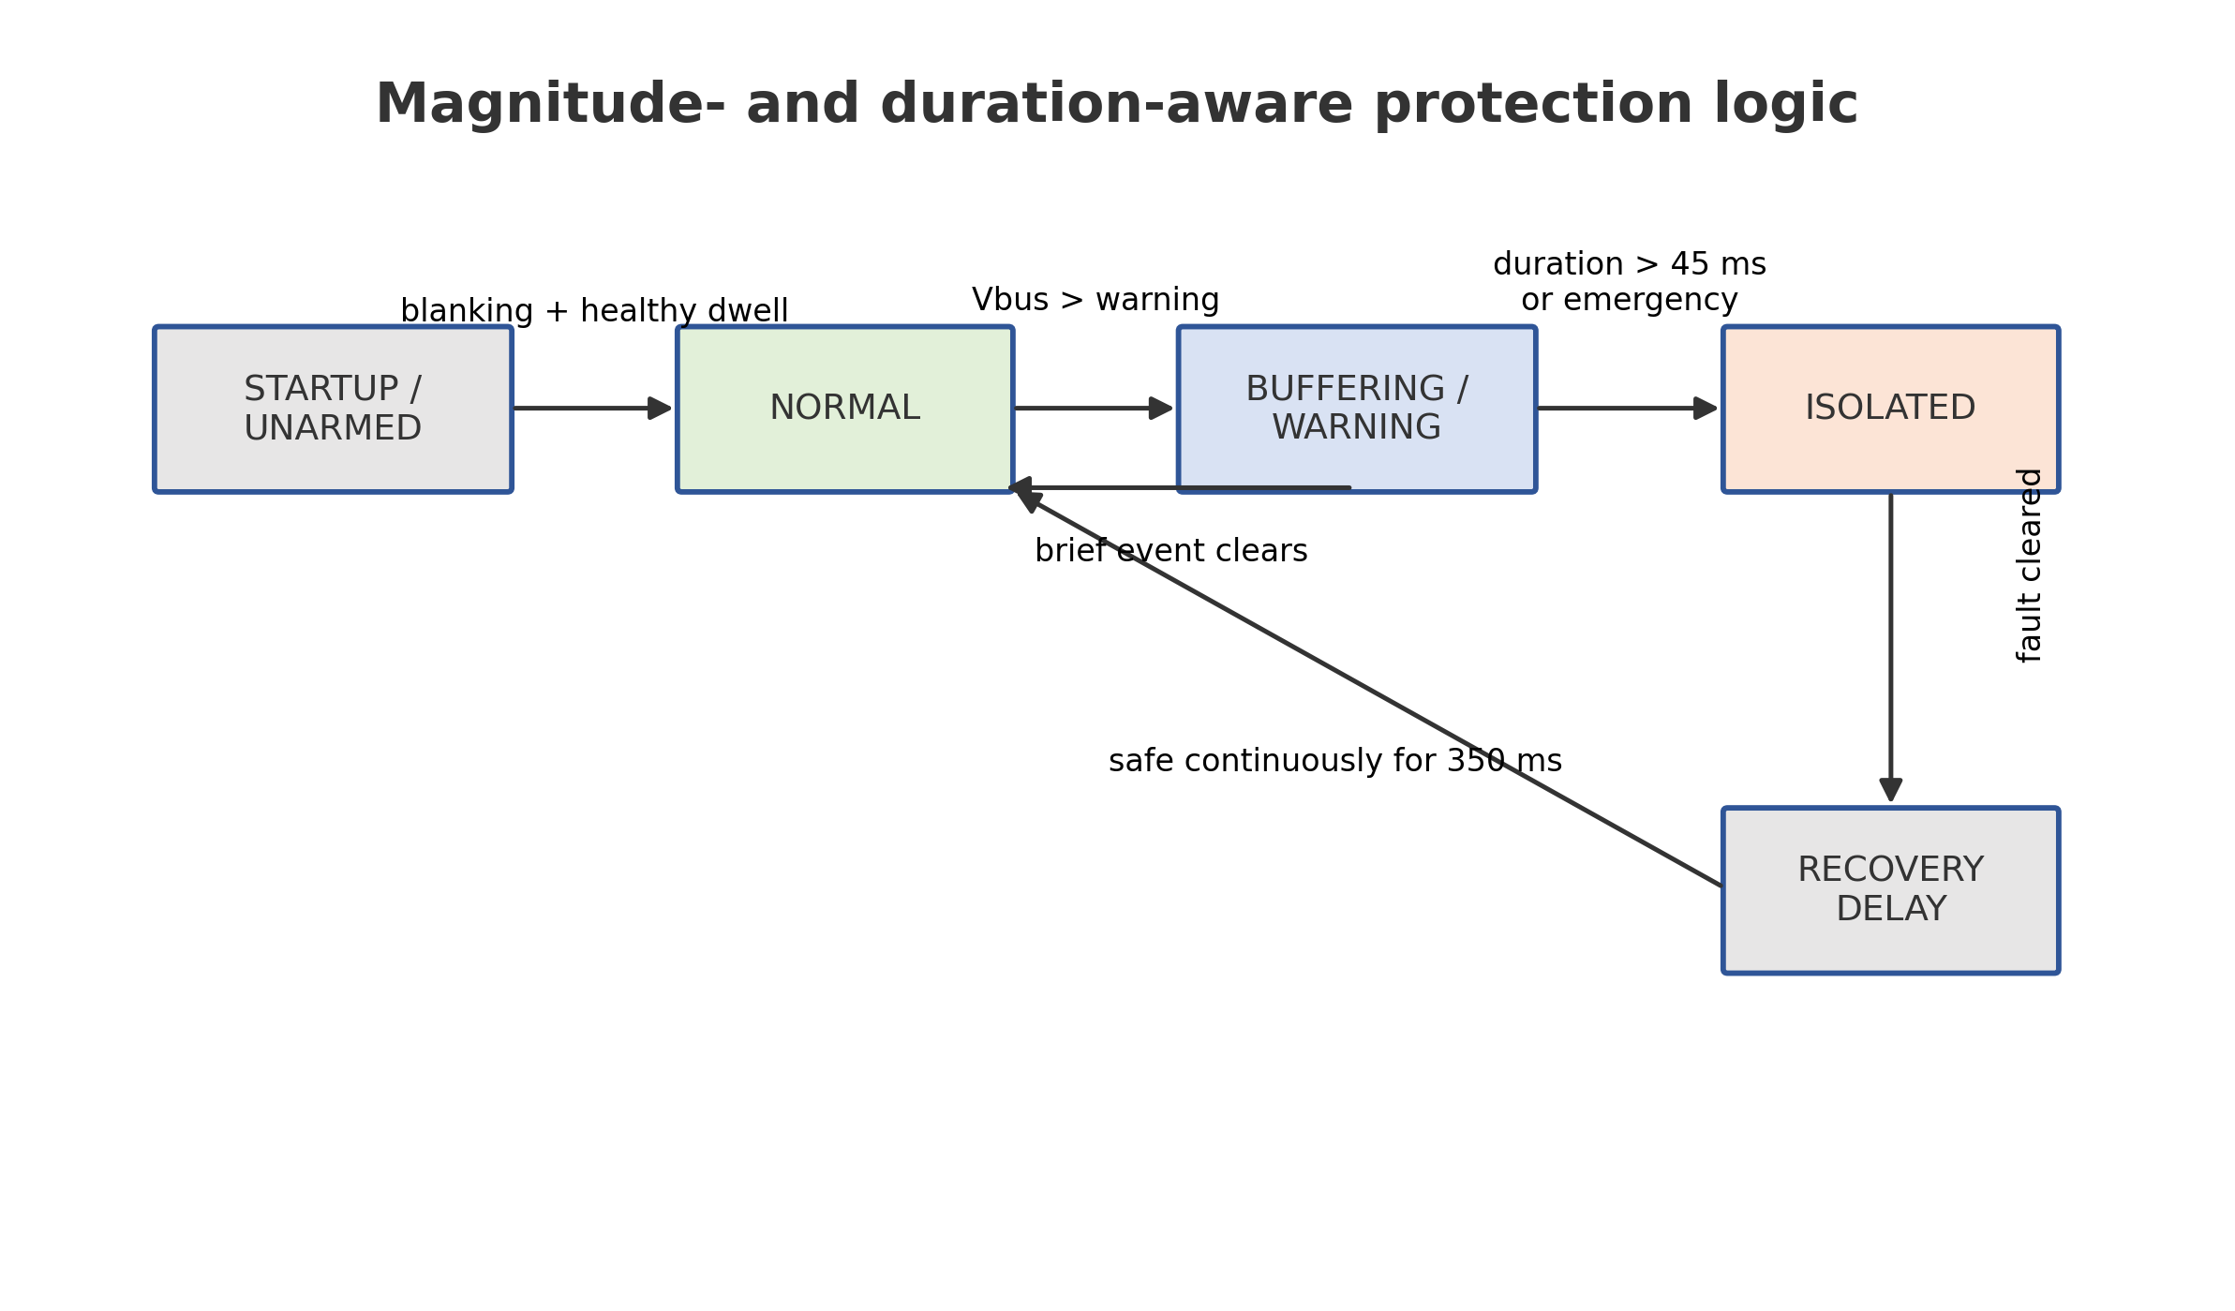
Figure 4. Magnitude-and-duration protection-state logic used by the integrated controller.
Figure 4 shows the conceptual state sequence. The warning threshold is 1.10 pu of the 48 V nominal bus, while the emergency threshold is 1.45 pu. A warning-level disturbance is permitted for 45 ms. A disturbance that falls below the warning threshold before the timer expires returns to a non-isolated state. An emergency threshold crossing commands immediate isolation, subject only to the physical relay opening delay. Once isolated, the system must remain continuously inside the 0.85-1.07 pu recovery band for 350 ms before automatic reconnection is permitted.
The relay/contactor model separates the logical command from the physical contact state. Opening resistance is 1 MΩ, closed resistance is 25 mΩ, opening delay is 8 ms and closing delay is 12 ms. Consequently, the evaluation records threshold crossing, trip command, physical opening, safe-interval start, reconnect command and physical closing as distinct times. If the voltage leaves the safe band during recovery, the safe timer resets.
Mode 2 in the protection comparison represents a startup-qualified conventional fixed-threshold relay. Once armed, it opens immediately when the warning threshold is exceeded and does not use the integrated 45 ms persistence logic or supercapacitor branch. This creates a more realistic conventional baseline than a relay that trips during startup while preserving the intended contrast between fixed-threshold and time-aware behaviour.

3.9 Averaged and switching inverter models
The main scenario sweep uses a regulated averaged microinverter input model. The requested AC-side power is 178 W, conversion efficiency is 0.91, and the DC input is subject to an 8 A current limit, 34 V undervoltage lockout, 82 V overvoltage shutdown and 80 ms soft start. The model converts requested output power into a DC current demand through power balance and protection limits. This produces more representative downstream behaviour than a simple static resistor while keeping the transient sweep computationally efficient.
A separate switching demonstration uses a 48 V DC source, H-bridge PWM at 10 kHz, a 2 mH output inductor, 22 µF capacitor and 12 Ω AC load. The commanded output is 24 V RMS at 50 Hz. The model verifies output voltage, frequency, RMS current, input-output power balance and shutdown after a protection command. It is intentionally a low-voltage demonstration and does not include grid synchronisation or anti-islanding certification.

3.10 Simulation scenarios and fair comparisons
Table 3. Final simulation scenario matrix
ID | Scenario | Disturbance | Protection | Primary expected behaviour
T01 | Normal operation | None | Integrated | Stable bus; no trip
T02 | Irradiance step | None | Integrated | MPPT adapts; no false trip
T03 | Short ripple | 18 ms ripple | Integrated | Buffer without isolation
T04 | Moderate design transient | Impulse, 160 | Integrated + paired modes | Coordinate SPD/SC; no relay trip
T05 | Severe design transient | Impulse, 1200 | Integrated + paired modes | Emergency isolation within SPD rating
T06 | Repeated design surges | 3 × impulse, 300 | Integrated + paired modes | Stable repeated response
T07 | Sustained overvoltage | 220 ms | Integrated + paired modes | Timed isolation
T08 | Emergency overvoltage | Impulse, 1200 | Integrated | Emergency isolation
T09 | Automatic recovery | 120 ms sustained | Integrated | Full safe-dwell reconnect
T10 | Manual reset | 120 ms sustained | Integrated | Wait for manual reset
T11 | Protection comparison | Impulse, 1200 | Four modes | Fair comparison
T12 | SC current limit | Impulse, 450 | Integrated | Current limit without SPD overstress
T13 | Sensor noise | 0.35 V std. dev. | Integrated | No false trip
T14 | Inverter integration | Impulse, 1200 | Integrated | Averaged inverter shutdown
T15 | Solver convergence | Impulse, 1200 | Integrated | 0.25 vs 0.125 ms
T16 | Intentional SPD overstress | Impulse, 100000 | Integrated | Detect out-of-envelope capability

Table 3 summarises the sixteen final scenarios. For paired comparison events, the unprotected, SPD-only, SPD plus conventional relay, and integrated modes use identical irradiance, temperature, surge, load, stop time, solver and initial conditions. The software additionally asserts that the protection is armed, the relay is closed and downstream current is nonzero immediately before the event. A comparison is marked invalid rather than calculated if these conditions are not satisfied.

3.11 Evaluation metrics and validation
Evaluation uses scenario-specific event windows. This is important because a full simulation contains startup, normal pre-event operation, the disturbance itself and recovery. Peak bus voltage is reported over the event, while settling time is measured from the relevant event end, fault clear, irradiance step or physical reconnection. A signal is considered settled only after it remains continuously inside the configured tolerance band for the specified dwell interval.
Paired voltage reduction is defined as
Voltage reduction = [(V_peak,unprotected - V_peak,protected)/V_peak,unprotected] × 100% (11)
The metric is reported only when a valid paired unprotected case exists. Event load energy is calculated by integrating load power over the same event window for all modes. Because a protected case can deliver more energy than an unprotected case that shuts down, the thesis uses the terms Relative Event Load Energy and Load Energy Improvement rather than the misleading term retention.
Component validation is distinct from scenario execution. A scenario can execute correctly while intentionally producing a component-overstress status, as in T16. The final report therefore counts scenario passes, assertion passes, expected overstress detections and unexpected component violations separately. This distinction prevents a successful detection test from being misinterpreted as a safe design result.

3.12 Numerical verification, safety and ethics
Numerical convergence was evaluated by rerunning a severe design transient at the 0.25 ms production step and at a 0.125 ms half step. The comparison includes peak and minimum bus voltage, demanded and actual SPD current, SPD energy, supercapacitor energy and ESR loss, trip time, physical opening time and reconnection time. The acceptance limit is 3% for the maximum important-metric difference. Deterministic repeatability was checked by repeating representative moderate, severe and recovery scenarios.
The study does not involve human participants, personal data or animals. The principal safety issue is electrical. All full-system scenarios are laboratory-scale numerical representations; no real lightning or high-voltage impulse was applied. A future hardware implementation should use low-energy programmable sources, suitable fusing, isolation, guarded test equipment, correctly rated SPDs, controlled grounding and institutional electrical-safety procedures. Any extension to direct-lightning or compliance testing would require a specialist high-voltage laboratory.

CHAPTER 4

RESULTS

4.1 End-to-end verification status
Before the numerical results were interpreted, the complete final workflow was executed from the canonical main.m entry point. The run completed all environment, model-build, preflight, component and scenario stages. Eighteen unit tests passed, all 16 final scenarios passed, and all 351 individual traceable assertions passed. The result package contained no unexpected SPD current violation, SPD energy violation, supercapacitor current violation or supercapacitor voltage violation. One SPD overstress detection was expected and occurred only in T16, the intentionally out-of-envelope capability test.
The output-generation stage produced raw MAT files for every scenario, the final evaluation workbooks, event log, figures, HTML report and PDF report. Critical logged signals were checked for missing values, NaN and Inf conditions where finite values were required. The paired-comparison validation also confirmed identical disturbance inputs and healthy pre-event operating states. These checks establish the data basis for the results reported in the remainder of this chapter.

4.2 PV-model and MPPT results
Table 4. Validation of the unified single-diode PV model
Quantity | Configured | Model-derived | Absolute error | Status
Voc | 43.2 | 43.1467 | 0.123% | PASS
Isc | 6.15 | 6.14754 | 0.040% | PASS
Vmp | 36.0 | 35.8182 | 0.505% | PASS
Imp | 5.56 | 5.64972 | 1.614% | PASS
Pmp | 200.0 | 202.363 | 1.181% | PASS

First, the unified PV model was evaluated against the configured module points. Table 4 shows that the open-circuit-voltage error was 0.123%, the short-circuit-current error was 0.040%, the maximum-power voltage error was 0.505%, the maximum-power current error was 1.614%, and the maximum-power error was 1.181%. All five quantities remained within their predefined validation limits.
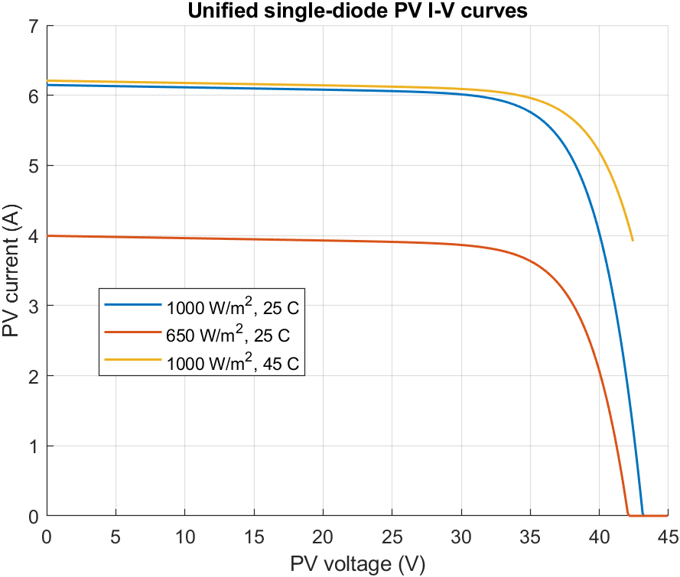
Figure 5. Modelled PV I-V curves at the evaluated irradiance and temperature conditions.
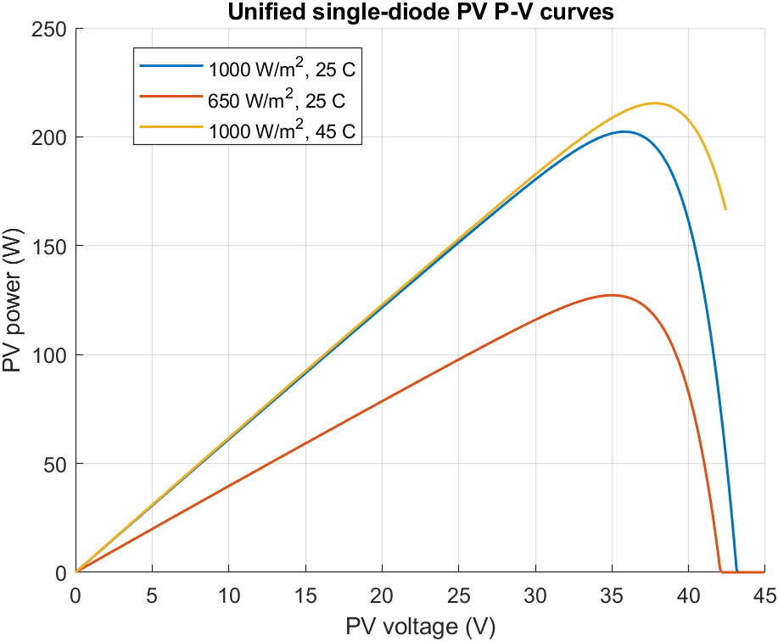
Figure 6. Modelled PV P-V curves using the same single-diode equation as the simulated plant.
Figures 5 and 6 show the I-V and P-V characteristics generated from the same single-diode solver used by the plant. The curves exhibit the expected reduction of current and available power at lower irradiance and the expected shift of the operating characteristic with temperature. No separate plotting approximation was used.
Table 5. MPPT validation results
Scenario | Startup efficiency | Steady efficiency | Post-step efficiency | Steady tracking error | Status
T01 Normal | 99.474% | 99.981% | — | 0.0186% | PASS
T02 Irradiance step | 99.474% | 99.975% | 99.950% | 0.0253% | PASS

The MPPT results are given in Table 5. The normal-operation steady efficiency was 99.981%, and the irradiance-step steady efficiency was 99.975%. The post-step efficiency was 99.950%. The automated recovery-time routine returned zero seconds because the first evaluated post-step sample already satisfied the recovery criterion; therefore, the observed recovery is more appropriately described as below the temporal resolution of the evaluation criterion rather than as a physically instantaneous response.
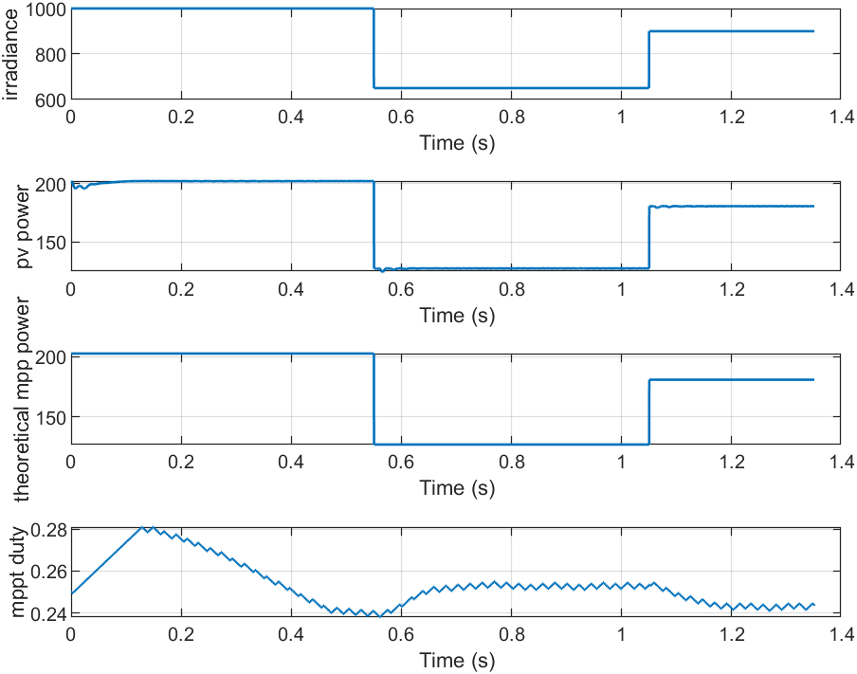
Figure 7. PV power and available MPP during the irradiance-step validation scenario.
Figure 7 shows the irradiance-step response. The actual PV power follows the change in the model-derived available MPP and the protection relay remains connected throughout the environmental transient.

4.3 Normal operation and short disturbances
Under T01 normal operation, the peak DC-bus voltage was 48.197 V and the minimum was 46.490 V. The peak therefore remained within approximately 0.41% above the 48 V nominal value. No relay trip or emergency flag occurred, and the SPD remained at leakage-level current. The supercapacitor exchanged a small amount of regulation energy with the bus, as expected from the dynamic buffering controller.
T03 applied a short 18 ms ripple. The peak bus voltage was 51.352 V, corresponding to a 6.98% overshoot. The integrated controller did not isolate the load. The supercapacitor incremental event energy was 1.516 J. The result therefore satisfies the scenario requirement that a short disturbance inside the permitted protection envelope be handled without unnecessary relay operation.
T04 applied the moderate design transient. In the integrated case the peak bus voltage was 61.695 V, which is slightly below the 62 V MOV knee. The MOV therefore remained near leakage current and the supercapacitor provided the dominant buffering response. Incremental supercapacitor event energy was 19.274 J and the relay remained closed. The measured response is important because it shows that the integrated branch can reduce a moderate transient without forcing every event to be dissipated by the SPD.

4.4 Paired protection-mode comparisons
The main comparative analysis used identical inputs and pre-event conditions for four protection configurations. The results are reported in Tables 6 and 7 and Figures 8-11. This section reports the measured differences only; their engineering interpretation is reserved for Chapter 5.
Table 6. Paired moderate and severe design-transient comparison
Scenario | Protection mode | Peak Vbus (V) | Reduction (%) | Event load energy (J) | SPD status
T04 Moderate | Unprotected | 69.46 | 0 | 17.76 | —
T04 Moderate | SPD only | 64.04 | 7.80 | 17.76 | SAFE
T04 Moderate | Conventional relay | 64.16 | 7.62 | 2.51 | SAFE
T04 Moderate | Integrated | 61.69 | 11.17 | 17.76 | SAFE
T05 Severe | Unprotected | 338.30 | 0 | 0.78 | —
T05 Severe | SPD only | 69.91 | 79.33 | 17.76 | SAFE
T05 Severe | Conventional relay | 69.91 | 79.33 | 1.80 | SAFE
T05 Severe | Integrated | 69.83 | 79.36 | 2.60 | SAFE

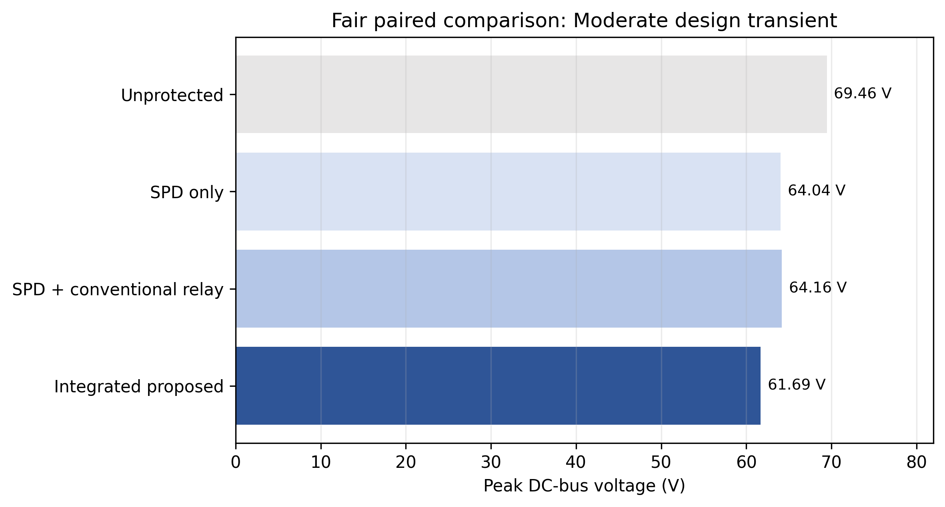
Figure 8. Fair paired comparison of DC-bus peak voltage for the moderate design transient.
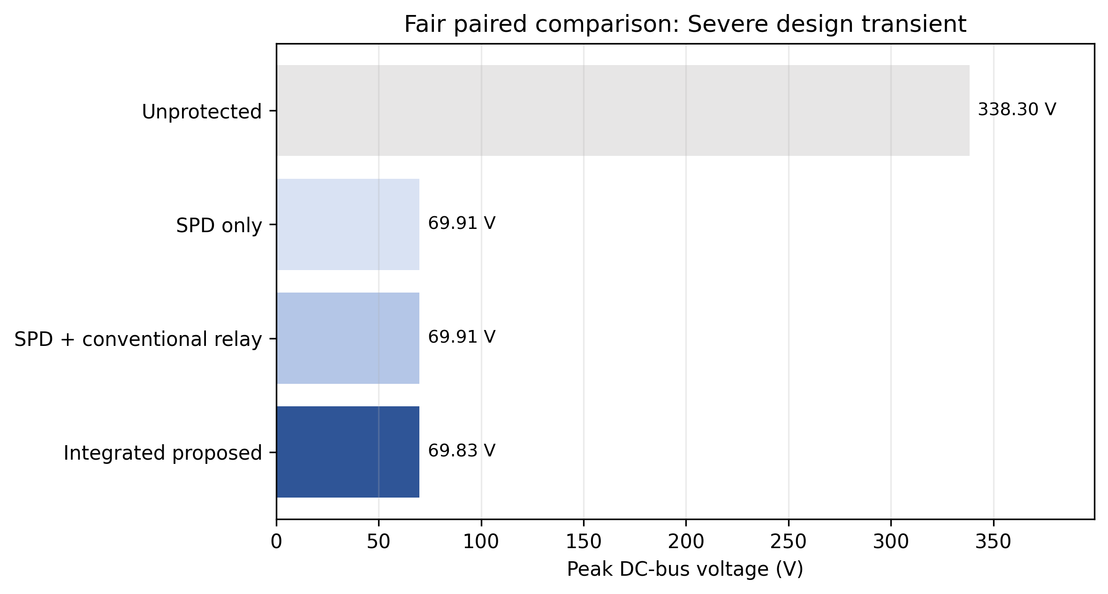
Figure 9. Fair paired comparison of DC-bus peak voltage for the severe design transient.
For T04, the unprotected peak was 69.455 V. The SPD-only case reduced the peak to 64.036 V, the conventional-relay case to 64.164 V, and the integrated case to 61.695 V. The corresponding integrated reduction was 11.174%. For T05, the unprotected peak was 338.304 V. The SPD-only and conventional-relay modes both produced approximately 69.911 V, while the integrated mode produced 69.831 V. The integrated reduction relative to the paired unprotected case was 79.358%.
Table 7. Paired repeated-surge and sustained-overvoltage comparison
Scenario | Protection mode | Peak Vbus (V) | Reduction (%) | Event load energy (J) | SPD status
T06 Repeated | Unprotected | 173.13 | 0 | 2.20 | —
T06 Repeated | SPD only | 65.82 | 61.98 | 48.06 | SAFE
T06 Repeated | Conventional relay | 65.89 | 61.94 | 2.16 | SAFE
T06 Repeated | Integrated | 65.68 | 62.06 | 10.26 | SAFE
T07 Sustained | Unprotected | 92.79 | 0 | 21.78 | —
T07 Sustained | SPD only | 63.35 | 31.73 | 39.12 | SAFE
T07 Sustained | Conventional relay | 63.58 | 31.48 | 3.09 | SAFE
T07 Sustained | Integrated | 62.69 | 32.44 | 12.13 | SAFE

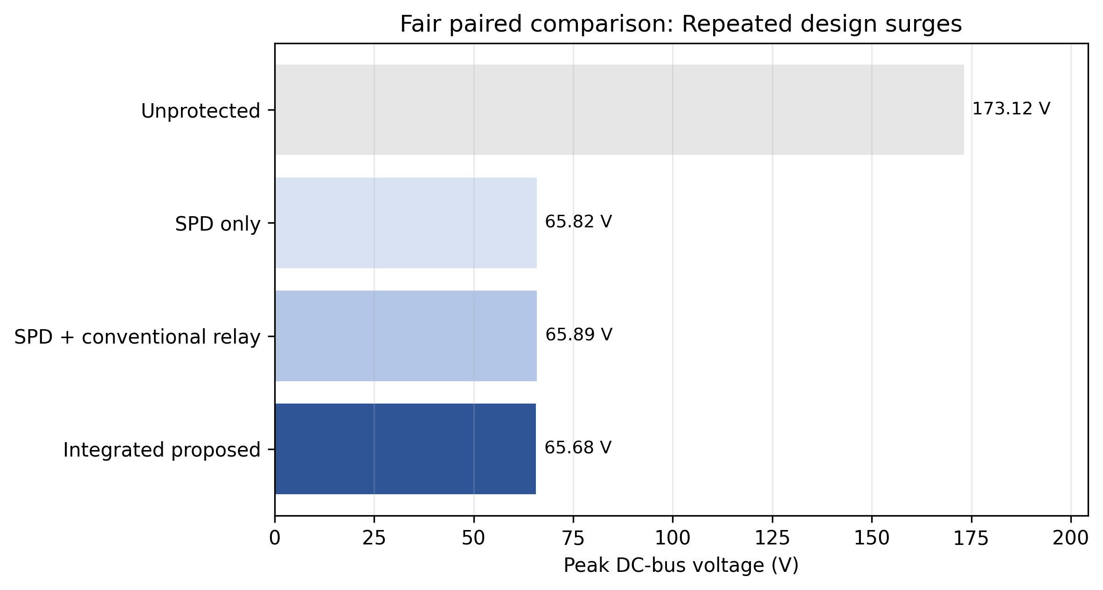
Figure 10. Fair paired comparison of DC-bus peak voltage for the repeated-surge scenario.
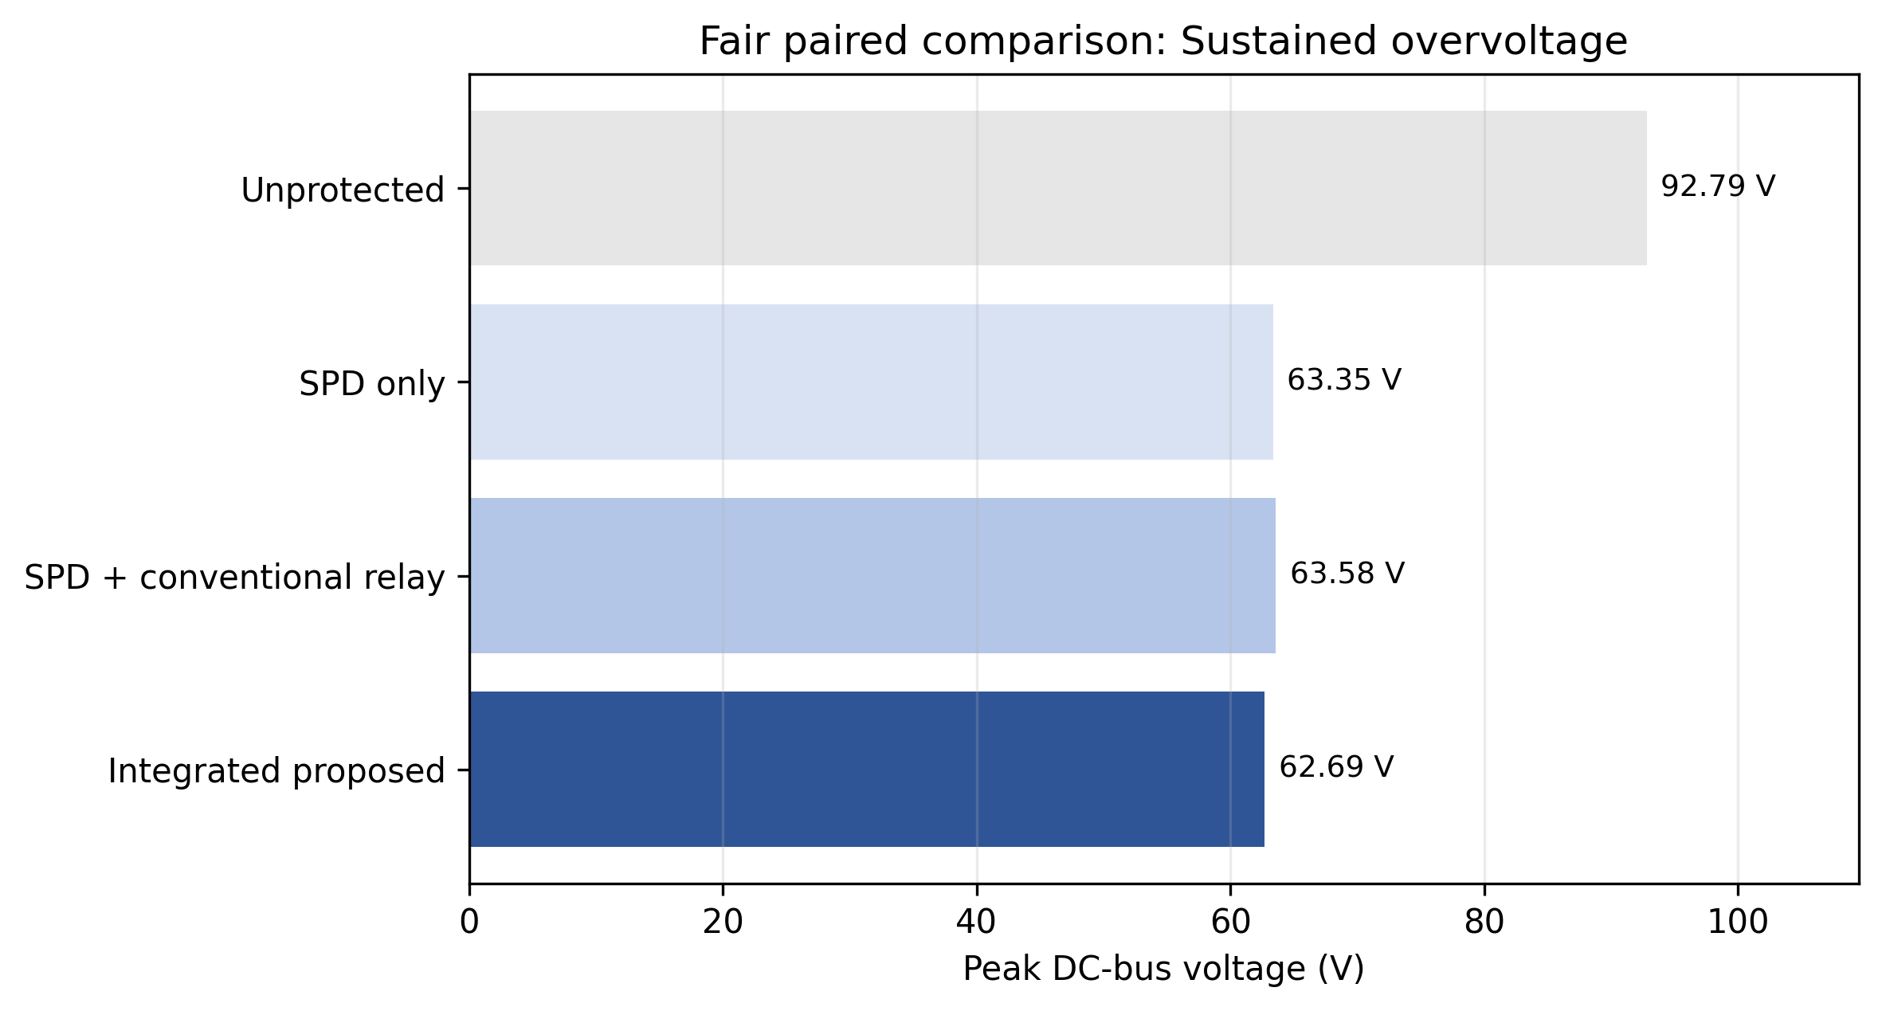
Figure 11. Fair paired comparison of DC-bus peak voltage for the sustained-overvoltage scenario.
For T06, the integrated peak was 65.685 V compared with 173.125 V unprotected, giving a 62.059% reduction. For T07, the integrated peak was 62.693 V compared with 92.791 V unprotected, giving a 32.436% reduction. The event-window load energy differs substantially among protection modes because the relay modes intentionally disconnect the downstream load after their respective trip criteria are satisfied.

4.5 SPD capability and design margins
Table 8. SPD capability results for design and intentional-overstress cases
Scenario | Demanded peak (A) | Actual peak (A) | Event energy (J) | Current utilisation | Energy utilisation | Status
T05 Severe | 344.87 | 344.87 | 514.14 | 34.49% | 25.71% | SAFE
T08 Emergency | 344.87 | 344.87 | 514.14 | 34.49% | 25.71% | SAFE
T11 Comparison | 344.87 | 344.87 | 514.14 | 34.49% | 25.71% | SAFE
T16 Intentional overstress | 19,711,291 | 1,000 | 96,247.86 | >100% | >100% | OVERSTRESSED

Table 8 shows the final SPD capability results. In the severe design case the demanded and actual peak currents were both 344.868 A. With a 1000 A selected rating, peak-current utilisation was 34.487%. Event energy was 514.136 J, equivalent to 25.707% of the 2000 J rating. The resulting current design margin was 2.90 and the energy margin was 3.89. The same final design state was obtained in the corresponding emergency and comparison tests.
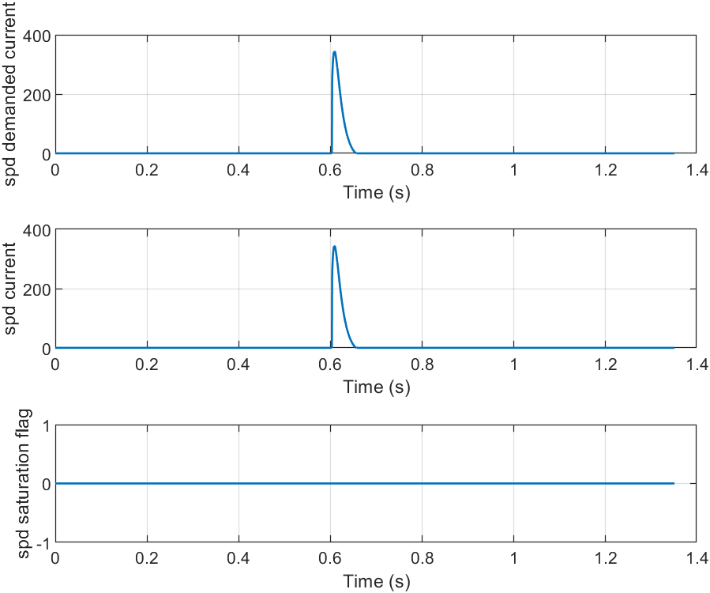
Figure 12. Demanded and actual MOV current in representative design and capability scenarios.
Figure 12 displays the separation between demanded and actual SPD current. In normal design operation the curves remain within capability, while the intentional overstress case produces demanded current far beyond the selected rating and the actual current is capability-limited.
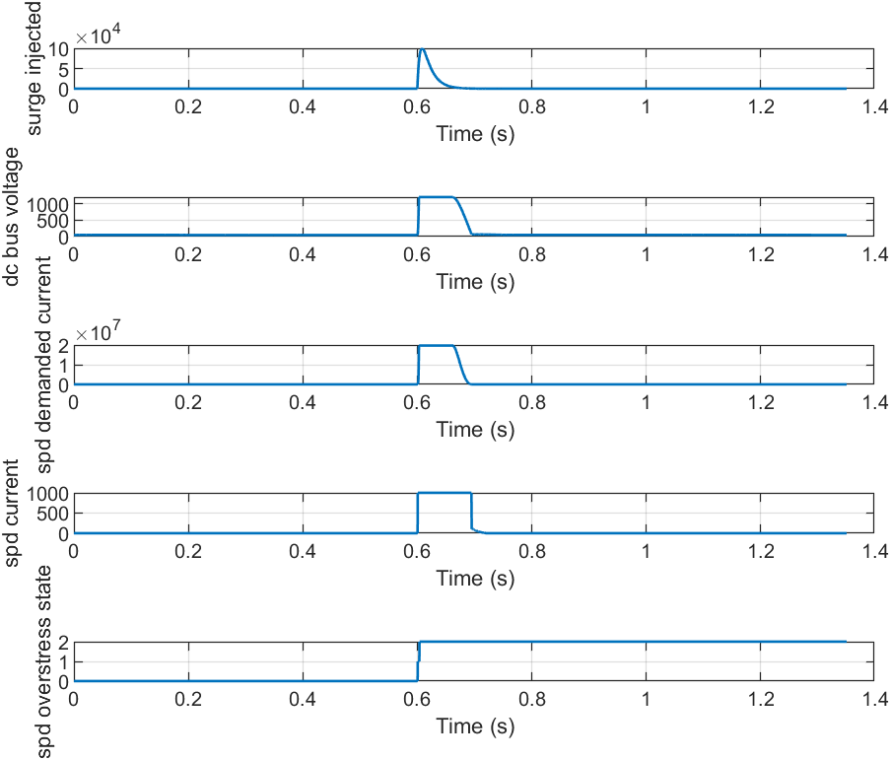
Figure 13. T16 intentional out-of-envelope SPD capability test.
In T16, the demanded current exceeded 19.7 MA, the actual current reached the configured 1000 A capability, saturation persisted for approximately 94 ms and the calculated event energy was 96.25 kJ. The final SPD state was OVERSTRESSED. The scenario itself passed because the purpose of T16 was to verify correct capability-exceedance detection rather than safe operation.

4.6 Supercapacitor response
Table 9. Supercapacitor dynamic response and current limiting
Scenario | Raw current request (A) | Actual peak current (A) | Limit duration (ms) | Incremental event energy (J) | ESR loss (J)
T03 Short ripple | 8.38 | 7.19 | 0 | 1.516 | 0.016
T04 Moderate | 34.24 | 16.36 | 25.75 | 19.274 | 0.477
T05 Severe | 54.58 | 16.36 | 70.00 | 43.679 | 1.168
T12 SC limit | 46.63 | 16.36 | 48.50 | 36.033 | 0.875

Table 9 reports the supercapacitor response. In T12 the raw current request reached 46.63 A, while the dynamic actual current peaked at 16.36 A and the current-limit flag was active for 48.50 ms. The current remained below the 18 A converter limit. Incremental event energy was 36.033 J and ESR loss was 0.875 J. The SPD remained within its design rating in this scenario, so the test isolates the intended supercapacitor current-limiting behaviour.
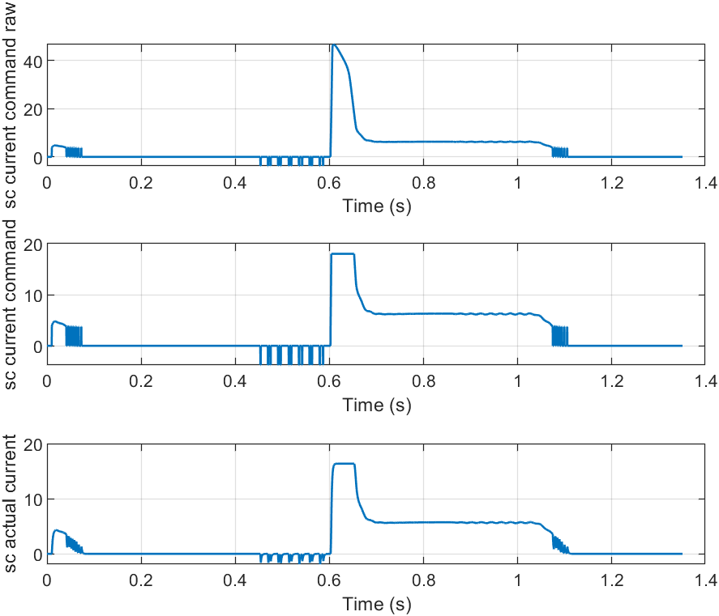
Figure 14. Supercapacitor current request, limited command and actual dynamic current.
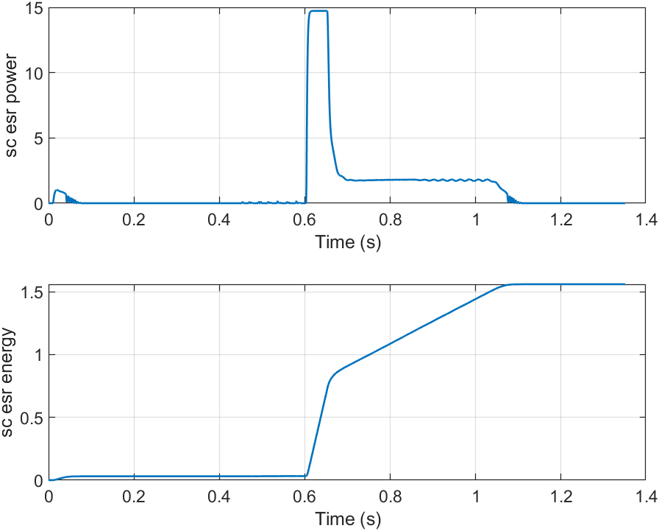
Figure 15. Supercapacitor ESR power and cumulative dissipated energy.
Figure 14 shows that the actual supercapacitor current follows a dynamic rather than instantaneous command and is constrained during high requests. Figure 15 shows non-negative ESR loss accumulating during charge and discharge current. Internal and terminal voltage remained inside the configured 20-38 V operating limits in all final design scenarios.

4.7 Timed isolation and recovery
T07 tested the persistence criterion under sustained overvoltage. The warning threshold was crossed at approximately 0.615 s, the trip command occurred at 0.65975 s, and the physical relay opened at 0.668 s. The interval from warning threshold crossing to trip command was approximately 44.75 ms, consistent with the configured 45 ms persistence criterion. The additional approximately 8.25 ms to physical opening is consistent with the 8 ms relay model delay.
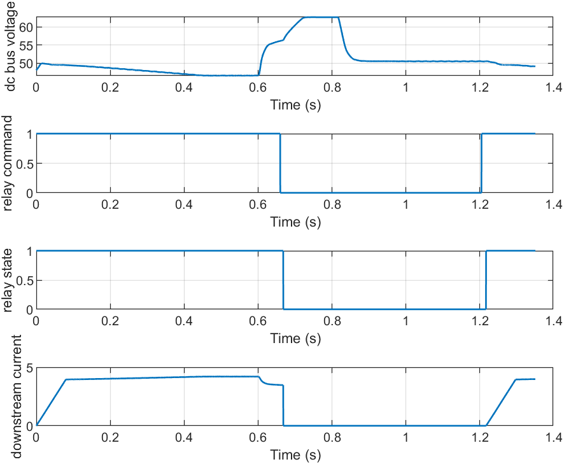
Figure 16. Separation of fault detection, controller command and physical relay state.
Figure 16 shows the distinction among detection, logical command and the physical contact state. The relay does not act as the first-line surge clamp; it opens only after the controller decision and mechanical-delay model.
T09 evaluated automatic recovery. The disturbance cleared at 0.720 s, the uninterrupted safe-voltage interval began at 0.754 s, and the reconnect command occurred at 1.104 s. The measured dwell was therefore exactly 0.350 s. Physical closing occurred at approximately 1.11625 s, giving a closing delay of approximately 12.25 ms relative to the 12 ms configured value.
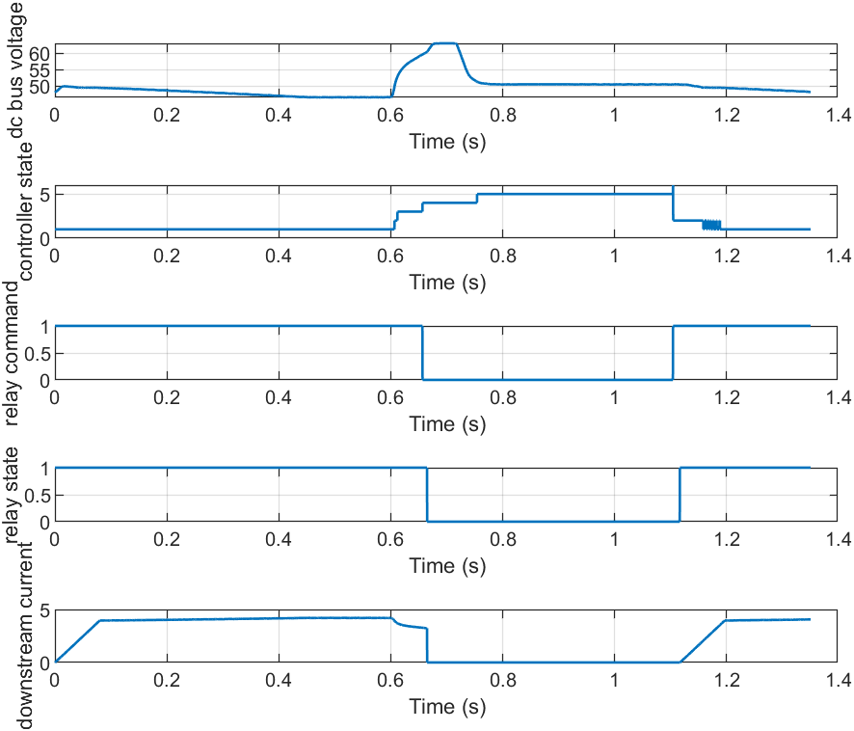
Figure 17. Automatic recovery timing showing the continuous safe-voltage dwell before reconnection.
Figure 17 shows the recovery sequence. The relay remains open throughout the safe dwell, and downstream current resumes only after the reconnection command and contact closing delay. T10 repeated the recovery test with automatic reset disabled; the relay remained isolated after the fault cleared until the manual reset command at 1.10 s.
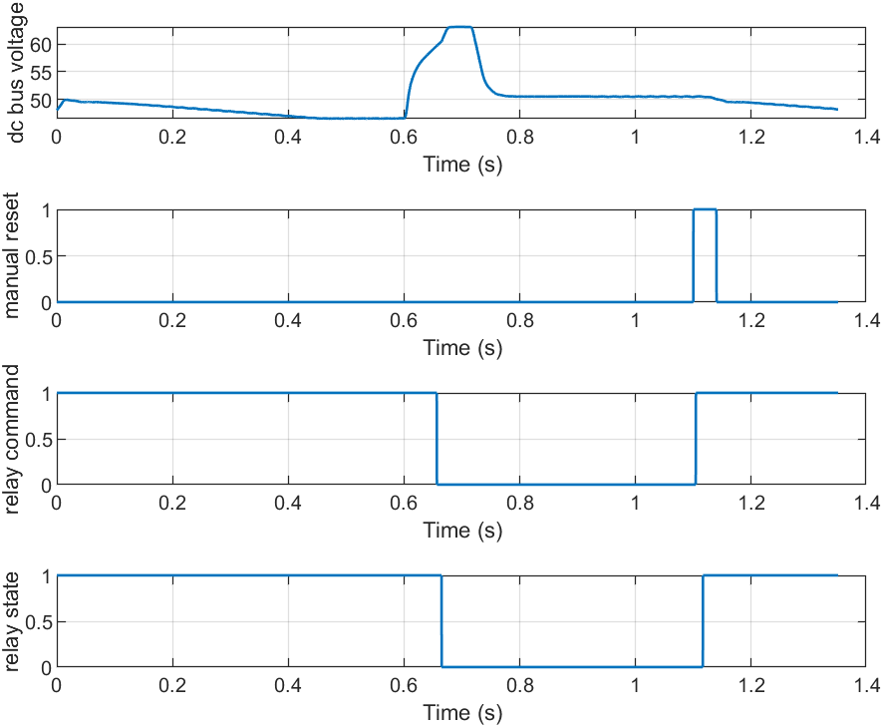
Figure 18. Manual-reset scenario showing retained isolation until reset is asserted.

4.8 Microinverter results
Table 10. Switching microinverter demonstration results
Metric | Measured result | Criterion/context | Status
Output RMS voltage | 23.894 V | 24 V target | PASS
Output frequency | 50.000 Hz | 50 Hz target | PASS
Output RMS current | 1.991 A | Finite load current | PASS
DC input power | 48.378 W | Measured | PASS
AC output power | 47.576 W | Measured | PASS
Power-balance error | 1.658% | Within tolerance | PASS
Post-shutdown RMS | 4.74×10⁻¹⁴ V | Approximately zero | PASS

The separate switching-inverter demonstration produced 23.894 V RMS at 50.000 Hz with 1.991 A RMS output current. DC input power was 48.378 W and AC output power was 47.576 W, producing a 1.658% power-balance error. After the protection shutdown command, the measured RMS output was approximately zero.
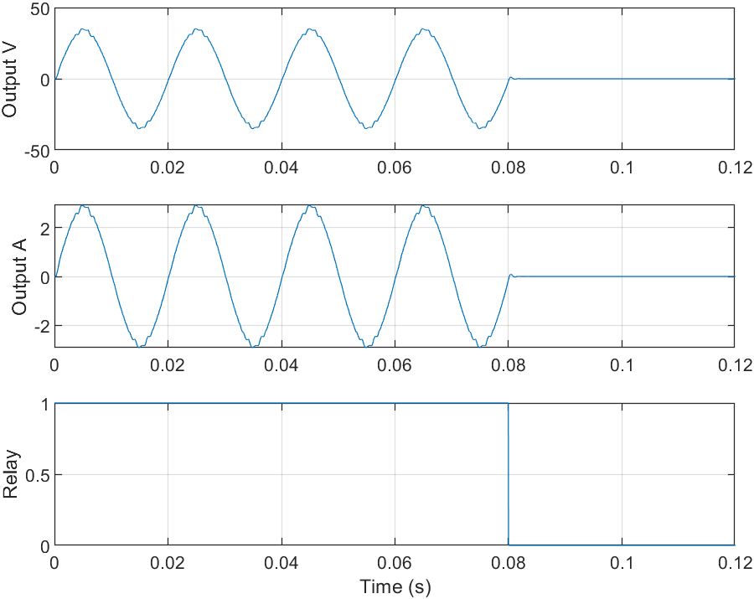
Figure 19. Low-voltage H-bridge inverter output voltage and current.
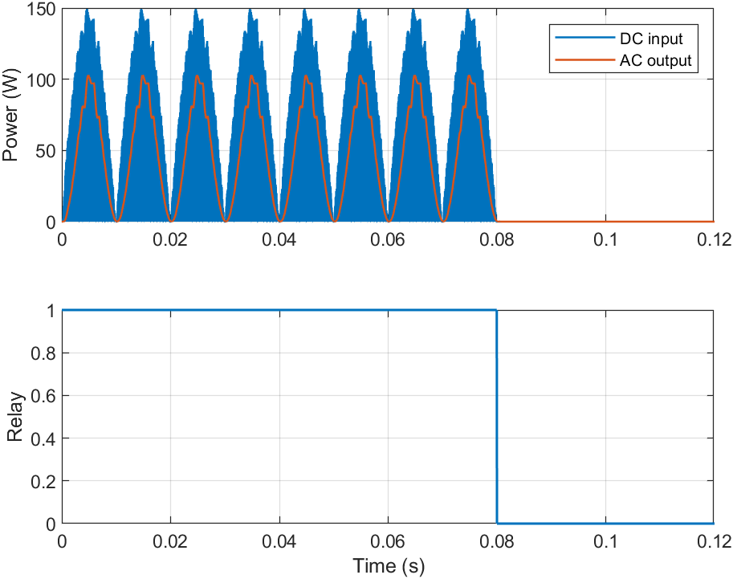
Figure 20. Switching-inverter shutdown response following the protection command.

4.9 Fast SPD component tests
Table 11. Standards-inspired fast SPD numerical component tests
Test | Measured front | Measured half-value | Source peak | Actual MOV peak | Clamp voltage | Energy | Status
1.2/50 µs voltage | 1.2 µs | 50 µs | 1000 V | 356.13 A | 930.33 V | 1.711 J | SAFE
8/20 µs current | 8 µs | 20 µs | 300 A | 193.49 A | 68.02 V | 0.418 J | SAFE

Table 11 reports the fast component tests. The voltage test reproduced a measured 1.2 µs front and 50 µs half-value time, with a 1000 V source peak, 356.13 A actual MOV current, 930.33 V clamp voltage and 1.711 J energy. The current test reproduced 8 µs and 20 µs timing, with a 300 A source peak, 193.49 A actual MOV current, 68.02 V clamp voltage and 0.418 J energy. Both tests remained inside the selected component capability.
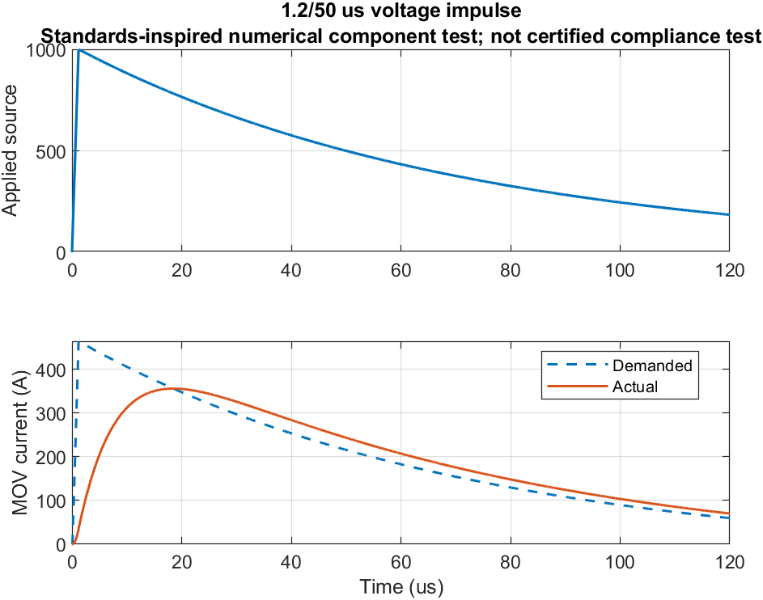
Figure 21. Standards-inspired 1.2/50 µs MOV voltage-impulse numerical test.
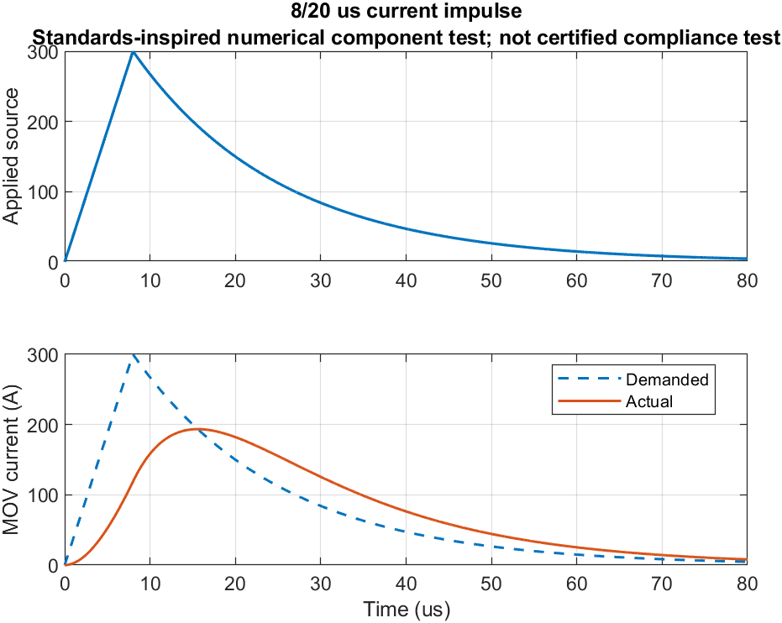
Figure 22. Standards-inspired 8/20 µs MOV current-impulse numerical test.
Figures 20 and 21 use the same MOV characteristic as the full-system simulation, but the surrounding circuit and time step are specialised for the microsecond test. These results are numerical component checks and are not presented as certified standards compliance.

4.10 Solver convergence and repeatability
Table 12. Solver-convergence results for the severe design transient
Compared metric | Relative difference, 0.25 ms vs 0.125 ms
Peak bus voltage | 0.0008%
Minimum bus voltage | 0.0106%
Demanded SPD peak current | 0.0161%
Actual SPD peak current | 0.0161%
SPD event energy | 0.0177%
SC absorbed energy | 0.4295%
SC ESR loss | 0.3849%
Trip command time | 0.0413%
Physical relay opening | 0.0611%
Reconnect command time | 0.0240%

The production step was 0.25 ms and the convergence step was 0.125 ms. The maximum relative difference among the reported critical metrics was 0.4295%, occurring in supercapacitor absorbed energy. All metrics were well below the predefined 3% convergence limit.
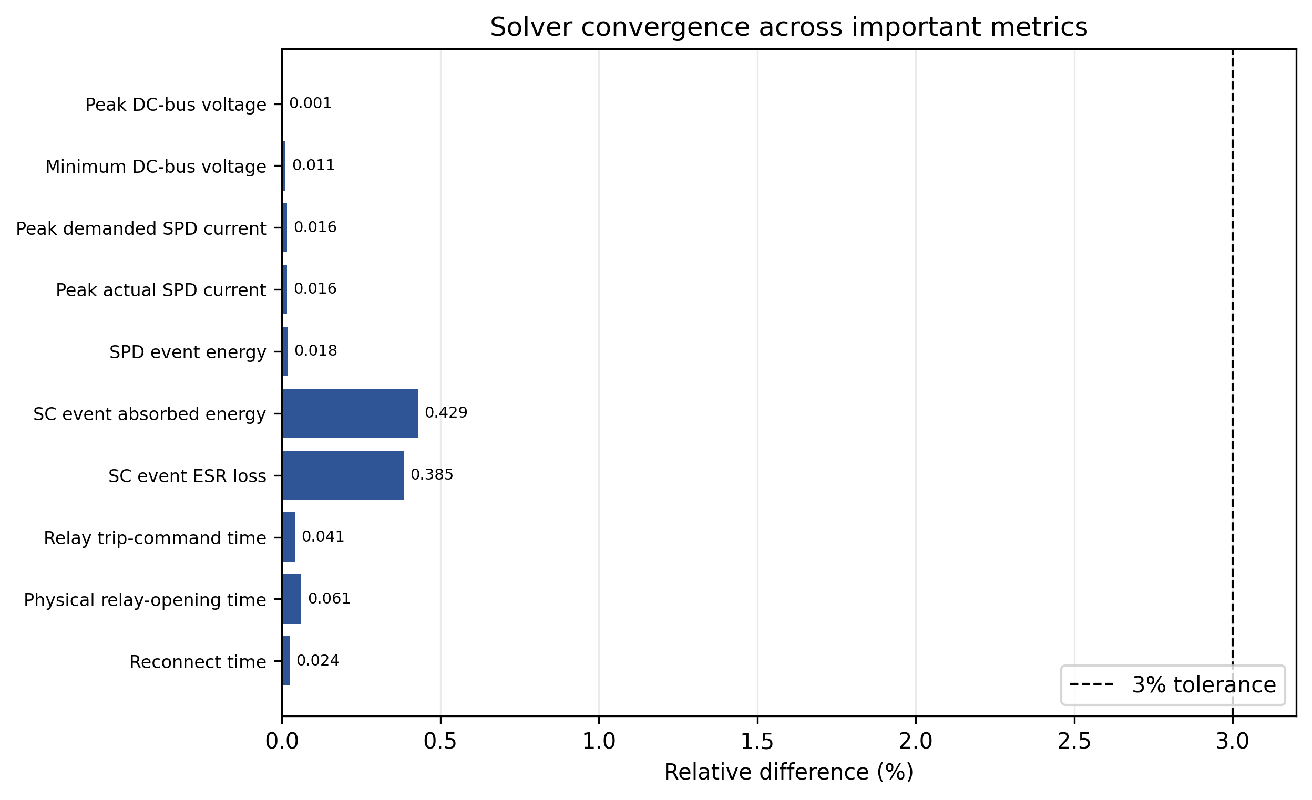
Figure 23. Relative solver-convergence differences for the principal electrical and timing metrics.
Repeatability was evaluated by rerunning representative moderate, severe and recovery scenarios. The monitored numeric metrics were identical between repeated runs within the stored numerical precision. Relay-open and reconnect metrics were treated as not applicable in scenarios where the relay correctly remained closed.

CHAPTER 5

DISCUSSION

5.1 Summary and interpretation of findings
The goal of this thesis was to determine whether coordinated fast clamping, bounded energy buffering and time-dependent isolation could improve the transient resilience of a small PV installation without converting every short overvoltage into an interruption. The results support that objective within the stated simulation scope. The PV model and MPPT remained well behaved under normal and irradiance-varying conditions, the MOV limited severe transients, the supercapacitor buffered short and residual bus energy, the controller distinguished brief and persistent disturbances, and the relay performed controlled isolation and recovery.
The severe paired comparison provides the clearest evidence for the role of the SPD. The unprotected peak of 338.30 V was reduced to approximately 69.91 V by the SPD-only configuration and 69.83 V by the integrated system. The difference between these two protected peaks is small compared with the reduction from the unprotected condition. Therefore, the results do not support a claim that the supercapacitor replaces or materially surpasses the SPD as the fast surge-clamping element. Instead, they confirm the intended layered interpretation: the MOV is responsible for most of the instantaneous peak reduction, while the storage and controller determine how the bus and load behave after the first fast response.
The moderate transient shows the complementary case. The integrated bus peak remained below the MOV knee, so the SPD contributed almost no surge current. The supercapacitor absorbed approximately 19.27 J of incremental event energy and the relay remained connected. This scenario illustrates the value of buffering for disturbances that are energetic enough to move the bus but not severe enough to justify a high-current SPD response or load interruption. The architecture therefore spans a broader operating range than a single hard threshold.

5.2 Relationship to previous research
The results are consistent with previous work that treats SPDs as the principal internal protection against lightning-induced overvoltage in PV installations. Hernández et al. [1], Pons and Tommasini [3], and Christodoulou et al. [5] all identify surge protection and grounding as central protective measures. The large peak reduction observed here under severe events is therefore not unexpected; it is the numerical expression of a well-established protection principle.
The explicit source, cable and ground impedance in the model also reflects findings in the transient-modelling literature. Formisano et al. demonstrated that geometry, coupling and converter connection affect induced PV transients [7], [8], while Wang et al. showed that protection distance depends on cable parameters and SPD characteristics [10]. Although the present lumped model is much simpler than these electromagnetic studies, the residual voltage does not collapse to the MOV knee because parasitic impedance and finite current flow are retained. This makes the comparison qualitatively consistent with the literature.
The supercapacitor response converges with renewable-energy storage research that emphasises rapid power exchange rather than long-duration energy supply. Mbendane et al. discuss supercapacitors as fast buffers for renewable power fluctuations [22], and Li et al. show why voltage equalisation and practical storage management matter [24]. In the present study, the converter current limit and ESR were significant: a raw request above 46 A in T12 produced only 16.36 A actual current and approximately 0.875 J ESR loss. These details support the decision to model a dynamic interface instead of an ideal capacitance directly connected to the bus.
The time-aware controller also aligns with emerging intelligent protection research. Edosa et al. used microcontroller-based sensing and relay control for solar-inverter overvoltage protection [15], and Emon demonstrated the need for adaptive coordination in PV-rich networks to mitigate nuisance operation [16]. The present work extends that general direction at the local DC-bus level by combining startup qualification, a persistence timer and uninterrupted safe-voltage recovery with the fast passive and storage branches.
Finally, the separate microinverter demonstration is consistent with the literature on panel-level power electronics [28]-[30]. The thesis does not advance a new inverter topology; rather, the switching model establishes that the protection command can shut down a realistic PWM stage and that the averaged load used in the multi-scenario sweep is connected to a plausible downstream power-conversion function.

5.3 Novelty and engineering implications
The novelty of the thesis lies in coordinated integration and verification. The literature review identified strong individual research streams for SPDs, transient modelling, MPPT, supercapacitors, adaptive protection and microinverters, but fewer studies place all of these functions inside one traceable comparison framework. The present implementation therefore contributes a reproducible method for asking not only whether protection reduces peak voltage, but also which component carried the transient energy, whether the component remained inside its capability, whether the relay acted at the intended time, whether recovery was sufficiently stable, and whether the conclusion was numerically converged.
The explicit SPD sizing step is one practical implication. The final engineering design required a 1000 A current rating and 2000 J energy rating to maintain at least 1.20 design margin against the executed design cases. The severe event then used only about 34.49% of current capability and 25.71% of energy capability. In contrast, T16 intentionally exceeded both limits and correctly produced an OVERSTRESSED state. This is preferable to selecting a convenient rating before simulation and then implicitly clipping every result to that value.
A second implication concerns timing. The T07 warning persisted for approximately 44.75 ms before the 45 ms criterion issued the trip command; the physical relay then opened after the expected additional delay. T09 required an uninterrupted 350 ms safe interval before the reconnect command. These results show that a protection description should distinguish detection, logical decision and physical switching. Conflating these times can produce unrealistic claims about how fast a relay protects the steep surge front.
A third implication concerns fairness of comparative studies. In an earlier development stage, a fixed-threshold relay could open during startup, which would artificially lower load energy before the intended test. The final model introduced startup blanking and healthy-state qualification and asserts that all paired cases are energised before the common event. This methodological control is useful beyond this specific thesis because protection comparisons are sensitive to initial state and pre-event controller status.

5.4 Protection trade-offs
No single protection mode dominates every metric. The SPD-only configuration frequently delivers the highest event-window load energy because it does not deliberately disconnect the load once the bus is clamped. Under the severe paired event, the SPD-only load received 17.76 J during the event window, whereas the integrated system delivered 2.60 J because the emergency logic isolated the downstream circuit. This is not evidence that the integrated system is less protective; it reflects a deliberate trade-off between service continuity and controlled isolation.
The conventional fixed-threshold relay represents the opposite end of the trade-off. During the moderate transient it disconnected and delivered only 2.51 J during the event window, whereas the integrated controller kept the relay closed and delivered 17.76 J. The 45 ms persistence criterion therefore avoids an interruption that the conventional threshold produces. During sustained or emergency conditions, however, the integrated system eventually isolates. The intended benefit is selective continuity, not uninterrupted operation under every condition.
The repeated-surge and sustained-overvoltage cases additionally show an energy-sharing benefit. In T06 the integrated SPD event energy was about 169.60 J, compared with 226.10 J for SPD only and 256.62 J for the conventional-relay configuration. In T07 the integrated SPD energy was only 9.74 J compared with 84.77 J for SPD only and 123.33 J for the conventional relay. These results suggest that the controlled supercapacitor and isolation logic can reduce MOV energy exposure in some event classes, although the magnitude of that benefit is scenario-dependent and should not be generalised beyond the tested model.

5.5 Limitations
The most important limitation is model fidelity relative to real lightning. The full-system disturbances are laboratory-scale averaged waveforms intended for controller and energy-coordination studies. They do not model leader attachment, electromagnetic field propagation, flashover, arc dynamics or the very high energy of a direct lightning current. Although the separate 1.2/50 µs and 8/20 µs tests exercise the same MOV characteristic at fast time scales, they remain numerical component tests and do not demonstrate IEC certification.
A second limitation is the absence of Simscape and Simscape Electrical. The Level-2 S-function implementation is physically derived, modular and numerically verified, but it relies on discrete lumped equations and engineering assumptions. Converter switching is averaged in the primary model, and parasitic capacitances and high-frequency semiconductor behaviour are simplified. A future Simscape Electrical or electromagnetic-transient implementation would provide an independent cross-validation route.
A third limitation is component provenance. The 1000 A/2000 J SPD, 15 F supercapacitor and associated converter parameters are engineering datasheet-style assumptions rather than part numbers selected from a manufacturer catalogue. The final design margins are therefore valid relative to the simulation model, not evidence that a particular commercial device has passed a qualification test. Hardware implementation would require selection based on MCOV, nominal discharge current, voltage protection level, energy, temporary overvoltage, thermal disconnect and relevant PV DC ratings.
The controller also contains simplifications. It observes one primary DC-bus voltage with synthetic noise rather than a redundant sensor network, does not estimate MOV temperature or ageing online, and uses fixed thresholds and timers. Although the relay itself did not chatter in the final tests, state transitions near buffering boundaries could be refined further with fully implemented hysteresis. These points do not invalidate the reported scenarios but define clear areas for future controller refinement.
Finally, the detailed switching inverter is a separate 24 V RMS demonstration. The main protection sweep uses an averaged inverter input model; therefore, interactions between microsecond surge currents, H-bridge device capacitances, gate-driver isolation and AC-side grid impedance are not captured. Grid-code functions such as phase-locked synchronisation, anti-islanding and fault ride-through are outside the research question.

5.6 Future research
Future work should proceed in three stages. First, the final equations should be reproduced in Simscape Electrical or another electromagnetic-transient tool to provide independent numerical validation and to include switching-device parasitics. A distributed cable representation and site-specific earthing model would allow the effect of SPD placement and protection distance to be assessed directly, building on the considerations identified by Wang et al. [10].
Second, a commercial PV-rated SPD and supercapacitor module should be selected from manufacturer data. The MOV V-I curve should be fitted to measured or published points, temperature dependence should be included, and cumulative surge ageing should be evaluated following the type of degradation behaviour discussed by van Niekerk and Bokoro [27]. The energy-buffer interface should include switching loss, thermal limits and cell balancing.
Third, the controller should be transferred to a low-voltage hardware prototype. A programmable DC source and isolated transient generator could reproduce the laboratory-scale events without using hazardous lightning energy. Measured bus voltage, MOV current, supercapacitor current, relay timing and inverter shutdown should then be compared directly with simulation. Only after that stage would it be appropriate to investigate specialist high-voltage impulse testing or standards-compliance work.

CHAPTER 6

CONCLUSIONS AND RECOMMENDATIONS

6.1 Conclusions
This thesis investigated whether a coordinated combination of MOV-based surge clamping, supercapacitor buffering and magnitude-and-duration-based relay isolation could improve the transient resilience of a small photovoltaic installation. A complete modular MATLAB/Simulink project was developed and verified. The study used one physically consistent PV source model, actual MPPT feedback, averaged power-converter dynamics, finite source/cable impedance, capability-aware MOV equations, a current-limited supercapacitor interface, startup-qualified protection logic, a physical relay-delay model and averaged/switching downstream inverter representations.
The final results answer the research question affirmatively within the laboratory-scale simulation scope. Under the severe paired design transient, the integrated architecture reduced the DC-bus peak from 338.30 V to 69.83 V, a 79.36% reduction. The result also established that the SPD was responsible for the majority of the instantaneous peak suppression: SPD-only protection achieved a very similar 69.91 V peak. The supercapacitor and supervisory controller therefore provide complementary rather than replacement functions.
For moderate disturbances, the integrated response provided a more selective outcome. T04 produced a 61.69 V peak, approximately 11.17% below the paired unprotected value, while the relay remained closed and the supercapacitor absorbed the event without substantial MOV conduction. Under sustained overvoltage, the controller waited approximately 44.75 ms before issuing the 45 ms persistence-based trip command, and automatic recovery required the full 350 ms uninterrupted safe-voltage interval. These results demonstrate the intended distinction between a brief tolerable disturbance and a persistent abnormal state.
Component capability and numerical integrity were also verified. The final 1000 A/2000 J engineering-assumption SPD retained current and energy design margins of approximately 2.90 and 3.89 in the severe design case, while an intentional out-of-envelope test correctly triggered an OVERSTRESSED status. The supercapacitor current controller limited high requests without exceeding its 18 A rating. The unified PV model matched all configured characteristic points within 1.62%, MPPT steady efficiency approached 99.98%, solver convergence showed a maximum 0.429% critical-metric difference, and deterministic repeatability was obtained. All 16 final scenarios and 351 assertions passed.
The principal conclusion is therefore that a layered protection architecture can offer advantages that are not visible from peak-voltage comparison alone. Fast passive clamping protects against the steep transient, controlled storage can absorb bounded residual energy and preserve continuity during short disturbances, and a time-aware supervisory layer can isolate and later reconnect the load when the abnormal condition persists. The approach is technically promising as a simulation-validated protection concept, but it is not yet a hardware-qualified or standards-certified design.

6.2 Recommendations
1. Retain the SPD as the primary surge protective element in any hardware implementation. Do not rely on a relay or supercapacitor to clamp the initial steep front.
2. Select a commercial PV-rated SPD from manufacturer data and repeat the capability analysis using the actual V-I curve, voltage protection level, MCOV, nominal discharge current, maximum discharge current and energy/thermal limits.
3. Implement the supercapacitor through a bidirectional current-limited converter with precharge, ESR/thermal monitoring and cell balancing. The 15 F equivalent value should be re-sized from the intended residual-energy envelope.
4. Preserve startup qualification, persistence timing and continuous safe-dwell recovery in the supervisory controller. Add explicit hysteresis and redundant sensing before hardware deployment.
5. Validate the canonical results in Simscape Electrical or an electromagnetic-transient package, including distributed cable and grounding models and a manufacturer-based SPD model.
6. Perform a low-voltage laboratory prototype test before any high-voltage work. Measure bus voltage, SPD current, SC current, relay delay and inverter shutdown using isolated instrumentation and appropriate fusing.
7. Treat the separate 1.2/50 µs and 8/20 µs simulations as numerical component checks only. Certified lightning/SPD compliance should be undertaken only in an accredited high-voltage laboratory.

References
[1] J. C. Hernández, P. G. Vidal, and F. Jurado, “Lightning and Surge Protection in Photovoltaic Installations,” IEEE Transactions on Power Delivery, vol. 23, no. 4, pp. 1961–1971, 2008, doi: 10.1109/TPWRD.2008.917886.
[2] C. A. Charalambous, N. D. Kokkinos, and N. Christofides, “External Lightning Protection and Grounding in Large-Scale Photovoltaic Applications,” IEEE Transactions on Electromagnetic Compatibility, vol. 56, no. 2, pp. 427–434, 2014, doi: 10.1109/TEMC.2013.2280027.
[3] E. Pons and R. Tommasini, “Lightning protection of PV systems,” in 2013 4th International Youth Conference on Energy (IYCE), Siófok, Hungary, 2013, pp. 1–5, doi: 10.1109/IYCE.2013.6604209.
[4] F. D. Martzloff, Lightning and Surge Protection of Photovoltaic Installations—Two Case Histories: Vulcano and Kythnos, NIST IR 89-4113, National Institute of Standards and Technology, 1989, doi: 10.6028/NIST.IR.89-4113.
[5] C. A. Christodoulou, L. Ekonomou, I. F. Gonos, and N. P. Papanikolaou, “Lightning protection of PV systems,” Energy Systems, vol. 7, no. 3, pp. 469–482, 2016, doi: 10.1007/s12667-015-0176-2.
[6] I. Hetita, A. S. Zalhaf, D.-E. A. Mansour, Y. Han, P. Yang, and C. Wang, “Modeling and protection of photovoltaic systems during lightning strikes: A review,” Renewable Energy, vol. 184, pp. 134–148, 2022, doi: 10.1016/j.renene.2021.11.083.
[7] A. Formisano, C. Petrarca, J. C. Hernández, and F. J. Muñoz-Rodríguez, “Assessment of induced voltages in common and differential-mode for a PV module due to nearby lightning strikes,” IET Renewable Power Generation, vol. 13, no. 8, pp. 1369–1378, 2019, doi: 10.1049/iet-rpg.2018.6033.
[8] A. Formisano, J. C. Hernández, C. Petrarca, and F. Sanchez-Sutil, “Modeling of PV Module and DC/DC Converter Assembly for the Analysis of Induced Transient Response Due to Nearby Lightning Strike,” Electronics, vol. 10, no. 2, Art. no. 120, 2021, doi: 10.3390/electronics10020120.
[9] K. Damianaki, C. A. Christodoulou, C.-C. A. Kokalis, A. Kyritsis, E. D. Ellinas, V. Vita, and I. F. Gonos, “Lightning Protection of Photovoltaic Systems: Computation of the Developed Potentials,” Applied Sciences, vol. 11, no. 1, Art. no. 337, 2021, doi: 10.3390/app11010337.
[10] P. Wang, L. Huang, S. Wang, X. Zhong, Z. Zheng, R. Wu, and Q. Sun, “Effective Protection Distance of SPD in PV System Under Lightning Surge,” IEEE Journal of Photovoltaics, vol. 14, pp. 637–645, 2024, doi: 10.1109/JPHOTOV.2024.3382502.
[11] G. B. Lo Piparo, T. Kisielewicz, C. Mazzetti, and R. Pomponi, “Assessment of probability of damage of an apparatus protected by a surge protective devices system,” International Journal of Electrical Power & Energy Systems, vol. 75, pp. 38–49, 2016, doi: 10.1016/j.ijepes.2015.08.022.
[12] G. B. Lo Piparo, R. Pomponi, T. Kisielewicz, C. Mazzetti, and A. Rousseau, “Protection against lightning overvoltages: Approach and tool for surge protective devices selection,” Electric Power Systems Research, vol. 188, Art. no. 106531, 2020, doi: 10.1016/j.epsr.2020.106531.
[13] Z. M. K. Abda, M. Z. A. Ab Kadir, H. Hizam, and C. Gomes, “Mitigation of Lightning-Induced Transient Effects on a Hybrid Photovoltaic–Wind System Based on Lightning Protection Standards,” Machines, vol. 11, no. 7, Art. no. 707, 2023, doi: 10.3390/machines11070707.
[14] K. Seklecki, M. Olesz, M. Adamowicz, M. Nowak, L. S. Litzbarski, K. Balcarek, and J. Grochowski, “A Comprehensive System for Protection of Photovoltaic Installations in Normal and Emergency Conditions,” Energies, vol. 18, no. 7, Art. no. 1749, 2025, doi: 10.3390/en18071749.
[15] O. Edosa, A. O. Yusuf, A. S. Ehie, J. Anslem, O. E. Victory, and E. Eghomwanre, “Design and Implementation of an Intelligent Over Voltage and Surge Protection System for Solar Inverters,” in Advances in Machinery, Materials Science and Engineering Application XI, 2025, doi: 10.3233/ATDE251030.
[16] A. E. Emon, “A dynamic state estimation framework for adaptive overcurrent and overvoltage relay coordination to address protection challenges in distribution systems with high PV integration,” Discover Electronics, vol. 3, Art. no. 72, 2026, doi: 10.1007/s44291-026-00219-6.
[17] T. Esram and P. L. Chapman, “Comparison of Photovoltaic Array Maximum Power Point Tracking Techniques,” IEEE Transactions on Energy Conversion, vol. 22, no. 2, pp. 439–449, 2007, doi: 10.1109/TEC.2006.874230.
[18] H. J. El-Khozondar, R. J. El-Khozondar, K. Matter, and T. Suntio, “A review study of photovoltaic array maximum power tracking algorithms,” Renewables: Wind, Water, and Solar, vol. 3, Art. no. 3, 2016, doi: 10.1186/s40807-016-0022-8.
[19] M. N. Bhukya and V. R. Kota, “A quick and effective MPPT scheme for solar power generation during dynamic weather and partial shaded conditions,” Engineering Science and Technology, an International Journal, vol. 22, no. 3, pp. 869–884, 2019, doi: 10.1016/j.jestch.2019.01.015.
[20] M. G. Villalva, J. R. Gazoli, and E. Ruppert Filho, “Comprehensive Approach to Modeling and Simulation of Photovoltaic Arrays,” IEEE Transactions on Power Electronics, vol. 24, no. 5, pp. 1198–1208, 2009, doi: 10.1109/TPEL.2009.2013862.
[21] E. Batzelis, “Non-Iterative Methods for the Extraction of the Single-Diode Model Parameters of Photovoltaic Modules: A Review and Comparative Assessment,” Energies, vol. 12, no. 3, Art. no. 358, 2019, doi: 10.3390/en12030358.
[22] B. Mbendane, B. Abe, and C. Richards, “Analysis of Supercapacitors in Renewable Energy Systems for Managing Power Fluctuations,” International Journal of Energy Research, vol. 2024, Art. no. 4575761, 2024, doi: 10.1155/2024/4575761.
[23] M. Uno and H. Toyota, “Supercapacitor-Based Energy Storage System with Voltage Equalizers and Selective Taps,” in 2008 IEEE Power Electronics Specialists Conference, Rhodes, Greece, 2008, pp. 755–760, doi: 10.1109/PESC.2008.4592020.
[24] L. Li, Z. Huang, H. Li, and H. Lu, “A High-Efficiency Voltage Equalization Scheme for Supercapacitor Energy Storage System in Renewable Generation Applications,” Sustainability, vol. 8, no. 6, Art. no. 548, 2016, doi: 10.3390/su8060548.
[25] J. He, Metal Oxide Varistors: From Microstructure to Macro-Characteristics. Wiley-VCH, 2019, doi: 10.1002/9783527684038.
[26] V. S. Brito, G. R. S. Lira, E. G. Costa, and M. J. A. Maia, “A Wide-Range Model for Metal-Oxide Surge Arrester,” IEEE Transactions on Power Delivery, vol. 33, no. 1, pp. 102–109, 2018, doi: 10.1109/TPWRD.2017.2704108.
[27] D. R. van Niekerk and P. Bokoro, “A Durability Model for Analysis of Switching Direct Current Surge Degradation of Metal Oxide Varistors,” Electronics, vol. 11, no. 9, Art. no. 1329, 2022, doi: 10.3390/electronics11091329.
[28] R. Hasan, S. Mekhilef, M. Seyedmahmoudian, and B. Horan, “Grid-connected isolated PV microinverters: A review,” Renewable and Sustainable Energy Reviews, vol. 67, pp. 1065–1080, 2017, doi: 10.1016/j.rser.2016.09.082.
[29] M. Premkumar, K. Karthick, and R. Sowmya, “A Review on Solar PV Based Grid Connected Microinverter Control Schemes and Topologies,” International Journal of Renewable Energy Development, vol. 7, no. 2, pp. 171–182, 2018, doi: 10.14710/ijred.7.2.171-182.
[30] J. Yuan, F. Blaabjerg, Y. Yang, A. Sangwongwanich, and Y. Shen, “An Overview of Photovoltaic Microinverters: Topology, Efficiency, and Reliability,” in 2019 IEEE 13th International Conference on Compatibility, Power Electronics and Power Engineering (CPE-POWERENG), 2019, pp. 1–6, doi: 10.1109/CPE.2019.8862334.
[31] F. Di Napoli, P. Guerriero, V. d’Alessandro, and S. Daliento, “Single-Panel Voltage Zeroing System for Safe Access on PV Plants,” IEEE Journal of Photovoltaics, vol. 5, no. 5, pp. 1428–1434, 2015, doi: 10.1109/JPHOTOV.2015.2448416.

Appendix A: Final System Parameters
This appendix records the final key parameters used by the canonical simulation. The complete executable parameter set is stored in config/project_parameters.m; the values below are the principal quantities required to reproduce the thesis cases.
Table 13. Final key simulation parameters
Subsystem | Parameter | Value
PV | Rated power | 200 W
PV | Voc / Isc | 43.2 V / 6.15 A
PV | Vmp / Imp | 36.0 V / 5.56 A
PV | Cells / ideality | 72 / 1.30
PV | Rs / Rsh | 0.12 Ω / 300 Ω
MPPT | Sample / step | 2 ms / 0.0005
Boost | L / R | 2.5 mH / 0.08 Ω
Boost | Switching reference / efficiency | 20 kHz / 0.94
Bus | Nominal / C | 48 V / 20 mF
Cable | R / L | 0.18 Ω / 45 µH
Surge source | R / L | 3 Ω / 120 µH
SPD | MCOV / knee | 58 V / 62 V
SPD | Exponent / dynamic R | 2.2 / 0.55 Ω
SPD | Current / energy rating | 1000 A / 2000 J
SC | Capacitance / ESR | 15 F / 55 mΩ
SC | Voltage range | 20–38 V
SC | Initial voltage | 30 V
SC converter | Current limit | 18 A
SC converter | Path L / R | 1.5 mH / 0.08 Ω
Controller | Warning / emergency | 1.10 pu / 1.45 pu
Controller | Allowed warning duration | 45 ms
Controller | Safe range | 0.85–1.07 pu
Controller | Recovery dwell | 350 ms
Protection | Startup blanking / stable qualification | 0.20 s / 0.04 s
Relay | Opening / closing delay | 8 ms / 12 ms
Averaged inverter | Requested AC power / efficiency | 178 W / 0.91
Switching demo | DC / AC target | 48 V / 24 V RMS, 50 Hz
Solver | Production / half step | 0.25 ms / 0.125 ms

Appendix B: Final Simulation Scenarios
The final suite contains fifteen design/verification scenarios and one intentional out-of-envelope capability test. All full-system design cases use the production 0.25 ms time step unless the scenario specifically performs solver convergence.
Table 14. Final scenario definitions
ID | Scenario | Disturbance | Protection | Expected behaviour
T01 | Normal operation | None | Integrated | Stable bus; no trip
T02 | Irradiance step | None | Integrated | MPPT adapts; no false trip
T03 | Short ripple | 18 ms ripple | Integrated | Buffer without isolation
T04 | Moderate design transient | Impulse, 160 | Integrated + paired modes | Coordinate SPD/SC; no relay trip
T05 | Severe design transient | Impulse, 1200 | Integrated + paired modes | Emergency isolation within SPD rating
T06 | Repeated design surges | 3 × impulse, 300 | Integrated + paired modes | Stable repeated response
T07 | Sustained overvoltage | 220 ms | Integrated + paired modes | Timed isolation
T08 | Emergency overvoltage | Impulse, 1200 | Integrated | Emergency isolation
T09 | Automatic recovery | 120 ms sustained | Integrated | Full safe-dwell reconnect
T10 | Manual reset | 120 ms sustained | Integrated | Wait for manual reset
T11 | Protection comparison | Impulse, 1200 | Four modes | Fair comparison
T12 | SC current limit | Impulse, 450 | Integrated | Current limit without SPD overstress
T13 | Sensor noise | 0.35 V std. dev. | Integrated | No false trip
T14 | Inverter integration | Impulse, 1200 | Integrated | Averaged inverter shutdown
T15 | Solver convergence | Impulse, 1200 | Integrated | 0.25 vs 0.125 ms
T16 | Intentional SPD overstress | Impulse, 100000 | Integrated | Detect out-of-envelope capability

