PV Simscape Model
Step-by-Step Surge-Protection Report
Physical-component model • Default 10 kA, 8/20 µs indirect-lightning case
Generated from an executed Simscape run on 2026-08-17

Purpose
This short report follows voltage and current through the model in the same order as the numbered Simulink Scopes. It explains what the PV panel supplies, where the surge is injected, how SPD1 and SPD2 divert surge current to ground, and what remains at the protected DC bus, supercapacitor, relay, inverter and load.
Stage | Measured result | Meaning
PV panel | 37.13 V, 5.28 A, 196.16 W | Normal energy entering MPPT/boost
Surge injection | 10000 A; node peak 496.33 V | Applied at 0.600 s with an 8/20 µs shape
SPD1 | 9948.04 A to ground (99.48%) | Primary high-current diversion
Protected bus | 49.65 V | Below 52.8 V warning and 69.6 V emergency thresholds
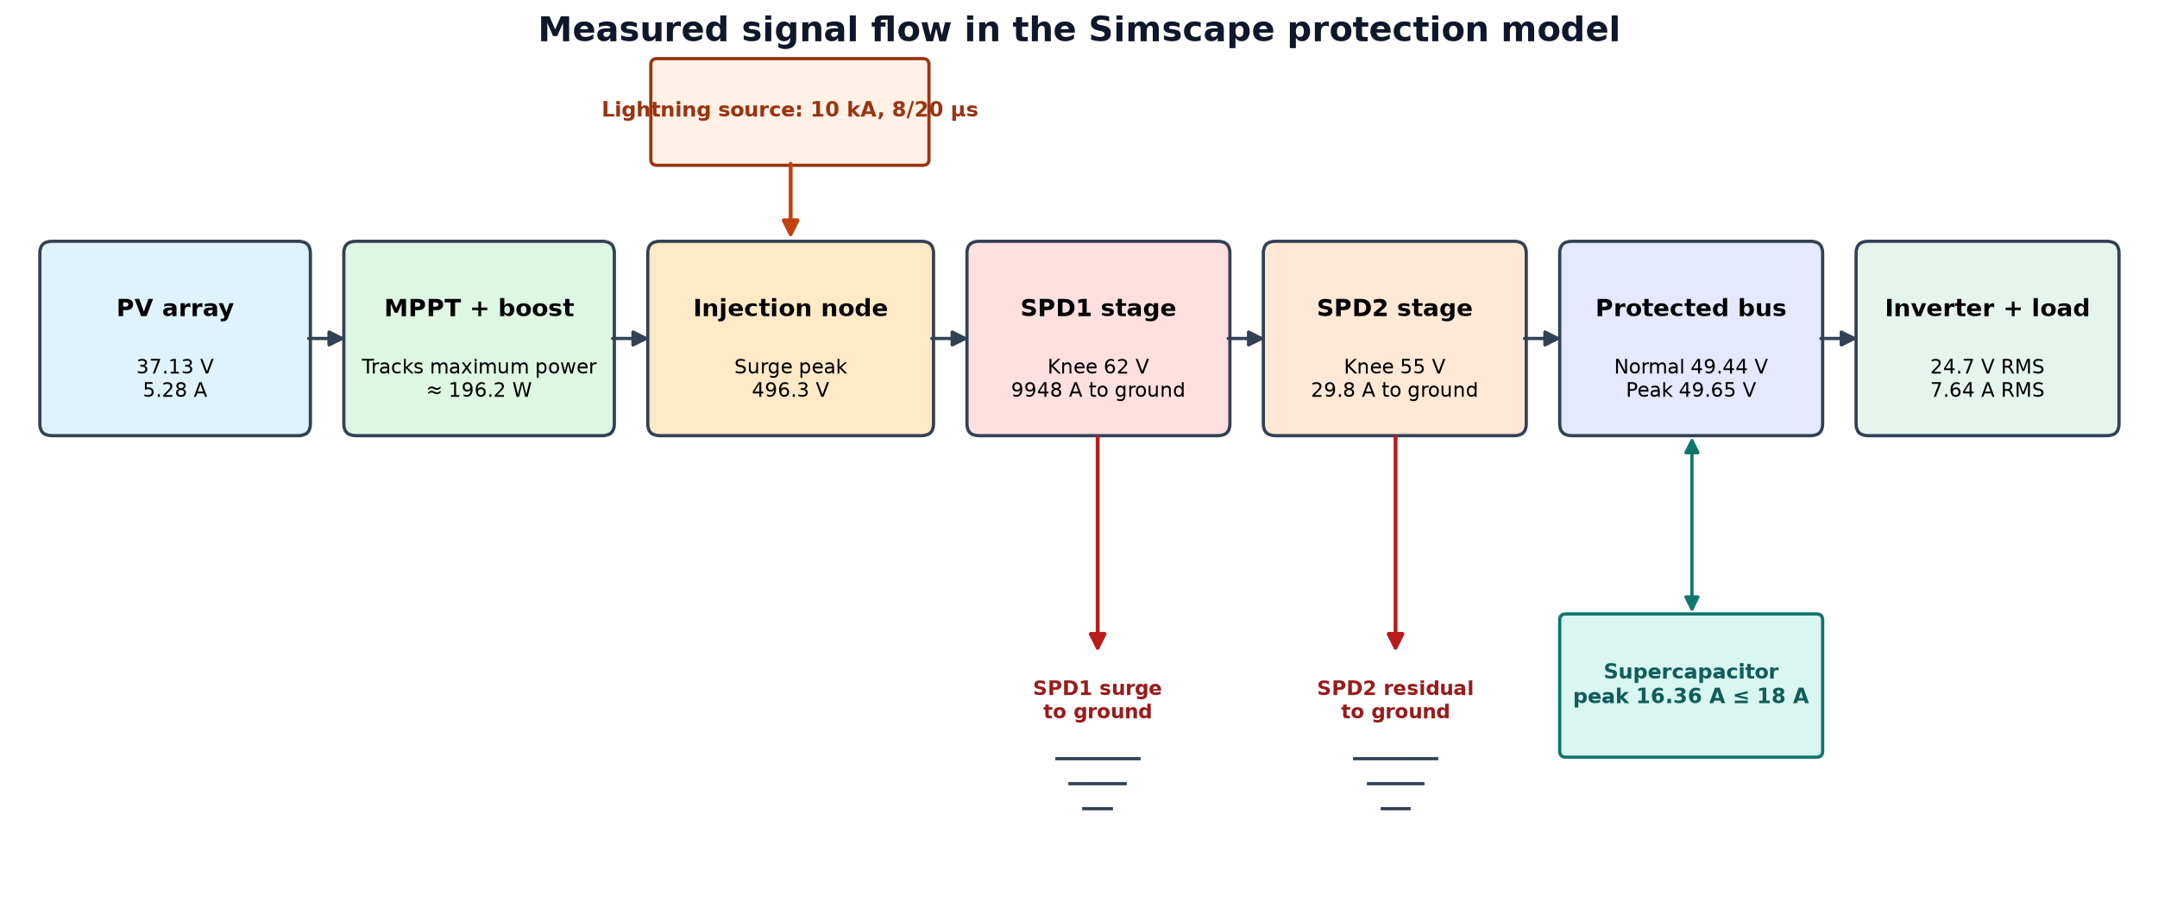
Figure 1. End-to-end electrical and protection path used in this report.

Step 1 — PV panel output and MPPT/boost input
Before the lightning event, the physical Solar Cell array supplies an average 37.13 V and 5.28 A. Their product is approximately 196.16 W. This is the DC power presented to the MPPT-controlled boost stage.
- The MPPT controller changes the converter duty cycle to keep the panel near its maximum-power operating point.
- The boost/DC network establishes an approximately 49.44 V protected bus before the surge.
- The lightning waveform is a separate source in the model; the PV panel does not generate the 10 kA surge.
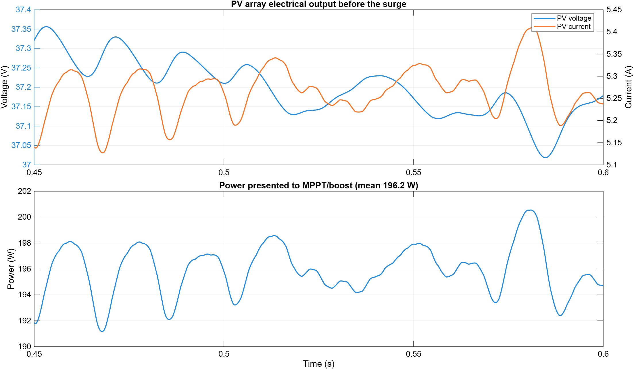
Figure 2. Scope 01 quantities: PV voltage, current and calculated power before surge injection.

Step 2 — Indirect-lightning surge injection
At t = 0.600 s, the controlled physical source injects an 8/20 µs line-to-ground current pulse. The measured peak is 10000.00 A, matching the configured 10000 A. The injection node reaches 496.33 V before the coordinated protection stages reduce the disturbance.
- 8 µs means the waveform reaches its peak 8 µs after the event begins.
- 20 µs means it has decayed to 50% of peak at 20 µs.
- Scope 02 shows both the configured command and the current/voltage measured in the physical network.
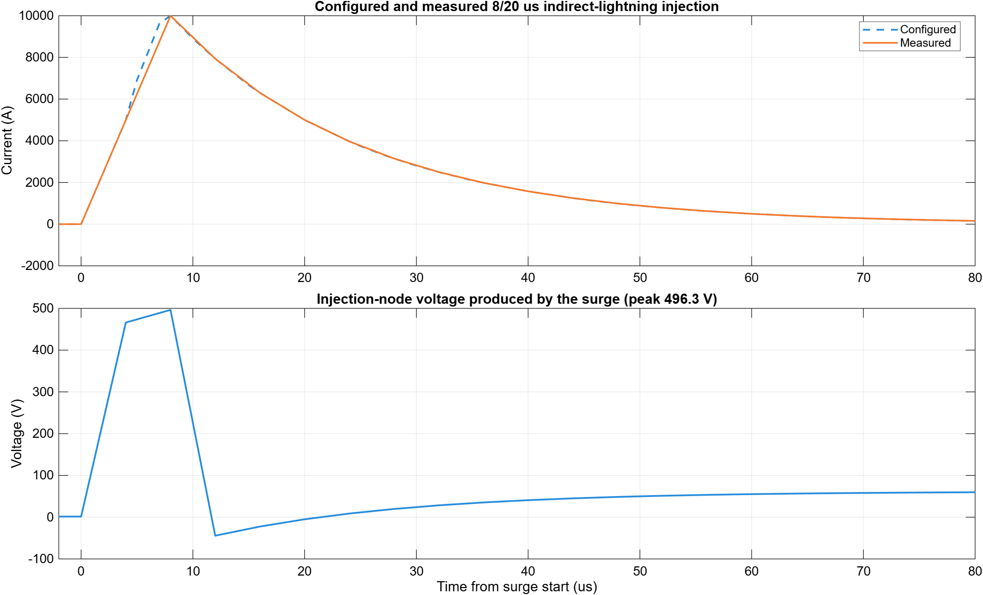
Figure 3. Scope 02 evidence: configured and measured surge current, plus injection-node voltage.

Step 3 — SPD1 primary diversion to ground
SPD1 is the upstream MOV stage. Its model conduction knee is 62 V. As the surge rises, the nonlinear MOV becomes strongly conductive and diverts a peak 9948.04 A to ground. This equals 99.48% of the injected peak, leaving a peak residual of 51.96 A for the coordinated second stage.
- The threshold is a nonlinear conduction knee, not an ideal switch that holds exactly 62 V.
- The measured SPD1 terminal peak is 371.33 V because lead/source inductance creates microsecond overshoot while current changes extremely quickly.
- Peak currents occur at different instants, so SPD1, SPD2 and residual peak values should not be subtracted as if they were simultaneous DC values.
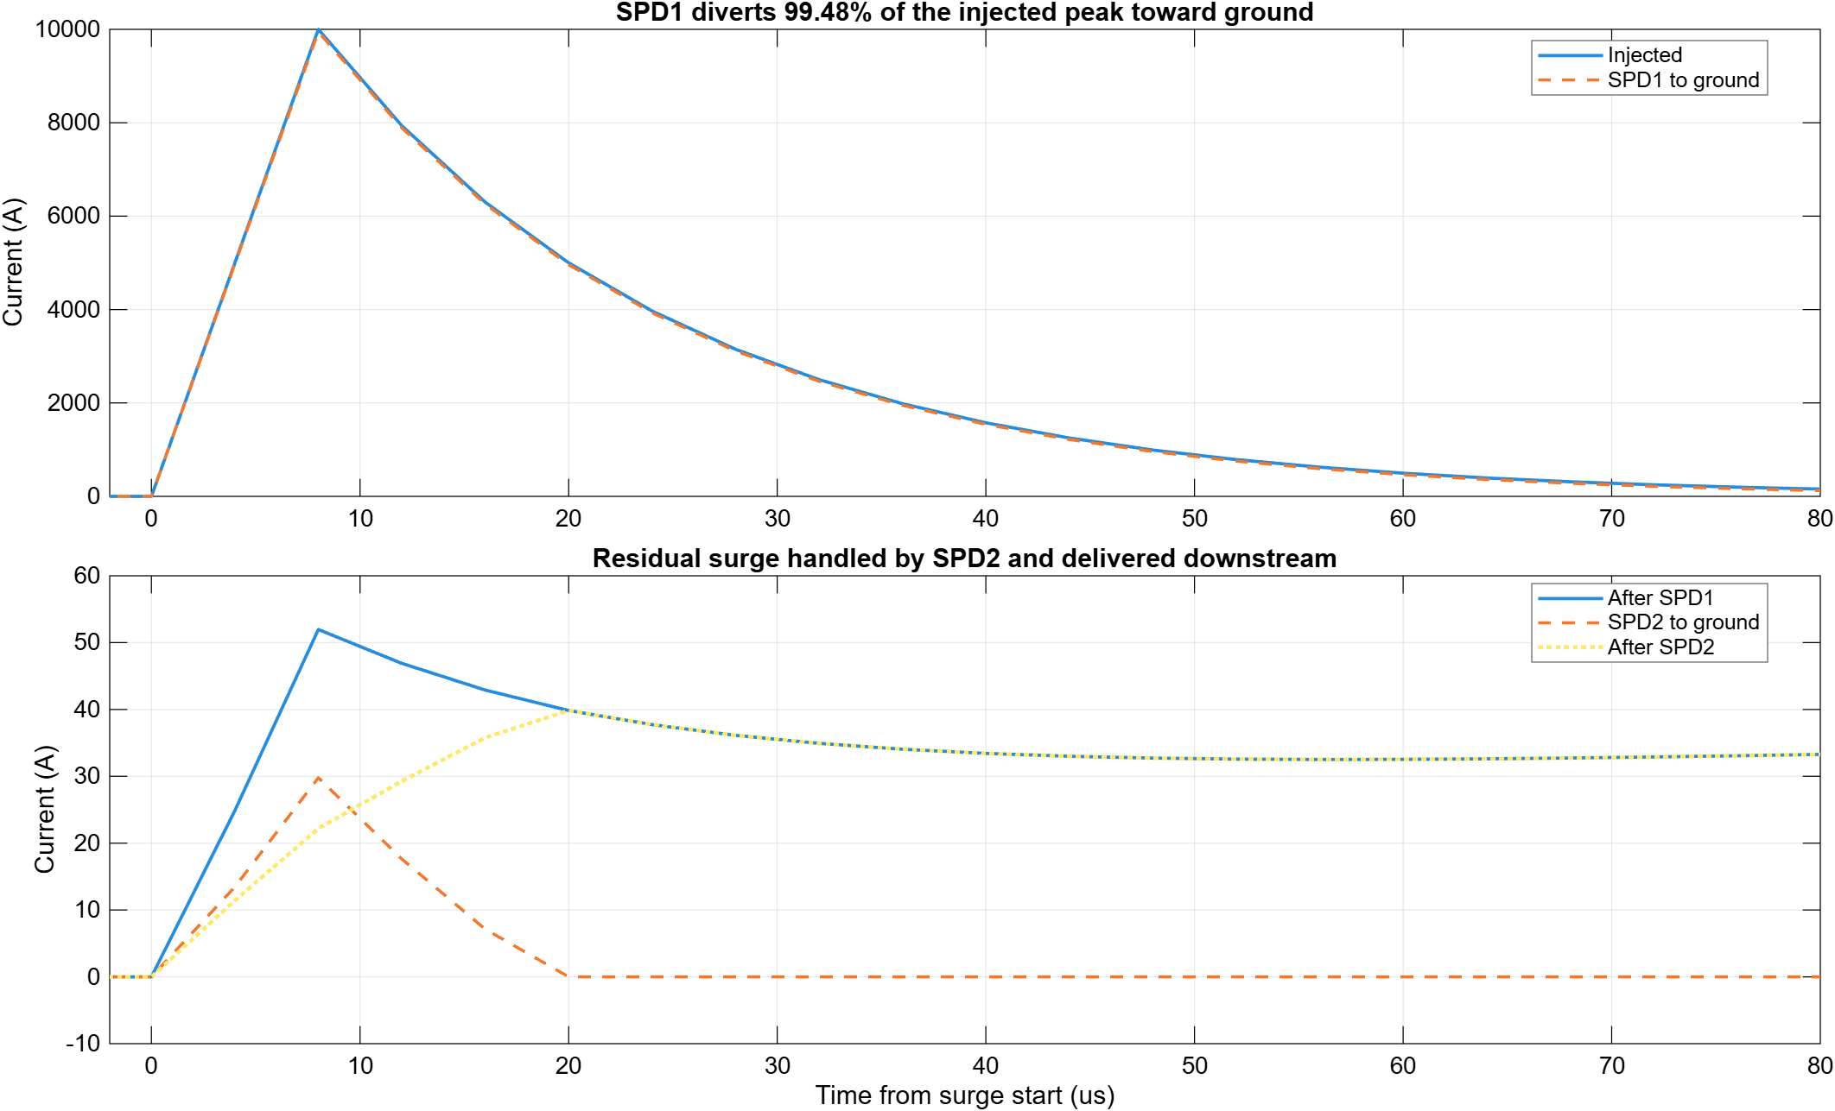
Figure 4. Scopes 03–04: primary SPD1 diversion and the smaller coordinated currents at SPD2.

Step 4 — SPD2 coordination and protected output voltage
SPD2 is placed downstream and has a lower 55 V conduction knee. It diverts a peak 29.78 A to ground. Its terminal voltage peaks at 55.94 V, and the peak residual-current measurement after SPD2 is 39.84 A.
Most importantly, the protected DC bus peaks at only 49.65 V. This is 19.95 V below the 69.6 V emergency relay threshold and also below the 52.8 V warning threshold. Therefore the relay remains closed in this default short surge case.
- SPD1 handles the high-current front; SPD2 reduces the coordinated residual close to the protected equipment.
- The DC-link capacitance and physical impedances also influence the protected-bus voltage; the SPDs are not ideal voltage sources.
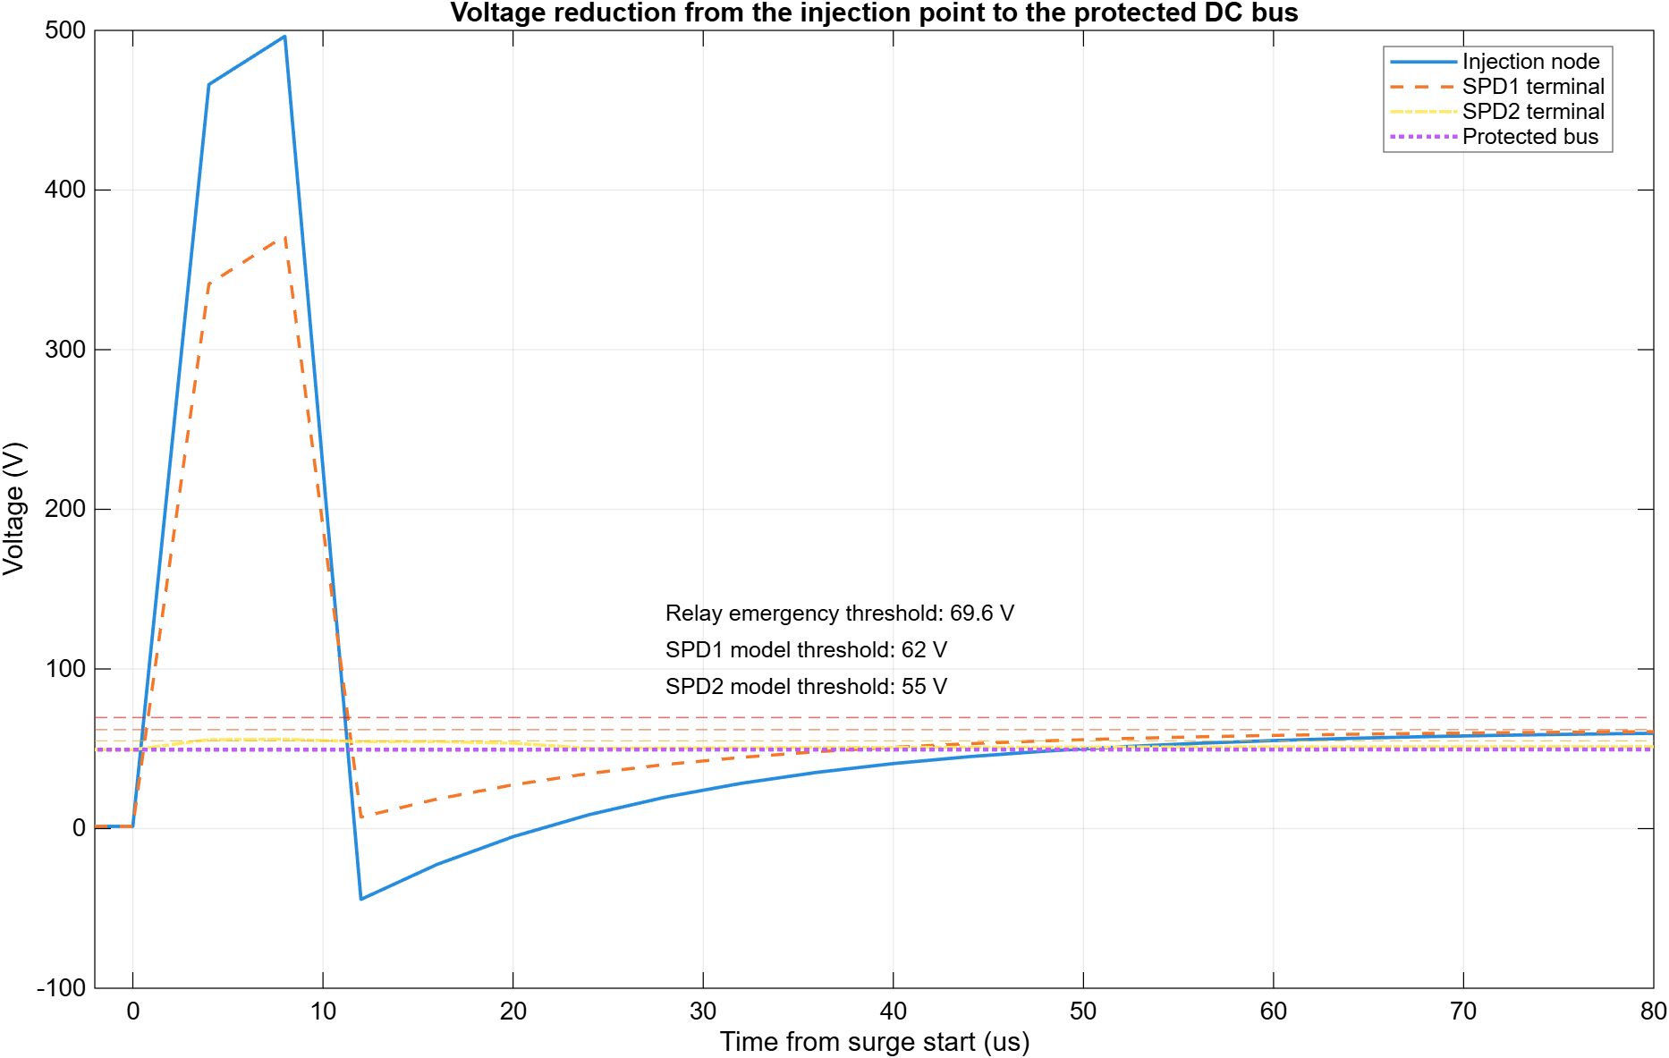
Figure 5. Scope 07 comparison from the high-voltage injection node to the protected DC bus.

Step 5 — Supercapacitor, relay, inverter and load
The supercapacitor is a slower energy buffer, not a 10 kA lightning-current path. Its maximum current over the executed run is 16.36 A, below its 18 A limit. The microsecond surge is primarily handled by the MOVs and DC-link capacitance.
Before the event, the averaged inverter supplies approximately 24.72 V RMS and 7.64 A RMS to the modeled load. Because the protected bus remains below the warning and emergency thresholds, the relay command and physical contact stay at logic 1 (closed).
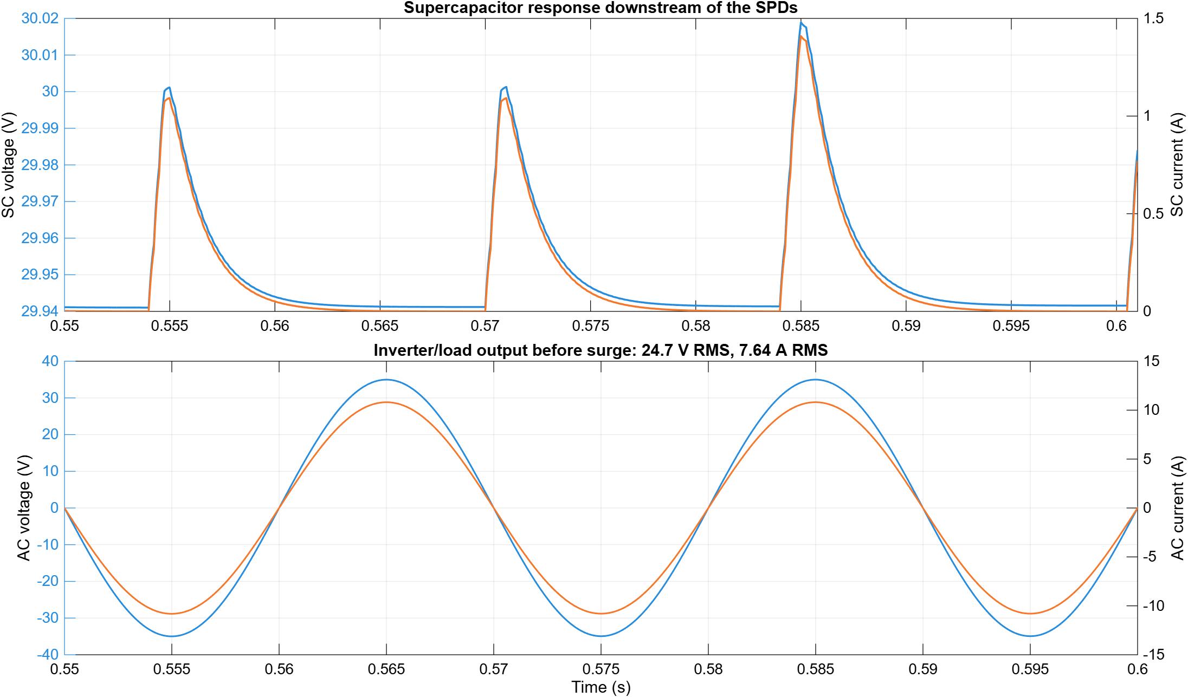
Figure 6. Scopes 05 and 08: supercapacitor behavior and inverter/load AC output.

Where to see each result in Simulink
Scope | What it shows
01 | PV voltage, PV current, PV power and MPPT duty
02 | Configured/measured lightning current and injection voltage
03 | Injected current, SPD1 current to ground and residual after SPD1
04 | SPD2 current, residual after SPD2 and protected-bus voltage
05 | Supercapacitor voltage, current, power and energy
06 | Warning/emergency thresholds, relay command and physical state
07 | Voltage comparison: injection, SPD1, SPD2 and protected output
08 | Protected bus, relay state and AC load voltage/current

Conclusion
The executed physical-component simulation shows the intended protection sequence: the PV/MPPT stage supplies normal DC power; the separate 10 kA indirect-lightning source creates a fast high-voltage disturbance; SPD1 sends nearly all peak surge current to ground; SPD2 handles the coordinated residual; and the protected bus remains below the warning and emergency relay thresholds while the downstream system continues operating.
Engineering limitation: These are model results using documented component assumptions. They are not certified surge-test results, insulation-coordination approval, or a substitute for manufacturer SPD data and laboratory validation.

