Smart Inverter-Based PV Hosting Capacity Enhancement in the IEEE 33-Bus Distribution Network
REAJ UDDIN HEMAL
Student Number: A00046863
Course Code: TU207
Department: School of Electrical and Electronic Engineering
Abstract—High penetration of photovoltaic distributed generation can cause voltage rise, voltage drop, and reduced operational flexibility in radial distribution feeders. This paper presents a MATLAB and Simulink supported quasi-static time-series framework for evaluating smart inverter based voltage regulation and photovoltaic hosting capacity enhancement in the IEEE 33-bus distribution network. Five operating strategies are compared: no smart-inverter control, Volt-VAR control, Volt-Watt control, default hybrid Volt-VAR and Volt-Watt control, and a particle swarm optimization based hybrid controller. The method combines radial load-flow simulation, PV and load profile modeling, inverter capability constraints, autonomous droop control, PSO based curve tuning, hosting-capacity assessment, and graphical result visualization. In the normal 80 percent PV partial-cloud case, the uncontrolled feeder produced 179 voltage violations, whereas Volt-VAR, default hybrid, and PSO hybrid control eliminated all violations. In the 150 percent PV stress case, the maximum uncontrolled voltage reached 1.1070 per unit; default hybrid control reduced it to 1.0415 per unit, and PSO hybrid control further reduced it to 1.0147 per unit. The hosting-capacity study showed that no control, Volt-VAR, and Volt-Watt control supported 80 percent, 100 percent, and 120 percent PV penetration, respectively, while both hybrid approaches reached 250 percent. The results demonstrate that coordinated hybrid smart-inverter control can substantially improve voltage security and PV hosting capacity in weak radial distribution networks.
Keywords—smart inverter, Volt-VAR control, Volt-Watt control, photovoltaic hosting capacity, IEEE 33-bus feeder, particle swarm optimization, MATLAB, Simulink

Introduction
The increasing penetration of photovoltaic (PV) distributed energy resources (DERs) is changing the operational behavior of radial distribution networks. Unlike conventional passive feeders, modern feeders experience bidirectional power flow, daytime reverse power flow, rapid voltage rise under high-generation/low-load periods, and time-varying voltage deviations caused by solar irradiance fluctuation. These conditions are especially critical in long radial feeders where the voltage profile is strongly affected by feeder impedance and the location of PV injection. IEEE Std 1547-2018 establishes interconnection and interoperability requirements for DERs and recognizes advanced inverter functions, including voltage and reactive-power support, as part of DER-grid integration [1], [2]. Therefore, distribution-level PV integration is no longer only a generation-capacity problem; it is also a voltage-control and hosting-capacity problem.
Smart inverters can provide autonomous grid-support functions without installing additional utility-owned compensation equipment. Among the most widely studied functions, Volt-VAR control uses reactive power absorption or injection according to local voltage, whereas Volt-Watt control limits active-power export during overvoltage conditions. Prior studies have shown that these functions can reduce voltage violations and increase PV hosting capacity, although their performance depends strongly on feeder topology, PV location, inverter rating, control curve parameters, and the interaction between active-power curtailment and reactive-power capability [3]-[6]. Consequently, a controller that performs well under one operating condition may not be optimal when PV penetration, load level, or irradiance variability changes.
The IEEE 33-bus radial distribution system is commonly used as a benchmark for testing distribution-system analysis and optimization methods because it represents a weak radial feeder with multiple laterals and nonuniform voltage sensitivity. The original studies by Baran and Wu established radial distribution-system optimization problems for loss reduction, load balancing, and capacitor placement, and the 33-bus feeder has since become a standard test network for evaluating voltage-control and distributed-generation strategies [7], [8]. In this type of feeder, PV placement at downstream buses can create severe local voltage rise, while reactive compensation and power curtailment can have different impacts depending on electrical distance from the substation.
Recent literature has examined smart-inverter functionality, optimal Volt-VAR settings, coordinated inverter dispatch, and hosting-capacity enhancement under high PV penetration [9]-[12]. These works demonstrate that default droop curves may not always provide the best trade-off between voltage regulation, network losses, and curtailment. Optimization-based approaches can improve control-curve settings, but they often focus on a limited set of inverter functions, a single operating scenario, or a specific performance index. Furthermore, many studies discuss smart-inverter operation from either a purely analytical perspective or a software-specific implementation perspective, leaving a practical need for a reproducible end-to-end workflow that connects feeder modeling, PV/load time-series simulation, inverter-control comparison, optimization, performance visualization, and hosting-capacity evaluation.
Motivated by this gap, this paper develops an end-to-end MATLAB/Simulink-supported framework for evaluating and optimizing smart-inverter control on the IEEE 33-bus radial distribution network. The framework combines quasi-static time-series (QSTS) load-flow simulation with multiple inverter-control strategies, including no control, Volt-VAR control, Volt-Watt control, default hybrid Volt-VAR/Volt-Watt control, and particle swarm optimization (PSO)-tuned hybrid control. PSO is selected because it is a population-based metaheuristic suitable for nonlinear, nonconvex parameter-search problems and has been widely used for engineering optimization since its introduction by Kennedy and Eberhart [13]. In the present work, PSO is used to tune the hybrid control curve parameters so that the controller can reduce voltage deviations and violations while considering the trade-off with curtailment and loss performance.
The main contributions of this paper are summarized as follows: (i) an integrated QSTS simulation framework is constructed for the IEEE 33-bus feeder under normal and stress PV-penetration cases; (ii) four smart-inverter control modes are implemented and compared against a no-control baseline; (iii) a PSO-based tuning procedure is developed for hybrid Volt-VAR/Volt-Watt control parameters; (iv) the evaluation is performed using multiple practical indices, including voltage limit violations, maximum and mean voltage deviation, active-power loss, PV curtailment, controller activation, response behavior, and PV hosting capacity; and (v) a Simulink-based visualization/result-viewing model is included to support model-based presentation of the workflow and results. Simulink is used here as a block-diagram environment for system-level visualization and result replay, while the numerical feeder solution and optimization are performed through MATLAB scripts [14].
The remainder of this paper is organized as follows. Section II presents the related literature and identifies the detailed research gap. Section III describes the IEEE 33-bus feeder model, PV/load profiles, smart-inverter controls, PSO tuning procedure, and Simulink-supported workflow. Section IV presents the numerical results and comparison with related studies. Section V discusses the technical implications, contribution justifications, and limitations. Section VI concludes the paper and outlines future research directions.

Literature Review

Smart inverter standards and autonomous voltage support
The transition from passive distributed PV interconnection to grid-supportive DER operation has been strongly influenced by IEEE Std 1547-2018. The standard and its implementation guidance recognize that DER interfaces are no longer limited to unity-power-factor injection; instead, they may support distribution operation through voltage and reactive-power related functions such as Volt-VAR, Volt-Watt, and other autonomous responses [1], [2]. In this context, smart inverters are attractive because they can respond locally to terminal voltage without requiring fast communication infrastructure, which is important for radial feeders with many small PV units.

PV hosting capacity and smart-inverter voltage control
PV hosting capacity refers to the amount of PV generation that a feeder can accommodate before violating operational limits such as overvoltage, thermal loading, protection constraints, or unacceptable power quality. Ding et al. reviewed technologies for increasing feeder hosting capacity and identified inverter-based reactive-power control and Volt-VAR optimization as practical alternatives to conventional reinforcement [3]. Seuss et al. further showed that reactive-power support from smart inverters can improve distribution-network PV hosting capacity [4]. These studies motivate the use of inverter control as a cost-effective operational approach rather than relying only on conductor upgrades, capacitor placement, or voltage-regulator changes.
A second group of studies has focused on the operational impact of specific smart-inverter functions. NREL studies on smart-inverter Volt-VAR control reported that autonomous reactive-power operation can influence conservation voltage reduction, power quality, and voltage-regulation behavior under varying PV penetration levels [5]. Giraldez et al. combined simulation and field-pilot evidence for advanced inverter voltage controls and emphasized the importance of both Volt-VAR and Volt-Watt functions in quasi-steady-state feeder voltage management [6]. More recent simulation-based work also investigated feeder operation with distributed PV smart-inverter functions, confirming that control performance depends strongly on feeder characteristics, PV location, control parameters, and operating scenario [12].

IEEE 33-bus radial distribution feeder as a benchmark
The IEEE 33-bus radial distribution system has been widely used as a benchmark for distribution-system optimization and voltage-profile studies. The original Baran and Wu works formulated radial distribution reconfiguration and capacitor-placement problems for loss reduction and voltage improvement [7], [8]. Because the feeder is radial, moderately weak, and contains several laterals, voltage sensitivity varies along the network. This makes it useful for evaluating PV-induced voltage rise and the effectiveness of inverter-based mitigation. However, many classical studies using this feeder focused on reconfiguration, capacitor placement, or distributed-generation sizing, while fewer works provide a complete comparison of default and optimized smart-inverter control modes on the same feeder under both normal and stressed PV penetration conditions.

Optimization of Volt-VAR and Volt-Watt control parameters
Although default smart-inverter curves are useful for standardization and deployment simplicity, several studies indicate that fixed control parameters may not be optimal for every feeder. Olowu et al. reviewed the functionality and feeder-level impact of smart inverters under high PV penetration [9], while Lee et al. optimized Volt-VAR parameters to improve distribution-system performance [10]. Murzakhanov et al. studied the optimal design of Volt/VAR control rules for inverter-interfaced DERs, highlighting that the shape of droop rules affects both voltage quality and feasibility [11]. These findings support the need for parameter-tuning methods that adapt control settings to the tested feeder and PV scenario.
Particle swarm optimization (PSO) is a population-based metaheuristic introduced by Kennedy and Eberhart [13]. It is attractive for smart-inverter curve tuning because the controller parameters are continuous, nonlinear, and coupled through AC power-flow behavior. In this project, PSO is not used as a black-box replacement for power-flow analysis; rather, it is used to search for improved hybrid Volt-VAR/Volt-Watt curve parameters based on voltage deviation, violation reduction, power loss, and curtailment-related objectives. This creates a direct connection between heuristic optimization and physically meaningful feeder-performance metrics.

Simulation, visualization, and Simulink-supported workflow
Distribution-network smart-inverter studies commonly rely on time-series or quasi-static time-series simulation because PV output and load demand vary over the day. Simulation-based evaluation is important because a controller that performs well at one PV/load operating point may not remain effective during cloud transients, midday reverse-power-flow conditions, or evening high-load periods. MATLAB-based analysis provides a suitable environment for implementing feeder power-flow calculations, time-series profiles, controller logic, PSO tuning, and post-processing. In addition, Simulink supports model-based design and visualization workflows that can help communicate the control architecture, simulation process, and result behavior [14]. In this paper, Simulink is therefore described as a supporting visualization and workflow component, while the main quantitative evaluation is based on the implemented IEEE 33-bus time-series simulation and controller-comparison results.

Identified research gap and positioning of this work
The reviewed literature establishes the technical value of smart-inverter voltage control, PV hosting-capacity assessment, and feeder-specific control-parameter tuning. However, a practical gap remains in presenting an integrated and reproducible workflow that combines: (i) IEEE 33-bus feeder simulation, (ii) PV and load time-series operation, (iii) side-by-side comparison of no control, Volt-VAR, Volt-Watt, default hybrid, and optimized hybrid control, (iv) PSO-based tuning of hybrid inverter curves, (v) hosting-capacity assessment under increasing PV penetration, and (vi) graphical and Simulink-supported interpretation of the results. This paper is positioned to address this gap by connecting literature-supported smart-inverter concepts with an end-to-end simulation, optimization, visualization, and result-analysis framework for PV hosting-capacity enhancement.

Methodology
The proposed framework is designed as an end-to-end quasi-static time-series (QSTS) methodology for evaluating smart-inverter voltage regulation and photovoltaic (PV) hosting-capacity enhancement in the IEEE 33-bus radial distribution feeder. The quantitative simulations are carried out in MATLAB using feeder data, load/PV profiles, smart-inverter control functions, backward/forward sweep load flow, PSO-based parameter tuning, and post-processing metrics. Simulink is used as a supporting workflow visualization and result-viewing environment; it is not claimed as an electromagnetic-transient or switching-level inverter model. The complete research workflow is summarized in Fig. 1.
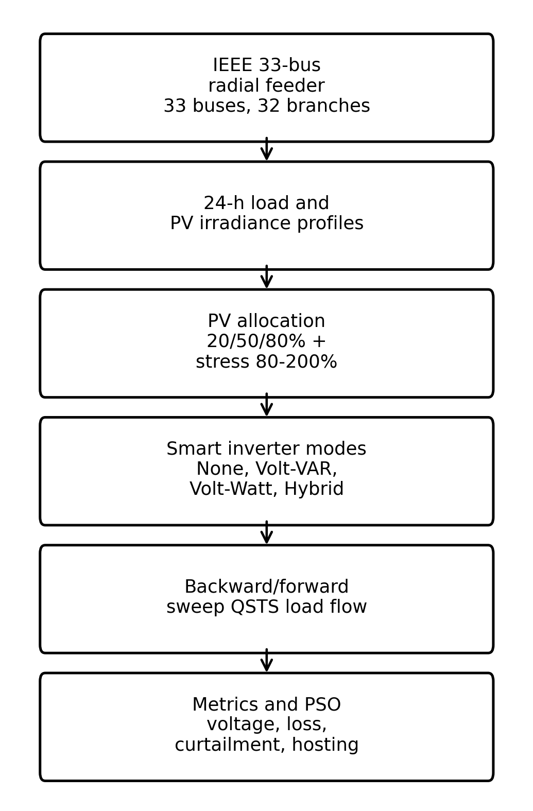
Fig. 1. End-to-end QSTS methodology used for smart-inverter controller comparison and optimization.

IEEE 33-bus feeder and load-flow model
The IEEE 33-bus radial distribution network is modeled with 33 buses and 32 branches following the standard benchmark feeder used in distribution-system optimization studies [7], [8]. Bus 1 is treated as the slack bus, while the remaining buses include fixed active and reactive load demands. At each time step, the net bus demand is calculated from the time-varying load multiplier, the available PV generation, and the active/reactive power commanded by the smart inverter. Positive active and reactive quantities represent demand from the feeder, whereas negative active power represents PV injection.
P_net,i(t) = alpha(t) P_L,i - P_PV,i(t), Q_net,i(t) = alpha(t) Q_L,i - Q_PV,i(t). (1)
A backward/forward sweep power-flow algorithm is used because the network is radial. For iteration k, the complex nodal power and current are computed as
S_i(t) = P_net,i(t) + jQ_net,i(t), I_i^(k)(t) = conj(S_i(t)/V_i^(k)(t)). (2)
The backward sweep accumulates the bus and downstream branch currents, while the forward sweep updates bus voltages from the sending-end bus to the receiving-end bus:
I_ij^(k)(t) = I_j^(k)(t) + sum I_jm^(k)(t), V_j^(k+1)(t) = V_i^(k+1)(t) - Z_ij I_ij^(k)(t). (3)
The load flow is iterated until the maximum bus-voltage change is below the numerical tolerance. The acceptable voltage envelope used in the evaluation is
0.95 <= |V_i(t)| <= 1.05 p.u. (4)

PV penetration, load profile, and inverter capability
The PV penetration level is defined as the ratio between the total installed PV active-power capacity and the total nominal feeder load. The normal proposal cases use 20%, 50%, and 80% PV penetration, while additional stress cases use higher PV penetration under low daytime load to activate overvoltage and Volt-Watt behavior. PV units are allocated to selected feeder buses; the normal case uses buses 6, 14, 18, 25, 30, and 33, and the stress case uses end-feeder buses 18, 25, 30, 31, 32, and 33.
rho_PV(%) = 100 * (sum P_PV,rated,i)/(sum P_L,i), P_av,i(t) = G(t) P_PV,rated,i. (5)
Here, rho_PV is the PV penetration level and G(t) is the normalized irradiance profile. Each inverter is rated at 1.1 times the installed PV capacity in the implemented project, and the apparent-power capability is enforced at every time step:
P_out,i^2(t) + Q_out,i^2(t) <= S_inv,i^2, |Q_out,i(t)| <= sqrt(S_inv,i^2 - P_out,i^2(t)). (6)

Smart-inverter control strategies
Five control strategies are compared: no smart-inverter control, Volt-VAR control, Volt-Watt control, default hybrid Volt-VAR/Volt-Watt control, and PSO-optimized hybrid control. In the no-control case, PV operates without reactive-power support or active-power curtailment. Volt-VAR control adjusts reactive power according to local voltage, while Volt-Watt control curtails active power during overvoltage. The default parameters are V1 = 0.94, V2 = 0.98, V3 = 1.02, V4 = 1.06, VW_Vstart = 1.03, VW_Vend = 1.08, and Pmin = 0.10. The optimized PSO case changes these curve points to improve the selected multi-objective performance.
The Volt-VAR controller uses a four-point droop curve. Positive Q indicates reactive-power injection and negative Q indicates reactive-power absorption:
Q_i(V) = Q_inj,max, V <= V1; Q_inj,max*(V2-V)/(V2-V1), V1 < V < V2;
Q_i(V) = 0, V2 <= V <= V3; -Q_abs,max*(V-V3)/(V4-V3), V3 < V < V4; -Q_abs,max, V >= V4. (7)
The Volt-Watt controller keeps the inverter at available PV power until the voltage exceeds the starting threshold, then linearly reduces active power to a minimum fraction:
P_out,i(V) = P_av,i, V <= V_s; P_av,i[1 - ((V-V_s)/(V_e-V_s))(1-P_min)], V_s < V < V_e;
P_out,i(V) = P_min P_av,i, V >= V_e. (8)
The hybrid controller applies Volt-Watt first and then applies Volt-VAR using the remaining inverter capability. Therefore, active-power curtailment can increase the reactive-power headroom available for voltage control. Fig. 2 shows the default and PSO-optimized control curves used in the study.
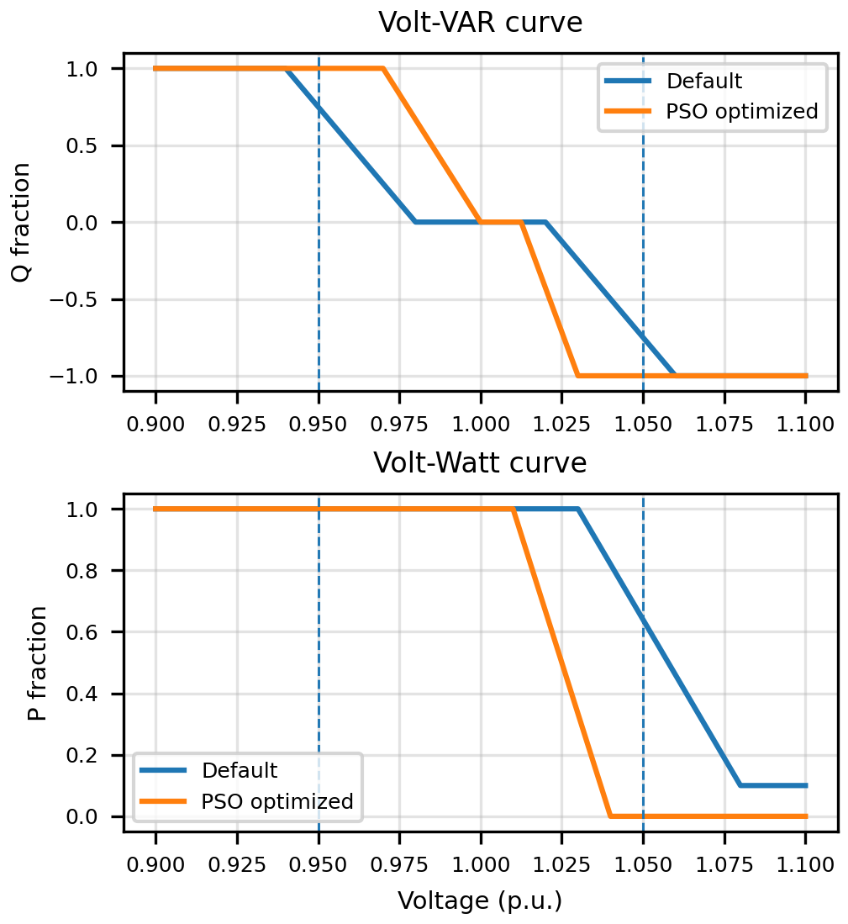
Fig. 2. Default and PSO-optimized Volt-VAR and Volt-Watt curves used by the smart-inverter controller.

PSO-based hybrid-controller tuning
The PSO stage tunes nine continuous decision variables that define the hybrid Volt-VAR/Volt-Watt controller:
x = [V1, V2, V3, V4, Q_inj, Q_abs, V_s, V_e, P_min]. (9)
The search is constrained so that V1 < V2 < V3 < V4 and V_s < V_e. The lower and upper search limits are selected to keep the controller within realistic smart-inverter voltage-control behavior. For each candidate vector, the QSTS simulation is repeated over multiple training scenarios, including the 80% partial-cloud case and higher-penetration stress cases. The standard PSO position update is expressed as [13]
v_p^(k+1) = omega v_p^k + c1 r1(pbest_p - x_p^k) + c2 r2(gbest - x_p^k), x_p^(k+1) = x_p^k + v_p^(k+1). (10)
The implemented multi-objective fitness function penalizes voltage deviation, maximum voltage deviation, voltage-limit violations, active-power loss, PV curtailment, reactive-power usage, and infeasible parameter combinations. A compact normalized representation is
J(x) = (1/N_s) sum_s [w1 D_mean,s + w2 D_max,s + w3 N_viol,s + w4 L_s + w5 C_s + w6 Q_s] + P_c. (11)
In (11), each performance term is normalized by the corresponding reference value from the no-control or default case, and P_c includes penalties for violated parameter ordering, nonconvergence, or apparent-power-limit violations. This formulation prevents the optimizer from improving one indicator while ignoring voltage feasibility or inverter capability.

Performance indices and hosting-capacity calculation
The controller comparison is based on voltage quality, violation removal, active-power loss, PV curtailment, response behavior, and hosting capacity. The main voltage-quality metric is the mean absolute voltage deviation over all buses and time steps:
D_mean = (1/(T N_b)) sum_t sum_i | |V_i(t)| - 1 |. (12)
Voltage violations are counted whenever a bus voltage is outside the 0.95-1.05 p.u. envelope:
N_viol = sum_t sum_i 1{ |V_i(t)| < 0.95 or |V_i(t)| > 1.05 }. (13)
The energy-based active loss and PV curtailment indicators are evaluated by summing the hourly values across the QSTS horizon:
E_loss = sum_t P_loss(t) Delta t, E_curt = sum_t sum_i [P_av,i(t) - P_out,i(t)] Delta t. (14)
Finally, hosting capacity is calculated as the maximum PV penetration that remains feasible over the stress profile, with converged load flow and without new voltage violations:
HC = max { rho_PV : 0.95 <= |V_i(t, rho_PV)| <= 1.05, for all i,t }. (15)
The response metric reported in this paper is interpreted as a quasi-static voltage-recovery indicator, defined by the number of QSTS time steps required for all bus voltages to return inside the allowable voltage range after a violation. It is not an EMT transient settling time.

MATLAB-Simulink implementation and visualization
The numerical feeder solution, controller logic, optimization, and metric calculations are performed by MATLAB scripts. Simulink is included to provide a model-based representation of the workflow and a results viewer that communicates the relationship between the feeder, PV generation, smart-inverter control, PSO tuning, measurements, and performance indices [14]. Fig. 3 summarizes this integration. The Simulink component is therefore used for documentation, presentation, and result replay, while the quantitative results reported in the paper are generated by the MATLAB QSTS simulation pipeline.
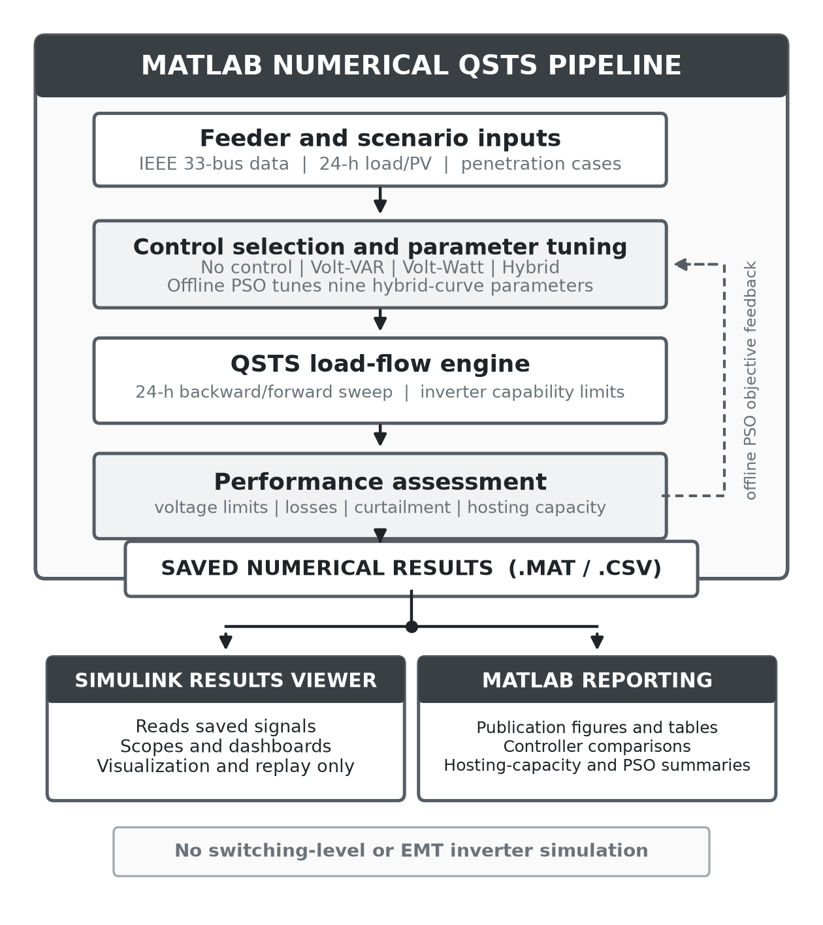
Fig. 3. Data flow between the MATLAB QSTS pipeline and the Simulink results viewer. MATLAB executes controller comparison, offline PSO, load flow, metric calculation, and reporting; Simulink loads saved signals only for visualization and replay.

Results
This section reports the numerical performance of the smart-inverter controllers using the proposed IEEE 33-bus QSTS framework. The discussion is organized around four questions: whether the feeder model is technically valid, how each controller behaves under the normal 80% PV partial-cloud case, how the controllers behave under the overvoltage stress case, and how the proposed hybrid and PSO-optimized approaches compare with existing literature. The reported values are taken from the generated MATLAB result tables and should be interpreted within the stated QSTS scope.

Feeder validation and baseline behavior
The base IEEE 33-bus load-flow validation converged successfully with 33 buses and 32 branches. The base case produced a minimum voltage of 0.9038 p.u. at the remote end of the feeder and an active power loss of 211.00 kW. This confirms that the test system represents a weak radial feeder in which voltage support is meaningful. Under time-series operation, the no-control cases exhibit both undervoltage behavior during low-generation/high-load periods and overvoltage behavior when high PV output is placed near the end of the feeder. Therefore, the test system is appropriate for evaluating both Volt-VAR and Volt-Watt actions.
Table I summarizes the two most important scenarios used for detailed controller comparison. The normal case shows an undervoltage-dominated operating condition, while the stress case is intentionally designed to activate overvoltage mitigation and Volt-Watt curtailment.
TABLE I. VOLTAGE-QUALITY SUMMARY FOR NORMAL AND STRESS CASES
Scenario | Control | Mean |V-1| | Min-Max V | Viol.
Normal 80% PV | No control | 0.0304 | 0.9094-1.0086 | 179
Normal 80% PV | Volt-VAR | 0.0215 | 0.9512-1.0086 | 0
Normal 80% PV | Volt-Watt | 0.0304 | 0.9094-1.0086 | 179
Normal 80% PV | Hybrid | 0.0215 | 0.9512-1.0086 | 0
Normal 80% PV | Hybrid-PSO | 0.0137 | 0.9651-1.0100 | 0
Stress 150% PV | No control | 0.0263 | 0.9511-1.1070 | 52
Stress 150% PV | Volt-VAR | 0.0170 | 0.9680-1.0582 | 15
Stress 150% PV | Volt-Watt | 0.0220 | 0.9511-1.0559 | 15
Stress 150% PV | Hybrid | 0.0160 | 0.9680-1.0415 | 0
Stress 150% PV | Hybrid-PSO | 0.0075 | 0.9802-1.0147 | 0

Normal 80% PV partial-cloud case
In the 80% PV partial-cloud case, the feeder without smart-inverter support produced 179 voltage violations and a minimum voltage of 0.9094 p.u. Volt-VAR control eliminated all violations by injecting reactive power during undervoltage intervals and reduced the mean active loss from 88.31 kW to 64.11 kW. Volt-Watt control did not improve this normal case because the dominant issue was undervoltage, not overvoltage; therefore, the Volt-Watt threshold was not activated and its result remained identical to the no-control case.
The hybrid controller matched Volt-VAR in this scenario because Volt-Watt curtailment was not needed. The PSO-optimized hybrid controller produced the best voltage-quality result, reducing the mean absolute voltage deviation from 0.0304 p.u. to 0.0137 p.u., corresponding to approximately 55.1% improvement over the no-control case. The minimum bus voltage increased from 0.9094 p.u. to 0.9651 p.u., and all violations were removed without PV curtailment. This justifies the first main contribution: the proposed comparison framework separates controllers that are useful for undervoltage support from controllers that only become useful during overvoltage operation.
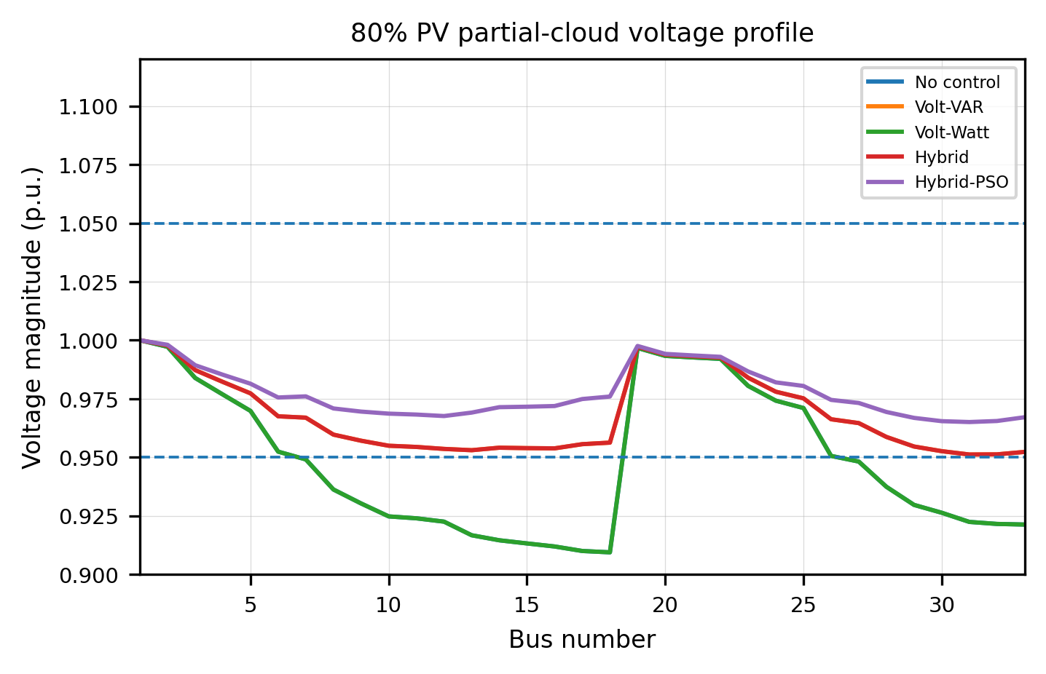
Fig. 4. Voltage profile of the 80% PV partial-cloud case at the worst no-control hour. Volt-VAR, hybrid, and hybrid-PSO remove undervoltage violations, while Volt-Watt remains inactive.

Stress 150% PV clear-sky case
The stress case uses low daytime loading and end-feeder PV placement to create a strong reverse-power-flow condition. At 150% PV penetration, the no-control case reached a maximum voltage of 1.1070 p.u. and produced 52 voltage violations. Volt-VAR reduced the maximum voltage to 1.0582 p.u., but 15 violations remained. Volt-Watt also reduced violations to 15 by curtailing active power, but the maximum voltage still exceeded the 1.05 p.u. limit. These results show that single-function autonomous control is not sufficient under this severe PV condition.
The default hybrid controller combined active-power curtailment with reactive-power absorption and reduced the maximum voltage to 1.0415 p.u., removing all violations. The PSO-optimized hybrid controller further reduced the maximum voltage to 1.0147 p.u. and reduced the mean absolute voltage deviation to 0.0075 p.u., the best voltage-quality result in the stress comparison. However, the optimized controller used more PV curtailment than the default hybrid controller. This trade-off is important: PSO improves the selected multi-objective voltage-quality objective, but it does not make every individual metric better. Therefore, the result should be interpreted as optimized voltage regulation with an explicit curtailment trade-off.
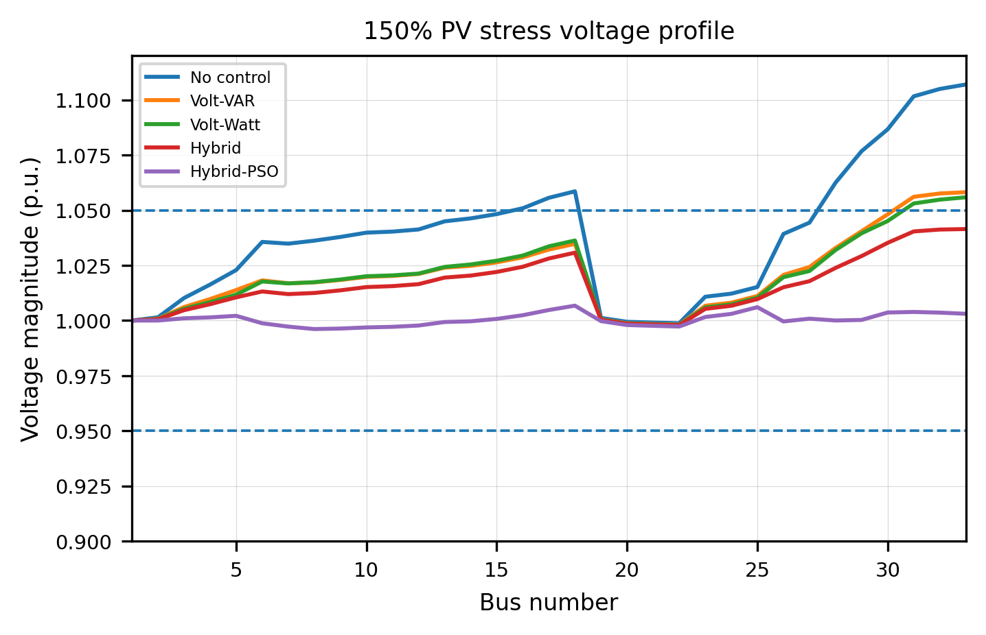
Fig. 5. Voltage profile of the 150% PV stress case at midday. The hybrid controllers keep all buses within the 0.95-1.05 p.u. voltage band.

PSO optimization and hosting capacity
The PSO stage optimized nine hybrid-control curve parameters. Across five random seeds, the best objective was 7.7890, while the default hybrid objective was 16.8724. This represents a 53.8% reduction in the selected objective function. The seed statistics also show that the mean final objective was 9.8676 with a standard deviation of 1.8297, indicating that multiple seeds were useful for avoiding dependence on a single PSO run. Fig. 6 shows the convergence behavior of the independent PSO seeds.
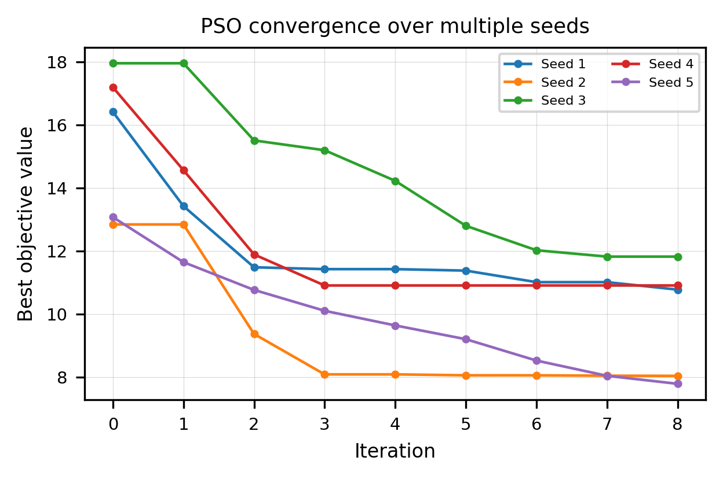
Fig. 6. PSO convergence over multiple seeds for hybrid Volt-VAR/Volt-Watt curve tuning.
Hosting capacity was evaluated by increasing the PV penetration until the controller could no longer satisfy the voltage-constraint criterion over the stress profile. Table II and Fig. 7 show that the no-control case supported only 80% PV penetration. Volt-VAR increased the feasible level to 100%, and Volt-Watt increased it to 120%. Both the default hybrid and PSO-optimized hybrid controllers achieved 250% PV penetration in the tested sweep, equivalent to a 3.125 times increase relative to the no-control case. This supports the main technical contribution of the paper: combining Volt-VAR and Volt-Watt actions is substantially more effective for hosting-capacity enhancement than using either function alone.
TABLE II. HOSTING CAPACITY COMPARISON
Control | Hosting (%) | Relative
No control | 80 | 1.00x
Volt-VAR | 100 | 1.25x
Volt-Watt | 120 | 1.50x
Hybrid | 250 | 3.12x
Hybrid-PSO | 250 | 3.12x
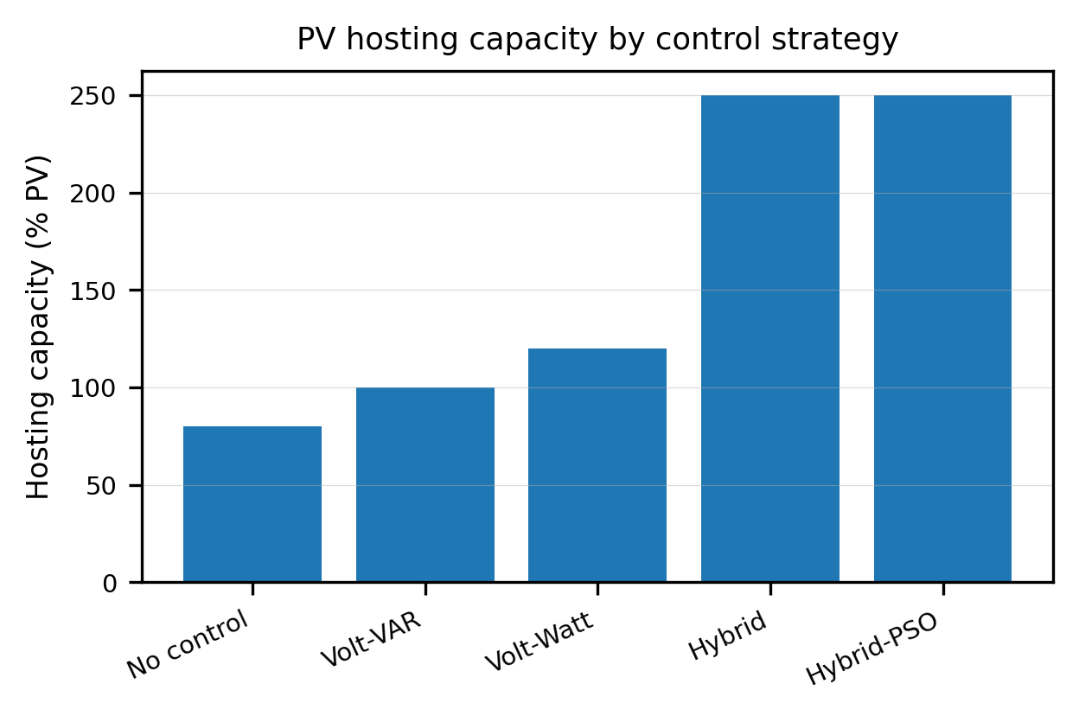
Fig. 7. PV hosting capacity obtained by each control strategy under the stress-profile feasibility criterion.

Comparison with related literature and contribution justification
Table III compares the scope of the present work with representative studies from the literature. The comparison is qualitative rather than a direct numerical ranking because different papers use different feeders, PV placement assumptions, constraints, and operating profiles. Nevertheless, the table clarifies the contribution of this work: instead of evaluating only one smart-inverter function or only one optimization problem, the proposed study connects multi-mode control comparison, PSO-based hybrid tuning, hosting-capacity evaluation, result-dashboard generation, and Simulink-supported result visualization within a single IEEE 33-bus workflow.
TABLE III. QUALITATIVE COMPARISON WITH RELATED STUDIES
Study | Main focus | Position of this work
Ding et al. [3] | PV hosting-capacity technologies; feeder-level stochastic simulation. | Adds IEEE 33-bus multi-mode comparison, hybrid control, PSO tuning, and result replay.
Seuss et al. [4] | Reactive-power support for PV hosting capacity. | Compares reactive support with Volt-Watt and hybrid actions under normal and stress cases.
NREL [5], [6], [12] | Advanced inverter voltage controls and field/simulation studies. | Provides a compact MATLAB/Simulink workflow with optimized hybrid curves.
Lee et al. [10] | Optimal Volt-VAR parameter selection. | Extends tuning to hybrid Volt-VAR/Volt-Watt control and reports curtailment trade-offs.
Murzakhanov et al. [11] | Optimal Volt/VAR rule design for inverter DERs. | Uses PSO-based engineering optimization and IEEE 33-bus hosting-capacity evaluation.
Proposed work | IEEE 33-bus smart-inverter hosting-capacity framework. | Demonstrates 179-to-0 violation removal and 80% to 250% hosting-capacity increase.

Summary of result-based contributions
The result section provides four justifications for the claimed contribution. First, the normal 80% PV case shows that Volt-VAR and hybrid control remove undervoltage violations, while Volt-Watt alone is inactive; this proves the need for multi-mode controller comparison rather than relying on one control function. Second, the 150% PV stress case shows that neither Volt-VAR nor Volt-Watt alone completely removes violations, whereas hybrid control does; this justifies the hybrid-control contribution. Third, PSO improves the selected voltage-quality objective and reduces the maximum stress-case voltage to 1.0147 p.u.; this justifies optimized parameter tuning, while the reported curtailment increase honestly identifies the trade-off. Fourth, hosting capacity increases from 80% without control to 250% with hybrid control, which demonstrates the practical feeder-level benefit of the proposed framework.
The main limitation of the current result set is that it is based on balanced QSTS simulation rather than detailed EMT switching simulation. Therefore, the reported response time is a quasi-static voltage-recovery indicator, not a sub-cycle transient settling time. Communication delays, protection coordination, unbalanced three-phase operation, harmonic distortion, and hardware-in-the-loop validation remain future extensions. This limitation does not invalidate the reported hosting-capacity and voltage-profile findings, but it defines the correct interpretation of the proposed methodology.

Discussion

Interpretation of voltage-control behavior
The results show that the effectiveness of each smart-inverter function depends strongly on the dominant feeder problem. In the normal 80 percent PV partial-cloud case, the primary issue was low voltage at remote buses. Volt-Watt control did not improve this case because active-power curtailment is mainly useful for overvoltage mitigation, not undervoltage support. In contrast, Volt-VAR and hybrid control supplied reactive-power support and moved the voltage profile inside the acceptable 0.95-1.05 per-unit operating band. This result confirms that reactive-power control is the most direct smart-inverter function for correcting undervoltage-dominated radial-feeder operation.
The stress 150 percent PV case demonstrates the opposite operating condition. Under high PV output and low load, reverse power flow caused the no-control case to exceed the upper voltage limit. In this situation, Volt-VAR absorption reduced the voltage but was not sufficient to provide the highest feasible hosting capacity alone. Volt-Watt control reduced active power when voltage became excessive, but active curtailment without coordinated reactive-power support gave limited flexibility. The default and PSO-optimized hybrid controllers performed better because they combined active-power reduction and reactive-power absorption while respecting the inverter capability constraint.

Justification of the proposed contribution
The main contribution of this paper is not only the use of a single smart-inverter function, but the construction of an integrated and reproducible evaluation framework. The numerical evidence supports this contribution in four ways. First, the proposed workflow compares five control cases under the same IEEE 33-bus network, PV profile, load profile, and voltage-limit criterion, which makes the controller comparison internally consistent. Second, the framework evaluates both normal and stress cases; therefore, it captures undervoltage and overvoltage behavior rather than optimizing for only one operating condition. Third, the PSO stage provides feeder-specific hybrid-control tuning instead of relying only on fixed default droop curves. Fourth, the paper connects voltage-quality metrics, hosting-capacity metrics, result dashboards, and Simulink-supported visualization, which improves interpretability for power-system planning and educational use.
The PSO-optimized hybrid controller provides the strongest voltage-quality result in the stress case by reducing the maximum voltage from 1.1070 per unit in the no-control case to 1.0147 per unit. This is a practical improvement because the voltage is not only returned inside the acceptable band but is also moved closer to nominal operation. The hosting-capacity result further justifies the hybrid-control contribution: no control supports only 80 percent PV penetration, while the hybrid methods support 250 percent under the implemented stress-profile feasibility criterion. This shows that coordinated use of inverter active and reactive power can unlock additional PV capacity without changing the feeder topology.

Practical implications and trade-offs
From a distribution-planning perspective, the results indicate that smart-inverter configuration should be selected according to feeder operating conditions. Volt-VAR control is attractive when undervoltage or moderate voltage regulation is the major concern, because it can improve voltage without curtailing PV energy when reactive-power capability is available. Volt-Watt control is more useful as a protection-oriented overvoltage function because it directly limits active-power injection. Hybrid control is the most robust option when both undervoltage and overvoltage may occur during the daily operating cycle.
The results also show an important trade-off. The PSO-optimized hybrid controller improves voltage quality and reduces the optimization objective, but stronger voltage regulation may require higher active-power curtailment under stress conditions. Therefore, the best controller cannot be selected from maximum voltage alone. A practical utility implementation should balance voltage security, PV energy utilization, inverter reactive-power use, and customer-side curtailment fairness. The multi-objective fitness function used in this paper provides one way to represent this trade-off, but the final weighting factors should be selected according to local grid-code and utility-planning priorities.

Limitations and future research direction
The present work is based on balanced quasi-static time-series load-flow simulation. Therefore, the reported response behavior should be interpreted as a QSTS voltage-recovery indicator rather than a switching-level electromagnetic transient response. Simulink is used in this project for workflow visualization and result replay, while MATLAB scripts provide the numerical feeder simulation and controller evaluation. Future work should extend the framework to unbalanced three-phase feeders, include detailed inverter dynamics, compare additional optimization algorithms, evaluate communication-assisted coordinated control, and validate the controller using real irradiance, load, and feeder measurement data.

Conclusion
This paper presented an end-to-end MATLAB and Simulink supported framework for evaluating smart-inverter based PV hosting-capacity enhancement in the IEEE 33-bus radial distribution network. The framework integrated radial load-flow simulation, PV and load time-series modeling, inverter capability constraints, Volt-VAR control, Volt-Watt control, default hybrid control, PSO-optimized hybrid control, hosting-capacity assessment, and visual result interpretation.
The numerical results demonstrate that smart-inverter control significantly improves voltage performance compared with the no-control case. In the normal 80 percent PV partial-cloud scenario, the uncontrolled feeder produced 179 voltage violations, while Volt-VAR, default hybrid, and PSO-hybrid control removed all violations. In the 150 percent PV stress scenario, the uncontrolled maximum voltage reached 1.1070 per unit. Default hybrid control reduced the maximum voltage to 1.0415 per unit, and the PSO-hybrid controller further reduced it to 1.0147 per unit. The hosting-capacity analysis showed that the no-control, Volt-VAR, and Volt-Watt cases supported 80 percent, 100 percent, and 120 percent PV penetration, respectively, while both hybrid approaches supported 250 percent.
Overall, the study confirms that coordinated Volt-VAR and Volt-Watt operation can provide stronger voltage regulation and higher PV hosting capacity than single-function control. The PSO-optimized hybrid controller provides additional feeder-specific voltage-quality improvement, although it must be implemented with attention to curtailment and inverter-utilization trade-offs. The proposed workflow can be used as a reproducible research and planning tool for studying smart-inverter control in distribution networks.

REFERENCES
[1] IEEE Standard for Interconnection and Interoperability of Distributed Energy Resources with Associated Electric Power Systems Interfaces, IEEE Std 1547-2018, Apr. 2018.
[2] D. Narang, M. Bello, B. Mather, and A. G. Florita, “Highlights of IEEE Standard 1547-2018,” National Renewable Energy Laboratory, Golden, CO, USA, Tech. Rep. NREL/PR-5D00-75436, 2019.
[3] F. Ding, B. Mather, and P. Gotseff, “Technologies to increase PV hosting capacity in distribution feeders,” in Proc. IEEE Power & Energy Society General Meeting, 2016, pp. 1-5.
[4] J. Seuss, M. J. Reno, R. J. Broderick, and S. Grijalva, “Improving distribution network PV hosting capacity via smart inverter reactive power support,” in Proc. IEEE Power & Energy Society General Meeting, Denver, CO, USA, 2015, pp. 1-5.
[5] F. Ding, A. Nagarajan, S. Chakraborty, A. Nguyen, S. Walinga, M. McCarty, and F. Bell, “Photovoltaic impact assessment of smart inverter Volt-VAR control on distribution system conservation voltage reduction and power quality,” National Renewable Energy Laboratory, Golden, CO, USA, Tech. Rep. NREL/TP-5D00-67296, 2016.
[6] J. Giraldez, A. Hoke, P. Gotseff, N. Wunder, M. Blonsky, M. Emmanuel, A. Latif, E. Ifuku, M. Asano, and S. Ueda, “Advanced inverter voltage controls: Simulation and field pilot findings,” National Renewable Energy Laboratory, Golden, CO, USA, Tech. Rep. NREL/TP-5D00-72298, 2018.
[7] M. E. Baran and F. F. Wu, “Network reconfiguration in distribution systems for loss reduction and load balancing,” IEEE Trans. Power Delivery, vol. 4, no. 2, pp. 1401-1407, Apr. 1989.
[8] M. E. Baran and F. F. Wu, “Optimal capacitor placement on radial distribution systems,” IEEE Trans. Power Delivery, vol. 4, no. 1, pp. 725-734, Jan. 1989.
[9] T. O. Olowu, A. I. Sarwat, S. Dharmasena, and A. Debnath, “Smart inverters’ functionalities and their impacts on distribution feeders at high photovoltaic penetration,” in Proc. IEEE Green Technologies Conf. (GreenTech), 2021, pp. 97-104.
[10] H. J. Lee, S. H. Park, and S. M. Cho, “Optimal parameters of Volt-Var function in smart inverters for improving system performance,” Energies, vol. 13, no. 9, Art. no. 2294, May 2020.
[11] I. Murzakhanov, S. Gupta, S. Chatzivasileiadis, and V. Kekatos, “Optimal design of Volt/VAR control rules for inverter-interfaced distributed energy resources,” arXiv:2210.12805, 2022.
[12] J. Wang, A. Hoke, B. Mather, and F. Ding, “Simulation-based analysis of feeder operation with distributed PV smart inverter functions,” National Renewable Energy Laboratory, Golden, CO, USA, Tech. Rep. NREL/TP-5D00-87285, 2024.
[13] J. Kennedy and R. Eberhart, “Particle swarm optimization,” in Proc. IEEE Int. Conf. Neural Networks, Perth, WA, Australia, 1995, pp. 1942-1948.
[14] MathWorks, “Simulink documentation: Simulation and model-based design,” The MathWorks, Inc., 2026. [Online]. Available: https://www.mathworks.com/help/simulink/. Accessed: Jun. 13, 2026.

