4-Phase 3-Module

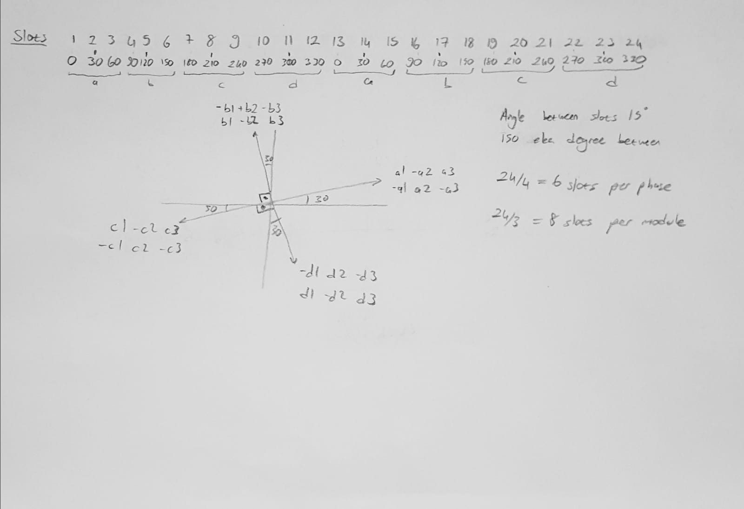

To obtain a 4-phase motor, the difference between the phase vectors must be 90 degree. In the above figure I chose the 30,120,210,300 degrees to construct the winding configurations. However, the module voltages cannot be equal for 3 modules. Because, each module needs 8 slots but there is no configuration for 3-modules with equalized voltage phasors. So, using 2-module can be solution for that problem.