**Research League Challenge Assignment**

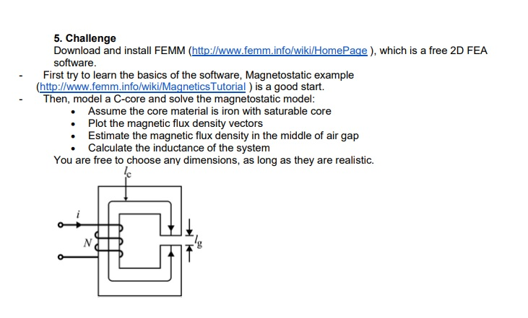

Figure : Challenge

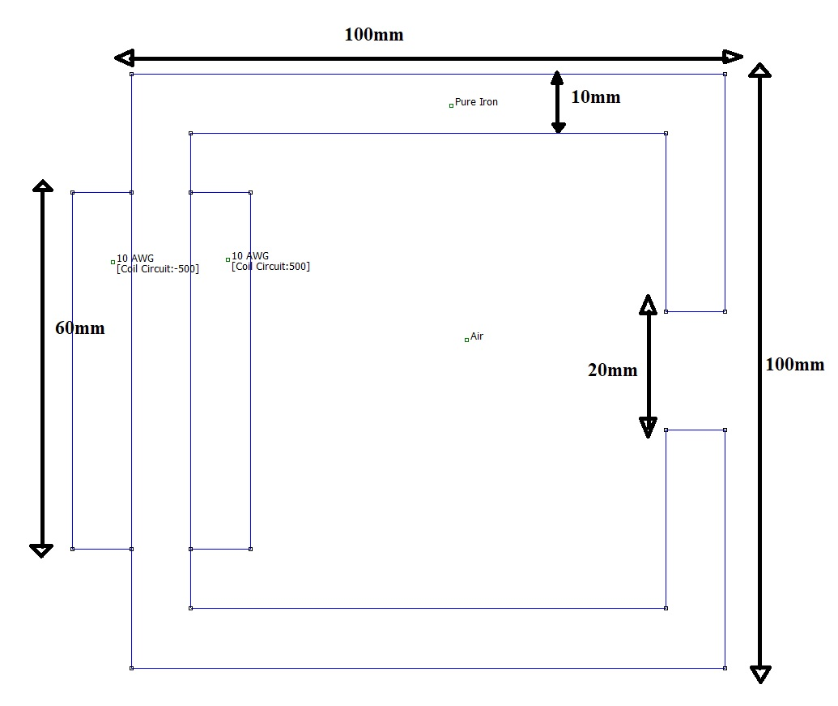

Figure : Schematic of the C-core

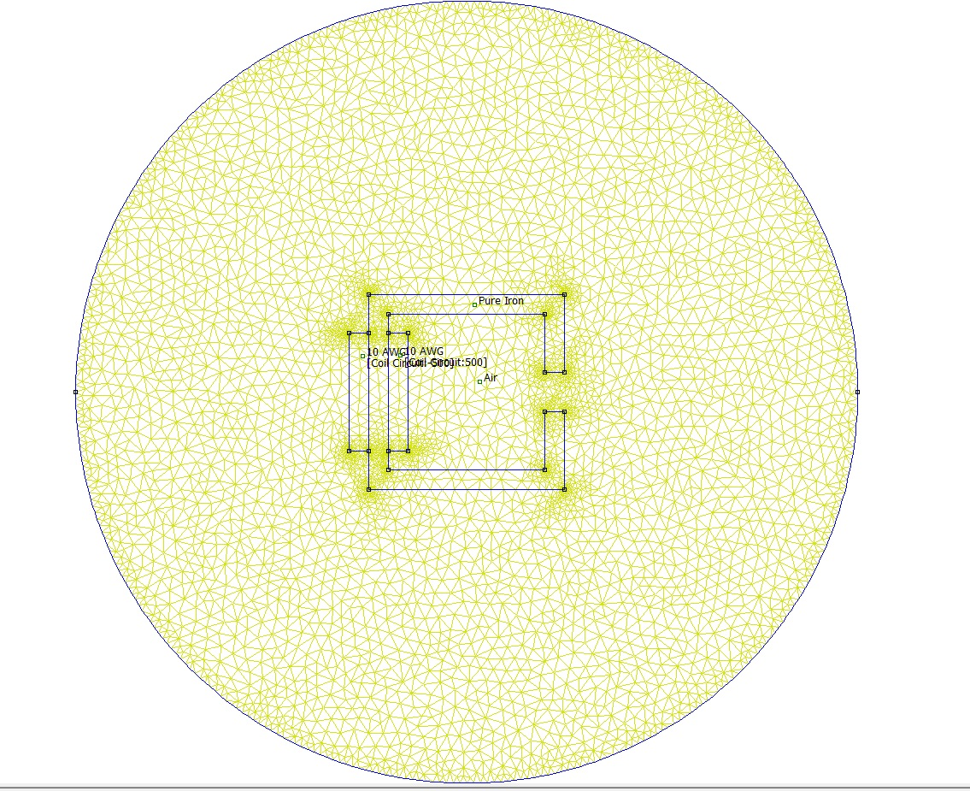

Figure : Restricted area and checking the materials

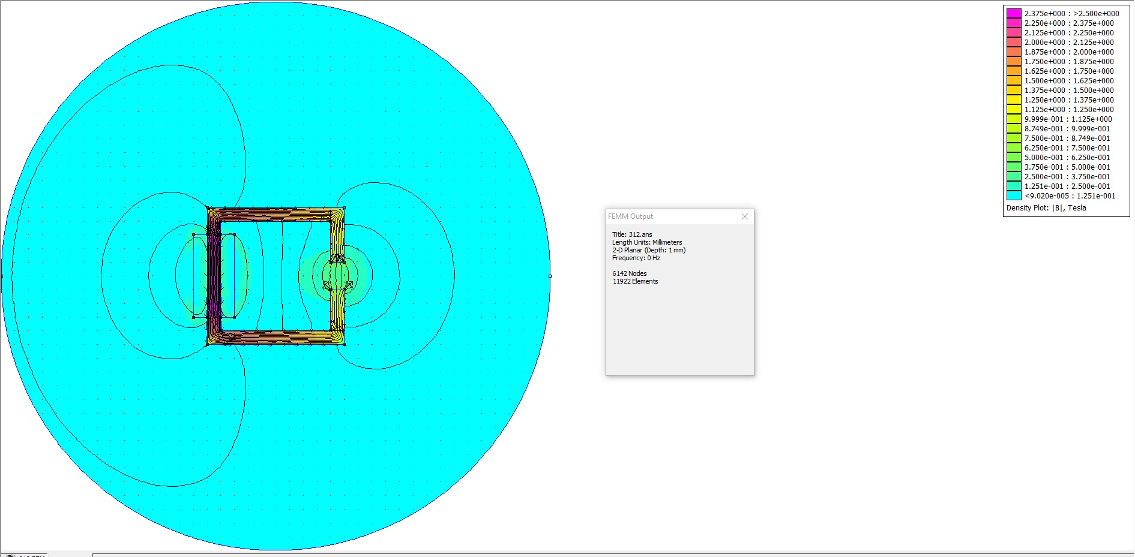

Figure : Colourfull flux density

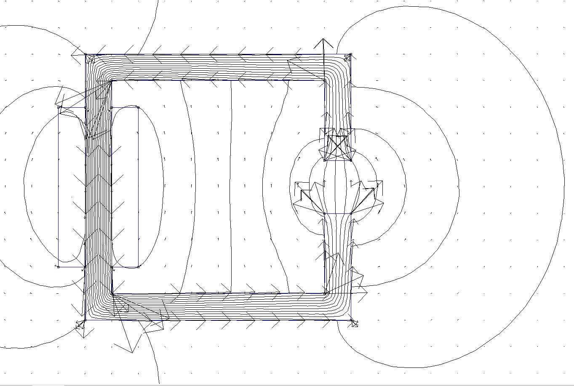

Figure : Magnetic flux density vectors

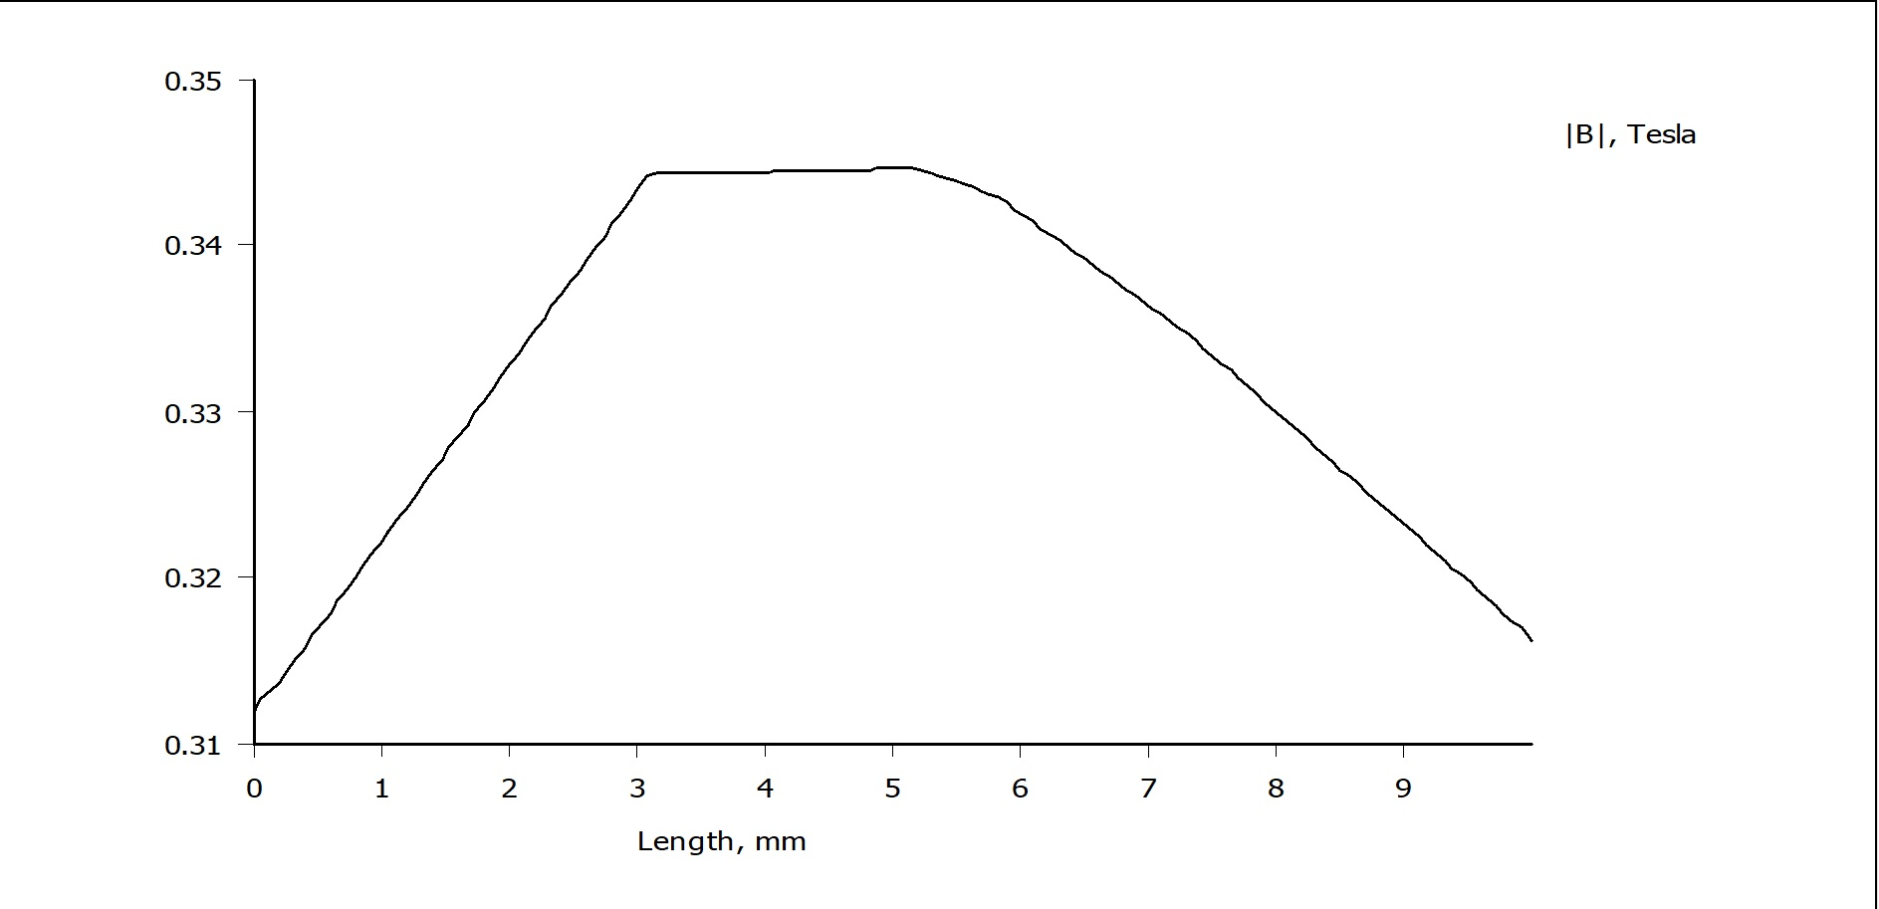

Figure : Magnetic flux density graph at the middle of the air-gap

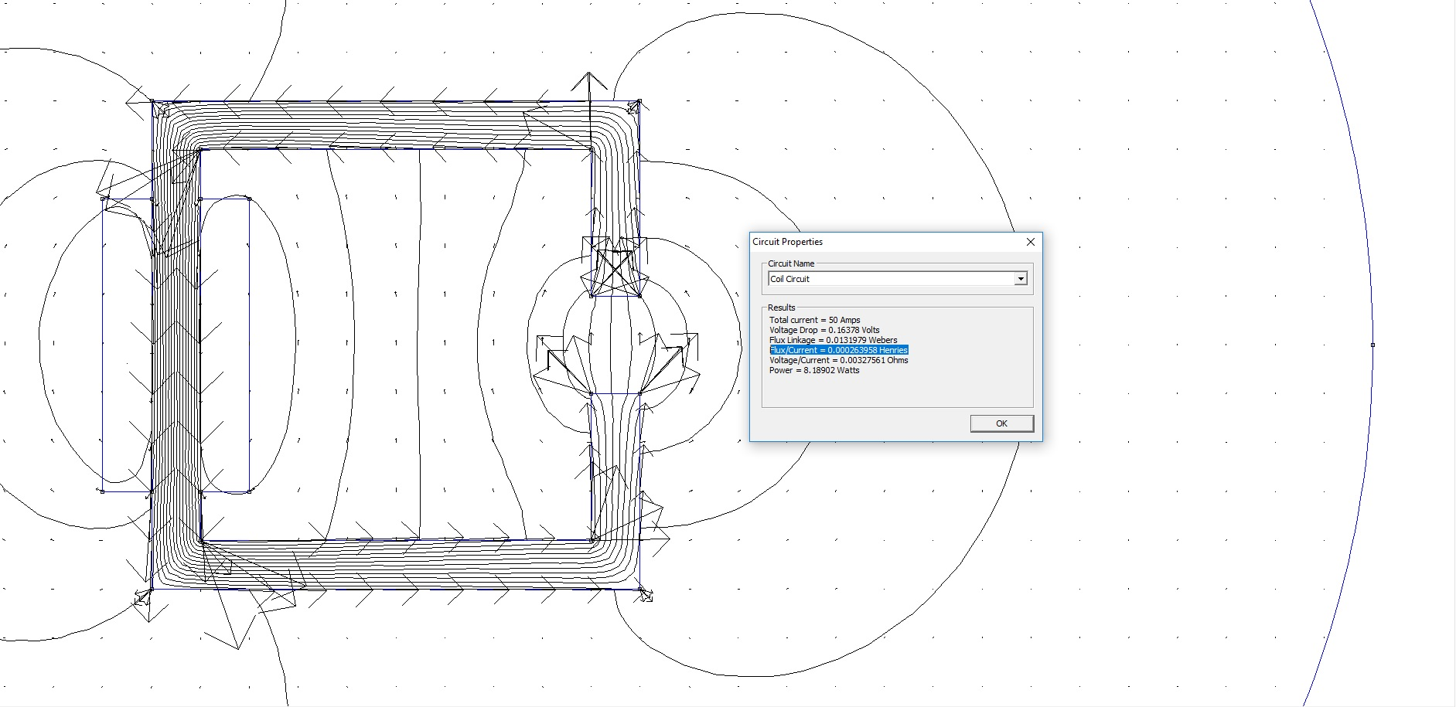

Figure : Inductance calculation from circuit properties

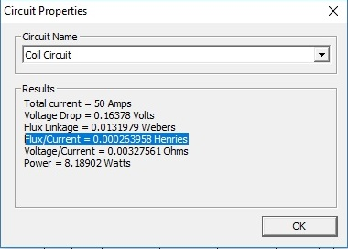

Figure : Inductance