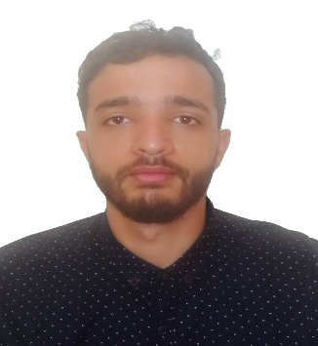

Basketball

**2020 – 2022** **:** **IT-Developement in Vocational**

**Training Center (OFPPT).**

**2017 – 2019** **:** **Faculty Ben M’sik Ensglish Studies**

**2016 – 2017 : Bachlor in earth science(SVT).**

[***https://chandaliportfolio.netlify.app/***](https://chandaliportfolio.netlify.app/)

07-74-10-42-86

my name is Chandali Ismail 23yo , i finished my eduation this year in IT development  and i'm looking for my first experience hopping to be a permanent one, i will be pleased if i get an answer from you.

Mhamedkamal123@email.com

* Create Attendances Management for vocational training center (OFPPT) with

Ado.Net for managing the students presence, relating teachers with establishment manager .

* Internship in Quikno company Creating a Website .
* Prototype designer in AH-INOX S.A.R.L for 3 months .
* **.Net – Ado/Asp**
* **Html5/CSS3 - Bootstrap**
* **Javascript - Jquery**
* **ReactJs - NodeJs**
* **SqlServer – MongoDB - MySQl**
* **Cyber Security (certified)**
* **Python (certified) - PHP**
* **Office Applications**
* **Photoshop – Blender – Figma**
* **Work wisth APIs**

**English**

**Frensh**

**Arabic**

Developper Designer

Chandali

**Ismail**

**Education**

**EXPERIENCE**

**ABOUT ME**

**HOBBIES**

**Skills**

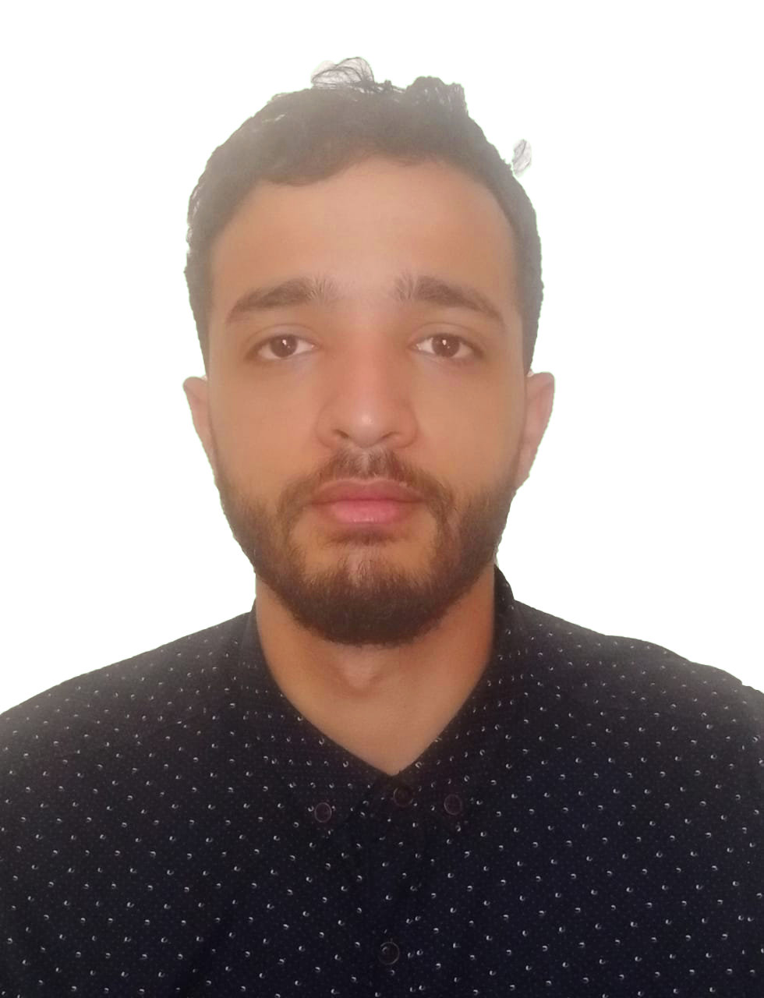

Reading

Music

**LANGUAGES**