Create an Android project

This lesson shows you how to create a new Android project with Android Studio, and it describes some of the files in the project.

To create your new Android project, follow these steps:

1. Install the latest version of Android Studio.

In the **Welcome to Android Studio**  window, click  **Start a new Android Studio project** .

1. If you have a project already opened, select **File > New > New Project** .
2. In the **Choose your project**  window, select **Empty Activity**  and click **Next** .

In the **Configure your project**  window, complete the following:

* Enter "My First App" in the **Name**  field.
* Enter "com.example.myfirstapp" in the **Package name**  field.
* If you'd like to place the project in a different folder, change its **Save**  location.
* Select either **Java**  or **Kotlin**  from the **Language**  drop-down menu.
* Select the checkbox next to **Use androidx.* artifacts** .
* Leave the other options as they are.

2. Enter "My First App" in the **Name**  field.
3. Enter "com.example.myfirstapp" in the **Package name**  field.
4. If you'd like to place the project in a different folder, change its **Save**  location.
5. Select either **Java**  or **Kotlin**  from the **Language**  drop-down menu.
6. Select the checkbox next to **Use androidx.* artifacts** .
7. Leave the other options as they are.
8. Click **Finish** .

After some processing time, the Android Studio main window appears.

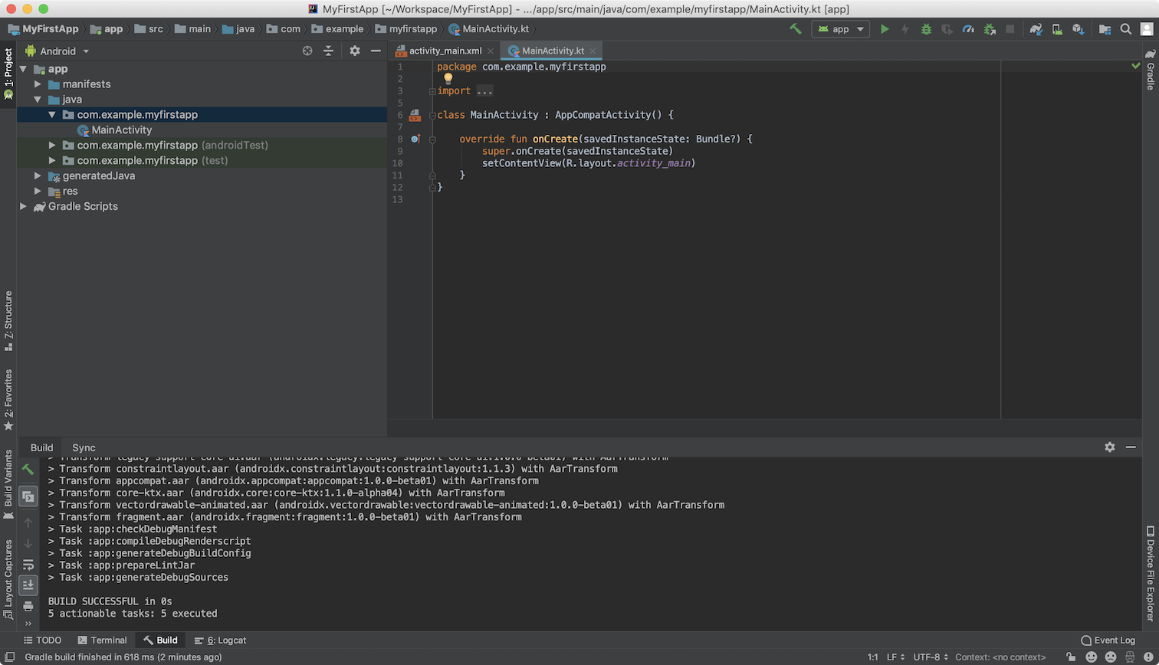

Now take a moment to review the most important files.

First, be sure the **Project**  window is open (select **View > Tool Windows > Project** ) and the Android view is selected from the drop-down list at the top of that window. You can then see the following files:

**app > java > com.example.myfirstapp > MainActivity**

This is the main activity. It's the entry point for your app. When you build and run your app, the system launches an instance of this Activity and loads its layout.

**app > res > layout > activity_main.xml**

This XML file defines the layout for the activity's user interface (UI). It contains a TextView element with the text "Hello, World!"

**app > manifests > AndroidManifest.xml**

The manifest file describes the fundamental characteristics of the app and defines each of its components.

**Gradle Scripts > build.gradle**

There are two files with this name: one for the project, "Project: My First App," and one for the app module, "Module: app." Each module has its own build.gradle file, but this project currently has just one module. Use each module's build.file to control how the Gradle plugin builds your app. For more information about this file, see Configure your build.

To run the app, continue to the next lesson, Run your app.