**1.Prepare a table of Sales and Profit month-wise in a working sheet**

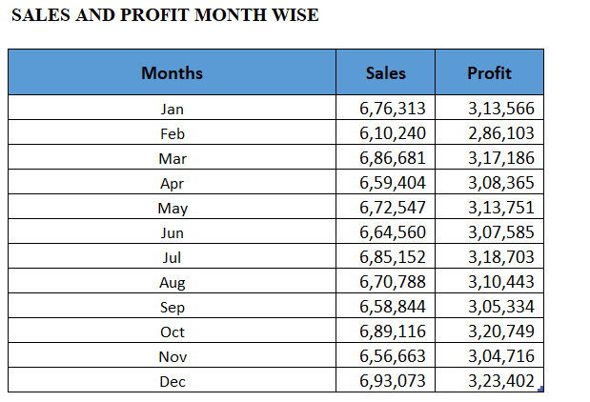

**2.Prepare the sales table region-wise in the working sheet**

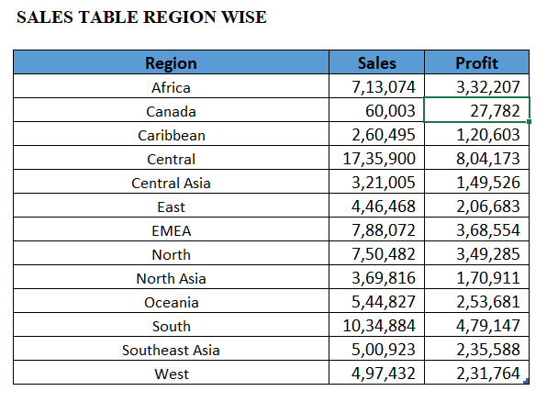

**3.Create User Control Combo box for Product Category**

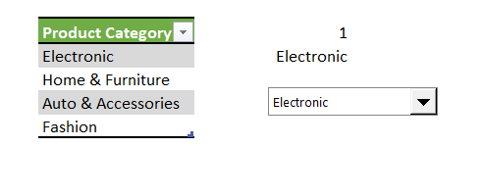

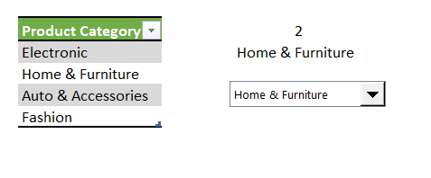

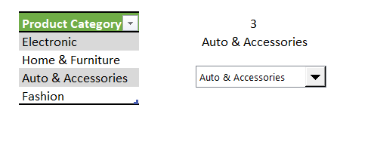

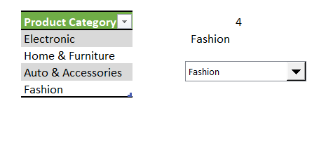

**4.Create a Column Chart of the month-wise table and region-wise table.**

**5.Link the table with a combo box**

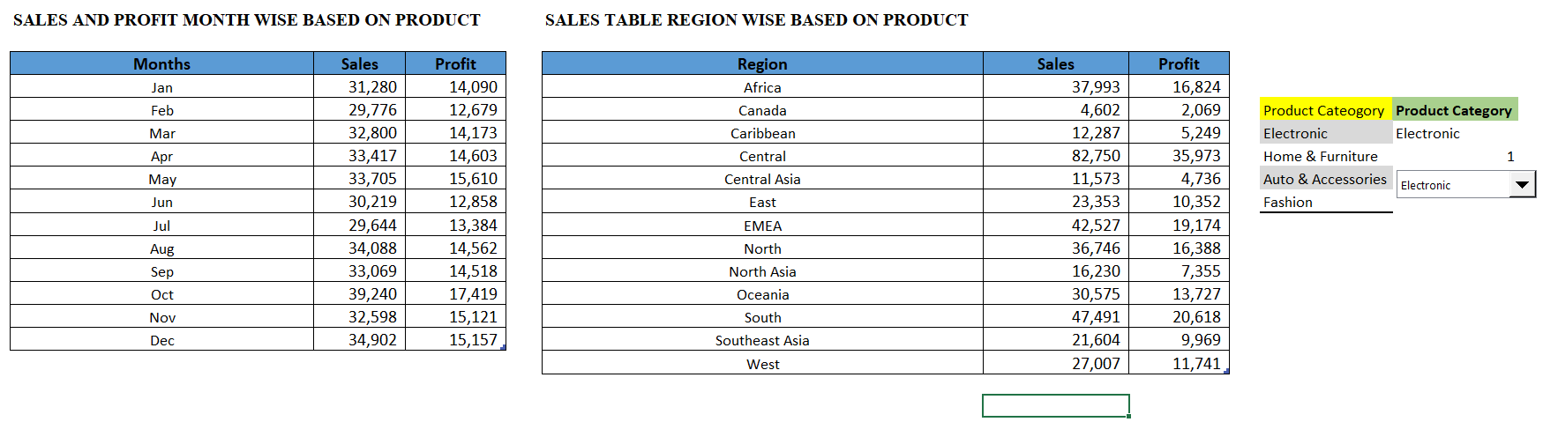

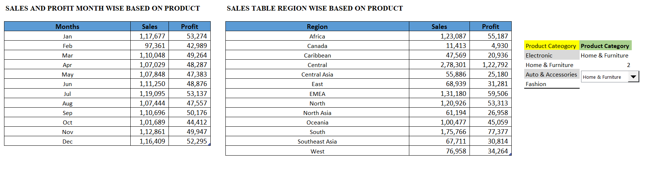

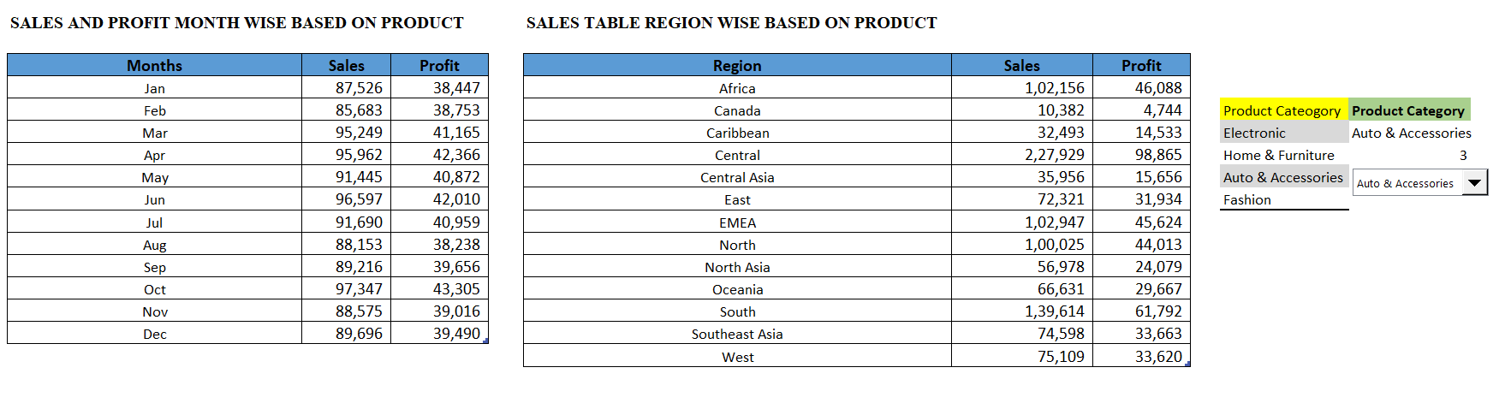

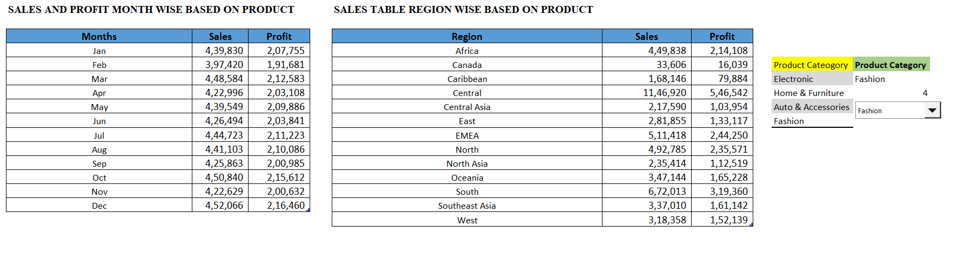

**6.Create a dashboard**

*Sales by month & Region based on product category “Electronic”.

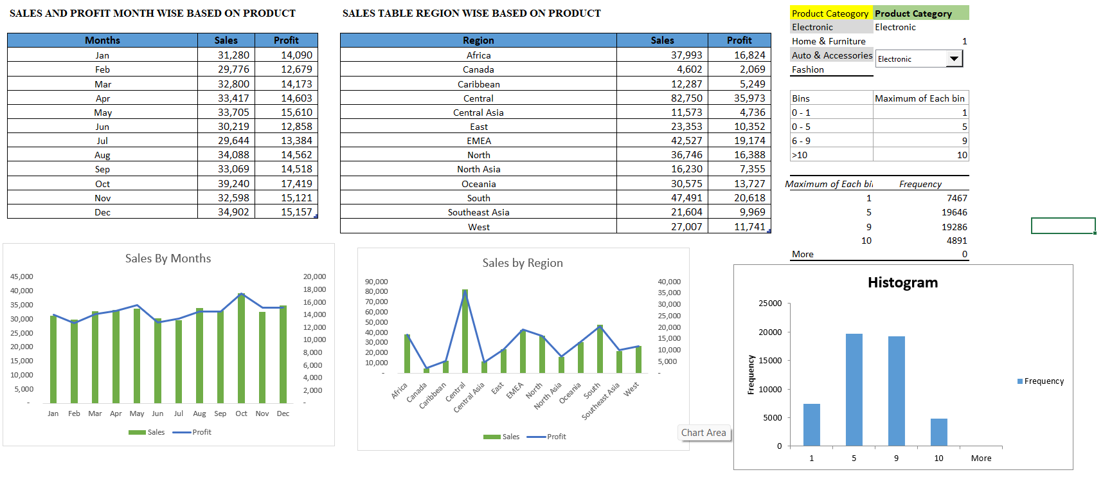

*Sales by month & Region based on product category “Home & Furniture”.

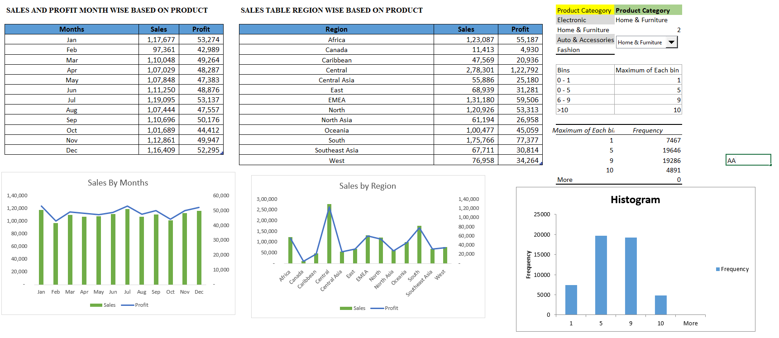

*Sales by month & Region based on product category “Auto & Accessories”.

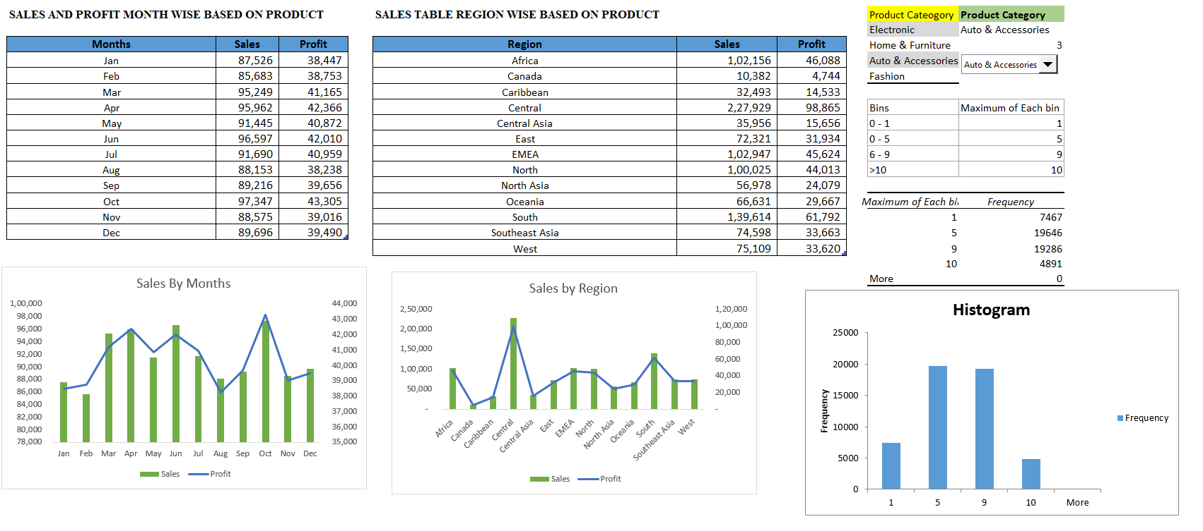

*Sales by month & Region based on product category “Fashion”.

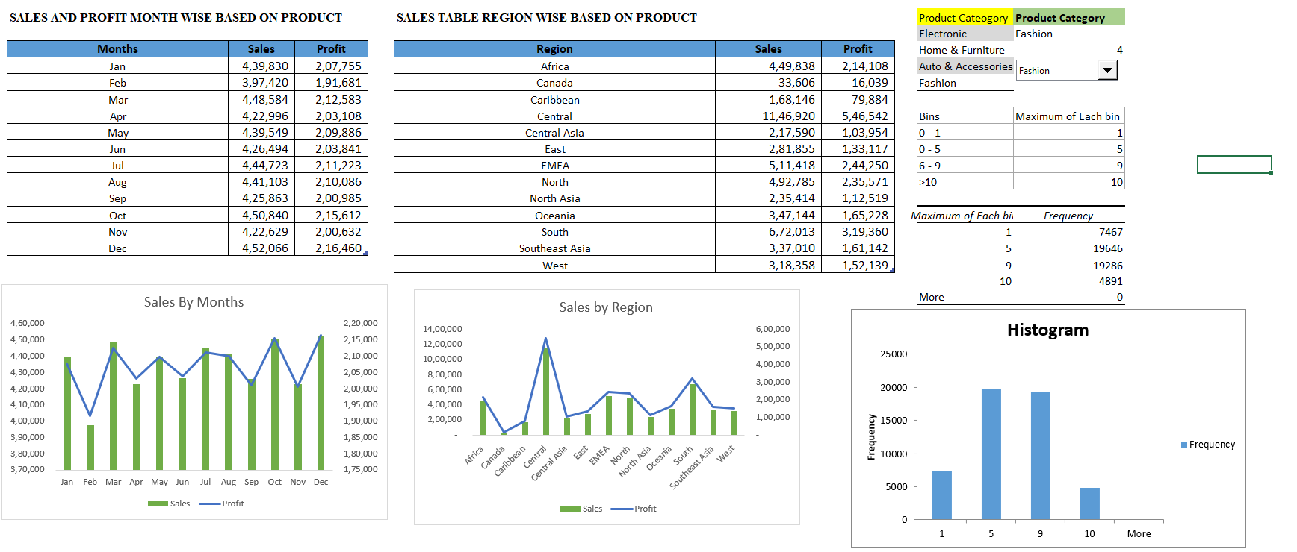

Combo box linked to entire table and database shown based on selected product category

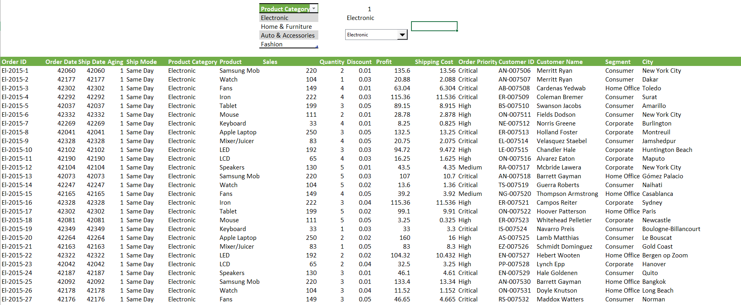

Pivot table region wise

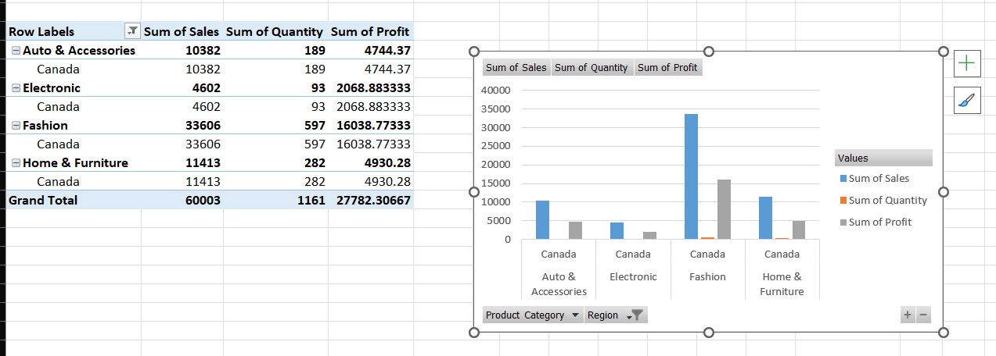

Pivot table month wise

