**Team 7**

Ismail Vandeliwala

Jay Modi

Samuel Benison

Sneha Kulkarni

Xie Dongdong

CSE 5322 – Software design patterns – fall 2014

DOMAIN MODEL GENERATOR

**Classes Implemented**

**1. IdentificationController and NLPExpert Class**

GUI first opens some file to read the requirements as shown. (Copy Paste is disabled)

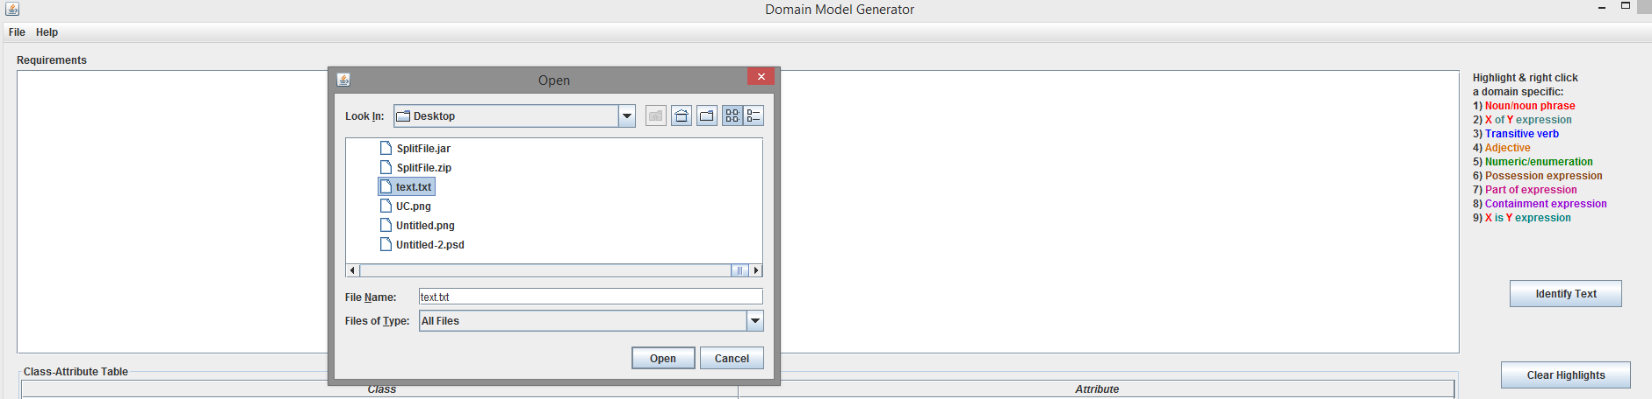

Once the text is loaded, user clicks on Identify Text

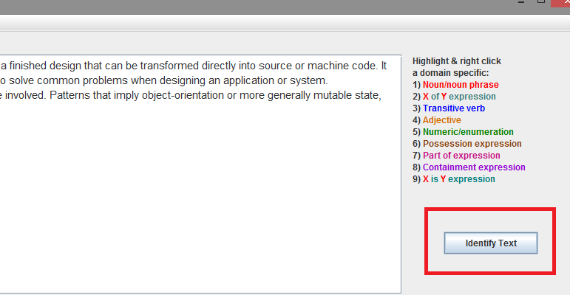

When the Identify Text Button is called, GUI calls the **IdentificationController** which in turn called the **NLPExpert** used to tag the text followed by IdentificationController coloring the text. The result is displayed in the GUI’s text box as shown.

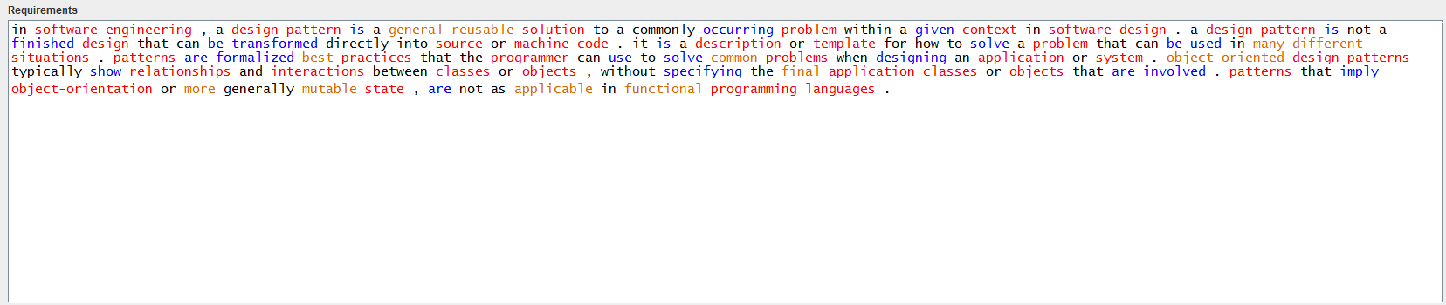

**2. GUI Class (Additional Code)**

In order to facilitate multiple selects and drag and drop we have created additional event based functions. We use mouse event to select/deselect entities from the requirement and also to drag and drop these entitites into the corresponding table.

The method that handles this is “**public** **void** mouseClicked(MouseEvent e) {“ inside the GUI Class

For example, on left click user can select entity and he can left click again to select another entitie. Similarly if the user right clicks a selected entitiy it gets deselected as show.



Now the user can **tripple click** any entity and keep the mouse button pressed to drag the entity into any of the tables below as shown. The mouse cursor is not visible in the screenshot but the blue line indicates something is being dropped in that row of the table. All the selected entities will be dropped in the table.

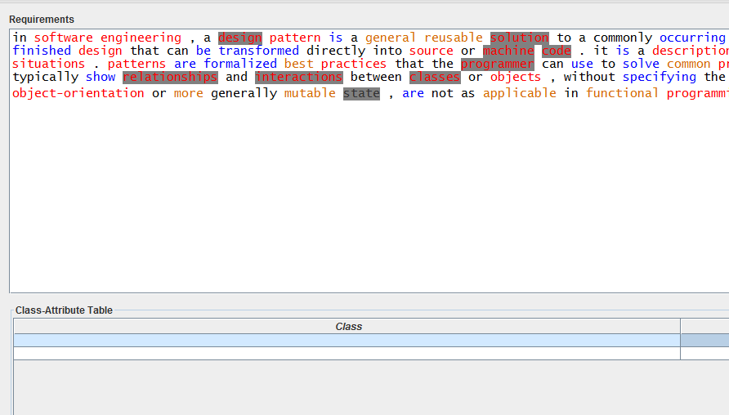

Dropping the entites in the table prompts for a dialog box which will be explained by the java classes in the next section.

**3. ClassificationController Class:**

This is the primary to handle all the words which are dragged and dropped from TextPane. It handles both Single select and multiple select. The Drag and Drop Handler is called as TransferHandler, and the abstract class of ClassificationController called StringTransferHandler implements TransferHandler. When the words are dropped into Class-Attribute table, then the import is done by ClassTableTransferHandler, and when it is dropped into Class-Relationship table, then it’s done by RelationshipTableTransferHandler.

**3.a. ClassTableTransferHandler Class:**

ClassTableTransferHandler basically have two actions to perform. When the words are dropped into the first column, then Add Class function will be triggered, but when the words are dropped into the second column, then Add Attributes function will be triggered. When the words are added to its appropriate Model Concept List, the handler will update the JTable.

Impacted Classes: AddClass, ClassObj, ClassOkAction, ClassDialog, AddAttributeAction, AttributeOkAction

1. **Add Class:**

When the words are dropped into Class column, it will open a dialog as shown below with dropped word as class name pre-filled.

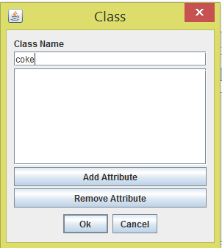

From the dialog, Attributes can also be added for each class.

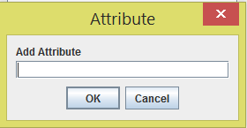

When there are multiple words are dropped, a new dialog for the next word will open when ok/cancel button of the first class is clicked.



1. **Add Attribute:**

When the words are dropped into Attributes column, then if a class is available in the dropped row, then the attributes are added to the corresponding class. If not no action will be taken.



**3.b. RelationshipTableTransferHandler Class:**

RelationshipTableTransferHandler will add a relationship between two classes, when a word is dropped into Class-Relationship table. Multiple drop is also possible, and the words can be dropped from either TextPane or Class-Attribute table. When a word is dropped, it will open up a dialog which will let the user the select the type of relationship. It can be Association, Aggregation, Inheritance and Association Class.

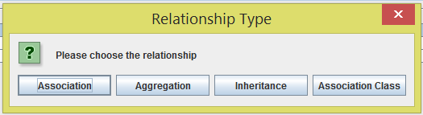

1. **Add Association:**

When Association option is selected, it gives the below dialog box. When Ok button is clicked, it will add the association relationship to the domain model concept list and update the JTables as given below:

SrcClass(Role)(Multiplicity) Association(RelName) DestClass(Role)(Multiplicity)

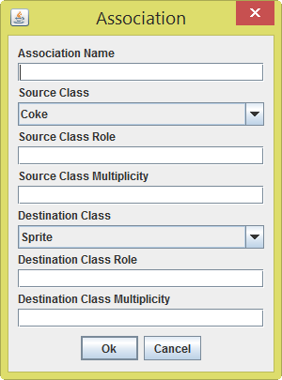

1. **Add Inheritance:**

When Inheritance option is selected, it gives the below dialog box. When Ok button is clicked, it will add the Inheritance relationship to the domain model concept list and update the JTables as given below:

SrcClass Inheritance DestClass

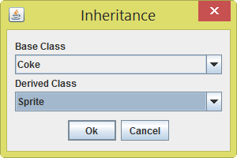

1. **Add Aggregation:**

When Aggregation option is selected, it gives the below dialog box. When Ok button is clicked, it will add the aggregation relationship to the domain model concept list and update the JTables as given below:

SrcClass Aggregation(RelName) DestClass(Multiplicity)

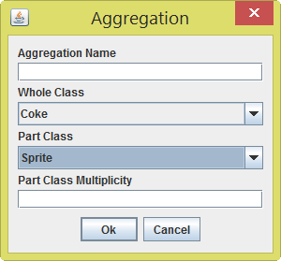

1. **Add Association Class:**

User must add an association class to an association. If system can’t find an association name for the association class, user can’t add it. This is the step to add association class:

Add an association for the association class.

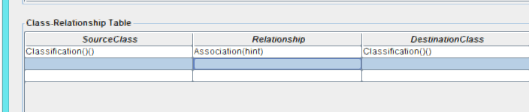

Drag the association verb and drop to the relationship column. In this example, user must drag the word “hint”.

In the pop dialog, choose AssociationClass

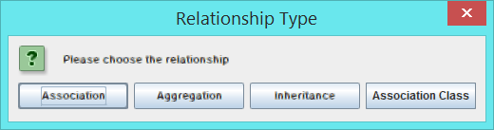

Then the AssociationClass dialog will display.

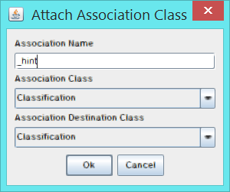

When Ok button is clicked, it will add the association class relationship to the domain model concept list and update the JTables as given below:

SrcClass AssociationClass(RelName) DestClass

**4. TableExpert class:**

Table Expert class is used to do all the JTable related actions like insert, deleted, update, etc.

**Patterns Applied in Iteration 2:**

Creator Pattern, Controller Pattern, Expert Pattern