* **Baremetal toggle led:**
* **Write startup in c**
* main.c

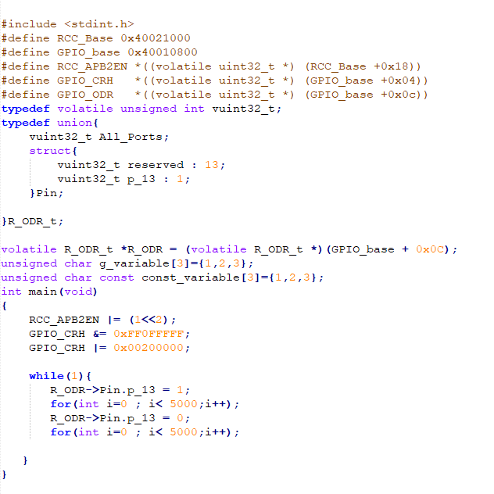

* Startup.c:

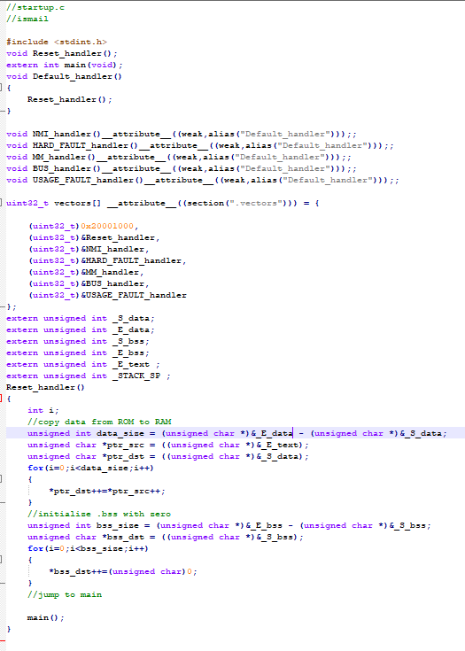

* Makefile :

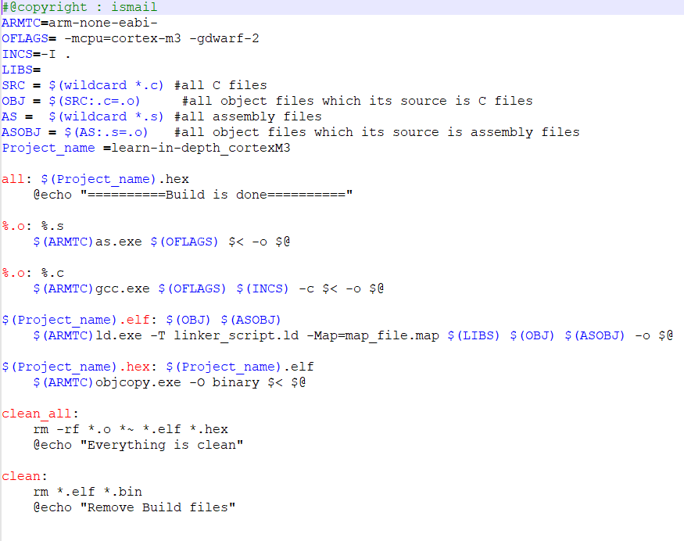

Run and debug simulation on proteus:

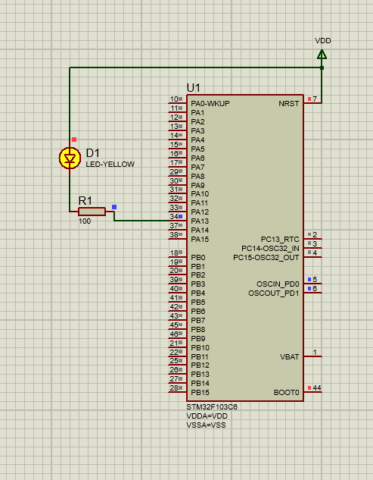

* **Linkerscript.ld**

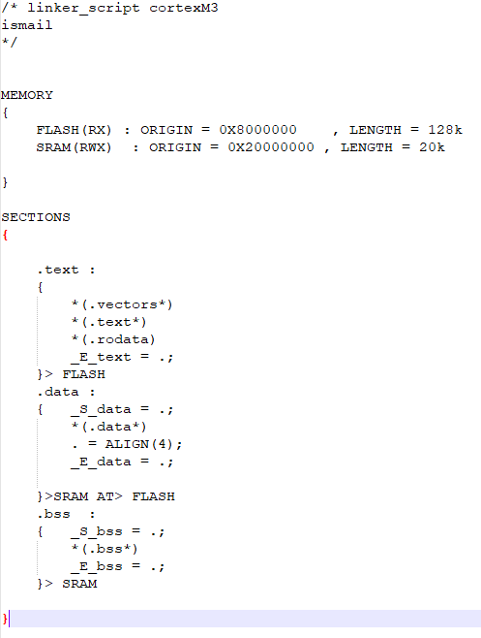

* **write startup in S**

**it’s gonna be the same thing for everything except:**

* **startup.s**

