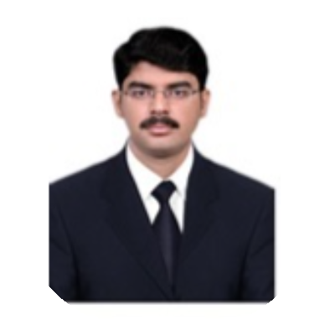

Ismail Sikkandar

## Senior IT Admin/IT Administrator/IT

**Engineer/Hardware & Network Support**

Email [ismailece@ymail.com](mailto:ismailece@ymail.com)

Address Vegetable Market Intersection Signal, Salwa Road, Doha

Phone +974 5206 5485

Date of birth May 23, 1987

Nationality Indian

Link https:/ [www.linkedin.com/in/ismail-sik](http://www.linkedin.com/in/ismail-sik) kandar-22639293/

# OBJECTIVE

Highly skilled and dedicated IT professional with a strong background in providing technical support and managing IT infrastructure. Experienced in troubleshooting, network administration, and software/hardware troubleshooting.

Seeking a challenging position as an Assistant IT Admin/IT Administrator/IT Support to contribute to the success of the organization.

# EXPERIENCE

Salwa Road , Qatar

*Jun 2016 - Present*

## Senior IT Administrator

***Al Jazira Group***

* Cloud Computing: Oracle, AWS - Implementation, Configuration, Troubleshoot & End user support.
* IT Annual Budget- Maintain & providing IT Annual budget to finance.
* windows server 2019,2016 - Troubleshoot, User support.
* ERP: end user support, installation & Troubleshoot.
* Network firewall: Troubleshoot, Installation & Troubleshoot.
* Computer hardware, software & Network:Troubleshoot, implementation &End user support.
* User & server data backup.
* CCTV: installation, troubleshoot & Centralization.
* Biometric & Facial Reorganizations device: implementation, Troubleshoot.
* Fixed Asset Management & Asset barcode system.

State of Kuwait

*Sep 2014 - Apr 2015*

## IT Administrator

***AATS General Trading & Stewdooring company***

* Proficient in managing and troubleshooting a wide range of hardware and software.
* Demonstrated expertise in managing IT help desk operations and providing excellent customer support.
* windows server 2019,2016 - Troubleshoot, User support.
* ERP : end user support, installation & Troubleshoot.
* Network firewall: Troubleshoot, Installation & Troubleshoot.
* Computer hardware, software & Network:Troubleshoot, implementation &End user support.
* User & server data backup.
* CCTV: installation, troubleshoot & Centralization.
* Biometric device: implementation, Troubleshoot.

State of Kuwait

*Apr 2011 - Aug 2014*

## IT Support/Hardware & Network Executive

***Las Palmas Restaurant & Management***

***(Subway, Charley’s, Classic Burger Joint & Benihana)***

* Windows server: installation, Troubleshoot & Configuration.
* POS (Point of Sales) - Troubleshoot, installation and configuration.
* Hospitality software: installation, Menu updates & SQL queries.
* Call center Management: VoIP Troubleshoot, Network installation.
* Biometric device: Configuration, implementation & Support.
* OS: Troubleshoot, Installation & configuration.

Bangalore - India

*May 2010 - Mar 2011*

## Quality Engineer

***EMI Solution Pvt.Ltd***

* Conducted extensive quality control tests to ensure compliance with industry standards and regulations.
* Collaborated with suppliers to establish quality assurance guidelines for incoming & Outgoing EMI & RFI Filters.
* Maintaining ISO standards for all EMI & RFI Filters

Chennai - India

*Jun 2009 - Feb 2010*

## System Administrator

*Hamsaveni So ware Pvt,Ltd*

* Troubleshoot computer hardware, software , Networking issue.
* User data backup.
* Installing Antivirus.
* Network implementation.
* Printer Troubleshoot and installation.

# EDUCATION

Tamil Nadu - India Tamil Nadu - India

*Jun 2005 - May 2009*

## BE/BTech

*P.S.R Engineering College /Anna university Affiliated*

Engineering & Information Technology - First class with distinction

*Mar 2003 - Apr 2005*

## Computer Science

*Asian Matric & Higher Secondary school*

# IT CERTIFICATIONS LANGUAGES

* Vulnerability Assessment & Penetration Test (VAPT)
* Diploma in Advance software Technology (DAST)
* Cisco Certified Network Associate (CCNA)
* Dot Net & Visual Basics

### Arabic

Intermediate

### Malayalam

Intermediate

### Tamil

Native

### Hindi

Intermediate

### English

Advanced

# PERSONAL INFORMATION

**Passport No** : S9950963

**Gender** : Male

**Marital Status** : Married

**Notice Period:** As per Norms

**Driving License:** Qatar & India

**Permanent Address:** 211B,Main Road, Thumbai Patti, Melur(Tk) Madurai(Dt), Tamil Nadu , India

# DECLERATION

I certify that information contained here is accurate, to the best of my knowledge.

SIGNATURE DATE

Ismail Sikkandar Sikkandar