**Assignment No. 04**

**Section 02**

**Topics:** Modified Condition Decision Coverage

Path Prediction Expression

Test Oracle

**Submitted by:**

Manahil Khalid **BSE173100**

Muhammad Ismail **BSE173065**

Muhammad Hashim Saleem **BSE161016**

Contents

**Description** 3

**Modified condition decision coverage(MCDC)** 3

**Test Oracle** 4

**Path Sensitization** 5

# **Description**

We have selected a program which can find the largest number. And the program contains four decisions and first three decisions there are three conditions. Let’s Look at the code where **Red** represents conditions and **black** represents decisions.

**if (n1 >= n2 && n1 >= n3 && n1 >= n4)**

**else if (n2 >= n1 && n2 >= n3 && n2 >= n4)**

**else if (n3 >= n1 && n3 >= n2 && n3 >= n4)**

**else**

**______________________**

# **Modified condition decision coverage(MCDC)**

There are total 24 = 16 test cases can me made because there are four variables which are used in condition. And through 16 cases there is the selection of that cases which satisfied MCDC.

**When n1=1, n2=4, n3=0, n4=2**

N1>=n2 && n1>=n3 && n1>=n4 **(False)**

N2>=n1 && n2>=n3 && n2>=n4 **(True)**

N3>=n1 && n3>=n2 && n3>=n4 **(False)**

N4>=n1 && n4>=n2 && n4>=n3 **(False)**

**When n1=5, n2=1, n3=1, n4=6**

N1>=n2 && n1>=n3 && n1>=n4 **(False)**

N2>=n1 && n2>=n3 && n2>=n4 **(False)**

N3>=n1 && n3>=n2 && n3>=n4 **(False)**

N4>=n1 && n4>=n2 && n4>=n3 **(True)**

**When n1=4, n2=1, n3=0, n4=2**

N1>=n2 && n1>=n3 && n1>=n4 **(True)**

N2>=n1 && n2>=n3 && n2>=n4 **(False)**

N3>=n1 && n3>=n2 && n3>=n4 **(False)**

N4>=n1 && n4>=n2 && n4>=n3 **(False)**

**When n1=0, n2=1, n3=3, n4=2**

N1>=n2 && n1>=n3 && n1>=n4 **(False)**

N2>=n1 && n2>=n3 && n2>=n4 **(False)**

N3>=n1 && n3>=n2 && n3>=n4 **(True)**

N4>=n1 && n4>=n2 && n4>=n3 **(False)**

These are the test cases which satisfies modified condition decision coverage because through these test cases it is conclude that all decisions give both true and false result and also all the conditions give both true and false result.

**______________________**

# **Test Oracle**

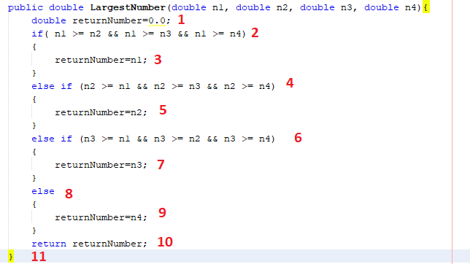

**From the above scenario:**

When n1=1, n2=4, n3=0, n4=2 then returnNumber=4

1🡪2🡪4🡪5🡪11

When n1=5, n2=1, n3=1, n4=6 then returnNumber=6

1🡪2🡪4🡪6🡪8🡪9🡪10🡪11

When n1=4, n2=1, n3=0, n4=2 then returnNumber=4

1🡪2🡪3🡪10🡪11

When n1=0, n2=1, n3=3, n4=2 then returnNumber=3

1🡪2🡪4🡪6🡪7🡪10🡪11

**______________________**

# **Path Sensitization**

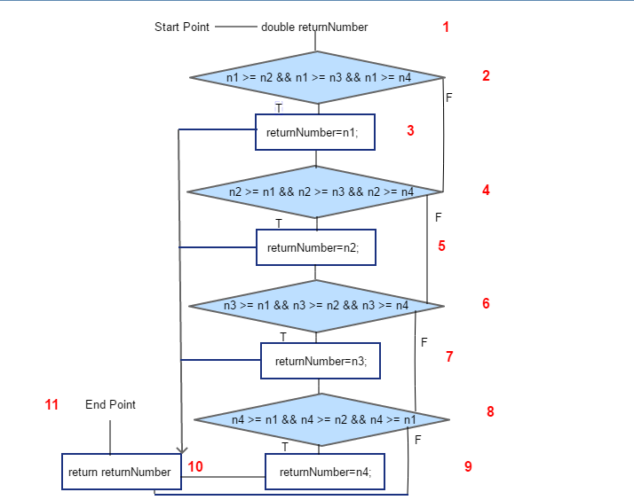

**Achievable path(s)**

1🡪2🡪3🡪10🡪11

1🡪2🡪4🡪5🡪10🡪11

1🡪2🡪4🡪6🡪10🡪11

1🡪2🡪4🡪6🡪8🡪10🡪11

**Unachievable path**

1🡪2🡪4🡪6🡪10🡪11

__________________________________________________________