i. What are the highest determinants for the expense of a used BMW?
The highest determinants of price of a used BMW are Engine Size, Mileage, Year, and Transmission. Larger engines and newer years increase the price, while higher mileage and manual transmissions decrease it.
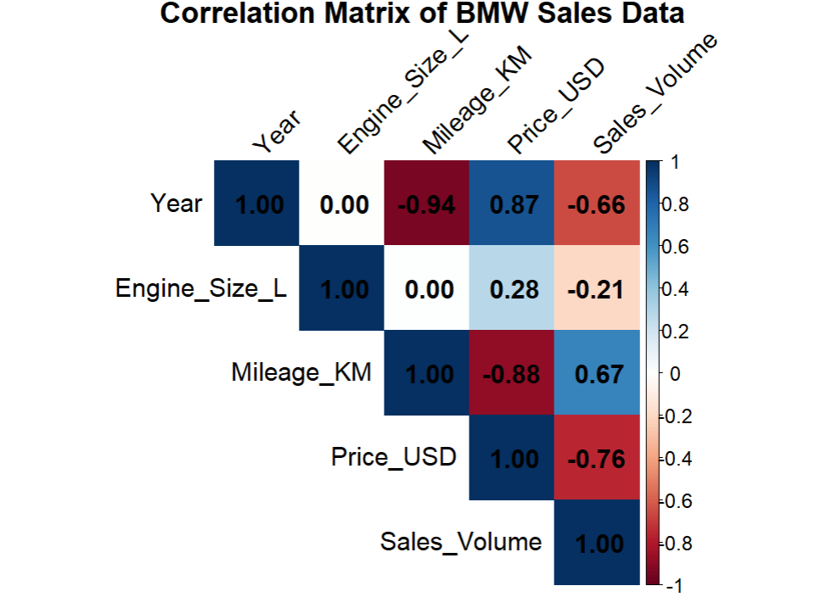
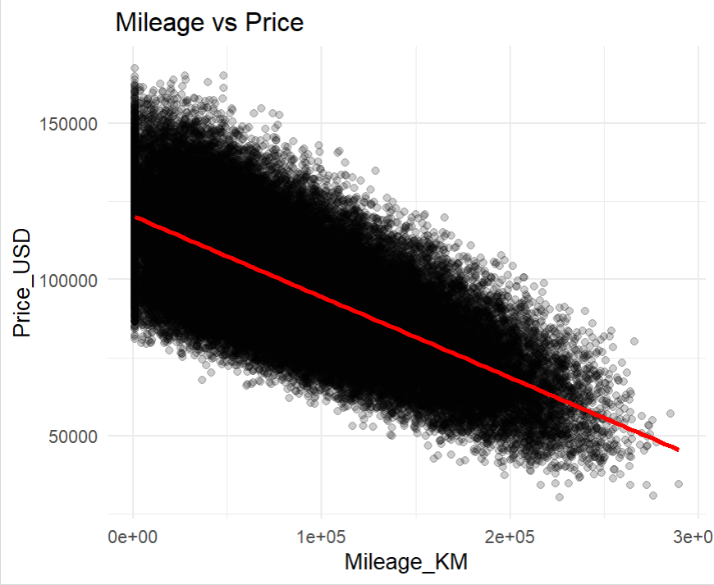

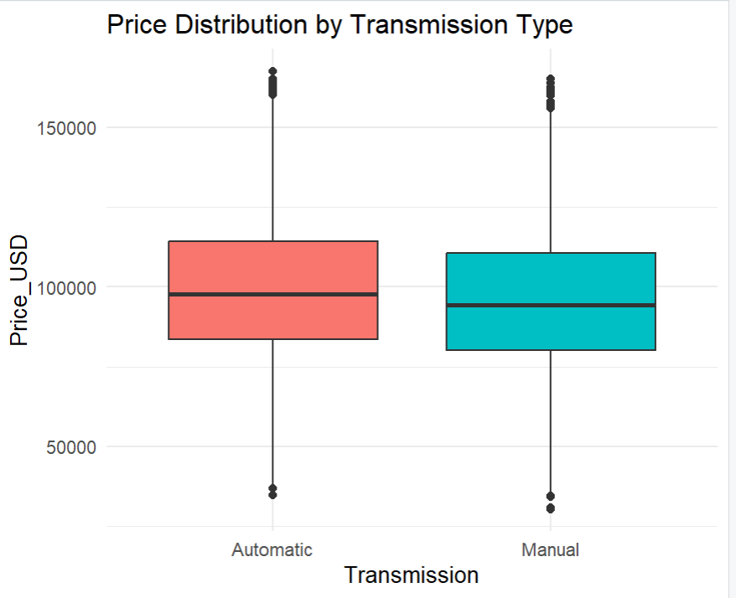
ii. How do the features of a vehicle like Engine Size, Mileage, Fuel Type and Transmission affect the final sale price and volume of sales?
Effect on Sale Price: Engine Size and Year have a strong positive effect on price. Mileage and a Manual Transmission have a strong negative effect. Fuel Type has a minimal impact.
Effect on Sales Volume: Price has the most direct impact: as price increases, sales volume decreases. Other features like Engine Size and Mileage affect sales indirectly by first changing the car's price.

