**__________________________________________________________________**

**Progress Report**

**Submitted to: Sir Haq Nawaz**

**Submitted by: Hafiz Muhammad Ismail Asad Roll No: BSEF18A044**

**Subject: Mobile Computing**

**Punjab University College of Information Technology,**

**PUCIT (Old Campus),**

**LAHORE**

**Step 1: You have to sign up on git hub if you are not already registered**

**Step 1.1: if you have account then you have to sign in**



**Step 1.2: give username and password to sign in**

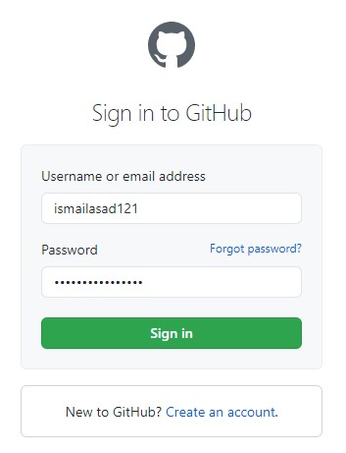

**Step 2: To create a new repository click on “+”**

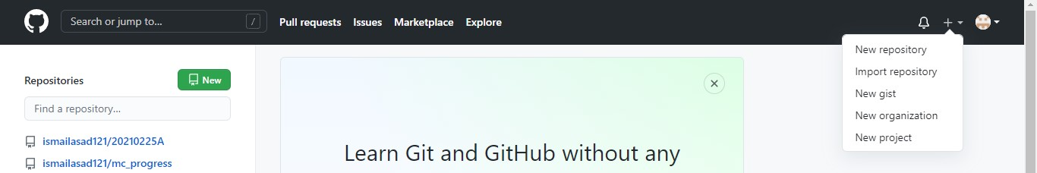

**Step 2.1: give name of repository if you want to have public repository then any one can see your repository**

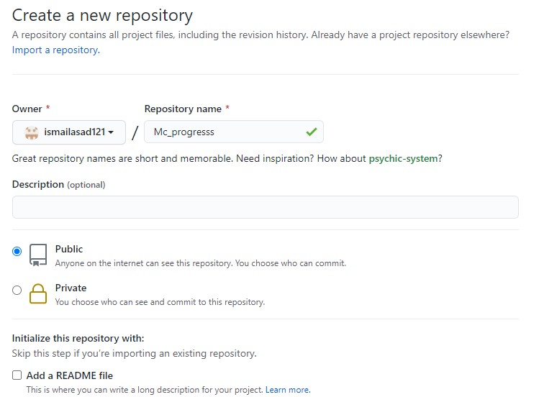

**Step 2.2: click on create repository**



**Step 2.3: here is link of your repository. You can share it with other .e.g team members**

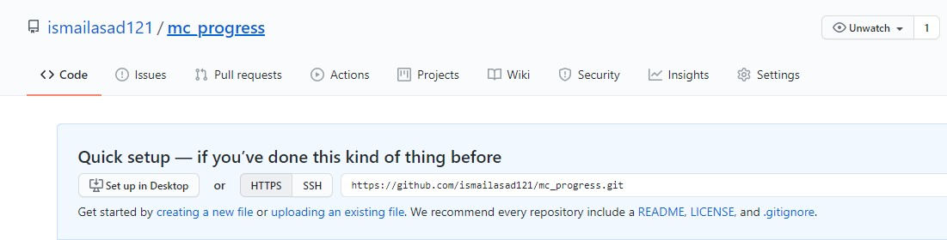

**Step 3: run cmd as administator**

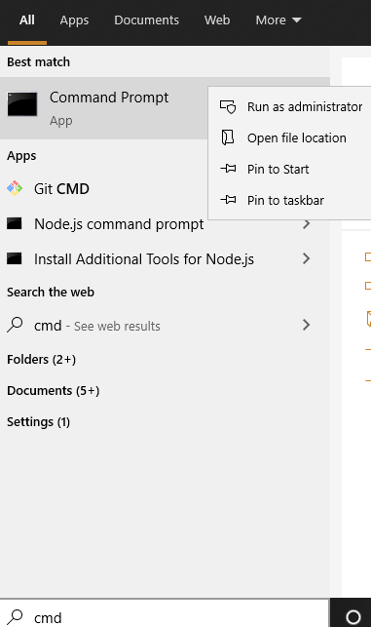

**Step 3.1 : copy link of repository and paste it to cmd to for cloning**

**We use command for this (git clone repository link)**

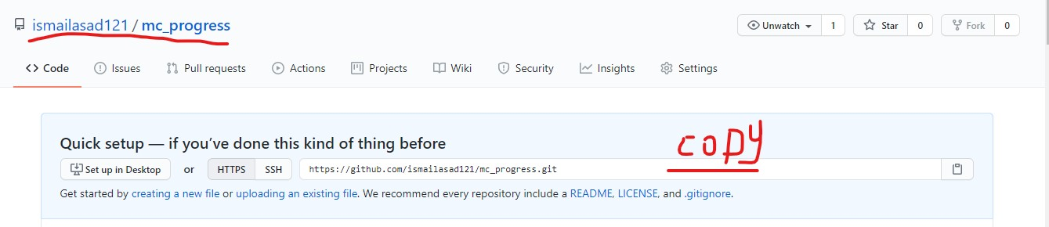

**Step 3.2 : We use command for this (git clone repository link)**

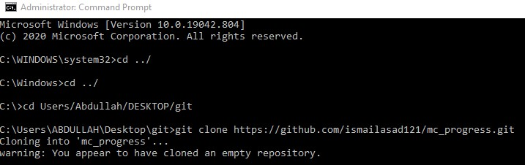

**Step 3.3 : You can see here is a folder named as our repository name**

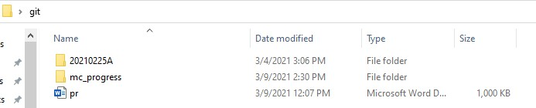

**Step 3.4 : We use command to add files (git add file name)**

**Step 3.5 : We use command to check status of files (git status)**

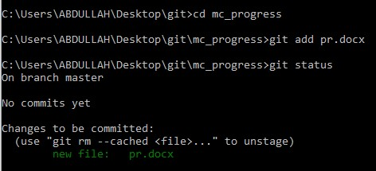

**Step 3.6 : We use command to give comments of files (git commit -m “comment”)**

**It will help others to identify file**

**Step 3.7 : We use command to sent files to online repository (git push -u origin master)**

**Git push command files sent to repository**

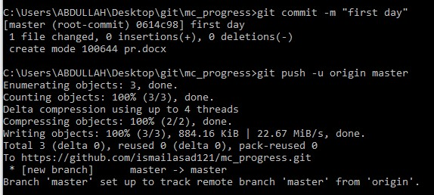

**Now you can see the file and comment added to repository**

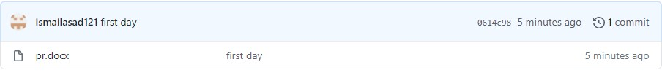

**Step 3.8 : when we change the file and add to git and check the status then you can see that git status is modified**

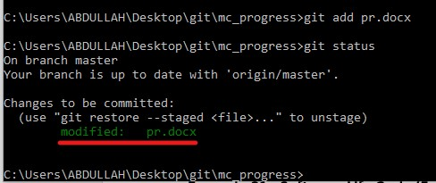

**We again use command to give comments of modified files (git commit -m “comment”).it tells us about changing ..i.e insertion deleltion.**

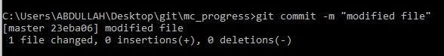

**We use push command to sent file online**



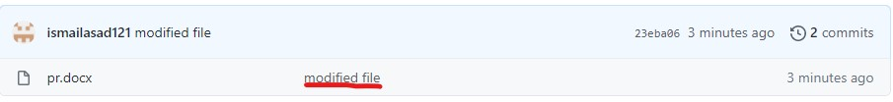

**Step 4 : We can edit files online .here you can see**

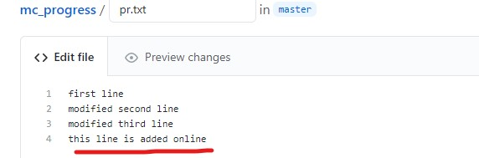

**Step 4.1 : we use pull command to extract file from online repository to our device. We use command to pull files (“git pull”)**

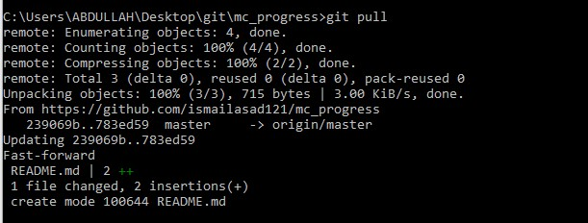

**Step 4.2 : We can edit files online and offline at the same time but we you have to save the files it will give you option that which changes you have to accept either one or both. here you can see example**

**Online changing file**

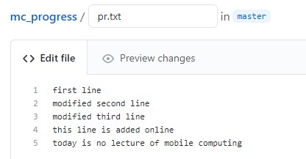

**On device changing file(offline)**

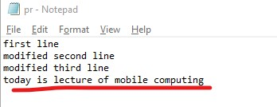

**Here you can see which files have to be accept**

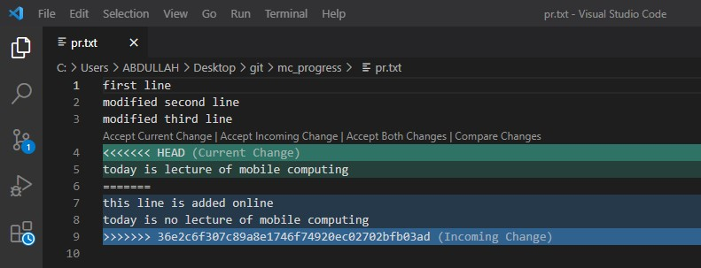

**Add file**

**Commit file**

**Push file**

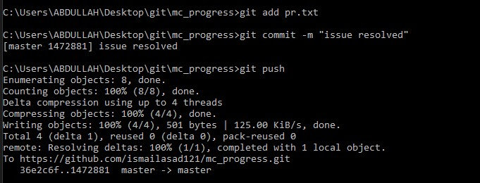

**Git log command is used to see the activity**

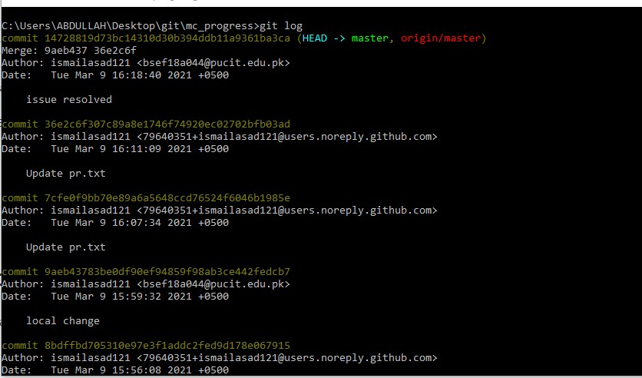

**Addition 2 files**

**Commit them**

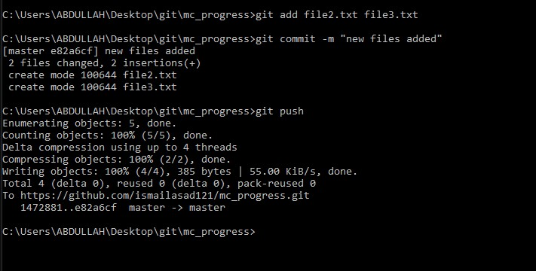

**Here you can see result**

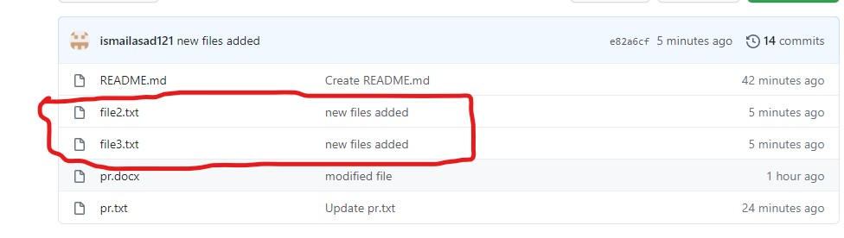

**Step 4.3: For deletion: We use command (“git rm file name”)**

**Git add . (.) Is used for adding all files**

**Commit them**

**Push them**

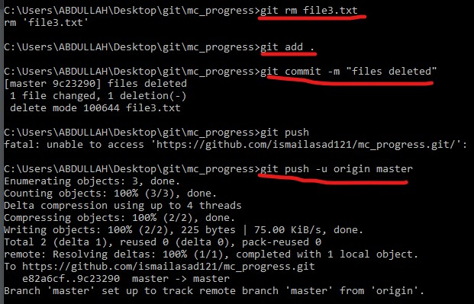

**Here is result …file deleted successfully**

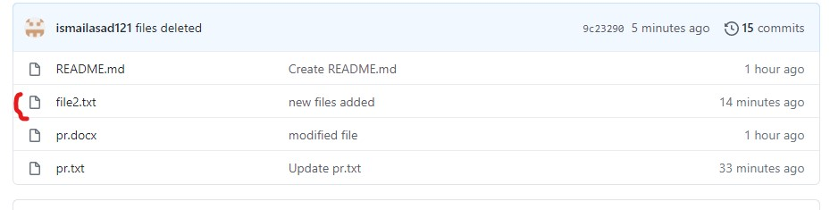

**Step 5:**

**Branch**

**Step 5.1: Git branch : this command is used to check in which branch you are**

**Step 5.2:Git chechout -b “branch name”: this command is used to add new branch**

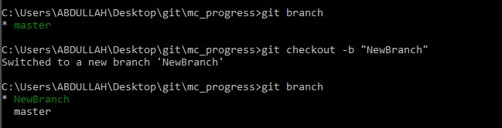

**Step 5.3:Git commit -am “comment”: This command is used to add and commit files or branch at the same time.**

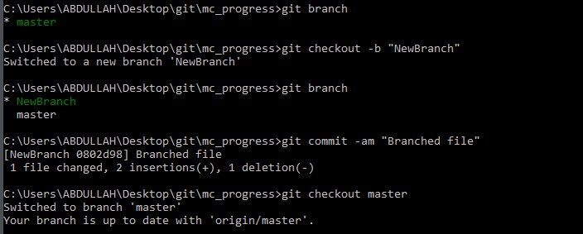

**Step 5.4: Git merge “branch name”. This command is used to merge branches. This command is very important.**

**Step 5.5: Git branch -D “branch name”. This command is used to delete branch.**

