A Comparative Study of Data Generation Strategies for Imbalanced Classification: Synthetic, Simulated, and Augmented Data
Full-paper draft based on completed 30-seed experiments | 27 October 2026

Abstract
Class imbalance is a persistent challenge in supervised classification, particularly when minority-class observations are limited. Although oversampling, generative modeling, simulation, and class weighting are frequently used to address this problem, their downstream predictive benefits may depend on the data-generating process and classifier. This study compares baseline learning, class weighting, Synthetic Minority Over-sampling Technique (SMOTE), Conditional Tabular Generative Adversarial Networks (CTGAN), and oracle-based simulation under controlled, reproducible conditions.
Five scenarios represent overlapping class distributions, nonlinear decision boundaries at two noise levels, and distribution shifts involving nuisance or informative variables. Logistic regression and random forest are evaluated using 30 independent evaluation seeds per scenario, with 750 fitting observations, 250 validation observations, and 2,000 test observations per seed. CTGAN training duration was selected separately using development seeds, yielding 10 epochs for both classifiers among the investigated candidates. Average Precision (AP) was designated the primary outcome, with ROC-AUC, F1-score, and balanced accuracy as secondary measures. For each scenario and classifier, four alternatives were compared with the baseline through paired AP differences; two-sided paired t-tests were adjusted using the Holm procedure across 40 comparisons.
The completed experiment generated 3,000 result rows, including default and validation-tuned decision-threshold policies. Twenty-five of the 40 primary comparisons showed a Holm-adjusted statistically significant difference, and all 25 favored the baseline. Across the ten scenario–classifier combinations, the descriptive mean AP differences relative to baseline were −0.0167 for class weighting, −0.0375 for SMOTE, −0.0519 for CTGAN, and −0.0018 for oracle-based simulation. The numbers of significant decreases were six, nine, eight, and two, respectively. No alternative demonstrated a statistically significant AP improvement after multiplicity adjustment. Effects nevertheless varied across scenarios and classifiers, with the oracle-based approach generally remaining closer to baseline than the other alternatives.
These results indicate that generating or reweighting minority-class observations does not guarantee better ranking performance, even when methods are evaluated under a shared experimental framework. They also underline the importance of classifier-specific responses, independent hyperparameter selection, and multiplicity-aware inference. Conclusions are restricted to the simulated settings and implementation choices examined here; the study does not establish that the baseline is universally preferable. The framework provides a reproducible basis for identifying when additional minority-class data may or may not improve imbalanced classification.
Keywords: Synthetic data; simulated data; data augmentation; class imbalance; machine learning.

1. Introduction
Class imbalance can make minority-class recognition difficult, while conventional aggregate accuracy may conceal poor minority-class behavior (He & Garcia, 2009). A family of responses includes cost-sensitive learning, interpolation-based oversampling, learned tabular generators, and simulation-based sampling. These interventions have different inductive assumptions and may distort the training distribution in different ways.
SMOTE synthesizes examples through interpolation among minority neighbors (Chawla et al., 2002), whereas CTGAN models tabular data with a conditional adversarial generator (Xu et al., 2019). Oracle-based simulation, in this controlled study, uses knowledge of the generating mechanism and is not an operational method available for ordinary real-world datasets. We ask whether these approaches improve test-set ranking performance relative to an unchanged baseline, and how their effects vary with scenario and classifier.
The contributions are (i) a common evaluation framework across five scenarios and two classifiers, (ii) independently selected CTGAN training duration, (iii) paired, multiplicity-adjusted comparisons on 30 evaluation seeds, and (iv) a transparent account of negative and heterogeneous outcomes.

2. Related Work
Imbalanced learning has long motivated sampling and cost-sensitive techniques (He & Garcia, 2009). SMOTE remains a foundational oversampling method, although its assumptions can be challenged by complex class geometry and overlapping distributions (Chawla et al., 2002; Fernández et al., 2018).
CTGAN was introduced to address mixed-type and multimodal tabular distributions (Xu et al., 2019). Its ability to imitate tabular distributions does not logically imply a downstream improvement in any specific classifier or metric. For imbalanced evaluation, precision–recall-oriented metrics offer information that ROC-based summaries can obscure (Saito & Rehmsmeier, 2015). Accordingly, AP is used as the primary endpoint.

3. Experimental Design
We compare baseline (unmodified fitting set), class weighting, SMOTE, CTGAN, and oracle-based minority sampling. The downstream learners are logistic regression (LR) and random forest (RF; 80 trees). Each of 30 evaluation seeds (10000–10029) is used across five scenarios. For each seed and scenario, 750 observations are allocated to fitting, 250 to validation, and 2,000 to testing. Augmentation is restricted to the fitting data; the validation set is used for threshold tuning, and the test set for evaluation.
S1 represents overlapping class distributions. S2a and S2b represent nonlinear ring-like boundaries with lower and higher noise, respectively. S3a and S3b are shifted-test variants of S1 involving nuisance and informative variables, respectively. These descriptions follow the established experimental design; the supplied result archive does not include the generator source code, so the manuscript does not assert unverified parameter-level implementation details.
The CTGAN epoch candidate set was {10, 50, 100}; independent development seeds 9100–9109 selected 10 epochs for LR and RF by average validation AP across scenarios. The confirmatory seed set did not inform this selection. For threshold-dependent secondary outcomes, a default 0.5 cutoff and a validation-F1-tuned cutoff were evaluated. AP and ROC-AUC do not depend on this threshold policy.
Primary inference compares each non-baseline method with the baseline within the same scenario, seed, and classifier, using test AP differences. For each of 5 × 2 × 4 = 40 contrasts, a two-sided paired t-test was applied to the 30 seed-level differences. The family of 40 p-values was adjusted with Holm’s step-down method (Holm, 1979), with adjusted p < 0.05 defining statistical significance. Reported 95% t intervals are unadjusted descriptive intervals, not simultaneous familywise intervals.

4. Results
All 3,000 expected result rows are present: 5 scenarios × 30 seeds × 5 methods × 2 classifiers × 2 threshold policies. The supplied primary analysis contains all 40 expected contrasts. No duplicate result keys or recorded failed units were found in the delivered archive.
Of 40 Holm-adjusted primary contrasts, 25 were statistically significant and all 25 had negative mean AP differences. No method yielded a Holm-significant positive AP difference. The method-level averages across ten scenario–classifier conditions were −0.0167 (class weighting), −0.0375 (SMOTE), −0.0519 (CTGAN), and −0.0018 (oracle). These averages are descriptive aggregations of condition-level effects rather than pooled inferential tests.
SMOTE had nine statistically significant negative contrasts; CTGAN eight; class weighting six; and oracle two. Importantly, the apparent oracle advantage in several LR settings did not survive Holm correction. Differences vary across classifier and scenario, making a single universal ranking inappropriate.

Table 1. Primary method-level comparison
Method | Mean ΔAP | Significant losses / 10 | Significant gains / 10
Class Weight | -0.0167 | 6 | 0
Smote | -0.0375 | 9 | 0
Ctgan | -0.0519 | 8 | 0
Oracle | -0.0018 | 2 | 0
Note: Mean ΔAP is the descriptive average of ten scenario–classifier contrasts; Holm significance is determined over the full family of 40 contrasts.
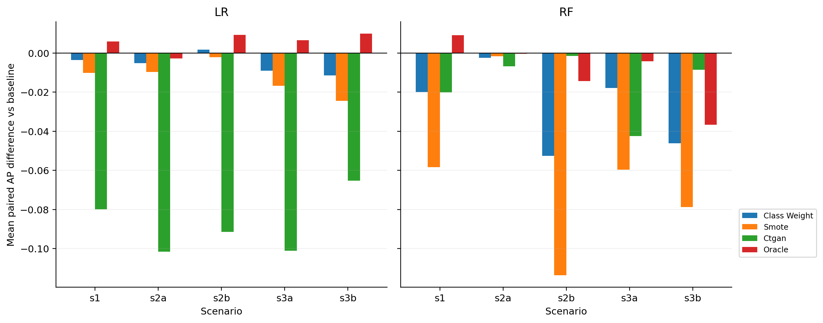
Figure 1. Mean paired AP difference relative to baseline by scenario and classifier.
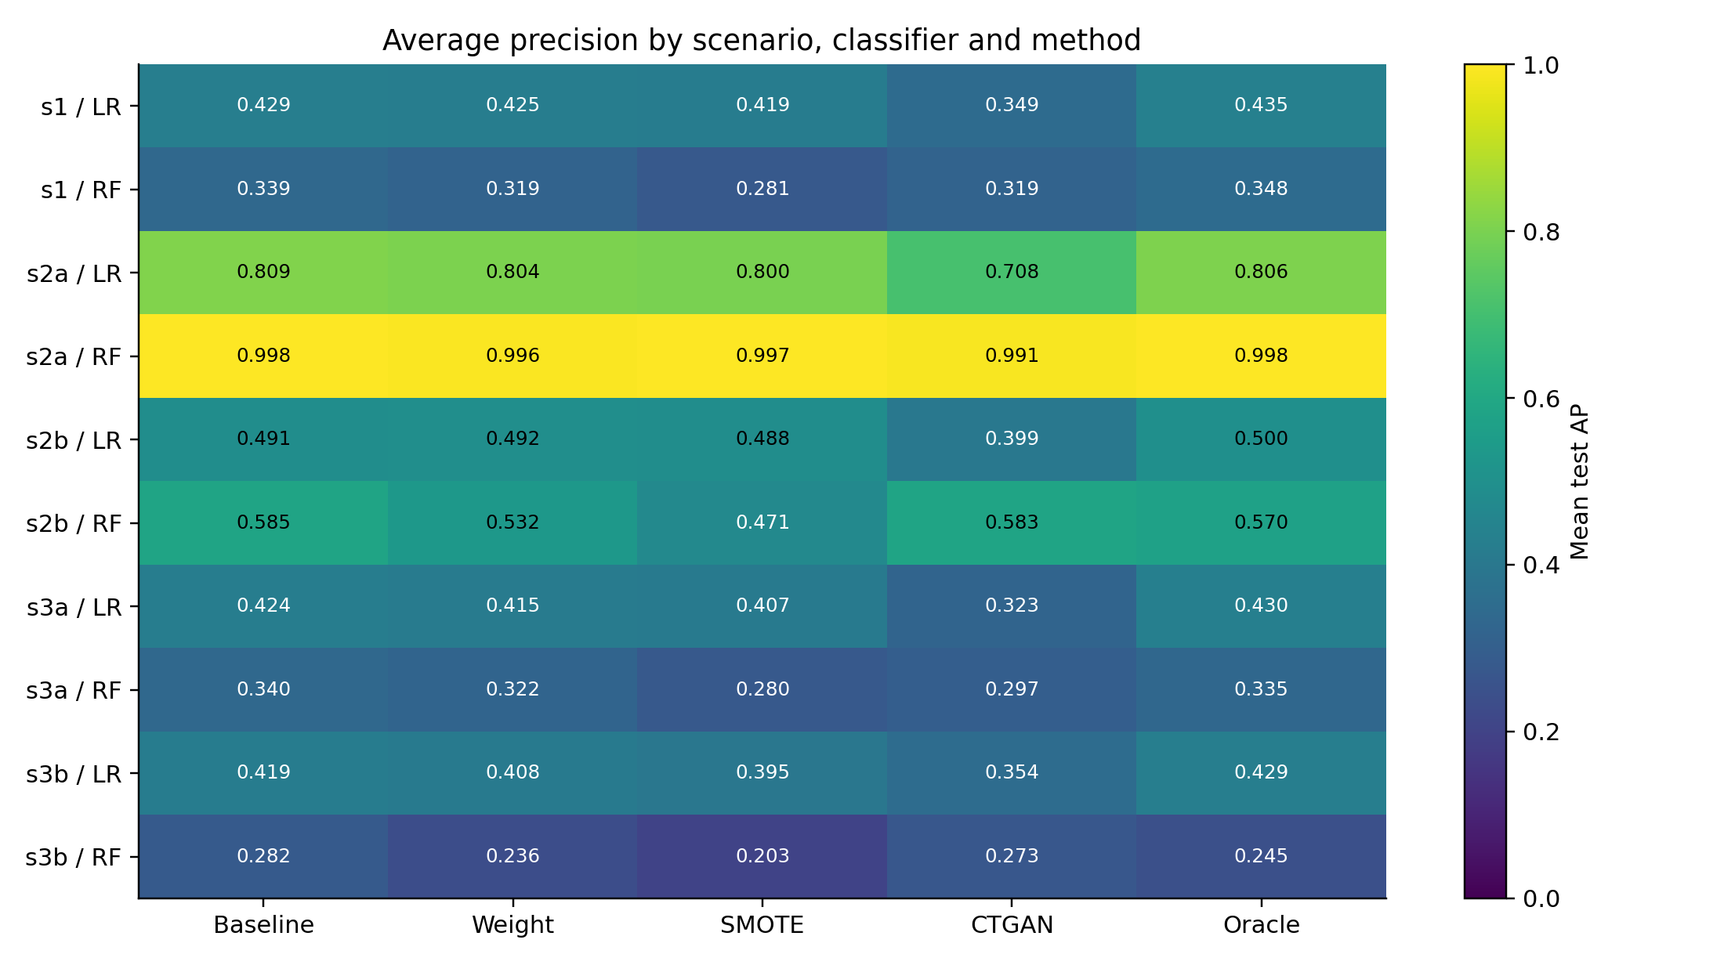
Figure 2. Mean test AP under the default decision-threshold policy.

5. Discussion
The findings caution against treating minority-class augmentation as an automatic route to improved ranking performance. Interpolation may place synthetic examples in regions poorly aligned with the true decision geometry; generative sampling may reproduce imperfect minority-class structure or alter the effective learning distribution. These are plausible mechanisms, not causal conclusions established by the current output tables.
Oracle-based sampling was generally closer to the baseline in average AP difference than the other approaches, but it was not uniformly beneficial. Because an oracle relies on the known data-generating mechanism, it should be viewed as an experimental reference rather than a directly deployable technique. The marked LR–RF and scenario differences underscore the need to report classifier–generator interactions rather than collapsing all experiments into one headline score.
An additional interpretive distinction is that the current results establish downstream predictive performance, not generative fidelity or computational efficiency. Although these dimensions motivated the broader research design, the supplied archive does not contain structural-consistency scores or generation-time measurements. Claims about those quantities are therefore withheld.

6. Limitations and Validity
All five scenarios are controlled simulations, not independent real-world datasets. The study uses two classifiers, a limited CTGAN epoch search, one fitting-set size, and one configured random-forest size. Consequently, these results cannot establish that augmentation generally fails or that the baseline is optimal outside the tested settings.
The 30 seeds provide paired replication within the specified generators, but do not represent 30 independent real-world datasets. The paired t-test assumes that seed-level differences provide an appropriate basis for inference; dependence introduced by generator design or shared scenario construction may constrain generalization. The 95% intervals are not multiplicity-adjusted. Additional sensitivity analyses, alternative inferential procedures, and real-data replication would strengthen external validity.
Finally, the experiment manifest and CSV outputs support computational traceability but do not constitute independent proof of prospective protocol registration. The manuscript reports the analysis as executed and avoids stronger claims about external preregistration.

7. Conclusion
Across five simulated scenarios, two classifiers, and 30 evaluation seeds, no alternative to baseline learning produced a Holm-significant AP improvement, whereas 25 of 40 comparisons showed significant decreases. This result supports careful, context-dependent evaluation of data generation and reweighting rather than routine adoption. Future work should test broader datasets, richer generators, and measured fidelity–utility–cost trade-offs.

References
He, H., & Garcia, E. A. (2009). Learning from imbalanced data. IEEE Transactions on Knowledge and Data Engineering, 21(9), 1263–1284. https://doi.org/10.1109/TKDE.2008.239
Chawla, N. V., Bowyer, K. W., Hall, L. O., & Kegelmeyer, W. P. (2002). SMOTE: Synthetic Minority Over-sampling Technique. Journal of Artificial Intelligence Research, 16, 321–357. https://doi.org/10.1613/jair.953
Xu, L., Skoularidou, M., Cuesta-Infante, A., & Veeramachaneni, K. (2019). Modeling tabular data using conditional GAN. Advances in Neural Information Processing Systems, 32. https://papers.nips.cc/paper_files/paper/2019/hash/254ed7d2de3b23ab10936522dd547b78-Abstract.html
Saito, T., & Rehmsmeier, M. (2015). The precision-recall plot is more informative than the ROC plot when evaluating binary classifiers on imbalanced datasets. PLOS ONE, 10(3), e0118432. https://doi.org/10.1371/journal.pone.0118432
Holm, S. (1979). A simple sequentially rejective multiple test procedure. Scandinavian Journal of Statistics, 6(2), 65–70. https://www.jstor.org/stable/4615733
Fernández, A., García, S., Herrera, F., & Chawla, N. V. (2018). SMOTE for learning from imbalanced data: Progress and challenges, marking the 15-year anniversary. Journal of Artificial Intelligence Research, 61, 863–905. https://doi.org/10.1613/jair.1.11192

Appendix A. Complete primary comparisons
Each row reports the mean seed-paired AP difference, 95% unadjusted t interval, Holm-adjusted p-value, and adjusted significance at α = 0.05. Full-precision values are also supplied in the accompanying CSV.

Scenario s1
Model | Method | Mean ΔAP | 95% t CI | Holm p | Sig.
LR | class_weight | -0.0036 | [-0.0059, -0.0013] | 0.0511 | No
LR | ctgan | -0.0799 | [-0.1108, -0.0490] | 0.000342 | Yes
LR | oracle | +0.0059 | [+0.0013, +0.0105] | 0.151 | No
LR | smote | -0.0101 | [-0.0145, -0.0058] | 0.00133 | Yes
RF | class_weight | -0.0200 | [-0.0273, -0.0126] | 0.00018 | Yes
RF | ctgan | -0.0201 | [-0.0326, -0.0077] | 0.0438 | Yes
RF | oracle | +0.0092 | [-0.0010, +0.0194] | 0.61 | No
RF | smote | -0.0583 | [-0.0678, -0.0488] | 1.16e-11 | Yes

Scenario s2a
Model | Method | Mean ΔAP | 95% t CI | Holm p | Sig.
LR | class_weight | -0.0053 | [-0.0088, -0.0018] | 0.064 | No
LR | ctgan | -0.1016 | [-0.1494, -0.0538] | 0.00389 | Yes
LR | oracle | -0.0027 | [-0.0087, +0.0033] | 1 | No
LR | smote | -0.0097 | [-0.0136, -0.0057] | 0.000828 | Yes
RF | class_weight | -0.0025 | [-0.0036, -0.0014] | 0.00133 | Yes
RF | ctgan | -0.0069 | [-0.0090, -0.0047] | 9.12e-06 | Yes
RF | oracle | -0.0004 | [-0.0014, +0.0006] | 1 | No
RF | smote | -0.0016 | [-0.0026, -0.0006] | 0.0438 | Yes

Scenario s2b
Model | Method | Mean ΔAP | 95% t CI | Holm p | Sig.
LR | class_weight | +0.0017 | [-0.0008, +0.0042] | 1 | No
LR | ctgan | -0.0915 | [-0.1225, -0.0604] | 4.7e-05 | Yes
LR | oracle | +0.0093 | [+0.0031, +0.0155] | 0.064 | No
LR | smote | -0.0021 | [-0.0057, +0.0015] | 1 | No
RF | class_weight | -0.0526 | [-0.0629, -0.0423] | 9.35e-10 | Yes
RF | ctgan | -0.0016 | [-0.0086, +0.0054] | 1 | No
RF | oracle | -0.0143 | [-0.0232, -0.0055] | 0.0436 | Yes
RF | smote | -0.1136 | [-0.1299, -0.0973] | 4.95e-13 | Yes

Scenario s3a
Model | Method | Mean ΔAP | 95% t CI | Holm p | Sig.
LR | class_weight | -0.0090 | [-0.0144, -0.0036] | 0.0365 | Yes
LR | ctgan | -0.1011 | [-0.1330, -0.0691] | 1.49e-05 | Yes
LR | oracle | +0.0065 | [-0.0003, +0.0132] | 0.534 | No
LR | smote | -0.0167 | [-0.0251, -0.0083] | 0.00715 | Yes
RF | class_weight | -0.0179 | [-0.0270, -0.0088] | 0.0081 | Yes
RF | ctgan | -0.0425 | [-0.0633, -0.0218] | 0.00551 | Yes
RF | oracle | -0.0043 | [-0.0176, +0.0090] | 1 | No
RF | smote | -0.0597 | [-0.0716, -0.0477] | 1.51e-09 | Yes

Scenario s3b
Model | Method | Mean ΔAP | 95% t CI | Holm p | Sig.
LR | class_weight | -0.0115 | [-0.0197, -0.0033] | 0.0949 | No
LR | ctgan | -0.0653 | [-0.0992, -0.0313] | 0.00957 | Yes
LR | oracle | +0.0099 | [+0.0008, +0.0190] | 0.339 | No
LR | smote | -0.0245 | [-0.0360, -0.0129] | 0.00401 | Yes
RF | class_weight | -0.0462 | [-0.0550, -0.0374] | 4.6e-10 | Yes
RF | ctgan | -0.0085 | [-0.0209, +0.0039] | 1 | No
RF | oracle | -0.0366 | [-0.0530, -0.0203] | 0.00213 | Yes
RF | smote | -0.0787 | [-0.0911, -0.0664] | 4.46e-12 | Yes

Appendix B. Reproducibility and outstanding checks
- Source: final_experiment_results.zip (3,000 per-seed rows; 40 comparison rows; run manifest).
- Analysis: Average Precision primary, threshold policy default; Holm-adjusted paired t-tests.
- The archive does not provide independent structural-fidelity or runtime measurements.
- Before conference submission: insert verified author names, affiliations, correspondence details, conflict/funding statements, and conference template requirements.
- Confirm whether the target conference requests an abstract only at first submission; do not include references or figures in the abstract-only file.

