In City Master:
- Add fields, Railway Station, Airport, Un/Loading Point, Warehouse, Port
GCN Booking - Transaction screen
- Add Pickup From – Dropdown list of branches
- Shipped To - Dropdown list of branches
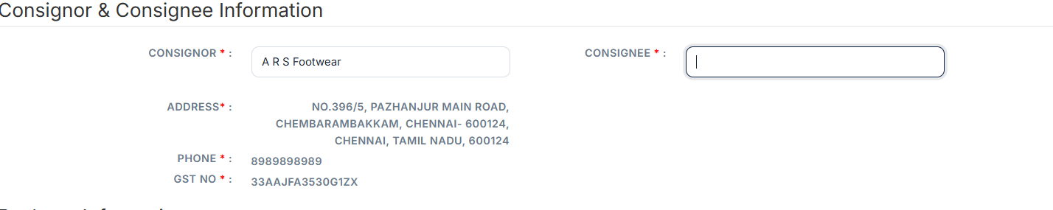
- Change Tracking Code – To PNR# - In all places
- Track Consignment – Any one Either GRN or PNR
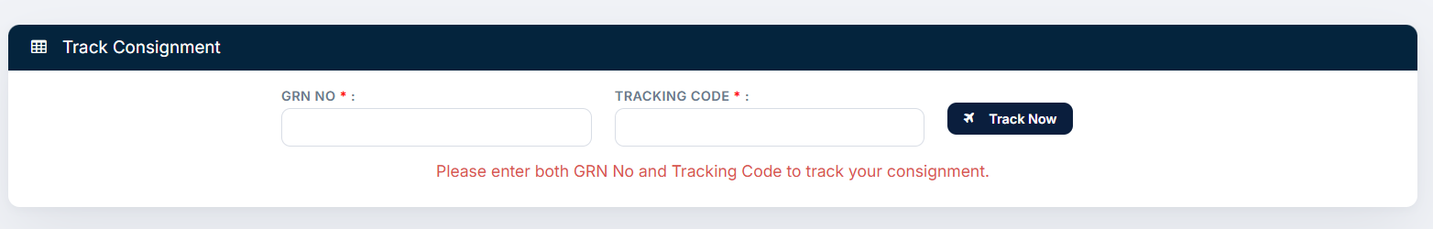
- Consignment Status – Add Current Date and Time, but editable.
- Consignment Status – Automated Notifications

1. Consignment Booked
Status: Booked
Message:
Your consignment [GCN#] from [Consignor, Location] to [Consignee, Location] has been booked successfully. Thank you for choosing EliteWave360 Logistics.

2. Consignment Picked Up
Status: Picked Up
Message:
Your consignment [GCN#] has been picked up from [Consignor, Location] and is on its way to our nearest processing and loading hub.

3. In Transit – Loading Hub
Status: In Transit
Message:
Your consignment [GCN#] has reached our [Loading Hub, City] and is being prepared for onward transportation via [Air / Rail / Surface].

4. In Transit – Destination Hub
Status: In Transit
Message:
Your consignment [GCN#] has arrived at [Destination Hub / Station / Airport, City] and will shortly proceed to the final delivery location.

5. In Transit – Destination City
Status: In Transit
Message:
Good news! Your consignment [GCN#] has reached [Destination City] and is being scheduled for final delivery.

6. At Destination
Status: At Destination
Message:
Your consignment [GCN#] has reached the destination branch and will be delivered soon.

7. Out for Delivery
Status: Out for Delivery
Message:
Your consignment [GCN#] is out for delivery and will be delivered today to [Consignee Name] at [Delivery Location].

8. Delivered Successfully
Status: Delivered
Message:
Your consignment [GCN#] from [Consignor, Location] to [Consignee, Location] has been delivered successfully. Thank you for choosing EliteWave360 Logistics.

