Task 1: Linux System Administration
- Systemd Service
  - Create a simple systemd service that runs a Python/NodeJS web server (using Flask/ExpressJS).
  - Configure the service to restart automatically if it stops unexpectedly.
- Kernel Tuning
  - Edit your /etc/sysctl.conf to adjust one network parameter (for example, increase net.core.somaxconn).
  - Apply the changes and verify they are in effect (using sysctl -p).
- Firewall Setup
  - Use UFW (or firewalld) to allow only HTTP/HTTPS traffic.
  - Block all other incoming connections.
Deliverable:
A short script or a set of command-line instructions that create the service, adjust the kernel parameter, and configure the firewall.

Output:

sudo nano /etc/systemd/system/express.service
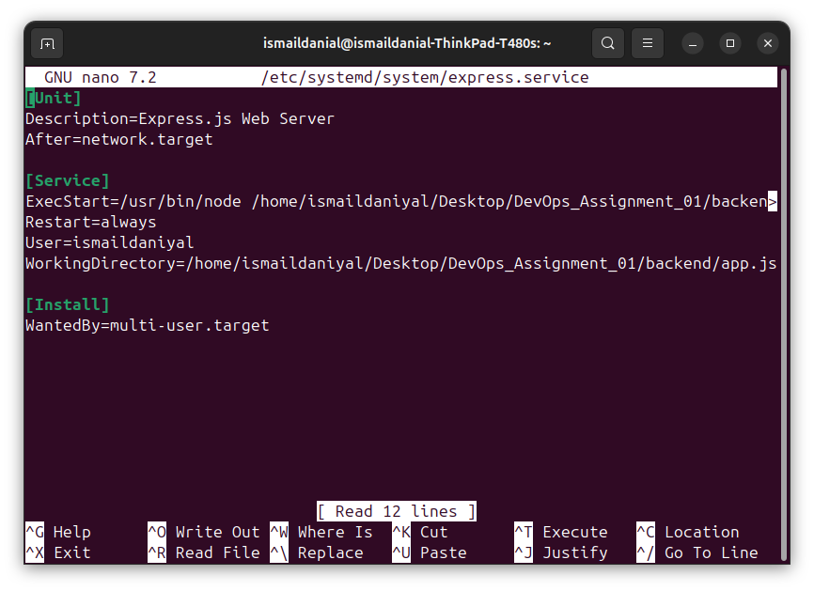

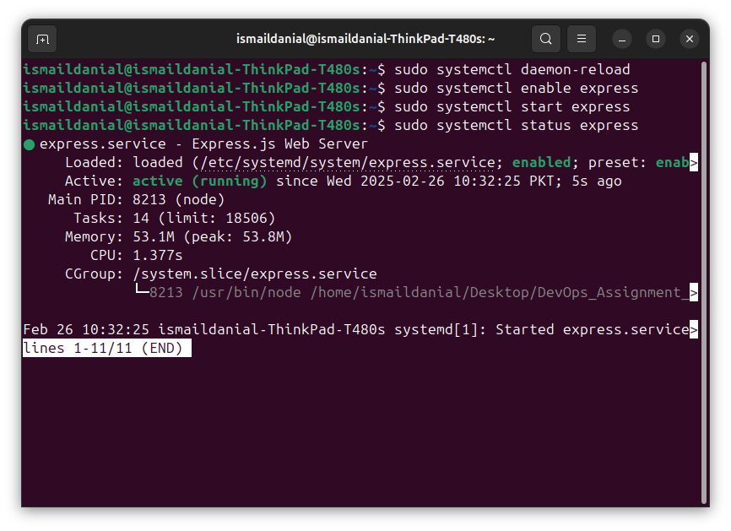

Kernal Tunning:

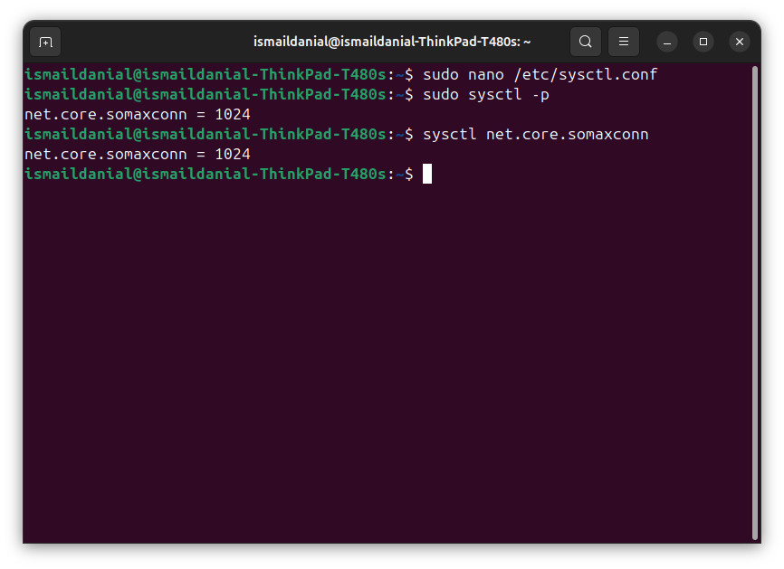
Firewall Setup:
