Machine Learning App for Commodity Price Prediction

1. Name and Purpose of the Application
GoldPricePredictor is a Python-based machine learning application designed to predict the next-day closing price of gold using historical price data and technical indicators. The purpose of this application is to demonstrate the application of supervised learning techniques to a real-world financial forecasting problem.

2. Algorithms Used
The application uses a Random Forest Regressor, a supervised machine learning algorithm well-suited for regression tasks involving nonlinear relationships. Random Forest was selected due to its robustness to noise, ability to model complex interactions between features, and strong performance on tabular financial datasets.

3. Dataset Information
3.1 Source
Yahoo Finance – Gold Futures (GC=F)
3.2 Number of Records
Approximately 2,700 daily records
3.3 Number of Features
7 input features, 1 target variable
3.4 Feature Description (example)
Feature | Description | Type
Open | Opening price | Float
MA5 | 5-day moving average | Float
Lag1 | Previous day close | Float
3.5 Preprocessing Steps
- Missing values removed
- Rolling averages computed
- Lagged features created
- Target variable shifted to predict next-day price

4. Libraries, Toolkits, and Frameworks
- Pandas: Data manipulation
- NumPy: Numerical operations
- Scikit-learn: Machine learning model and evaluation
- Matplotlib: Data visualization
- yfinance: Data acquisition

5. Application Design and Implementation
The application follows a structured pipeline: data acquisition, feature engineering, target shifting for future prediction, model training, evaluation, and visualization of results.

6. Instructions for Running the App
- Install Python 3.11 or later
- Install dependencies using pip install -r requirements.txt
- Run the script using python gold_price_predictor.py

7. Results
The model successfully generated next-day price predictions for gold. Figure 1 shows a comparison between actual and predicted prices. The Mean Absolute Error (MAE) demonstrates reasonable predictive performance given the volatility of commodity markets.
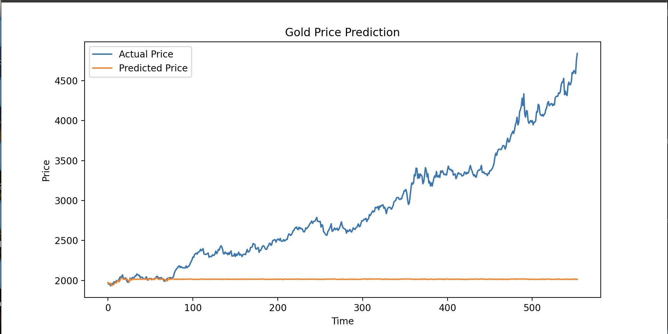

8. Discussion and Insights
Initially, the model underfit the data by predicting near-constant values. This issue was resolved by shifting the target variable to predict the next-day closing price, transforming the task into a true forecasting problem. While the model captures short-term trends, it struggles with rapid market changes. Future improvements could include incorporating macroeconomic indicators or using time-series models such as LSTM networks.

9. References (APA)
- Pedregosa, F., et al. (2011). Scikit-learn: Machine learning in Python. Journal of Machine Learning Research.
- Yahoo Finance. (2024). Gold Futures historical data.

