Length belt: 52 cm , time 43,51 sec -> speed belt = > v=s/t = 52/43.51 = 1.195 cm/s = 0.01195 m/s

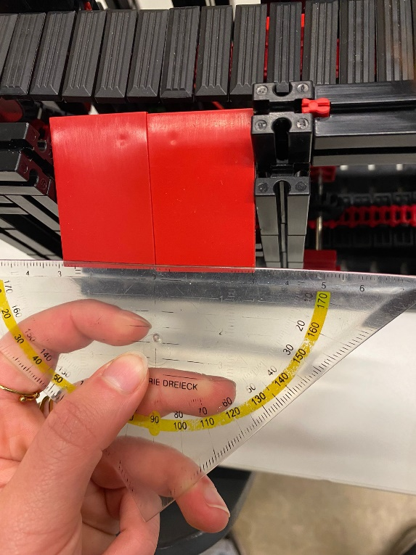Width rolling belt: 3 cm

Width 2 red blocks: 6 cm

Length red blocks: 4,5 cm

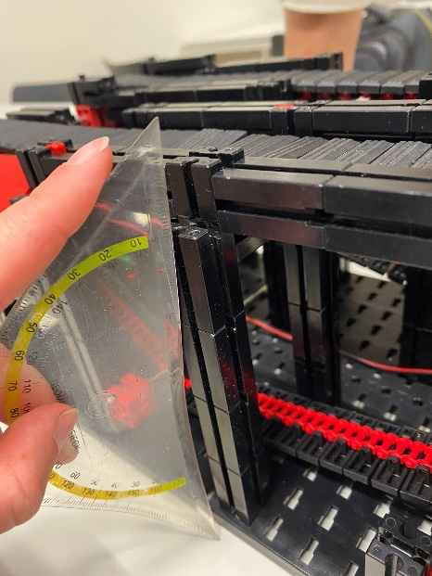Height belt: 14 cm

Picture from above: picture form the front side:

Distance between belts: 6cm(inner) 12 cm(outer)