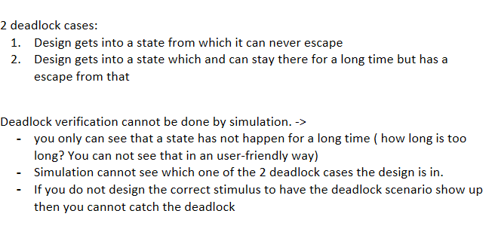

State machine: behavior model based on the current state and a given input the machine performs state transitions and produces outputs.

The basic building blocks are states and transitions.

State: situation of a system depending on previous inputs and causes a reaction on following inputs.

Initial state: where execution of the machine starts.

State transition: defines for which input a state is changed from one to another (arrow)

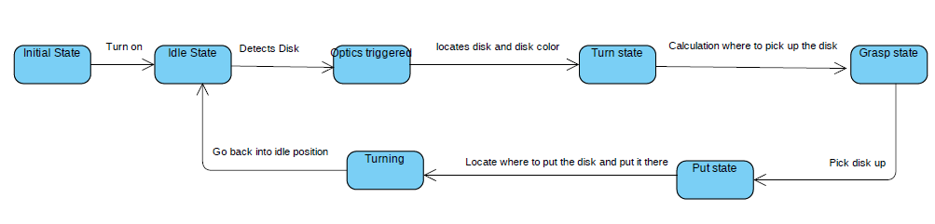

**Deadlock cases that could appear:**  
in all states: staying in that state, not going into the next state

Initial state: not turning on/off

Idle state: not detecting anything/ detecting while there is no disk

Optics: no recognition of disk, disk moving forward, detecting wrong color, detecting something else then disk

Turning: turn the wrong side, not turning at all, turning too far/ too little, turning too fast/ too slow

Grasping: grasp past the disk, grasp something else then disk, to slow to grasp the disk, grasping to aggressive, grasping to kind that it disk falls out

Picking: moving too fast that disk falls out, picking it with too little height that the grasp mechanism collide with the belt, to slow that the next disk is already there before properly picking up the previous one

Putting: put disk to hard that it moves from desired putting space/(puts away previous placed disks), put in wrong place,