<https://www.circuito.io/static/reply/index.html?solutionId=62a06985be776a0030b09c4c&solutionPath=storage.circuito.io>

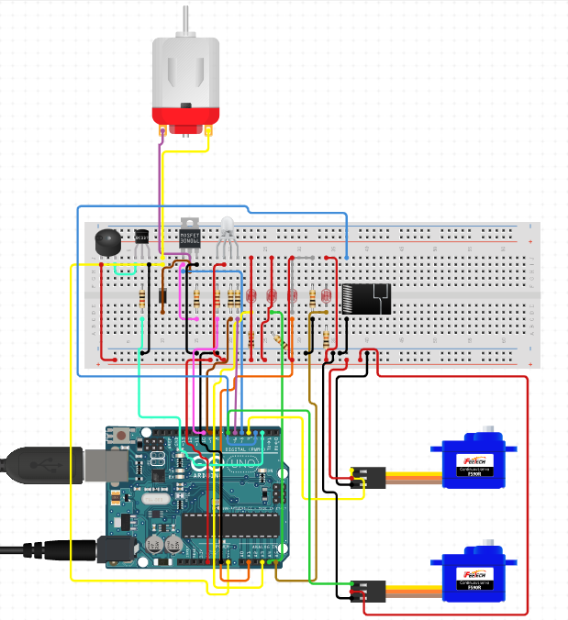

<https://www.circuito.io/static/reply/index.html?solutionId=62a06985be776a0030b09c4c&solutionPath=storage.circuito.io>

