Appendix

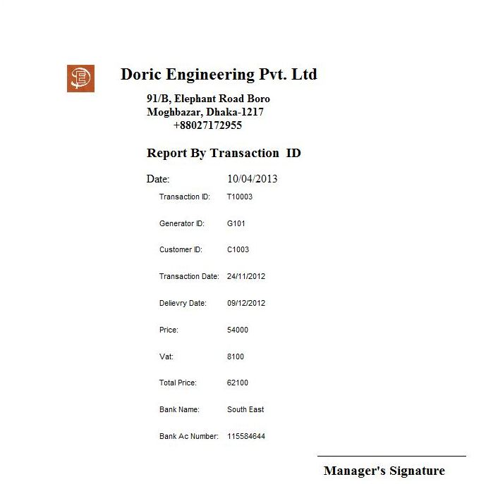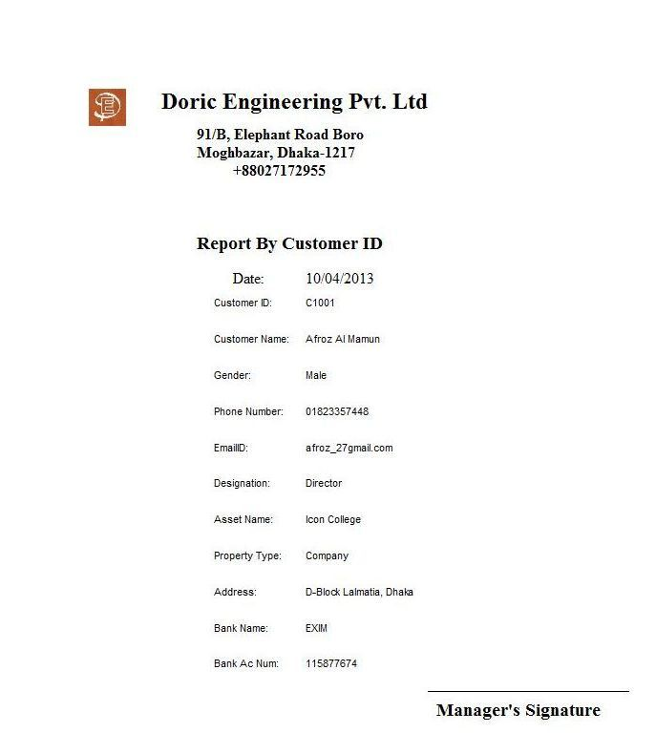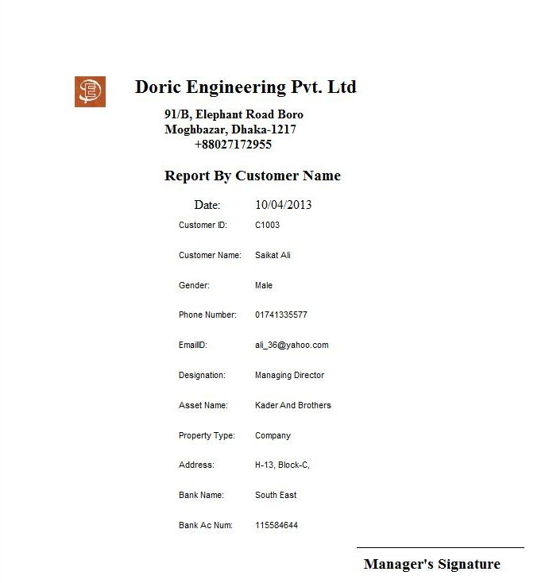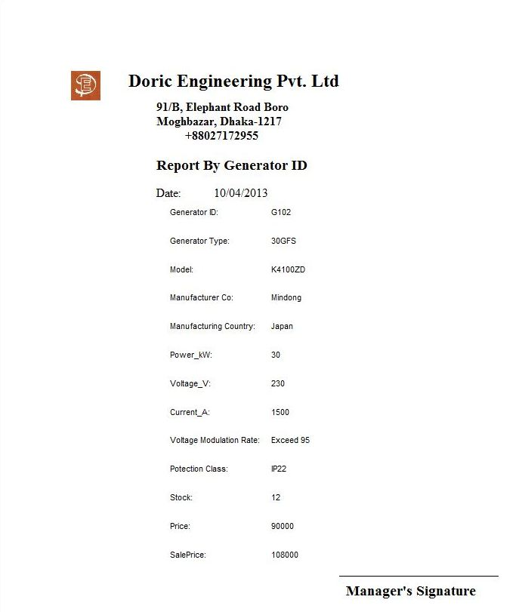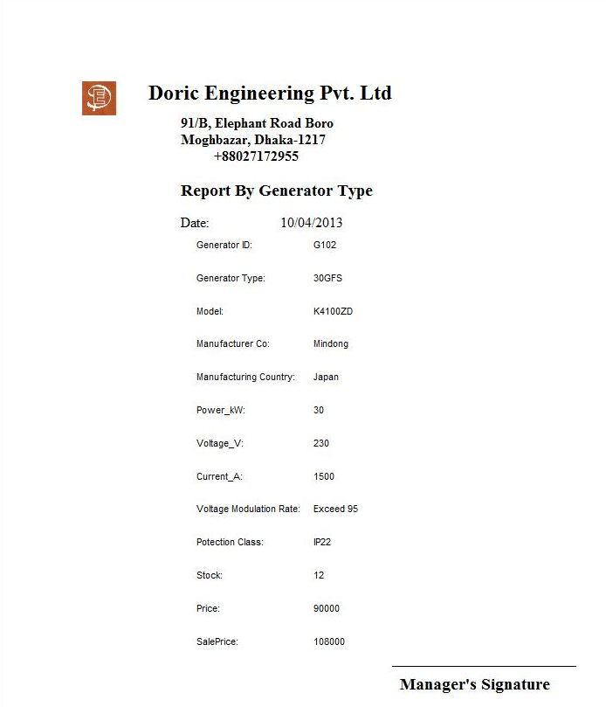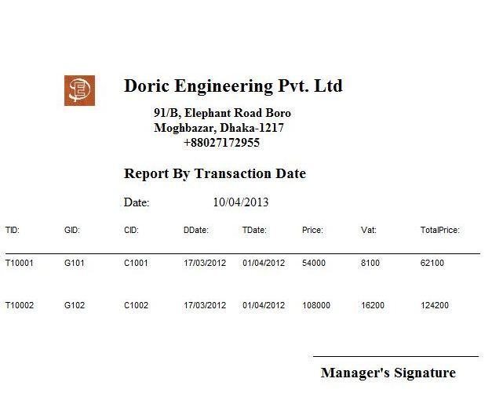

First letter from the Managing Director

Dear Mr. Ismail

I am highly pleased to tell you that your software has been a great success. I was very joyous when we got rid of all those mundane registers which were not only hard to organize but also maintain and search from. Your software has reduced the use of those registers and has made our searching for data much easier. We now have more staff in the transactions and marketing department because no staffs were needed to maintain the registers. We no longer face any time delay with our transactions because of the highly efficient data flow in the software. Our calculations are done at the blink of any eye without any chance of miscalculation. Though it took some time to implement the new system, your User Guide and Demo CD helped our workers to understand how to use the software very easily. Our customers are very happy that we changed to a computerized system and are now more enthusiastic to do more purchases with us. We are now able to expand the company to a more sophisticated level.

We are very glad that we took your advice of using a computerized system rather a manual one.

Yours Sincerely

Washim

Washim Ahmed

Managing Director

Doric Engineering Pvt. Ltd

Second letter from the Managing Director

Dear Mr. Ismail

I am pleased to tell you that your software is functioning very well. But there are some things which I would like to be updated. The current software automatically sets the sales price during the transactions and we have to do more than one step to set the price of our own for making more profit. It would have been better if the sales price was not automatically set. I would also like the feature of adding users to use the system and allow old users to change their login passwords. There is also one another form which I would like to be added to the software, that is a payroll form. I would like to manage the employees' payroll by using the software. I would make that task much easier. So, if you could manage the time, I would very like it if you could come and add some new improvements to the software and also include some additional features of your own.

Yours Sincerely

Washim

Washim Ahmed

Managing Director

Doric Engineering Pvt. Ltd