Software Requirents Scifiat
for
<Project>
Version 1.0 approved
Prepared by <author>
<organization>
<date created>
Table of Contents
Table of Contents ii
Revision History ii
1. Introduction 1
1.1 Purpose 1
1.2 Document Conventions 1
1.3 Intended Audience and Reading Suggestions 1
1.4 Product Scope 1
1.5 References 1
2. Overall Description 2
2.1 Product Perspective 2
2.2 Product Functions 2
2.3 User Classes and Characteristics 2
2.4 Operating Environment 2
2.5 Design and Implementation Constraints 2
2.6 User Documentation 2
2.7 Assumptions and Dependencies 3
3. External Interface Requirements 3
3.1 User Interfaces 3
3.2 Hardware Interfaces 3
3.3 Software Interfaces 3
3.4 Communications Interfaces 3
4. System Features 4
4.1 System Feature 1 4
4.2 System Feature 2 (and so on) 4
5. Other Nonfunctional Requirements 4
5.1 Performance Requirements 4
5.2 Safety Requirements 5
5.3 Security Requirements 5
5.4 Software Quality Attributes 5
5.5 Business Rules 5
6. Other Requirements 5
Appendix A: Glossary 5
Appendix B: Analysis Models 5
Appendix C: To Be Determined List 6

Revision History
Name | Date | Reason For Changes | Version

Introduction

Purpose
Car Spare Part is a famous shop of car spare parts; they detail in all kind of car products. They want to take their business in every corner of the country. By website they can access all the customers in the country. The motive is to gain the audience's trust in auto industry. To assuring them that they can easily find the quality car parts they need at the lowest price.

Document Conventions
Every bold heading and sub heading in this document has special importance.

Intended Audience and Reading Suggestions
This Software Requirements Specification document is to be read by the project managers,
developers, marketing analyst, users, documentation writers and testers.

Product Scope
The product scope is to build a full flash responsive web application of car spare parts. So, the user can buy spare parts for his\her car anywhere at any time by using only web browser. It would be very easy for the customer to find the quality car spare parts they need at the lowest price. So, they will be confident when they will receive a high-quality car parts product with a year warranty. This will also reduce the time of any customer who want a quality car parts.

References
- http://www.maxautoparts.ca/
- https://aaaaautomotive.com/collections/all
- https://www.australianonlinecarparts.com.au/car-parts-accessories/mats-accessories/
- http://www.enginehightechinc.com/interior-parts/1
- https://www.templatemonster.com/website-templates/autozone-auto-dealer-bootstrap-html5-website-template-68156.html.

Overall Description
The web application of car spare products, connect through online where customer can buy car parts without going to the shop and on other hand there is an administrator who has the authority
to reject or approve customer requests. Administrator can manage product items, where as a customer can only view or place an order of their desirable product.

Product Perspective
The objective of this product is to provide access to the customer that can buy car parts
without going to the shop. The diagram shows the major components of the website.

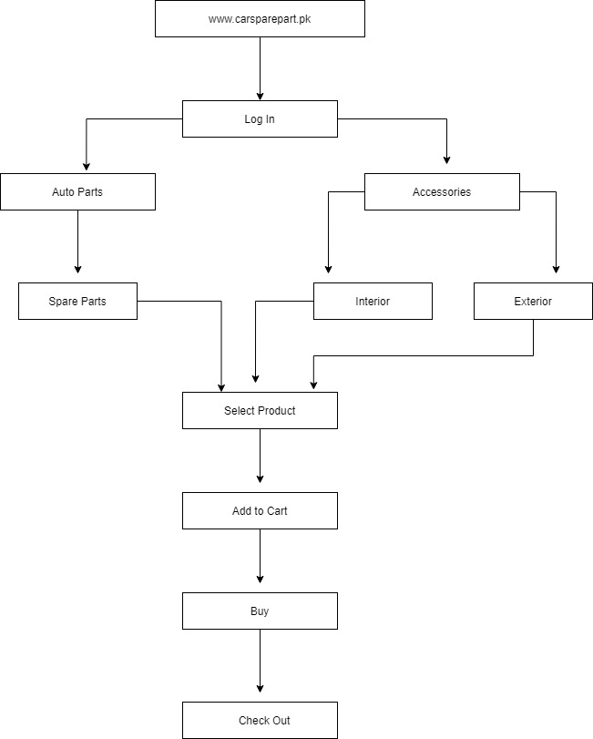

Product Functions
The following are the requirements of the system which will be implemented later by the
developers.
- Login Authentication
User login to the website by entering their valid username and password.

- Searching and Select
User can search and view all the information related to any product.

- Add to Cart
It adds user items into the cart.

- Buy
It is a button which will take a user to a billing page.

- Check Out
Registered user can place an order or cancel order of the product from the shopping cart

The following diagram is the use case of Car Spare Part website.
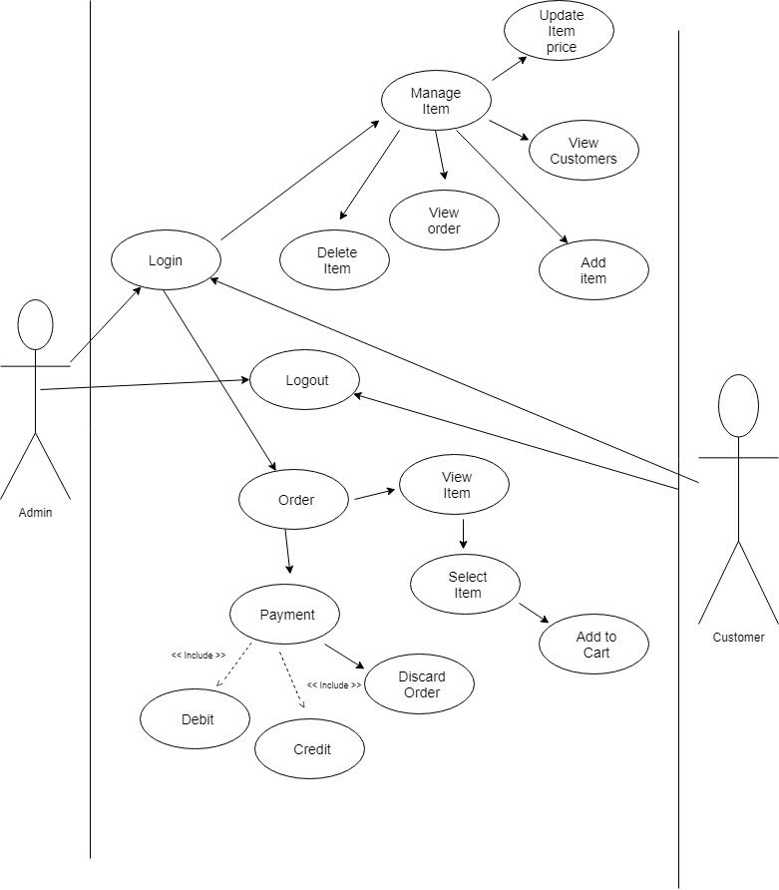

User Classes and Characteristics
In this product there are two actors one is administrator (who has a control of whole website) and the other is a customer. It is necessarily for both the actors to have a knowledge about some terms like register, login, order, checkout etc.

Administrator: The responsibility of the administrator is to manage items and to look on every customer requests.
Customer: who can use this website to buy high-quality car products for their vehicle.

Operating Environment
< Operating environment for this product comes under web browser environments using Secure Sockets Layer (SSL) / Transport Layer Security (TLS) cryptographic protocols at a minimum encryption level of 128 bits. The minimum set of browsers that must be supported is:
- Google Chrome
- Mozilla Firefox
- Microsoft Internet Explorer
- Apple Safari
- Opera all are highly recommended

Design and Implementation Constraints
<Describe any items or issues that will limit the options available to the developers. These might include: corporate or regulatory policies; hardware limitations (timing requirements, memory requirements); interfaces to other applications; specific technologies, tools, and databases to be used; parallel operations; language requirements; communications protocols; security considerations; design conventions or programming standards (for example, if the customer’s organization will be responsible for maintaining the delivered software).>

User Documentation
<List the user documentation components (such as user manuals, on-line help, and tutorials) that will be delivered along with the software. Identify any known user documentation delivery formats or standards.>

Assumptions and Dependencies
<List any assumed factors (as opposed to known facts) that could affect the requirements stated in the SRS. These could include third-party or commercial components that you plan to use, issues around the development or operating environment, or constraints. The project could be affected if these assumptions are incorrect, are not shared, or change. Also identify any dependencies the project has on external factors, such as software components that you intend to reuse from another project, unless they are already documented elsewhere (for example, in the vision and scope document or the project plan).>

External Interface Requirements

User Interfaces
<Describe the logical characteristics of each interface between the software product and the users. This may include sample screen images, any GUI standards or product family style guides that are to be followed, screen layout constraints, standard buttons and functions (e.g., help) that will appear on every screen, keyboard shortcuts, error message display standards, and so on. Define the software components for which a user interface is needed. Details of the user interface design should be documented in a separate user interface specification.>

Hardware Interfaces
<Describe the logical and physical characteristics of each interface between the software product and the hardware components of the system. This may include the supported device types, the nature of the data and control interactions between the software and the hardware, and communication protocols to be used.>

Software Interfaces
<Describe the connections between this product and other specific software components (name and version), including databases, operating systems, tools, libraries, and integrated commercial components. Identify the data items or messages coming into the system and going out and describe the purpose of each. Describe the services needed and the nature of communications. Refer to documents that describe detailed application programming interface protocols. Identify data that will be shared across software components. If the data sharing mechanism must be implemented in a specific way (for example, use of a global data area in a multitasking operating system), specify this as an implementation constraint.>

Communications Interfaces
<Describe the requirements associated with any communications functions required by this product, including e-mail, web browser, network server communications protocols, electronic forms, and so on. Define any pertinent message formatting. Identify any communication standards that will be used, such as FTP or HTTP. Specify any communication security or encryption issues, data transfer rates, and synchronization mechanisms.>

System Features

Multiple Categories
4.1.1 Description and Priority
This is a feature in which we provide our customers with multiple categories to select their product within. This feature is very high priority as it can catch our customers attention
4.1.2 Stimulus/Response Sequences
To access this feature in our product the user just has to open the website there he can find the categories on the left-hand side of the website
4.1.3 Functional Requirements
With the inclusion of this feature on our website a user can have our user interested with multiple different categories of items to browse with. With having a multiple category, we are able to cater multiple clients because they will get each and every items of multiple different categories from one site instead of browsing multiple websites and getting hectic.

User Friendly UI/UX Design
4.1.1 Description and Priority
In this feature we provide our user with an easy-to-use user interface (UI) to facilitate the experience of our customer. The is feature is very high priority because a good user interface can be a good sign for more users to join in.
4.1.2 Stimulus/Response Sequences
To access this feature, you just need a browser and open our website
4.1.3 Functional Requirements
With the inclusion of this feature on our website we can facilitate our customer to browse easier on to the required items he wants to. The user when enters our website has these beautiful pictures with list of our items and the categories section provided on the left side. These categories can be seen through out ever if the user scroll down, he will have these present all the time.

Ability to Search
4.1.1 Description and Priority
In this feature we provide our users to search the required items within the website. The priority of this feature is high as it can help a user quickly get through his desired items
4.1.2 Stimulus/Response Sequences
To access this feature, the user has to click on the search bar provided at the top of the home bar and then type the word he is looking for.
4.1.3 Functional Requirements
With the inclusion of this feature on our website user is able to search the required product he wants to. This feature allows the user to search for his specific item that can any thing he want. If the desired keyword matches on to the database the user will be displayed with it and if not, the user will be displayed no match found.

Add to Cart
4.1.1 Description and Priority
In this feature we provide our users to add multiple items on to his order in one go. The priority of this feature is very high as user can buy multiple things in one go
4.1.2 Stimulus/Response Sequences
To access this feature, the user has to click on the add to cart option when he is viewing the item, when this button is pressed user must be logged in or if not logged in will be asked to log in to access this feature once this item is added the user can move on to different item to add it too
4.1.3 Functional Requirements
With the inclusion of this feature on our website user is able to purchase multiple items in one go. Most of the time when user wants to buy more than one item then instead of provided his information again and again. The add to cart feature will help the user to add multiple items to its inventory so he can buy it one time and pay one time

Other Nonfunctional Requirements

Performance Requirements
<If there are performance requirements for the product under various circumstances, state them here and explain their rationale, to help the developers understand the intent and make suitable design choices. Specify the timing relationships for real time systems. Make such requirements as specific as possible. You may need to state performance requirements for individual functional requirements or features.>

Safety Requirements
<Specify those requirements that are concerned with possible loss, damage, or harm that could result from the use of the product. Define any safeguards or actions that must be taken, as well as actions that must be prevented. Refer to any external policies or regulations that state safety issues that affect the product’s design or use. Define any safety certifications that must be satisfied.>

Security Requirements
<Specify any requirements regarding security or privacy issues surrounding use of the product or protection of the data used or created by the product. Define any user identity authentication requirements. Refer to any external policies or regulations containing security issues that affect the product. Define any security or privacy certifications that must be satisfied.>

Software Quality Attributes
<Specify any additional quality characteristics for the product that will be important to either the customers or the developers. Some to consider are: adaptability, availability, correctness, flexibility, interoperability, maintainability, portability, reliability, reusability, robustness, testability, and usability. Write these to be specific, quantitative, and verifiable when possible. At the least, clarify the relative preferences for various attributes, such as ease of use over ease of learning.>

Business Rules
<List any operating principles about the product, such as which individuals or roles can perform which functions under specific circumstances. These are not functional requirements in themselves, but they may imply certain functional requirements to enforce the rules.>

Other Requirements
<Define any other requirements not covered elsewhere in the SRS. This might include database requirements, internationalization requirements, legal requirements, reuse objectives for the project, and so on. Add any new sections that are pertinent to the project.>
Appendix A: Glossary
<Define all the terms necessary to properly interpret the SRS, including acronyms and abbreviations. You may wish to build a separate glossary that spans multiple projects or the entire organization, and just include terms specific to a single project in each SRS.>
Appendix B: Analysis Models
<Optionally, include any pertinent analysis models, such as data flow diagrams, class diagrams, state-transition diagrams, or entity-relationship diagrams.>
Appendix C: To Be Determined List
<Collect a numbered list of the TBD (to be determined) references that remain in the SRS so they can be tracked to closure.>

