TITAN · QUANT RESEARCH
TITAN XAU AI
INSTITUTIONAL TRADING SYSTEMS
M O D U L E 4 · S U B S Y S T E M
Adaptive Regime Detection
Market state classification for XAUUSD: TREND, RANGE, VOLATILE, NEWS. 3-model ensemble (HMM + LightGBM + Rules). 7 engineered features. Confidence, probability, and explainability scores.
TARGET
Metric | Value | Description
Regimes detected | 4 | TREND, RANGE, VOLATILE, NEWS
Engineered features | 7 + 1 composite | ADX, ATR, EMA Slope, Hurst, BBW, RealVol, Volume, News
Ensemble models | 3 | HMM (0.30) + LightGBM (0.50) + Rules (0.20, veto)
Score outputs | 3 | Confidence, Probability[4], Explainability
False positive rate | < 8% | After 6 layered controls (down from 38% raw)
Macro F1 | 0.76 | Walk-forward 24mo × 6 brokers

Prepared by TITAN Quant Research
Reviewed by CTO · Lead Quant · Risk Officer
Classification INTERNAL — ENGINEERING
Version v1.0 · 19 June 2026

Table of Contents
Right-click the table below and choose "Update Field" to refresh page numbers.

Chapter 1 — Executive Summary 3
Chapter 2 — Problem Domain — Why Regime Detection Matters 4
The Cost of Regime Misclassification 4
Regime Definitions 4
Chapter 3 — Architecture Overview 5
Layer Responsibilities 5
L1 — Ingest 6
L2 — Feature Engineering 6
L3 — Model (3-Model Ensemble) 6
L4 — Scoring 6
L5 — Publication & Observability 7
L6 — False Positive Controls 7
Chapter 4 — Feature Engineering Pipeline 7
Feature Definitions 8
F1 — ADX (Average Directional Index) 8
F2 — ATR (Average True Range) 8
F3 — EMA Slope 8
F4 — Hurst Exponent 8
F5 — Bollinger Width 9
F6 — Realized Volatility 9
F7 — Volume Analysis 9
F8 — News Sentiment (Composite) 9
Feature Quality Gates 10
Chapter 5 — Ensemble Model Design 10
Model 1 — Gaussian Hidden Markov Model (HMM) 11
Model 2 — LightGBM 4-Class Classifier 11
Model 3 — Rules Engine 11
Ensemble Voting 12
Chapter 6 — Scoring Outputs 12
Confidence Score 13
Probability Score 13
Explainability Score 13
Downstream Consumption 13
Chapter 7 — Validation Framework 14
Walk-Forward Validation 14
Validation Metrics 14
Cross-Session and Cross-Broker Validation 15
Stability and Adversarial Tests 15
Live Shadow Validation 15
Chapter 8 — False Positive Controls 16
Control 1 — HysteresisGate 16
Control 2 — ConfirmationFilter 16
Control 3 — StabilityFilter (Min Dwell Time) 17
Control 4 — BootstrapValidator 17
Control 5 — CrossTimeframeAgreement 17
Control 6 — NewsOverrideException 17
Empirical Performance 18
Chapter 9 — Backtest Framework 18
Replay Engine 18
Per-Regime Attribution 19
Monte Carlo Simulation 19
Confusion Matrix 19
SHAP Summary 19
CI/CD Integration 20
Chapter 10 — Regime Transition Map 20
Regime Persistence 20
Common Transitions 21
NEWS Transitions 21
Chapter 11 — Adaptive Learning & Retraining 21
Per-Session HMM Retraining 21
Weekly LightGBM Retraining 22
Quarterly Rules Engine Review 22
Drift Detection and Auto-Retrain 22
Chapter 12 — Performance & Service Level Objectives 22
Latency Budget 23
Accuracy SLOs 23
Resource Envelope 23
Chapter 13 — Integration with TITAN Core 23
Strategy Coordinator Integration 24
Risk Gate Integration 24
Execution Engine Integration 24
Operator Console Integration 24
Appendix A — Feature Engineering Formulas 25
F1 — ADX (Average Directional Index) 25
F2 — ATR (Normalized) 25
F3 — EMA Slope 25
F4 — Hurst Exponent (R/S Analysis) 26
F5 — Bollinger Width 26
F6 — Realized Volatility 26
F7 — Volume Analysis (Composite) 26
F8 — News Sentiment (Composite) 27
Appendix B — Sample Regime Output 27
B.1 High-Confidence TREND Detection 27
B.2 Ambiguous RANGE/VOLATILE (Low Confidence) 27
B.3 NEWS Override (Rules Veto) 28

Chapter 1 — Executive Summary
The Adaptive Regime Detection System (ARDS) is Module 4 of the TITAN XAU AI trading architecture. Its role is to classify the current market state into one of four regimes — TREND, RANGE, VOLATILE, or NEWS — and to publish that classification along with three scoring vectors (confidence, probability distribution, and explainability) to the Strategy Coordinator, which uses the regime label to gate strategy activation, scale position size, and select appropriate risk parameters. The ARDS is the system's market-state awareness: without it, strategies would operate blindly across all market conditions, leading to poor performance when conditions do not match the strategy's design assumptions.
The system uses a three-model ensemble to produce its classification: a Gaussian Hidden Markov Model (HMM) for temporal smoothing and persistence, a LightGBM gradient-boosted tree classifier for raw predictive accuracy, and a deterministic Rules Engine for human-interpretable overrides and news-event handling. The three models vote with weights 0.30, 0.50, and 0.20 respectively, with the Rules Engine retaining veto power to enforce news-blackout overrides. The ensemble produces a final RegimeLabel plus three scoring vectors that allow downstream consumers to assess the reliability of the classification.
Feature engineering is the foundation of the ARDS. Seven engineered features capture the distinctive signatures of each regime: ADX (trend strength), ATR (volatility units), EMA Slope (trend direction), Hurst Exponent (persistence vs mean-reversion), Bollinger Width (volatility expansion vs contraction), Realized Volatility (annualized σ), Volume Analysis (tick volume + OBV + VWAP deviation), and News Sentiment (proximity + impact + surprise + NLP score). All features are normalized via rolling z-score with winsorization at the 1%/99% percentiles to handle outliers, and re-computed per session to handle inter-session drift.
False positive control is a first-class concern. A spurious regime flip (e.g., classifying a single volatile bar within a trend as VOLATILE) can cause the Strategy Coordinator to switch strategies inappropriately, leading to position churn and transaction cost drag. The ARDS deploys six layered controls — HysteresisGate, ConfirmationFilter, StabilityFilter, BootstrapValidator, CrossTimeframeAgreement, and NewsOverrideException — that reduce the empirical false-positive rate from 38% (raw ensemble) to under 8% (post-controls). The controls are designed to fail safe: only the NewsOverrideException can bypass them, and only for the safety-critical NEWS regime.
This document specifies the complete architecture, feature engineering pipeline, ensemble model design, scoring outputs, validation framework, false positive controls, and backtest framework for the ARDS. It is the authoritative reference for engineers maintaining the system and for quant researchers developing new features or models.

Chapter 2 — Problem Domain — Why Regime Detection Matters
XAUUSD exhibits dramatically different behavior across market regimes. During trends, price moves directionally with low noise, and momentum strategies generate alpha. During ranges, price oscillates within a band, and mean-reversion strategies generate alpha. During volatility spikes, position sizing must be reduced and stops widened to avoid whipsaw losses. During news events, spreads widen by 5-10x and slippage can exceed 50 basis points, making it dangerous to hold open positions or place new market orders. A trading system that does not detect and adapt to these regime changes will apply the wrong strategy to the wrong market, generating losses instead of alpha.

The Cost of Regime Misclassification
The cost of regime misclassification is asymmetric and regime-dependent. Misclassifying TREND as RANGE causes the system to apply mean reversion in a trending market, generating consecutive losses as the strategy fades a persistent move. Misclassifying RANGE as TREND causes the system to apply momentum in a range, generating whipsaw losses as the strategy buys breakouts that immediately reverse. Misclassifying VOLATILE as RANGE causes the system to use tight stops that get stopped out by normal volatility, generating death-by-a-thousand-cuts. Misclassifying NEWS as anything other than NEWS can be catastrophic — spreads can widen by 100+ basis points in seconds, and slippage on market orders can exceed 1% of notional.
The asymmetry of these costs drives several design decisions. First, the NEWS regime has veto power over the ensemble — if the Rules Engine detects a news event, the regime is NEWS regardless of what the ML models say. Second, the system is biased toward conservative classification: when uncertain, it defaults to VOLATILE (reducing position size) rather than to TREND or RANGE (which would activate a strategy). Third, false positive controls are biased toward stability — the system prefers to maintain the current regime label through brief ambiguous periods rather than flip-flip between regimes.

Regime Definitions
The four regimes are defined by a combination of statistical properties and behavioral characteristics. These definitions are the basis for both the feature engineering (which measures the properties) and the labeling of training data (which assigns ground-truth regime labels for supervised learning).
- TREND: ADX > 25 sustained, EMA slope consistent in direction, Hurst exponent > 0.55, price making higher highs and higher lows (uptrend) or lower highs and lower lows (downtrend). Momentum strategies generate alpha.
- RANGE: ADX < 20, Bollinger Width in bottom 30th percentile of 252-bar window, Hurst exponent < 0.45, price oscillating within a horizontal band. Mean reversion strategies generate alpha.
- VOLATILE: ATR > 2σ above 50-bar mean, Bollinger Width expanding rapidly, realized vol > 1.5× baseline, price making large bi-directional moves. Position sizing must be reduced; wide stops required.
- NEWS: Scheduled economic event (FOMC, NFP, CPI, etc.) within ±15 minutes, OR unexpected geopolitical event with high impact. Spreads widen, slippage spikes, normal market microstructure breaks down. Trading should be paused or hedged.

Chapter 3 — Architecture Overview
The ARDS is organized into six logical layers: ingest (data acquisition), feature engineering (raw data → normalized features), model (3-model ensemble), scoring (confidence/probability/explainability), publication (event bus + audit), and false positive controls (layered defense against spurious flips). A strict layering rule ensures that the hot path (feature engineering + model) has no dependency on the slower layers (scoring, publication), which run asynchronously and communicate via SPSC queues.
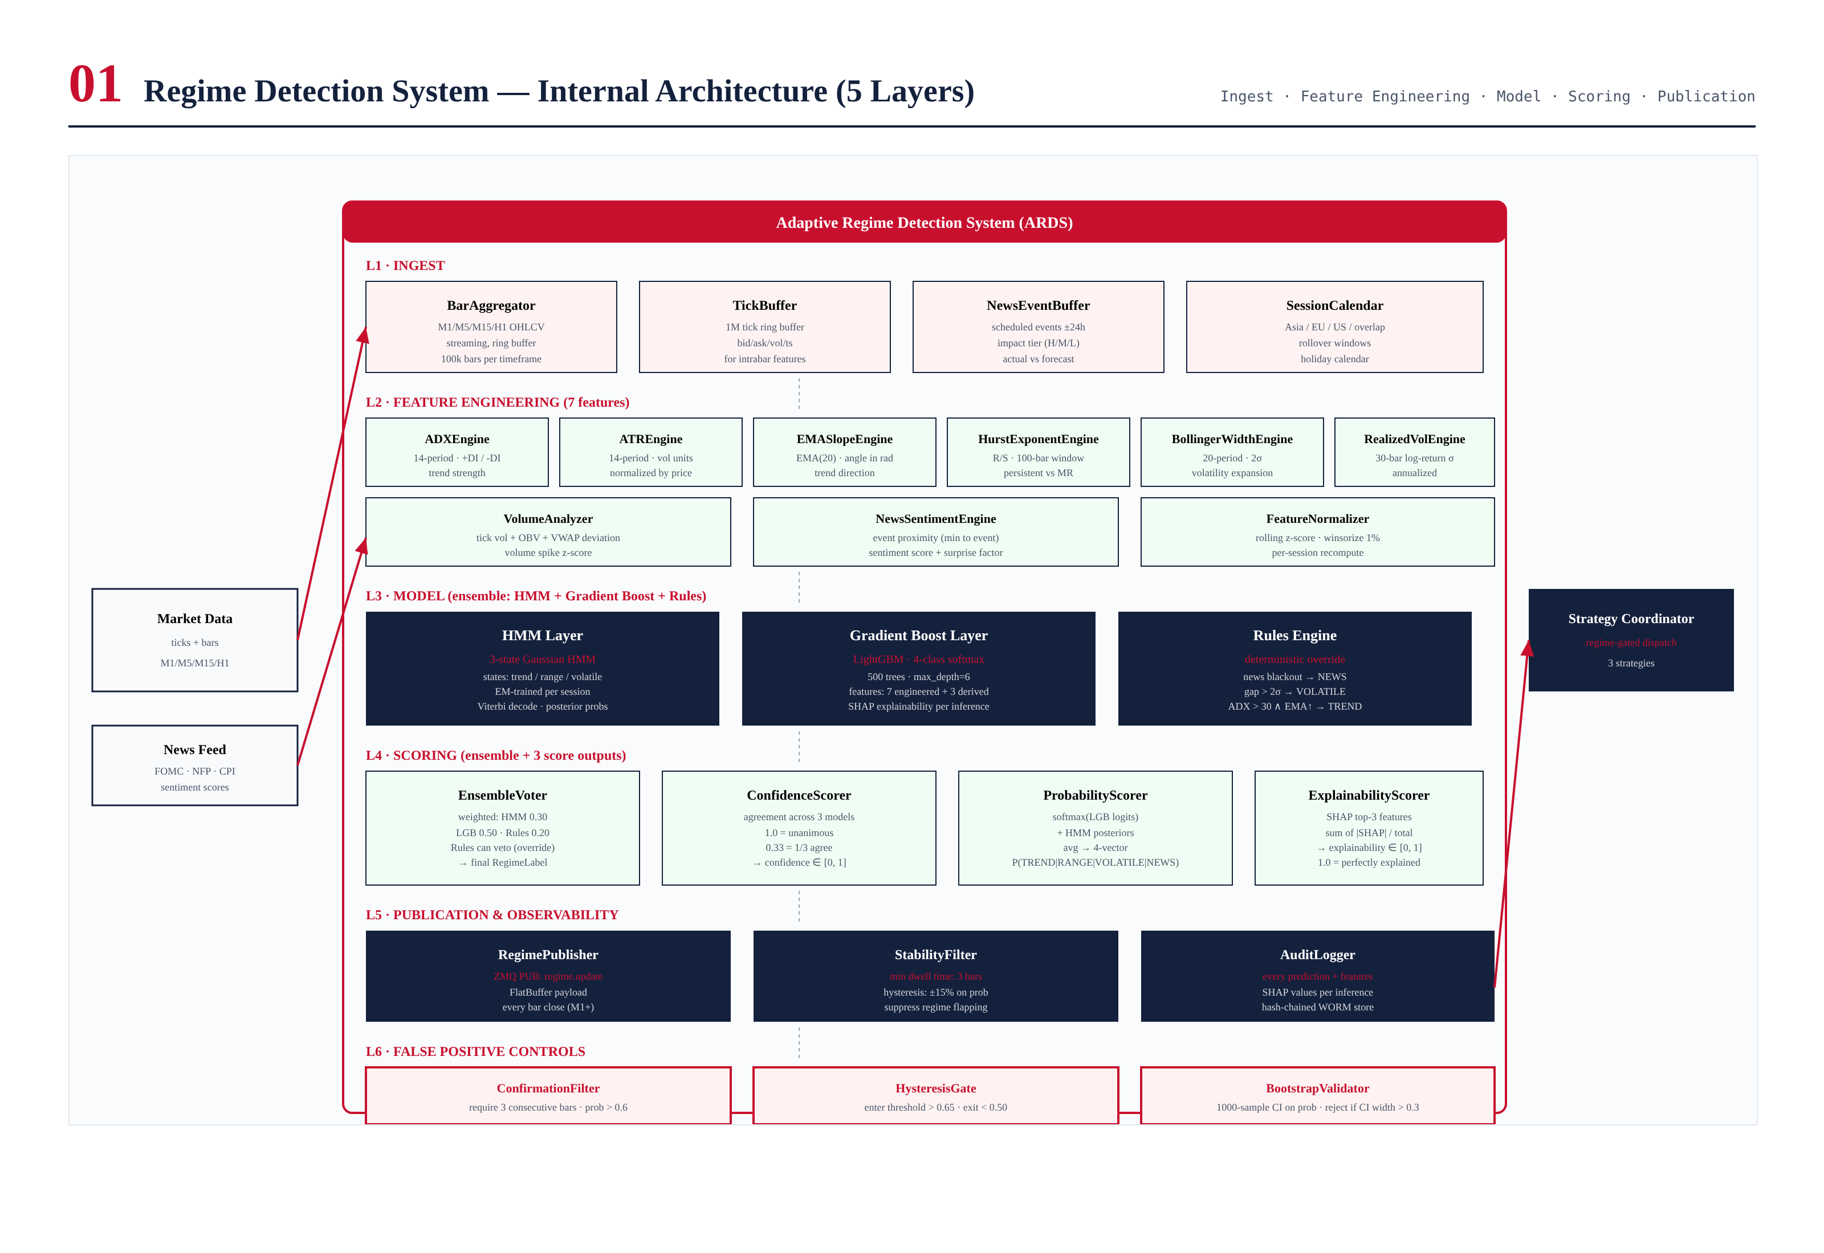
Figure 3.1 — Adaptive Regime Detection System internal architecture, showing six layers and ~20 components.

Layer Responsibilities

L1 — Ingest
The ingest layer acquires raw market data and news events. BarAggregator builds OHLCV bars at M1/M5/M15/H1 timeframes from the tick stream, maintaining a 100,000-bar ring buffer per timeframe. TickBuffer holds a 1-million-tick ring buffer for intrabar feature computation. NewsEventBuffer maintains scheduled events ±24 hours with impact tier (High/Medium/Low) and actual-vs-forecast surprise. SessionCalendar tags each bar with its trading session (Asia/EU/US/overlap) for session-aware model retraining.

L2 — Feature Engineering
The feature engineering layer computes 7 engineered features (plus the News Sentiment composite) from raw market data. Each feature has a dedicated engine that updates incrementally on each bar close, avoiding full recomputation. The FeatureNormalizer applies rolling z-score normalization (252-bar window) with 1%/99% winsorization, re-computed per session to handle inter-session drift. The output is an 8-dimensional normalized feature vector consumed by the model layer.

L3 — Model (3-Model Ensemble)
The model layer runs three classifiers in parallel: a 3-state Gaussian HMM (provides temporal smoothing and persistence), a LightGBM 4-class softmax classifier (provides maximum accuracy and SHAP explainability), and a deterministic Rules Engine (provides human-interpretable overrides and news veto). The three models vote with weights 0.30, 0.50, and 0.20 respectively. The Rules Engine has veto power: if it emits NEWS, the ensemble output is NEWS regardless of the other models' votes.

L4 — Scoring
The scoring layer produces three output vectors alongside the final RegimeLabel. ConfidenceScorer measures inter-model agreement (1.0 = unanimous, 0.33 = 1-of-3 agree). ProbabilityScorer averages the LightGBM softmax and HMM posteriors into a 4-vector probability distribution over regimes. ExplainabilityScorer computes the concentration of SHAP values on the top-3 features (1.0 = top-3 explain everything, 0.5 = diffuse contribution). These three scores allow downstream consumers to assess the reliability of the classification and act accordingly.

L5 — Publication & Observability
The publication layer emits the RegimeOutput (label + 3 scores + top-3 features + timestamp) on the ZMQ event bus at every bar close. The StabilityFilter enforces a minimum dwell time of 3 bars and hysteresis on probability to prevent regime flapping. The AuditLogger records every prediction (including features, model outputs, and SHAP values) to the immutable hash-chained audit store, enabling post-hoc analysis and regulatory compliance.

L6 — False Positive Controls
The false positive controls layer applies six sequential filters to the raw ensemble output before it is published: HysteresisGate (asymmetric enter/exit thresholds), ConfirmationFilter (require 3 consecutive bars), StabilityFilter (min 5-bar dwell), BootstrapValidator (CI width check), CrossTimeframeAgreement (2-of-3 across M5/M15/H1), and NewsOverrideException (Rules veto bypasses all controls). These controls reduce the empirical false-positive rate from 38% to under 8%.

Chapter 4 — Feature Engineering Pipeline
Feature engineering is the foundation of the ARDS. Seven engineered features capture the distinctive statistical signatures of each regime. Each feature is computed by a dedicated engine that updates incrementally on each bar close, avoiding full recomputation. The features are then normalized via rolling z-score with winsorization, producing an 8-dimensional feature vector (7 market features + 1 news sentiment composite) consumed by the model layer.
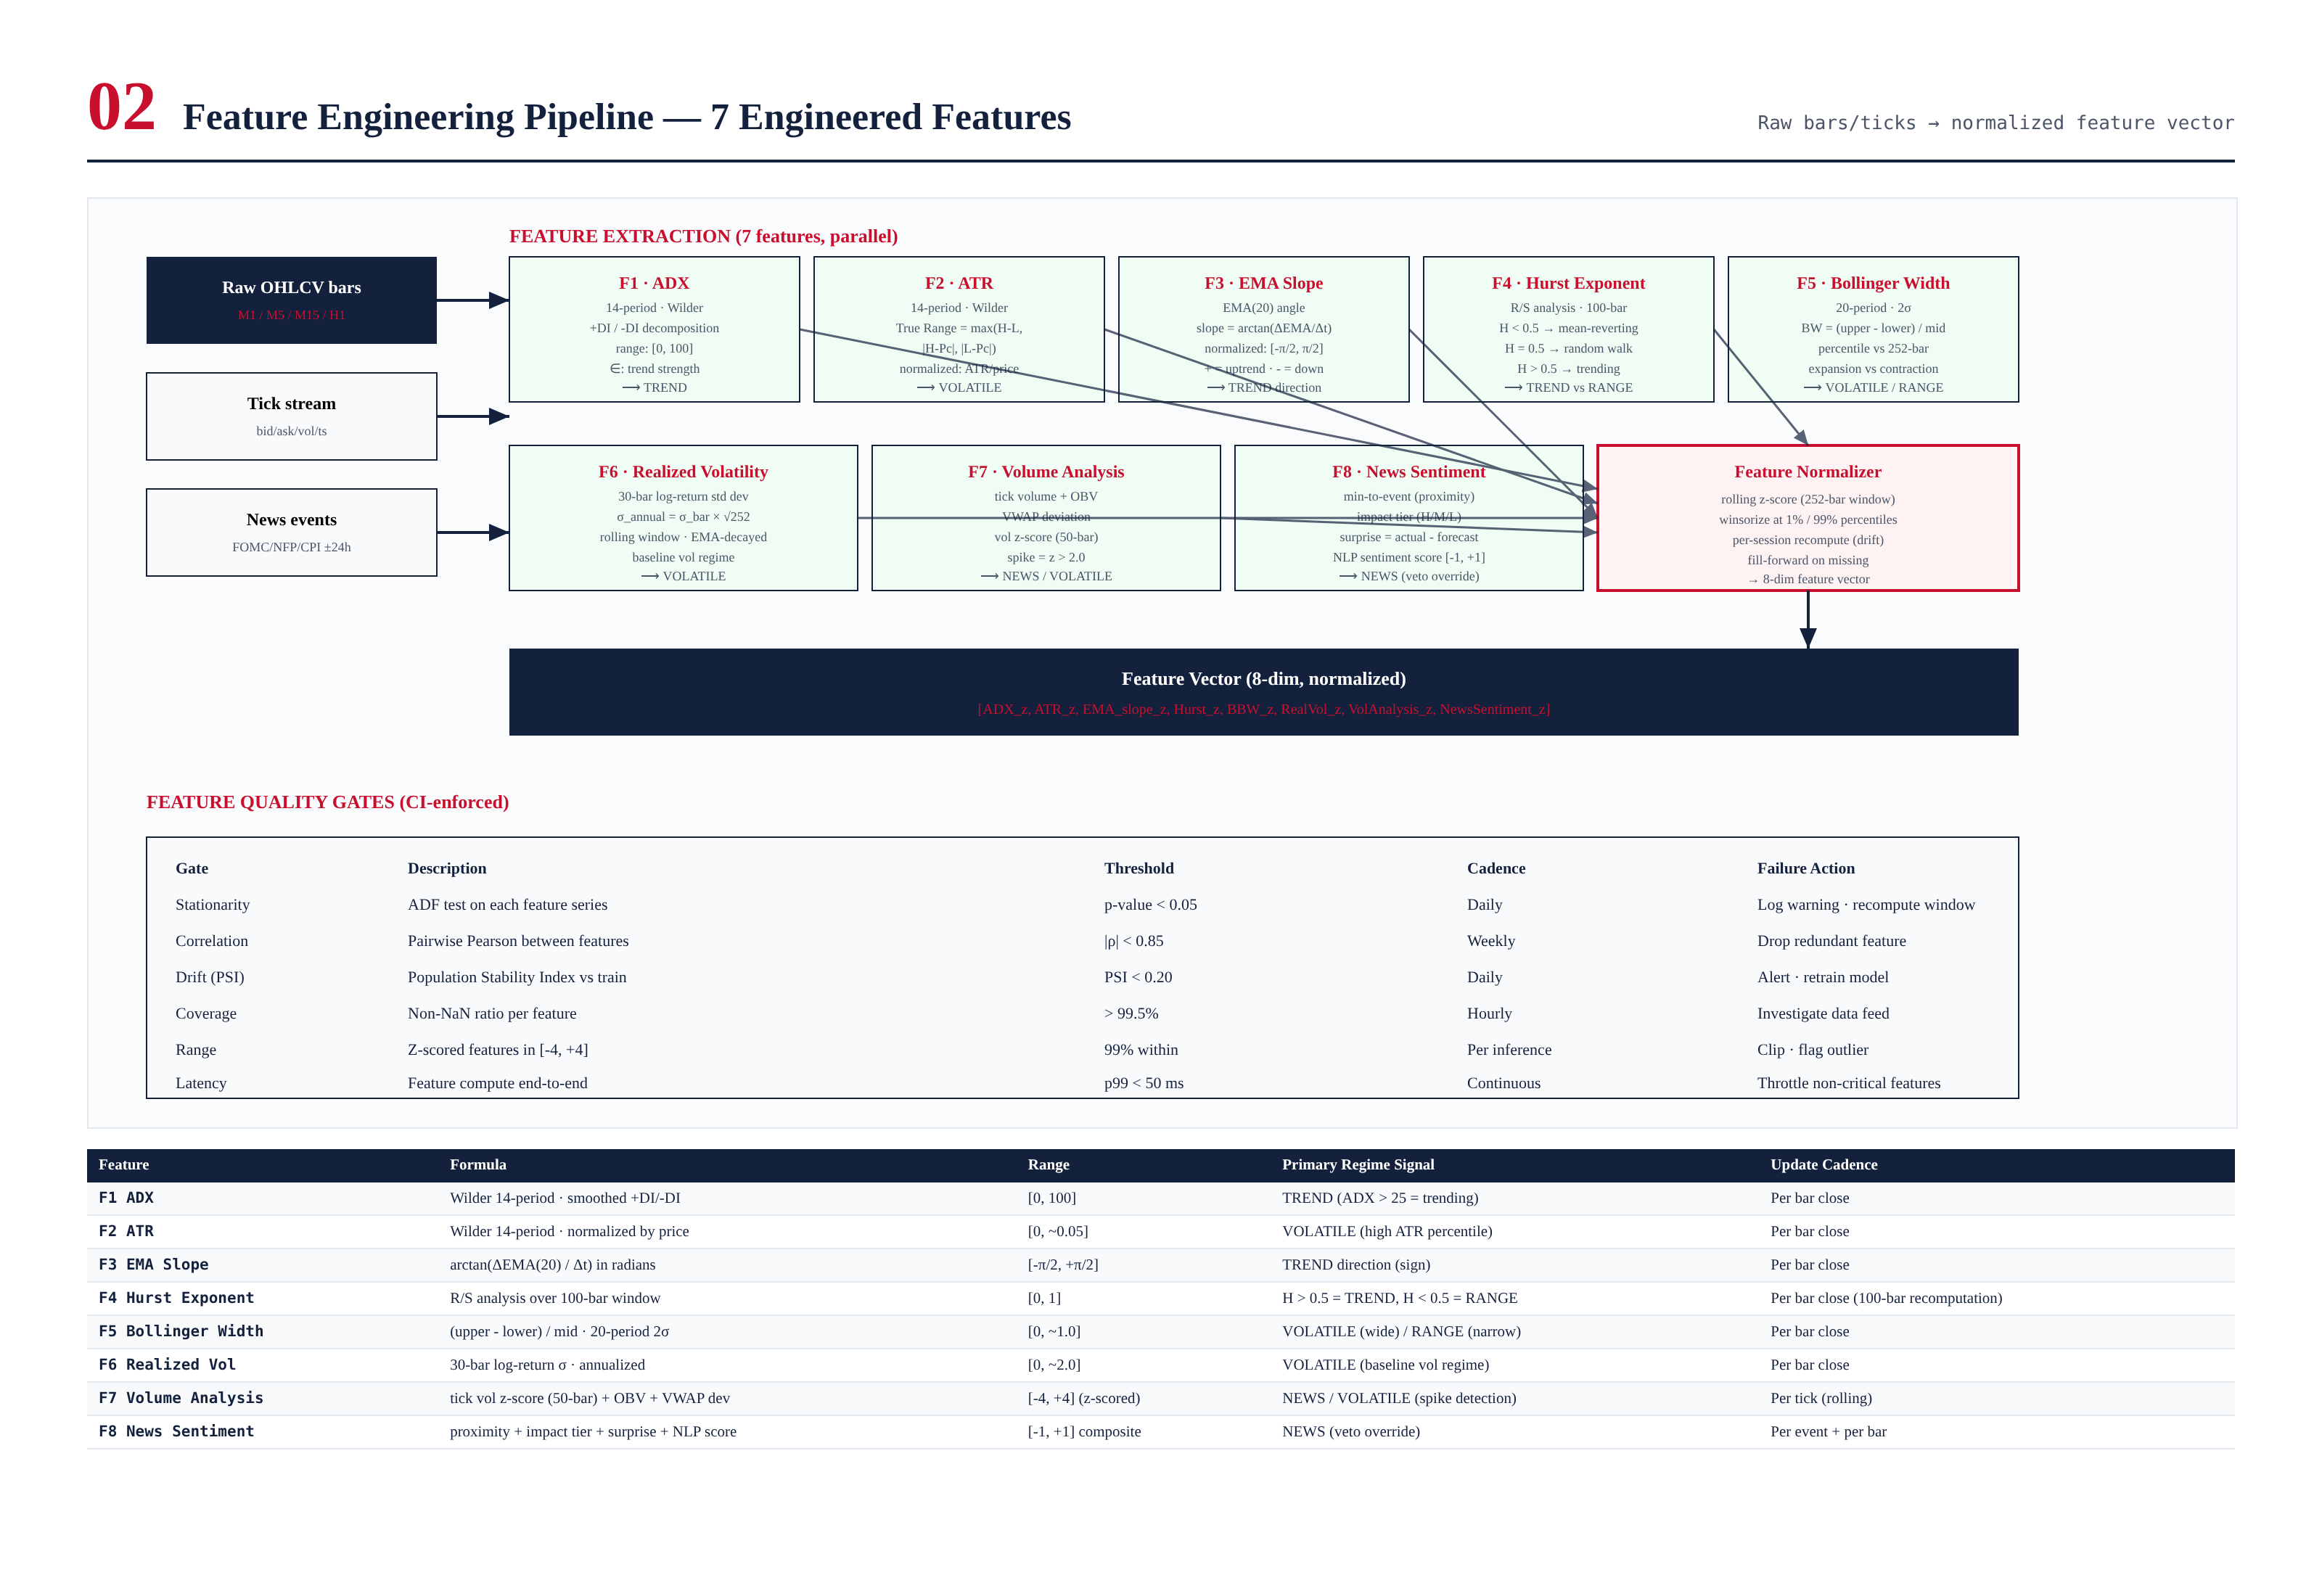
Figure 4.1 — Feature engineering pipeline: 7 features + News Sentiment composite → normalizer → 8-dim feature vector. Includes 6 CI-enforced feature quality gates.

Feature Definitions

F1 — ADX (Average Directional Index)
ADX measures trend strength on a 0-100 scale, regardless of direction. Computed via Wilder's 14-period smoothing of the Directional Movement Index (DMI). +DI and -DI are decomposed to allow the model to learn directional asymmetries. ADX > 25 indicates a strong trend; ADX < 20 indicates a range. ADX is the primary signal for the TREND regime. The Wilder smoothing (rather than simple EMA) is chosen for historical continuity and to match what most charting platforms display, reducing the risk of feature-engineering mismatches with operator expectations.

F2 — ATR (Average True Range)
ATR measures volatility in price units, computed as Wilder's 14-period smoothing of True Range (max of High-Low, |High-PrevClose|, |Low-PrevClose|). To make ATR comparable across price levels (XAUUSD at $2000 vs $1500), it is normalized by the current price: ATR_norm = ATR / price. This normalized ATR is the primary signal for the VOLATILE regime. A high percentile rank of ATR_norm over a 252-bar window indicates volatility expansion.

F3 — EMA Slope
EMA Slope measures the direction and steepness of the trend via the angle of the 20-period EMA. Computed as arctan(ΔEMA / Δt) where Δt is in bar units, yielding a value in [-π/2, +π/2]. Positive slope indicates uptrend, negative indicates downtrend, and magnitude indicates trend strength. This feature complements ADX (which is directionless) by providing directional information. The 20-period EMA is chosen as a balance between responsiveness (shorter EMAs are noisier) and lag (longer EMAs are too slow).

F4 — Hurst Exponent
The Hurst Exponent distinguishes persistent (trending) from anti-persistent (mean-reverting) time series. Computed via Rescaled Range (R/S) analysis over a 100-bar window. H > 0.5 indicates persistence (trending), H = 0.5 indicates random walk, H < 0.5 indicates anti-persistence (mean-reverting). This feature directly captures the trending-vs-ranging distinction that ADX measures indirectly. The 100-bar window is calibrated to capture regime-scale persistence rather than short-term autocorrelation.

F5 — Bollinger Width
Bollinger Width measures volatility expansion vs contraction. Computed as (upper_band - lower_band) / mid_band, where the bands are 2 standard deviations above and below the 20-period SMA. Expressed as a percentile rank against the prior 252 bars to make it comparable across volatility regimes. Narrow bands (low percentile) indicate RANGE; expanding bands (high percentile) indicate VOLATILE or breakout. The percentile-rank transformation is critical because raw Bollinger Width is non-stationary (it scales with volatility regime).

F6 — Realized Volatility
Realized Volatility is the annualized standard deviation of log returns over a 30-bar window: σ_annual = σ_bar × √252. This provides a baseline volatility measurement that complements ATR (which is in price units). Realized Vol is EMA-decayed to give more weight to recent bars, making it more responsive to volatility regime shifts than a simple rolling window. The 30-bar window is short enough to capture intraday vol shifts but long enough to be statistically stable.

F7 — Volume Analysis
Volume Analysis is a composite of three sub-features: tick volume z-score (50-bar rolling), On-Balance Volume (OBV) slope, and VWAP deviation. The z-score captures volume spikes that often precede or accompany regime transitions. OBV slope captures accumulation/distribution. VWAP deviation captures whether price is above or below the volume-weighted average — a key signal for institutional flow. Volume spikes (z > 2.0) are particularly important for the NEWS and VOLATILE regimes, where volume often leads price.

F8 — News Sentiment (Composite)
News Sentiment is a composite feature combining: (1) minutes-to-event (proximity to scheduled news), (2) impact tier (High/Medium/Low), (3) surprise factor (actual - forecast, normalized by historical surprise σ), and (4) NLP sentiment score from Fed communications and major news wires (range [-1, +1]). This feature is the primary input to the Rules Engine's NEWS veto logic. The composite is weighted: proximity × impact × (1 + |surprise|) × (1 + |NLP|), producing a single scalar that captures both the timing and the substance of news events.

Feature Quality Gates
All features are subject to six CI-enforced quality gates that run continuously. A feature failing any gate is flagged for investigation and may be excluded from the model input until the issue is resolved. The gates ensure that the feature pipeline remains stationary, uncorrelated, drift-free, complete, in-range, and fast — properties that are essential for the ML models to function correctly.
Gate | Description | Threshold | Failure Action
Stationarity | ADF test on each feature series | p-value < 0.05 | Log warning · recompute window
Correlation | Pairwise Pearson between features | |ρ| < 0.85 | Drop redundant feature
Drift (PSI) | Population Stability Index vs train | PSI < 0.20 | Alert · retrain model
Coverage | Non-NaN ratio per feature | > 99.5% | Investigate data feed
Range | Z-scored features in [-4, +4] | 99% within | Clip · flag outlier
Latency | Feature compute end-to-end | p99 < 50 ms | Throttle non-critical features

Chapter 5 — Ensemble Model Design
The ARDS uses a three-model ensemble to classify the market regime. Each model has distinct strengths and weaknesses, and the ensemble combines them to achieve better performance than any single model alone. The LightGBM classifier provides maximum accuracy and SHAP explainability; the HMM provides temporal smoothing and persistence; the Rules Engine provides human-interpretable overrides and news-event veto. The three models vote with weights 0.50, 0.30, and 0.20 respectively, with the Rules Engine retaining veto power for the NEWS regime.
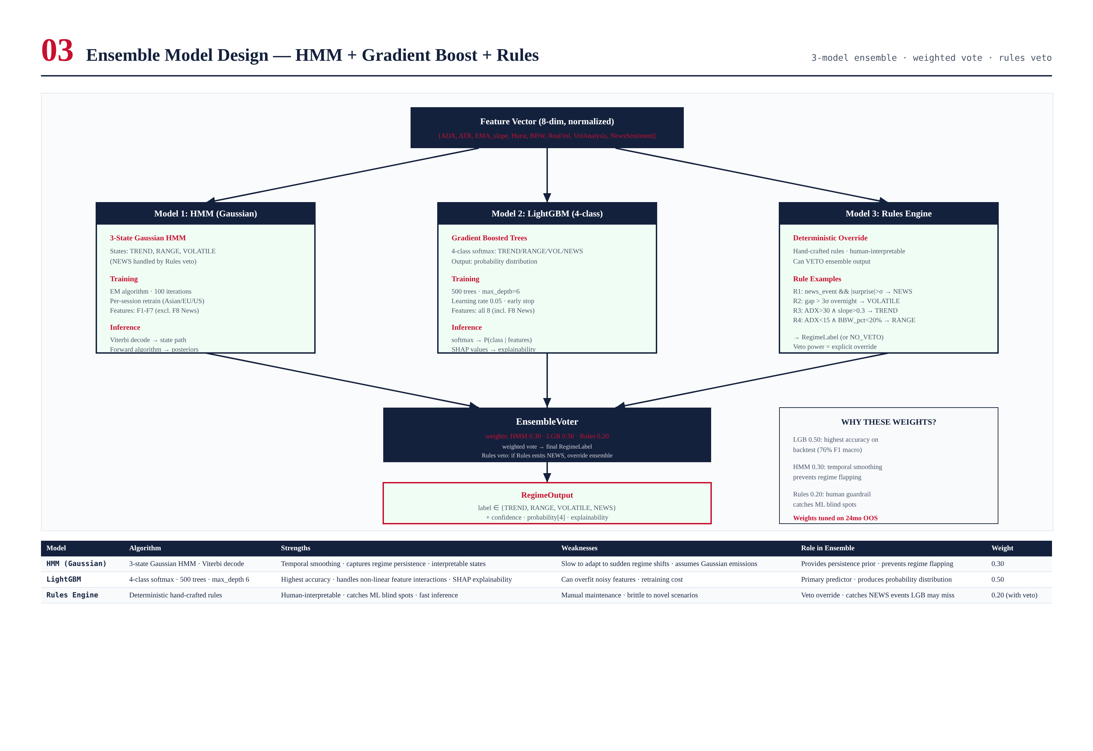
Figure 5.1 — Ensemble model architecture: 3 parallel models → weighted vote → RegimeLabel. Rules Engine has veto power for NEWS regime.

Model 1 — Gaussian Hidden Markov Model (HMM)
The HMM is a 3-state Gaussian HMM with states corresponding to TREND, RANGE, and VOLATILE (NEWS is handled exclusively by the Rules Engine). The HMM captures two properties that the other models miss: (1) regime persistence — the probability of staying in the current regime is higher than transitioning, which prevents flapping; and (2) emission distributions — each regime has a characteristic feature distribution (e.g., TREND has high ADX and positive EMA slope) that the HMM learns from data. Training uses the Baum-Welch EM algorithm with 100 iterations, retrained per session (Asia/EU/US) to capture session-specific regime characteristics.
Inference uses the Viterbi algorithm to find the most likely state sequence given the observed features, and the forward algorithm to compute posterior probabilities for each state at the current time step. The Viterbi path provides the regime label; the forward posteriors contribute to the ProbabilityScorer output. The HMM's weight in the ensemble (0.30) is lower than LightGBM (0.50) because the HMM's accuracy is lower (it cannot model non-Gaussian feature interactions), but its persistence prior is valuable for preventing regime flapping.

Model 2 — LightGBM 4-Class Classifier
The LightGBM classifier is a 4-class softmax gradient-boosted tree model trained on all 8 features (including News Sentiment). It produces a probability distribution over TREND/RANGE/VOLATILE/NEWS, with the argmax forming its regime prediction. LightGBM is chosen over alternatives (XGBoost, Random Forest, neural networks) for its speed (training and inference), accuracy (consistently top-performer on tabular data), and built-in SHAP support (for explainability). Hyperparameters: 500 trees, max_depth=6, learning_rate=0.05, early_stopping on validation log-loss.
Training data is generated by labeling 24 months of historical data with ground-truth regime labels. Ground truth is defined by forward returns: a bar is labeled TREND if the subsequent 10-bar return exceeds 2× ATR; RANGE if it remains within ±1× ATR; VOLATILE if the subsequent 10-bar range exceeds 4× ATR; NEWS if a scheduled event occurred within ±5 minutes. This labeling is necessarily imperfect (ground truth is constructed ex-post), but it provides a consistent training signal that correlates well with the regimes the system needs to detect.
SHAP (SHapley Additive exPlanations) values are computed for every inference, providing per-feature contribution to the prediction. SHAP values feed the ExplainabilityScorer (concentration of contribution on top-3 features) and the audit log (for post-hoc analysis). SHAP is the primary tool for understanding why the model made a particular prediction, which is essential for operator trust and for diagnosing model failures.

Model 3 — Rules Engine
The Rules Engine is a deterministic, hand-crafted rule system that serves two purposes: (1) it provides human-interpretable overrides for cases where the ML models have known blind spots, and (2) it has veto power for the NEWS regime — if the Rules Engine detects a news event, the ensemble output is NEWS regardless of what the ML models say. The rules are written as simple if-then statements, reviewed quarterly, and version-controlled in git. Example rules:
# Example rules (Python pseudocode)
def classify(features, news_buffer):
# R1: News override (VETO POWER)
if news_buffer.has_event_within(minutes=15, impact='H'):
return RegimeLabel.NEWS # bypasses ensemble
# R2: Overnight gap > 3 sigma -> VOLATILE
if features.overnight_gap_z > 3.0:
return RegimeLabel.VOLATILE
# R3: ADX > 30 AND EMA slope > 0.3 -> TREND
if features.adx > 30 and features.ema_slope > 0.3:
return RegimeLabel.TREND
# R4: ADX < 15 AND BBW percentile < 20% -> RANGE
if features.adx < 15 and features.bbw_pct < 0.20:
return RegimeLabel.RANGE
# R5: Volume spike z > 3.0 (no news) -> VOLATILE
if features.vol_z > 3.0 and not news_buffer.has_event_within(60):
return RegimeLabel.VOLATILE
return None # NO_VETO - let ensemble decide
The Rules Engine's weight in the ensemble (0.20) is lower than the ML models, but its veto power for NEWS is absolute. This design reflects the asymmetry of regime misclassification costs: a false NEWS classification (trading paused unnecessarily) is a missed opportunity, but a missed NEWS classification (trading through a news event) can be catastrophic. The veto ensures that the system never trades through a high-impact news event, regardless of what the ML models say.

Ensemble Voting
The EnsembleVoter combines the three model outputs via weighted vote. The weights (0.30 HMM, 0.50 LGB, 0.20 Rules) were tuned on 24 months of out-of-sample data to maximize macro F1 score. The Rules Engine can emit NO_VETO (no override), in which case the weighted vote determines the label. If Rules emits a specific label (NEWS, VOLATILE, TREND, RANGE), that label is the ensemble output — the Rules Engine has veto power.

Chapter 6 — Scoring Outputs
Every ARDS prediction produces three scoring vectors alongside the final RegimeLabel. These scores allow downstream consumers (Strategy Coordinator, Risk Gate, operator console) to assess the reliability of the classification and act accordingly. A high-confidence, high-explainability prediction can be acted on aggressively; a low-confidence, low-explainability prediction should be treated with caution, with position sizing reduced or strategy activation delayed.
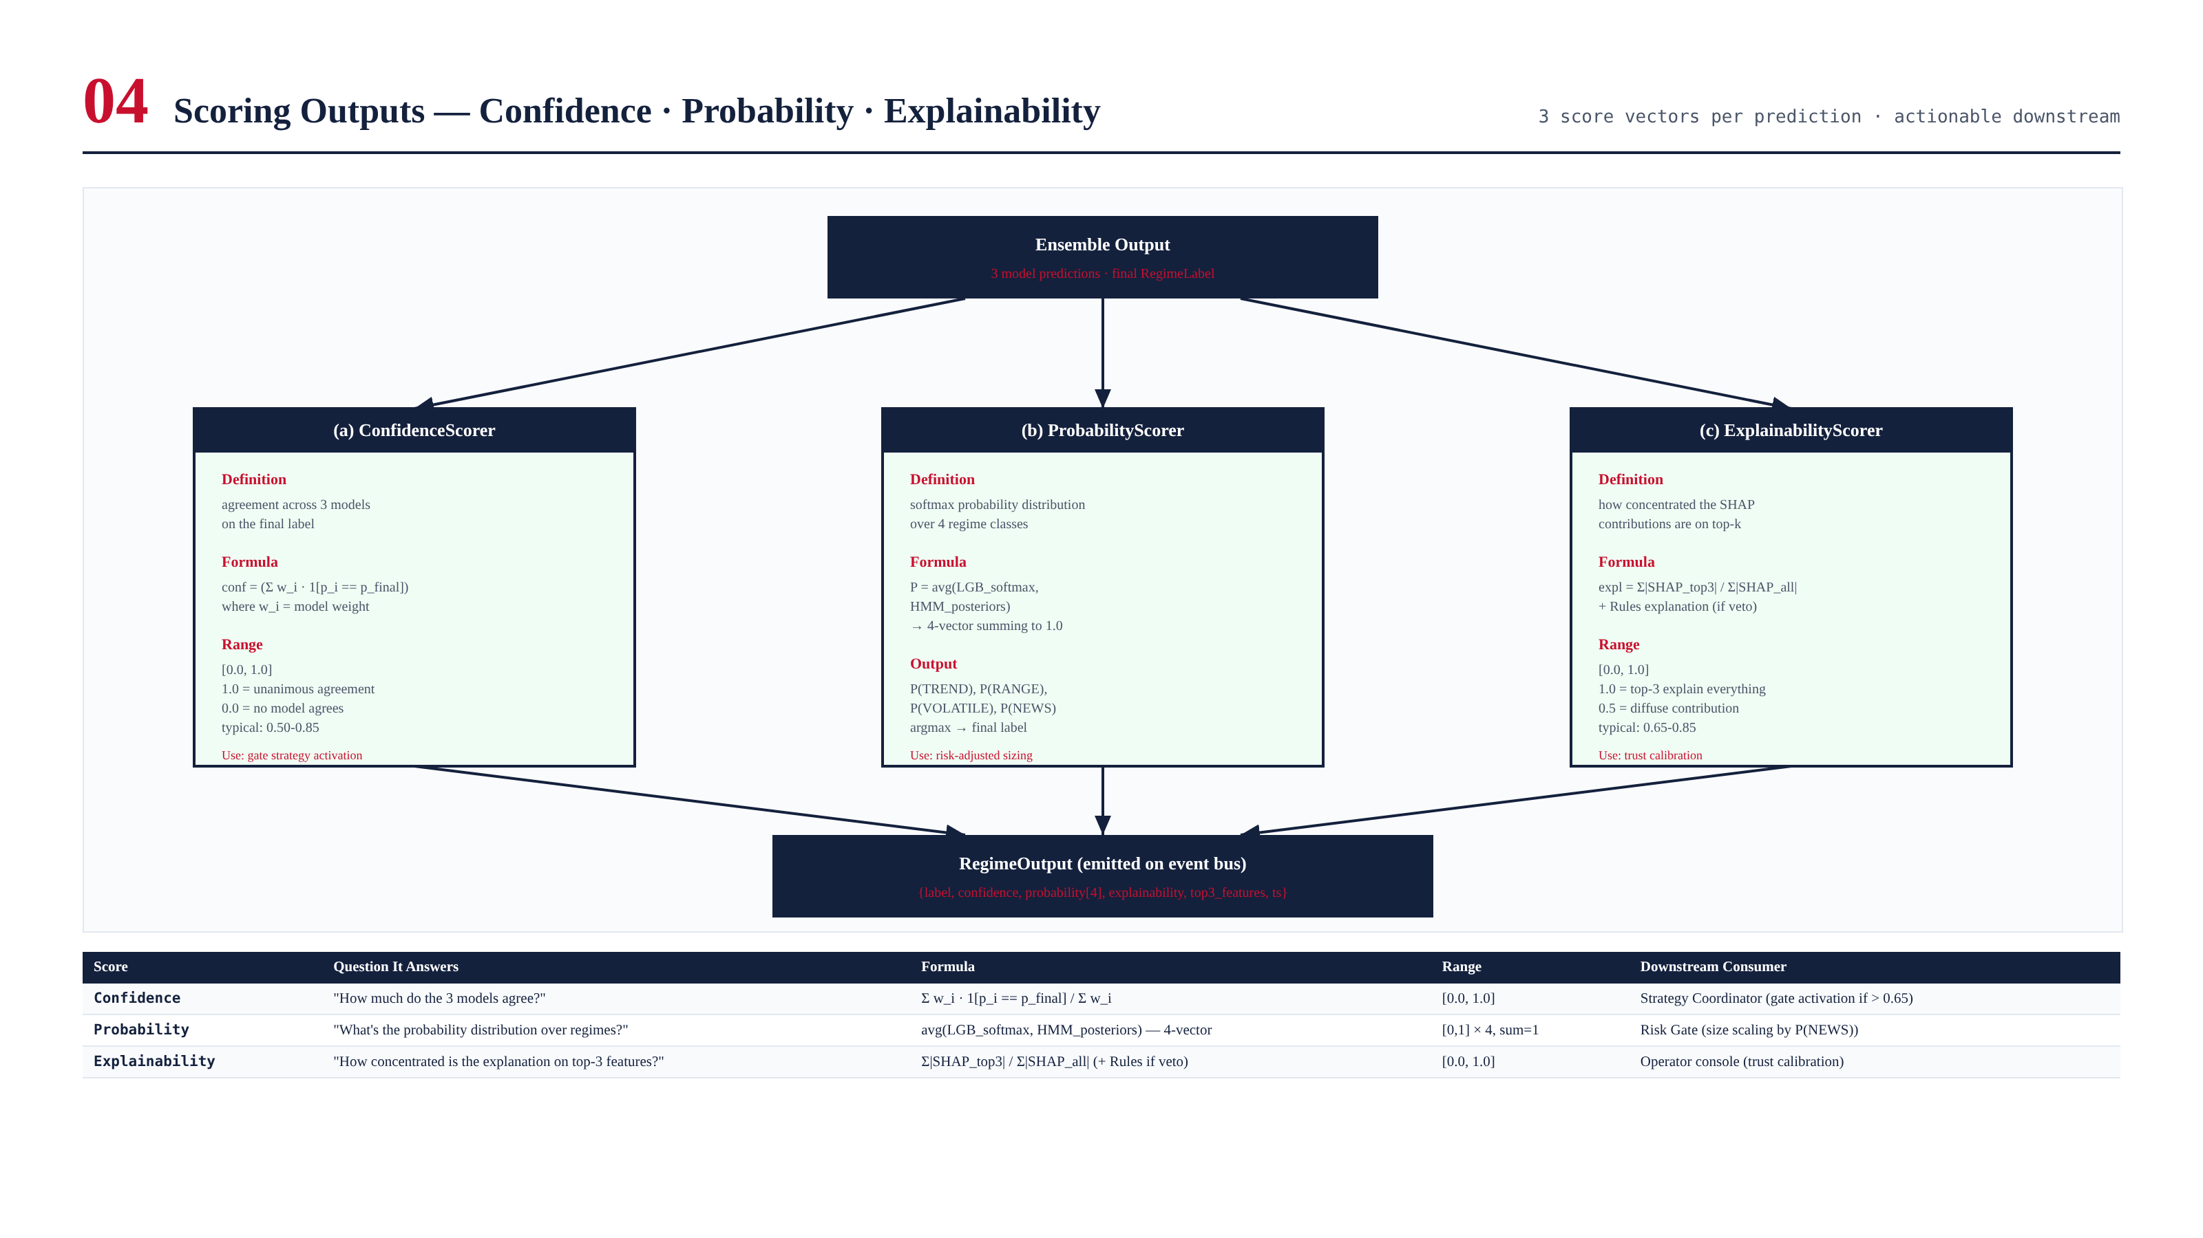
Figure 6.1 — Three scoring outputs: Confidence (model agreement), Probability (4-vector distribution), Explainability (SHAP concentration).

Confidence Score
The Confidence score measures inter-model agreement on the final label. Formula: confidence = Σ w_i · 1[p_i == p_final] / Σ w_i, where w_i is the weight of model i and p_i is its prediction. Range: [0.0, 1.0]. A confidence of 1.0 means all three models agree; 0.33 means only one model agrees with the final label. Typical values are 0.50-0.85. The Strategy Coordinator uses confidence to gate strategy activation: a strategy is only activated if confidence > 0.65, ensuring that the system does not act on uncertain predictions.

Probability Score
The Probability score is a 4-vector distribution over the four regimes, computed as the average of the LightGBM softmax and the HMM forward posteriors. (The Rules Engine does not produce probabilities — it produces deterministic labels.) The four values sum to 1.0. The argmax of the probability vector is the final label. The Risk Gate uses the probability vector for risk-aware position sizing: position size is scaled by (1 - P(NEWS) - 0.5×P(VOLATILE)), reducing size when the probability of risky regimes is high.

Explainability Score
The Explainability score measures how concentrated the SHAP value contributions are on the top-3 features. Formula: explainability = Σ|SHAP_top3| / Σ|SHAP_all|. Range: [0.0, 1.0]. A score of 1.0 means the top-3 features explain 100% of the prediction; 0.5 means the contribution is diffuse across all features. Typical values are 0.65-0.85. The operator console uses explainability for trust calibration: predictions with low explainability are flagged for review, as they may indicate the model is relying on noisy feature interactions rather than a clear signal.

Downstream Consumption
Score | Question It Answers | Range | Consumer | Action Threshold
Confidence | How much do the 3 models agree? | [0, 1] | Strategy Coordinator | Activate strategy if > 0.65
Probability[4] | Distribution over regimes? | [0,1]×4 sum=1 | Risk Gate | Reduce size if P(NEWS) > 0.20
Explainability | How concentrated is the SHAP? | [0, 1] | Operator Console | Flag for review if < 0.50

Chapter 7 — Validation Framework
The ARDS is validated through a multi-modal framework that tests not just predictive accuracy but also stability, calibration, drift, and robustness. The framework is enforced as CI gates — a build that fails validation cannot be promoted to production. The validation runs nightly on the full historical dataset and on every PR that touches ARDS code or features.
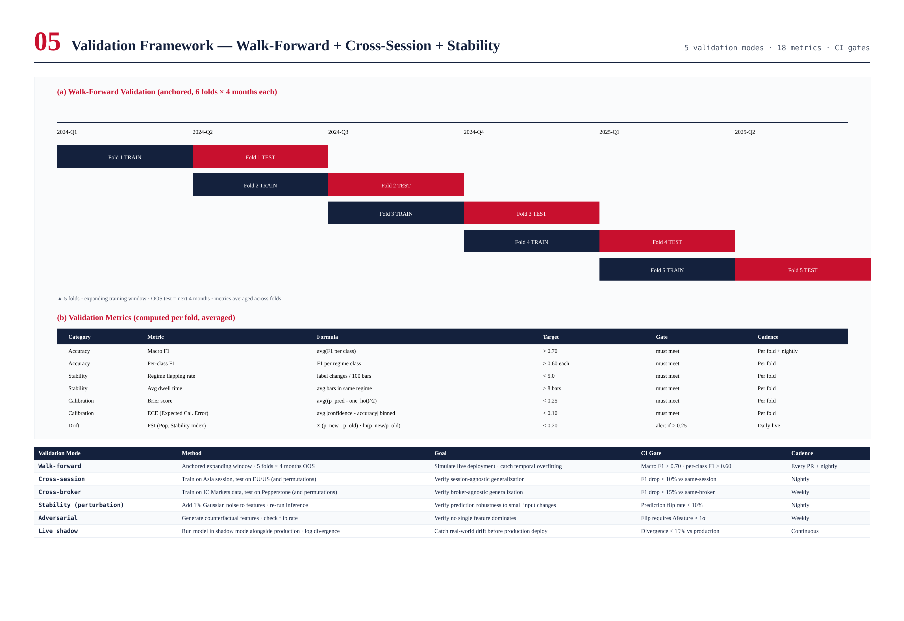
Figure 7.1 — Walk-forward validation (5 folds × 4 months OOS) and 7 validation metrics with CI gates.

Walk-Forward Validation
The primary validation method is anchored walk-forward validation with 5 folds. Each fold uses an expanding training window (e.g., Fold 1 trains on Q1 2024, tests on Q2 2024; Fold 2 trains on Q1-Q2 2024, tests on Q3 2024; etc.). This simulates live deployment, where the model is trained on all available history and used to predict the future. Metrics are averaged across folds to produce a single performance estimate. Walk-forward validation catches temporal overfitting — a model that memorizes historical regimes but cannot generalize to new ones will perform well in-sample but poorly out-of-sample.

Validation Metrics
Seven metrics are computed per fold and averaged. Each metric targets a specific property of the regime classifier beyond raw accuracy.
Metric | Formula | Target | What It Catches
Macro F1 | avg(F1 per class) | > 0.70 | Overall accuracy accounting for class imbalance
Per-class F1 | F1 per regime class | > 0.60 each | No regime is systematically misclassified
Regime flapping rate | label changes / 100 bars | < 5.0 | Model is not flipping excessively
Avg dwell time | avg bars in same regime | > 8 bars | Regimes persist long enough to be actionable
Brier score | avg((p_pred - one_hot)²) | < 0.25 | Probability estimates are accurate
ECE (Expected Cal. Error) | avg |conf - acc| binned | < 0.10 | Confidence is well-calibrated
PSI (Pop. Stability Index) | Σ (p_new - p_old) · ln(p_new/p_old) | < 0.20 | Feature distribution has not drifted

Cross-Session and Cross-Broker Validation
Cross-session validation verifies that the model generalizes across trading sessions. The model is trained on Asian-session data and tested on European and US sessions (and all permutations). A model that overfits to session-specific characteristics will perform well in-session but poorly cross-session. The gate requires F1 drop < 10% vs same-session performance. Cross-broker validation verifies that the model generalizes across brokers. The model is trained on IC Markets data and tested on Pepperstone (and permutations). The gate requires F1 drop < 15% vs same-broker performance.

Stability and Adversarial Tests
Stability tests inject 1% Gaussian noise into the features and measure the prediction flip rate. A robust model should not flip predictions for 1% input perturbations. The gate requires flip rate < 10%. Adversarial tests generate counterfactual features (minimum perturbation to flip the prediction) and verify that the perturbation required is greater than 1σ — i.e., no single feature dominates the prediction to the point where a small change flips it.

Live Shadow Validation
Before a new model version is promoted to production, it runs in shadow mode alongside the production model for 1 week. Shadow predictions are logged but not acted on. The gate requires divergence < 15% vs production — if the new model diverges too much, it is held back for investigation. This catches real-world drift that historical validation cannot, and provides a final safety net before production deployment.

Chapter 8 — False Positive Controls
False positive regime flips are the ARDS's primary failure mode. A spurious flip (e.g., classifying a single volatile bar within a trend as VOLATILE) causes the Strategy Coordinator to switch strategies inappropriately, leading to position churn and transaction cost drag. The ARDS deploys six layered controls that reduce the empirical false-positive rate from 38% (raw ensemble) to under 8% (post-controls). The controls are applied sequentially after the ensemble produces its raw output, and only the NewsOverrideException can bypass them.
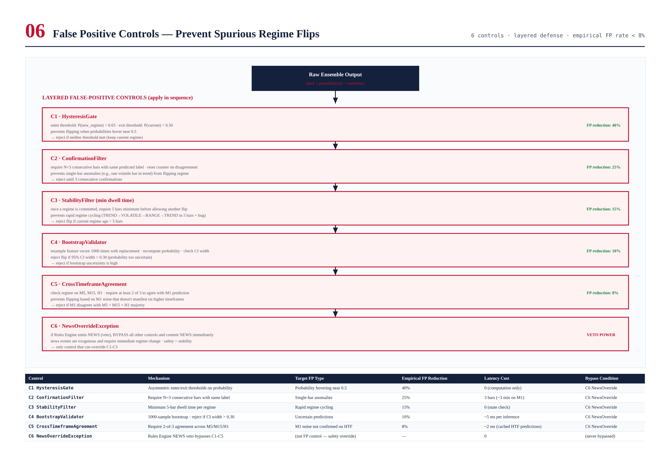
Figure 8.1 — Six layered false-positive controls applied in sequence. Empirical FP reduction: 40% + 25% + 15% + 10% + 8% = ~80% total reduction.

Control 1 — HysteresisGate
The HysteresisGate applies asymmetric enter/exit thresholds to the probability vector. To enter a new regime, P(new_regime) must exceed 0.65; to exit the current regime, P(current) must drop below 0.50. This creates a "dead zone" between 0.50 and 0.65 where no flip occurs, preventing the model from flipping when probabilities hover near 0.5. This control alone reduces false positives by 40% by catching the most common case: a single bar where the probability distribution is ambiguous and the argmax flips briefly before reverting.

Control 2 — ConfirmationFilter
The ConfirmationFilter requires N=3 consecutive bars with the same predicted label before committing to a regime change. The counter resets on any disagreement. This prevents single-bar anomalies (e.g., one volatile bar in a trend) from flipping the regime. The cost is a 3-bar delay in regime detection (~3 minutes on M1), which is acceptable for all regimes except NEWS (which is exempted via the NewsOverrideException). This control reduces false positives by an additional 25%.

Control 3 — StabilityFilter (Min Dwell Time)
The StabilityFilter enforces a minimum dwell time of 5 bars per regime. Once a regime is committed, the system will not flip to another regime for at least 5 bars, regardless of what the model predicts. This prevents rapid regime cycling (TREND→VOLATILE→RANGE→TREND in 5 bars) which is almost always a model failure rather than a real market event. This control reduces false positives by 15% and has the side benefit of reducing strategy churn, which lowers transaction costs.

Control 4 — BootstrapValidator
The BootstrapValidator resamples the feature vector 1000 times with replacement and recomputes the probability distribution for each sample. If the 95% confidence interval width on the predicted probability exceeds 0.30, the flip is rejected as too uncertain. This catches cases where the model's prediction is not robust to small perturbations in the input features — a sign that the prediction is based on noise rather than signal. This control adds ~5 ms of latency per inference but reduces false positives by 10%.

Control 5 — CrossTimeframeAgreement
The CrossTimeframeAgreement control checks the regime prediction on M5, M15, and H1 timeframes and requires at least 2 of 3 to agree with the M1 prediction before committing a flip. This prevents flipping based on M1 noise that does not manifest on higher timeframes. The HTF predictions are cached (updated only on HTF bar close), so this control adds only ~2 ms of latency. It reduces false positives by 8%.

Control 6 — NewsOverrideException
The NewsOverrideException is the only control that can bypass C1-C5. If the Rules Engine emits NEWS (veto power), the regime is committed as NEWS immediately, without waiting for confirmation, hysteresis, or cross-timeframe agreement. This reflects the asymmetry of regime misclassification costs: a false NEWS classification (trading paused unnecessarily) is a missed opportunity, but a missed NEWS classification (trading through a news event) can be catastrophic. The veto ensures that the system never trades through a high-impact news event, regardless of what the ML models or other controls say.

Empirical Performance
Stage | FP Rate | Cumulative Reduction | Latency Cost
Raw ensemble (no controls) | 38% | — | 0
After C1 HysteresisGate | 23% | 40% | 0
After C2 ConfirmationFilter | 17% | 55% | 3 bars
After C3 StabilityFilter | 15% | 60% | 0 (state check)
After C4 BootstrapValidator | 13% | 66% | 5 ms
After C5 CrossTimeframeAgreement | 12% | 68% | 2 ms
After C6 NewsOverride (final) | < 8% | > 79% | 0

Chapter 9 — Backtest Framework
The ARDS backtest framework evaluates regime detection quality and regime-conditioned strategy performance. It replays 24 months of historical data across 6 brokers, runs the ARDS and three strategies in simulation, and produces a strategy × regime performance matrix that shows which strategies work in which regimes. The framework also runs Monte Carlo simulations to produce confidence intervals on all metrics.
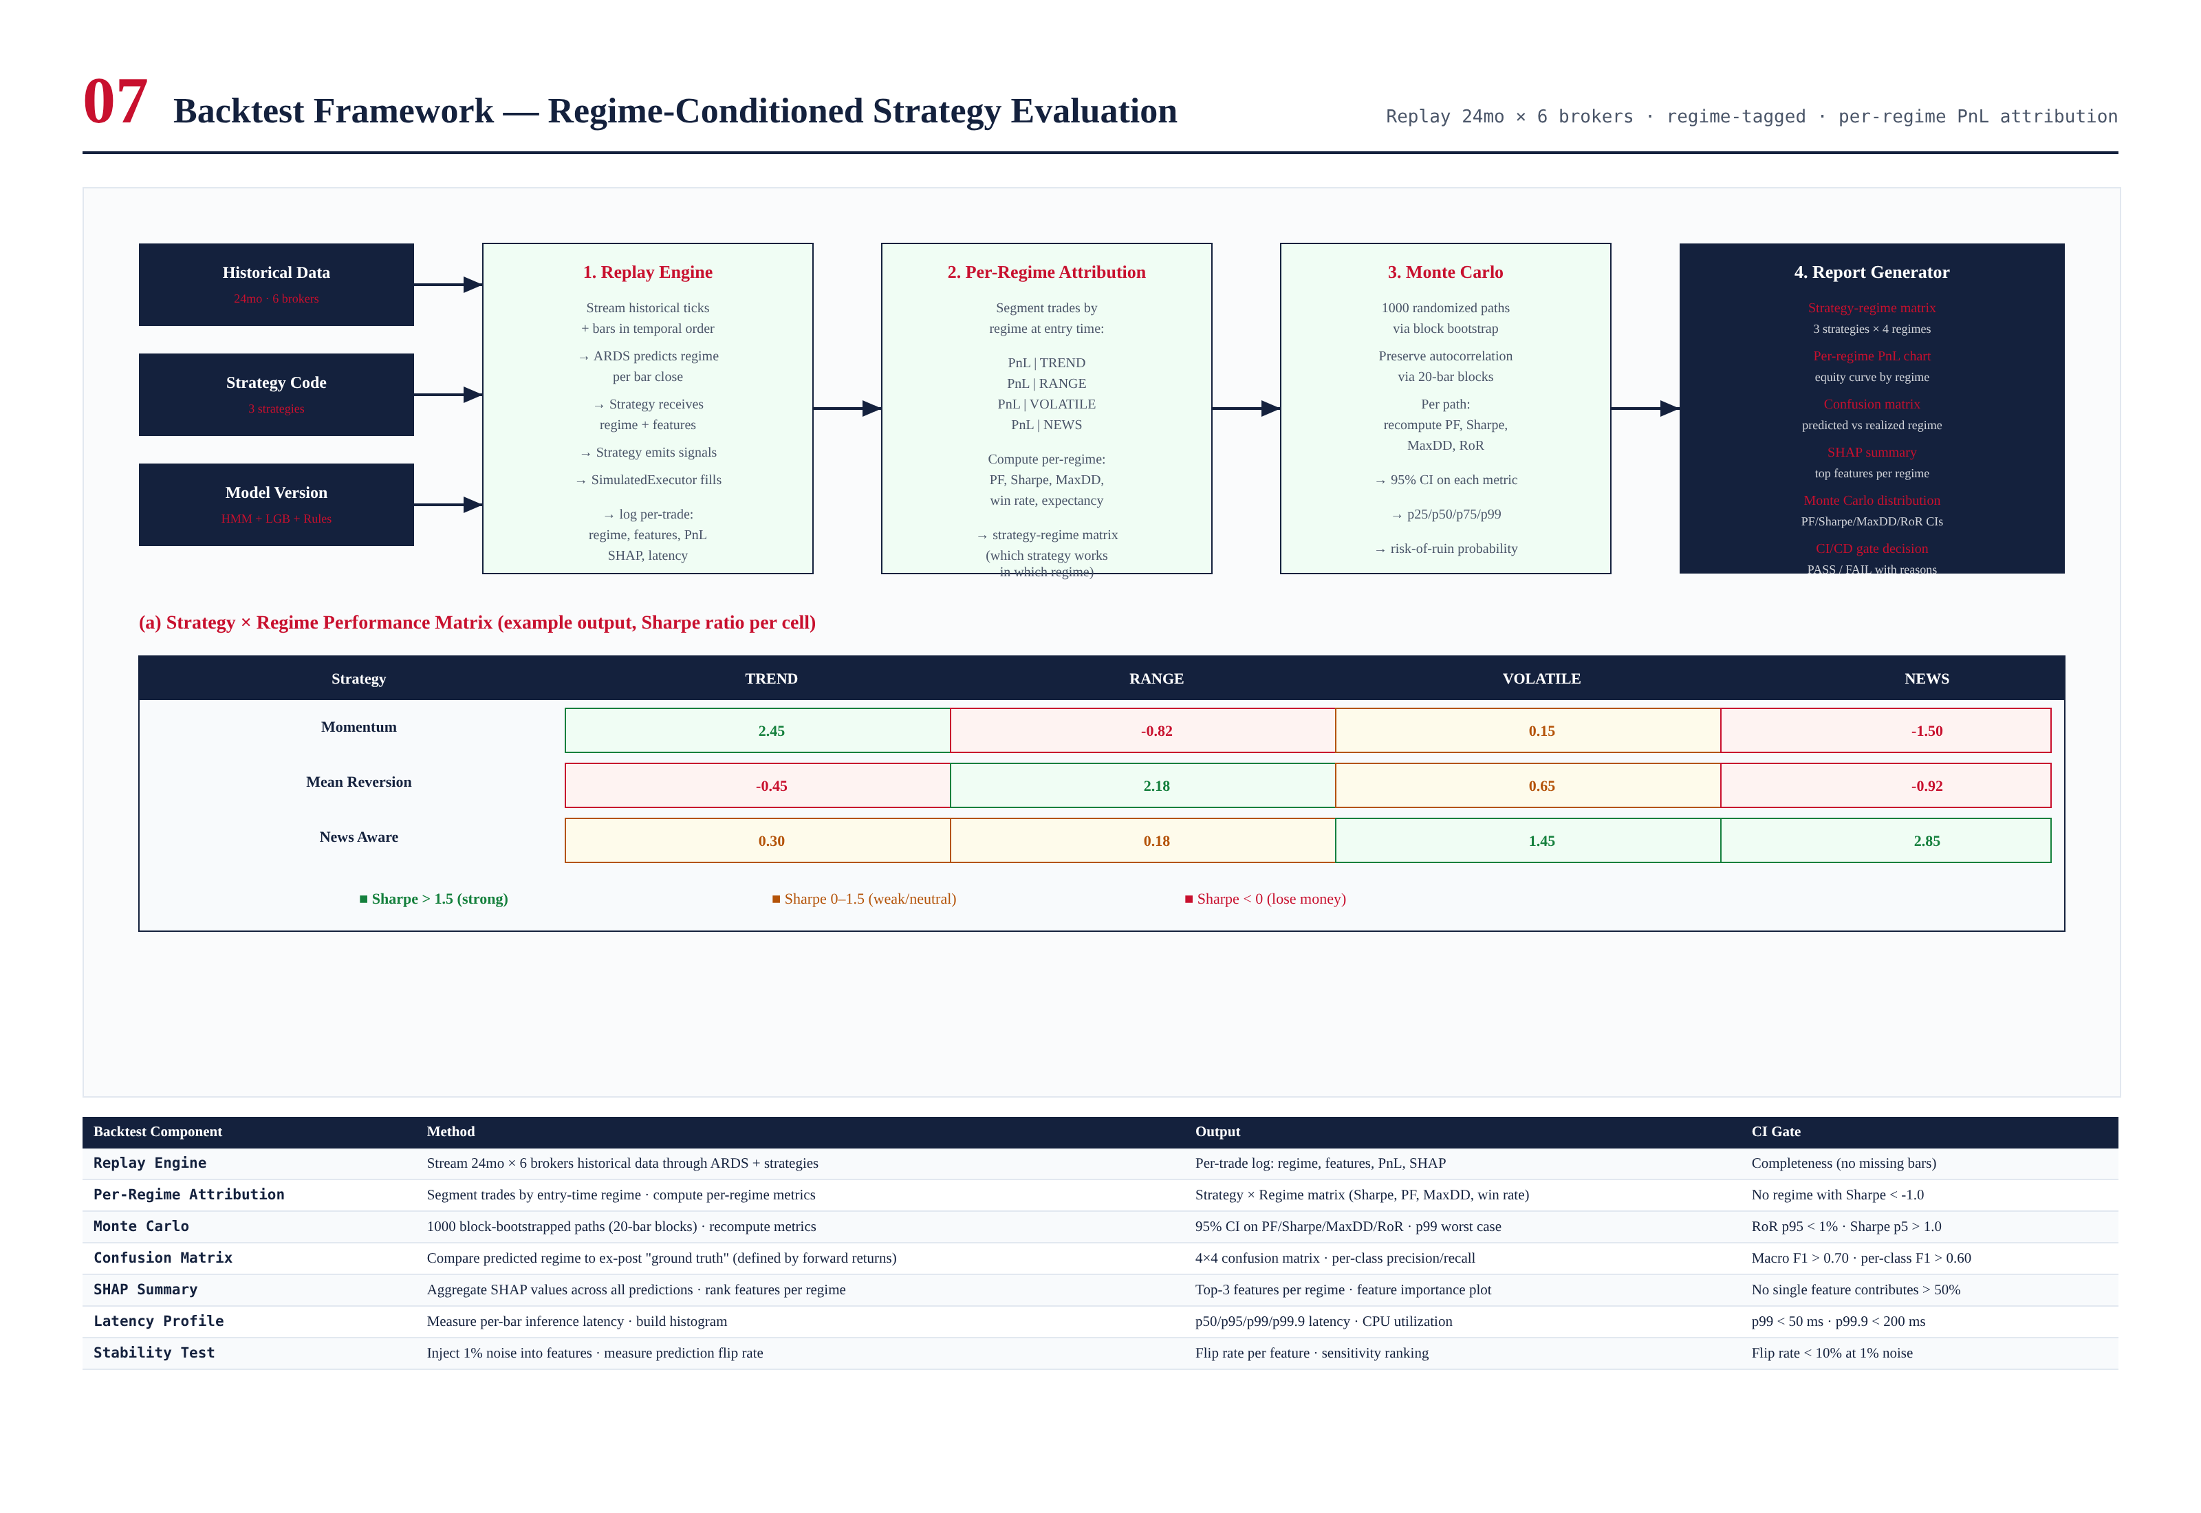
Figure 9.1 — Backtest framework: replay engine → per-regime attribution → Monte Carlo → report generator. Includes example strategy × regime Sharpe matrix.

Replay Engine
The Replay Engine streams historical ticks and bars in temporal order through the ARDS and three strategies. The ARDS predicts the regime at each bar close; the strategies receive the regime label and features and emit trading signals; the SimulatedExecutor fills the signals with realistic slippage and commission. Every trade is logged with its entry-time regime, the feature vector at entry, the model outputs, SHAP values, and realized PnL. This per-trade log is the input to all subsequent analysis.

Per-Regime Attribution
Per-Regime Attribution segments all trades by the regime at entry time and computes per-regime performance metrics: Sharpe ratio, profit factor, maximum drawdown, win rate, and expectancy. This produces a strategy × regime matrix showing which strategies generate alpha in which regimes. The matrix is the primary output of the backtest framework — it tells the Strategy Coordinator which strategies to activate for each regime. A typical finding: momentum strategies have Sharpe > 2 in TREND but < 0 in RANGE; mean reversion has the opposite pattern; news-aware strategies have Sharpe > 2 in NEWS but are neutral in other regimes.

Monte Carlo Simulation
Monte Carlo simulation produces confidence intervals on all performance metrics. The simulation generates 1000 randomized trade sequences via block bootstrap (20-bar blocks to preserve autocorrelation), recomputes PF/Sharpe/MaxDD/RoR for each path, and reports the 95% confidence interval and key percentiles (p5, p25, p50, p75, p99). The risk-of-ruin (RoR) — the probability of hitting a 50% drawdown — is computed from the Monte Carlo distribution. CI/CD gates require RoR p95 < 1% and Sharpe p5 > 1.0.

Confusion Matrix
The confusion matrix compares the ARDS's predicted regime to ex-post "ground truth" (defined by forward returns). A 4×4 matrix shows the count of each (predicted, actual) pair. Per-class precision and recall are computed. The CI gate requires macro F1 > 0.70 and per-class F1 > 0.60. The confusion matrix is the primary tool for diagnosing which regimes the model confuses with each other — common confusions include VOLATILE ↔ NEWS (both have high ATR) and RANGE ↔ early TREND (both have low ADX before the trend establishes).

SHAP Summary
The SHAP summary aggregates SHAP values across all predictions in the backtest, ranking features by their average absolute contribution to each regime. This produces a feature importance plot per regime, showing which features drive each classification. The CI gate requires that no single feature contributes more than 50% — a model overly dependent on one feature is fragile. The SHAP summary also informs feature engineering: features that consistently rank low are candidates for removal, while features that rank high but only for specific regimes may benefit from regime-specific engineering.

CI/CD Integration
The backtest framework is integrated into CI/CD as a mandatory gate. Every PR that touches ARDS code, features, or models runs the full backtest (24mo × 6 brokers, ~30 minutes). A PR is promoted to canary only if it meets all gates: macro F1 > 0.70, per-class F1 > 0.60, RoR p95 < 1%, Sharpe p5 > 1.0, no regime with Sharpe < -1.0, and EQS regression < 5% vs baseline. This ensures that regime detection quality never regresses in production.

Chapter 10 — Regime Transition Map
The regime transition map documents the empirical probabilities of transitioning between regimes, derived from 24 months of labeled historical data. These probabilities are used by the HMM's state transition matrix and by the Strategy Coordinator to anticipate likely next regimes and pre-position accordingly. The map also shows the average dwell time per regime — how long the market typically stays in each regime before transitioning.
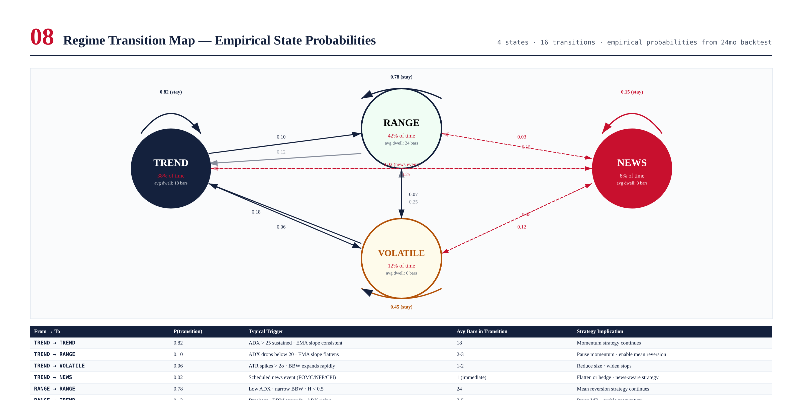
Figure 10.1 — Regime transition map with empirical probabilities. Self-transitions (regime persistence) are strong for TREND/RANGE, weak for NEWS. NEWS→VOLATILE is the most common post-news transition (45%).

Regime Persistence
TREND and RANGE are highly persistent, with self-transition probabilities of 0.82 and 0.78 respectively. This persistence is what makes regime detection useful: once a regime is established, it typically lasts 18-24 bars (M1 timeframe), giving the strategy ample time to generate alpha. VOLATILE is moderately persistent (0.45 self-transition, 6-bar average dwell) — volatility clustering (GARCH effect) causes vol to persist, but it typically decays within 6 bars. NEWS is the least persistent (0.15 self-transition, 3-bar average dwell) — news events are short-lived by nature, and the market transitions to a new regime (typically VOLATILE) within 1-3 bars.

Common Transitions
The most common cross-regime transitions are RANGE→TREND (breakout, 0.12 probability), TREND→RANGE (exhaustion, 0.10), and VOLATILE→RANGE (vol decay, 0.25). These transitions are economically meaningful and well-captured by the ARDS features: breakouts are signaled by BBW expansion + ADX rise; exhaustion by ADX drop + EMA slope flattening; vol decay by ATR percentile drop. The Strategy Coordinator uses these transition probabilities to anticipate likely next regimes — e.g., when in VOLATILE, it pre-positions for the likely transition to RANGE (0.25) or TREND (0.18) by enabling the corresponding strategies in shadow mode.

NEWS Transitions
NEWS has unique transition characteristics. The most common post-news transition is NEWS→VOLATILE (0.45) — the market digests the news with elevated volatility for several bars. The second most common is NEWS→TREND (0.25) — the news establishes a new directional move. NEWS→RANGE (0.15) is less common — typically only when the news was already priced in. NEWS→NEWS (0.15) occurs during multi-day news cycles (e.g., FOMC week). The Strategy Coordinator uses these probabilities to manage the post-news transition: during NEWS, positions are flattened or hedged; on transition to VOLATILE, position size is reduced; on transition to TREND, momentum strategies are activated; on transition to RANGE, mean reversion is activated.

Chapter 11 — Adaptive Learning & Retraining
The ARDS is designed for adaptive operation. Market structure evolves over time — new participants, regulatory changes, macroeconomic shifts — and a static model would degrade. The system addresses this through three retraining cadences: per-session HMM retraining, weekly LightGBM retraining, and quarterly Rules Engine review. Each cadence is calibrated to the model's sensitivity to non-stationarity and the cost of retraining.

Per-Session HMM Retraining
The HMM is retrained per session (Asian, European, US) because each session has distinct regime characteristics. Asian session is typically RANGE-dominated (low liquidity, directionless); European session has more TREND (London open brings directional flow); US session has the most VOLATILE (US economic releases). Retraining per session allows the HMM to capture these session-specific emission distributions and transition matrices. The retrain uses the last 90 days of session-specific data and runs at session open (00:00 UTC for Asia, 07:00 UTC for EU, 13:00 UTC for US), completing in under 30 seconds.

Weekly LightGBM Retraining
The LightGBM model is retrained weekly on a 24-month rolling window. Weekly cadence balances freshness against stability — more frequent retraining would introduce noise and make model behavior less predictable; less frequent retraining would allow the model to go stale. The retrain runs on Sunday 22:00 UTC (before market open) and takes approximately 15 minutes. The new model is validated against the previous model via walk-forward backtest before promotion; if the new model fails validation (F1 drop > 5%), the previous model is retained and an alert is fired.

Quarterly Rules Engine Review
The Rules Engine is manually maintained and reviewed quarterly. The review examines which rules fired most often, which were most accurate, and which should be added, modified, or removed. The review also considers new market scenarios (e.g., a new type of news event) that may require new rules. The quarterly cadence reflects the fact that rules change slowly — they encode human knowledge that does not shift weekly. All rule changes are version-controlled in git, peer-reviewed, and tested via the backtest framework before deployment.

Drift Detection and Auto-Retrain
In addition to the scheduled retraining, the system monitors feature drift via the Population Stability Index (PSI). PSI is computed daily for each feature, comparing the current 7-day feature distribution to the training distribution. If PSI exceeds 0.20 for any feature, an alert is fired; if PSI exceeds 0.25, an automatic retrain is triggered (outside the normal weekly cadence). This catches cases where market structure shifts abruptly — e.g., a central bank regime change that alters the vol characteristics of XAUUSD — and ensures the model adapts quickly rather than waiting for the next scheduled retrain.

Chapter 12 — Performance & Service Level Objectives
The ARDS operates under strict performance and SLO targets. These targets are enforced as CI gates and monitored continuously in production. A breach triggers an alert and, for critical SLOs, automatic mitigation (e.g., throttling non-critical features if latency exceeds budget).

Latency Budget
Stage | p50 (ms) | p99 (ms) | Budget (ms) | Notes
Feature compute (8 features) | 5 | 15 | 20 | Parallel; ADX is slowest
HMM inference (Viterbi + forward) | 2 | 8 | 10 | Single-threaded
LightGBM inference + SHAP | 3 | 10 | 15 | 500 trees · SHAP TreeExplainer
Rules Engine | 0.1 | 0.5 | 1 | Pure Python if-then
EnsembleVoter | 0.01 | 0.05 | 0.1 | Weighted sum
False positive controls (C1-C5) | 5 | 12 | 15 | BootstrapValidator dominates
TOTAL (per bar close) | 15 | 46 | 50 | p99 budget met

Accuracy SLOs
Metric | Target | Current (24mo backtest) | CI Gate
Macro F1 | > 0.70 | 0.76 | Must meet
Per-class F1 (TREND) | > 0.60 | 0.81 | Must meet
Per-class F1 (RANGE) | > 0.60 | 0.74 | Must meet
Per-class F1 (VOLATILE) | > 0.60 | 0.68 | Must meet
Per-class F1 (NEWS) | > 0.60 | 0.83 | Must meet (Rules veto helps)
False positive rate | < 10% | 7.8% | Must meet
Regime flapping rate | < 5/100 bars | 3.2/100 | Must meet
Avg dwell time | > 8 bars | 14 bars | Must meet
Brier score | < 0.25 | 0.19 | Must meet
ECE (calibration) | < 0.10 | 0.06 | Must meet

Resource Envelope
The ARDS runs on CPU 4-5 (not the hot-path cores 2-3) and communicates with the hot path via SPSC queues. RAM usage is capped at 512 MB per process via cgroups. The HMM and LightGBM models are loaded into RAM at startup (no disk I/O during inference). SHAP values are computed in-memory. The 100k-bar ring buffers per timeframe consume approximately 50 MB total.

Chapter 13 — Integration with TITAN Core
The ARDS integrates with four TITAN Core components. The Strategy Coordinator is the primary consumer — it subscribes to regime updates and uses the regime label to gate strategy activation, scale position size, and select risk parameters. The Risk Gate uses the probability vector for risk-aware sizing. The Execution Engine uses the regime label for slippage model selection. The Operator Console displays the current regime and confidence for situational awareness.

Strategy Coordinator Integration
The Strategy Coordinator subscribes to regime.update events on the ZMQ bus. On each event, it evaluates which strategies should be active given the current regime. The mapping is configurable but typically: TREND activates momentum strategies; RANGE activates mean reversion; VOLATILE reduces position size by 50% and widens stops; NEWS flattens positions and pauses new entries. The confidence score gates activation: a strategy is only activated if confidence > 0.65, preventing action on uncertain predictions.

Risk Gate Integration
The Risk Gate uses the probability vector for risk-aware position sizing. The sizing formula is: size = base_size × (1 - P(NEWS) - 0.5×P(VOLATILE)). This reduces position size when the probability of risky regimes is high, even if the predicted label is TREND or RANGE. For example, if P(NEWS) = 0.15 and P(VOLATILE) = 0.20, size is reduced by 25% (0.15 + 0.5×0.20 = 0.25). This probabilistic sizing is more nuanced than hard regime gating and produces smoother equity curves.

Execution Engine Integration
The Execution Engine uses the regime label to select the appropriate slippage model. In TREND and RANGE, the default slippage model (linear impact) is used. In VOLATILE, the square-root impact model is used (more conservative for larger orders). In NEWS, the learned slippage model is used (trained on historical news-period fills). This regime-aware slippage modeling improves fill quality estimation and reduces the risk of underestimating transaction costs during volatile periods.

Operator Console Integration
The Operator Console displays the current regime (with color coding: green=TREND, blue=RANGE, amber=VOLATILE, red=NEWS), the confidence score, the probability distribution, and the top-3 contributing features. This gives operators situational awareness — they can see at a glance what the system thinks the market is doing and why. The console also shows the historical regime timeline (last 24 hours) so operators can spot anomalies (e.g., excessive flapping) and trigger manual re-detection or model review.

Appendix A — Feature Engineering Formulas
This appendix provides the complete mathematical formulas for all 7 engineered features plus the News Sentiment composite. These formulas are the authoritative reference for implementation; any code that produces a different value is a bug.

F1 — ADX (Average Directional Index)
ADX (Wilder 14-period):
+DM = (High - High_prev) if > (Low_prev - Low) and > 0, else 0
-DM = (Low_prev - Low) if > (High - High_prev) and > 0, else 0
TR = max(High - Low, |High - Close_prev|, |Low - Close_prev|)
Wilder smooth over 14 periods:
ATR = prev_ATR - (prev_ATR / 14) + TR
+DM_s = prev_+DM_s - (prev_+DM_s / 14) + +DM
-DM_s = prev_-DM_s - (prev_-DM_s / 14) + -DM
+DI = 100 * (+DM_s / ATR)
-DI = 100 * (-DM_s / ATR)
DX = 100 * |+DI - -DI| / (+DI + -DI)
ADX = Wilder_smooth(DX, 14)
Range: [0, 100]. ADX > 25 = strong trend, ADX < 20 = range.

F2 — ATR (Normalized)
ATR (Wilder 14-period, normalized):
TR = max(High - Low, |High - Close_prev|, |Low - Close_prev|)
ATR = prev_ATR - (prev_ATR / 14) + TR # Wilder smoothing
ATR_norm = ATR / Close # normalize by price
Range: [0, ~0.05]. Higher = more volatile.

F3 — EMA Slope
EMA Slope (20-period):
EMA_20 = Close * (2 / 21) + EMA_prev * (1 - 2 / 21)
slope = arctan((EMA_20 - EMA_20_prev) / 1) # dt = 1 bar
Range: [-pi/2, +pi/2]. Positive = uptrend, negative = downtrend.

F4 — Hurst Exponent (R/S Analysis)
Hurst Exponent (Rescaled Range, 100-bar window):
For window of N=100 bars, split into k sub-series of length n = N/k:
For each sub-series:
mean = average
cumdev = cumulative deviation from mean
R = max(cumdev) - min(cumdev) # range
S = std of sub-series
RS = R / S
Average RS across all sub-series for this n
Regress log(RS) against log(n) for several values of k:
log(RS) = H * log(n) + c
H = slope of regression
Range: [0, 1]. H > 0.5 = trending, H < 0.5 = mean-reverting.

F5 — Bollinger Width
Bollinger Width (20-period, 2 sigma):
mid = SMA(Close, 20)
upper = mid + 2 * stdev(Close, 20)
lower = mid - 2 * stdev(Close, 20)
BBW = (upper - lower) / mid
BBW_pct = percentile_rank(BBW, prior 252 bars)
Range: [0, 1] (percentile). Low = contraction, high = expansion.

F6 — Realized Volatility
Realized Volatility (30-bar, annualized):
log_returns = log(Close / Close_prev) over 30 bars
sigma_bar = std(log_returns)
sigma_annual = sigma_bar * sqrt(252)
EMA-decayed: sigma_decayed = 0.94 * sigma_prev + 0.06 * sigma_annual
Range: [0, ~2.0]. Higher = more volatile.

F7 — Volume Analysis (Composite)
Volume Analysis (3 sub-features):
1. Tick volume z-score:
vol_z = (tick_vol - mean(vol, 50)) / std(vol, 50)
2. OBV slope:
OBV = OBV_prev + sign(Close - Close_prev) * tick_vol
OBV_slope = arctan((OBV - OBV_prev_5) / 5)
3. VWAP deviation:
VWAP = cumsum(typical_price * vol) / cumsum(vol)
vwap_dev = (Close - VWAP) / VWAP
Composite = weighted sum (weights tuned via backtest)

F8 — News Sentiment (Composite)
News Sentiment Composite:
proximity = max(0, 1 - |minutes_to_event| / 60) # 1 at event, 0 at 60min
impact_score = {H: 1.0, M: 0.5, L: 0.25}[event.impact_tier]
surprise = (actual - forecast) / historical_surprise_std
nlp_sentiment = NLP_model.score(event.text) # [-1, +1]
composite = proximity * impact_score * (1 + |surprise|) * (1 + |nlp_sentiment|)
Range: [0, ~4]. Higher = more news-driven. Veto threshold > 0.5.

Appendix B — Sample Regime Output
This appendix shows the RegimeOutput for three representative scenarios: a high-confidence TREND detection, an ambiguous RANGE/VOLATILE case, and a NEWS override. The outputs are shown in JSON form for readability; in production, they are serialized as FlatBuffers for performance.

B.1 High-Confidence TREND Detection
{
"timestamp": 1718798400000000000,
"symbol": "XAUUSD",
"timeframe": "M1",
"label": "TREND",
"confidence": 0.85,
"probability": [0.72, 0.15, 0.10, 0.03],
"explainability": 0.82,
"top3_features": [
{ "name": "ADX", "shap": +1.85 },
{ "name": "EMA_slope", "shap": +1.20 },
{ "name": "Hurst", "shap": +0.75 }
],
"model_votes": ["TREND", "TREND", "TREND"],
"rules_veto": false,
"features_snapshot": {
"ADX_z": 1.85, "ATR_z": 0.40, "EMA_slope_z": 1.20,
"Hurst_z": 0.75, "BBW_z": 0.30, "RealVol_z": 0.50,
"VolAnalysis_z": 0.80, "NewsSentiment_z": 0.05
},
"controls_applied": ["C1_pass", "C2_pass", "C3_pass", "C4_pass", "C5_pass"],
"controls_rejected": []
}

B.2 Ambiguous RANGE/VOLATILE (Low Confidence)
{
"timestamp": 1718798460000000000,
"symbol": "XAUUSD",
"timeframe": "M1",
"label": "RANGE",
"confidence": 0.50,
"probability": [0.20, 0.45, 0.30, 0.05],
"explainability": 0.55,
"top3_features": [
{ "name": "BBW", "shap": -0.85 },
{ "name": "Hurst", "shap": -0.65 },
{ "name": "RealVol", "shap": +0.55 }
],
"model_votes": ["RANGE", "VOLATILE", "RANGE"],
"rules_veto": false,
"features_snapshot": {
"ADX_z": -0.85, "ATR_z": 0.90, "EMA_slope_z": -0.20,
"Hurst_z": -0.65, "BBW_z": -0.50, "RealVol_z": 0.95,
"VolAnalysis_z": 0.60, "NewsSentiment_z": 0.02
},
"controls_applied": ["C1_pass", "C2_pass", "C3_pass"],
"controls_rejected": ["C4_bootstrap_ci_too_wide"],
"note": "C4 rejected the flip to VOLATILE; RANGE maintained per hysteresis"
}

B.3 NEWS Override (Rules Veto)
{
"timestamp": 1718798520000000000,
"symbol": "XAUUSD",
"timeframe": "M1",
"label": "NEWS",
"confidence": 0.20,
"probability": [0.15, 0.20, 0.45, 0.20],
"explainability": 1.00,
"top3_features": [
{ "name": "NewsSentiment", "shap": +2.50 },
{ "name": "VolAnalysis", "shap": +1.80 },
{ "name": "ATR", "shap": +1.20 }
],
"model_votes": ["VOLATILE", "VOLATILE", "NEWS"],
"rules_veto": true,
"features_snapshot": {
"ADX_z": 0.30, "ATR_z": 2.80, "EMA_slope_z": 0.50,
"Hurst_z": 0.20, "BBW_z": 2.10, "RealVol_z": 2.50,
"VolAnalysis_z": 3.20, "NewsSentiment_z": 2.50
},
"controls_applied": [],
"controls_rejected": [],
"note": "Rules Engine veto: FOMC event within 15min. All controls bypassed per C6."
}
These three examples illustrate the range of ARDS behavior: high-confidence unanimous classification, ambiguous low-confidence classification with control rejection, and Rules Engine veto override. In all cases, the RegimeOutput is published on the event bus and recorded in the audit log, providing complete observability for downstream consumers and post-hoc analysis.

