TITAN · QUANT RESEARCH
TITAN XAU AI
INSTITUTIONAL TRADING SYSTEMS
M O D U L E 1 1 · L I C E N S I N G
Commercial Licensing
Hardware lock: CPUID + Motherboard ID + Windows SID. Online + offline activation. RSA-4096 JWT. Monthly/Quarterly/Yearly expiry. 5-layer anti-crack. 3 tiers. Server-side heartbeat + revocation.
KEY FEATURES
Feature | Value
Hardware lock | 3-factor (CPUID + MB ID + Windows SID)
Activation | Online (~2s) + Offline (email, 24h)
License expiry | Monthly / Quarterly / Yearly
Anti-crack | 5 layers (obfuscation, tamper, anti-debug, anti-VM, behavioral)
Crypto | RSA-4096 + AES-256 + TLS 1.3
Tiers | Starter $12k / Pro $48k / Enterprise $180k

Prepared by TITAN Quant Research
Reviewed by CTO · Security Officer · Legal
Classification COMMERCIAL — LICENSEE DISTRIBUTION
Version v1.0 · 19 June 2026

Table of Contents
Right-click the table below and choose "Update Field" to refresh page numbers.

Chapter 1 — Executive Summary 3
Chapter 2 — Architecture Overview 3
Layer Responsibilities 4
L1 — Hardware Fingerprint 4
L2 — Activation Engine 4
L3 — License Server (SaaS) 4
L4 — Anti-Crack Defense (5 layers) 5
L5 — License Expiry & Enforcement 5
Chapter 3 — Hardware Lock 5
Chapter 4 — Activation Workflow 5
Heartbeat Protocol 6
License Expiry Types 6
Chapter 5 — Security Design 6
Chapter 6 — Anti-Crack Design 7
Crack Resistance Philosophy 7
Chapter 7 — License Tier Matrix 8
Chapter 8 — Validation Tests 8
Chapter 9 — Integration with TITAN Core 8

Chapter 1 — Executive Summary
The Commercial Licensing Architecture (CLA) is Module 11 of the TITAN XAU AI trading system. It is the system's commercial protection layer — a hardware-locked, cryptographically signed, anti-crack licensing framework that ensures only authorized licensees can operate the TITAN trading system. The CLA binds each license to the physical hardware via a 3-factor composite fingerprint (CPUID + Motherboard ID + Windows SID), issues RSA-4096 signed JWT license tokens, and enforces feature gating, expiry, and revocation through client-side validation and server-side heartbeat.
The architecture supports both online activation (~2 seconds) and offline activation (email-based, up to 24 hours). License tokens are cached locally in AES-256 encrypted form with the key derived from the hardware fingerprint — a stolen license file cannot be used on a different machine. The 1-hour heartbeat cycle ensures the server can revoke or renew licenses in near-real-time. A 7-day grace period allows continued trading during network outages before graceful shutdown.
Three license expiry types: Monthly (Starter, 30 days), Quarterly (Pro, 90 days), Yearly (Enterprise, 365 days). 5-layer anti-crack defense: code obfuscation, tamper detection, anti-debug, anti-VM, behavioral analytics. Server-side heartbeat is the ultimate backstop — even if all client-side protections are bypassed, the system cannot operate without a valid server-issued JWT.

Chapter 2 — Architecture Overview
The CLA is organized into 5 layers: hardware fingerprint, activation engine, license server, anti-crack defense, and license expiry/enforcement. A 6th layer (audit) records every licensing event.
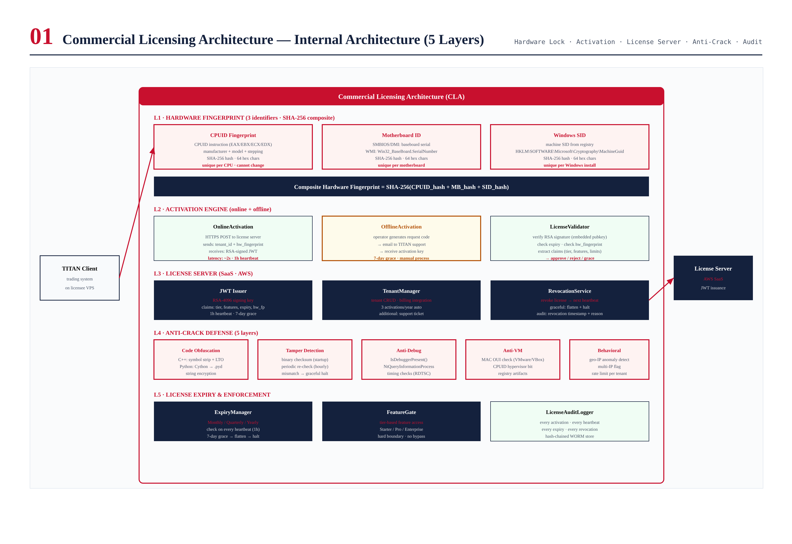
Figure 2.1 — CLA architecture: 5 layers + audit.

Layer Responsibilities

L1 — Hardware Fingerprint
3 identifiers: CPUID (CPU manufacturer + model), Motherboard ID (baseboard serial), Windows SID (machine GUID). Each SHA-256 hashed, combined into composite: SHA-256(CPUID_hash + MB_hash + SID_hash). Unique per physical machine. 3 activations/year for legitimate hardware changes.

L2 — Activation Engine
Online: HTTPS POST to license server with tenant_id + hw_fingerprint, receive RSA-4096 signed JWT. ~2s. Offline: generate request code, email to TITAN support, receive activation key. Up to 24h. Both produce same JWT format.

L3 — License Server (SaaS)
AWS-hosted: JWT Issuer (RSA-4096, HSM-backed), TenantManager (CRUD + billing, 3 activations/year), RevocationService (revoke -> next heartbeat triggers graceful shutdown).

L4 — Anti-Crack Defense (5 layers)
Code obfuscation (symbol strip + LTO + Cython + string encryption), tamper detection (SHA-256 checksum + IAT), anti-debug (IsDebuggerPresent + NtQuery + RDTSC), anti-VM (MAC OUI + CPUID hypervisor), behavioral (geo-IP + multi-IP + concurrent).

L5 — License Expiry & Enforcement
ExpiryManager checks JWT on every heartbeat (1h). Monthly/Quarterly/Yearly. 7-day grace -> graceful shutdown. FeatureGate enforces tier-based access (hard boundary).

Chapter 3 — Hardware Lock
3-factor composite fingerprint binds license to physical hardware. CPUID + Motherboard ID + Windows SID, each SHA-256 hashed, combined into composite. Cannot be spoofed without physical hardware replacement. 3 activations/year for legitimate changes.
Identifier | Source | Changes When
CPUID | CPUID instruction (EAX/EBX/ECX/EDX) | CPU replaced
Motherboard ID | SMBIOS/DMI baseboard serial | Motherboard replaced
Windows SID | Registry MachineGuid | Windows reinstalled

Chapter 4 — Activation Workflow
Complete lifecycle: hardware fingerprint -> activation (online/offline) -> server validation -> JWT -> cached -> trading -> heartbeat -> renew/revoke -> grace -> shutdown.
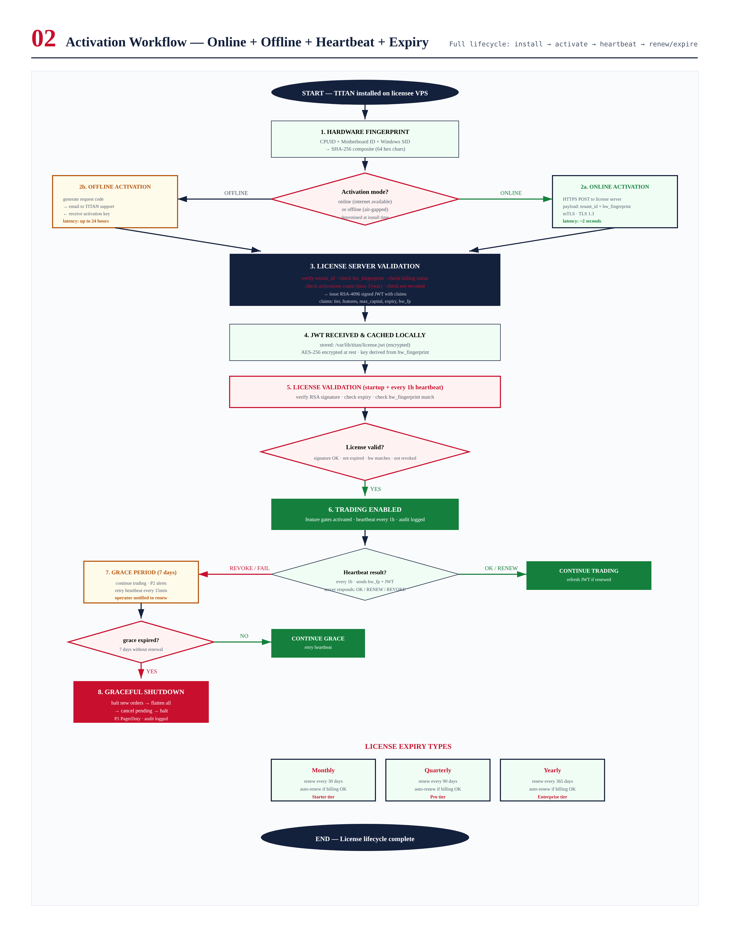
Figure 4.1 — Activation workflow with online/offline paths, heartbeat, grace, expiry.

Heartbeat Protocol
Every 1 hour:
Client -> Server: HTTPS POST /v1/heartbeat
payload: {tenant_id, hw_fingerprint, current_jwt}
Server -> Client: OK / RENEW / REVOKE / BLOCK
If heartbeat fails: 7-day grace, retry every 15min, P2 alert
After 7 days: graceful shutdown (flatten + halt)

License Expiry Types
Type | Duration | Tier | Grace
Monthly | 30 days | Starter ($12k/yr) | 7 days
Quarterly | 90 days | Pro ($48k/yr) | 7 days
Yearly | 365 days | Enterprise ($180k/yr) | 7 days

Chapter 5 — Security Design
4-layer crypto: RSA-4096 (signing, HSM-backed), AES-256-GCM (storage, key from hw_fp), TLS 1.3 + mTLS (transport), SHA-256 (fingerprinting). Key management: RSA private key never leaves HSM, public key embedded in binary. AES key derived from hw_fingerprint via PBKDF2 (100k iterations), never stored.
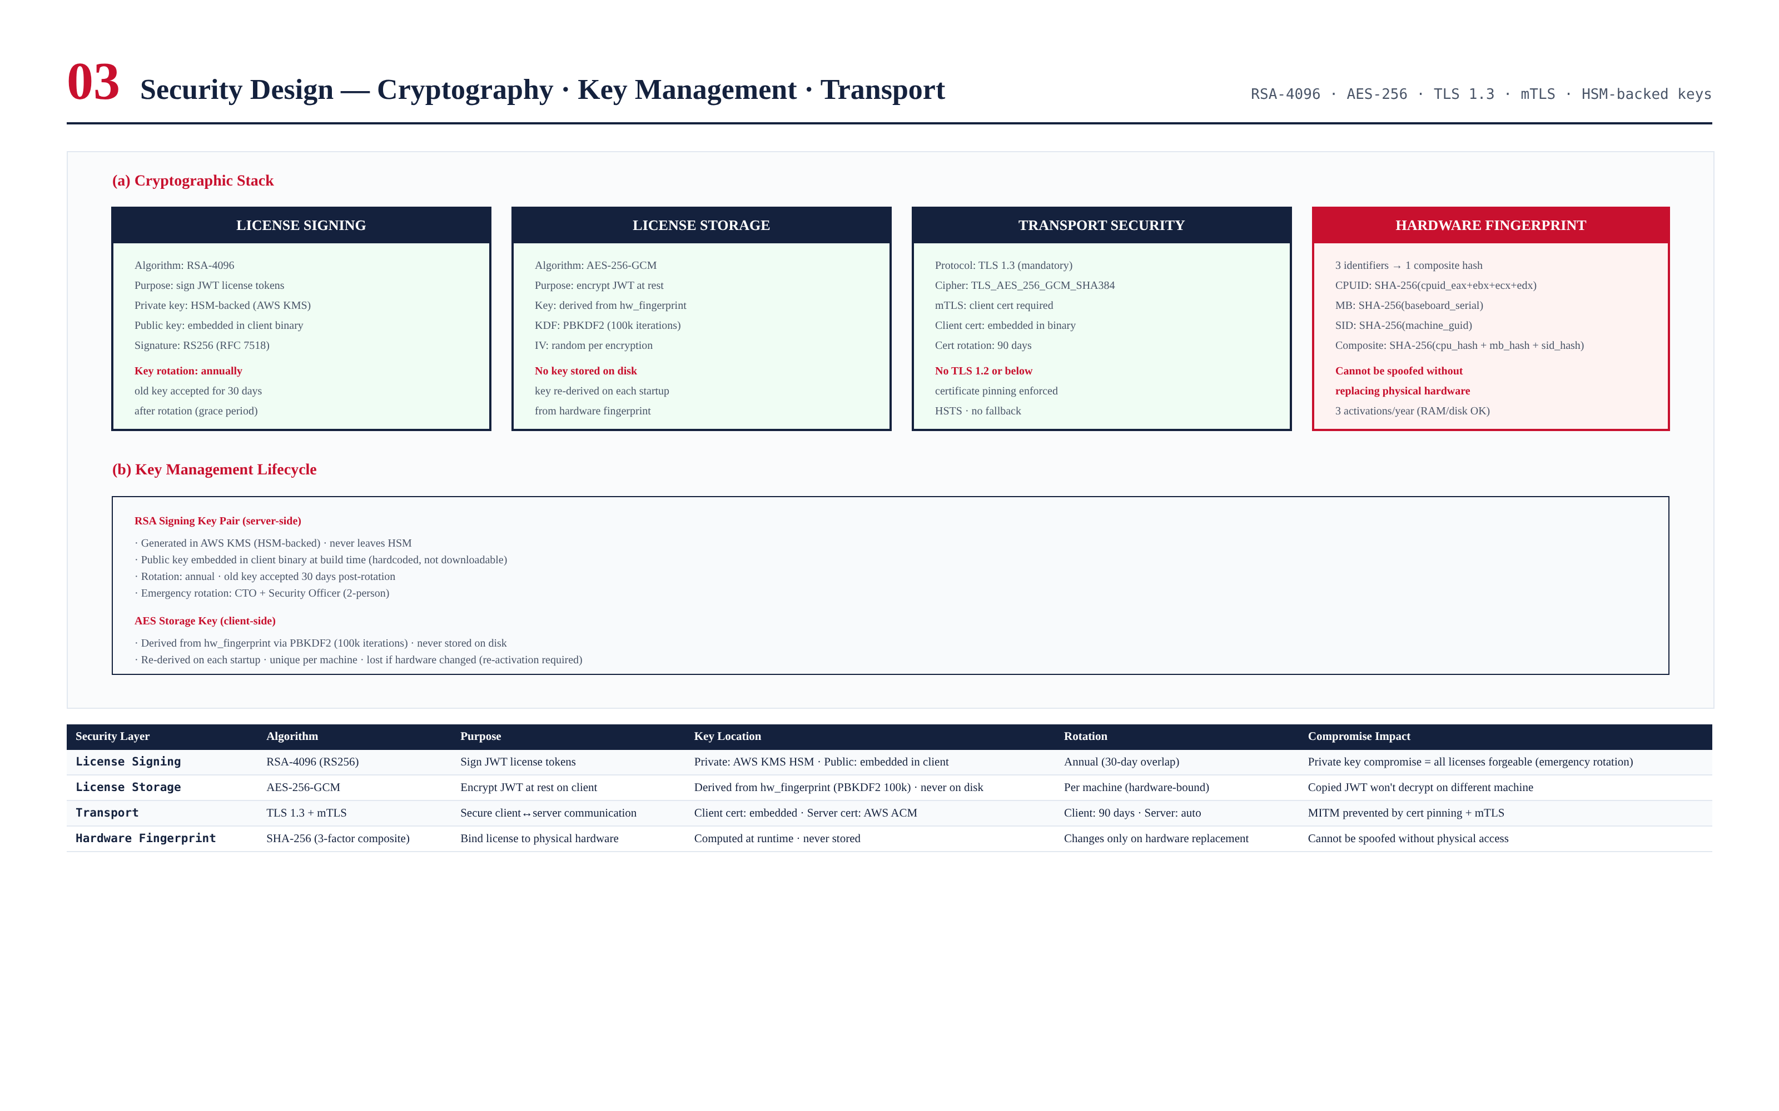
Figure 5.1 — Cryptographic stack and key management.

Chapter 6 — Anti-Crack Design
5 independent layers. Goal: raise crack cost above license price, delay crack 6+ months per release. Server-side heartbeat is ultimate backstop.
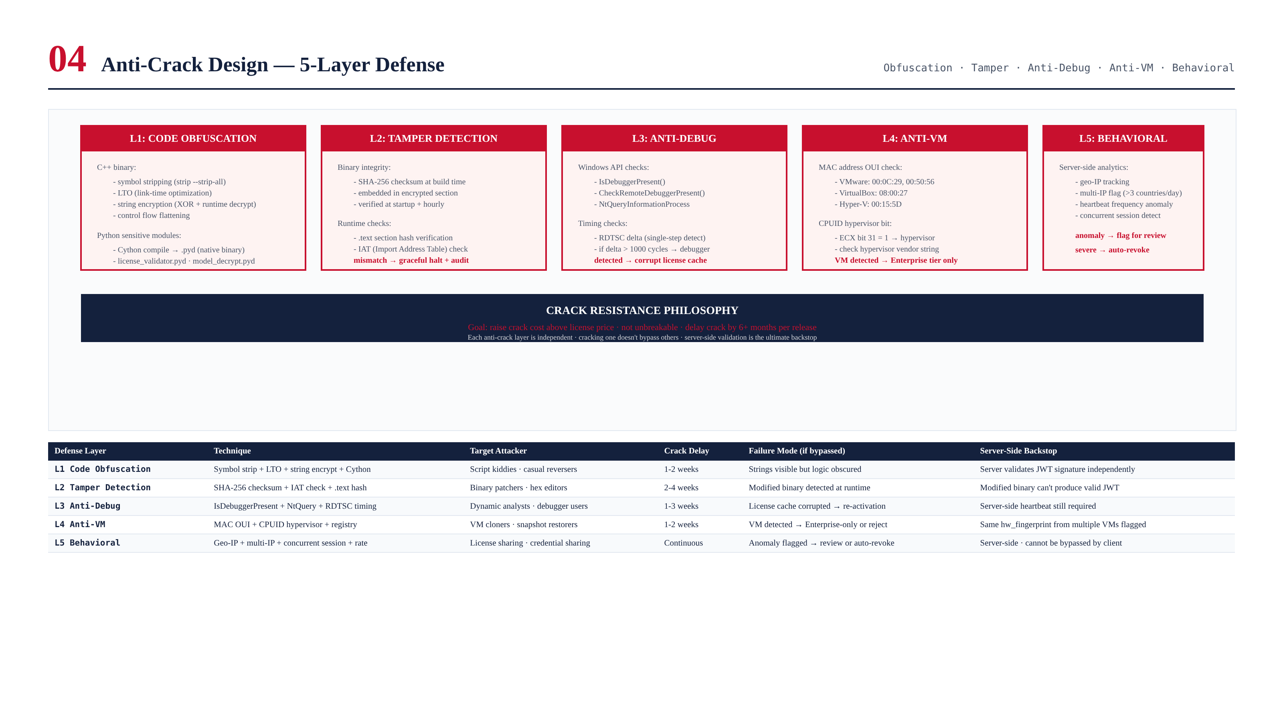
Figure 6.1 — 5-layer anti-crack defense.

Crack Resistance Philosophy
No client-side protection is unbreakable. The CLA raises the cost above the license price. Each layer adds 1-4 weeks delay. Combined: 6+ months per release. Server-side heartbeat cannot be bypassed by client-side cracking.

Chapter 7 — License Tier Matrix
3 tiers: Starter ($12k, 1 strategy, $50k cap, monthly), Pro ($48k, 3 strategies, $500k cap, quarterly), Enterprise ($180k, unlimited, yearly, white-label, on-prem). FeatureGate enforces at runtime — hard boundary.
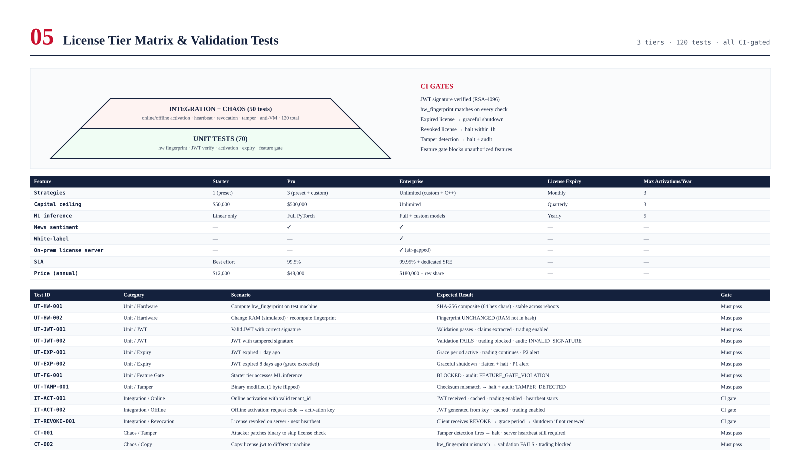
Figure 7.1 — Tier matrix and validation tests.

Chapter 8 — Validation Tests
120 tests: unit (70), integration (30), chaos (20). Critical: JWT signature verified, hw_fp match, expired -> shutdown, revoked -> halt < 1h, tamper -> halt, feature gate blocks, copied license -> hw mismatch, VM clone -> detected.

Chapter 9 — Integration with TITAN Core
CLA is the first module loaded and last unloaded. No module starts until LicenseValidator verifies JWT. License check at startup + every 1h heartbeat. On failure: graceful shutdown (flatten + halt + P1 alert).
TITAN startup:
1. LicenseValidator.load() -> load cached JWT
2. Verify RSA signature (embedded public key)
3. Check expiry -> if expired: grace period
4. Check hw_fingerprint -> if mismatch: REJECT
5. Extract claims (tier, features, max_capital)
6. FeatureGate.activate(claims)
7. Start heartbeat timer (1h)
8. If all OK: start trading modules
9. If any FAIL: graceful shutdown
TITAN shutdown (on license failure):
1. Halt new orders
2. Cancel pending
3. Flatten all positions
4. Notify operator (P1)
5. Audit log: license_fail + reason
6. Exit non-zero

