TITAN · QUANT RESEARCH
TITAN XAU AI
INSTITUTIONAL TRADING SYSTEMS
M O D U L E 9 · C O S T I N T E L
Execution Cost Intelligence
5 cost components (spread, commission, swap, slippage, latency) in bps. Trade only if expected edge remains positive. EQS per-trade scoring. BQS broker ranking. Adaptive cost learning.
KEY METRICS
Metric | Value
Cost components | 5 (spread, commission, swap, slippage, latency)
Min edge threshold | 3.0 bps
Brokers ranked | 6 (BQS monthly)
EQS factors | 5 (per-trade, 0-100)
Decision | Trade only if edge > 0

Prepared by TITAN Quant Research
Reviewed by CTO · Lead Quant · Risk Officer
Classification INTERNAL — ENGINEERING
Version v1.0 · 19 June 2026

Table of Contents
Right-click the table below and choose "Update Field" to refresh page numbers.

Chapter 1 — Executive Summary 3
Chapter 2 — Architecture Overview 3
Chapter 3 — Decision Model 4
Chapter 4 — 5 Cost Components 4
Chapter 5 — Performance & Broker Scoring 5
Chapter 6 — Validation Logic 5
Chapter 7 — Cost Learning Engine 6
Chapter 8 — Validation Tests 6
Chapter 9 — Integration with TITAN Core 7

Chapter 1 — Executive Summary
The Execution Cost Intelligence (ECI) module is Module 9 of the TITAN XAU AI trading architecture. It is the system's cost-awareness layer — a real-time cost measurement, modeling, and decision framework that ensures no trade is placed unless the expected edge remains positive after all execution costs. The ECI measures 5 cost components (spread, commission, swap, slippage, latency), aggregates them into a total cost estimate in basis points, and computes the expected net edge: signal_edge minus total_cost. If the net edge is negative, the trade is rejected.
The module's core innovation is the EdgeCalculator — a pre-trade decision model that normalizes all costs to basis points of notional, making them comparable across brokers. Two scoring systems provide ongoing quality assessment: EQS (per-trade, 5-factor) and BQS (per-broker, comparative ranking). A Cost Learning Engine continuously updates slippage and latency models from realized fills.

Chapter 2 — Architecture Overview
The ECI is organized into 6 layers: cost measurement, cost model, decision model, performance scoring, broker quality scoring, and audit/observability.
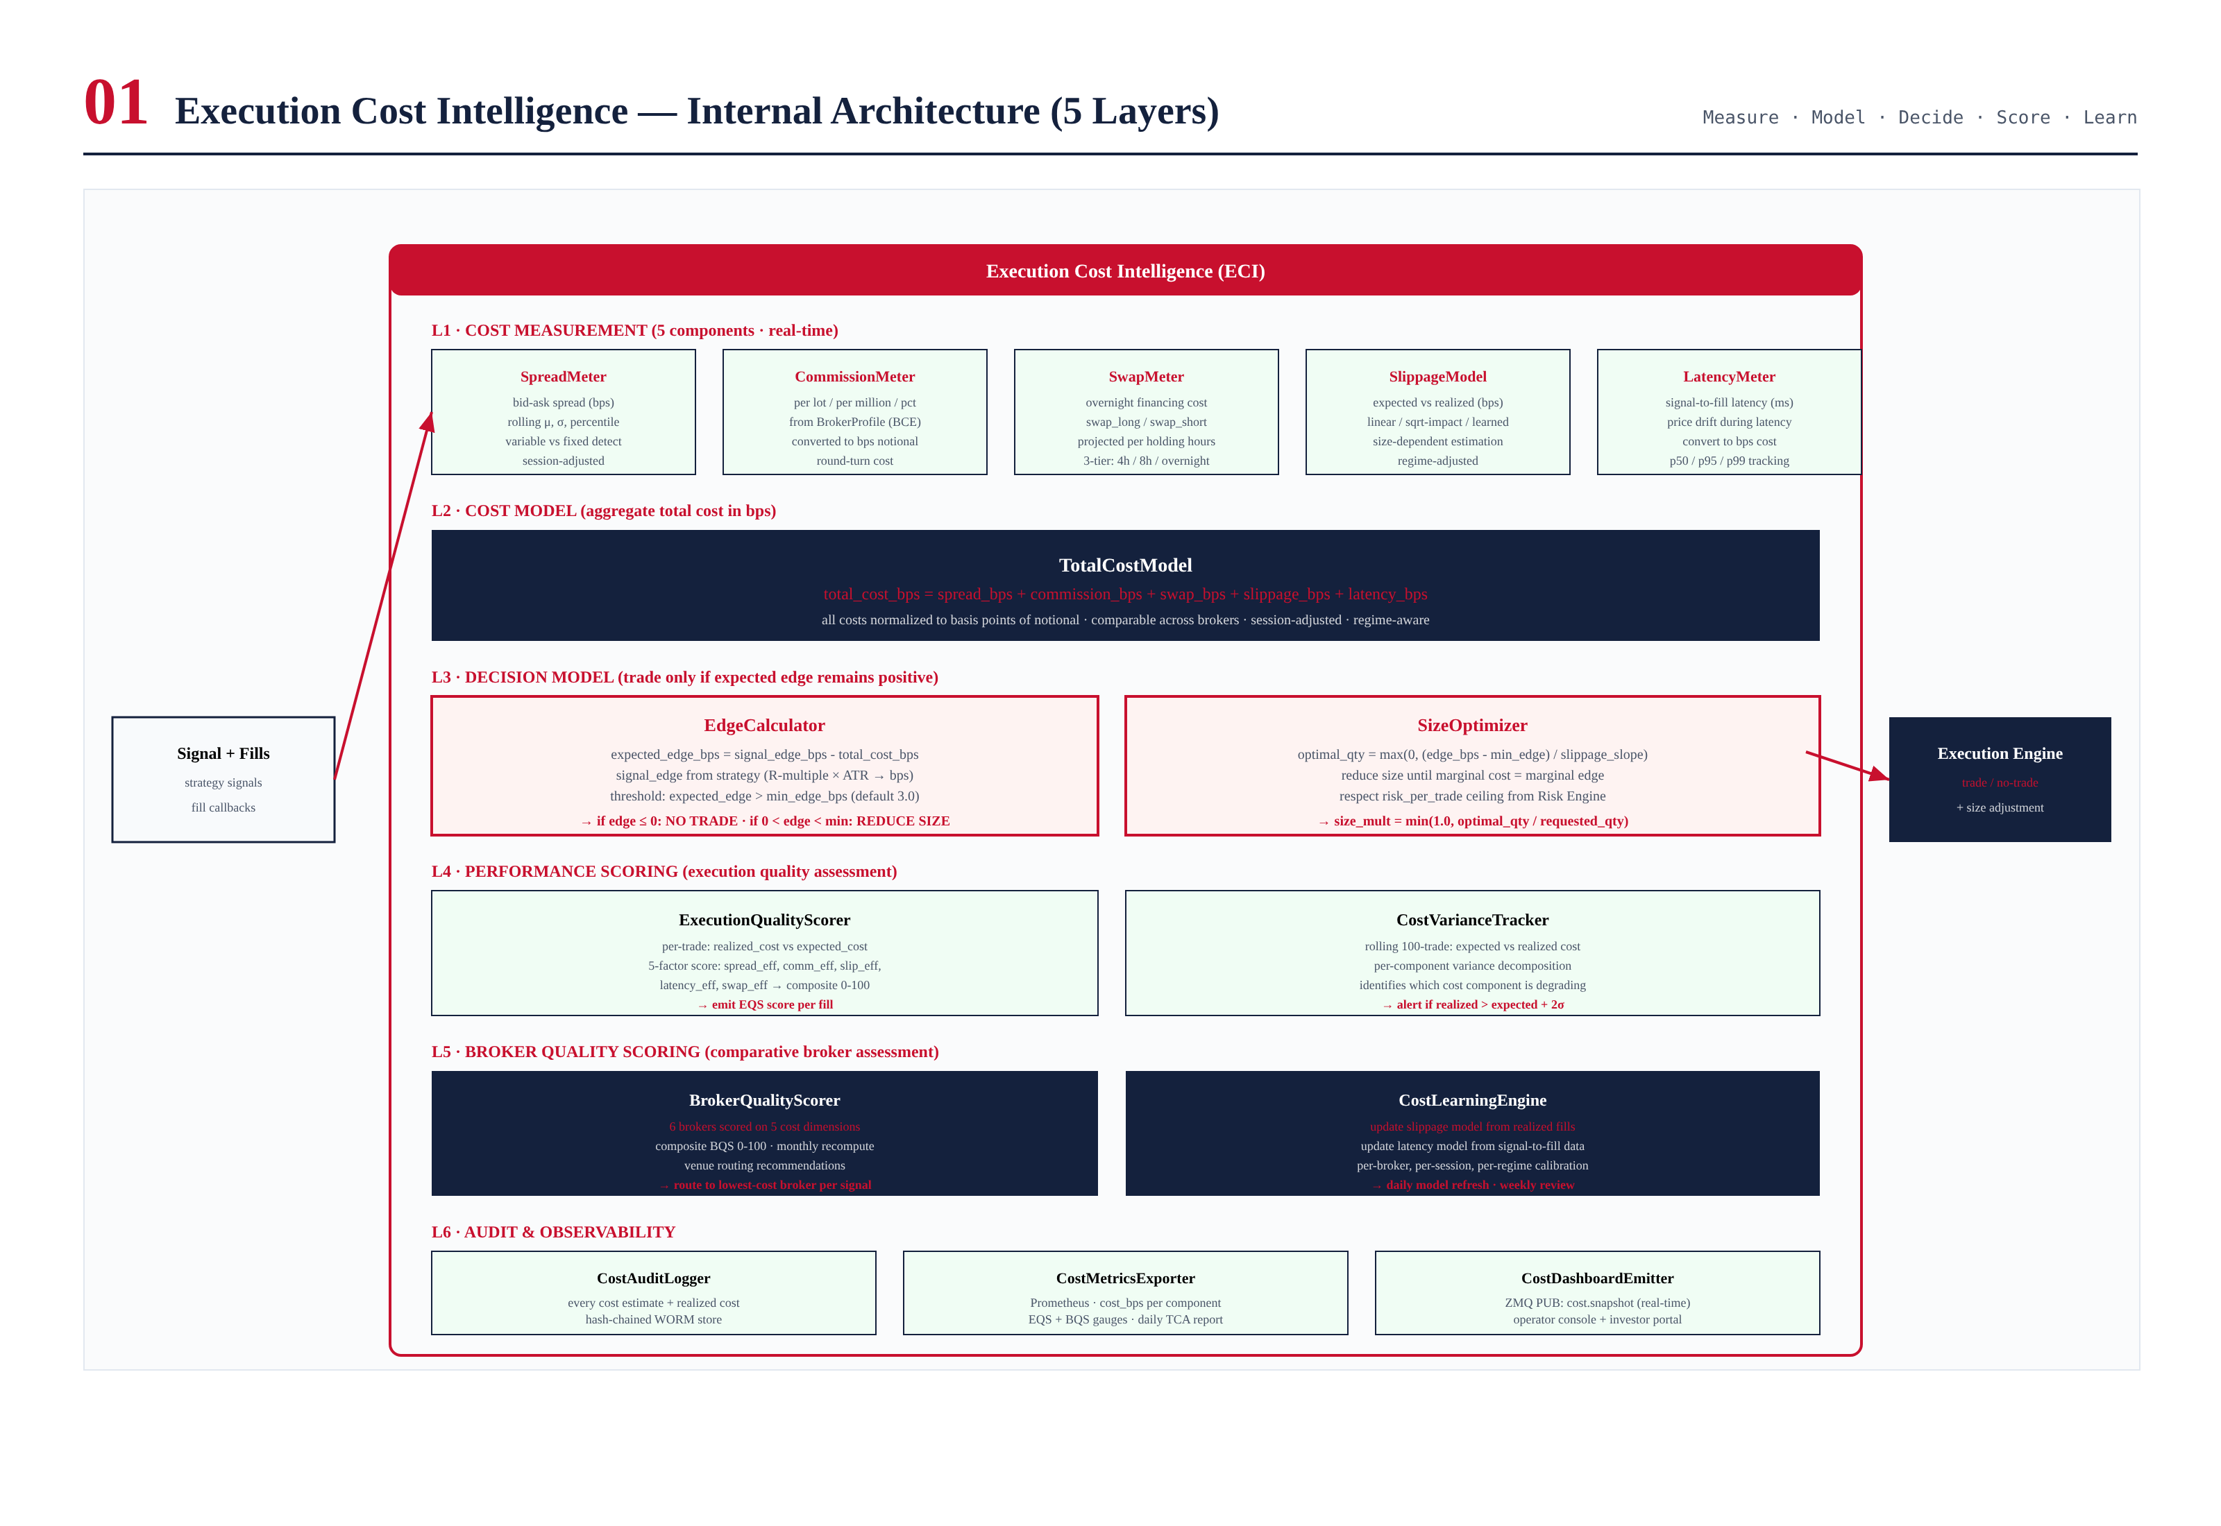
Figure 2.1 — ECI architecture: 6 layers, 5 cost meters, decision model, scoring, learning.

Chapter 3 — Decision Model
The decision model computes expected net edge for every signal: expected_edge = signal_edge - total_cost. If edge <= 0: NO TRADE. If 0 < edge < 3 bps: REDUCE SIZE. If edge >= 3 bps: TRADE (full size).
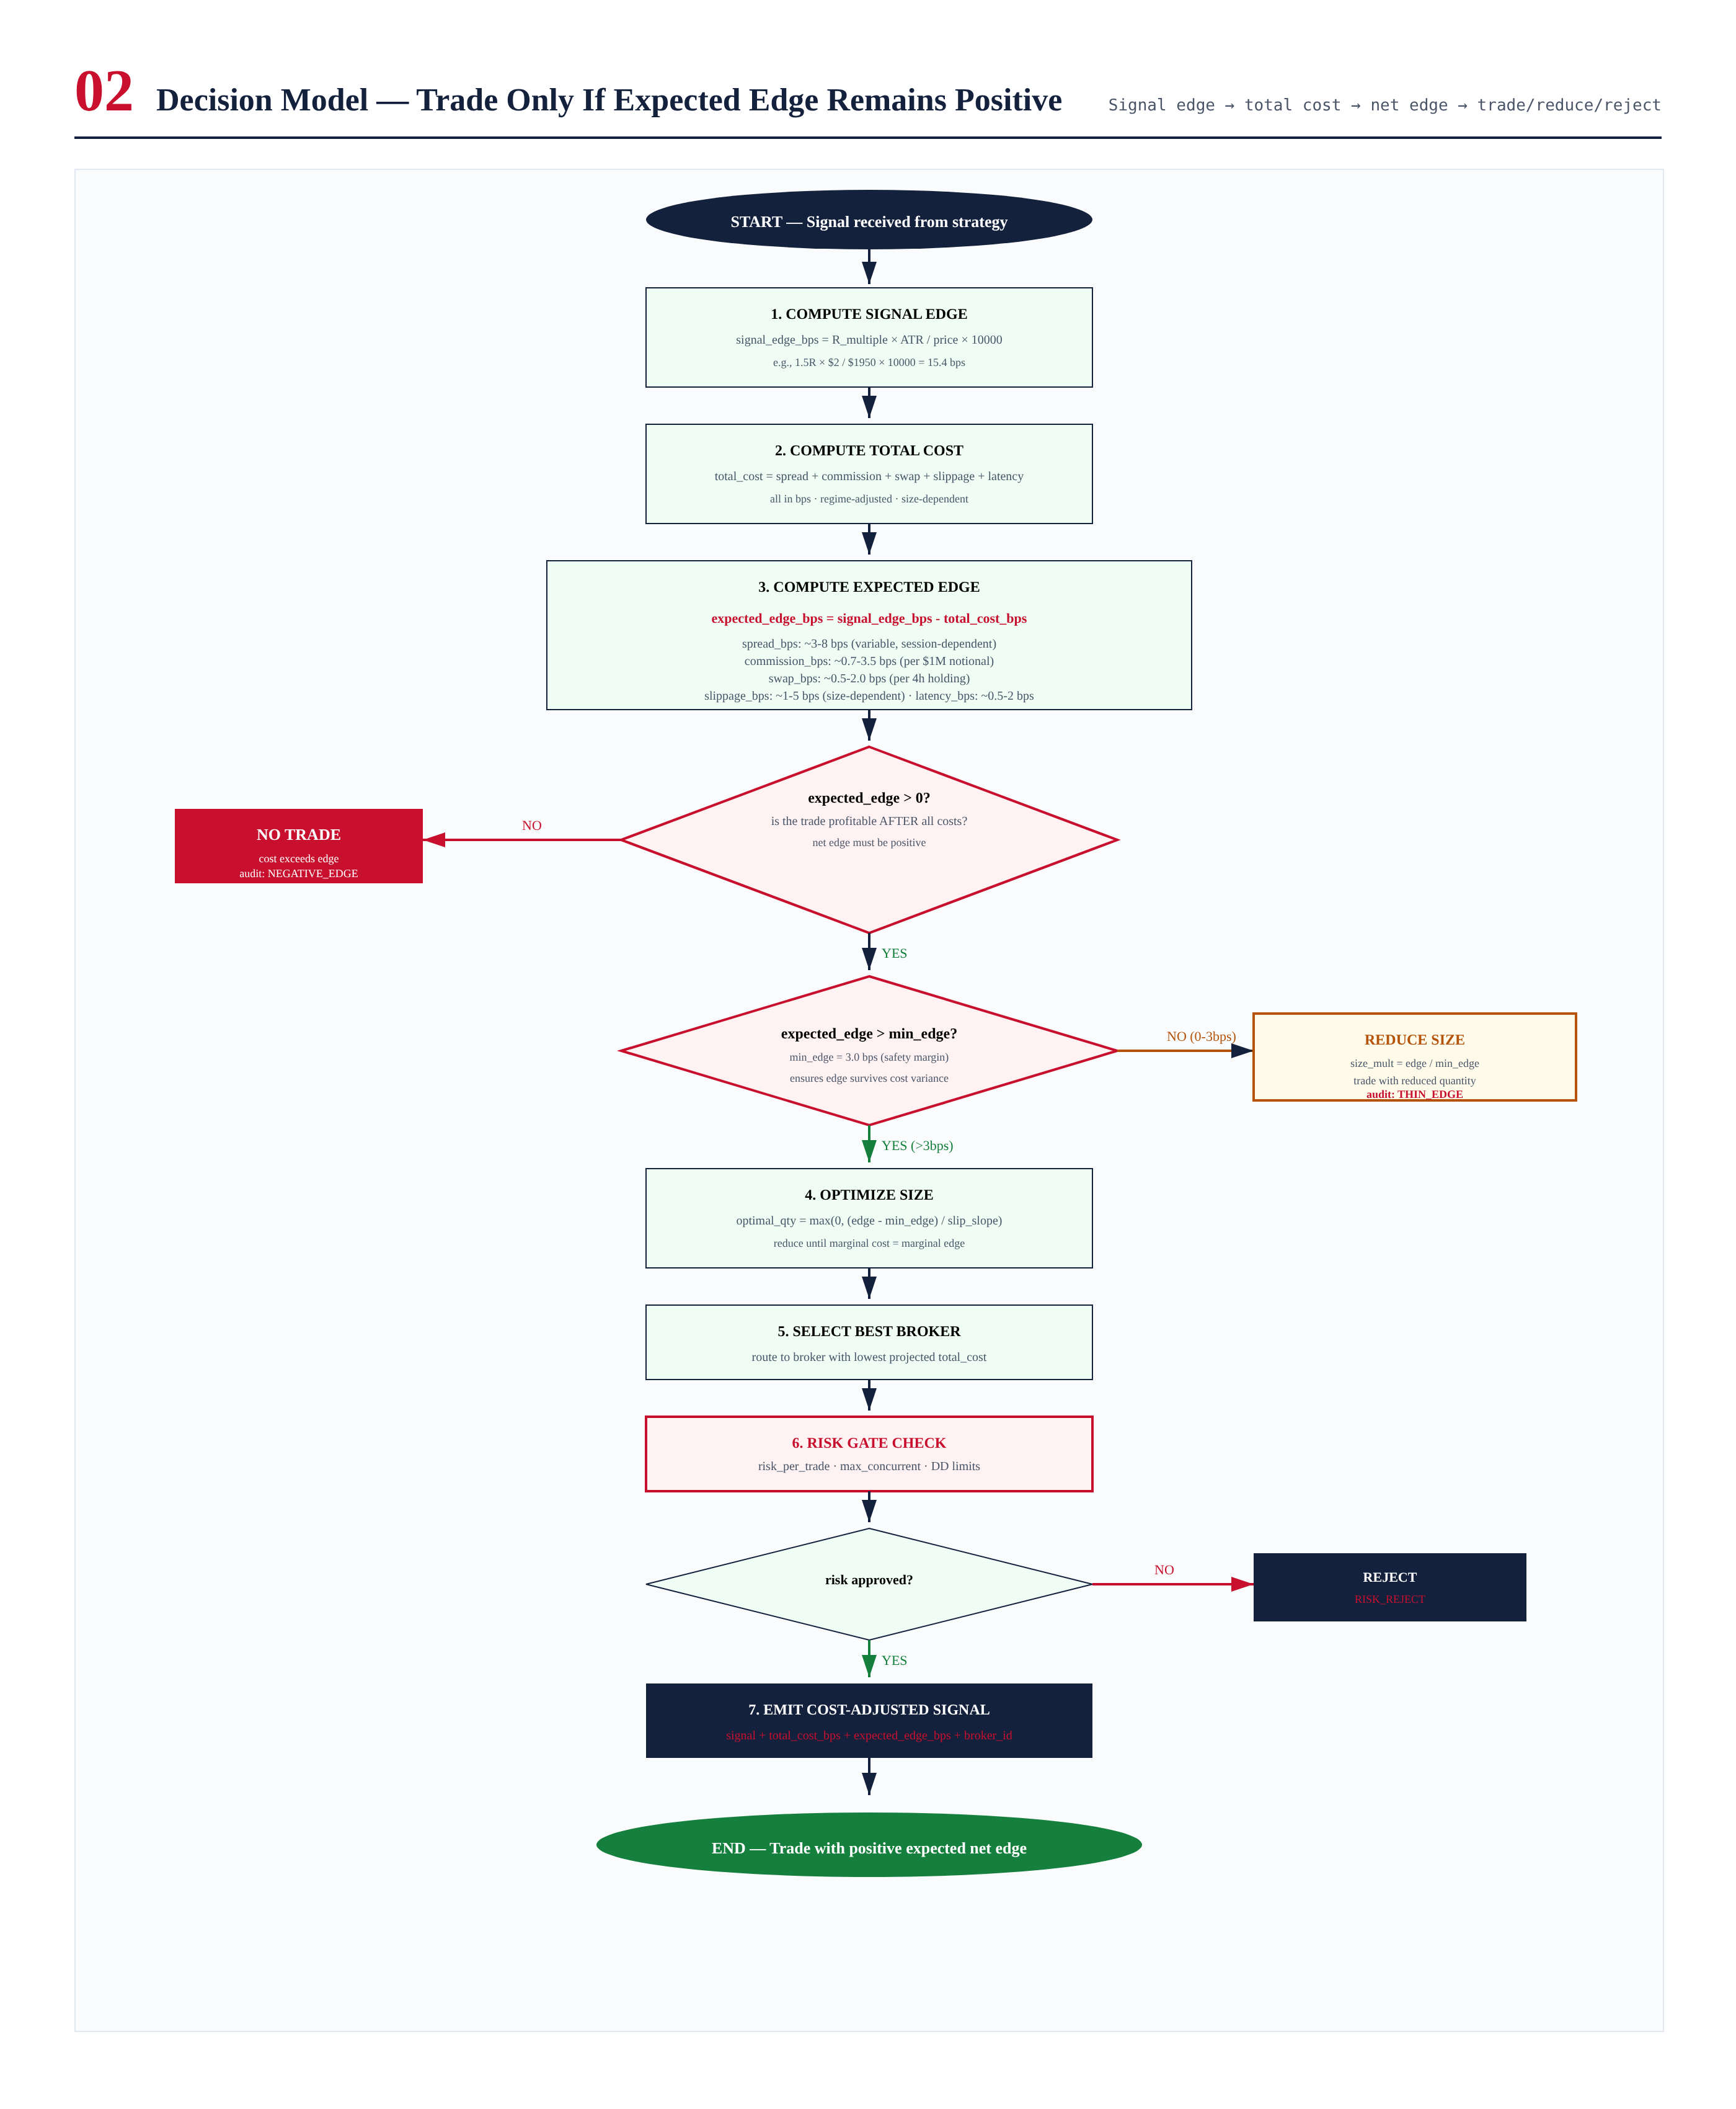
Figure 3.1 — Decision model flowchart.

Chapter 4 — 5 Cost Components
All costs normalized to bps: spread (bid-ask), commission (per lot/million/pct), swap (overnight), slippage (size-dependent), latency (price drift during signal-to-fill).
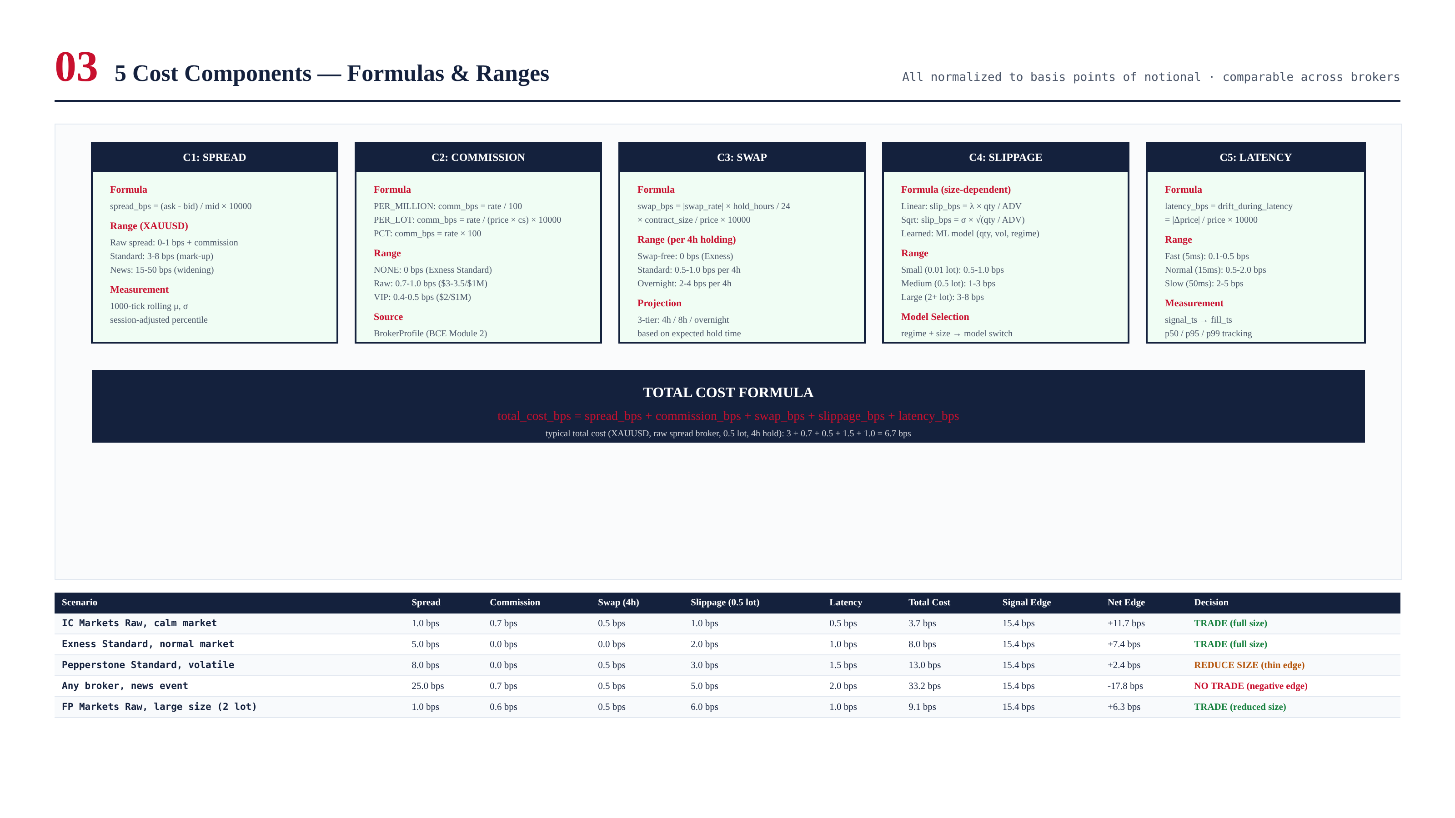
Figure 4.1 — 5 cost components with formulas and ranges.

Chapter 5 — Performance & Broker Scoring
EQS = 5-factor per-trade score (spread 0.30, slip 0.25, comm 0.20, latency 0.15, swap 0.10). BQS = 6-broker comparative ranking, monthly recompute.
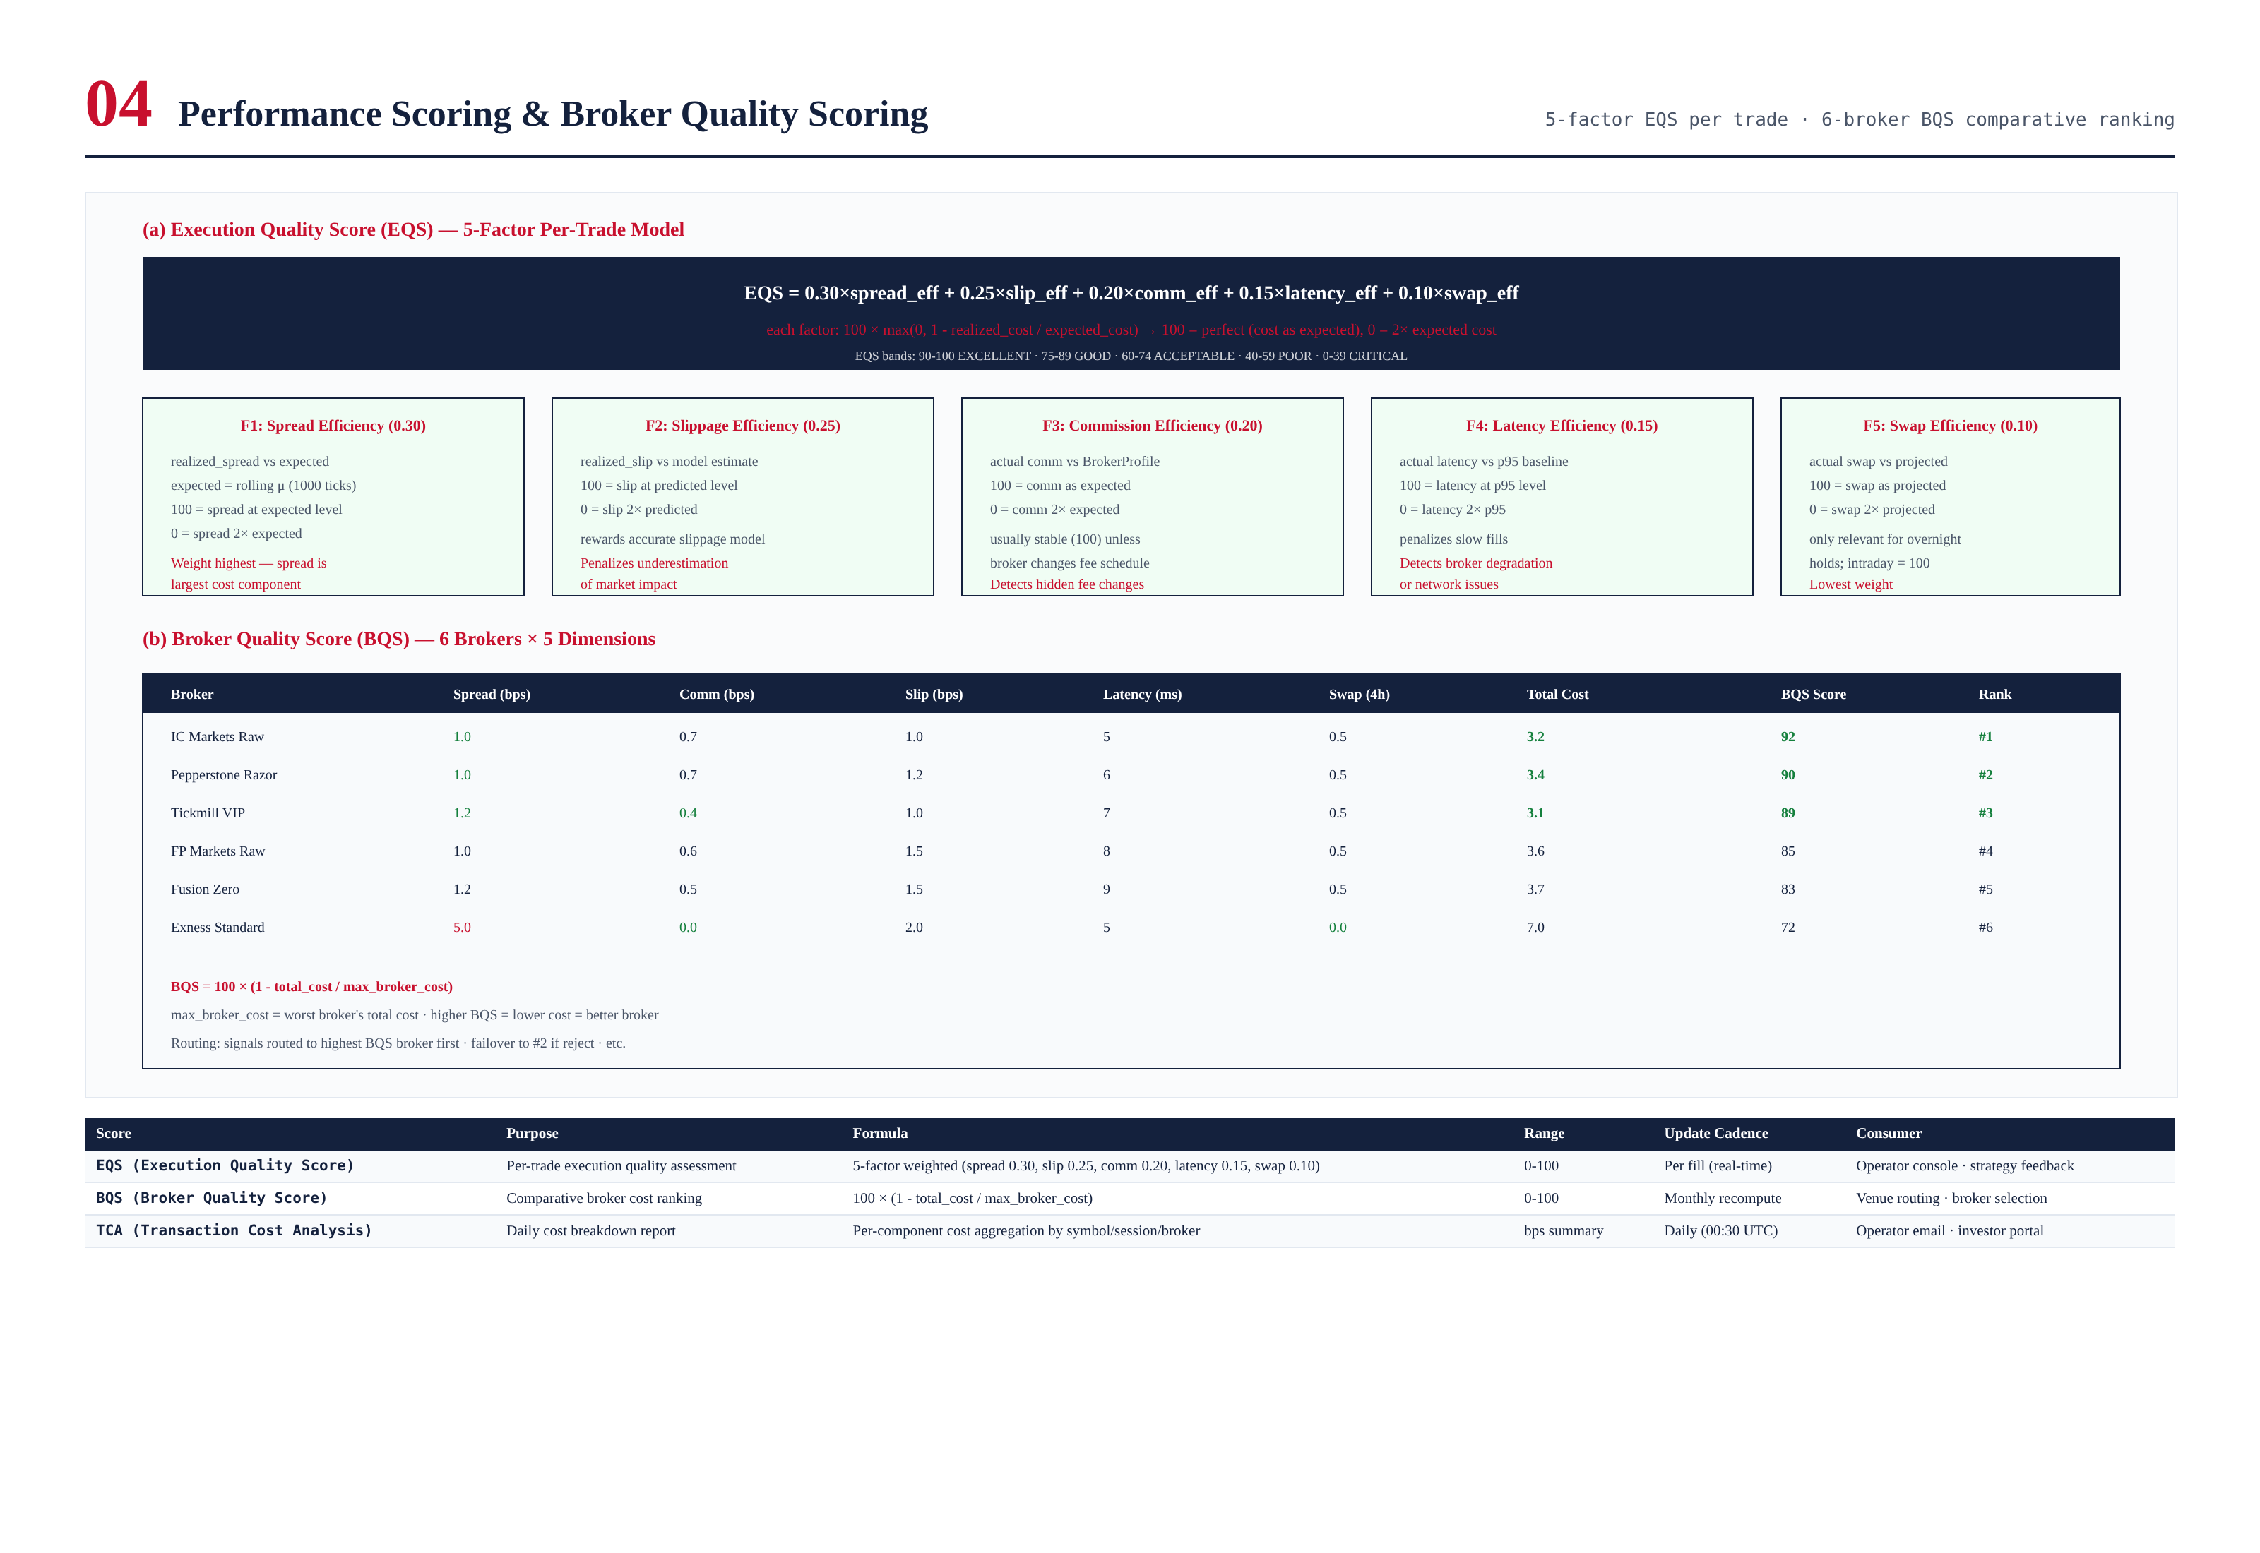
Figure 5.1 — EQS 5-factor model and BQS 6-broker ranking.

Chapter 6 — Validation Logic
8 pre-trade checks + 6 post-trade verifications. Key: V6 (edge > 0), V7 (edge > 3 bps), V10 (slip <= 1.5x predicted), V14 (EQS >= 40).
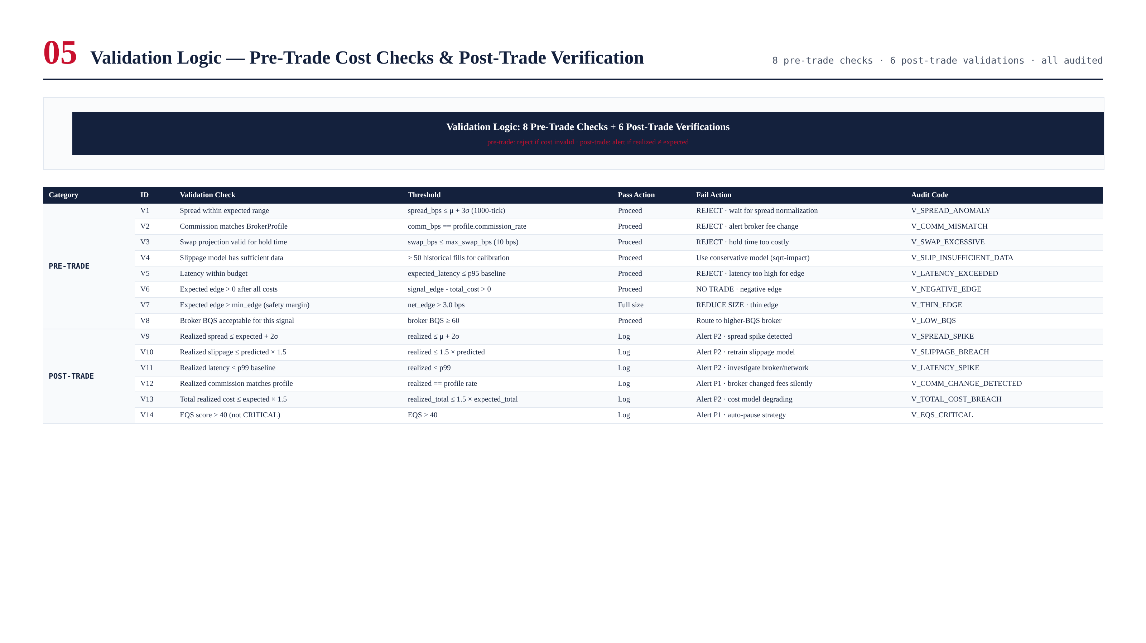
Figure 6.1 — 8 pre-trade + 6 post-trade validation checks.

Chapter 7 — Cost Learning Engine
Continuous model calibration from realized fills. EMA updates (alpha=0.05) on slippage, latency, and spread models. Per-broker, per-session, per-regime.
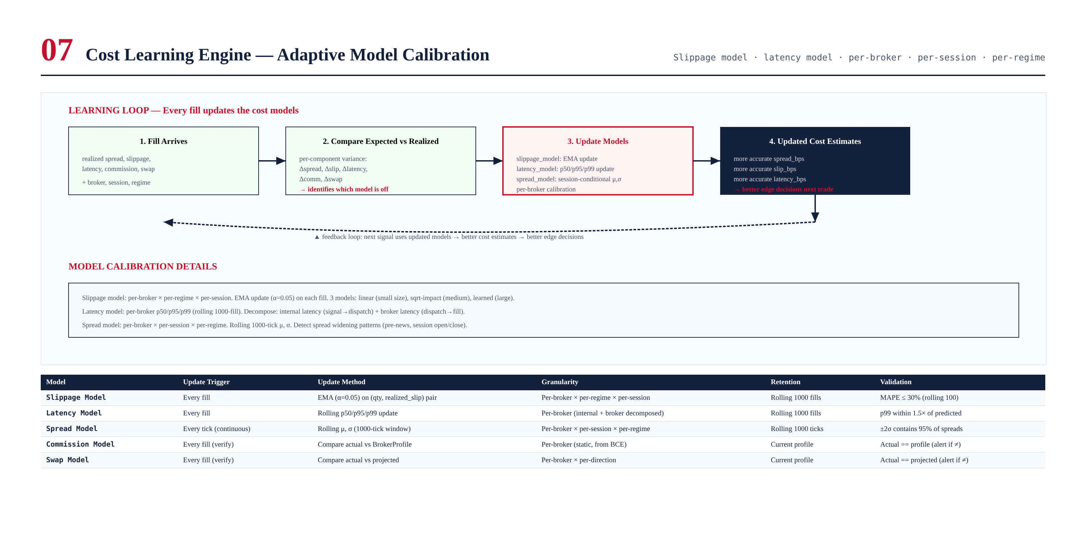
Figure 7.1 — Learning loop: fill → compare → update → better estimates.

Chapter 8 — Validation Tests
180 tests. CI gates: no negative-edge trade, EQS >= 60 rolling, realized <= 1.5x expected (95%), BQS monthly.
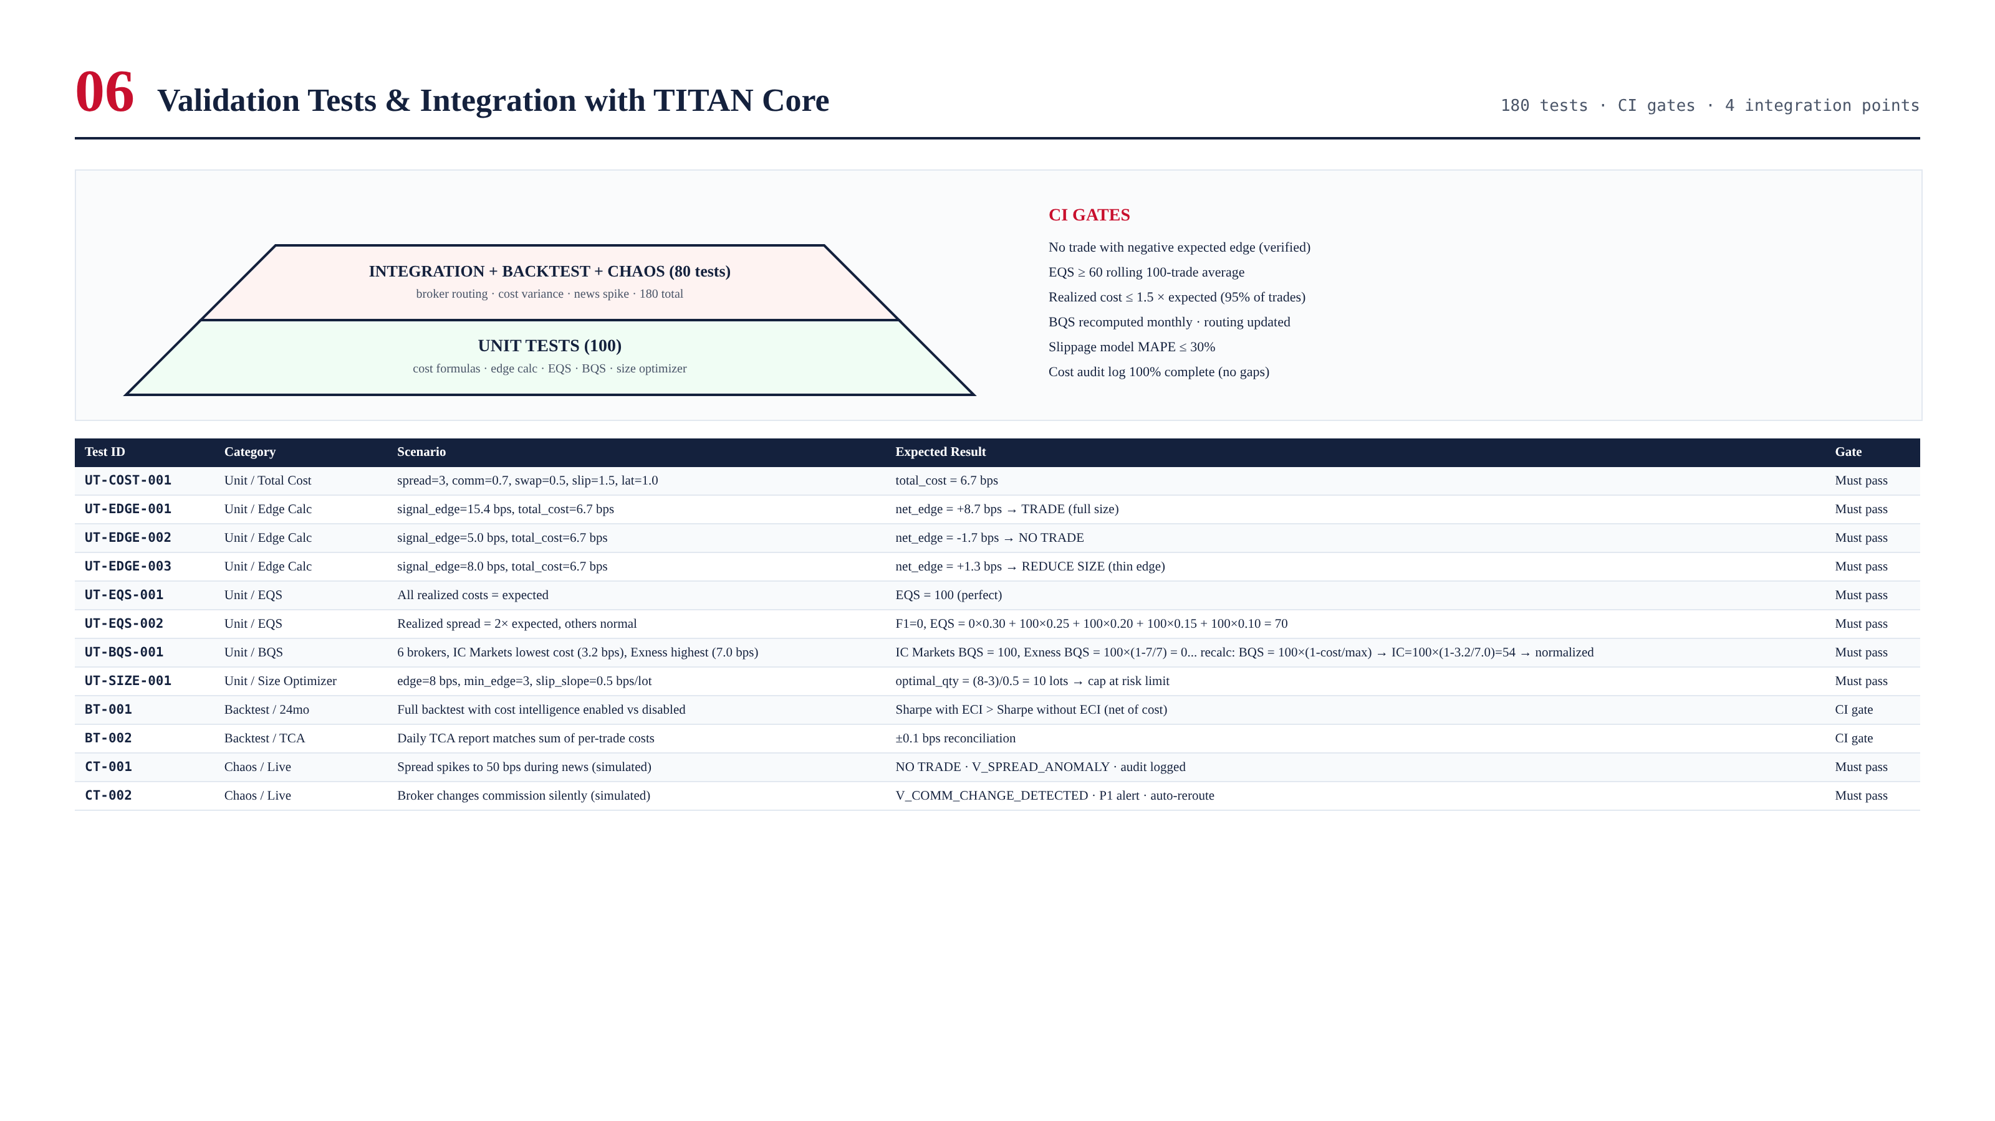
Figure 8.1 — Test pyramid and sample cases.

Chapter 9 — Integration with TITAN Core
ECI sits between Strategy Coordinator and Execution Engine. Consumes BrokerProfile (Module 2), emits cost-adjusted signals to Execution Engine (Module 3), respects Risk Engine (Module 8) ceiling.
Signal from Strategy / AI Ensemble
-> ECI pre-trade check:
-> compute total_cost_bps (5 components)
-> expected_edge = signal_edge - total_cost
-> if edge <= 0: NO TRADE
-> if 0 < edge < 3 bps: REDUCE SIZE
-> if edge >= 3 bps: TRADE (full size)
-> select best broker (highest BQS)
-> risk gate check (Module 8)
-> emit cost-adjusted signal to Execution Engine
-> Post-trade: update models, compute EQS, daily TCA report

