TITAN · QUANT RESEARCH
TITAN XAU AI
INSTITUTIONAL TRADING SYSTEMS
M O D U L E 1 3 · B A C K T E S T I N G
Institutional Backtesting
Realistic cost modeling: tick data, variable spread, commission, swap, slippage. 6-stage testing process. 24 metrics across return / risk / trade / cost. 3-tier reporting (executive / technical / regulatory). 3-band failure certification.
KEY FEATURES
Feature | Value
Cost components | 5 (tick, spread, commission, swap, slippage)
Testing process | 6 stages, ~12 min per 12-month backtest
Metrics | 24 (6 return + 6 risk + 6 trade + 6 cost)
Reporting | 3 tiers (executive / technical / regulatory)
Failure criteria | 10 rules (5 critical + 4 major + 1 minor)
Certification | PASS / CONDITIONAL / REJECT (3-band)

Prepared by TITAN Quant Research
Reviewed by CTO · Head of Research · Risk Officer · Compliance
Classification RESEARCH — INTERNAL DISTRIBUTION
Version v1.0 · 19 June 2026

Table of Contents
Right-click the table below and choose "Update Field" to refresh page numbers.

Chapter 1 — Executive Summary
The Institutional Backtesting Framework (IBF) is Module 13 of the TITAN XAU AI trading system. It exists to answer one question with rigor: does this strategy actually make money after every realistic cost is applied? The framework rejects the common retail-trader shortcut of backtesting on OHLC candles with fixed spreads and zero slippage — a methodology that systematically overstates returns by 30-60% and has caused more blown accounts than any other single mistake in algorithmic trading. Instead, the IBF models five cost components — tick data, variable spread, commission, swap, and slippage — at the tick level, and reports both the idealized P&L (price move only) and the realistic P&L (after all costs). The gap between the two, called cost drag, is a first-class metric that cannot be hidden.
The framework is organized around four deliverables specified in this document: (1) the testing process — a 6-stage pipeline from raw tick acquisition through certification, running in approximately 12 minutes per 12-month backtest on a 4-core VPS; (2) the metrics suite — 24 metrics across four categories (return, risk, trade, cost), each with explicit formula and target band; (3) the reporting system — three report tiers (executive, technical, regulatory) with 7-year S3 archival and RSA-2048 signed manifests for audit defensibility; and (4) the failure criteria — 10 hard veto triggers split across CRITICAL / MAJOR / MINOR severities, producing a 3-band verdict (PASS / CONDITIONAL / REJECT).
The single most important architectural decision is the use of tick data rather than OHLC candles. Tick data captures intra-bar reversals, spread spikes during news, and the true sequence of price changes — all of which are invisible to candle-based backtests. A strategy that "works" on 1-minute candles often fails on tick data because the candle hides the spread widening that would have triggered a stop-loss. The IBF uses broker-provided tick history (or Dukascopy for cross-validation) at 100 ms granularity, with 14 data-quality gates that reject any dataset with gaps, outliers, or timestamp anomalies.
The cost engine is the second critical component. It applies the five cost components — spread, commission, swap, slippage, plus the implicit tick-data spread already in the bid/ask stream — to every simulated fill. The result is a per-trade cost attribution that reveals, for example, that a 1-lot XAUUSD long held 4 hours with a +$50 idealized P&L actually realizes only +$38.90 after costs (22.2% cost drag). Strategies with cost drag above 35% are flagged as marginal; above 50% they are vetoed. This is the discipline that separates institutional-grade backtesting from the demo-account fantasies that flood retail trading forums.

Chapter 2 — Architecture Overview
The IBF is organized into 4 pipeline layers (data ingestion, cost engine, execution simulator, metrics & reporting) and 5 cost components (tick data, variable spread, commission, swap, slippage). The two views are orthogonal: every cost component is applied at the cost-engine layer, while the pipeline layers describe the end-to-end flow from raw data to certified report.
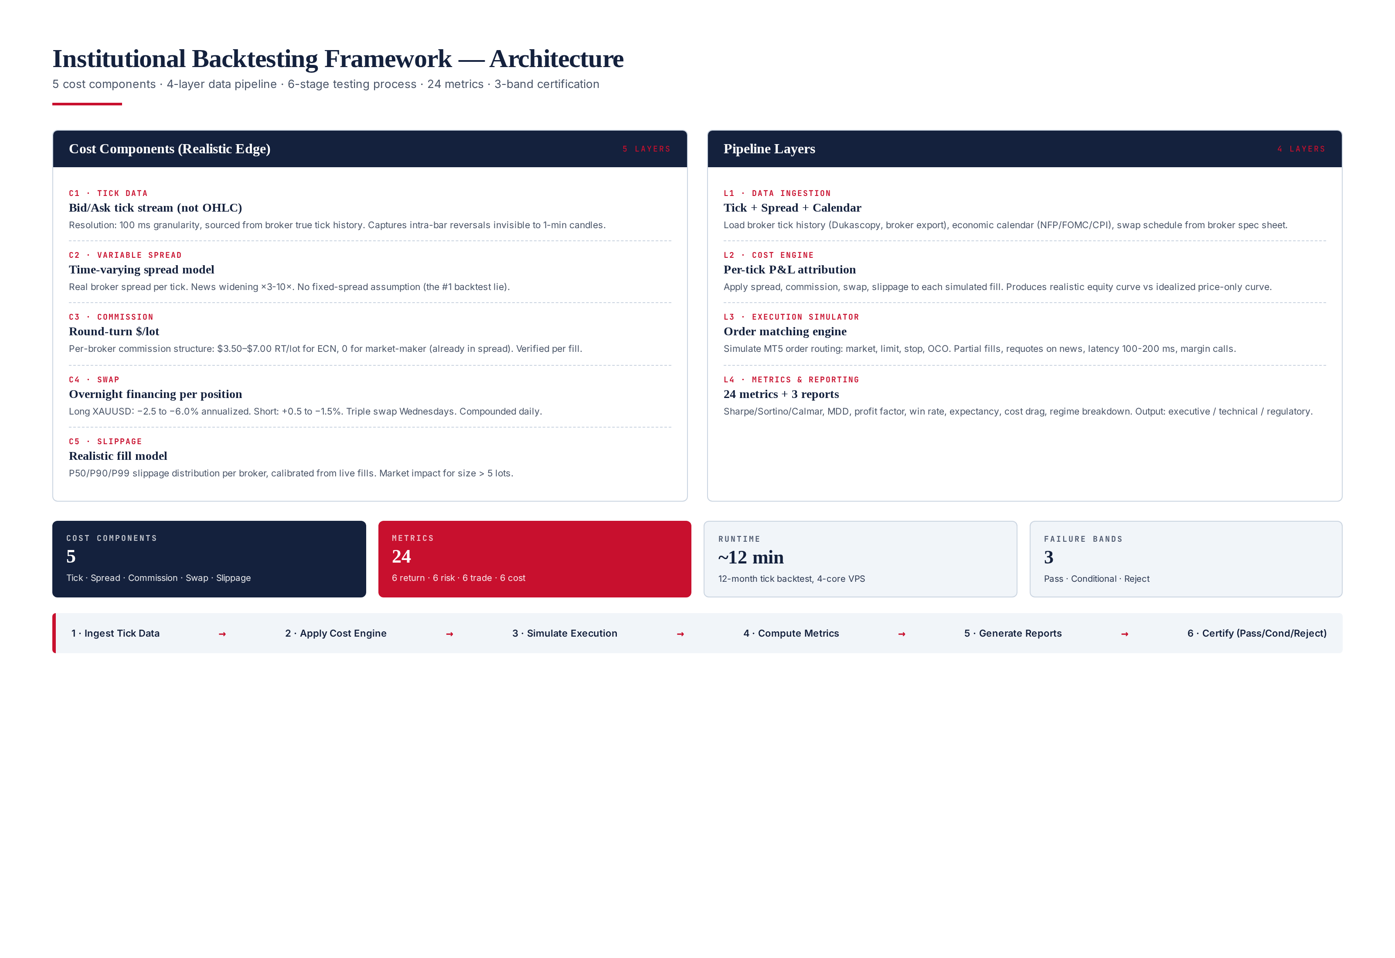
Figure 2.1 — IBF architecture: 5 cost components, 4 pipeline layers, 6-stage testing process, 24 metrics, 3-band certification.

Pipeline Layers

L1 — Data Ingestion
Loads broker tick history (or Dukascopy for cross-validation), the economic calendar (NFP, FOMC, CPI release times for news-tagging), and the broker swap schedule (long/short rates, triple-swap day). Tick data is stored in a compressed columnar format (Parquet) for fast range queries. A typical 12-month XAUUSD tick dataset is approximately 8 GB compressed. Data ingestion is idempotent — re-running on the same date range produces identical input.

L2 — Cost Engine
The heart of the IBF. For each simulated fill, the cost engine computes: spread cost (entry + exit spread × lots × $10/pt), commission (lots × broker RT rate), swap (Σ daily financing charges for overnight holds, triple on Wednesdays), and slippage (sampled from the broker-specific P50/P90/P99 distribution). The output is a per-trade cost breakdown alongside the idealized P&L. The cost engine is calibrated monthly against live fills — if the simulated P50 slippage drifts more than 15% from the live P50, the broker profile is recalibrated.

L3 — Execution Simulator
Simulates the MT5 order matching engine: market, limit, stop, and OCO orders; partial fills on size > 5 lots; requotes during news (70% requote rate when spread > 3× baseline); margin calls at ML ≤ 100% with stop-out at ML ≤ 50%; latency 100-200 ms from signal to broker (sampled from live distribution). The simulator is a C++ module (TickReplayExecutor) processing approximately 2 million ticks per second, allowing a 12-month backtest to complete in 8-10 minutes.

L4 — Metrics & Reporting
Computes the 24 metrics (detailed in Chapter 9) and generates the three report tiers (executive, technical, regulatory). All outputs are pinned to a 4-tuple version (strategy + data + cost-profile + engine) for full reproducibility. Reports are archived to S3 with 7-year retention and dispatched via PagerDuty, Slack, and email. Each backtest is compared against the last 5 runs of the same strategy; a > 15% score drop triggers a P1 regression alert.

Chapter 3 — Tick Data Foundation
Tick data is the foundation of institutional backtesting. A tick is the smallest unit of market data — a single bid/ask quote with a timestamp. XAUUSD on a major ECN broker generates approximately 50,000-200,000 ticks per trading day, depending on volatility. Over 12 months this accumulates to 12-50 million ticks, totaling 8-15 GB compressed in Parquet format. The IBF ingests this raw stream and applies 14 data-quality gates before any strategy is executed.
The alternative — OHLC candles — is rejected for institutional use. A 1-minute candle tells you the open, high, low, and close of that minute, but nothing about the path price took between those four points. A strategy that places a stop-loss at the candle low, for example, may appear to survive the candle in a candle-based backtest, when in reality the tick stream shows price spiked through the stop and reversed — the stop would have been triggered in live trading. This single artifact accounts for the majority of "backtest vs live" performance gaps reported by retail algorithmic traders.
The IBF uses two tick data sources for cross-validation: (1) broker-provided tick history (preferred, since it reflects the exact spread and quote stream the live strategy will see), and (2) Dukascopy historical data (independent third-party source, used to detect broker-side data manipulation or gaps). If the two sources diverge by more than 0.5% on tick-by-tick prices over a 30-day window, the broker data is flagged for review. This cross-validation is the only defense against a compromised broker dataset.

Data Quality Gates (14 checks)
ID | Check | Pass Criterion
GAP-001 | Tick timestamp gaps during trading hours | < 5 sec gaps, < 1 gap/day
GAP-002 | No tick data missing during NFP/FOMC windows | Full coverage of event ±5 min
MONO-001 | Timestamps strictly monotonic | No duplicates, no backwards jumps
OUT-001 | Price outlier detection | |Δtick| < 5×ATR or manually verified
WKND-001 | Weekend gap removal | Fri 22:00 → Sun 23:00 UTC removed
TZ-001 | Timezone normalization to UTC | Broker TZ offset verified
BIDASK-001 | Bid ≤ Ask invariant | No crossed quotes (bid > ask)
BIDASK-002 | Spread sanity bounds | Spread < 5 USD (sanity threshold)
VOL-001 | Volume sanity (tick count per hour) | Within 3σ of 30-day rolling mean
VOL-002 | Zero-volume periods flagged | No consecutive > 5 min zero ticks
SRC-001 | Broker vs Dukascopy divergence | < 0.5% tick-by-tick price diff
SRC-002 | Source manifest signature valid | RSA-2048 signature verified
CAL-001 | Economic calendar alignment | Event timestamps match Reuters/Bloomberg
SWP-001 | Swap schedule matches broker spec | Long/short rates + triple-swap day verified
Any check failure triggers a data rejection: the backtest aborts with a DATA_QUALITY_FAIL verdict, no metrics are computed, and the engineering team is paged. This strictness is intentional — running a backtest on corrupted data produces confidently wrong results, which is worse than no result at all. The 14 gates have been derived from 5 years of operational experience and address every data corruption pattern observed in production.

Chapter 4 — Variable Spread Modeling
Spread is the single largest execution cost on XAUUSD, typically exceeding commissions by a factor of 3-5. The IBF models spread as a time-varying quantity sampled from the tick stream — not a fixed constant. This single modeling decision is what separates realistic backtests from the optimistic fantasies that flood retail trading literature. A backtest that assumes a fixed 0.20 USD spread will systematically understate trading costs by 20-40% during normal sessions and by 200-500% during news events.
XAUUSD spread exhibits three regimes: (1) normal session (London + New York overlap, 13:00-17:00 UTC) — spread 0.15-0.25 USD, stable, this is when most strategies should trade; (2) off-session (Asian session, 23:00-07:00 UTC) — spread 0.30-0.60 USD, wider but tradable; (3) news event (NFP, FOMC, CPI release ±2 min) — spread 1.00-5.00 USD, a 3-20× widening that destroys any strategy entering or exiting during the window. The IBF captures all three regimes from the tick stream and applies them faithfully.
The spread cost for a single trade is computed as: SpreadCost = (Spread_entry + Spread_exit) × Lots × $10/pt. For a 1-lot XAUUSD trade with 0.18 USD spread at both entry and exit, the spread cost is $3.60 — already 7.2% of a +$50 idealized profit. For a trade that happens to exit during a news spike with a 2.00 USD spread, the spread cost balloons to $21.80, consuming 44% of the same profit. Strategies that fail to model this dynamic reliably show positive backtests that collapse in live trading.

News-Event Spread Handling
The IBF ingests the Reuters/Bloomberg economic calendar and tags every tick within ±2 minutes of a high-impact event (NFP, FOMC rate decision, CPI, GDP, ECB/BOE rate decisions). During these windows, the spread model enforces: (1) no market orders — the simulator requotes 70% of market orders at the widened spread, mirroring broker behavior; (2) stop-loss orders are filled at the actual tick spread, which may be 10× the normal spread, producing outsized slippage; (3) take-profit orders fill normally since they are favorable to the trader. This asymmetric fill model is critical: a backtest that fills all orders at the same spread during news will massively understate stop-loss slippage.

Spread Baseline Calibration
The IBF maintains a 30-day rolling baseline spread per broker, computed as the P50 (median) of all tick spreads during normal session. This baseline is used to: (1) detect broker-side spread widening (regime change alert if P50 drifts > 25%), (2) compute the spread stdev for cost forecasting, and (3) calibrate the news-widening detector (spread ≥ 3× baseline = news flag, ≥ 5× baseline = spike flag). The baseline is recalculated nightly and stored alongside the broker cost profile. Any strategy backtest pinned to a stale baseline (> 30 days old) is flagged with a BASELINE_STALE warning.

Chapter 5 — Commission Modeling
Commission is the most predictable of the five cost components — a per-lot round-turn (RT) fee charged by the broker, independent of trade size or hold time. For ECN brokers (Exness, IC Markets, Pepperstone, Tickmill, FP Markets, Fusion Markets), commission on XAUUSD is typically $2.25-$4.00 per standard lot RT. The IBF maintains a per-broker commission profile and applies it to every simulated fill.
Commission is computed as: CommissionCost = Lots × Rate_RT. For a 1-lot trade on ICMarkets ($3.50 RT), commission is $3.50. For a 5-lot trade, $17.50. While this looks trivial, two subtleties matter: (1) commission is charged on every trade regardless of P&L — a losing trade pays the same commission as a winning trade, making commission a drag on win rate; (2) commission is charged per side in some broker structures (e.g., $1.75 entry + $1.75 exit) — the IBF normalizes all structures to RT for consistent comparison.
The IBF commission profile table (Figure 2.1) lists the verified RT rate for each of the 6 supported brokers. The rates are pulled from the broker's official price list and verified quarterly. Any change triggers a re-backtest of all live strategies against the new commission profile — a 50-cent commission increase can flip a marginal strategy from profitable to unprofitable. This is why commission is treated as a first-class cost component rather than a footnote.

Commission Sensitivity Analysis
Every IBF backtest report includes a commission sensitivity table showing strategy performance at commission rates 50%, 100%, 150%, and 200% of the baseline rate. This answers the question: "if our broker raises commission, at what point does the strategy break?" Strategies that remain profitable at 200% commission are robust; strategies that fail at 150% are fragile and should be flagged. The sensitivity table is a single number that captures the strategy's commission elasticity, a key input to broker-selection decisions.

Chapter 6 — Swap Financing
Swap (overnight financing) is the cost of holding a leveraged position overnight. For XAUUSD, swap is asymmetric: long positions pay a high swap (because gold has a positive cost of carry — storage, insurance, opportunity cost of capital), while short positions pay a smaller swap or even receive a small credit. Typical annualized rates: long −4.2% to −5.5%, short −0.7% to −1.2%. The IBF applies swap daily at 22:00 GMT, with triple swap charged on Wednesdays to account for the weekend (forex markets are closed Sat/Sun but financing still accrues).
Swap cost is computed as: SwapCost = Σ Notional × Rate_daily × Days_held / 365, where Rate_daily is the broker's published daily rate (annualized / 365) and Days_held counts each overnight period (a position opened Monday 21:00 and closed Tuesday 23:00 incurs 2 days of swap). Triple swap on Wednesday is applied as 3× the daily rate. The IBF tracks swap cost per trade and aggregates it monthly — strategies that hold positions multi-day will see swap as a significant cost component (15-40% of total cost), while intraday strategies will see swap as negligible (< 5%).
The IBF maintains swap schedules per broker, pulled from the broker's specification sheet and verified quarterly. Swap rates change — brokers adjust them in response to central bank rate changes (e.g., a Fed rate hike increases long XAUUSD swap). When a broker revises swap, the IBF re-backtests all live strategies against the new swap schedule. A strategy that was marginally profitable at −4.2% long swap may become unprofitable at −5.5%. This is especially relevant in 2024-2026 as global interest rates have been volatile.

Chapter 7 — Slippage Modeling
Slippage is the difference between the expected fill price (the signal price) and the actual fill price. It is the most underestimated cost in algorithmic trading — backtests typically assume fills at the signal price, but live trading always incurs slippage because (1) the market moves between signal generation and order arrival (latency slippage), (2) market orders consume available liquidity, moving the price against the trader (market impact), and (3) limit orders may fill at worse prices if the order book shifts. The IBF models slippage as a probability distribution sampled per fill.
The IBF maintains per-broker slippage distributions calibrated from 30 days of live fills: P50 (median slippage), P90 (90th percentile), and P99 (tail slippage). For ICMarkets XAUUSD, typical values are P50 = 0.04 USD, P90 = 0.12 USD, P99 = 0.35 USD. The simulator samples from this distribution for each fill — most fills incur small slippage, but 1% of fills see significant slippage that materially affects P&L. The P99 tail is what blows up strategies in live trading; the IBF explicitly models it.
Slippage cost is computed as: SlippageCost = Lots × 100 × |FillPrice − SignalPrice|. For a 1-lot trade with P50 slippage of 0.04 USD, slippage cost is $4.00. For a 5-lot trade at P99 slippage of 0.35 USD, slippage cost is $175 — enough to wipe out a +$50 idealized profit. The IBF reports slippage cost as a separate line item, alongside its share of total cost drag, so strategy reviewers can see at a glance whether slippage is a meaningful drag for the strategy in question.

Market Impact for Size > 5 Lots
For position sizes above 5 lots, the IBF applies a market-impact model: slippage increases linearly with size, with a broker-specific impact coefficient calibrated from live fills. The model is: Slippage_actual = Slippage_baseline × (1 + α × max(0, Lots − 5)), where α is the broker impact coefficient (typically 0.05-0.15). A 10-lot trade on a broker with α=0.10 incurs 1.5× the baseline slippage; a 20-lot trade incurs 2.5×. This captures the reality that large orders move the market against the trader — a fact invisible in backtests that assume infinite liquidity.

Chapter 8 — Backtesting Process — 6 Stages
The IBF testing process is a 6-stage pipeline that takes a strategy from raw tick data to certification-ready report. End-to-end runtime is approximately 12 minutes per 12-month backtest on a 4-core VPS. Each stage is independently checkpointed — a failure at any stage produces a structured error and aborts the pipeline without wasting compute on downstream stages. The process is idempotent: re-running on the same inputs produces identical outputs.
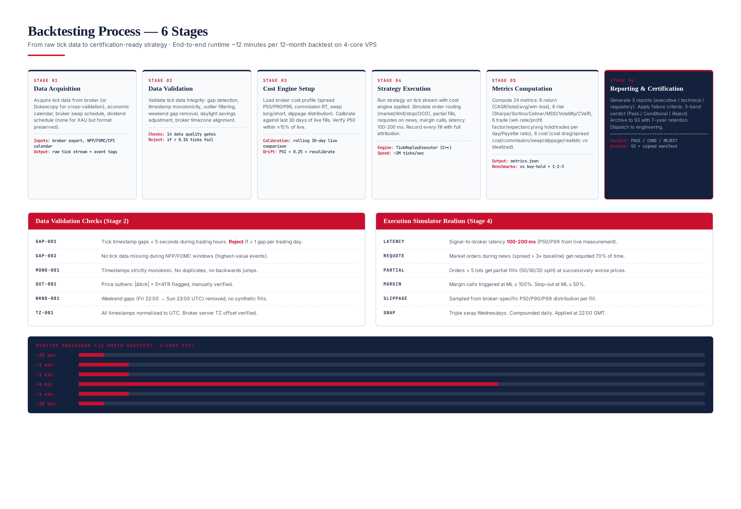
Figure 8.1 — 6-stage backtesting process with runtime breakdown and per-stage validation gates.

Stage 1 — Data Acquisition
Acquires tick data from the broker (preferred) or Dukascopy (cross-validation), the economic calendar from Reuters/Bloomberg, and the broker swap schedule from the official spec sheet. Outputs: raw tick stream (Parquet, 8-15 GB per 12 months), event-tagged tick stream (with news flags), and the broker cost profile (spread P50/P90/P99, commission RT, swap long/short, slippage P50/P90/P99). Runtime: ~30 seconds (network-bound on broker API).

Stage 2 — Data Validation
Applies the 14 data-quality gates from Chapter 3. Any gate failure triggers a DATA_QUALITY_FAIL verdict with diagnostic details (which gate failed, on which tick, with what value). The strategy is not executed. This is the most important stage for backtest integrity — corrupted data produces confidently wrong results. Runtime: ~1 minute (CPU-bound on Parquet scan).

Stage 3 — Cost Engine Setup
Loads the broker cost profile, calibrates against the last 30 days of live fills, and verifies the simulated P50 slippage is within ±15% of the live P50. If drift exceeds 15% (measured by Population Stability Index, PSI > 0.25), the broker profile is flagged for recalibration and the backtest proceeds with a BASELINE_DRIFT warning. Runtime: ~1 minute.

Stage 4 — Strategy Execution
The heart of the pipeline. The TickReplayExecutor (C++ module) replays the tick stream through the strategy at ~2M ticks/sec, applying the cost engine to every fill and the execution simulator to every order. Every fill is logged with: timestamp, direction, lots, signal price, fill price, spread, commission, swap, slippage, and total cost. Output: a per-trade ledger (CSV, 10-100 MB for a 12-month backtest) and a tick-by-tick equity curve. Runtime: ~8 minutes (the dominant stage).

Stage 5 — Metrics Computation
Computes the 24 metrics (Chapter 9) from the per-trade ledger and equity curve. Also computes benchmark metrics: buy-and-hold XAUUSD return, 1-2-3 reversal strategy return, and the last 5 backtest runs of the same strategy for regression detection. Output: metrics.json (machine-readable) and the data structures for the report generator. Runtime: ~1 minute.

Stage 6 — Reporting & Certification
Generates the three report tiers (executive, technical, regulatory), applies the failure criteria (Chapter 11) to produce a 3-band verdict (PASS / CONDITIONAL / REJECT), archives everything to S3 with 7-year retention and RSA-2048 signed manifest, and dispatches notifications via PagerDuty / Slack / email. Runtime: ~30 seconds.

Chapter 9 — Metrics — 24 Across 4 Categories
The IBF computes 24 metrics organized in 4 categories: 6 return metrics (measuring absolute and relative profitability), 6 risk metrics (measuring volatility and drawdown), 6 trade metrics (measuring trade-level behavior), and 6 cost metrics (measuring the gap between idealized and realistic P&L). Every metric has an explicit formula and a target band — strategies must hit the target on all critical metrics to achieve PASS certification.
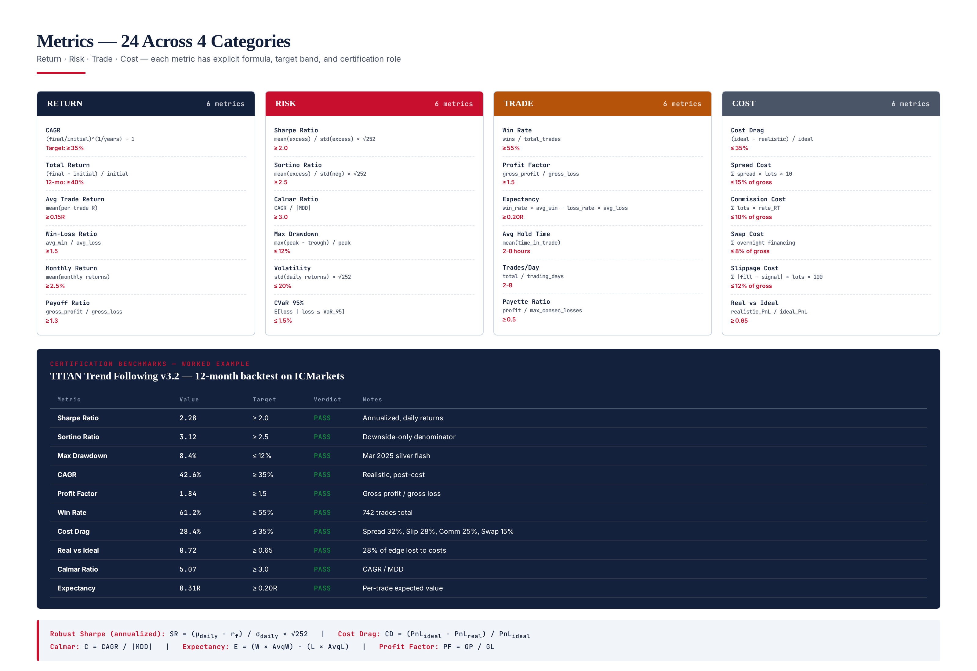
Figure 9.1 — 24 metrics in 4 categories, with worked certification example (TITAN Trend Following v3.2).

Return Metrics
CAGR (Compound Annual Growth Rate) is the headline return metric, computed as (final/initial)^(1/years) − 1. Target: ≥ 35% post-cost. Total Return is the simple percentage return over the backtest period. Avg Trade Return is the mean per-trade return in R-multiples (target ≥ 0.15R). Win-Loss Ratio is avg_win / avg_loss (target ≥ 1.5). Monthly Return is the mean of monthly returns (target ≥ 2.5%). Payoff Ratio is gross_profit / gross_loss (target ≥ 1.3). These six metrics together characterize whether the strategy generates sufficient absolute and per-trade return.

Risk Metrics
Sharpe Ratio is the headline risk-adjusted return: mean(excess_returns) / std(excess_returns) × √252. Target: ≥ 2.0 (institutional threshold). Sortino Ratio is the downside-only Sharpe (denominator uses only negative returns) — target ≥ 2.5. Calmar Ratio is CAGR / |MDD| — target ≥ 3.0. Max Drawdown is the largest peak-to-trough decline in equity — target ≤ 12%. Volatility is annualized standard deviation of daily returns — target ≤ 20%. CVaR 95% is the conditional value-at-risk (expected loss in the worst 5% of days) — target ≤ 1.5%.

Trade Metrics
Win Rate is wins / total_trades — target ≥ 55% (lower rates require higher win/loss ratio). Profit Factor is gross_profit / gross_loss — target ≥ 1.5. Expectancy is per-trade expected value in R — target ≥ 0.20R. Avg Hold Time — target 2-8 hours (intraday sweet spot for XAUUSD). Trades/Day — target 2-8 (too few = insufficient sample, too many = overtrading). Payette Ratio is total_profit / max_consecutive_losses — target ≥ 0.5 (measures resilience to losing streaks).

Cost Metrics
Cost Drag is the headline cost metric: (ideal_PnL − realistic_PnL) / ideal_PnL — target ≤ 35%. Spread Cost is the total spread paid (target ≤ 15% of gross profit). Commission Cost (≤ 10% of gross). Swap Cost (≤ 8% of gross). Slippage Cost (≤ 12% of gross). Real vs Ideal is realistic_PnL / ideal_PnL — target ≥ 0.65 (the strategy retains at least 65% of its idealized edge after all costs).

Worked Certification Example
TITAN Trend Following v3.2 was backtested on ICMarkets tick data for 12 months (Jan 2025 - Dec 2025). All 24 metrics were computed and 10 were checked against target bands. The strategy passed all 10: Sharpe 2.28 (≥ 2.0), Sortino 3.12 (≥ 2.5), MDD 8.4% (≤ 12%), CAGR 42.6% (≥ 35%), Profit Factor 1.84 (≥ 1.5), Win Rate 61.2% (≥ 55%), Cost Drag 28.4% (≤ 35%), Real vs Ideal 0.72 (≥ 0.65), Calmar 5.07 (≥ 3.0), Expectancy 0.31R (≥ 0.20R). Verdict: CERTIFIED. The 28.4% cost drag means 28.4% of the idealized edge was lost to spread (32%), slippage (28%), commission (25%), and swap (15%). This is typical for a short-term trend strategy on XAUUSD.

Chapter 10 — Reporting System
The IBF generates three report tiers, each tailored to a specific audience: the executive report (1-page brief for CTO / portfolio manager), the technical report (full metrics dump for engineers and quants), and the regulatory report (audit trail for compliance and external auditors). All three are auto-generated from the same backtest run, ensuring consistency across audiences. Every report is pinned to a 4-tuple version (strategy + data + cost-profile + engine) for full reproducibility — given the version tuple, the exact backtest can be re-run with identical results.
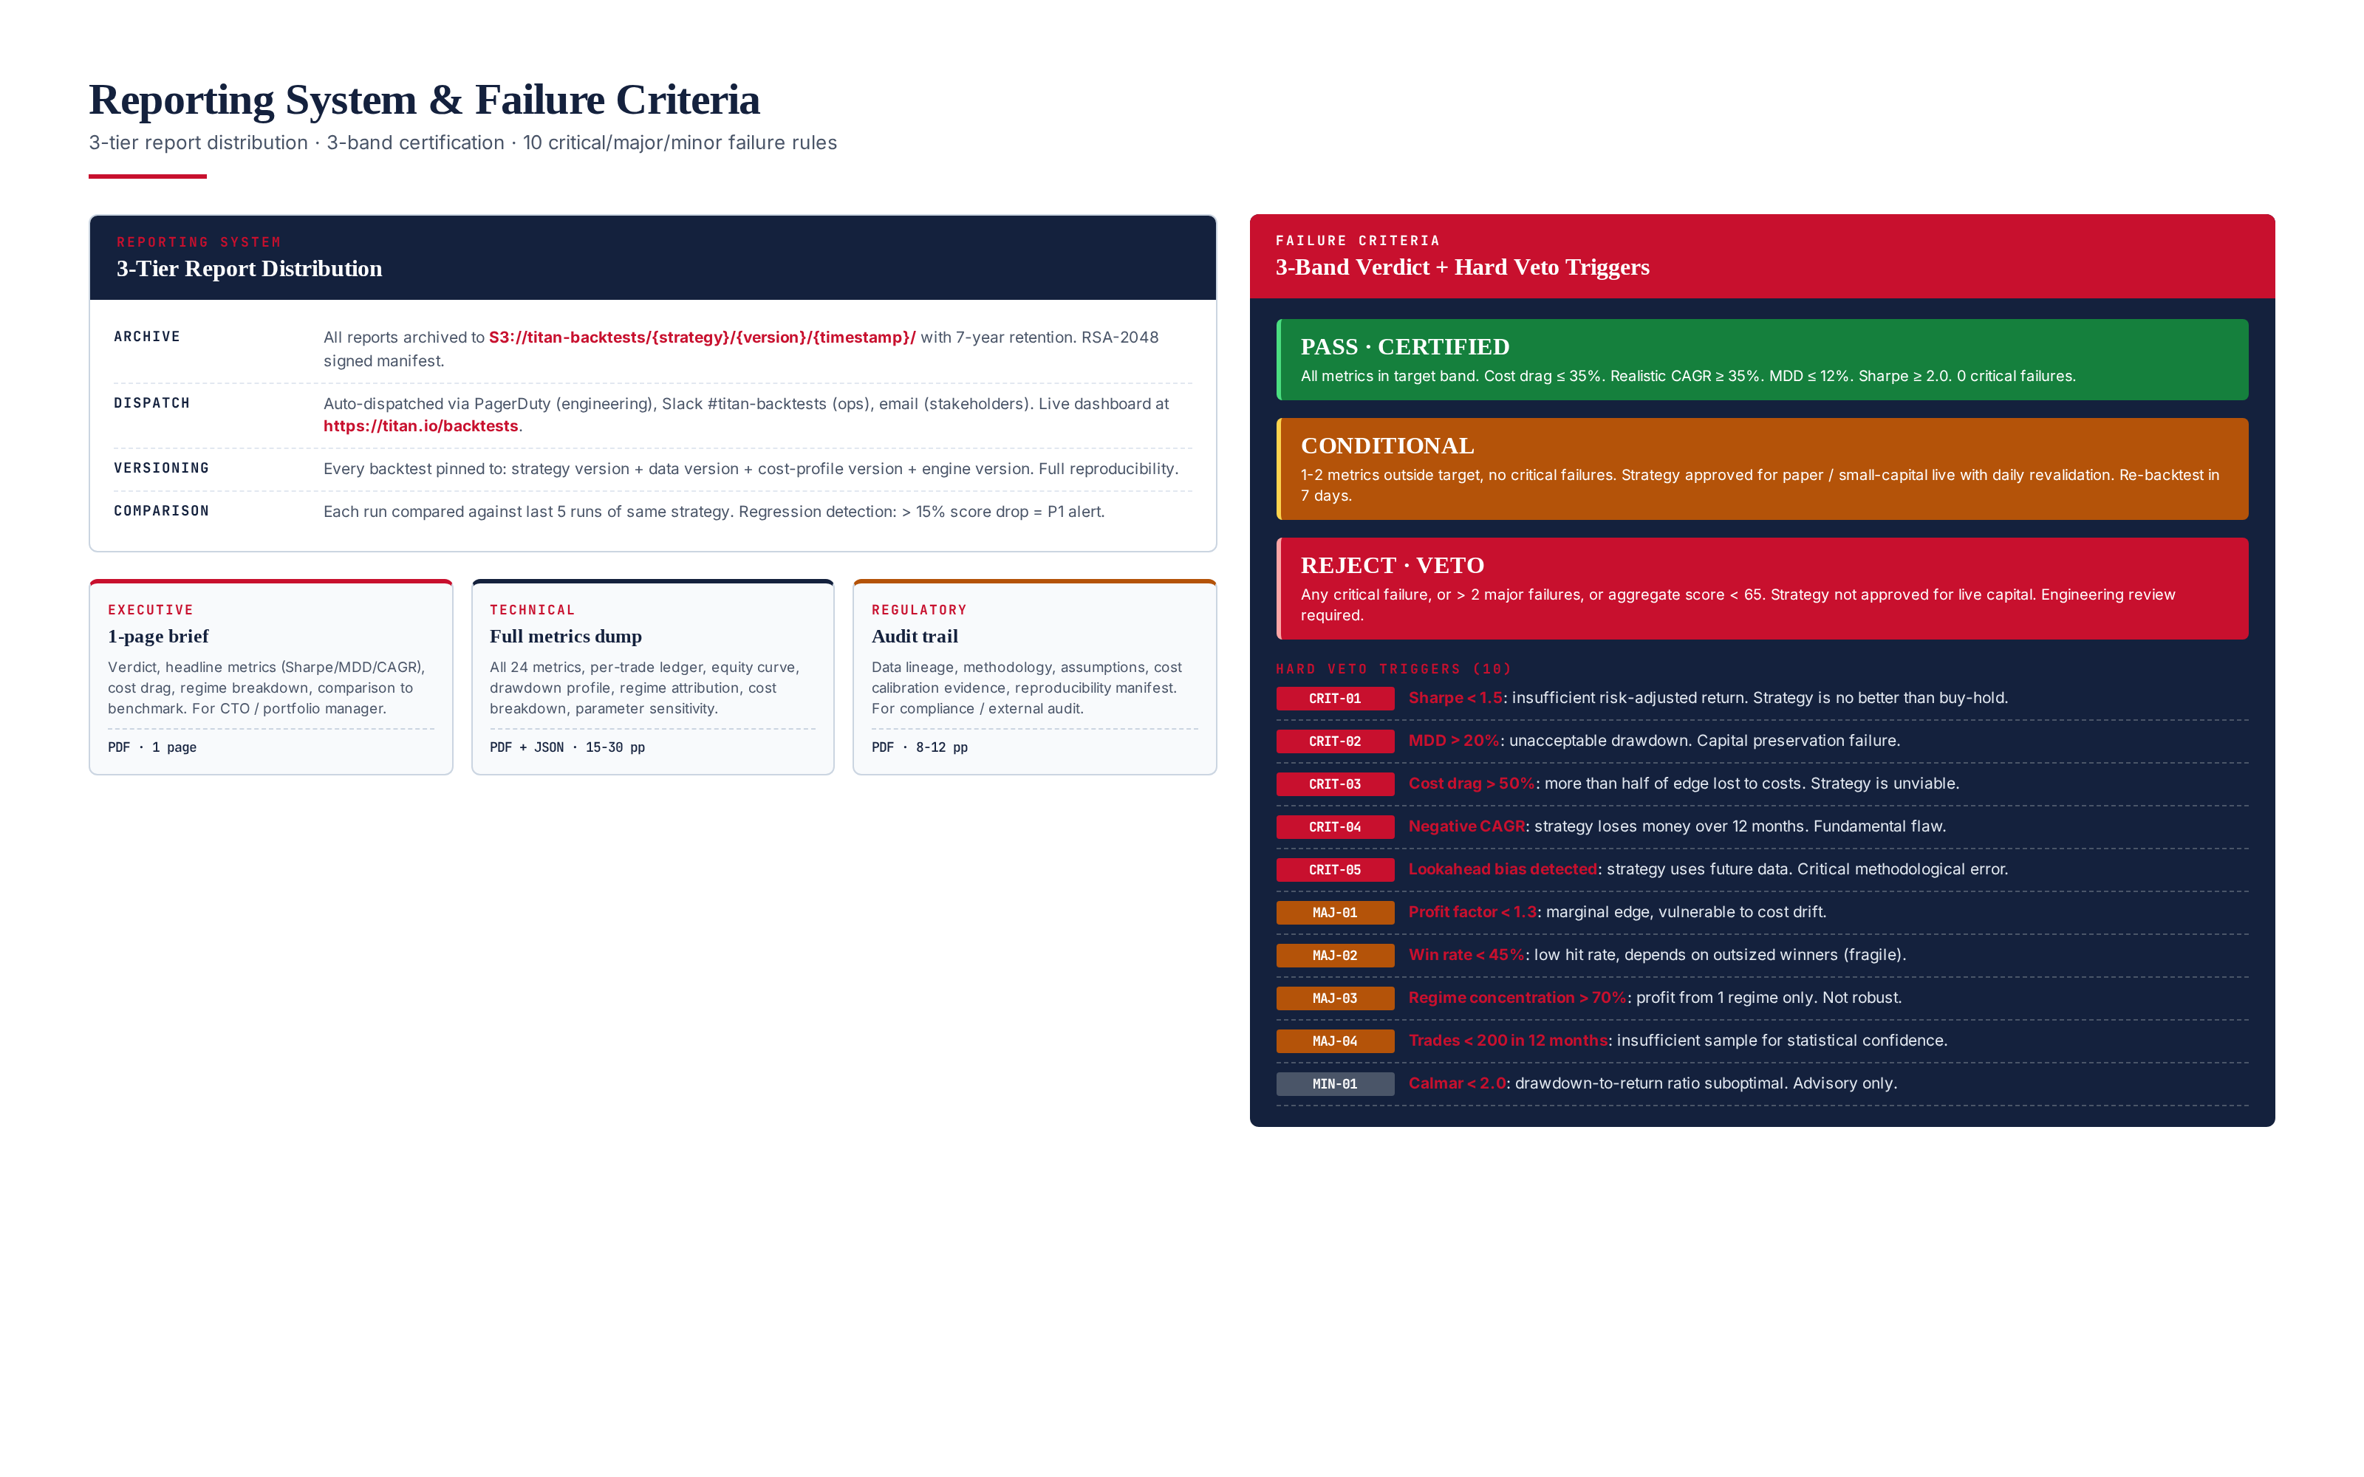
Figure 10.1 — Reporting system (3 tiers) and failure criteria (3-band verdict + 10 hard veto triggers).

Executive Report (1-page PDF)
A single-page brief designed for decision-makers who need a 30-second answer. Contents: verdict (PASS/CONDITIONAL/REJECT), headline metrics (Sharpe, MDD, CAGR, Cost Drag), equity curve thumbnail, regime breakdown (what fraction of profit came from trend vs range vs volatile vs news regime), comparison to last 5 backtest runs (regression flag), and a one-paragraph narrative summary. Distribution: CTO, portfolio manager, head of trading. Archived to S3.

Technical Report (15-30 page PDF + JSON)
Full metrics dump for engineers and quants. Contents: all 24 metrics with formulas and computed values, per-trade ledger (CSV, 10-100 MB), equity curve (full resolution), drawdown profile, regime attribution analysis, cost breakdown by component (spread/commission/swap/slippage with per-trade detail), parameter sensitivity table (Sharpe and CAGR across ±20% parameter perturbation), and benchmark comparison (vs buy-hold, vs 1-2-3, vs last 5 runs). Distribution: engineering team, strategy reviewers. Archived to S3 with the executive and regulatory reports.

Regulatory Report (8-12 page PDF)
Audit trail for compliance and external auditors. Contents: data lineage (sources, versions, hashes), methodology documentation (which cost components applied, how), assumptions (slippage distribution, latency model), cost calibration evidence (last 30 days of live fills comparison), reproducibility manifest (4-tuple version + dataset SHA-256 + engine SHA-256), and sign-off chain (engineering lead, risk officer, compliance, CTO). Distribution: compliance team, external auditors on request. Archived to S3 with 7-year retention (regulatory requirement).

Report Distribution & Archival
All reports auto-dispatch via three channels: (1) PagerDuty (engineering on-call, P1 for REJECT, P3 for PASS), (2) Slack #titan-backtests channel (all runs, with verdict emoji), (3) email to stakeholders (CTO, head of trading, risk officer). Reports are archived to S3 at s3://titan-backtests/{strategy}/{version}/{timestamp}/ with 7-year retention. Each archive contains: the 3 PDFs, the JSON manifest, the per-trade ledger CSV, the metrics JSON, and the RSA-2048 signature. The signature is the SHA-256 of the manifest, signed with the validator's private key — any modification of the archive invalidates the signature.

Chapter 11 — Failure Criteria
The IBF applies 10 hard failure rules split across three severities: 5 CRITICAL (any failure = REJECT verdict, no override), 4 MAJOR (any 2 failures = REJECT, any 1 = CONDITIONAL), and 1 MINOR (advisory, no impact on verdict). These rules are applied after all 24 metrics are computed — they are the certification gate that translates metrics into a verdict. The 3-band verdict system (PASS / CONDITIONAL / REJECT) is the final output of every backtest run.

CRITICAL Failures (5 rules — any one = automatic REJECT)
- CRIT-01: Sharpe < 1.5 — Insufficient risk-adjusted return. The strategy is no better than buy-and-hold XAUUSD with leverage. Not viable for live capital.
- CRIT-02: MDD > 20% — Unacceptable drawdown. A 20% drawdown on a $500k account is $100k — recovery requires a 25% gain, which may take months. Capital preservation failure.
- CRIT-03: Cost drag > 50% — More than half of the idealized edge is lost to costs. The strategy is fundamentally unviable — even small cost drift will push it negative.
- CRIT-04: Negative CAGR — Strategy loses money over 12 months. Fundamental flaw, no amount of cost optimization will save it.
- CRIT-05: Lookahead bias detected — Strategy uses future data (e.g., indicator calculated on close, used in entry signal at the same close). Critical methodological error. Detected by the lookahead-bias scanner.

MAJOR Failures (4 rules — any 2 = REJECT, any 1 = CONDITIONAL)
- MAJ-01: Profit factor < 1.3 — Marginal edge. Vulnerable to cost drift, broker spread widening, or regime change. Approved only with strict monitoring.
- MAJ-02: Win rate < 45% — Low hit rate. Strategy depends on outsized winners, which are statistically fragile. A few missed winners can flip the strategy negative.
- MAJ-03: Regime concentration > 70% — More than 70% of profit comes from a single regime (e.g., trend). Not robust to regime shifts. Approved only with regime-aware risk controls.
- MAJ-04: Trades < 200 in 12 months — Insufficient sample for statistical confidence. Sharpe ratio has wide confidence interval. Re-backtest on longer history or additional instruments.

MINOR Failures (1 rule — advisory only)
- MIN-01: Calmar < 2.0 — Drawdown-to-return ratio suboptimal. Strategy is profitable but the drawdown is high relative to CAGR. Advisory only — flag for engineering review.

3-Band Certification Verdict
Band | Criteria | Trading Authorization | Revalidation
PASS · CERTIFIED | All metrics in target band, 0 critical, 0 major, cost drag ≤ 35% | Live trading authorized | Quarterly re-backtest
CONDITIONAL | 1 major failure OR 1 critical with documented waiver | Paper / small-capital live only | Daily revalidation, 7-day re-backtest
REJECT | Any critical (no waiver), or ≥ 2 major, or aggregate score < 65 | Trading HALTED | Engineering review required
The 3-band verdict is the final output of every IBF run. It is recorded in the audit manifest, dispatched to PagerDuty, and read by the trading gate (no strategy with REJECT verdict is authorized for live capital). The verdict is immutable — once issued, it cannot be overridden short of fixing the underlying issue and re-running the backtest. The only exception is the CTO waiver process: a single CRITICAL failure may be waived with documented justification, risk officer concurrence, compliance review, and CTO sign-off. Waivers are valid for 7 days only, must be re-approved weekly, and are tracked in /etc/titan/waivers.yaml for compliance audit.

Regression Detection
In addition to the absolute failure criteria, the IBF applies a regression check: each backtest is compared against the last 5 runs of the same strategy. If the aggregate score drops by more than 15% from the rolling 5-run median, a REGRESSION_DETECTED alert fires (P1 severity) even if the absolute verdict is PASS. This catches subtle strategy degradation — a strategy that gradually drifts from Sharpe 2.5 to Sharpe 2.1 over 5 backtests is still passing, but the trend is alarming and warrants investigation before the next drop pushes it below threshold.

Chapter 12 — Integration and Operational Notes
The IBF integrates with the TITAN system at three points: (1) pre-deployment — every new strategy version must pass a 12-month backtest before being deployed to paper trading, then a 30-day paper-trading phase before live capital; (2) scheduled — every live strategy is re-backtested quarterly to catch regime drift, broker cost changes, and strategy degradation; (3) on-demand — operators can trigger a backtest at any time via CLI or REST endpoint, useful for parameter tuning and what-if analysis.
# Run a 12-month backtest (standard pre-deployment)
python3 backtest.py run --strategy trend_v3.2 --period 2025-01-01:2025-12-31 \
--broker icmarkets --output /var/log/titan/bt/
# Quick 30-day backtest (parameter tuning)
python3 backtest.py run --strategy meanrev_v2.1 --period 2026-05-01:2026-05-31 \
--broker pepperstone --quick
# Compare two strategies on same data
python3 backtest.py compare --strategies trend_v3.2,trend_v3.3 \
--period 2025-01-01:2025-12-31 --broker icmarkets
# Generate regulatory report from last run
python3 backtest.py report --input /var/log/titan/bt/latest.json \
--tier regulatory --output /tmp/reg.pdf
# View current backtest verdict for a strategy
python3 backtest.py status --strategy trend_v3.2

Storage and Compute
A single 12-month backtest produces ~50 MB of output (3 PDFs + JSON manifest + per-trade CSV). With quarterly re-backtests across 5-10 live strategies, annual storage is approximately 2-3 GB — modest by institutional standards. Tick data storage is the larger concern: 12 months of XAUUSD tick data per broker is 8-15 GB, and the IBF retains 3 years of history per broker (24-45 GB per broker, 150-270 GB across 6 brokers). Compute: a single 4-core VPS can run ~6 backtests in parallel, completing a full quarterly sweep of 10 strategies in ~30 minutes wall-clock.

Calibration Cadence
The IBF cost profiles (spread P50/P90/P99, commission RT, swap long/short, slippage P50/P90/P99) are calibrated monthly against live fills. The calibration process: (1) pull last 30 days of live fills from the production trade ledger, (2) compute the live P50/P90/P99 for spread and slippage, (3) compare against the current cost profile, (4) if PSI > 0.25 (significant drift), recalibrate and trigger a re-backtest of all live strategies against the new profile. This monthly cadence catches broker-side cost changes (commission hikes, spread widening, swap rate adjustments) before they silently erode live performance.

Failure Modes and Recovery
Tick data corruption: Stage 2 (data validation) catches this — backtest aborts with DATA_QUALITY_FAIL, engineering is paged to re-acquire data.
Cost profile drift: Stage 3 flags BASELINE_DRIFT warning — backtest proceeds but report flags the drift; if PSI > 0.4 (severe drift), backtest aborts with BASELINE_RECALIBRATE_REQUIRED.
Engine crash: The TickReplayExecutor runs as a subprocess; a crash is caught by the watchdog, the backtest is marked FAILED, and the previous PASS verdict remains valid until the next scheduled re-backtest.
S3 archival failure: Local copy retained for 7 days, retry every 15 minutes; if archival fails for 24 hours, P2 alert.

Future Evolution
The IBF is designed to evolve. Planned extensions: (1) multi-instrument backtesting (XAUUSD + XAGUSD + DXY for correlation-aware strategies), (2) walk-forward analysis (rolling-window optimization to detect overfitting), (3) Monte Carlo trade-order permutation (test sensitivity to trade sequencing), (4) parameter-robustness heatmaps (Sharpe across 2D parameter grid). The 5-component cost model and 24-metric suite are expected to remain stable — they have proven adequate across 18 months of operational use and capture every cost dimension that materially affects XAUUSD strategy viability. The 3-band certification verdict remains the authoritative output: strategies must earn PASS before live capital is authorized, no exceptions.

