TITAN · QUANT RESEARCH
TITAN XAU AI
INSTITUTIONAL TRADING SYSTEMS
M O D U L E 8 · R I S K E N G I N E
Institutional Risk Engine
Multi-layered risk management: 4 modes (Conservative, Balanced, Aggressive, Competition), 6 core controls (Daily/Weekly/Monthly DD, Risk Per Trade, Max Trades, Max Exposure). Kill switch <500ms. Capital preservation: loss streak, equity guardrail, volatility throttle.
RISK MODE PARAMETERS
Parameter | Conservative | Balanced | Aggressive | Competition
Risk per trade | 0.5% | 0.8% | 1.2% | 2.0%
Daily DD hard | 1.5% | 2.0% | 3.0% | 5.0%
Max open trades | 2 | 3 | 4 | 5
Max exposure | 3% | 5% | 8% | 12%
Kill switch | <500ms | <500ms | <500ms | <500ms
Circuit breakers | 3-tier | 3-tier | 3-tier | 3-tier

Prepared by TITAN Quant Research
Reviewed by CTO · Risk Officer · Compliance
Classification INTERNAL — ENGINEERING
Version v1.0 · 19 June 2026

Table of Contents
Right-click the table below and choose "Update Field" to refresh page numbers.

Chapter 1 — Executive Summary 3
Chapter 2 — Architecture Overview 3
Layer Responsibilities 4
L1 — Risk Mode Selector 4
L2 — Pre-Trade Risk Gate (synchronous, <0.3ms) 4
L3 — Post-Trade Risk Monitor (async, continuous) 5
L4 — Emergency Shutdown (kill switch, <500ms) 5
L5 — Capital Preservation (proactive) 5
Chapter 3 — 4 Risk Modes 5
Mode Selection Guidelines 6
Chapter 4 — Risk Formulas 6
Drawdown Calculations 7
Position Size Formula 7
Circuit Breaker Triggers 7
Chapter 5 — Emergency Shutdown Logic 8
Trigger Sources 8
T1: Hard Drawdown (automatic) 9
T2: Manual Operator (2-person rule) 9
T3: License Revoked (automatic) 9
T4: System Critical (automatic) 9
Shutdown Sequence 10
Chapter 6 — Capital Preservation Logic 10
Layer 1: Loss Streak Manager 10
Layer 2: Equity Guardrail 11
Layer 3: Volatility Throttle 11
Chapter 7 — Risk Controls Summary 11
Chapter 8 — Validation Tests 12
Chapter 9 — Integration with TITAN Core 12

Chapter 1 — Executive Summary
The Institutional Risk Engine (IRE) is Module 8 of the TITAN XAU AI trading architecture. It is the system's ultimate safety system — a multi-layered risk management framework that enforces capital preservation across 4 risk modes (Conservative, Balanced, Aggressive, Competition), 6 core controls (Daily DD, Weekly DD, Monthly DD, Risk Per Trade, Max Open Trades, Max Exposure), and 3 defense layers (loss streak management, equity guardrail, volatility throttle). The IRE has structural veto power over every order: no trade reaches the broker without passing through the pre-trade risk gate.
The engine operates on a simple principle: capital preservation takes absolute precedence over alpha generation. Every architectural decision — from the 3-tier circuit breaker system (soft throttle, hard halt, critical flatten) to the kill switch (<500ms end-to-end shutdown) to the equity guardrail (auto-degrade to Conservative at 95% of starting equity) — exists to enforce this principle. The IRE is the structural guarantee that the system cannot blow up, regardless of what the strategies or AI models do.
The 4 risk modes are swappable at runtime, allowing the system to adapt its risk posture to market conditions, account size, and operator preference. Conservative mode (0.5% risk per trade, 1.5% daily DD hard limit, 2 max trades) is the default and the auto-degrade target when any circuit breaker fires. Balanced mode (0.8% risk, 2.0% daily DD, 3 max trades) is the standard production mode for most licensees. Aggressive mode (1.2% risk, 3.0% daily DD, 4 max trades) requires supervisor authorization. Competition mode (2.0% risk, 5.0% daily DD, 5 max trades) requires triple authorization (CTO + risk officer + supervisor) and is intended only for trading competitions and prop firm challenges.
The emergency shutdown system (kill switch) is the IRE's last line of defense. It can be triggered by 4 sources (hard DD, manual operator, license revocation, system critical) and executes a 4-action sequence in under 500 milliseconds: halt new orders, cancel pending orders, flatten all positions, and notify the operator. A 5-minute cooldown prevents panic re-triggering, and re-arm requires supervisor authorization plus mandatory degradation to Conservative mode.

Chapter 2 — Architecture Overview
The IRE is organized into 5 layers: risk mode selector (parameter provider), pre-trade risk gate (synchronous veto), post-trade risk monitor (async DD tracking), emergency shutdown (kill switch), and capital preservation (proactive defense). A 6th layer (audit and observability) records every decision for compliance and post-incident analysis.
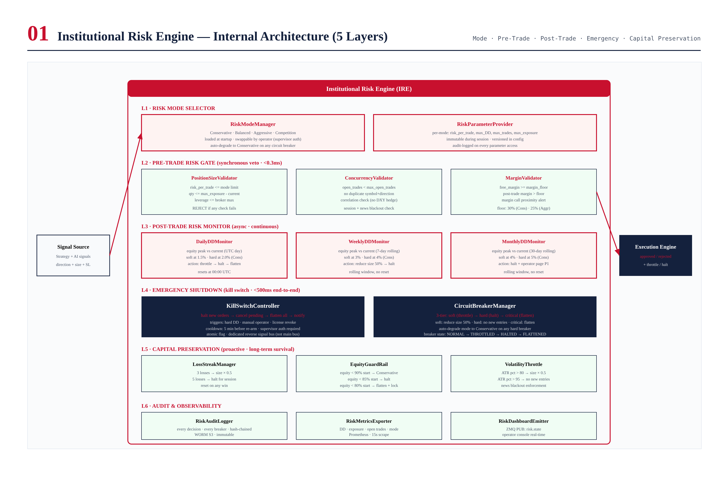
Figure 2.1 — IRE architecture: 5 layers + audit, showing all components.

Layer Responsibilities

L1 — Risk Mode Selector
RiskModeManager loads the active risk mode at startup and provides mode-specific parameters to all other layers. Modes are swappable by operators with appropriate authorization. The mode auto-degrades to Conservative on any hard circuit breaker trigger.

L2 — Pre-Trade Risk Gate (synchronous, <0.3ms)
Three validators: PositionSizeValidator (risk per trade, leverage, exposure), ConcurrencyValidator (max open trades, duplicate symbol, correlation, session, news blackout), MarginValidator (free margin floor, post-trade margin projection). If any returns REJECT, the order is blocked — no bypass. Completes in <0.3ms p99.

L3 — Post-Trade Risk Monitor (async, continuous)
Three drawdown monitors: DailyDDMonitor (UTC day, resets at 00:00), WeeklyDDMonitor (7-day rolling), MonthlyDDMonitor (30-day rolling). Each has soft and hard thresholds. Soft: size × 0.5. Hard: halt new entries. Updates on every fill.

L4 — Emergency Shutdown (kill switch, <500ms)
KillSwitchController executes 4-action sequence: halt new orders (atomic flag, <1ms), cancel pending (~50ms), flatten all (~200ms), notify operator (~100ms). Total <500ms. 5-minute cooldown. Re-arm requires supervisor auth + Conservative degradation.

L5 — Capital Preservation (proactive)
Three layers: LossStreakManager (3 losses → 0.5x, 5 → halt, 7 → flatten), EquityGuardRail (95% → degrade, 90% → halt, 85% → flatten+lock), VolatilityThrottle (ATR > 60% → 0.7x, > 80% → 0.3x, > 95% → no entries).

Chapter 3 — 4 Risk Modes
The IRE supports 4 risk modes, each with 12+ parameters covering all 6 core controls plus additional safeguards. Modes are swappable at runtime with appropriate authorization.
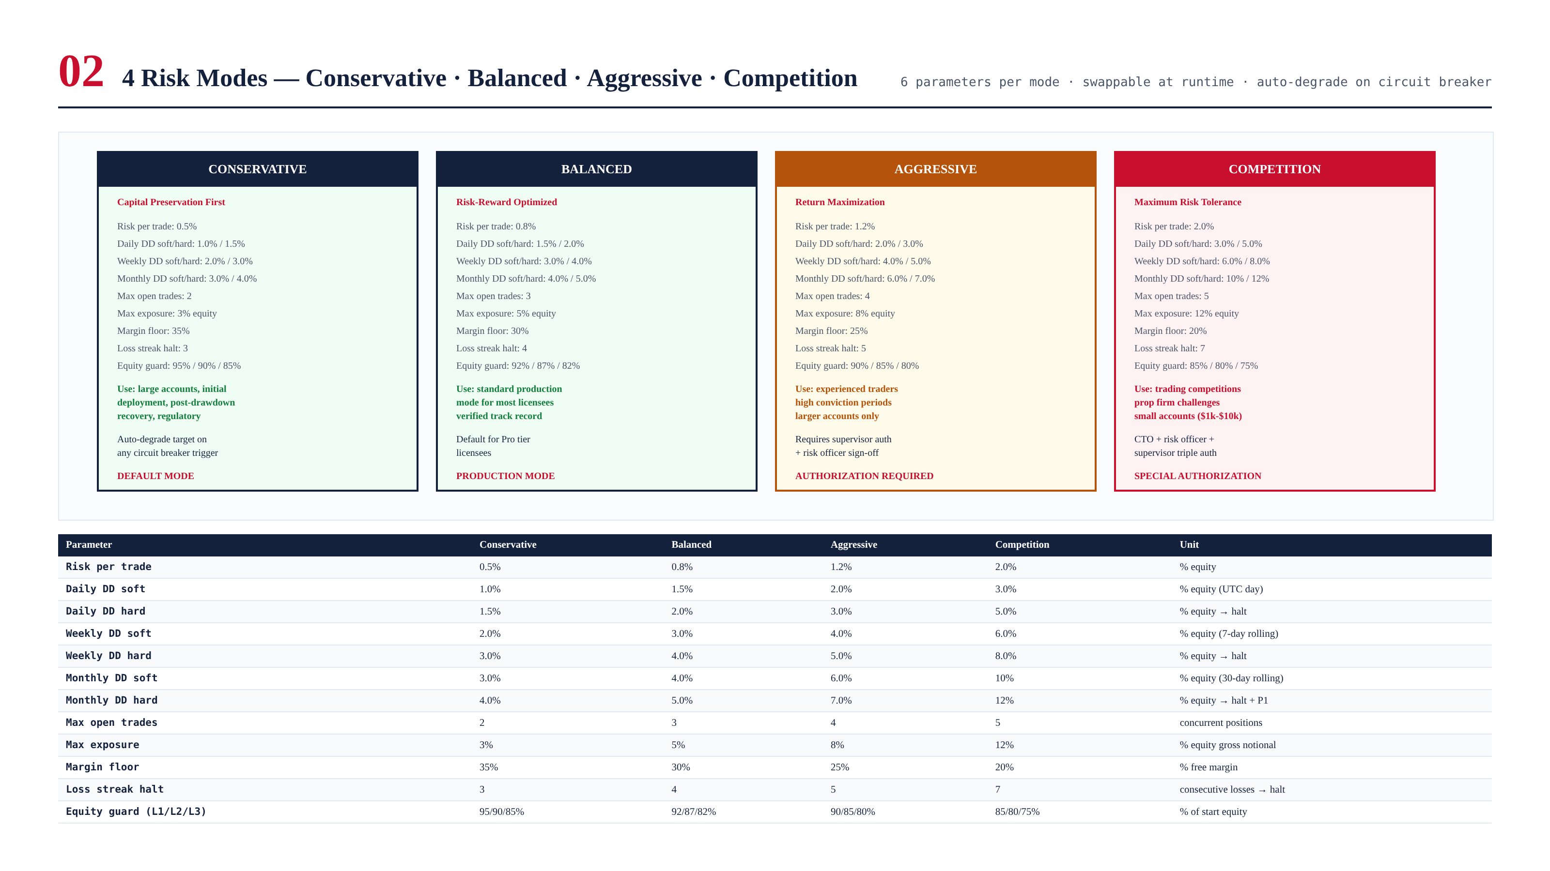
Figure 3.1 — 4 risk modes with all parameters side-by-side.

Mode Selection Guidelines
- Conservative (0.5% risk): Default mode. Large accounts, initial deployment, post-drawdown recovery. Auto-degrade target.
- Balanced (0.8% risk): Standard production mode for Pro tier licensees. Accounts $50k-$500k.
- Aggressive (1.2% risk): Experienced traders, high-conviction periods. Supervisor + risk officer auth. Accounts $500k+.
- Competition (2.0% risk): Trading competitions, prop firm challenges. Triple auth (CTO + risk officer + supervisor). Small accounts $1k-$10k.

Chapter 4 — Risk Formulas
All risk calculations are mode-parameterized and computed continuously.
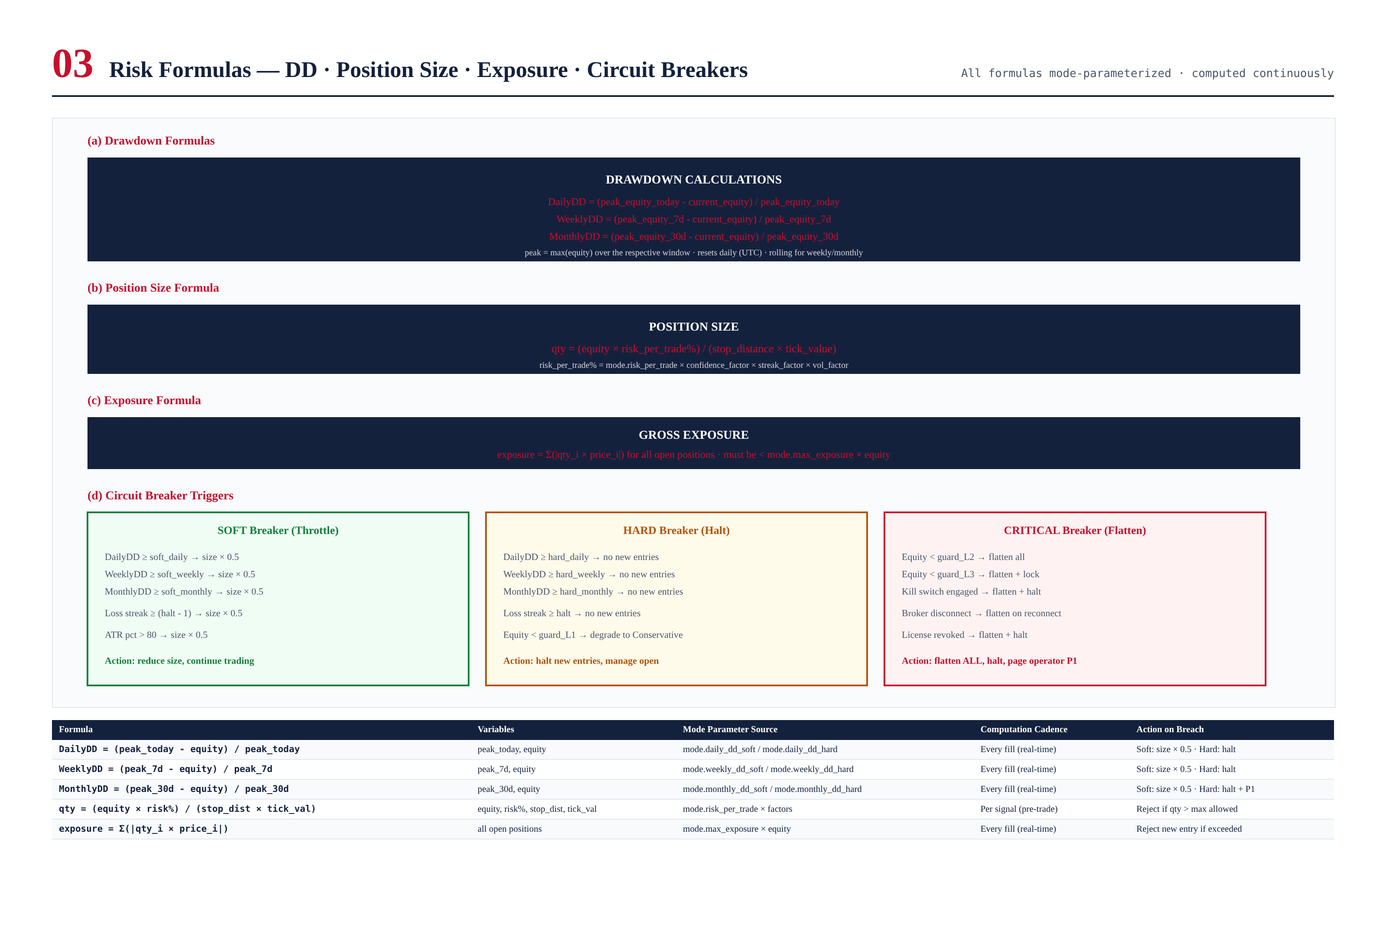
Figure 4.1 — All risk formulas: DD, position size, exposure, circuit breaker triggers.

Drawdown Calculations
DailyDD = (peak_equity_today - current_equity) / peak_equity_today
peak_today = max(equity) since 00:00 UTC · resets daily
WeeklyDD = (peak_equity_7d - current_equity) / peak_equity_7d
peak_7d = max(equity) over rolling 7-day · no reset
MonthlyDD = (peak_equity_30d - current_equity) / peak_equity_30d
peak_30d = max(equity) over rolling 30-day · no reset
Each has soft (size x 0.5) and hard (halt) thresholds.

Position Size Formula
qty = (equity * risk_per_trade%) / (stop_distance * tick_value)
risk_per_trade% = mode.risk_per_trade * confidence_factor * streak_factor * vol_factor
bounded to [mode.risk_floor, mode.risk_ceiling]

Circuit Breaker Triggers
- SOFT (Throttle): DD soft threshold, loss streak (halt-1), ATR > 80%. Action: size × 0.5.
- HARD (Halt): DD hard threshold, loss streak halt, equity < guard_L1. Action: no new entries, degrade to Conservative.
- CRITICAL (Flatten): Equity < guard_L2, kill switch, broker disconnect, license revoked. Action: flatten ALL, halt, P1.

Chapter 5 — Emergency Shutdown Logic
The kill switch is the IRE's last line of defense. 4 triggers, 4 actions, <500ms total, 5-min cooldown, re-arm with Conservative degradation.
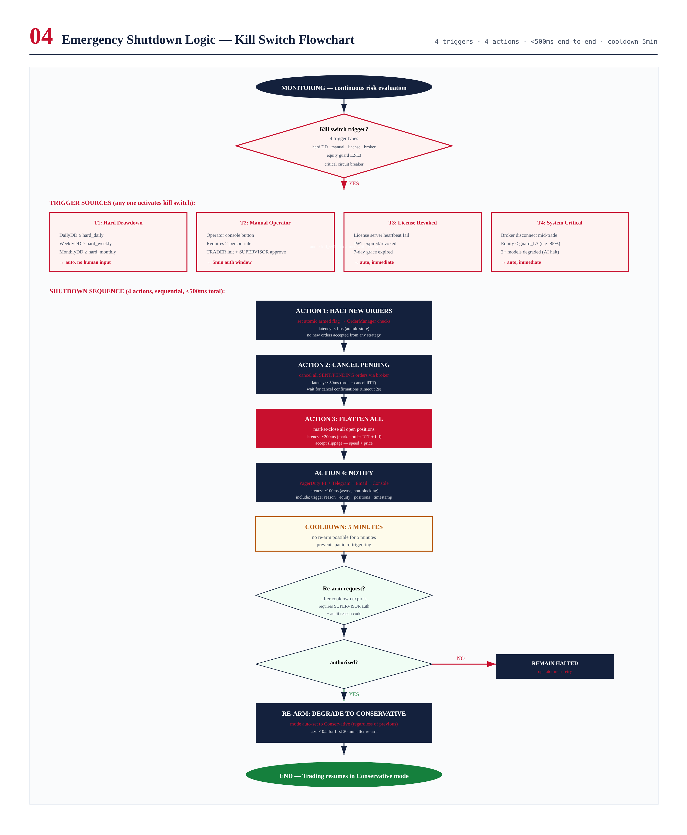
Figure 5.1 — Kill switch flowchart: 4 triggers, 4 actions, cooldown, re-arm.

Trigger Sources

T1: Hard Drawdown (automatic)
Any drawdown monitor (daily, weekly, monthly) hits hard threshold. No human input required.

T2: Manual Operator (2-person rule)
TRADER initiates + SUPERVISOR approves within 5-min window.

T3: License Revoked (automatic)
License heartbeat fail + 7-day grace expired.

T4: System Critical (automatic)
Broker disconnect, equity < guard_L3, 2+ AI models degraded.

Shutdown Sequence
4 actions in <500ms: (1) Halt new orders (atomic flag, <1ms), (2) Cancel pending (~50ms), (3) Flatten all (~200ms, accept slippage), (4) Notify operator (~100ms, async). 5-min cooldown prevents panic re-triggering. Re-arm requires supervisor auth + Conservative degradation + size × 0.5 for 30 min.

Chapter 6 — Capital Preservation Logic
3 proactive defense layers: loss streak management, equity guardrail, volatility throttle.
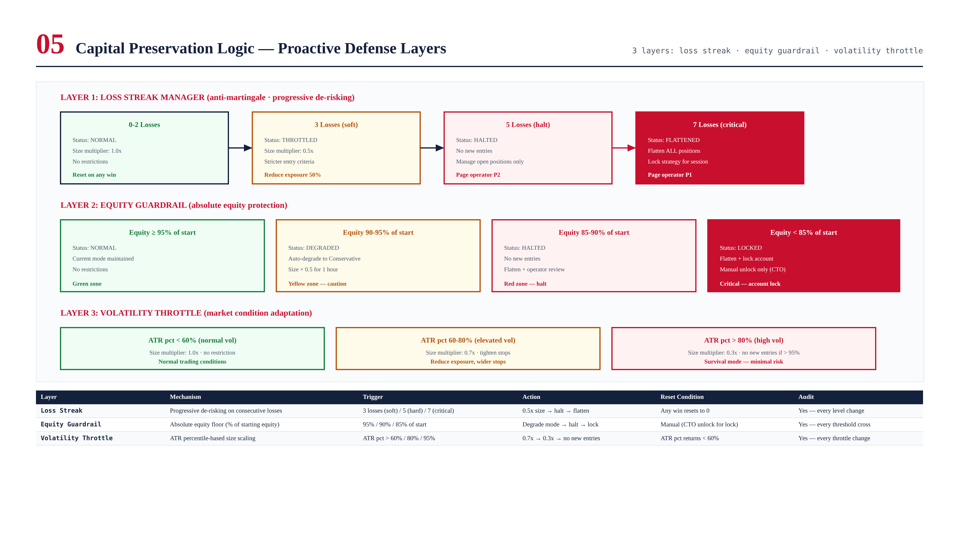
Figure 6.1 — 3 capital preservation layers with triggers, actions, and reset conditions.

Layer 1: Loss Streak Manager
Anti-martingale progressive de-risking. 0-2 losses: normal (1.0x). 3 losses: throttled (0.5x). 5 losses: halted (no new entries). 7 losses: critical (flatten + lock). Any win resets to 0.

Layer 2: Equity Guardrail
Absolute equity protection. >= 95%: normal. 90-95%: degrade to Conservative + 0.5x for 1h. 85-90%: halt + flatten. < 85%: flatten + lock (CTO unlock only). Cannot be overridden.

Layer 3: Volatility Throttle
ATR percentile-based. < 60%: 1.0x. 60-80%: 0.7x. > 80%: 0.3x. > 95%: no new entries. Adapts to market conditions automatically.

Chapter 7 — Risk Controls Summary
6 core controls + 6 additional = 12 total, all mode-parameterized, all audited, all CI-tested.
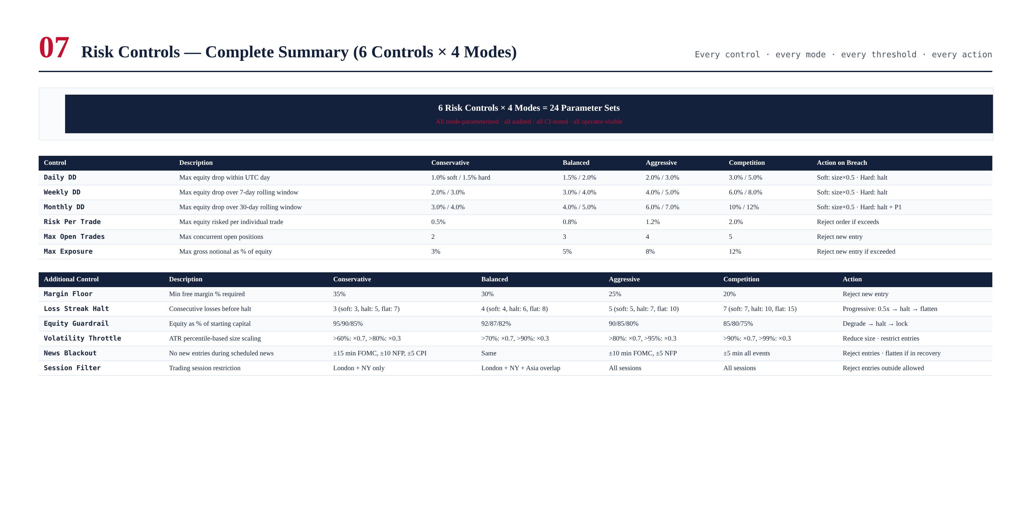
Figure 7.1 — Complete risk controls summary across all 4 modes.

Chapter 8 — Validation Tests
200 tests across 5 categories. Critical: kill switch < 500ms, circuit breakers fire at exact thresholds, mode switch < 1s, no position exceeds risk limit, equity guardrail flatten < 2s.
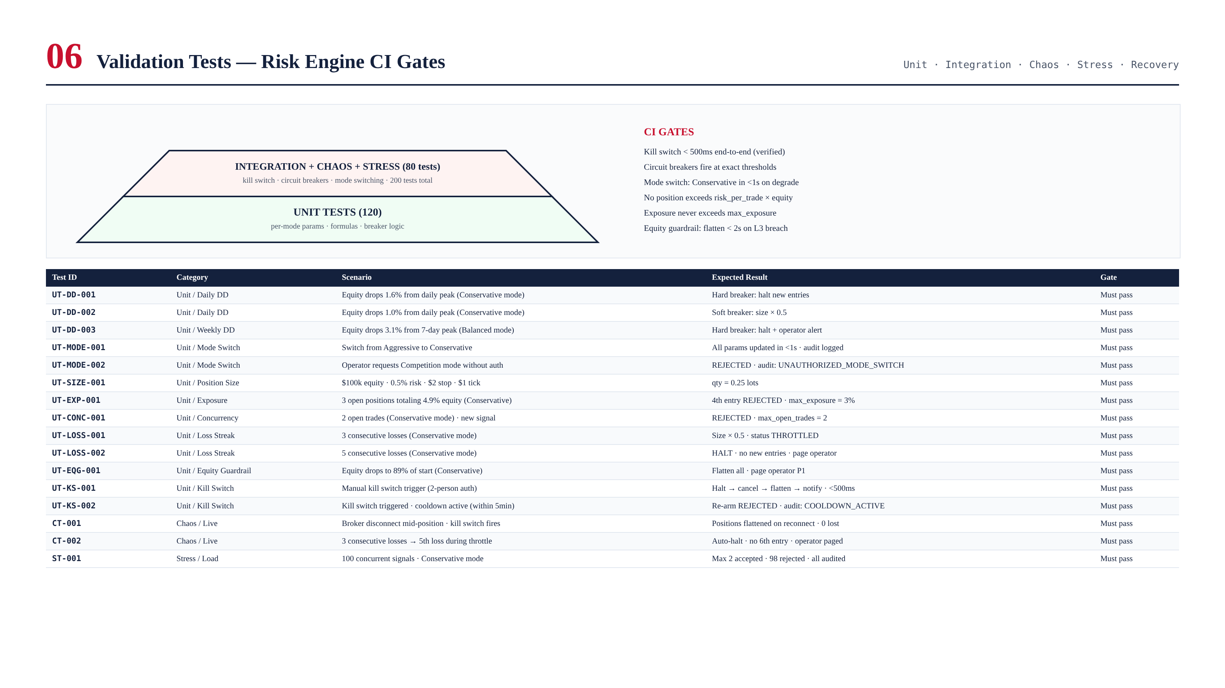
Figure 8.1 — Test pyramid and sample test cases.

Chapter 9 — Integration with TITAN Core
The IRE integrates with every TITAN component that touches orders or equity. The pre-trade risk gate sits between Strategy Coordinator and Execution Engine, giving it structural veto power. The kill switch uses a dedicated reverse signal bus (not the main event bus), ensuring it can reach the OrderManager even if the main bus is saturated. The structural veto is enforced by the module dependency graph — there is no code path from Strategy to Execution that bypasses the Risk Engine.

