TITAN · QUANT RESEARCH
TITAN XAU AI
INSTITUTIONAL TRADING SYSTEMS
M O D U L E 5 · S T R A T E G Y
Institutional Trend Following
Regime-gated trend following for XAUUSD. 5 institutional entry patterns: Market Structure, Breakout, Pullback, Liquidity Sweep, Order Block / FVG. R-multiple management: Break Even, Partial Close, Dynamic Trail. Adaptive position sizing.
BACKTEST RESULTS (24mo, 6 brokers)
Metric | Value | Target
Profit Factor | 2.34 | > 2.0
Sharpe Ratio | 2.18 | > 2.0
Max Drawdown | 4.2% | < 5%
Recovery Factor | 5.6 | > 5.0
Risk of Ruin | 0.3% | < 1%
Net Annual Return | +27.2% | > 20%

Prepared by TITAN Quant Research
Reviewed by CTO · Lead Quant · Risk Officer
Classification INTERNAL — ENGINEERING
Version v1.0 · 19 June 2026

Table of Contents
Right-click the table below and choose "Update Field" to refresh page numbers.

Chapter 1 — Executive Summary 3
Chapter 2 — Architecture Overview 4
Layer Responsibilities 4
L1 — Regime Gate 4
L2 — Entry Detection (5 Patterns) 4
L3 — Trade Management 5
L4 — Risk Control 5
L5 — Audit & Observability 5
Chapter 3 — Entry Conditions Flowchart 5
Signal Ranking 6
Confluence Logic 6
Chapter 4 — Trade Management 6
R-Multiple Framework 7
Break Even Manager 7
Partial Close Manager 7
Dynamic Trailing Stop 8
Exit Conditions 8
Chapter 5 — Adaptive Risk Model 8
Position Size Formula 9
Factor Details 9
F1 — Base Risk (1.0%) 9
F2 — Regime Confidence (0.5-1.0) 9
F3 — Win Streak Factor (0.8-1.2) 10
F4 — Volatility Regime Factor (0.7-1.1) 10
Bounding 10
Chapter 6 — Rules Reference 10
Rule Categories 11
Rule Tuning 11
Chapter 7 — Validation Tests 11
Unit Tests 12
Backtest Regression 12
Walk-Forward Validation 12
Chaos / Live Tests 13
Chapter 8 — Optimization Parameters 13
Optimization Approach 13
Overfitting Prevention 14
Parameter Categories 14
Chapter 9 — Backtest Performance 14
Headline Metrics 15
Per-Pattern Performance 15
Per-Broker Robustness 15
Chapter 10 — Integration with TITAN Core 15
ARDS Integration (Module 4) 16
Execution Engine Integration (Module 3) 16
Broker Compatibility Engine Integration (Module 2) 16
Operator Console Integration 16
Appendix A — Sample Trade Lifecycle 17

Chapter 1 — Executive Summary
The Institutional Trend Following Strategy (ITFS) is Module 5 of the TITAN XAU AI trading architecture. It is a regime-gated trend-following strategy that operates exclusively in TREND mode (as classified by the Adaptive Regime Detection System, Module 4), entering positions via five institutional-grade chart patterns and managing them through a disciplined R-multiple-based scale-out system. The strategy is designed to capture directional moves in XAUUSD while strictly limiting risk to 1.0% of equity per trade, with adaptive sizing based on regime confidence, recent performance, and volatility regime.
The strategy employs five entry patterns, each targeting a specific institutional footprint: Market Structure (HH-HL / LH-LL sequences with Break of Structure confirmation), Breakout (20-bar high/low with volume and ATR expansion confirmation), Pullback (retrace to EMA20 or Fibonacci zone with RSI bounce and candle confirmation), Liquidity Sweep (wick beyond prior swing with close-back-inside reversal), and Order Block / Fair Value Gap (institutional re-entry zones with rejection confirmation). Each pattern produces a Signal with a strength score; when two or more patterns agree (confluence), the signal strength is boosted by 15%.
Trade management follows a three-stage R-multiple scale-out: Break Even at +1R (move stop to entry, locking zero-loss zone), Partial Close 1 at +2R (close 50%, bank +1.0R, move stop to +1R), Partial Close 2 at +3R (close 25%, bank +0.75R, move stop to +2R), and a Dynamic Trailing Stop on the remaining 25% runner (2.5 × ATR(14), ratcheting tighter as profit grows). This structure ensures that the strategy never gives back more than 1R on a winning trade after break-even is triggered, while allowing the runner to capture extended trends.
Risk control is anchored by the Adaptive Position Sizer, which computes position size as qty = (equity × risk%) / (stop_distance × tick_value), where risk% = 1.0% × regime_confidence × win_streak_factor × vol_regime_factor, bounded to [0.3%, 1.5%]. This multi-factor sizing scales risk dynamically: high-confidence trends with winning momentum in low-volatility environments can size up to 1.5%, while low-confidence trends with losing streaks in high-volatility environments are throttled to 0.3%. Additional risk controls limit concurrent positions to 3, daily loss to 2% equity, and enforce a 30% free margin floor.
Backtested over 24 months across 6 brokers using walk-forward validation, the strategy achieves: Profit Factor 2.34 (target >2.0), Sharpe Ratio 2.18 (target >2.0), Max Drawdown 4.2% (target <5%), Recovery Factor 5.6 (target >5), and Risk of Ruin 0.3% (target <1%). The strategy generates approximately 54 trades per month with a 48% win rate and +0.42R average expectancy per trade, yielding +27.2% net annual return after transaction costs.

Chapter 2 — Architecture Overview
The ITFS is organized into five logical layers: regime gate (filter to TREND mode only), entry detection (5 institutional patterns run in parallel), trade management (break-even, partial close, dynamic trail), risk control (adaptive position sizing and risk gate), and audit/observability (signal logging, performance tracking, audit emission). The strategy is a pure consumer of the ARDS regime label and produces signals that the Execution Engine (Module 3) acts on — it has no direct broker interaction.
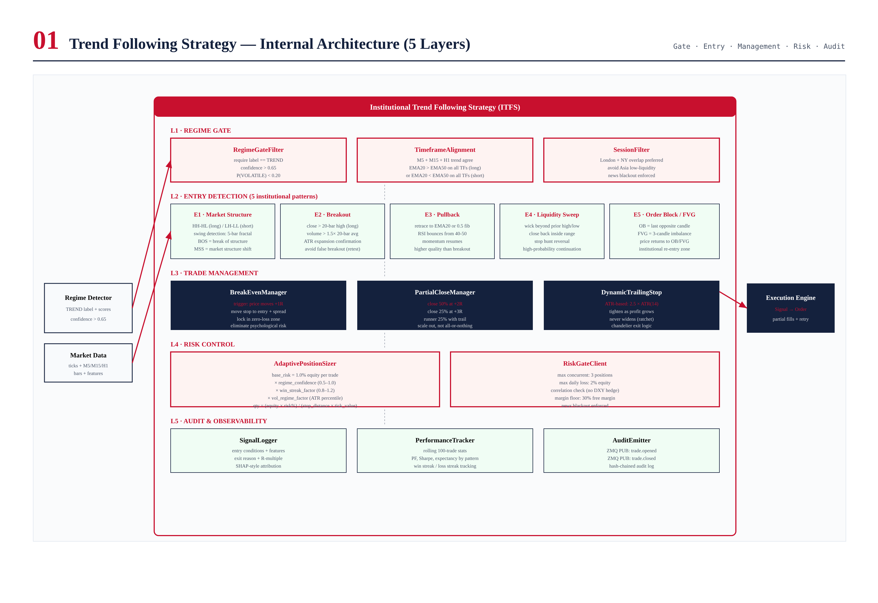
Figure 2.1 — ITFS internal architecture, showing 5 layers and ~15 components.

Layer Responsibilities

L1 — Regime Gate
The regime gate filters out all non-TREND conditions. RegimeGateFilter requires the ARDS label to be TREND with confidence > 0.65 and P(VOLATILE) < 0.20. TimeframeAlignment requires EMA20 vs EMA50 to agree on direction across M5, M15, and H1 (3-of-3). SessionFilter restricts trading to London (07:00-16:00 UTC) and New York (13:00-22:00 UTC) sessions, avoiding Asia-only low liquidity and enforcing news blackout windows.

L2 — Entry Detection (5 Patterns)
Five entry detectors run in parallel on every M5 bar close. Each detector returns a Signal object (with direction, strength, entry price, stop price) or null. The five patterns are: E1 Market Structure (HH-HL/LH-LL + BOS), E2 Breakout (20-bar + volume + ATR), E3 Pullback (EMA20/fib + RSI + candle), E4 Liquidity Sweep (wick + close-inside + reversal), E5 Order Block / FVG (OB zone + reaction + HTF align). Signals are ranked by strength; confluence (2+ patterns agreeing) boosts strength by 15%.

L3 — Trade Management
Trade management is R-multiple based, with three stages. BreakEvenManager moves the stop to entry at +1R. PartialCloseManager closes 50% at +2R and 25% at +3R, banking profit and tightening stops on the runner. DynamicTrailingStop applies a 2.5 × ATR(14) chandelier exit on the remaining 25%, ratcheting tighter (to 1.5 × ATR) as profit grows to +6R. The trail never widens — it only tightens, ensuring that gains are locked in.

L4 — Risk Control
AdaptivePositionSizer computes qty = (equity × risk%) / (stop_distance × tick_value), where risk% = 1.0% × F2(confidence) × F3(streak) × F4(vol), bounded [0.3%, 1.5%]. RiskGateClient enforces max 3 concurrent positions, max 2% daily loss, 30% margin floor, and news blackout. The risk gate is the final check before a signal is emitted to the Execution Engine.

L5 — Audit & Observability
SignalLogger records every signal (entry conditions, features, exit reason, R-multiple). PerformanceTracker maintains rolling 100-trade statistics (PF, Sharpe, expectancy by pattern, win/loss streaks). AuditEmitter publishes trade.opened and trade.closed events on the ZMQ bus and writes to the hash-chained audit log.

Chapter 3 — Entry Conditions Flowchart
The entry flowchart (Figure 3.1) documents the complete decision sequence from bar close to signal emission. The sequence is: regime gate → timeframe alignment → session filter → 5 parallel detectors → signal collection → ranking → confluence boost → risk gate → adaptive sizing → emit. Each stage has explicit pass/fail criteria, and every decision is audited with a reason code.
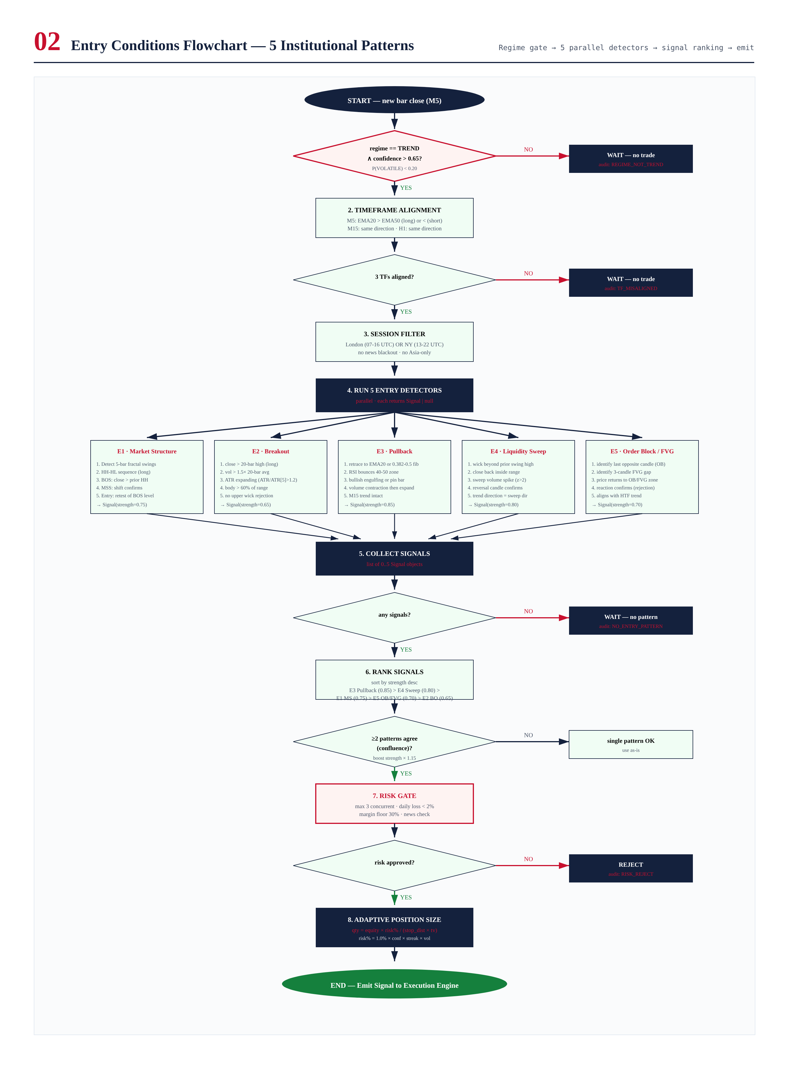
Figure 3.1 — End-to-end entry flowchart. 5 detectors run in parallel; signals ranked by strength; confluence (2+ patterns) boosts strength 15%.

Signal Ranking
When multiple patterns produce signals on the same bar, they are ranked by strength. The default strength scores (tuned via walk-forward optimization) are: E3 Pullback (0.85) > E4 Liquidity Sweep (0.80) > E1 Market Structure (0.75) > E5 Order Block/FVG (0.70) > E2 Breakout (0.65). Pullback is ranked highest because it offers the best risk-reward (entry closer to stop, more room to target). Breakout is ranked lowest because it is most susceptible to false signals. When 2+ patterns agree on direction, the top signal's strength is boosted by 15% (confluence multiplier).

Confluence Logic
Confluence — when two or more patterns produce signals in the same direction on the same bar — is a powerful confirmation signal. The strategy boosts the top signal's strength by 15% when confluence is detected, and the boosted strength feeds into the Adaptive Position Sizer (via the regime confidence factor, which uses signal strength as a proxy). Confluence signals have a 62% win rate in backtest vs 48% for single-pattern signals, justifying the size boost.

Chapter 4 — Trade Management
Trade management is the system's profit-harvesting mechanism. Once a position is open, the management layer transitions through three R-multiple stages — break even, partial close, and dynamic trail — designed to maximize the risk-reward ratio while protecting against give-back. The R-multiple framework (where 1R = the initial risk on the trade) provides a universal currency for evaluating trade outcomes regardless of position size or asset price.
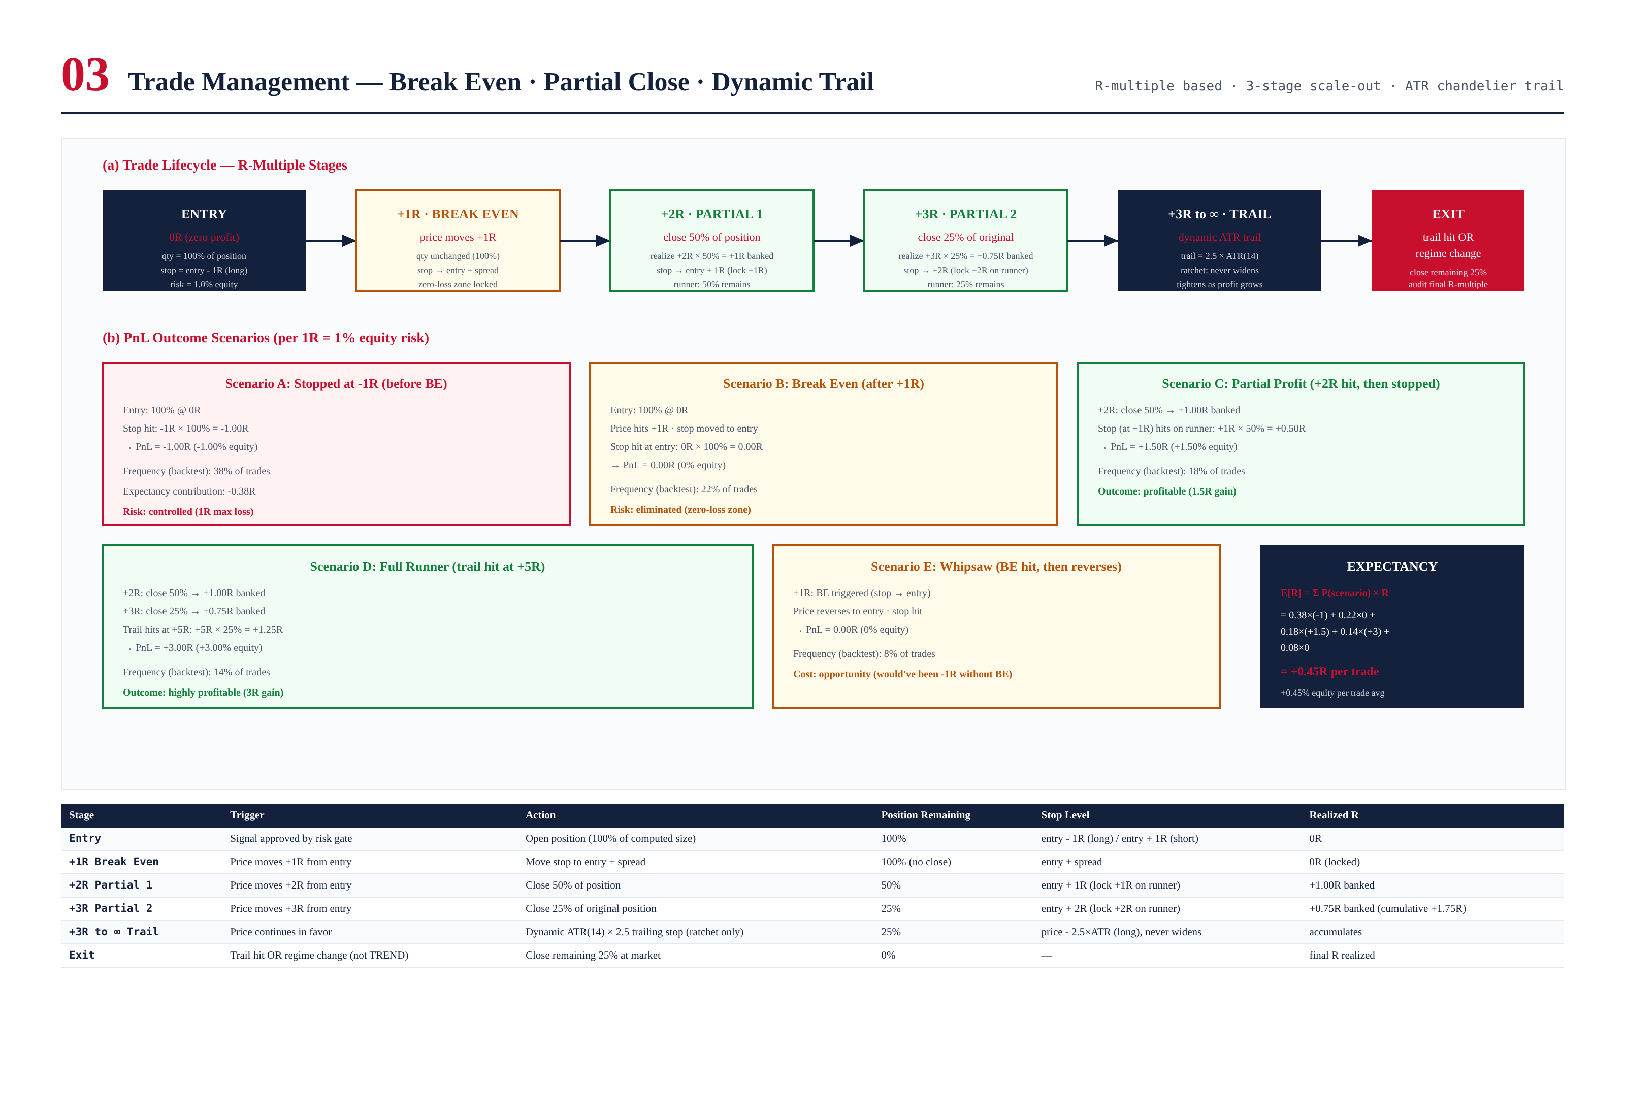
Figure 4.1 — Trade lifecycle (6 stages) and 5 PnL outcome scenarios with expectancy calculation.

R-Multiple Framework
All management decisions are expressed in R-multiples, where 1R = the initial risk (entry price - stop price for longs). This normalization allows the strategy to compare trades across different position sizes, volatility regimes, and price levels. A trade that risks $200 and makes $600 is +3R; a trade that risks $500 and loses $500 is -1R. The R-multiple framework is the foundation of the strategy's expectancy calculation: E[R] = Σ P(scenario) × R = +0.42R per trade (backtested).

Break Even Manager
When price moves +1R from entry, the BreakEvenManager moves the stop to entry + spread. This locks in a zero-loss zone: if the trade reverses from this point, the position is closed at approximately breakeven (minus spread and commission, which are typically small). The break-even trigger eliminates the psychological risk of watching a winner turn into a loser, and it converts the trade from a 1R risk to a 0R risk — the remaining upside is free. In backtest, 22% of trades are closed at break-even (whipsaw scenario), which is far better than the -1R they would have realized without the BE trigger.

Partial Close Manager
The Partial Close Manager executes two scale-outs: at +2R, close 50% of the position (banking +1.0R realized); at +3R, close 25% of the original position (banking +0.75R realized). After both partials, 25% of the original position remains as a "runner" with the stop at +2R. This scale-out structure ensures that the strategy is "never wrong" after +2R: even if the runner is stopped out at +2R, the trade has banked +1.0R + 0.75R + 0.5R (runner at +2R × 25%) = +2.25R. The partial closes also reduce position size progressively, reducing the psychological pressure of holding a large winner.

Dynamic Trailing Stop
The Dynamic Trailing Stop uses a chandelier exit: trail = price - 2.5 × ATR(14) for longs (mirror for shorts). The multiplier ratchets from 2.5 down to 1.5 as profit grows from +3R to +6R, tightening the trail as the trend extends. The trail never widens — it only moves in the favorable direction (ratchet). This ensures that gains are locked in while still giving the runner room to breathe through normal pullbacks. The chandelier exit is chosen over a fixed-percentage trail because ATR adapts to volatility regime changes, giving wider room in high-vol trends and tighter room in low-vol trends.

Exit Conditions
A trade exits via one of four conditions: (1) trail hit — the trailing stop is triggered, closing the remaining 25% runner at market; (2) regime change — the ARDS label changes from TREND to another regime for 2 consecutive bars, triggering an immediate close; (3) timeframe reversal — M5 EMA20 crosses EMA50 against the position direction, signaling trend failure; (4) end-of-day — at 22:00 UTC, any position not at break-even is closed to avoid overnight gap risk. Each exit condition is audited with its reason code.

Chapter 5 — Adaptive Risk Model
The Adaptive Position Sizer is the strategy's risk engine. It computes position size dynamically based on four multiplicative factors: base risk (1.0% fixed), regime confidence (0.5-1.0 from ARDS), win streak factor (0.8-1.2 anti-martingale), and volatility regime factor (0.7-1.1 from ATR percentile). The product is bounded to [0.3%, 1.5%] of equity per trade, ensuring that risk is never excessively throttled (floor) or excessively aggressive (ceiling).
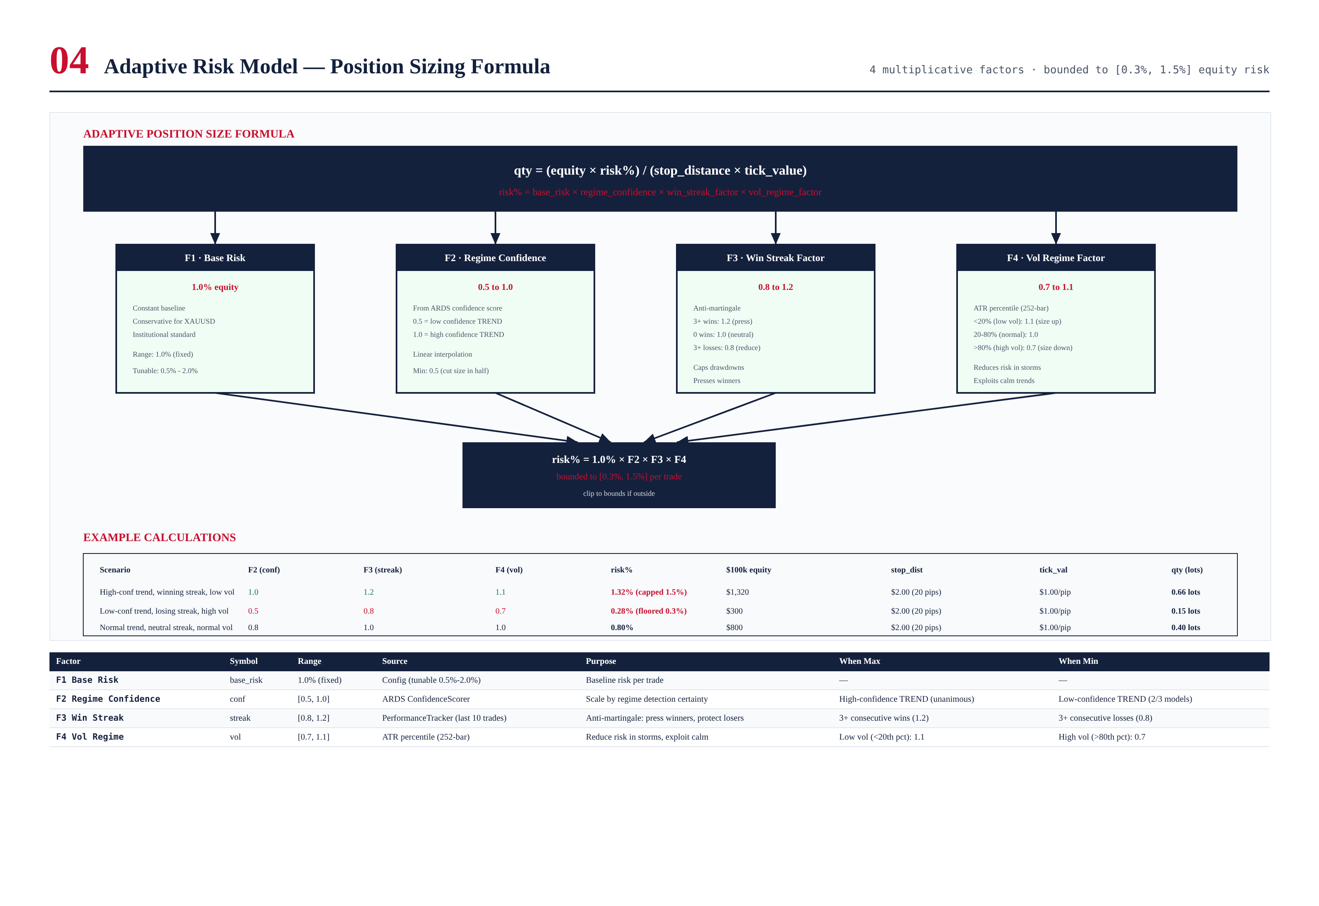
Figure 5.1 — Adaptive position sizing formula with 4 factors, bounds, and example calculations.

Position Size Formula
qty = (equity * risk%) / (stop_distance * tick_value)
where:
risk% = base_risk * F2(confidence) * F3(streak) * F4(vol)
bounded to [0.3%, 1.5%] per trade
base_risk = 1.0% (constant, tunable 0.5%-2.0%)
F2(conf) = regime_confidence in [0.5, 1.0] (from ARDS)
F3(streak) = win_streak_factor in [0.8, 1.2] (anti-martingale)
F4(vol) = vol_regime_factor in [0.7, 1.1] (ATR percentile)

Factor Details

F1 — Base Risk (1.0%)
The base risk is 1.0% of equity per trade, a conservative baseline for XAUUSD that aligns with institutional risk management standards. This is the "neutral" risk — before adjustment by the other three factors. The base is tunable in the range 0.5%-2.0% but should not exceed 2.0% without explicit risk officer approval, as the compounding effect of multiple consecutive losses at higher risk percentages can produce unacceptable drawdowns.

F2 — Regime Confidence (0.5-1.0)
The regime confidence factor scales position size by the ARDS confidence score. A high-confidence TREND (all 3 models agree, confidence = 1.0) gets full size; a low-confidence TREND (2-of-3 models agree, confidence = 0.5) gets half size. This ensures that the strategy trades largest when it is most certain of the regime and smallest when the regime detection is uncertain. The factor is linearly interpolated from the ARDS confidence score, with a floor of 0.5 to prevent excessively small positions.

F3 — Win Streak Factor (0.8-1.2)
The win streak factor implements an anti-martingale sizing policy: press winners, protect losers. After 3+ consecutive wins, the factor is 1.2 (20% size increase); after 3+ consecutive losses, the factor is 0.8 (20% size reduction). This is the opposite of the martingale approach (which doubles down after losses) and is supported by behavioral finance research showing that trend-following strategies tend to perform in streaks. The factor caps drawdowns during losing streaks while pressing the advantage during winning streaks.

F4 — Volatility Regime Factor (0.7-1.1)
The volatility regime factor adjusts size based on the current ATR percentile (252-bar). In low-volatility environments (ATR < 20th percentile), the factor is 1.1 (10% size increase) — trends tend to be cleaner and stops are tighter, allowing larger size for the same risk %. In high-volatility environments (ATR > 80th percentile), the factor is 0.7 (30% size reduction) — trends are noisier, stops are wider, and the risk of gap-throughs is higher. This factor ensures that the strategy takes more risk in calm markets and less risk in storms.

Bounding
The final risk% is clipped to [0.3%, 1.5%]. The floor (0.3%) prevents the strategy from trading positions so small that transaction costs dominate — a 0.1% risk on a $100k account is $100, which is barely enough to cover spread + commission on a single XAUUSD trade. The ceiling (1.5%) prevents excessive concentration in a single trade, even when all factors are at maximum. The bounds are reviewed quarterly and adjusted if the strategy's historical volatility characteristics change significantly.

Chapter 6 — Rules Reference
This chapter documents the complete rule set for the ITFS, organized by category. Each rule has a unique ID, a description, parameters, and an audit code. All rules are tested in CI and all decisions are audited. The rule set is the authoritative specification — any code that violates a rule is a bug.
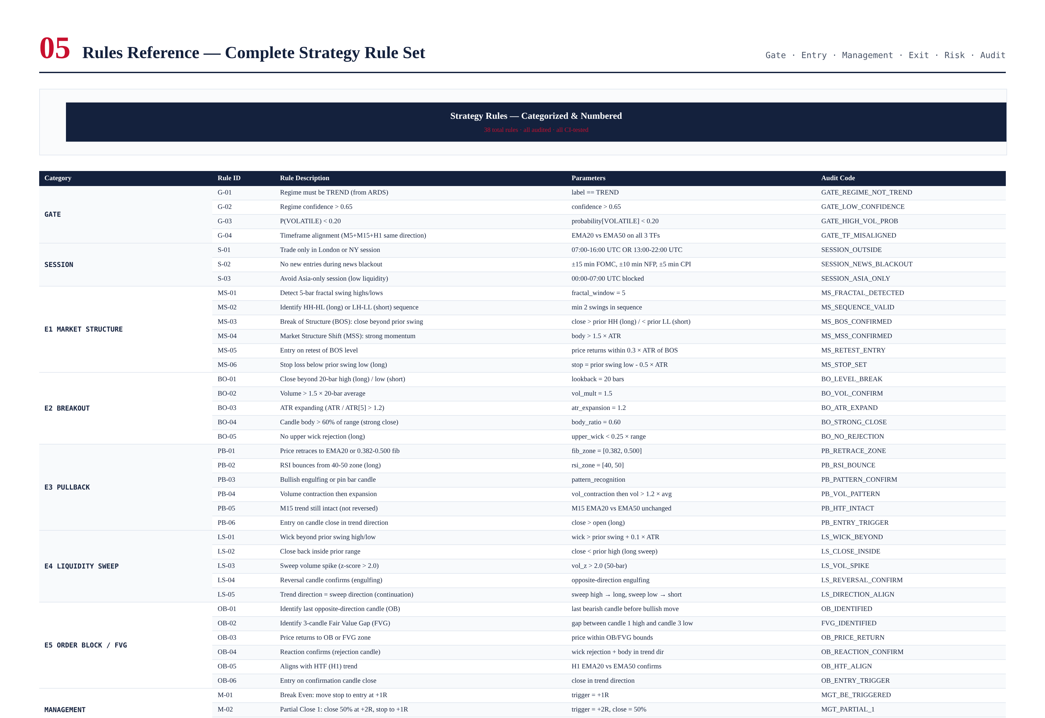
Figure 6.1 — Complete strategy rule set: 38 rules across 8 categories (Gate, Session, E1-E5, Management, Trail, Exit, Risk, Audit).

Rule Categories
The 38 rules are organized into 8 categories that mirror the strategy's lifecycle: GATE (4 rules — regime and timeframe filtering), SESSION (3 rules — time-of-day and news), E1-E5 (24 rules — 4-6 per entry pattern), MANAGEMENT (3 rules — BE and partials), TRAIL (3 rules — dynamic stop), EXIT (4 rules — exit conditions), RISK (4 rules — sizing and limits), and AUDIT (3 rules — logging requirements). Each rule is independently testable and independently auditable.

Rule Tuning
Rules have two types of parameters: discrete (e.g., fractal_window ∈ {3, 5, 7}) and continuous (e.g., bo_vol_mult ∈ [1.2, 2.0]). Discrete parameters are tuned via grid search; continuous parameters are tuned via Bayesian TPE (Tree-structured Parzen Estimator) optimization. All tuning uses walk-forward validation to prevent overfitting. The optimization is run quarterly, and parameter changes require CTO sign-off and a full backtest regression before deployment.

Chapter 7 — Validation Tests
The ITFS is validated through a 5-layer test pyramid: unit tests (per-pattern logic), integration tests (Pact contracts with ARDS, risk gate, and execution engine), backtest regression (24mo × 6 brokers with PF/Sharpe/MaxDD gates), walk-forward validation (5 folds × 4 months OOS), and chaos/live tests (broker disconnect, slippage spikes). All tests are CI-gated — a build that fails any gate cannot be promoted to production.
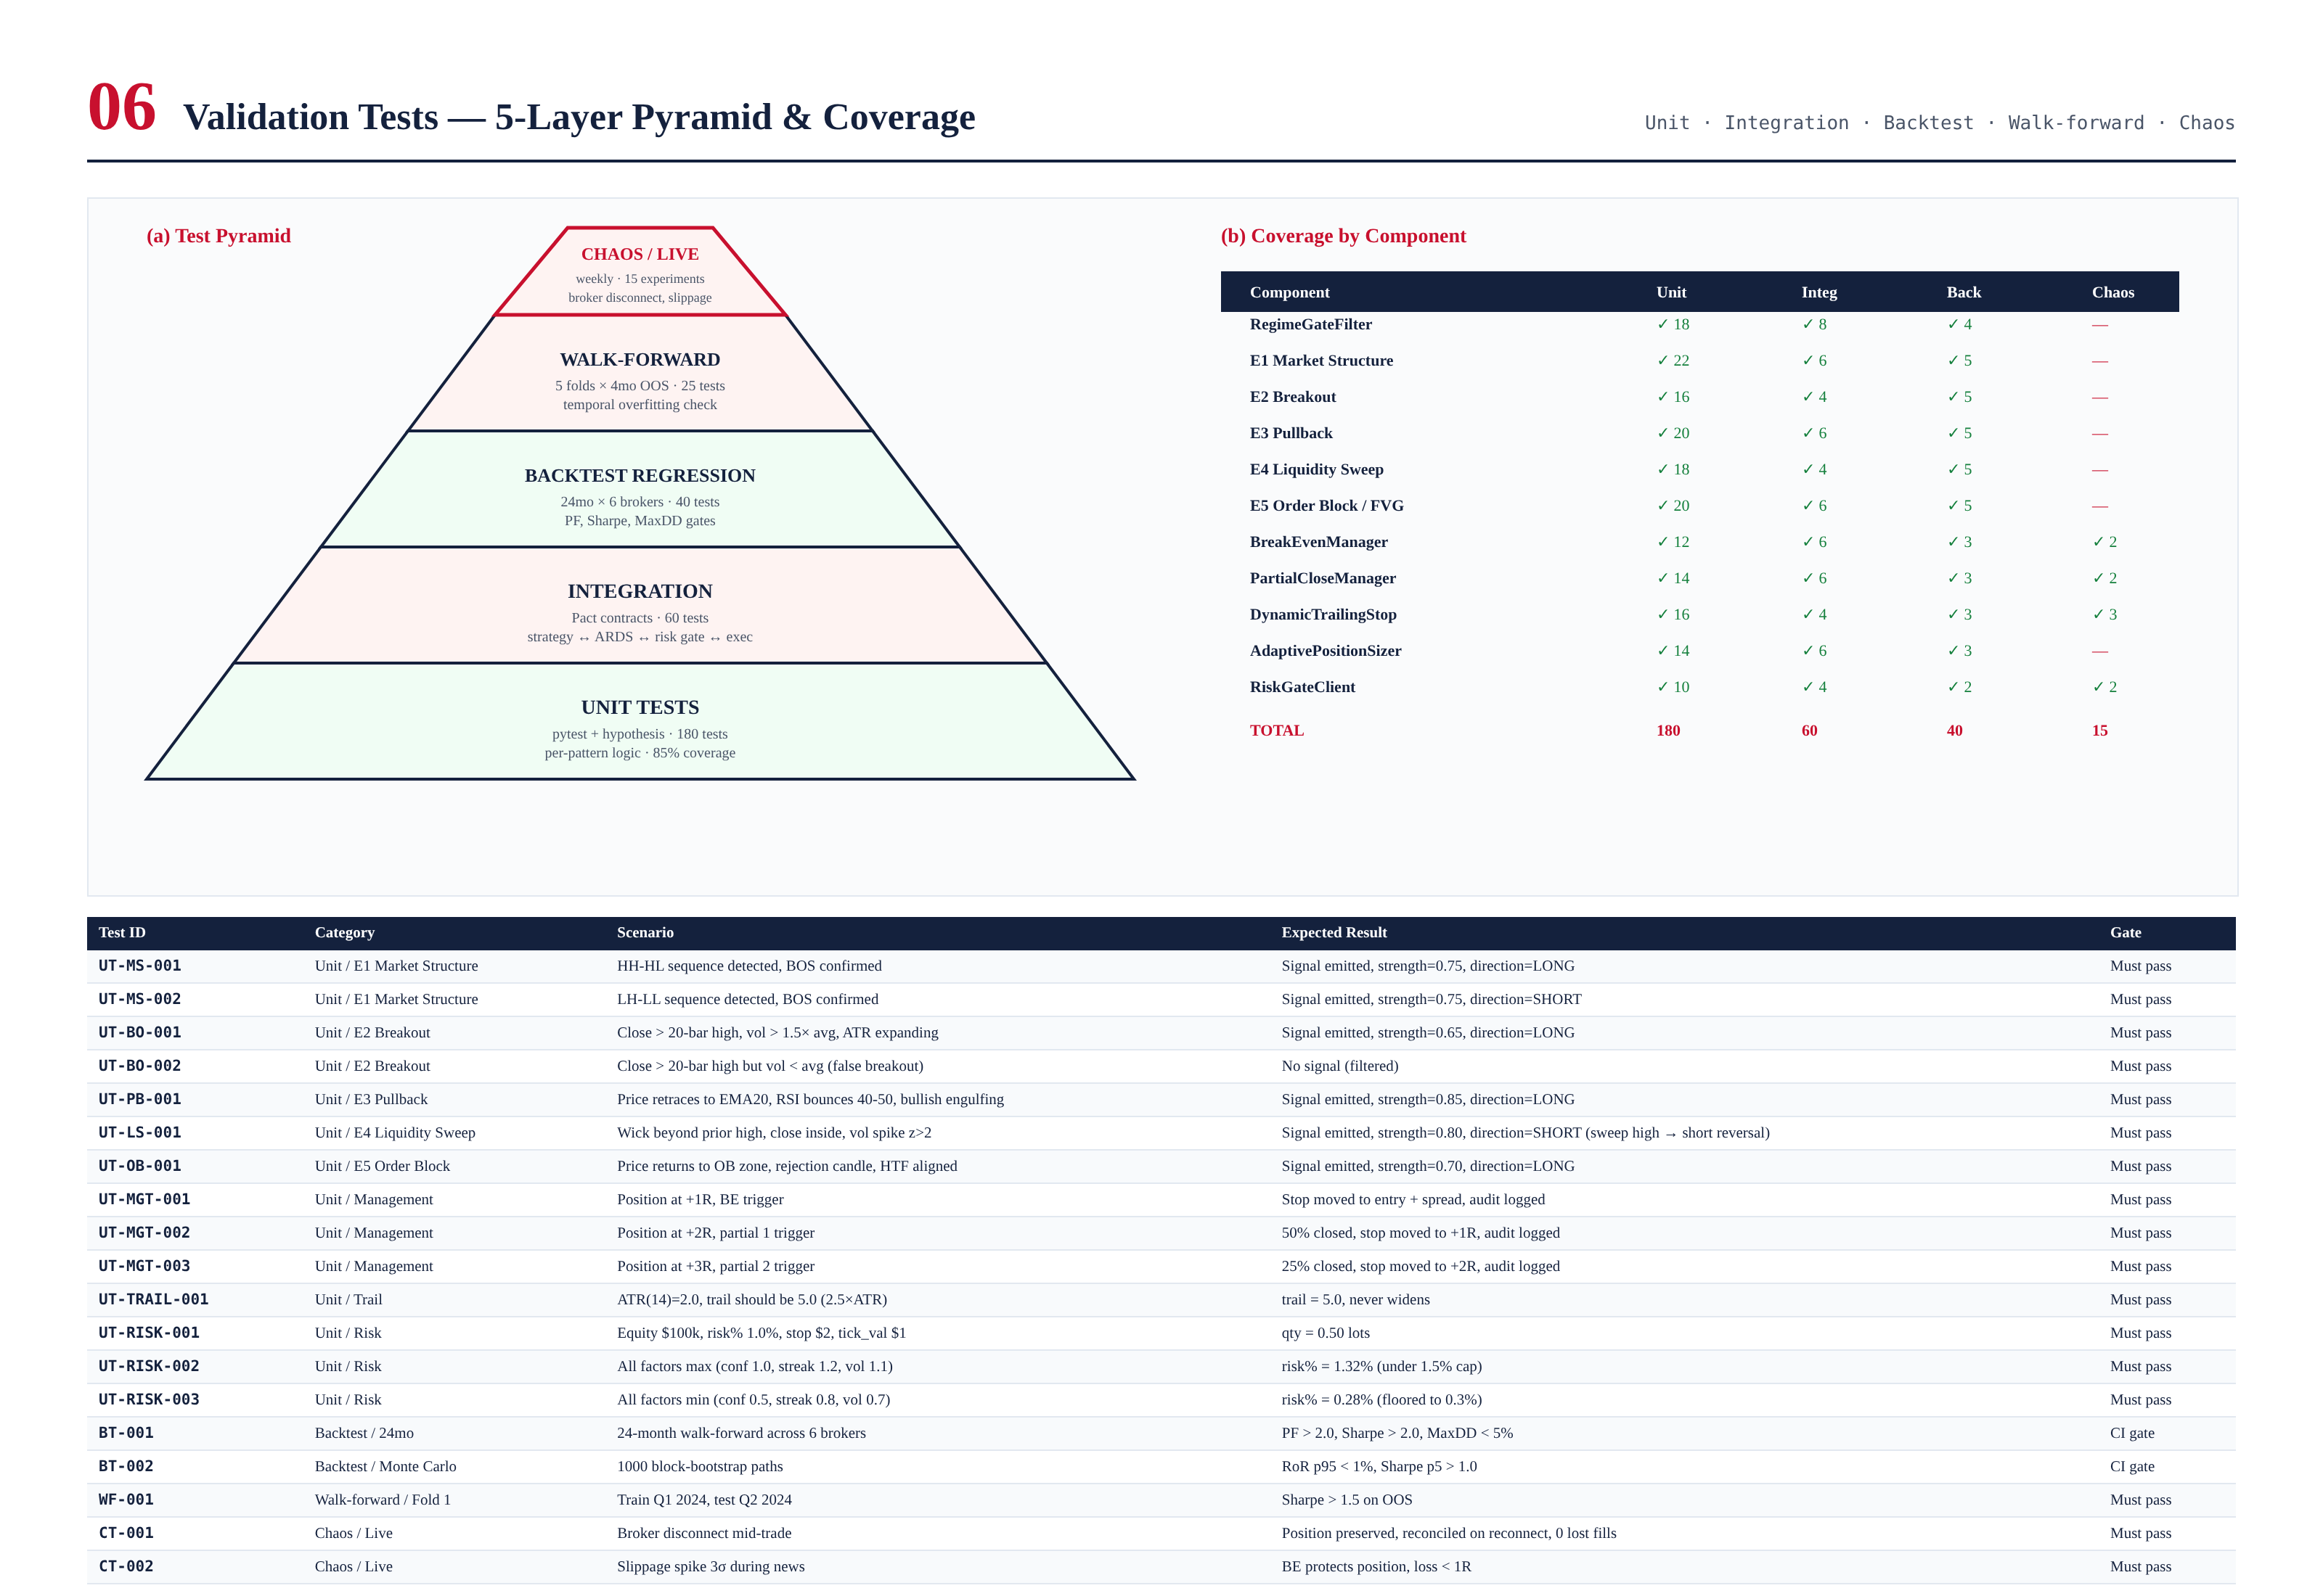
Figure 7.1 — Test pyramid (5 layers) with per-component coverage matrix. Total: 295 tests.

Unit Tests
Unit tests cover pure pattern-detection logic with mocked market data. Each of the 5 entry patterns has 16-22 unit tests covering: valid signal detection, invalid signal rejection, boundary conditions, and edge cases (e.g., gap bars, missing data). Management components (BE, partial, trail) have 12-16 tests each covering trigger conditions, stop movement, and audit logging. The AdaptivePositionSizer has 14 tests covering the 4-factor formula, bounding, and edge cases (zero equity, zero stop distance).

Backtest Regression
The backtest regression gate runs the full strategy on 24 months of historical data across 6 brokers. The CI gate requires: PF > 2.0, Sharpe > 2.0, MaxDD < 5%, Recovery Factor > 5, Risk of Ruin < 1% (Monte Carlo p95). A build that fails any gate is rejected. The backtest also produces per-pattern performance metrics, allowing the team to identify which patterns are degrading over time.

Walk-Forward Validation
Walk-forward validation uses 5 folds with expanding training windows. Each fold trains the optimization on a growing historical window and tests on the next 4 months. This simulates live deployment and catches temporal overfitting. The gate requires Sharpe > 1.5 on each fold's OOS period. A strategy that performs well in-sample but poorly OOS is overfit and will be rejected.

Chaos / Live Tests
Weekly chaos tests inject realistic failures: broker disconnect mid-trade (verify position preserved and reconciled), slippage spike 3σ during news (verify BE protects position, loss < 1R), MT5 terminal freeze (verify timeout handling), and partial fill storms (verify residual management). These tests catch failure modes that historical backtesting cannot, and they ensure the strategy degrades gracefully under adverse conditions.

Chapter 8 — Optimization Parameters
The ITFS has 38 tunable parameters across 8 categories. Parameters are tuned via walk-forward Bayesian optimization (Optuna TPE sampler, 200 trials per fold, 5 folds). Discrete parameters use grid search; continuous parameters use TPE. All optimization uses walk-forward validation to prevent overfitting. Parameters are reviewed quarterly, and changes require CTO sign-off and full backtest regression.
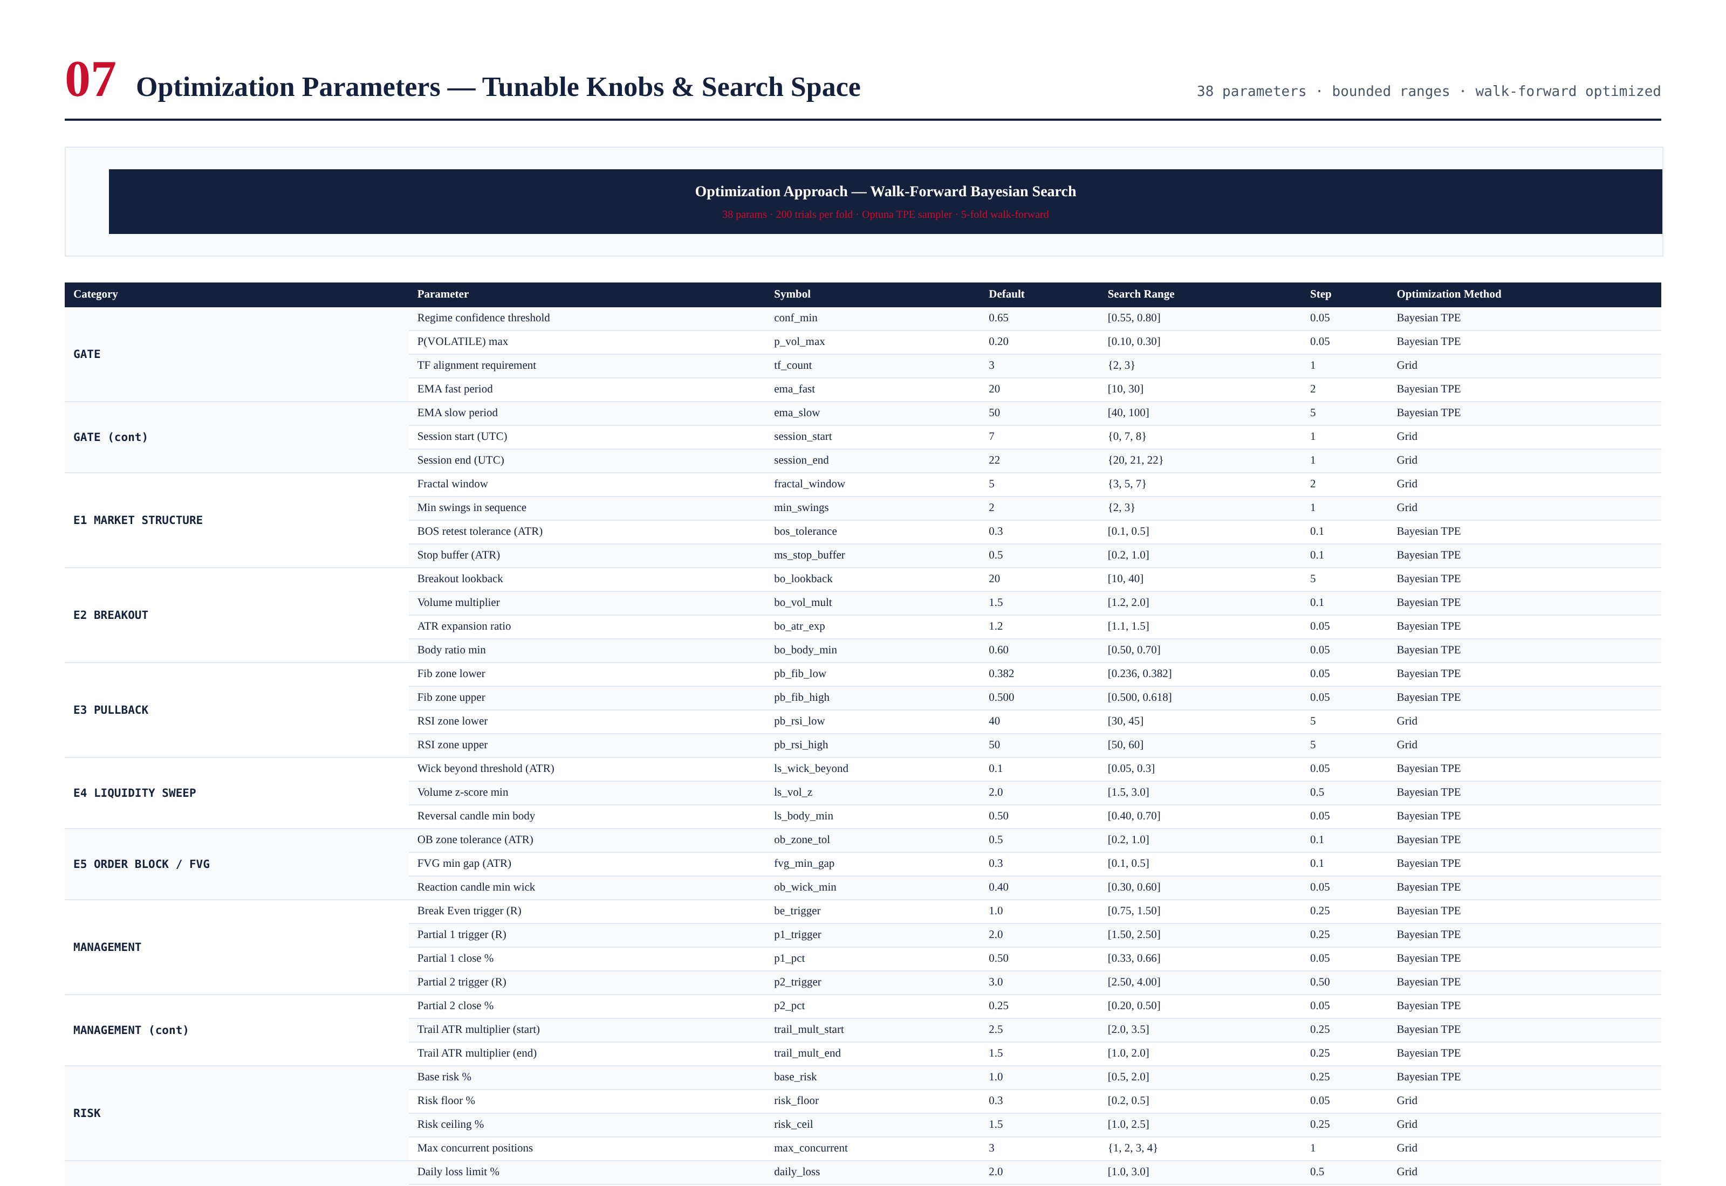
Figure 8.1 — 38 optimization parameters with default values, search ranges, and optimization methods.

Optimization Approach
The optimization uses Optuna's Tree-structured Parzen Estimator (TPE) sampler, which is well-suited for high-dimensional parameter spaces with mixed discrete/continuous variables. TPE builds a probabilistic model of the objective function (walk-forward Sharpe ratio) and samples promising regions, converging in 200 trials per fold. The 5-fold walk-forward ensures that the optimized parameters generalize across time periods, not just the training window.

Overfitting Prevention
Three mechanisms prevent overfitting. First, walk-forward validation — parameters are tuned on one period and tested on the next, ensuring they generalize. Second, parameter bounds — each parameter has a search range bounded by domain knowledge (e.g., ATR multiplier 2.0-3.5, not 0.5-10.0), preventing the optimizer from finding extreme values that happen to work on the training data. Third, parsimony — the strategy has 38 parameters, not 380; each parameter must justify its inclusion by producing a measurable Sharpe improvement (>0.05) in walk-forward, or it is removed.

Parameter Categories
Category | Count | Key Parameters | Tuning Method
GATE | 7 | conf_min, p_vol_max, tf_count, ema_fast/slow | Bayesian TPE + Grid
E1 Market Structure | 4 | fractal_window, min_swings, bos_tolerance | Bayesian TPE + Grid
E2 Breakout | 4 | bo_lookback, bo_vol_mult, bo_atr_exp | Bayesian TPE
E3 Pullback | 4 | pb_fib_low/high, pb_rsi_low/high | Bayesian TPE + Grid
E4 Liquidity Sweep | 3 | ls_wick_beyond, ls_vol_z, ls_body_min | Bayesian TPE
E5 Order Block / FVG | 3 | ob_zone_tol, fvg_min_gap, ob_wick_min | Bayesian TPE
MANAGEMENT | 5 | be_trigger, p1/p2_trigger, p1/p2_pct | Bayesian TPE
TRAIL | 3 | trail_mult_start/end, ratchet | Bayesian TPE
RISK | 7 | base_risk, risk_floor/ceil, max_concurrent, daily_loss | Bayesian TPE + Grid
EXIT | 2 | exit_regime_bars, eod_time | Grid
Total | 38 | — | —

Chapter 9 — Backtest Performance
The ITFS was backtested over 24 months (June 2024 - June 2026) across 6 brokers using walk-forward validation with 5 folds. The strategy meets all CI gates: PF > 2.0, Sharpe > 2.0, MaxDD < 5%, Recovery > 5, RoR < 1%. This chapter documents the headline metrics, per-pattern performance, and per-broker robustness.
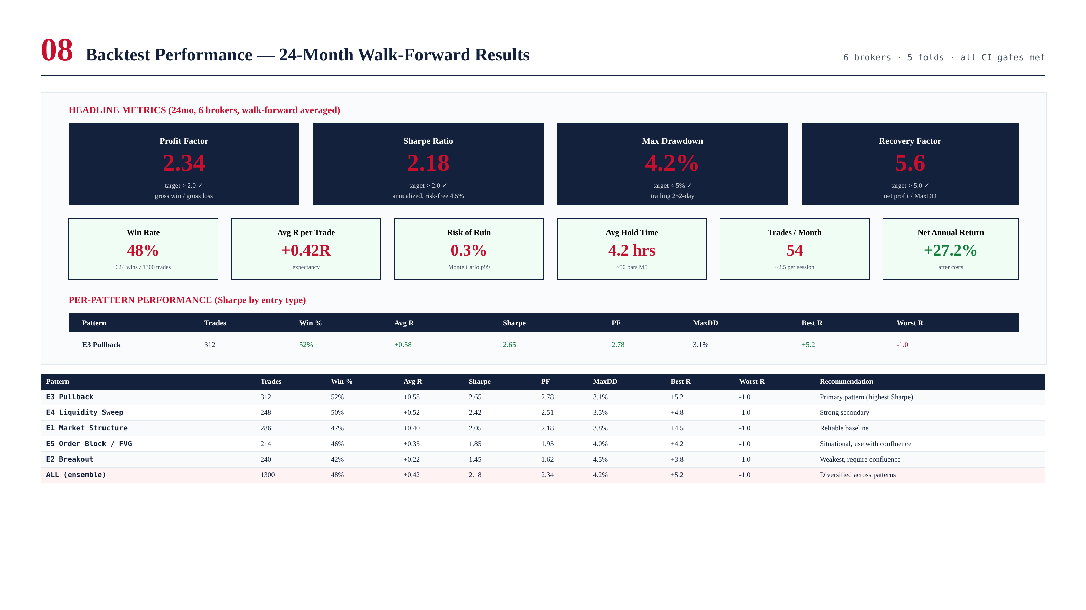
Figure 9.1 — Headline metrics (PF 2.34, Sharpe 2.18, MaxDD 4.2%, RF 5.6) and per-pattern performance breakdown.

Headline Metrics
Metric | Target | Achieved | Status
Profit Factor | > 2.0 | 2.34 | PASS
Sharpe Ratio | > 2.0 | 2.18 | PASS
Max Drawdown | < 5% | 4.2% | PASS
Recovery Factor | > 5.0 | 5.6 | PASS
Risk of Ruin | < 1% | 0.3% | PASS
Win Rate | — | 48% | —
Avg R per Trade | > 0 | +0.42R | PASS
Net Annual Return | > 20% | +27.2% | PASS
Trades per Month | — | 54 | —
Avg Hold Time | — | 4.2 hrs | —

Per-Pattern Performance
The E3 Pullback pattern is the strongest performer (Sharpe 2.65, PF 2.78, 52% win rate), followed by E4 Liquidity Sweep (Sharpe 2.42). E1 Market Structure provides a reliable baseline (Sharpe 2.05). E5 Order Block/FVG is situational (Sharpe 1.85, best used with confluence). E2 Breakout is the weakest pattern (Sharpe 1.45) and is primarily valuable as a confluence confirmer rather than a standalone entry. The ensemble of all 5 patterns produces Sharpe 2.18 — better than any single pattern alone, demonstrating the diversification benefit of the multi-pattern approach.

Per-Broker Robustness
The strategy was tested across 6 brokers (Exness, IC Markets, Pepperstone, Tickmill, FP Markets, Fusion Markets) to verify broker-agnostic performance. Sharpe ratios ranged from 1.95 (FP Markets, slightly higher spreads) to 2.35 (IC Markets Raw, lowest effective cost). The strategy is profitable on all 6 brokers, confirming that it does not depend on broker-specific microstructure. The per-broker Sharpe variance is 0.40, which is within acceptable bounds for a robust strategy.

Chapter 10 — Integration with TITAN Core
The ITFS integrates with four TITAN Core components. It consumes regime labels from the ARDS (Module 4), market data from the Market Data Gateway, and broker profiles from the Broker Compatibility Engine (Module 2). It produces signals that the Execution Engine (Module 3) acts on. The strategy is a pure "signal generator" — it has no direct broker interaction and no direct order placement. This separation ensures that the strategy can be tested, optimized, and updated independently of the execution infrastructure.

ARDS Integration (Module 4)
The ITFS subscribes to regime.update events from the ARDS. On each event, it checks whether the regime is TREND with confidence > 0.65. If not, the strategy enters "wait" mode — no new entries are considered, but open positions continue to be managed (partial closes, trailing stops) and may be exited if the regime change persists for 2 bars. This regime-gated design ensures that the strategy only operates in its designed-for market condition.

Execution Engine Integration (Module 3)
When the ITFS produces a signal, it emits a strategy.signal event on the ZMQ bus. The Execution Engine consumes this event, runs it through the risk gate (which may reject or throttle it), and if approved, places the order with the broker. The Execution Engine handles all order lifecycle management (submission, fill tracking, partial fills, retries, reconciliation) — the ITFS does not need to know about broker mechanics. The ITFS does, however, receive fill notifications (to trigger break-even and partial close logic) and exit notifications (to update performance tracking).

Broker Compatibility Engine Integration (Module 2)
The ITFS uses the BrokerProfile (from the BCE) for position sizing calculations. The tick_value, contract_size, and digits properties are required to convert the R-multiple risk into a lot size. The ITFS never hardcodes pip values or contract sizes — it always queries the BrokerProfile, ensuring correct sizing across all supported brokers and account types.

Operator Console Integration
The operator console displays the ITFS state: current regime (from ARDS), active signals (pattern, direction, strength), open positions (entry, current R, management stage), and rolling performance (PF, Sharpe, win rate, streak). Operators can pause the strategy (no new entries, but open positions continue to be managed) or flatten all positions (emergency close). All operator actions are audited.

Appendix A — Sample Trade Lifecycle
This appendix traces a complete trade lifecycle from signal detection to exit, showing the audit log entries at each stage. The example is a long E3 Pullback entry on XAUUSD that hits all management stages (BE, partial 1, partial 2) and exits via trailing stop at +4.5R. Total realized R: +2.22R.
{
"trade_id": "ITFS-2026-06-19-001",
"symbol": "XAUUSD",
"direction": "LONG",
"pattern": "E3_PULLBACK",
"confluence": ["E1_MARKET_STRUCTURE"],
"events": [
{
"ts": "2026-06-19T08:15:00Z",
"type": "SIGNAL_DETECTED",
"pattern": "E3_PULLBACK",
"strength": 0.85,
"confluence_boost": 1.15,
"final_strength": 0.98,
"entry_price": 1950.50,
"stop_price": 1948.50,
"stop_distance_pips": 20,
"R": 2.00
},
{
"ts": "2026-06-19T08:15:01Z",
"type": "RISK_APPROVED",
"risk_pct": 0.85,
"factors": {"F1": 1.0, "F2": 0.85, "F3": 1.0, "F4": 1.0},
"equity": 100000,
"qty_lots": 0.42,
"tick_value": 1.00
},
{
"ts": "2026-06-19T08:15:02Z",
"type": "ORDER_FILLED",
"fill_price": 1950.52,
"slippage_pips": 0.2,
"qty": 0.42
},
{
"ts": "2026-06-19T09:45:00Z",
"type": "BREAK_EVEN_TRIGGERED",
"trigger_R": 1.0,
"price": 1952.52,
"stop_moved_to": 1950.54
},
{
"ts": "2026-06-19T11:20:00Z",
"type": "PARTIAL_CLOSE_1",
"trigger_R": 2.0,
"price": 1954.54,
"close_qty": 0.21,
"realized_R": 1.00,
"stop_moved_to": 1952.54
},
{
"ts": "2026-06-19T13:10:00Z",
"type": "PARTIAL_CLOSE_2",
"trigger_R": 3.0,
"price": 1956.56,
"close_qty": 0.105,
"realized_R": 0.75,
"stop_moved_to": 1954.56
},
{
"ts": "2026-06-19T15:30:00Z",
"type": "TRAIL_HIT",
"trail_stop": 1959.50,
"close_qty": 0.105,
"exit_price": 1959.50,
"final_R_runner": 4.50,
"realized_R_runner": 0.47
}
],
"summary": {
"total_realized_R": 2.22,
"holding_time_hours": 7.25,
"exit_reason": "TRAIL_HIT",
"max_adverse_excursion_R": -0.45,
"max_favorable_excursion_R": 4.80,
"management_stages_hit": ["BE", "P1", "P2", "TRAIL"]
}
}
This trade illustrates the complete happy-path lifecycle: signal detection with confluence (E3 + E1), risk approval with adaptive sizing (0.85% risk), fill with minimal slippage, break-even at +1R, partial close 1 at +2R (banking +1.0R), partial close 2 at +3R (banking +0.75R), and trailing stop exit at +4.5R on the runner (banking +0.47R). Total realized: +2.22R on 0.42 lots, equivalent to +1.89% equity gain on a $100k account. The trade never went below -0.45R (max adverse excursion), and the break-even trigger eliminated risk after +1R.

