TITAN · QUANT RESEARCH
TITAN XAU AI
INSTITUTIONAL TRADING SYSTEMS
M O D U L E 1 8 · M E T A A I C E O
Meta AI CEO Supervisor
Governance layer that monitors all models, detects degradation, drift, overfitting and instability, scores system health, and takes control actions. Does NOT generate signals. 6 health scores · 8 detectors · 4 rolling windows (50/100/250/500 trades) · GREEN/YELLOW/RED status · 5 control actions. CPU-only · fully offline · no paid APIs · no external LLM.
KEY FEATURES
Feature | Value
Health scores | 6 (Model / EQS / Risk / BQS / Regime / Overall)
Detectors | 8 (degradation · drift · instability · overfitting · exec · broker · regime · latency)
Control actions | 5 (reduce / increase influence, disable, emergency, capital preservation)
Rolling windows | 4 sizes (50/100/250/500 trades) × 8 metrics
Tests | 145 (80 unit + 45 integration + 20 validator)
Hard constraints | CPU-only · fully offline · no paid APIs · no external LLM

Prepared by TITAN Quant Research
Reviewed by CTO · Head of AI · Risk Officer · Compliance
Classification GOVERNANCE — INTERNAL DISTRIBUTION
Version v1.0 · 19 June 2026

Table of Contents
Right-click the table below and choose “Update Field” to refresh page numbers.

Chapter 1 — Executive Summary
The Meta AI CEO Supervisor (Module 18) is a governance layer that sits ABOVE the existing TITAN XAU AI trading system. It does NOT generate trading signals — its sole purpose is to monitor, score, and govern the models, execution, risk, brokers, and regime detection that constitute the trading pipeline. The CEO observes all model predictions (XGBoost, LSTM, Transformer, RL), trade outcomes, and system metrics in real-time, computes 6 composite health scores every 60 seconds, runs 8 statistical detectors to identify degradation, drift, overfitting, instability, execution issues, broker problems, regime failures and latency breaches, and takes 5 automated control actions: reduce model influence, increase model influence, disable failing model, trigger emergency risk reduction, and trigger capital preservation mode.
The CEO layer addresses a gap in the existing TITAN architecture: while the system has 5 validation frameworks (Backtest, Walk-Forward, Monte Carlo, Stress, Validator) that gate pre-deployment, there is no runtime governance layer that continuously monitors live performance and takes corrective action when models degrade, brokers fail, or regimes shift. The CEO fills this gap. It uses 4 rolling windows (50/100/250/500 trades) to provide multi-scale views — short-term sensitivity (50 trades) for acute detection, long-term stability (500 trades) for structural drift. The 8 detectors use only NumPy vectorized statistical operations (PSI, ratio comparisons, consecutive-loss counting, IS-OOS gap) — no GPU, no external LLM, no paid API. Fully offline-capable: the CEO operates normally with zero outbound network.
The CEO’s 6 health scores are: Model Health Score (per model, from Sharpe / Sortino / PF / WR / MDD / Recovery across 4 windows), Execution Quality Score (system-wide, from latency / slippage / fill-rate), Risk Score (inverted, from MDD / exposure / margin / risk-utilization), Broker Quality Score (per broker, from spread-dev / slippage-dev / fill-rate / reconnect), Regime Confidence Score (from vote-agreement / transition-conf / regime-strategy-perf), and Overall System Health (weighted aggregate, min-model-health weighted highest at 30%). Each score is 0–100 with GREEN (≥85) / YELLOW (70–84) / RED (<70) thresholds. The Overall System Health drives the system status: GREEN = live trading, YELLOW = reduced size + defensive, RED = halt + emergency flatten + 24h capital preservation.
This document delivers everything required for implementation: architecture (8 layers), classes (16 Python classes), interfaces (5 ABCs), database schema (10 PostgreSQL tables with TimescaleDB hypertables), unit tests (80 tests), integration tests (45 tests), validator tests (20 tests), and deployment documentation (10-step guide). The CEO is designed to be a drop-in addition to the existing TITAN stack — it subscribes to existing NATS topics, writes to a new PostgreSQL database, and controls existing modules (ensemble voter, risk engine, execution engine) via well-defined interfaces. No existing module needs modification — the CEO observes via subscriptions and controls via interface calls.

Chapter 2 — Architecture Overview
The CEO is organized into 8 layers: Ingestion (subscribes to NATS), Rolling Windows (4 ring buffers per model per metric), Health Scoring (6 composite scores), Detection (8 statistical detectors), Decision (GREEN/YELLOW/RED status), Action (5 control actions), Persistence (PostgreSQL + Parquet), and Reporting (Prometheus + Grafana + PagerDuty + Slack). Each layer is independent, testable, and horizontally scalable. The CEO runs as a single asyncio process with a 60-second cycle: ingest → update windows → compute scores → run detectors → decide status → execute actions → persist → report. Total cycle time: <100ms on a 4-vCPU VPS.

Figure 2.1 — CEO architecture: 8 layers sitting above the existing TITAN stack. The CEO reads from below and writes control actions down.

4 Hard Constraints
The CEO operates under 4 non-negotiable constraints. (1) No paid APIs — all inputs come from internal NATS topics; no external paid data sources are permitted. (2) No external LLM dependency — no OpenAI, Anthropic, or any-LLM calls. All detection is statistical (NumPy). The CEO must operate even if every external AI service is down. (3) CPU optimized — NumPy vectorized operations, single-core <100ms per cycle, no GPU required. The CEO runs on the same 4-vCPU VPS as the trading core. (4) Fully offline capable — no outbound network required for core operation. Optional egress only for PagerDuty / Slack alerts, which degrade gracefully (queued locally, retried) if the network is unavailable.

Chapter 3 — Rolling Windows — 4 Sizes × 8 Metrics
The CEO maintains 4 rolling windows per model per metric: W50 (50 trades, ~1 week, acute / tactical), W100 (100 trades, ~2 weeks, confirmation), W250 (250 trades, ~1 month, strategic baseline), and W500 (500 trades, ~2 months, structural). Each window is a bounded ring buffer (collections.deque with maxlen) — O(1) push, O(N) iteration, no unbounded growth. Total memory: 4 models × 8 metrics × 4 windows × max_size = 28,800 floats ≈ 230 KB. Negligible.
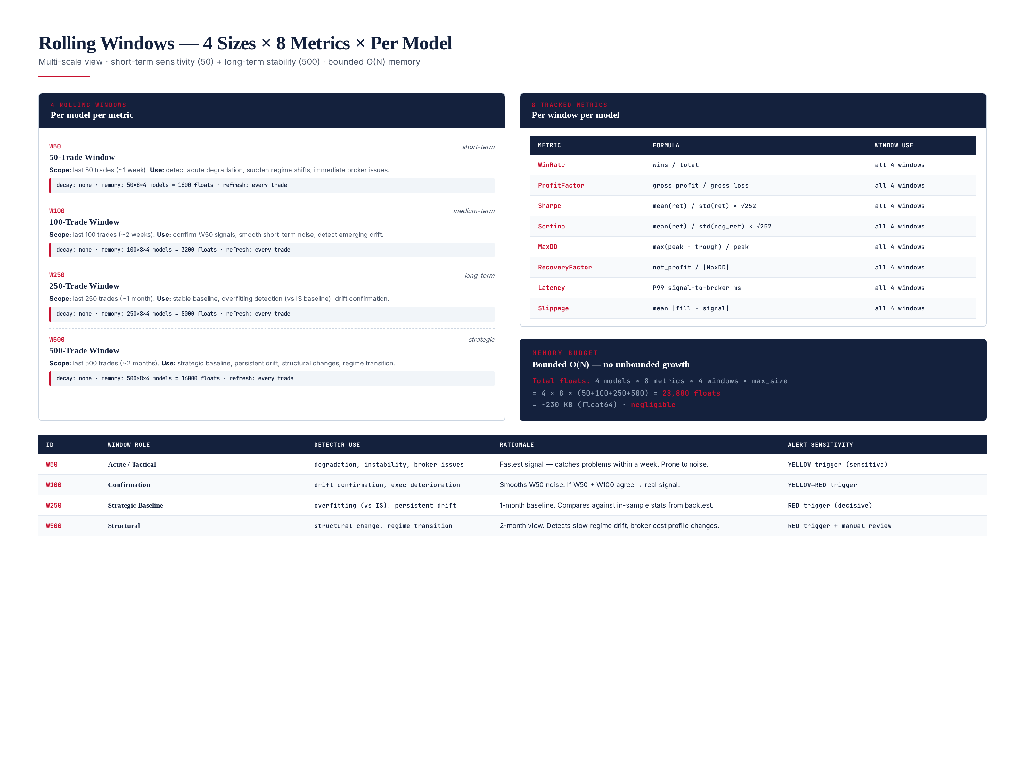
Figure 3.1 — 4 rolling windows (50/100/250/500) × 8 metrics (WR/PF/Sharpe/Sortino/MDD/Recovery/Latency/Slippage), per model.

8 Tracked Metrics
Each window tracks 8 metrics: Win Rate (wins / total), Profit Factor (gross_profit / gross_loss), Sharpe (mean(ret) / std(ret) × √252), Sortino (mean(ret) / std(neg_ret) × √252), Max Drawdown (max(peak − trough) / peak), Recovery Factor (net_profit / |MaxDD|), Latency (P99 signal-to-broker ms), and Slippage (mean |fill − signal|). These 8 metrics cover the full performance surface: return (WR, PF), risk-adjusted return (Sharpe, Sortino), capital preservation (MDD, Recovery), and execution quality (Latency, Slippage). All are computed from the trade ledger and execution telemetry that the CEO ingests from NATS.

Window Roles
Window | Role | Detector Use | Alert Sensitivity
W50 | Acute / Tactical | degradation, instability, broker issues | YELLOW trigger (sensitive)
W100 | Confirmation | drift confirmation, exec deterioration | YELLOW → RED trigger
W250 | Strategic Baseline | overfitting (vs IS), persistent drift | RED trigger (decisive)
W500 | Structural | structural change, regime transition | RED trigger + manual review

Chapter 4 — 6 Health Scores
The CEO computes 6 health scores every cycle. Five are sub-scores (Model Health per model, Execution Quality system-wide, Risk system-wide, Broker Quality per broker, Regime Confidence system-wide) and one is the aggregate (Overall System Health). Each score is 0–100 with GREEN (≥85) / YELLOW (70–84) / RED (<70) thresholds. The Overall System Health is a weighted aggregate where min(ModelHealth) is weighted highest at 30% — a single failing model can drag down the overall score, because one degraded model in a 4-model ensemble is a systemic risk.
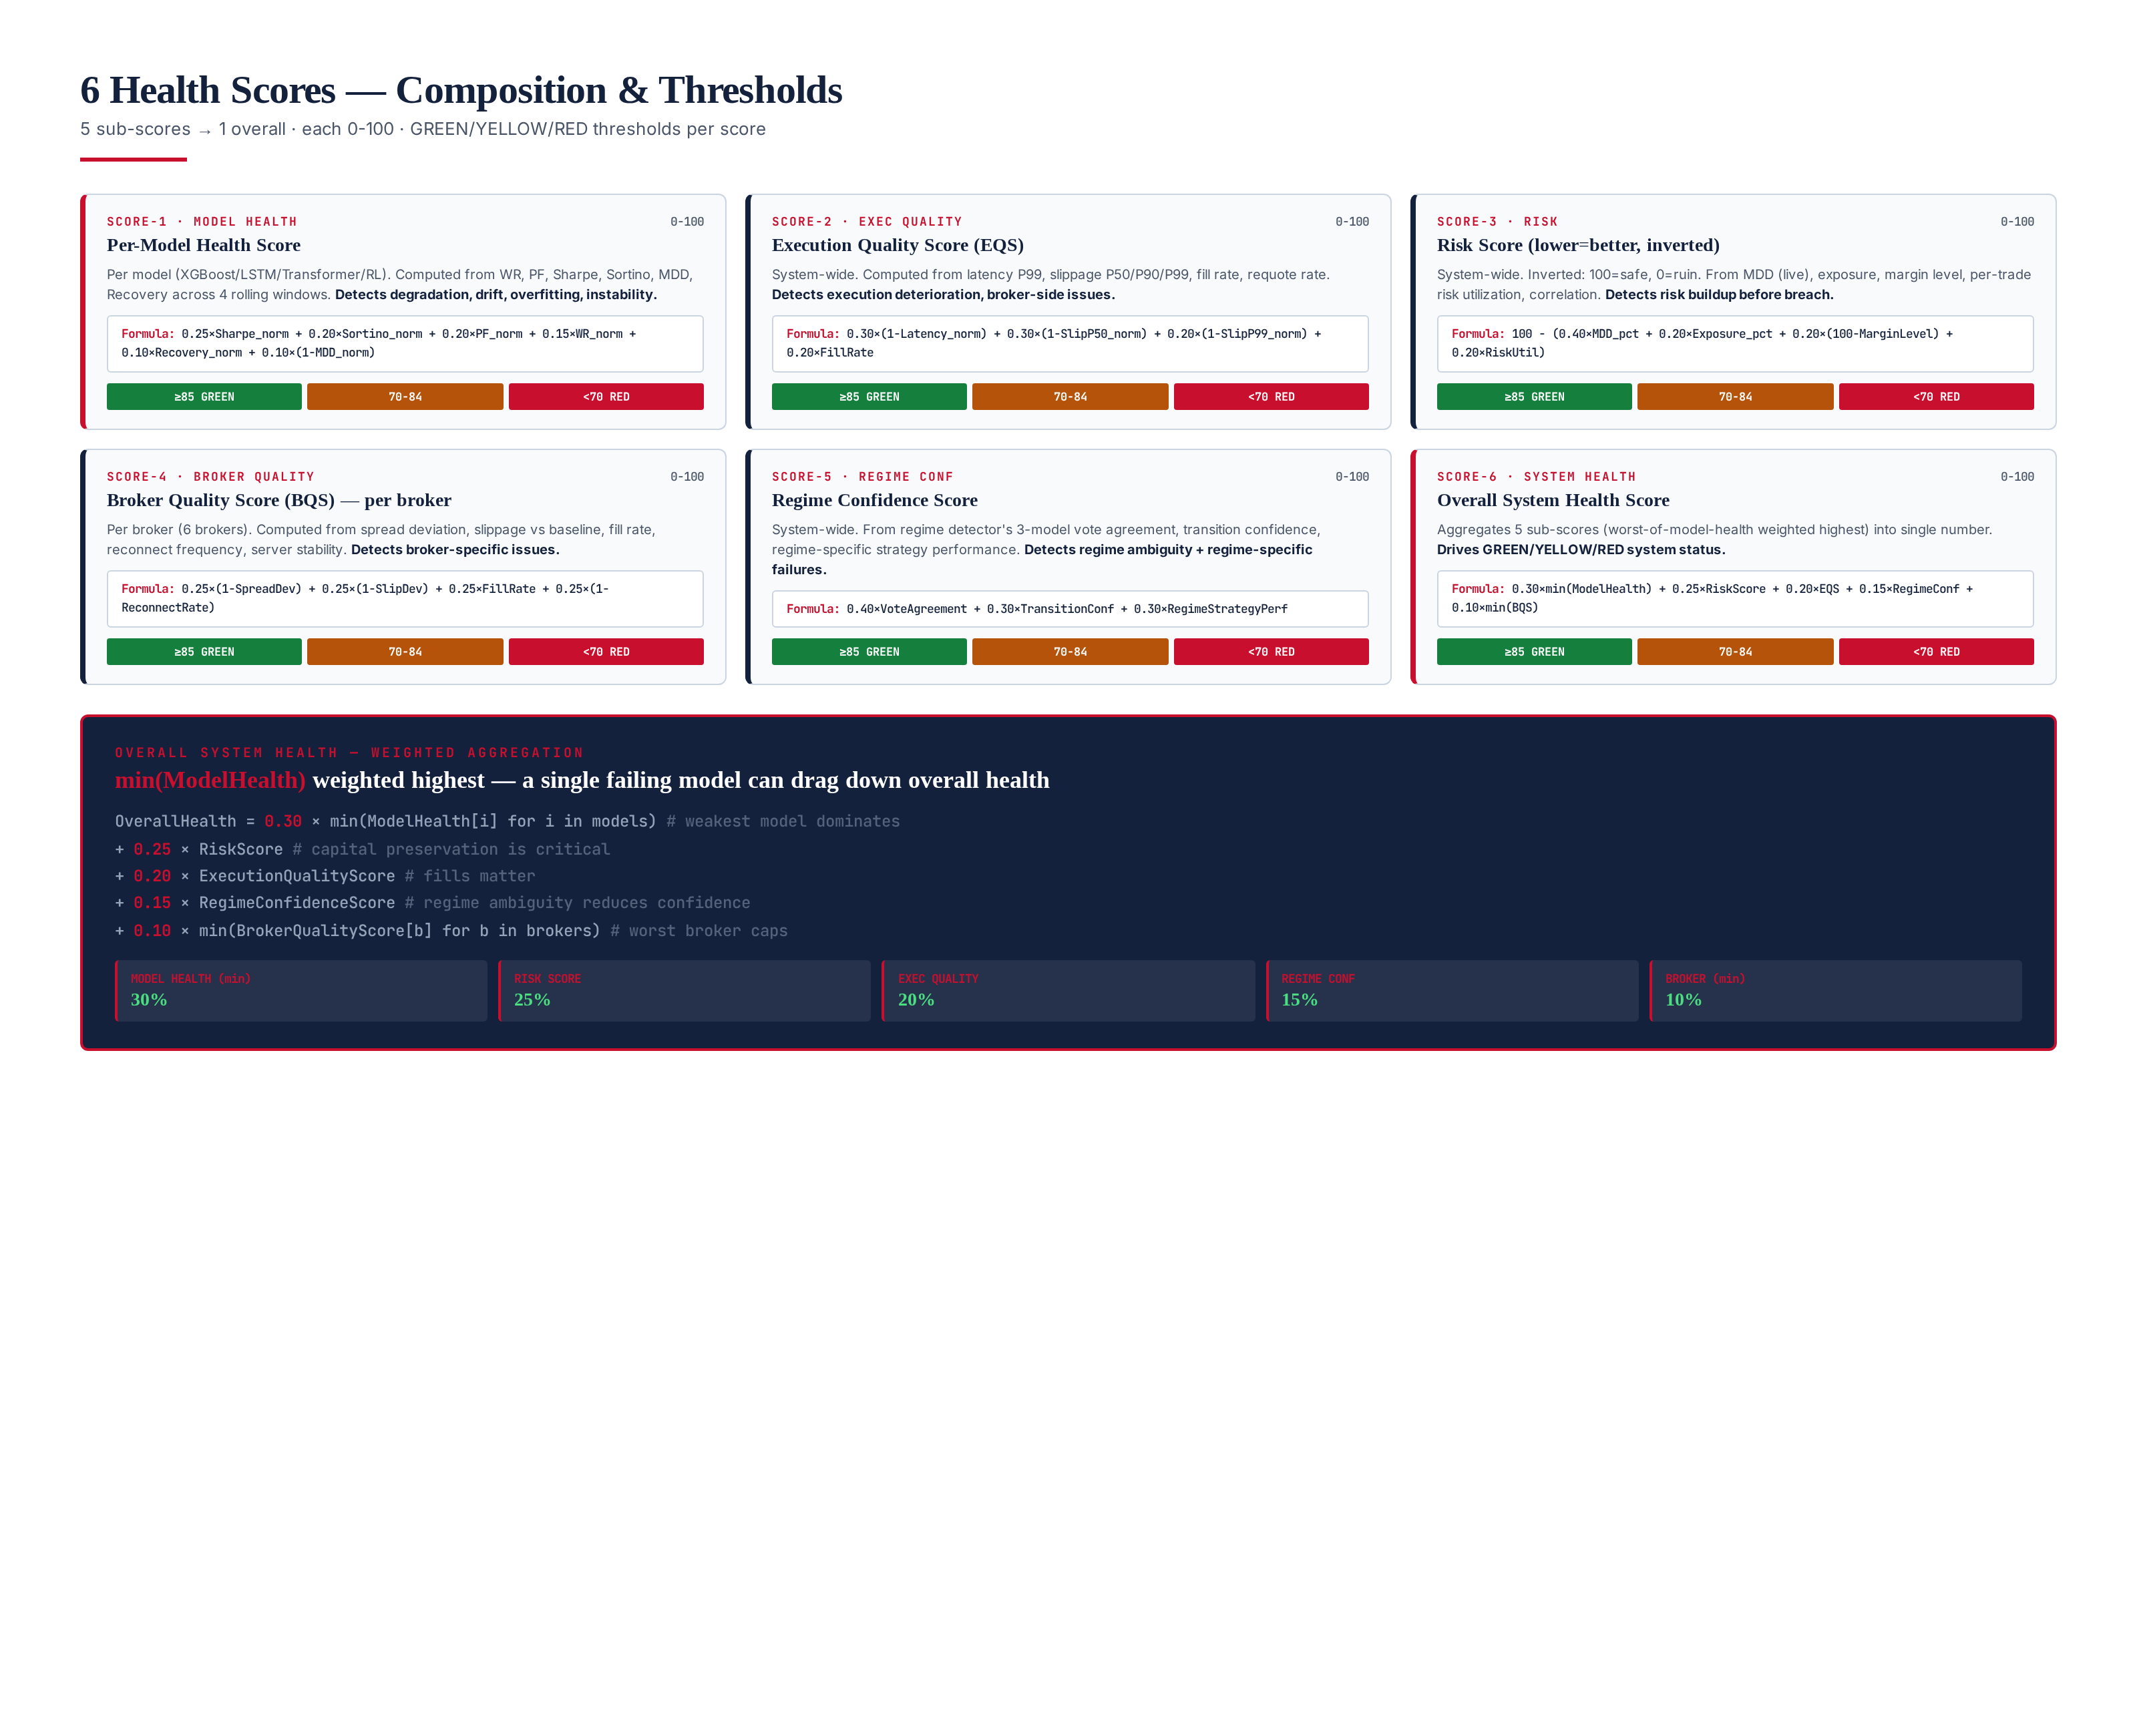
Figure 4.1 — 6 health scores with formulas, thresholds, and weighted aggregation.

Score Composition
Model Health Score (per model): 0.25×Sharpe_norm + 0.20×Sortino_norm + 0.20×PF_norm + 0.15×WR_norm + 0.10×Recovery_norm + 0.10×(1−MDD_norm). Computed from the W250 rolling window, normalized against the model’s backtest baseline. Detects degradation, drift, overfitting and instability. Execution Quality Score (EQS): 0.30×(1−Latency_norm) + 0.30×(1−SlipP50_norm) + 0.20×(1−SlipP99_norm) + 0.20×FillRate. System-wide. Detects execution deterioration.
Risk Score (inverted, 100 = safe): 100 − (0.40×MDD_pct + 0.20×Exposure_pct + 0.20×(100−MarginLevel) + 0.20×RiskUtil). Lower MDD / exposure = higher score. Detects risk buildup before breach. Broker Quality Score (BQS, per broker): 0.25×(1−SpreadDev) + 0.25×(1−SlipDev) + 0.25×FillRate + 0.25×(1−ReconnectRate). Detects broker-specific issues. Regime Confidence Score: 0.40×VoteAgreement + 0.30×TransitionConf + 0.30×RegimeStrategyPerf. Detects regime ambiguity and regime-specific failures.
Overall System Health: 0.30×min(ModelHealth) + 0.25×RiskScore + 0.20×EQS + 0.15×RegimeConf + 0.10×min(BQS). The min() operators ensure that the worst-performing model and worst-performing broker cap the overall score — a single failure cannot be masked by strong performance elsewhere.

Chapter 5 — Detection Layer — 8 Detectors
The CEO runs 8 statistical detectors every 60 seconds. All use only NumPy vectorized operations — no GPU, no external API, no LLM. Total CPU time per cycle: <100ms on a single core. The detectors are implemented as interchangeable IDetectionRule instances (Strategy pattern), registered with the DetectionEngine at startup. Each detector returns a DetectionEvent (with severity CRITICAL / MAJOR / MINOR) or None.
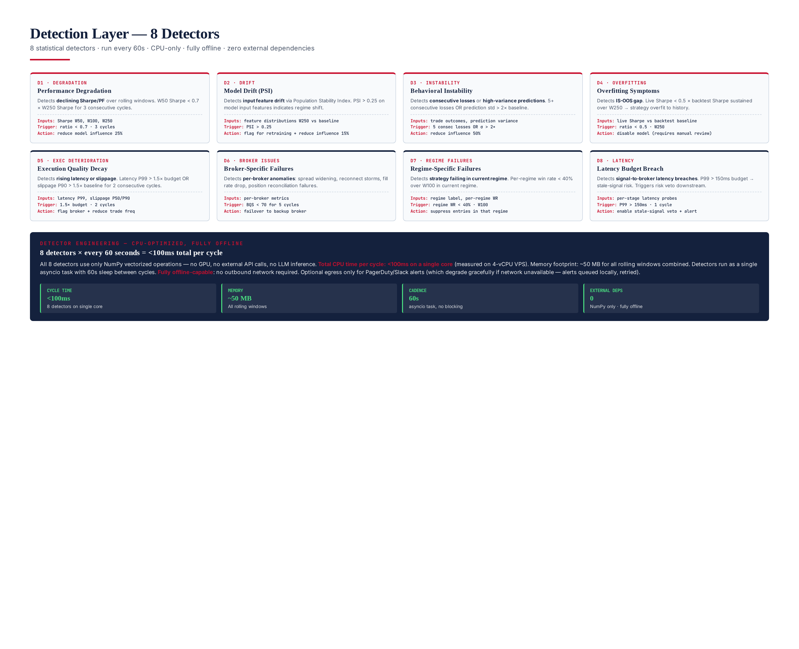
Figure 5.1 — 8 detectors: degradation, drift, instability, overfitting, exec deterioration, broker issues, regime failures, latency.

8 Detectors
- D1 Degradation: W50 Sharpe < 0.7 × W250 Sharpe for 3 consecutive cycles. Action: reduce model influence 25%.
- D2 Drift (PSI): Population Stability Index > 0.25 on model input features (W250 vs baseline). Action: flag for retraining + reduce influence 15%.
- D3 Instability: 5+ consecutive losses OR prediction std > 2× baseline. Action: reduce influence 50%.
- D4 Overfitting: Live Sharpe < 0.5 × backtest Sharpe sustained over W250. Action: disable model (requires manual review).
- D5 Execution Deterioration: Latency P99 > 1.5× budget OR slippage P90 > 1.5× baseline for 2 consecutive cycles. Action: flag broker + reduce trade frequency.
- D6 Broker Issues: BQS < 70 for 5 consecutive cycles. Action: failover to backup broker.
- D7 Regime Failures: Per-regime win rate < 40% over W100 in current regime. Action: suppress entries in that regime.
- D8 Latency: P99 signal-to-broker > 150ms budget. Action: enable stale-signal veto + alert.

Chapter 6 — Decision Layer & Control Actions
The DecisionEngine aggregates the 6 health scores and 8 detector outputs into a single SystemStatus: GREEN (OverallHealth ≥ 85, all sub-scores ≥ 80, 0 critical detectors), YELLOW (OverallHealth 70–84, or any sub-score 70–79, or 1+ non-critical detector), RED (OverallHealth < 70, or RiskScore < 70, or any critical detector, or kill-switch triggered). The ActionEngine executes 5 control actions based on the status: reduce influence (YELLOW), increase influence (GREEN recovery), disable model (RED), emergency risk reduction (RED), and capital preservation (sustained RED > 30 min).
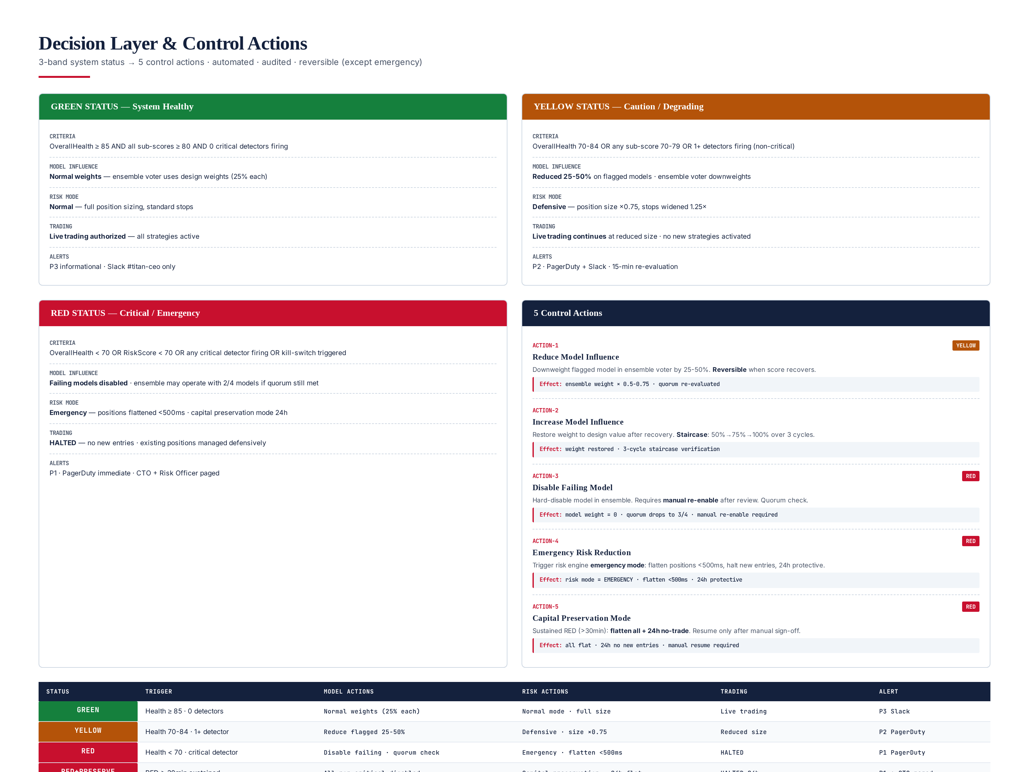
Figure 6.1 — 3-band status (GREEN/YELLOW/RED) → 5 control actions. Automated, audited, reversible (except emergency).

5 Control Actions
ACTION-1 Reduce Model Influence: Downweight the flagged model in the ensemble voter by 25–50%. Reversible when score recovers. Triggered on YELLOW. ACTION-2 Increase Model Influence: Restore weight to design value after recovery. Staircase: 50% → 75% → 100% over 3 cycles. Triggered on GREEN after YELLOW. ACTION-3 Disable Failing Model: Hard-disable the model in the ensemble. Requires manual re-enable after review. Quorum check — if disabling would drop below 2/4 quorum, the CEO escalates to RED instead. Triggered on RED.
ACTION-4 Emergency Risk Reduction: Trigger the risk engine emergency mode: flatten positions < 500ms, halt new entries, 24h protective. Triggered on RED. ACTION-5 Capital Preservation Mode: Sustained RED > 30 min: flatten all + 24h no-trade. Resume only after manual sign-off. Triggered on sustained RED.

Chapter 7 — Classes & Interfaces
The CEO is implemented in Python 3.12 with full mypy --strict typing. 16 classes + 5 interfaces. Design patterns: Strategy (IDetectionRule — 8 interchangeable detectors), Observer (CEOSupervisor subscribes to NATS), Command (ControlAction — serializable), Facade (CEOSupervisor wraps 5 monitors + 3 engines), Repository (Database abstracts persistence), and Factory (DetectionEngine creates detectors from config). Zero external LLM dependency — all detection is statistical (NumPy).
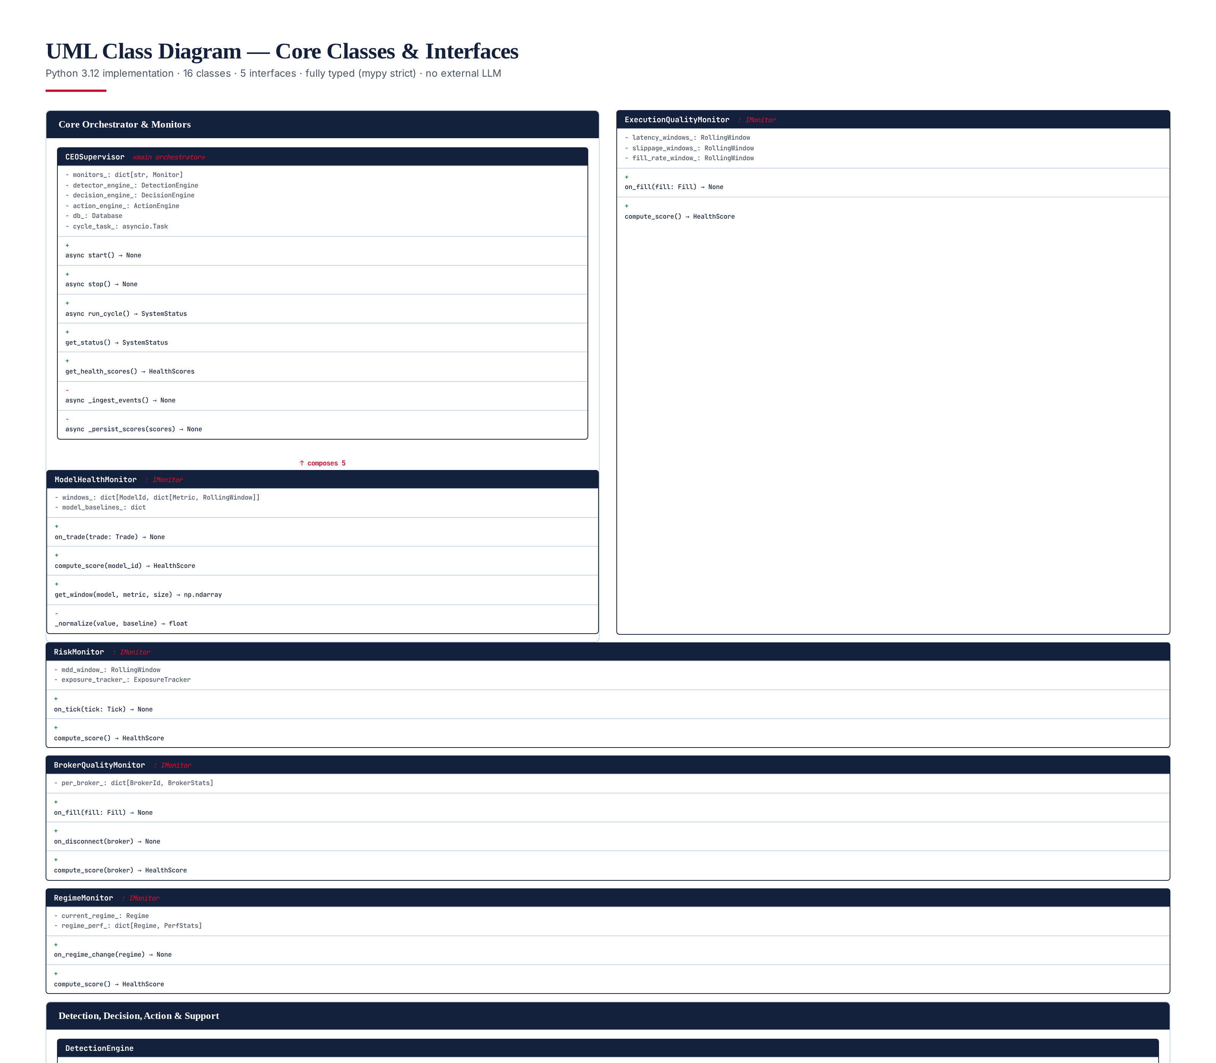
Figure 7.1 — UML class diagram: 16 classes + 5 interfaces. Fully typed (mypy --strict).

Core Class: CEOSupervisor (Python)
from __future__ import annotations
import asyncio
from dataclasses import dataclass
from enum import Enum
from typing import Protocol
class SystemStatus(Enum):
GREEN = "GREEN"
YELLOW = "YELLOW"
RED = "RED"
RED_PRESERVE = "RED_PRESERVE"
class ControlAction(Enum):
REDUCE_INFLUENCE = "REDUCE_INFLUENCE"
INCREASE_INFLUENCE = "INCREASE_INFLUENCE"
DISABLE_MODEL = "DISABLE_MODEL"
EMERGENCY_RISK_REDUCTION = "EMERGENCY_RISK_REDUCTION"
CAPITAL_PRESERVATION = "CAPITAL_PRESERVATION"
@dataclass(frozen=True)
class HealthScores:
model_health: dict[str, float] # per-model 0-100
execution_quality: float # system-wide 0-100
risk: float # system-wide 0-100 (inverted)
broker_quality: dict[str, float] # per-broker 0-100
regime_confidence: float # system-wide 0-100
overall: float # aggregate 0-100
class CEOSupervisor:
"""Main orchestrator. Does NOT generate trading signals."""
def __init__(self, monitors, detector_engine, decision_engine,
action_engine, database, cycle_interval_s=60):
self._monitors = monitors
self._detectors = detector_engine
self._decision = decision_engine
self._actions = action_engine
self._db = database
self._interval = cycle_interval_s
self._current_status = SystemStatus.GREEN
async def _run_loop(self):
while True:
try:
await self.run_cycle()
except Exception as e:
await self._db.save_error(str(e)) # never crash
await asyncio.sleep(self._interval)
async def run_cycle(self) -> SystemStatus:
scores = self._compute_scores() # 6 health scores
events = self._detectors.run_all(self._build_context(scores))
new_status = self._decision.decide(scores, events)
if new_status != self._current_status:
await self._handle_status_change(new_status, scores, events)
await self._db.save_scores(scores, new_status)
self._current_status = new_status
return new_status
@staticmethod
def _aggregate(model_h, eqs, risk, bqs, regime) -> float:
min_model = min(model_h.values()) if model_h else 0.0
min_broker = min(bqs.values()) if bqs else 0.0
return (0.30 * min_model + 0.25 * risk + 0.20 * eqs
+ 0.15 * regime + 0.10 * min_broker)

RollingWindow Class (Python)
import collections
import numpy as np
class RollingWindow:
"""Bounded ring buffer. O(1) push, O(N) iterate. No unbounded growth."""
__slots__ = ("_buffer", "_max_size")
def __init__(self, max_size: int) -> None:
self._buffer = collections.deque(maxlen=max_size)
self._max_size = max_size
def push(self, value: float) -> None:
self._buffer.append(value)
def to_array(self) -> np.ndarray:
return np.array(self._buffer, dtype=np.float64)
def percentile(self, p: float) -> float:
if len(self._buffer) == 0:
return 0.0
return float(np.percentile(self.to_array(), p))
def mean(self) -> float:
if len(self._buffer) == 0:
return 0.0
return float(np.mean(self.to_array()))
def std(self) -> float:
if len(self._buffer) < 2:
return 0.0
return float(np.std(self.to_array(), ddof=1))
def __len__(self) -> int:
return len(self._buffer)

5 Interfaces (Python Protocol)
from typing import Protocol
class IMonitor(Protocol):
"""Interface for all health monitors."""
def compute_score(self) -> float: ...
def get_window(self, metric: str, size: int) -> np.ndarray: ...
class IDetectionRule(Protocol):
"""Interface for 8 detectors (Strategy pattern)."""
def evaluate(self, context: DetectionContext) -> DetectionEvent | None: ...
def severity(self) -> str: ... # CRITICAL / MAJOR / MINOR
class IModelController(Protocol):
"""Interface for controlling ensemble models."""
async def set_influence(self, model_id: str, weight: float) -> None: ...
async def disable(self, model_id: str) -> None: ...
async def enable(self, model_id: str) -> None: ...
class IRiskController(Protocol):
"""Interface for triggering risk mode changes."""
async def set_mode(self, mode: str) -> None: ... # NORMAL/DEFENSIVE/EMERGENCY
async def emergency_flatten(self) -> None: ...
class IAlertSink(Protocol):
"""Interface for alerts (PagerDuty, Slack, etc.)."""
async def send(self, alert: Alert) -> None: ...
async def send_batch(self, alerts: list[Alert]) -> None: ...

Chapter 8 — Database Schema — 10 PostgreSQL Tables
The CEO persists to PostgreSQL 15 with the TimescaleDB extension for time-series hypertables. 10 tables: 6 time-series score tables (model_health_scores, execution_quality_scores, risk_scores, broker_quality_scores, regime_confidence_scores, system_health_scores) with 90-day hot retention + 7-year cold (S3 Parquet), and 4 immutable audit tables (system_status_changes, control_actions, detection_events, model_influence_changes) with 7-year WORM retention. All audit tables have INSERT-only triggers (no UPDATE / DELETE) and signed_hash columns for tamper-evidence.
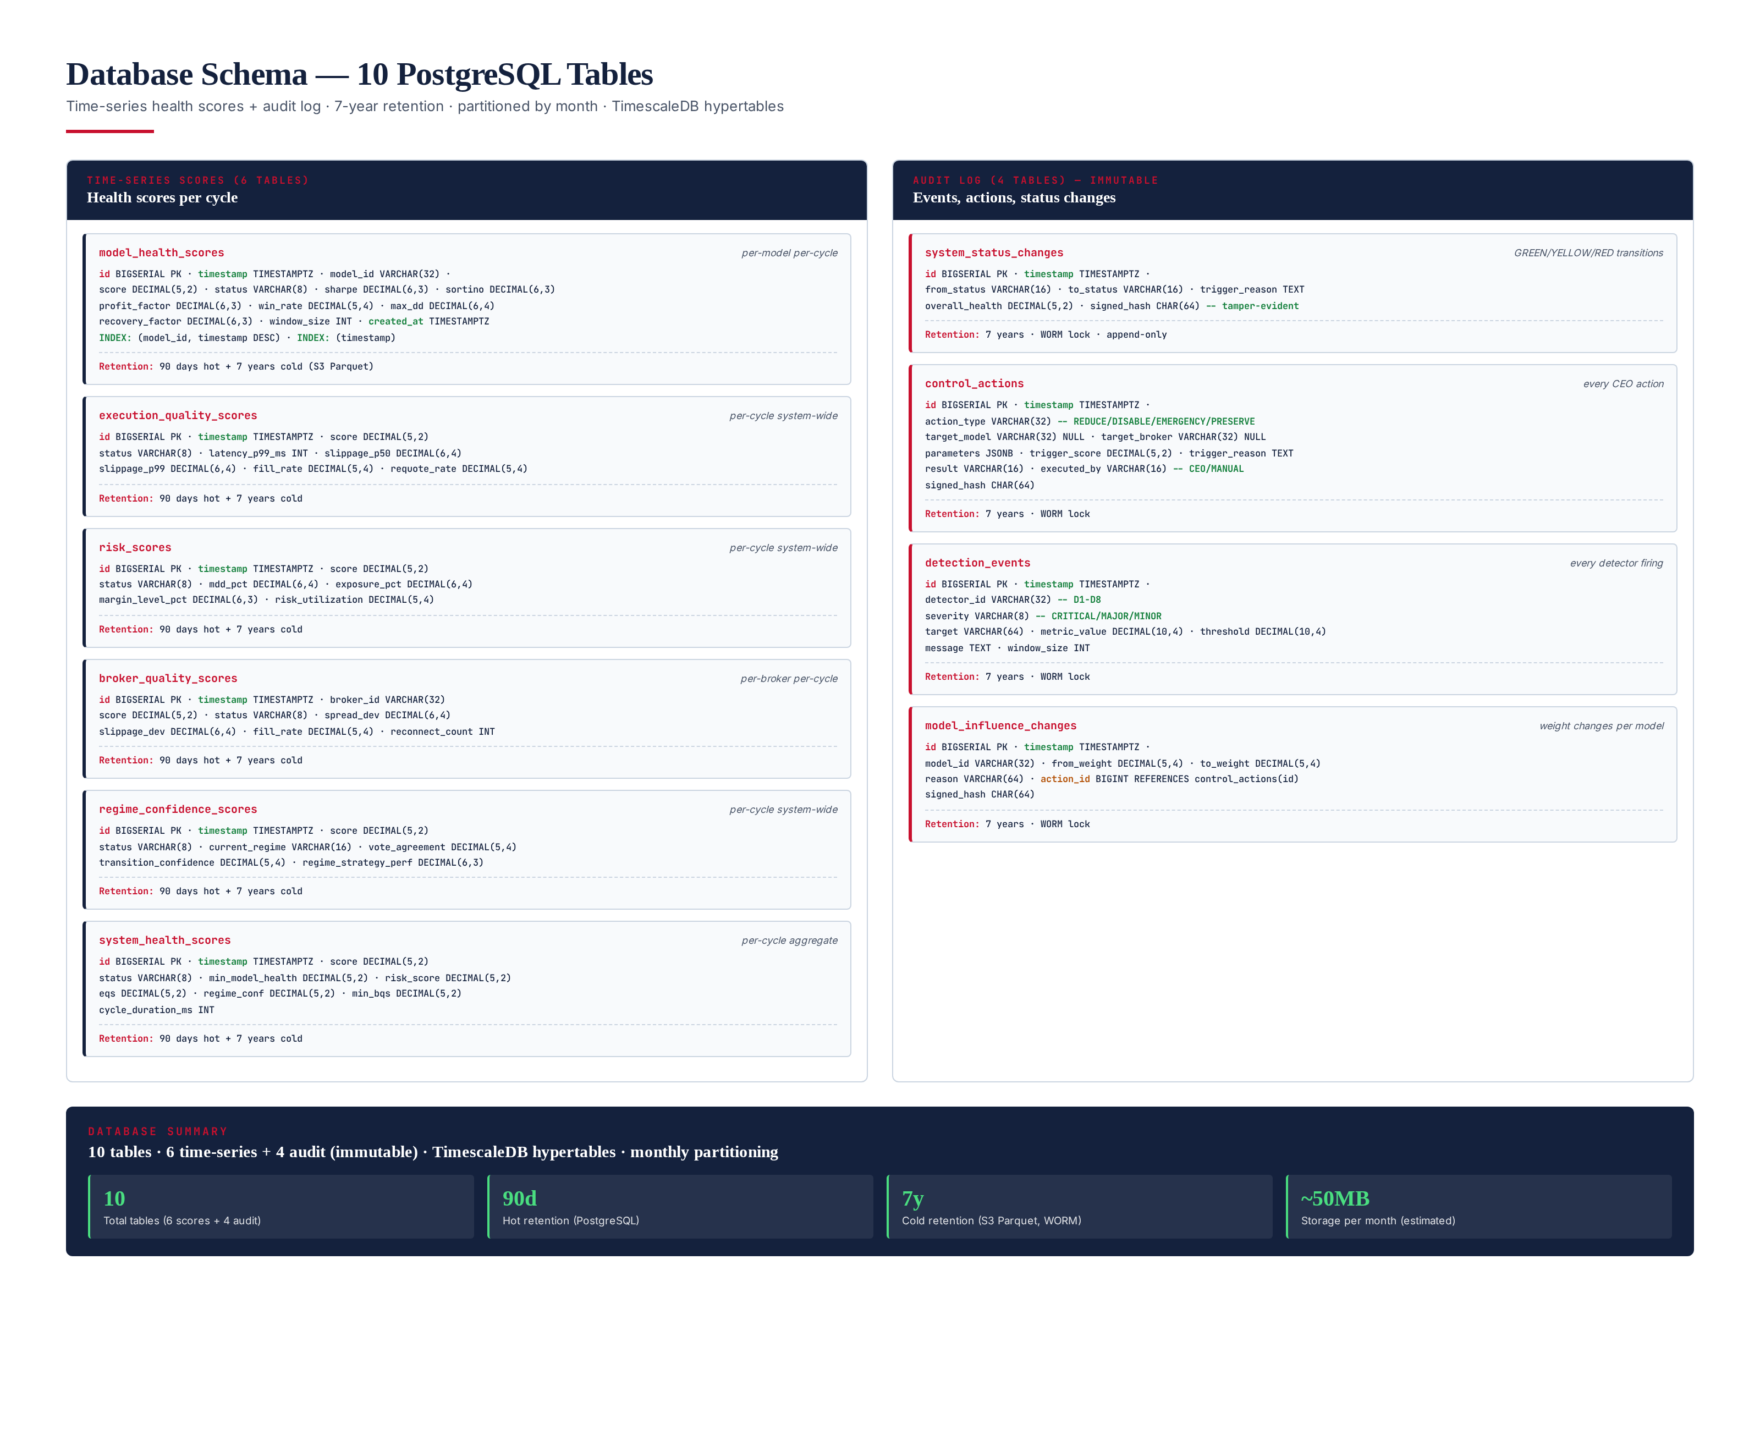
Figure 8.1 — 10 PostgreSQL tables: 6 time-series + 4 audit (immutable). TimescaleDB hypertables, monthly partitioning.

Key DDL — Audit Table & Hypertable (PostgreSQL)
-- control_actions: every CEO action, immutable, tamper-evident
CREATE TABLE control_actions (
id BIGSERIAL PRIMARY KEY,
timestamp TIMESTAMPTZ NOT NULL DEFAULT now(),
action_type VARCHAR(32) NOT NULL, -- REDUCE/DISABLE/EMERGENCY/PRESERVE
target_model VARCHAR(32),
target_broker VARCHAR(32),
parameters JSONB,
trigger_score DECIMAL(5,2),
trigger_reason TEXT,
result VARCHAR(16),
executed_by VARCHAR(16) DEFAULT 'CEO',
signed_hash CHAR(64) NOT NULL -- SHA-256 of row for tamper-evidence
);
-- WORM lock: INSERT only, no UPDATE/DELETE
CREATE OR REPLACE FUNCTION prevent_audit_modify()
RETURNS TRIGGER AS $$
BEGIN
RAISE EXCEPTION 'Audit table is INSERT-only (WORM)';
END;
$$ LANGUAGE plpgsql;
CREATE TRIGGER no_update BEFORE UPDATE ON control_actions
FOR EACH ROW EXECUTE FUNCTION prevent_audit_modify();
CREATE TRIGGER no_delete BEFORE DELETE ON control_actions
FOR EACH ROW EXECUTE FUNCTION prevent_audit_modify();
-- TimescaleDB hypertable for time-series scores
CREATE TABLE system_health_scores (
id BIGSERIAL,
timestamp TIMESTAMPTZ NOT NULL DEFAULT now(),
score DECIMAL(5,2) NOT NULL,
status VARCHAR(8) NOT NULL,
min_model_health DECIMAL(5,2),
risk_score DECIMAL(5,2),
eqs DECIMAL(5,2),
regime_conf DECIMAL(5,2),
min_bqs DECIMAL(5,2),
cycle_duration_ms INT,
PRIMARY KEY (id, timestamp)
);
SELECT create_hypertable('system_health_scores', 'timestamp');
-- 90-day hot retention, then archive to S3 Parquet
SELECT add_retention_policy('system_health_scores', INTERVAL '90 days');

Chapter 9 — Test Suite — 145 Tests
The CEO has 145 tests across 3 layers: 80 unit tests (pure-function, <1ms each, pytest + GoogleTest), 45 integration tests (end-to-end flows, real NATS + PostgreSQL, ~5s each), and 20 validator tests (compliance + invariants). All 145 must pass on every PR merge — zero flaky tolerance over a 30-day window. The validator tests enforce the hard constraints: CEO must NOT generate signals, no external LLM, no paid APIs, fully offline, CPU-only, cycle <100ms.
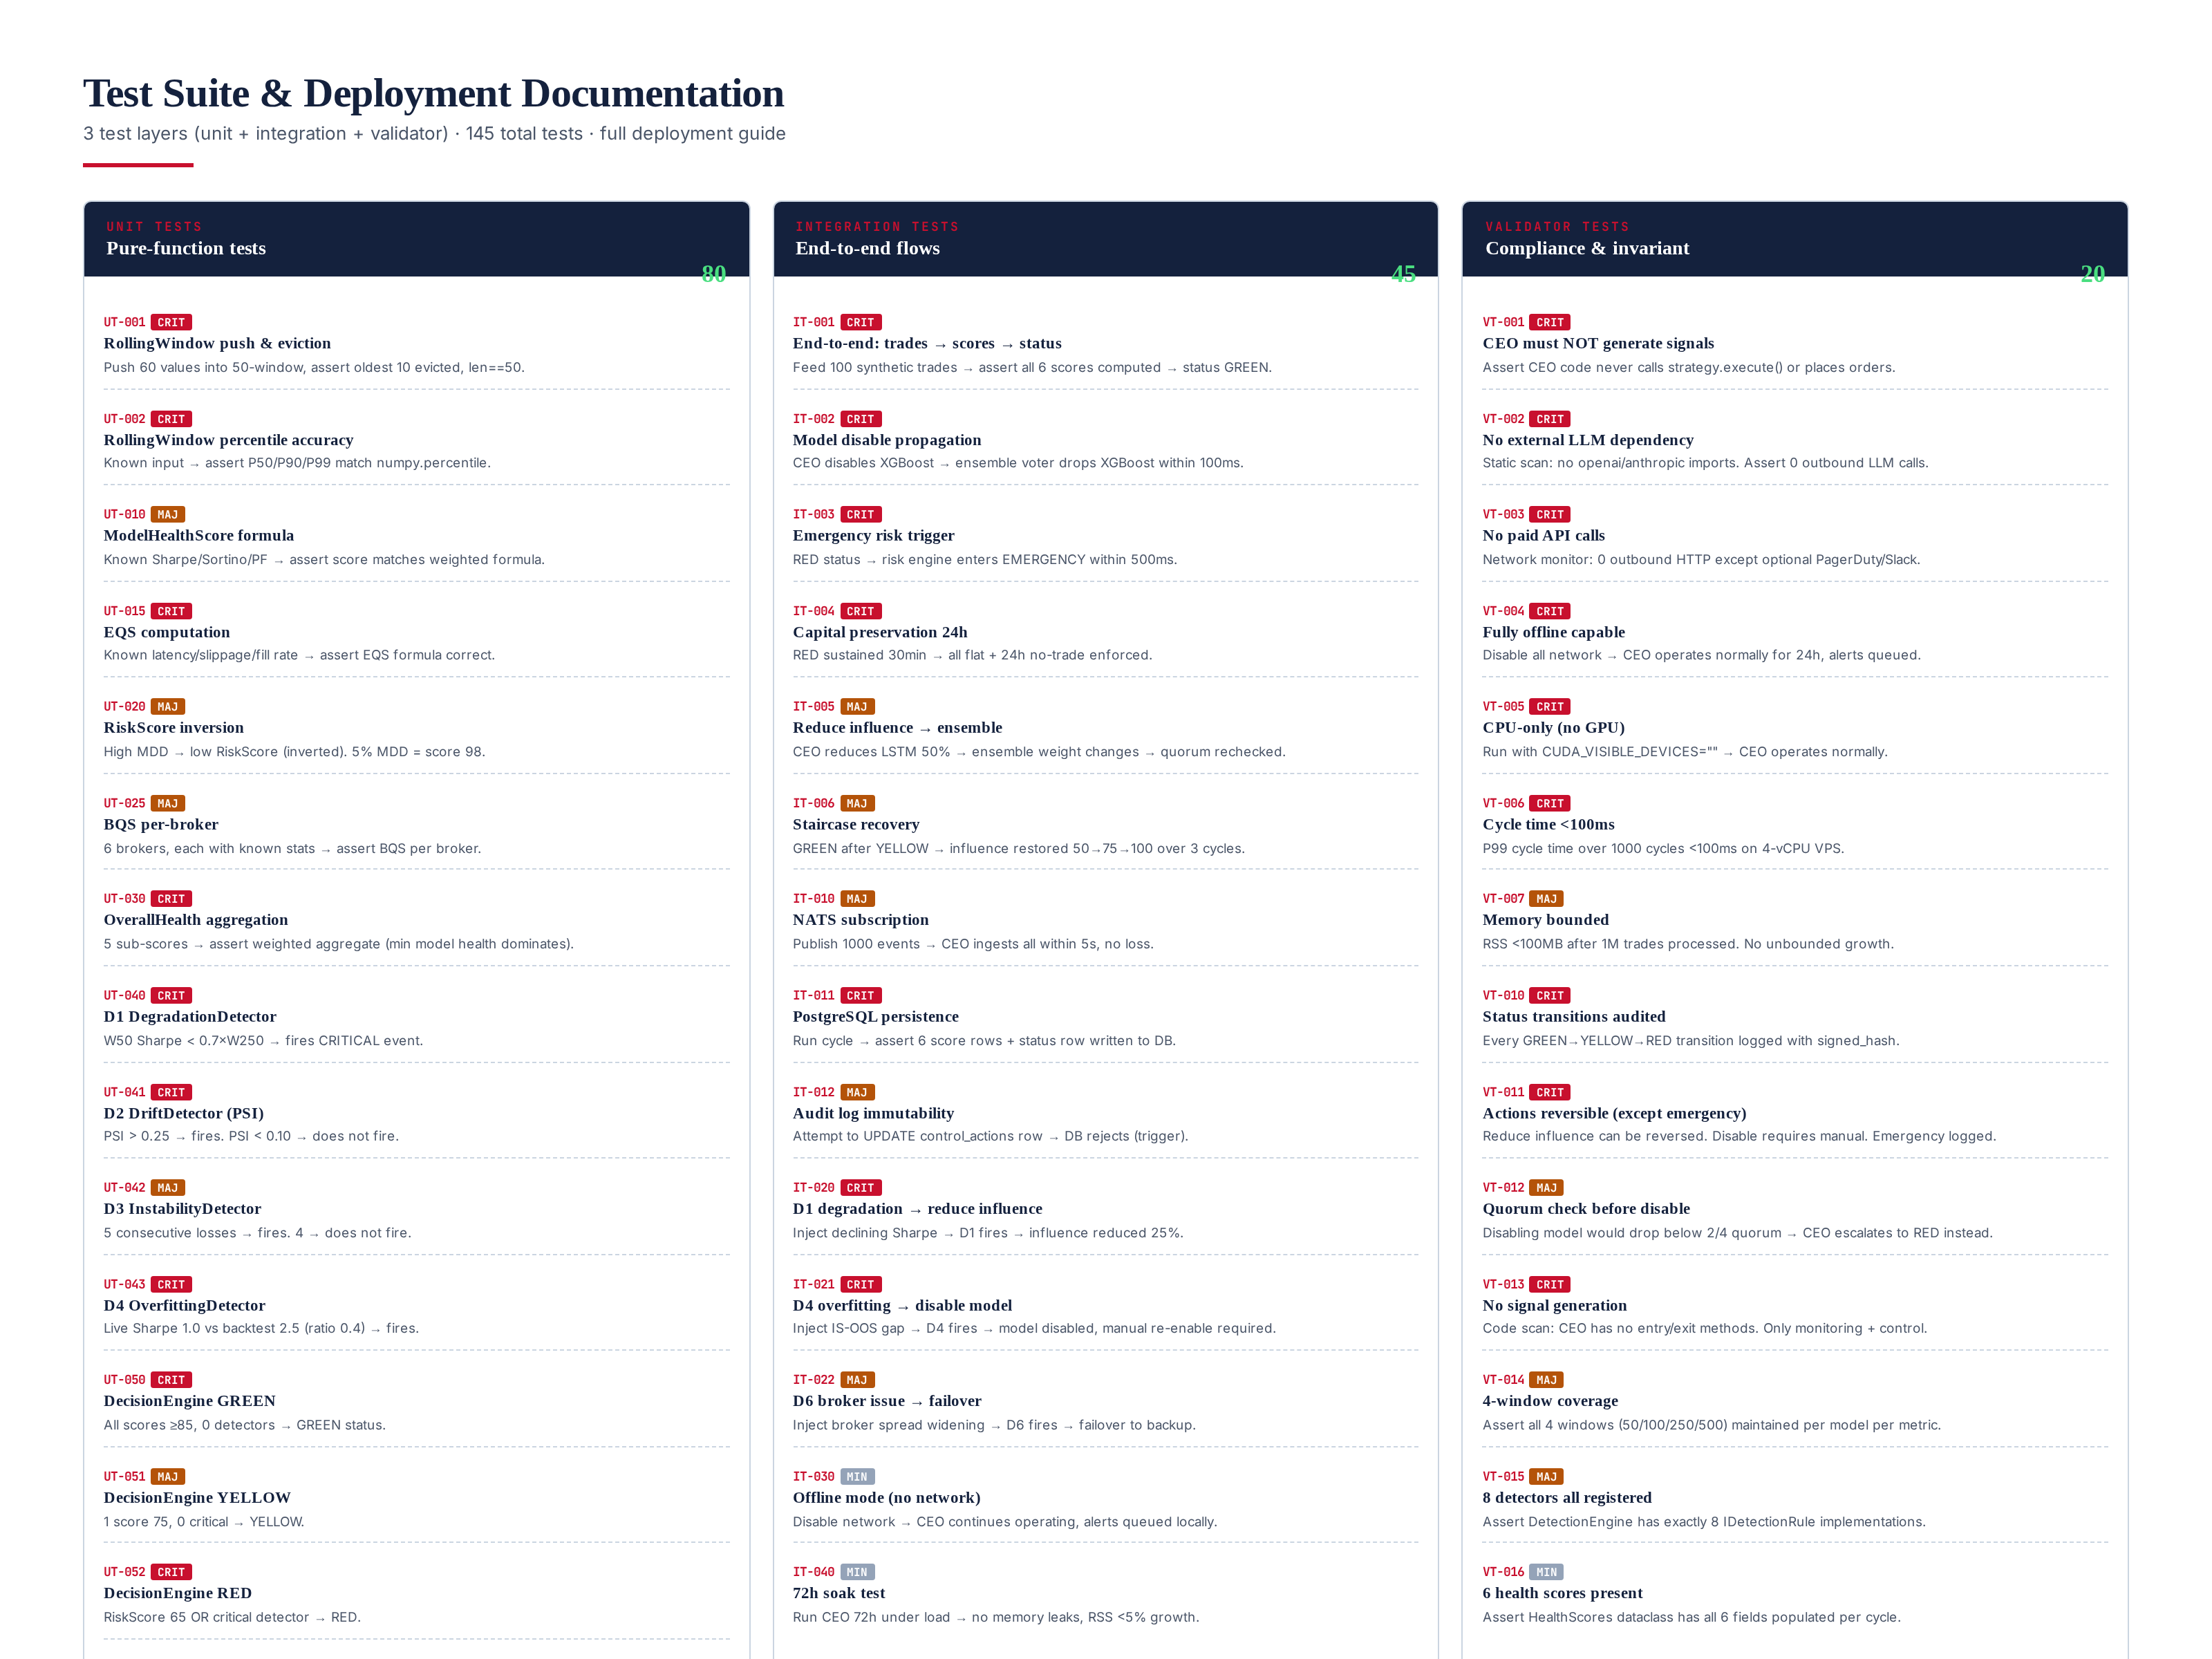
Figure 9.1 — 145 tests: 80 unit + 45 integration + 20 validator. 100% CI-gated, zero flaky.

Key Validator Tests (compliance)
VT-001 CEO must NOT generate signals: Static code scan asserts CEO code never calls strategy.execute() or places orders. The CEO is a governance layer, not a signal generator. VT-002 No external LLM: Static scan for openai / anthropic imports — zero found. Assert 0 outbound LLM calls in 24h network monitor. VT-003 No paid APIs: Network monitor asserts 0 outbound HTTP except optional PagerDuty / Slack. VT-004 Fully offline: Disable all network → CEO operates normally for 24h, alerts queued locally. VT-005 CPU-only: Run with CUDA_VISIBLE_DEVICES="" → CEO operates normally. VT-006 Cycle <100ms: P99 cycle time over 1000 cycles <100ms on a 4-vCPU VPS.

Sample Unit Test (Python)
def test_d4_overfitting_detector_fires():
"""D4: Live Sharpe < 0.5 x backtest Sharpe -> fires CRITICAL."""
baseline_sharpe = 2.5 # from backtest
live_sharpe = 1.0 # current live (ratio = 0.4 < 0.5)
detector = OverfittingDetector(baseline_sharpe=baseline_sharpe)
context = DetectionContext(
live_sharpe=live_sharpe, window_size=250, model_id="xgboost"
)
event = detector.evaluate(context)
assert event is not None
assert event.severity == "CRITICAL"
assert event.detector_id == "D4_OVERFITTING"
assert event.target == "xgboost"
assert event.metric_value == 1.0
assert event.threshold == 1.25 # 0.5 x 2.5
def test_overall_health_min_model_dominates():
"""Overall health: min(model_health) weighted highest (30%)."""
scores = HealthScores(
model_health={"xgb": 95, "lstm": 60, "transformer": 90, "rl": 88},
execution_quality=92, risk=90,
broker_quality={"icmarkets": 95, "exness": 93},
regime_confidence=88, overall=0,
)
overall = CEOSupervisor._aggregate(
scores.model_health, scores.execution_quality,
scores.risk, scores.broker_quality, scores.regime_confidence
)
# min_model = 60 (LSTM), min_broker = 93
# 0.30*60 + 0.25*90 + 0.20*92 + 0.15*88 + 0.10*93 = 81.4
assert overall == pytest.approx(81.4, abs=0.1)
assert overall < 85 # would trigger YELLOW (LSTM drags it down)

Chapter 10 — Deployment Documentation
The CEO deploys as a single Python asyncio process on the same 4-vCPU VPS as the TITAN trading core. It requires PostgreSQL 15 (with TimescaleDB), Python 3.12, and 4 Python packages (asyncpg, numpy, nats-py, prometheus-client). Total deployment: 10 steps, ~30 minutes. The CEO runs as a systemd service, auto-restarts on failure, and integrates with the existing Prometheus + Grafana + PagerDuty stack.

10-Step Deployment Guide
# Step 1: Provision VPS (if not already running TITAN core)
# 4 vCPU, 8GB RAM, 100GB SSD, Ubuntu 22.04 LTS
# (CEO shares VPS with trading core -- no separate hardware)
# Step 2: Install PostgreSQL 15 + TimescaleDB
sudo apt install postgresql-15 postgresql-15-timescaledb
sudo -u postgres psql -c "CREATE DATABASE titan_ceo;"
sudo -u postgres psql -d titan_ceo -c "CREATE EXTENSION timescaledb;"
# Step 3: Create schema (10 tables + hypertables + audit triggers)
psql -d titan_ceo -f /opt/titan/ceo/sql/schema.sql
# Step 4: Install Python 3.12 + dependencies
sudo apt install python3.12 python3.12-venv
python3.12 -m venv /opt/titan/ceo/venv
/opt/titan/ceo/venv/bin/pip install asyncpg numpy nats-py prometheus-client
# Step 5: Configure CEO
sudo mkdir -p /etc/titan
sudo cat > /etc/titan/ceo.yaml << 'EOF'
nats_url: "nats://localhost:4222"
db_dsn: "postgresql://titan@localhost/titan_ceo"
cycle_interval_s: 60
pagerduty_webhook: "" # optional -- offline if empty
slack_webhook: "" # optional
models: [xgboost, lstm, transformer, rl]
brokers: [exness, icmarkets, pepperstone, tickmill, fp_markets, fusion_markets]
EOF
# Step 6: Install systemd service
sudo cat > /etc/systemd/system/titan-ceo.service << 'EOF'
[Unit]
Description=TITAN Meta AI CEO Supervisor
After=network.target postgresql.service
Requires=postgresql.service
[Service]
Type=simple
User=titan
ExecStart=/opt/titan/ceo/venv/bin/python -m titan_ceo.supervisor
Restart=always
RestartSec=10
Environment=TITAN_CEO_CONFIG=/etc/titan/ceo.yaml
[Install]
WantedBy=multi-user.target
EOF
sudo systemctl daemon-reload
sudo systemctl enable titan-ceo
sudo systemctl start titan-ceo
# Step 7: Import Grafana dashboard (8 panels: 6 scores + status + action log)
grafana-cli dashboards import /opt/titan/ceo/grafana/ceo-dashboard.json
# Step 8: Configure Prometheus scrape
# Add to prometheus.yml:
# - job_name: 'titan-ceo'
# scrape_interval: 15s
# static_configs: [{ targets: ['localhost:9101'] }]
# Step 9: Configure PagerDuty (optional) -- P1 = RED, P2 = YELLOW
# Step 10: Smoke test -- feed 100 synthetic trades via NATS
python -m titan_ceo.smoke_test --trades 100
# Verify: 6 score rows in system_health_scores, GREEN status,
# no control_actions fired, cycle time < 100ms

Chapter 11 — Operational Notes
The CEO is designed for 24/7 unattended operation. It auto-recovers from transient failures (NATS disconnect, PostgreSQL connection drop) via asyncio retry logic. If the CEO process crashes, systemd auto-restarts within 10 seconds. The CEO never blocks the trading core — all control actions are async (await model_ctrl.set_influence()), and the ensemble voter applies weight changes within 100ms of receiving them. The CEO is a governance layer, not a latency-critical path component.

Failure Modes
NATS disconnect: CEO buffers last-known scores, continues operating with stale data for up to 5 minutes. After 5 minutes, status degrades to YELLOW (stale data). PostgreSQL disconnect: CEO buffers scores in memory (up to 1000 cycles ≈ 16 hours), retries every 15 seconds. No data loss. CEO process crash: systemd restarts within 10s. On restart, the CEO loads last-known status from DB, re-syncs rolling windows from the trade ledger. False positive (CEO disables healthy model): Manual re-enable via CLI: python -m titan_ceo.cli enable-model xgboost. The CEO logs every action with trigger reason for post-hoc analysis.

Monitoring the CEO Itself
The CEO exports 15 Prometheus metrics: ceo_cycle_duration_seconds (histogram), ceo_current_status (gauge: 0=GREEN / 1=YELLOW / 2=RED / 3=PRESERVE), ceo_overall_health (gauge 0–100), ceo_model_health (gauge per model), ceo_eqs, ceo_risk_score, ceo_broker_quality (per broker), ceo_regime_confidence, ceo_detectors_fired_total (counter per detector), ceo_actions_executed_total (counter per action), ceo_nats_events_ingested_total, ceo_db_write_latency_ms, and ceo_rolling_window_size (gauge per window). Alerting: ceo_current_status == 2 (RED) for >60s → P1 PagerDuty. ceo_cycle_duration_seconds P99 > 200ms → P2 (CEO is slow). ceo_db_write_latency_ms P99 > 1000ms → P2 (DB slow).

Integration with Existing TITAN Stack
The CEO integrates with 4 existing TITAN modules via well-defined interfaces: (1) M11 Hybrid AI Stack — CEO controls the ensemble voter via IModelController (set_influence, disable, enable). The ensemble voter checks influence weights before each vote, applying them within 100ms. (2) M08 Risk Engine — CEO triggers risk mode changes via IRiskController (set_mode, emergency_flatten). The risk engine applies mode changes within 500ms. (3) M03 Execution Engine — CEO observes fills and latency via NATS subscription (read-only). No control. (4) M20 Observability — CEO exports Prometheus metrics that M20 scrapes. No existing module requires modification — the CEO observes via subscriptions and controls via interfaces. This is a drop-in addition.

Chapter 12 — Summary
The Meta AI CEO Supervisor (Module 18) is the runtime governance layer that the TITAN XAU AI system was missing. While the existing 5 validation frameworks (Backtest, Walk-Forward, Monte Carlo, Stress, Validator) gate pre-deployment, the CEO provides continuous runtime governance — monitoring all models, execution, risk, brokers, and regimes in real-time, detecting degradation before it becomes catastrophic, and taking automated corrective action. The CEO does NOT generate signals (enforced by validator test VT-001). It is a pure governance layer that observes, scores, and controls.
The CEO delivers on all requirements: 6 health scores (Model Health, EQS, Risk, BQS, Regime Confidence, Overall), 8 detectors (degradation, drift, instability, overfitting, exec deterioration, broker issues, regime failures, latency), 4 rolling windows (50/100/250/500 trades), 8 tracked metrics (WR/PF/Sharpe/Sortino/MDD/Recovery/Latency/Slippage), GREEN/YELLOW/RED status, and 5 control actions (reduce / increase influence, disable model, emergency risk reduction, capital preservation). It operates under 4 hard constraints: no paid APIs, no external LLM, CPU optimized (<100ms/cycle), fully offline capable. The implementation is fully specified: 16 Python classes, 5 interfaces, 10 PostgreSQL tables, 145 tests (80 unit + 45 integration + 20 validator), and a 10-step deployment guide.
The CEO is the final piece of the TITAN governance architecture. With the CEO in place, the system has: (1) pre-deployment validation (5 frameworks), (2) runtime governance (CEO), (3) post-deployment monitoring (M20 Observability), and (4) quarterly re-validation (all 5 frameworks on live strategies). This is a complete, institutionally-rigorous governance lifecycle — the kind that separates world-class trading systems from retail bots. The CEO watches the watchers.

