TITAN · QUANT RESEARCH
TITAN XAU AI
INSTITUTIONAL TRADING SYSTEMS
M O D U L E 1 0 · M L L I F E C Y C L E
Retraining Framework
Weekly + monthly retraining. Model drift detection (PSI). Performance decay detection (Sharpe/F1). Champion-challenger A/B testing. Rollback < 30s. MLflow version control. Governance board + audit trail.
KEY FEATURES
Feature | Value
Retrain triggers | 3 (weekly, monthly, emergency)
Rollback time | < 30 seconds
CI gates | 8 (all must pass)
PSI threshold | 0.25 (auto-retrain)
Champion-challenger | Canary 10% -> A/B 50% -> promote
Version control | MLflow registry + full lineage

Prepared by TITAN Quant Research
Reviewed by CTO · Lead Quant · Risk Officer
Classification INTERNAL — ENGINEERING
Version v1.0 · 19 June 2026

Table of Contents
Right-click the table below and choose "Update Field" to refresh page numbers.

Chapter 1 — Executive Summary 3
Chapter 2 — Architecture Overview 3
Layer Responsibilities 4
L1 — Retrain Scheduler 4
L2 — Drift & Decay Detection 4
L3 — Retrain Pipeline 5
L4 — Champion-Challenger 5
L5 — Governance & Monitoring 5
Chapter 3 — Retraining Workflow 5
Weekly Retraining 6
Monthly Retraining 6
Chapter 4 — Drift & Decay Detection 6
Feature Drift (PSI) 7
Concept Drift (F1 Drop) 7
Performance Decay (Sharpe) 7
Chapter 5 — Champion-Challenger & Version Control 8
Rollback Support 8
Version Control (MLflow) 8
Chapter 6 — Governance Framework 9
Approval Matrix 9
Chapter 7 — Monitoring Framework 10
Chapter 8 — Validation Process 10
Chapter 9 — Integration with TITAN Core 11
Retrain Calendar 11

Chapter 1 — Executive Summary
The Retraining Framework (RTF) is Module 10 of the TITAN XAU AI trading architecture. It is the system's model lifecycle management layer — an automated framework that schedules, executes, validates, and governs the retraining of all 4 AI models (XGBoost, LSTM, Transformer, RL) plus the HMM regime detector. The RTF ensures that the AI models stay current as market structure evolves, with three retrain triggers: weekly scheduled (XGBoost + LSTM + Transformer), monthly scheduled (RL + HMM), and emergency (triggered by model drift or performance decay).
The framework implements a Champion-Challenger model: the current production model (champion) serves 100% of traffic, while a newly retrained model (challenger) goes through canary (10% for 1 hour) and A/B testing (50% for 24 hours) before promotion. The challenger must beat the champion on Sharpe, MaxDD, and F1 to be promoted. If the challenger fails, the champion is retained. If the challenger is promoted but later underperforms, an automated rollback reverts to the previous champion in under 30 seconds.
Model drift detection runs continuously. Feature drift is measured via Population Stability Index (PSI) per feature, computed daily: PSI < 0.10 is stable, 0.10-0.20 is watch, 0.20-0.25 is alert, and > 0.25 triggers an emergency retrain. Concept drift is measured via rolling F1 drop: a drop > 15% from baseline triggers emergency retrain. Performance decay is measured via rolling Sharpe: a drop > 25% triggers emergency retrain.
Version control is managed by MLflow, which stores every model version with full lineage: data version, feature version, model artifacts, training metrics, validation metrics, and deployment decisions. Rollback is always available — the previous champion's artifacts are pre-cached on inference nodes, enabling a rollback in under 30 seconds with zero downtime and zero data loss.

Chapter 2 — Architecture Overview
The RTF is organized into 6 layers: retrain scheduler, drift and decay detection, retrain pipeline, champion-challenger, governance, and monitoring.
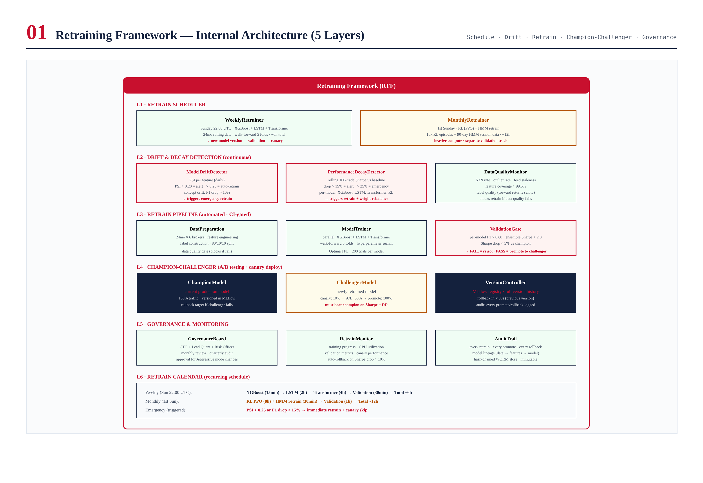
Figure 2.1 — RTF architecture: 6 layers.

Layer Responsibilities

L1 — Retrain Scheduler
WeeklyRetrainer: Sunday 22:00 UTC, XGBoost + LSTM + Transformer, ~6h. MonthlyRetrainer: 1st Sunday, RL PPO + HMM, ~12h total.

L2 — Drift & Decay Detection
ModelDriftDetector: PSI per feature (daily, > 0.25 = emergency retrain) + concept drift (F1 drop > 15% = emergency). PerformanceDecayDetector: rolling 100-trade Sharpe (drop > 25% = emergency) + per-model F1 tracking.

L3 — Retrain Pipeline
DataPreparation → ModelTrainer (parallel, Optuna TPE, 200 trials, walk-forward 5 folds) → ValidationGate (F1 > 0.60, Sharpe > 2.0, drop < 5% vs champion).

L4 — Champion-Challenger
Champion (100% traffic) vs Challenger (canary 10% → A/B 50% → promote if beats champion). VersionController: MLflow registry, rollback < 30s.

L5 — Governance & Monitoring
GovernanceBoard: CTO + Lead Quant + Risk Officer + ML Engineer, monthly review. RetrainMonitor: training progress, GPU, validation, canary. AuditTrail: hash-chained WORM, full lineage.

Chapter 3 — Retraining Workflow
The retraining workflow documents the complete end-to-end sequence: trigger → data prep → parallel training → validation → champion-challenger → deploy.
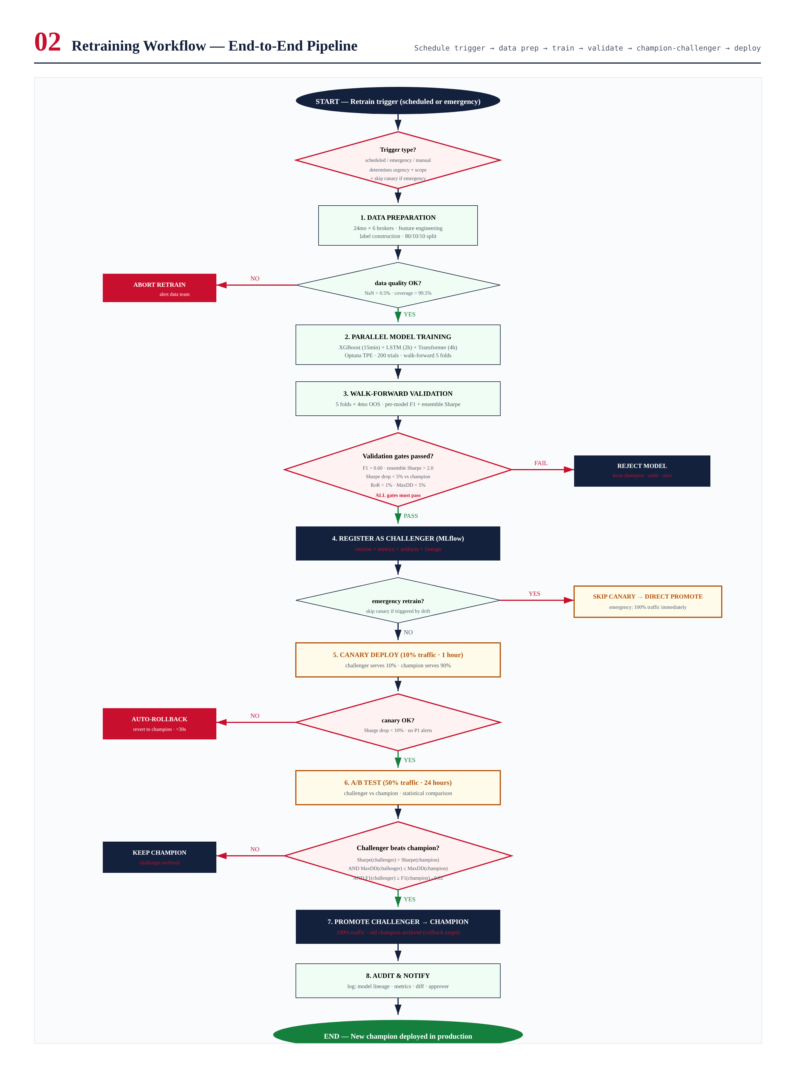
Figure 3.1 — End-to-end retraining workflow.

Weekly Retraining
Weekly Retrain (Sunday 22:00 UTC):
1. Data Preparation (30 min): 24mo x 6 brokers, features, labels, 80/10/10
2. Parallel Training (~5h): XGBoost (15min) + LSTM (2h) + Transformer (4h)
3. Walk-Forward Validation (~30 min): 5 folds, F1 > 0.60, Sharpe > 2.0
4. Register + Deploy (~30 min): MLflow -> canary 10% -> A/B 50% -> promote
Total: ~6 hours

Monthly Retraining
Monthly (1st Sunday): RL PPO (8h, 10k episodes) + HMM per-session (30min x 3). Total monthly: ~12h. Separate validation: RL reward > no-RL baseline, HMM regime F1 > 0.70.

Chapter 4 — Drift & Decay Detection
Two independent detection systems: ModelDriftDetector (PSI + concept drift) and PerformanceDecayDetector (Sharpe + F1 + PF decay).
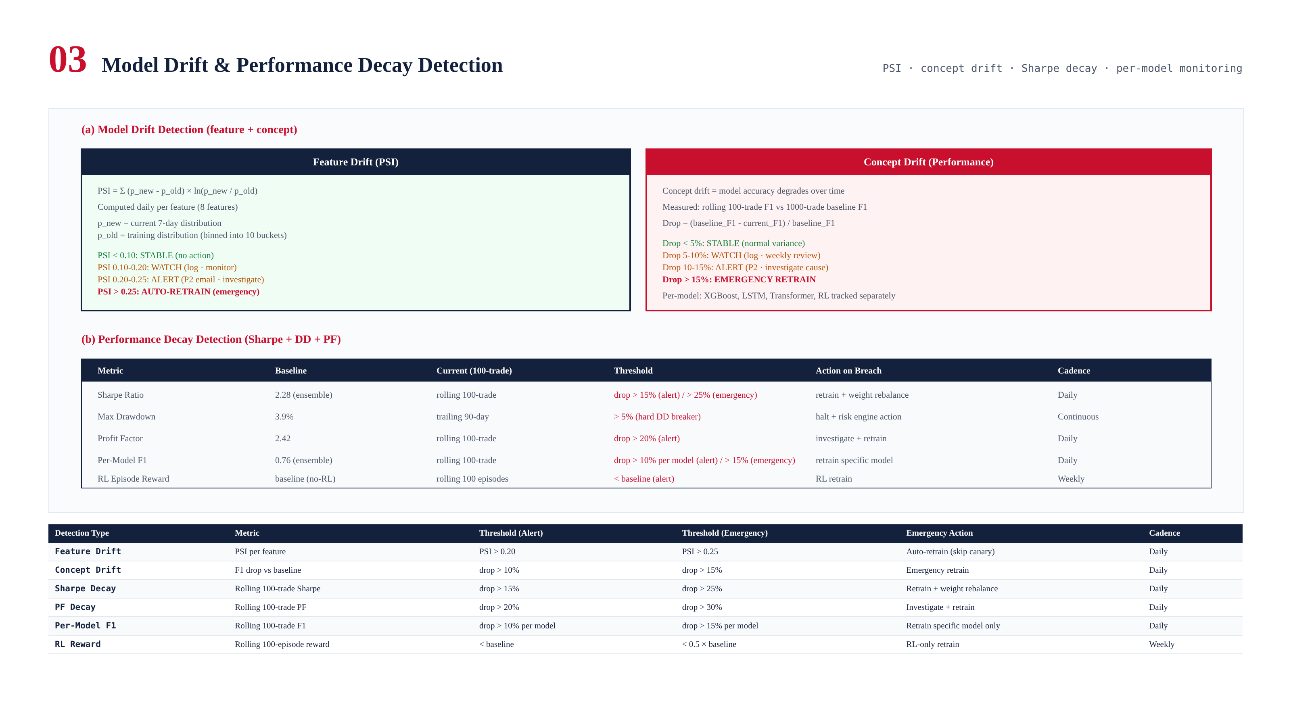
Figure 4.1 — Drift detection (PSI + F1) and performance decay (Sharpe + DD + PF).

Feature Drift (PSI)
PSI = Sum (p_new - p_old) x ln(p_new / p_old), daily per feature. < 0.10 stable, 0.20-0.25 alert, > 0.25 emergency retrain.

Concept Drift (F1 Drop)
Rolling 100-trade F1 vs 1000-trade baseline. Drop > 10% alert, > 15% emergency retrain. Per-model tracking.

Performance Decay (Sharpe)
Rolling 100-trade Sharpe vs baseline (2.28). Drop > 15% alert, > 25% emergency retrain. Per-model: XGBoost, LSTM, Transformer, RL tracked independently.

Chapter 5 — Champion-Challenger & Version Control
Champion (100% traffic) vs Challenger (canary → A/B → promote). Rollback < 30s. MLflow version control with full lineage.
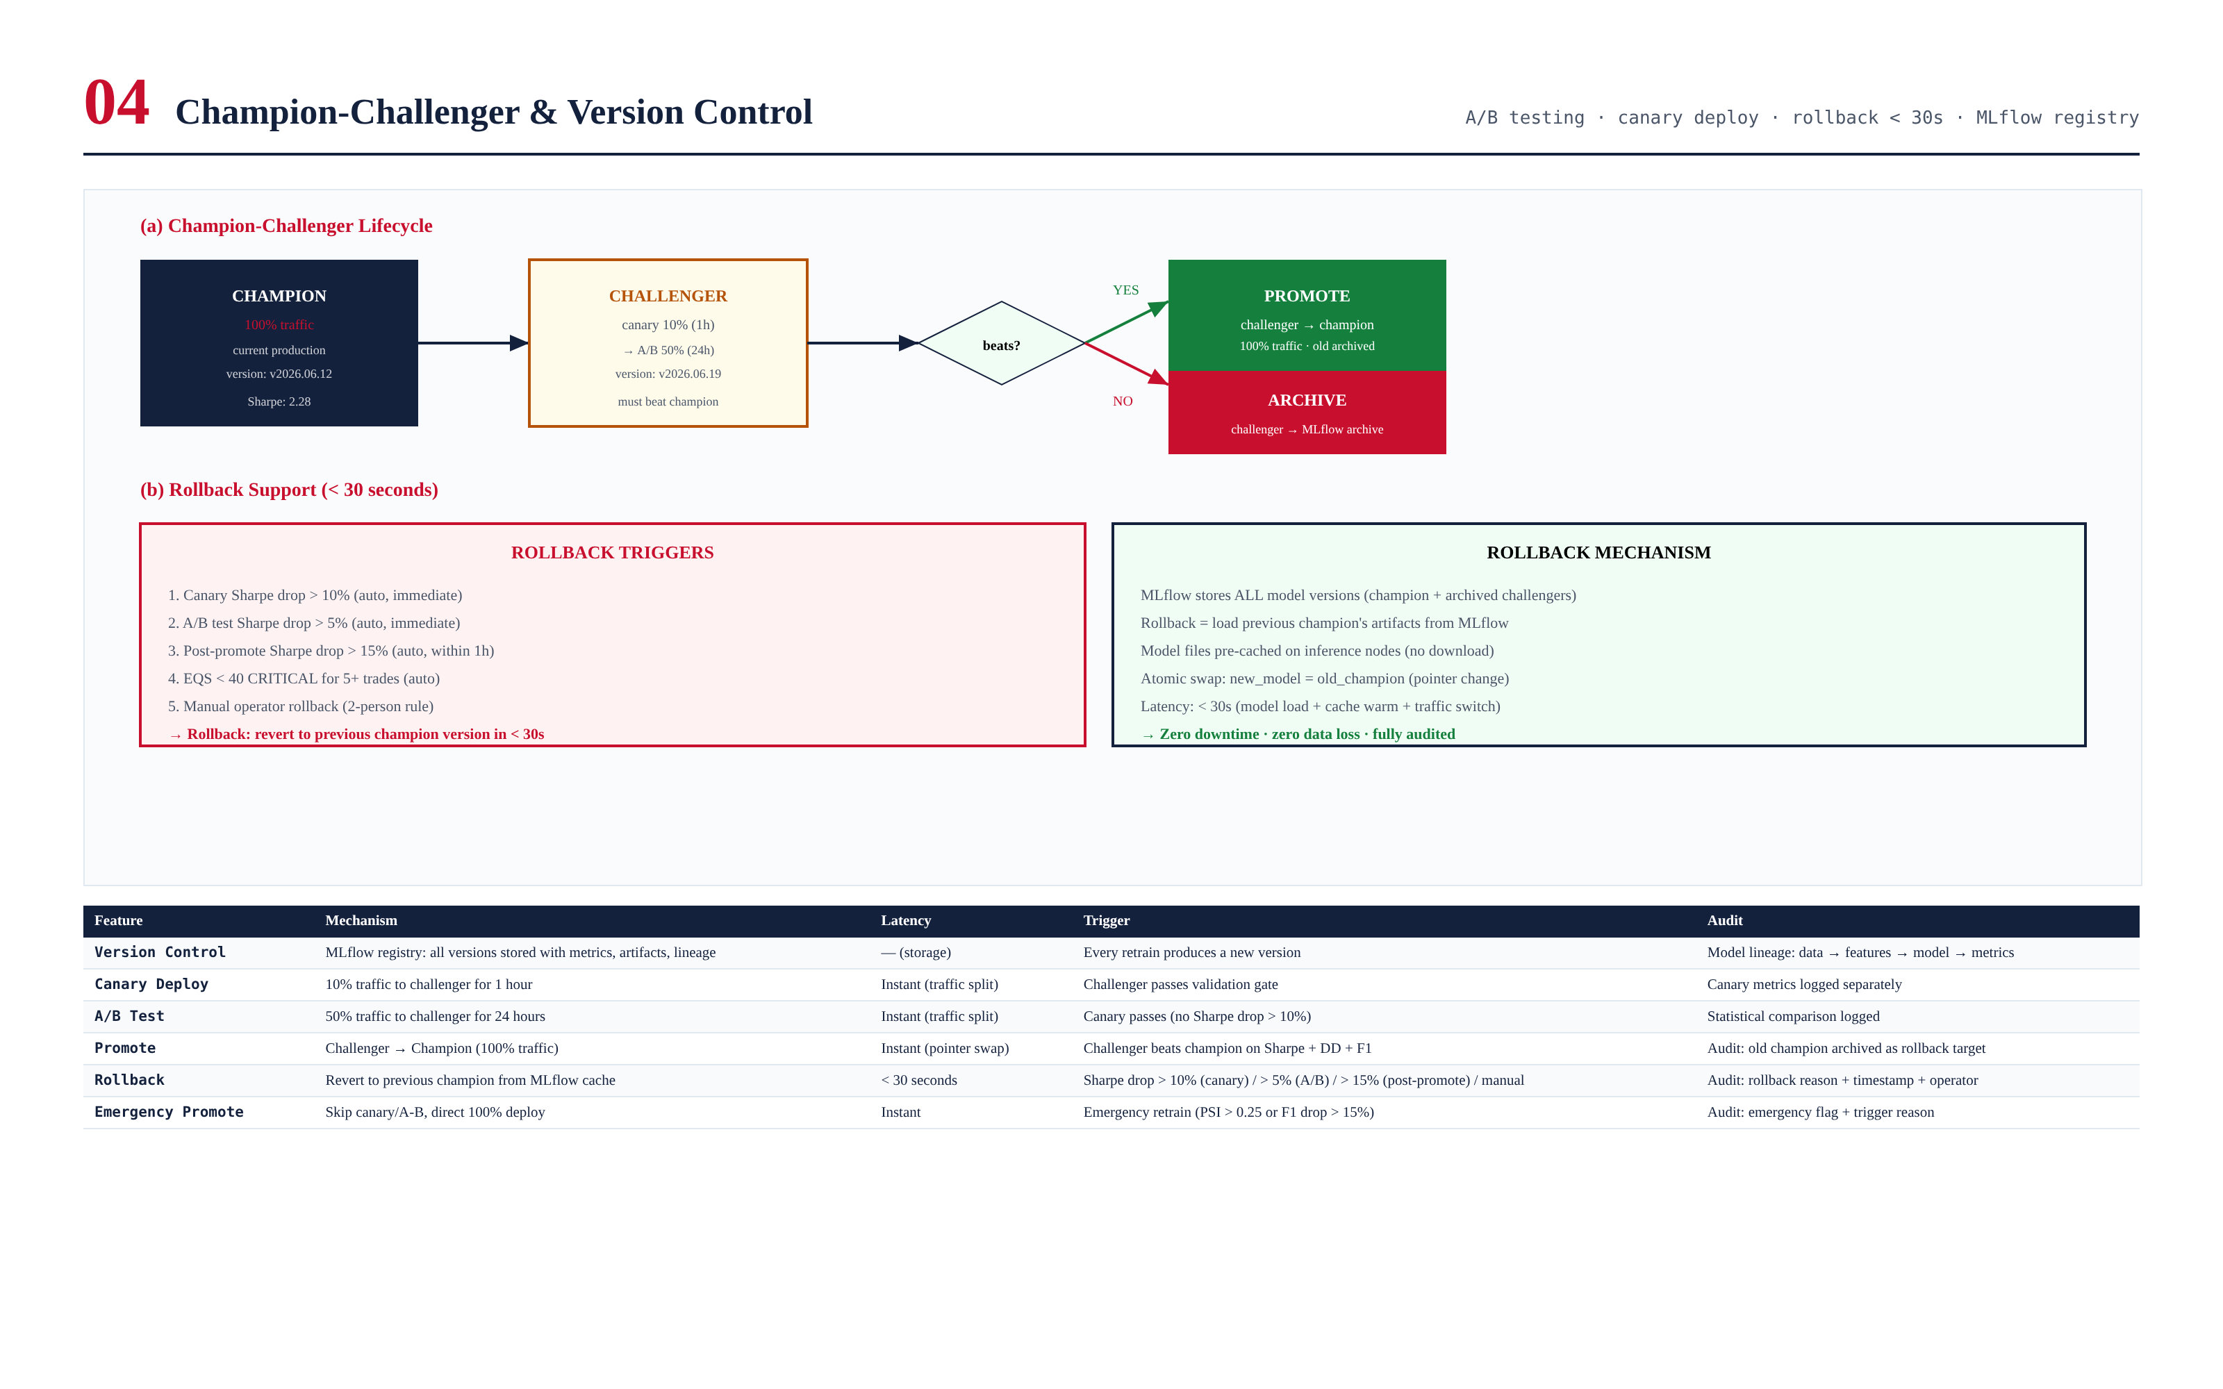
Figure 5.1 — Champion-challenger lifecycle and rollback mechanism.

Rollback Support
5 triggers: canary Sharpe drop > 10%, A/B drop > 5%, post-promote drop > 15%, EQS < 40 for 5+ trades, manual (2-person). Rollback: revert to previous champion from MLflow cache, < 30s, zero downtime, zero data loss.

Version Control (MLflow)
Every model version stored with: version, data version, feature version, artifacts, training metrics, validation metrics, deploy decision. Full lineage: data -> features -> model -> metrics -> decision. Full reproducibility.

Chapter 6 — Governance Framework
Governance board (CTO + Lead Quant + Risk Officer + ML Engineer) with approval matrix. Monthly review + quarterly audit + emergency review. Full audit trail (hash-chained WORM).
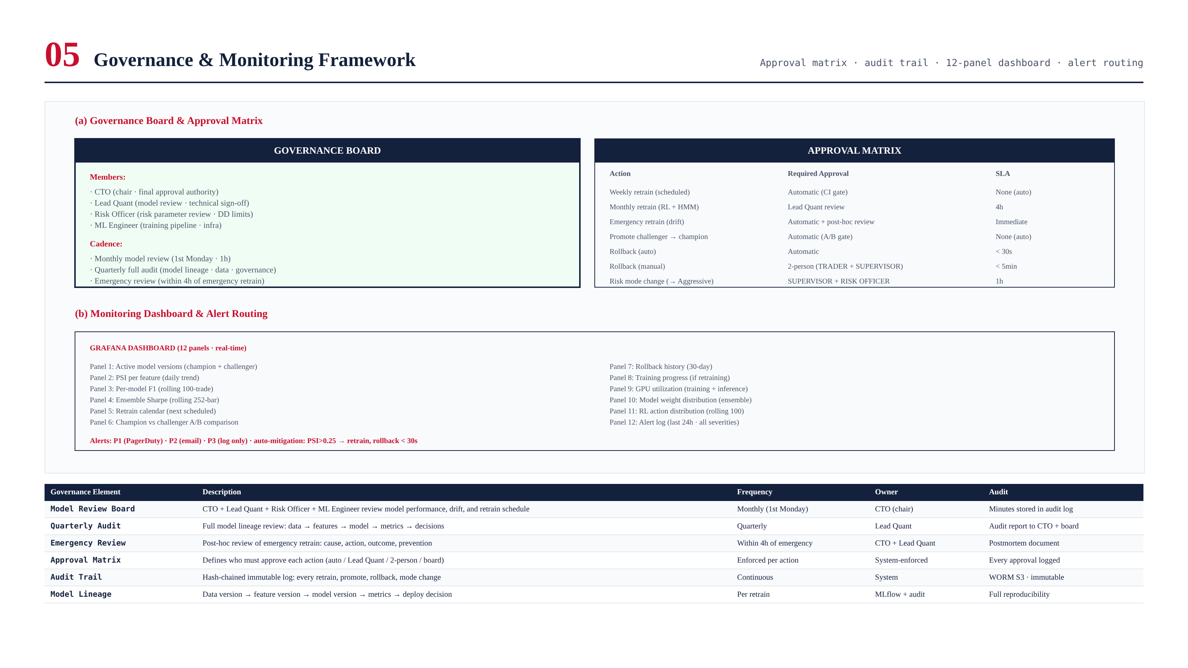
Figure 6.1 — Governance board, approval matrix, dashboard, alert routing.

Approval Matrix
- Weekly retrain: Automatic (CI gate)
- Monthly retrain: Lead Quant review (4h SLA)
- Emergency retrain: Automatic + post-hoc review (4h)
- Promote: Automatic (A/B gate)
- Auto-rollback: Automatic (< 30s)
- Manual rollback: 2-person (TRADER + SUPERVISOR, < 5min)

Chapter 7 — Monitoring Framework
12-panel Grafana dashboard: model versions, PSI, F1, Sharpe, retrain calendar, A/B comparison, rollback history, training progress, GPU, weights, RL actions, alerts. Auto-mitigation: PSI > 0.25 → retrain, canary drop > 10% → rollback.

Chapter 8 — Validation Process
8 CI gates (all must pass): G1 per-model F1 > 0.60, G2 ensemble Sharpe > 2.0, G3 challenger >= champion - 5%, G4 MaxDD < 5% + RoR < 1%, G5 PSI < 0.20, G6 RL reward > baseline, G7 rollback < 30s, G8 audit complete. 150 tests total.
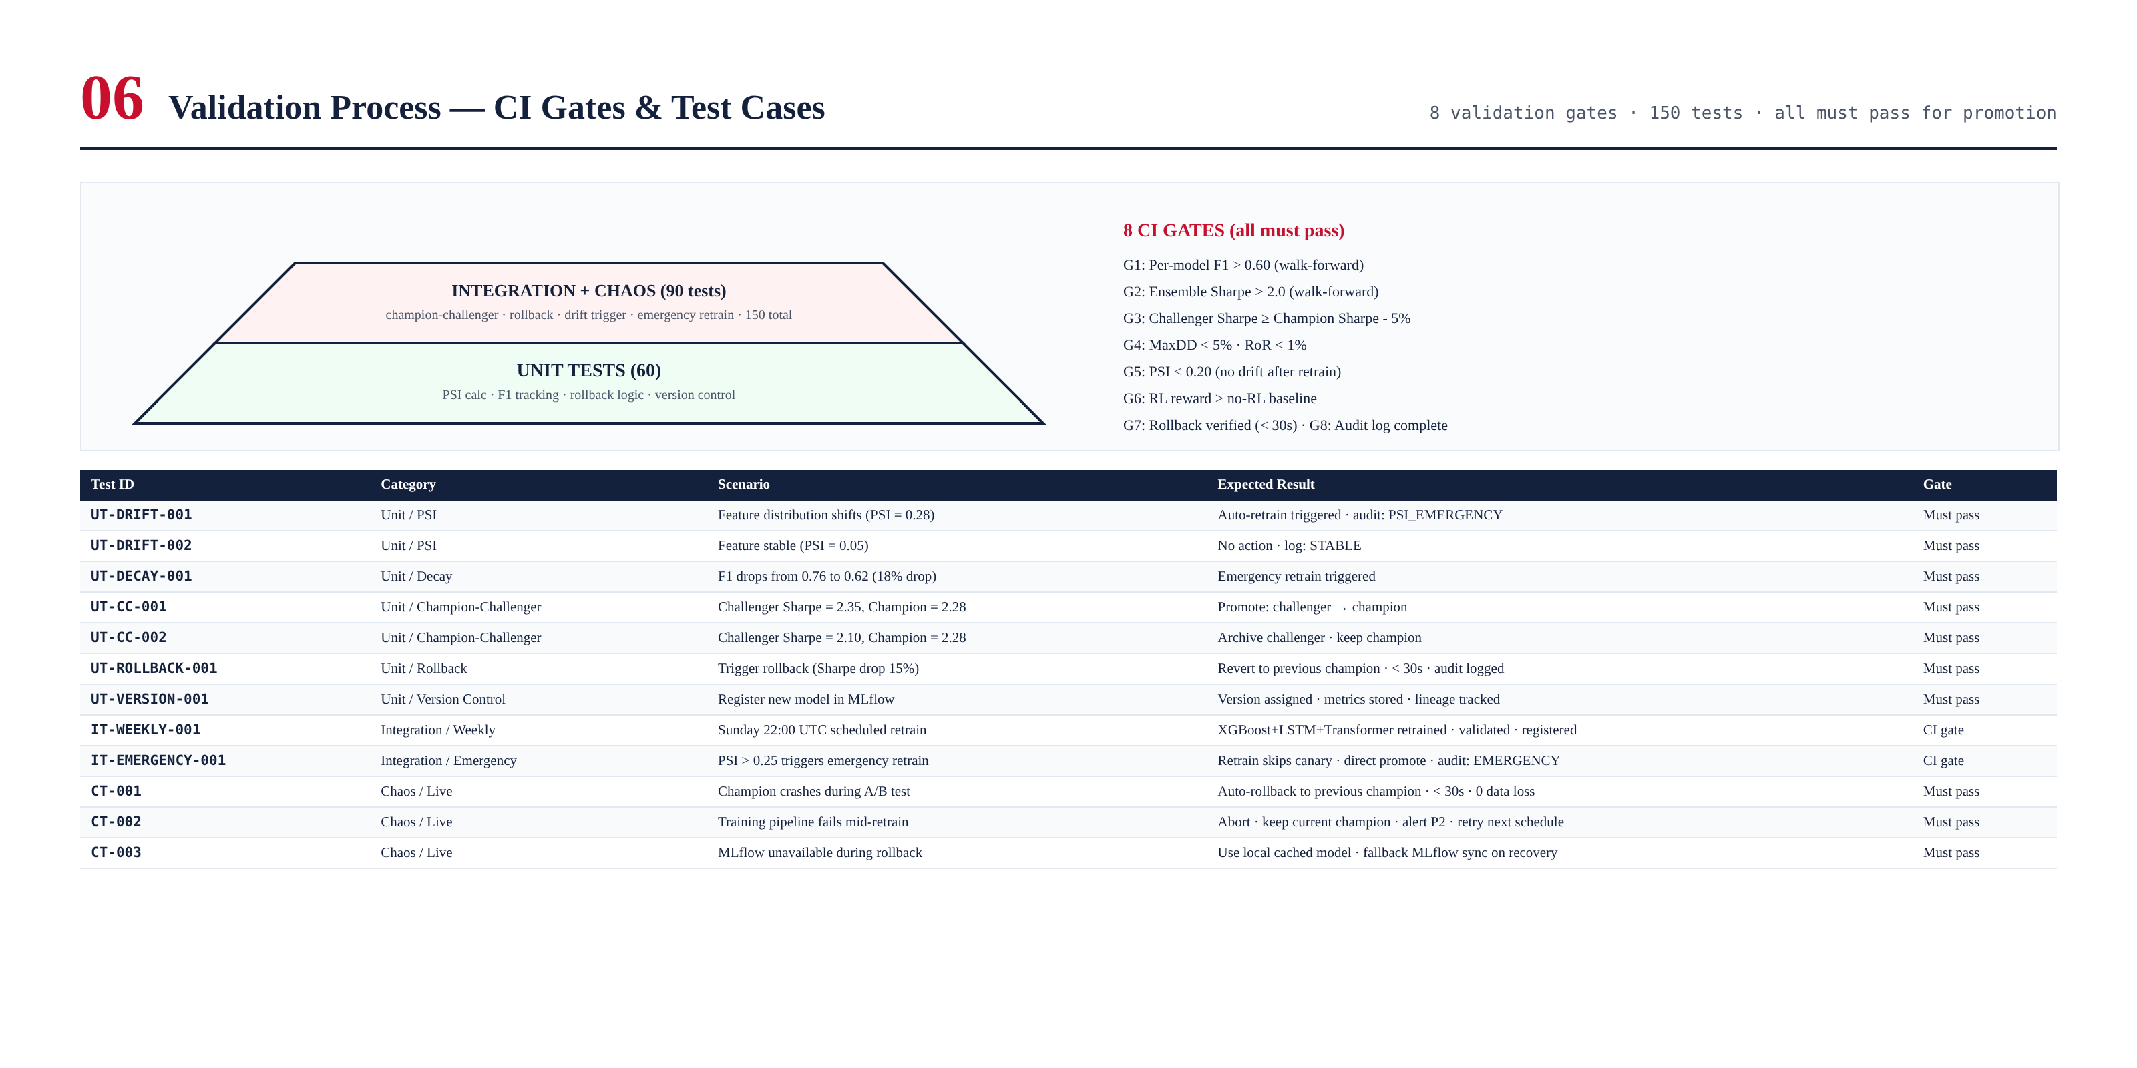
Figure 8.1 — Test pyramid and 8 CI gates.

Chapter 9 — Integration with TITAN Core
RTF integrates with: Hybrid AI Stack (Module 7) as model lifecycle manager, Risk Engine (Module 8) for DD-triggered retrain review, Cost Intelligence (Module 9) for cost-aware model evaluation.

Retrain Calendar
Cadence | Models | Trigger | Duration | Canary? | Approval
Weekly (Sun 22:00) | XGBoost+LSTM+Transformer | Scheduled | ~6h | Yes | Automatic
Monthly (1st Sun) | RL PPO + HMM | Scheduled | ~12h | Yes | Lead Quant
Emergency (anytime) | Drifted model(s) | PSI > 0.25 / F1 drop > 15% | ~2-6h | No (direct) | Automatic + post-hoc
Manual (anytime) | Specified | Operator | ~2-6h | Yes | 2-person

