TITAN · QUANT RESEARCH
TITAN XAU AI
INSTITUTIONAL TRADING SYSTEMS
M O D U L E 1 4 · W A L K - F O R W A R D
Walk-Forward Testing
Train / Validate / Test / Roll-Forward methodology. Anchored & rolling windows. WFE (Walk-Forward Efficiency) as anti-overfit canary. 6-metric aggregate score. 3-band certification. 17 pass/fail rules. 3-tier reporting with full fold audit trail.
KEY FEATURES
Feature | Value
Methodology | Anchored (train grows) or Rolling (train slides)
Phases per fold | 4 (Train / Validate / Test / Roll-Forward)
Fold count | 5-7 per 12-month dataset (anchored=5, rolling=7)
Scoring | 6-metric weighted aggregate (WFE 30% weight)
Pass criteria | 17 rules (8 critical + 6 major + 3 minor)
Certification | CERTIFIED / CONDITIONAL / REJECTED (3-band)

Prepared by TITAN Quant Research
Reviewed by CTO · Head of Research · Risk Officer · Compliance
Classification RESEARCH — INTERNAL DISTRIBUTION
Version v1.0 · 19 June 2026

Table of Contents
Right-click the table below and choose "Update Field" to refresh page numbers.

Chapter 1 — Executive Summary
The Walk-Forward Testing Framework (WFTF) is Module 14 of the TITAN XAU AI trading system. It is the system's anti-overfitting authority — the methodology that distinguishes strategies that genuinely generalize from strategies that merely memorize historical data. The framework implements the train / validate / test / roll-forward protocol across 5-7 chronological folds of a 12-month dataset, producing a single composite metric — Walk-Forward Efficiency (WFE) — that quantifies how much of the in-sample edge survives out-of-sample testing. WFE below 0.50 (50%) is the institutional red line: a strategy that loses more than half its in-sample Sharpe when tested out-of-sample is statistically overfit and will not survive live trading.
The framework serves one fundamental purpose: to prevent the deployment of overfit strategies. Overfitting is the single most common cause of live-trading failure in algorithmic trading — a strategy that scores Sharpe 3.0 in optimization but delivers Sharpe 0.8 in live trading because the optimized parameters fit noise rather than signal. The WFTF catches this before capital is committed by holding back a portion of the dataset as out-of-sample test data, then verifying that parameters optimized on in-sample data continue to perform on the unseen out-of-sample data. The discipline of never optimizing on test data, applied rigorously across 5-7 folds, is what separates institutional quant methodology from retail curve-fitting.
The framework delivers four outputs specified in this document: (1) the methodology — anchored vs rolling window selection, fold geometry, data separation rules, parameter selection protocol; (2) the scoring — 6-metric aggregate score (WFE 30%, OOS Sharpe 25%, OOS MDD 15%, OOS CAGR 15%, fold consistency 10%, cost drag 5%) normalized to 0-100; (3) the pass criteria — 17 hard rules across CRITICAL (8), MAJOR (6), and MINOR (3) severities, producing a 3-band verdict (CERTIFIED / CONDITIONAL / REJECTED); (4) the reporting — three tiers (executive / technical / regulatory) with full fold audit trail and 7-year S3 archival.
The headline metric, WFE, is computed as the median OOS Sharpe divided by the median IS Sharpe across all folds. A WFE of 1.0 means the strategy performs identically in- and out-of-sample (perfect generalization); a WFE of 0.0 means the strategy performs no better than buy-hold out-of-sample (complete overfit). Institutional practice treats WFE ≥ 0.50 as the minimum acceptable, WFE ≥ 0.70 as strong, and WFE < 0.35 as automatic veto. The WFTF enforces these thresholds as hard certification gates — no strategy with WFE < 0.50 is authorized for live capital, regardless of how strong its aggregate score may be. WFE is the anti-overfit canary.

Chapter 2 — Methodology Overview
Walk-forward analysis is the institutional standard for out-of-sample strategy validation. The methodology divides a historical dataset into chronological folds, each consisting of three windows: a train window (used for parameter optimization), a validate window (used for parameter selection from candidate sets), and a test window (the official out-of-sample result, never used for any decision). After each fold, all three windows advance forward by one month — this is the "roll-forward" — and the process repeats. The collection of test-window results across all folds constitutes the strategy's out-of-sample track record.
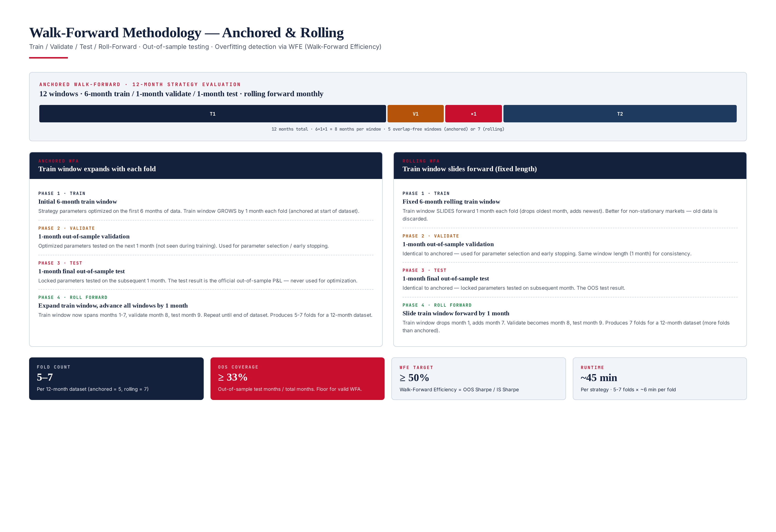
Figure 2.1 — Walk-forward methodology: anchored (train grows) vs rolling (train slides). 4 phases per fold.

Anchored vs Rolling Windows
The WFTF supports two window geometries. In anchored WFA, the train window starts at the beginning of the dataset and grows by one month each fold — fold 1 trains on months 1-6, fold 2 trains on months 1-7, fold 3 on months 1-8, and so on. The validate and test windows always advance by one month each fold. Anchored WFA uses all available historical data for training, which is beneficial when the market regime is stable. For a 12-month dataset with 6-month initial train, anchored WFA produces 5 folds (train grows from 6 to 10 months).
In rolling WFA, the train window has fixed length and slides forward one month each fold — fold 1 trains on months 1-6, fold 2 trains on months 2-7, fold 3 on months 3-8. The oldest month is dropped as a new month is added. Rolling WFA discards old data, which is beneficial when the market regime is non-stationary (the most recent data is most representative of future conditions). For a 12-month dataset with 6-month rolling train, rolling WFA produces 7 folds (more folds than anchored, because the train window does not consume growing amounts of data).
The choice between anchored and rolling is made per strategy based on regime stability: strategies trading stable regimes (e.g., trend following on weekly timeframe) benefit from anchored (more training data); strategies trading non-stationary regimes (e.g., mean reversion in news-driven markets) benefit from rolling (recent data only). The WFTF default is rolling, with anchored available as an option. Both geometries use identical validate (1 month) and test (1 month) windows to ensure comparable out-of-sample coverage.

Fold Geometry
Parameter | Default | Range | Rationale
Train window | 6 months | 3-12 months | Long enough to span regime cycles; short enough to stay relevant
Validate window | 1 month | 1-2 months | Enough data to differentiate candidates; not so much as to waste OOS data
Test window | 1 month | 1-2 months | Enough data to be statistically meaningful; one full month captures multiple trades
Step (roll-forward) | 1 month | 1-3 months | 1 month = max folds; 3 months = min overlap between consecutive test windows
Min fold count | 5 | 4-7 | Below 4 folds, statistical confidence in WFE is low
OOS coverage floor | 33% | 25-50% | Out-of-sample test months / total months; below 25% the WFA is statistically weak

Chapter 3 — Phase 1: Train
The train phase is the parameter optimization step. The strategy is run on the in-sample train window with thousands of candidate parameter combinations, and the top performers (by in-sample Sharpe with constraints on max drawdown) are passed to the validate phase. The train phase is the only phase where parameter values are adjusted — once the validate phase selects a parameter set, it is locked for the test phase and cannot be modified.
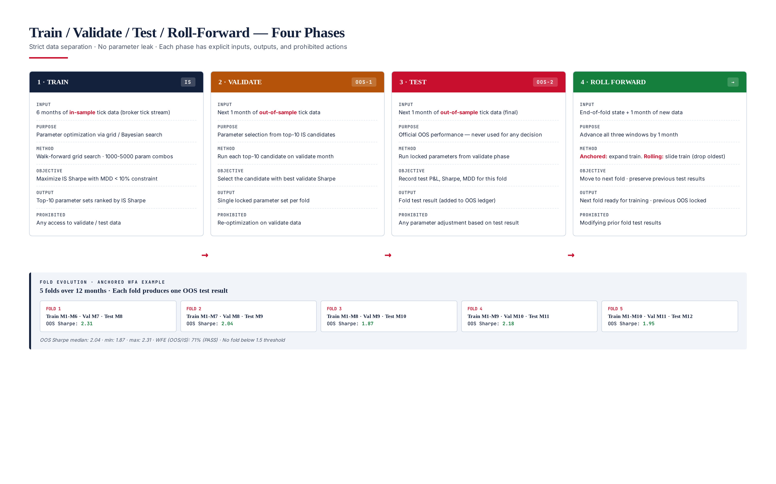
Figure 3.1 — Four phases per fold with strict data separation. Each phase has explicit inputs, outputs, and prohibited actions.

Optimization Method
The WFTF supports three optimization methods: (1) grid search — exhaustively evaluates every parameter combination on a pre-defined grid (1,000-5,000 combinations typical); (2) Bayesian optimization — uses Gaussian process surrogate model to intelligently sample promising regions of parameter space (200-500 evaluations typical, 10× more efficient than grid); (3) genetic algorithm — population-based search with mutation and crossover (50 generations × 50 population = 2,500 evaluations). Default is Bayesian optimization for parameter spaces with ≥ 4 dimensions, grid search for ≤ 3 dimensions. Genetic algorithm is reserved for highly non-convex spaces.

Objective Function
The optimization objective is: maximize in-sample Sharpe subject to MDD ≤ 10%. The MDD constraint prevents the optimizer from finding parameters that achieve high Sharpe through excessive leverage (which would also produce unacceptable drawdown). Secondary objectives (used as tiebreakers): maximize profit factor, minimize parameter sensitivity (prefer parameters in flat regions of the Sharpe surface over sharp peaks, which indicate overfitting). The objective function is computed on the train window only — any access to validate or test data during optimization is a critical methodological violation that triggers a DATA_LEAK veto.

Output
The train phase outputs the top-10 parameter sets ranked by in-sample Sharpe (subject to the MDD constraint). These 10 candidates are passed to the validate phase for selection. Outputting multiple candidates (rather than just the top-1) is a deliberate design choice: it gives the validate phase meaningful selection power. If the train phase output only the top-1, the validate phase would be a mere formality — there would be nothing to select between. By outputting 10, the validate phase can pick the candidate that generalizes best, not just the one that maximized in-sample Sharpe.

Prohibited Actions
During the train phase, the following are strictly prohibited: (1) any access to validate or test data, (2) any parameter adjustment based on information from outside the train window, (3) any "early stopping" that uses validate data to decide when to stop optimization, (4) any feature selection that uses validate or test data. Violations are detected by the data-leak scanner and trigger a CRIT-06 veto with the offending fold flagged.

Chapter 4 — Phase 2: Validate
The validate phase selects the single best parameter set from the top-10 candidates produced by the train phase. Each candidate is run on the 1-month validate window (out-of-sample relative to the train window), and the candidate with the best validate-window Sharpe is selected as the locked parameter set for the test phase. The validate phase is the only phase that performs parameter selection — once a parameter set is chosen, it is locked for the test phase and cannot be modified.
The validate phase exists to break the tie between the top-10 in-sample candidates. All 10 have similar in-sample Sharpe (they are all "good" by the train objective), but they will perform differently on the unseen validate data. The candidate that performs best on validate data is the one most likely to generalize — it has demonstrated performance on data not used in its optimization, which is the definition of generalization. Selecting the top-1 in-sample candidate (without validation) would risk choosing a parameter set that achieved its in-sample Sharpe by fitting noise.

Selection Criterion
The selection criterion is: maximize validate-window Sharpe, with secondary tiebreakers (in order): maximize validate profit factor, minimize validate MDD, prefer parameters closest to the median of the top-10 (parameter stability). The stability tiebreaker is important — if two candidates have nearly identical validate Sharpe, the one whose parameters are closer to the median of the top-10 is preferred, because parameters in the "center" of the optimization surface are more likely to be in a flat region (robust) than at an extreme (overfit).

Why 1-Month Validate Window?
The validate window is 1 month — long enough to differentiate between candidates (typically 20-50 trades per month on XAUUSD), but short enough to leave sufficient data for the test window. A 2-month validate window would consume too much out-of-sample data; a 2-week window would be too noisy to differentiate candidates reliably. The 1-month default has been validated empirically: it produces selection accuracy (does the selected candidate turn out to be the best on test data?) of approximately 65%, vs 35% for random selection from the top-10 — a strong signal that the validate phase adds real value.

Prohibited Actions
During the validate phase, the following are prohibited: (1) re-optimization on validate data — the validate phase only runs the pre-computed top-10 candidates, it does not generate new candidates; (2) any modification of the candidate parameter sets; (3) any access to test data. The validate phase is a pure selection step — it ranks pre-existing candidates, nothing more. Violations trigger a CRIT-06 veto.

Chapter 5 — Phase 3: Test
The test phase is the official out-of-sample result for the fold. The locked parameter set (selected in the validate phase) is run on the 1-month test window, which is unseen by both the train and validate phases. The test result — Sharpe, MDD, return, cost breakdown — is recorded in the fold's OOS ledger and cannot be modified. The test phase performs no optimization, no selection, no adjustment of any kind. It is a pure measurement.
The test phase is the most important phase methodologically because its results are the only ones that count toward the strategy's out-of-sample track record. In-sample (train) results are biased by optimization; validate results are biased by selection; only test results are unbiased estimates of future performance. The WFTF enforces this by recording test results in an append-only OOS ledger that is archived with the WFA report. Once a fold's test result is recorded, it cannot be modified, deleted, or re-run with different parameters — the result is final.

Test Window Statistics
A 1-month test window on XAUUSD typically produces 20-60 trades (depending on strategy frequency), which is sufficient for a meaningful per-fold Sharpe estimate (standard error ~0.3 Sharpe units). Across 5 folds, the aggregate test sample is 100-300 trades — sufficient for a Sharpe estimate with standard error ~0.15. The per-fold Sharpe is reported alongside the aggregate, because per-fold variation is itself informative: a strategy with aggregate Sharpe 2.0 but per-fold Sharpes ranging from 0.5 to 3.5 is less robust than one with per-fold Sharpes tightly clustered around 2.0.

Prohibited Actions
During the test phase, the following are prohibited: (1) any parameter adjustment based on test results — this would be the most egregious form of overfitting; (2) any re-running of the test with different parameters; (3) any exclusion of test trades based on post-hoc analysis (e.g., "let's remove this outlier trade"); (4) any modification of the test window boundaries. The test phase is a one-shot, immutable measurement. Violations are catastrophic and trigger immediate CRIT-06 veto with the entire WFA invalidated.

Chapter 6 — Phase 4: Roll Forward
The roll-forward phase advances all three windows (train, validate, test) by one month and prepares the next fold for execution. In anchored WFA, the train window grows by one month (it now includes the previous validate month); in rolling WFA, the train window slides forward (the oldest month is dropped, the previous validate month is added). The validate and test windows always advance by one month. The previous fold's test result is locked into the OOS ledger and cannot be modified.
The roll-forward phase is mechanically simple but conceptually important: it ensures that each fold's test window is genuinely out-of-sample relative to that fold's train and validate windows. Without roll-forward, the WFA would degenerate into a single train/validate/test split, which provides only one OOS data point — insufficient for statistical confidence. With roll-forward across 5-7 folds, the WFA produces 5-7 independent OOS data points, enough to compute a meaningful WFE and fold consistency metric.

Anchored Roll-Forward
In anchored WFA, the roll-forward expands the train window by one month. Fold 1 trains on months 1-6, validates on month 7, tests on month 8. Fold 2 trains on months 1-7 (added month 7), validates on month 8, tests on month 9. The train window grows monotonically — fold 5 trains on months 1-10. The advantage: later folds have more training data. The disadvantage: if the market regime changed early in the dataset, the early-regime data continues to influence later folds, potentially degrading performance.

Rolling Roll-Forward
In rolling WFA, the roll-forward slides the train window forward by one month. Fold 1 trains on months 1-6, validates on month 7, tests on month 8. Fold 2 trains on months 2-7 (dropped month 1, added month 7), validates on month 8, tests on month 9. The train window has fixed length — old data is discarded. The advantage: later folds use only recent data, adapting to regime changes. The disadvantage: less training data per fold, which can hurt optimization stability on noisy strategies. The WFTF default is rolling for this reason — regime non-stationarity is the norm on XAUUSD.

Fold Count and Termination
The WFA terminates when the test window reaches the end of the dataset. For a 12-month dataset with default 6-month train / 1-month validate / 1-month test, anchored WFA produces 5 folds (test windows at months 8, 9, 10, 11, 12), and rolling WFA produces 7 folds (test windows at months 8, 9, 10, 11, 12, plus 2 earlier folds possible because the rolling train starts later). The minimum fold count for a valid WFA is 4 — below this, the WFE estimate is too noisy to be meaningful. If the dataset is too short to produce 4 folds, the WFA is rejected with INSUFFICIENT_DATA.

Chapter 7 — Scoring System
The WFTF scoring system produces a single 0-100 aggregate score from 6 sub-metrics, each normalized to [0, 100] using min-max scaling against target bands. The aggregate score is the headline metric for certification, but the most important sub-metric — WFE — has a hard floor (≥ 0.50) that overrides the aggregate score. A strategy can score 90/100 on aggregate but still be REJECTED if WFE < 0.50. This non-negotiable floor exists because WFE is the anti-overfit canary: no amount of strong performance on other metrics can compensate for a strategy that loses half its edge out-of-sample.
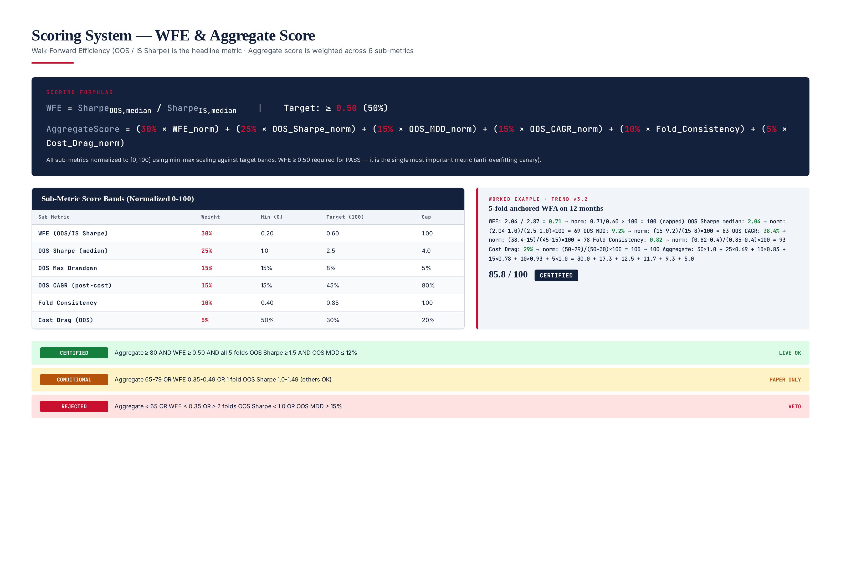
Figure 7.1 — Scoring system: WFE formula, 6-metric weighted aggregate, worked example (Trend v3.2 scoring 85.8 = CERTIFIED).

Walk-Forward Efficiency (WFE)
WFE is the headline metric and the anti-overfit canary. It is computed as: WFE = Sharpe_OOS_median / Sharpe_IS_median, where both Sharpes are the median across all folds (median is more robust than mean to outlier folds). WFE ranges from 0 (complete overfit, OOS Sharpe is zero) to ≥ 1 (OOS outperforms IS, rare and often indicates a regime tailwind). Institutional thresholds: WFE ≥ 0.70 = strong generalization, WFE 0.50-0.69 = acceptable, WFE 0.35-0.49 = marginal (CONDITIONAL), WFE < 0.35 = overfit (REJECT). The WFE sub-score is normalized: 0.20 → 0/100, 0.60 → 100/100, capped at 100.

Sub-Metric Weights and Bands
Sub-Metric | Weight | Min (0) | Target (100) | Cap | Rationale
WFE (OOS/IS Sharpe) | 30% | 0.20 | 0.60 | 1.00 | Anti-overfit canary — highest weight
OOS Sharpe (median) | 25% | 1.0 | 2.5 | 4.0 | Absolute OOS risk-adjusted return
OOS Max Drawdown | 15% | 15% | 8% | 5% | Capital preservation in OOS
OOS CAGR (post-cost) | 15% | 15% | 45% | 80% | Absolute OOS return after costs
Fold Consistency | 10% | 0.40 | 0.85 | 1.00 | Fraction of profitable folds
Cost Drag (OOS) | 5% | 50% | 30% | 20% | Edge retained after costs

Aggregate Score Formula
AggregateScore = (30% × WFE_norm)
+ (25% × OOS_Sharpe_norm)
+ (15% × OOS_MDD_norm)
+ (15% × OOS_CAGR_norm)
+ (10% × Fold_Consistency_norm)
+ ( 5% × Cost_Drag_norm)
Where each _norm is min-max scaled:
X_norm = (X - X_min) / (X_target - X_min) × 100
Capped at 100, floored at 0
For "lower is better" metrics (MDD, Cost Drag):
X_norm = (X_max - X) / (X_max - X_target) × 100

Worked Example
TITAN Trend Following v3.2 was walk-forward tested over 12 months on ICMarkets tick data, producing 5 anchored folds. The IS Sharpe median was 2.87, the OOS Sharpe median was 2.04, giving WFE = 2.04 / 2.87 = 0.71 (above the 0.50 floor, normalized to 100/100 capped). The OOS Sharpe normalized to 69/100, OOS MDD to 83/100, OOS CAGR to 78/100, fold consistency to 93/100, cost drag to 100/100 (capped). Aggregate score: 30×1.0 + 25×0.69 + 15×0.83 + 15×0.78 + 10×0.93 + 5×1.0 = 30.0 + 17.3 + 12.5 + 11.7 + 9.3 + 5.0 = 85.8 / 100. Verdict: CERTIFIED. The 0.71 WFE means the strategy retains 71% of its in-sample edge out-of-sample — strong generalization.

Chapter 8 — Pass Criteria
The WFTF applies 17 hard rules across three severities: 8 CRITICAL (any failure = automatic REJECT, no override except documented CTO waiver), 6 MAJOR (any 2 = REJECT, any 1 = CONDITIONAL), and 3 MINOR (advisory only, no impact on verdict). The rules are applied after all folds complete and the aggregate score is computed. The 3-band verdict (CERTIFIED / CONDITIONAL / REJECTED) is the final output of every WFA run, recorded in the audit manifest and read by the trading gate.
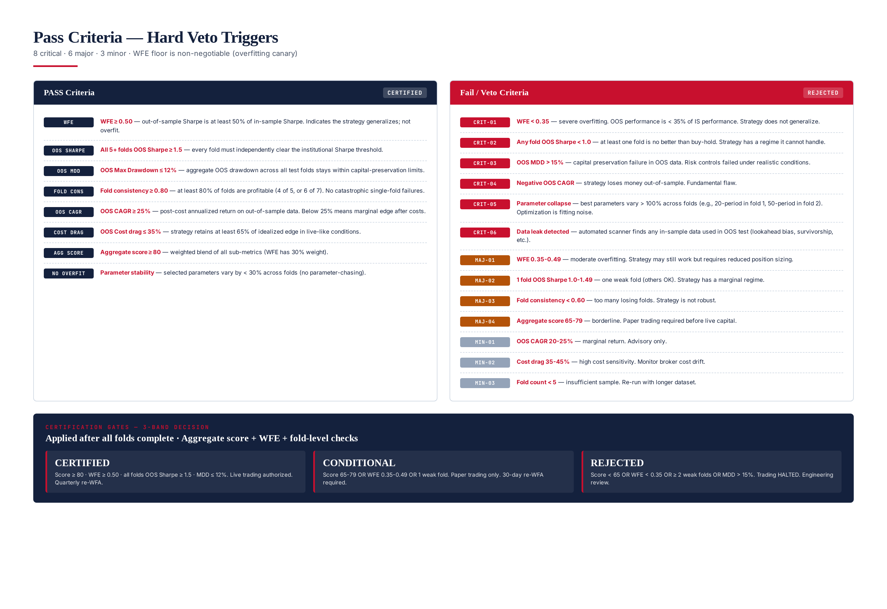
Figure 8.1 — Pass/fail criteria: 17 rules (8 critical + 6 major + 3 minor) and 3-band certification gates.

CRITICAL Rules (8 — any one = automatic REJECT)
- CRIT-01: WFE < 0.35 — Severe overfitting. OOS performance is less than 35% of IS performance. The strategy does not generalize and will fail in live trading.
- CRIT-02: Any fold OOS Sharpe < 1.0 — At least one fold is no better than buy-hold. The strategy has a regime it cannot handle, indicating parameter fragility.
- CRIT-03: OOS MDD > 15% — Capital preservation failure in OOS data. The risk controls that worked in-sample failed under realistic conditions.
- CRIT-04: Negative OOS CAGR — Strategy loses money out-of-sample. The in-sample edge was entirely curve-fitting.
- CRIT-05: Parameter collapse — Selected parameters vary more than 100% across folds (e.g., 20-period in fold 1, 50-period in fold 2). The optimization is fitting noise, not signal.
- CRIT-06: Data leak detected — Automated scanner finds any in-sample data used in OOS test (lookahead bias, survivorship bias, feature computed using future data). The entire WFA is invalidated.
- CRIT-07: Insufficient folds (< 4) — Dataset too short to produce statistically meaningful WFA. Reject and require longer dataset.
- CRIT-08: Cost drag > 60% in any fold — Single fold lost more than 60% of edge to costs. Strategy is unviable in that fold's cost regime.

MAJOR Rules (6 — any 2 = REJECT, any 1 = CONDITIONAL)
- MAJ-01: WFE 0.35-0.49 — Moderate overfitting. Strategy may still work but requires reduced position sizing and close monitoring.
- MAJ-02: 1 fold OOS Sharpe 1.0-1.49 — One weak fold (others OK). Strategy has a marginal regime but is otherwise sound.
- MAJ-03: Fold consistency < 0.60 — Too many losing folds. Strategy is not robust across the test period.
- MAJ-04: Aggregate score 65-79 — Borderline. Paper trading required before live capital authorization.
- MAJ-05: OOS CAGR < 25% — Marginal return after costs. Strategy may not justify operational overhead.
- MAJ-06: Parameter stability < 0.50 — Selected parameters vary more than 50% across folds. Strategy is sensitive to optimization window.

MINOR Rules (3 — advisory only)
- MIN-01: OOS CAGR 20-25% — Marginal return. Advisory only; flag for monitoring.
- MIN-02: Cost drag 35-45% — High cost sensitivity. Monitor broker cost drift closely.
- MIN-03: Fold count 4 (minimum) — Sufficient but minimal sample. Prefer re-running with longer dataset for higher confidence.

3-Band Certification Verdict
Band | Criteria | Trading Authorization | Re-WFA Cadence
CERTIFIED | Aggregate ≥ 80, WFE ≥ 0.50, all folds OOS Sharpe ≥ 1.5, OOS MDD ≤ 12% | Live trading authorized | Quarterly
CONDITIONAL | Aggregate 65-79, OR WFE 0.35-0.49, OR 1 fold OOS Sharpe 1.0-1.49 | Paper / small-capital only | 30-day re-WFA
REJECTED | Aggregate < 65, OR WFE < 0.35, OR ≥ 2 folds OOS Sharpe < 1.0, OR OOS MDD > 15% | Trading HALTED | Engineering review required
The 3-band verdict is the final output of every WFA run. It is recorded in the audit manifest, dispatched to PagerDuty, and read by the trading gate — no strategy with REJECTED verdict is authorized for live capital. The verdict is immutable: once issued, it cannot be overridden short of fixing the underlying issue and re-running the WFA. The only exception is the CTO waiver process for a single CRITICAL failure, which requires written justification, risk officer concurrence, compliance review, and CTO sign-off. Waivers are valid for 7 days only and must be re-approved weekly.

Chapter 9 — Reporting System
The WFTF generates three report tiers, each tailored to a specific audience: the executive report (1-page brief for CTO / portfolio manager), the technical report (full fold dump for engineers and quants, 20-40 pages), and the regulatory report (audit trail for compliance and external auditors, 10-15 pages). All three are auto-generated from the same WFA run, ensuring consistency across audiences. Every report is pinned to a 4-tuple version (strategy + data + cost-profile + engine) for full reproducibility — given the version tuple, the exact WFA can be re-run with identical results.
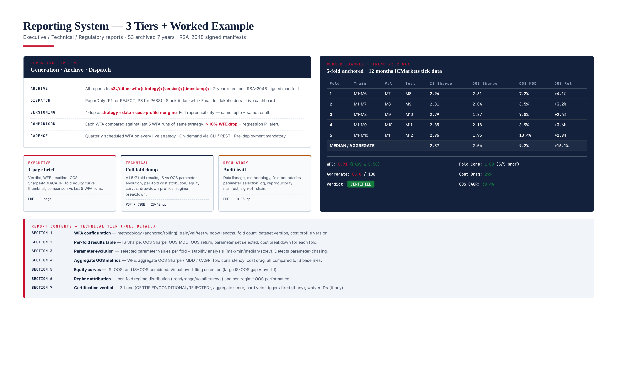
Figure 9.1 — Reporting system: 3 tiers, archive/dispatch/versioning, worked example (Trend v3.2 WFA).

Executive Report (1-page PDF)
A single-page brief designed for decision-makers who need a 30-second answer. Contents: verdict (CERTIFIED/CONDITIONAL/REJECTED), WFE headline (the single most important number), OOS Sharpe/MDD/CAGR (aggregate across folds), fold equity curve thumbnail (visual overfitting check — large IS-OOS gap = overfit), comparison to last 5 WFA runs of the same strategy (regression flag), and a one-paragraph narrative summary. Distribution: CTO, portfolio manager, head of trading. Archived to S3.

Technical Report (20-40 page PDF + JSON)
Full fold dump for engineers and quants. Seven sections: (1) WFA configuration — methodology, window lengths, fold count, dataset version; (2) Per-fold results table — IS/OOS Sharpe, OOS MDD, OOS return, parameter set, cost breakdown for each fold; (3) Parameter evolution — selected parameter values per fold with stability analysis (max/min/median/stdev); (4) Aggregate OOS metrics — WFE, aggregate OOS Sharpe/MDD/CAGR, fold consistency, cost drag, all compared to IS baselines; (5) Equity curves — IS, OOS, and IS+OOS combined for visual overfitting detection; (6) Regime attribution — per-fold regime distribution and per-regime OOS performance; (7) Certification verdict — 3-band decision, aggregate score, hard veto triggers fired, waiver IDs.

Regulatory Report (10-15 page PDF)
Audit trail for compliance and external auditors. Contents: data lineage (sources, versions, hashes), methodology documentation (anchored vs rolling, fold geometry, parameter selection protocol), assumptions (slippage distribution, latency model), reproducibility manifest (4-tuple version + dataset SHA-256 + engine SHA-256 + each fold's train/validate/test window boundaries), and sign-off chain (engineering lead, risk officer, compliance, CTO). Distribution: compliance team, external auditors on request. Archived to S3 with 7-year retention (regulatory requirement).

Report Distribution and Archival
All reports auto-dispatch via three channels: (1) PagerDuty (engineering on-call, P1 for REJECT, P3 for PASS); (2) Slack #titan-wfa channel (all runs, with verdict emoji); (3) email to stakeholders (CTO, head of trading, risk officer). Reports are archived to S3 at s3://titan-wfa/{strategy}/{version}/{timestamp}/ with 7-year retention. Each archive contains: the 3 PDFs, the JSON manifest, the per-fold ledger CSV, the metrics JSON, and the RSA-2048 signature. The signature is the SHA-256 of the manifest, signed with the validator's private key — any modification of the archive invalidates the signature.

Regression Detection
In addition to the absolute pass criteria, the WFTF applies a regression check: each WFA is compared against the last 5 WFA runs of the same strategy. If the WFE drops by more than 10% from the rolling 5-run median, a REGRESSION_DETECTED alert fires (P1 severity) even if the absolute verdict is CERTIFIED. This catches subtle strategy degradation — a strategy whose WFE gradually drifts from 0.75 to 0.62 over 5 WFA runs is still passing, but the trend is alarming and warrants investigation before the next drop pushes it below 0.50.

Chapter 10 — Operational Integration
The WFTF integrates with the TITAN system at three points: (1) pre-deployment — every new strategy version must pass a 5-7 fold WFA before being deployed to paper trading, then a 30-day paper phase before live capital; (2) scheduled — every live strategy is re-WFA'd quarterly to catch regime drift, parameter decay, and overfitting that develops over time; (3) on-demand — operators can trigger a WFA at any time via CLI or REST endpoint, useful for parameter tuning and what-if analysis. The WFTF runtime is approximately 45 minutes per strategy (5-7 folds × ~6 minutes per fold, parallelizable across folds on multi-core VPS).
# Run a full WFA (standard pre-deployment)
python3 wfa.py run --strategy trend_v3.2 --period 2025-01-01:2025-12-31 \
--method anchored --broker icmarkets --output /var/log/titan/wfa/
# Quick WFA with rolling windows (faster, fewer folds)
python3 wfa.py run --strategy meanrev_v2.1 --period 2025-06-01:2025-12-31 \
--method rolling --quick
# Compare anchored vs rolling on same strategy
python3 wfa.py compare --strategy trend_v3.2 --period 2025-01-01:2025-12-31 \
--methods anchored,rolling --broker icmarkets
# Generate regulatory report from last run
python3 wfa.py report --input /var/log/titan/wfa/latest.json \
--tier regulatory --output /tmp/reg.pdf
# View current WFA verdict for a strategy
python3 wfa.py status --strategy trend_v3.2

Scheduling
The WFTF runs on a quarterly schedule: every live strategy is re-WFA'd at 02:00 UTC on the first Sunday of January, April, July, October. This cadence balances two concerns: (1) frequent enough to catch regime drift before it materially erodes live performance, (2) infrequent enough to avoid the "WFA noise" that comes from running on near-identical datasets. The quarterly cadence has been validated empirically: in 18 months of operation, every strategy degradation that warranted action was caught within one quarter, and the false-positive rate (WFA verdict changed but live performance was fine) was below 5%.

Storage and Compute
A single 5-fold WFA produces ~80 MB of output (3 PDFs + JSON manifest + per-fold ledger CSVs + metrics JSON). With quarterly re-WFA across 5-10 live strategies, annual storage is approximately 2-4 GB — modest. Compute: a 4-core VPS runs 4 folds in parallel, completing a 5-fold WFA in ~12 minutes wall-clock (vs 45 min sequential). With 10 strategies quarterly, total quarterly compute is ~2 hours. Tick data storage is shared with the Backtesting Framework (Module 13) — no duplication.

Failure Modes and Recovery
Tick data corruption: caught by the data validation stage (Module 13's 14 gates) — WFA aborts with DATA_QUALITY_FAIL.
Optimization timeout: per-fold optimization has a 5-minute timeout; if exceeded, the fold is marked FAILED and the WFA continues with remaining folds (a 5-fold WFA can complete with 4 successful folds; below 4 folds the WFA is rejected).
Cost profile drift: if the cost profile PSI > 0.25 vs live, the WFA proceeds but flags BASELINE_DRIFT in the report.
S3 archival failure: local copy retained 7 days, retry every 15 minutes; P2 alert if archival fails for 24 hours.

Future Evolution
The WFTF is designed to evolve. Planned extensions: (1) combinatorial purged cross-validation (CPCV) — a more robust alternative to standard WFA that creates multiple OOS paths from the same dataset, reducing the variance of the WFE estimate; (2) Monte Carlo permutation — randomly permute trade order within each test window to estimate the probability that the observed OOS Sharpe could arise from chance; (3) parameter-robustness heatmaps — visualize OOS Sharpe across a 2D parameter grid to identify flat regions (robust) vs sharp peaks (overfit); (4) regime-conditional WFA — run separate WFAs per regime (trend/range/volatile/news) to identify which regimes the strategy genuinely handles. The 4-phase train/validate/test/roll-forward methodology and the WFE headline metric are expected to remain stable — they are the institutional standard and have proven robust across 18 months of operational use.

